EMS1558BM01 |  | 02-Mar-2011

Benchmarking Document
 | 1.1
 |  | E_RM021T/6.1/25-Jun-10
DOCUMENT HISTORY
Ver./ Rel. No | Release Date | Mod.By  Mod. Dt | Rev. By  Relevant Stakeholders  Rev. Dt. | Auth By  Auth Dt. | Remarks/ Revision details
1.0 | 25-Feb-2011 | VP | VP,UM | RKM | Initial Release
1.0 | 25-Feb-2011 | 25-Feb-2011 | 25-Feb-2011 | 25-Feb-2011 | Initial Release
1.1 | 02-Mar-2011 | VP | VP,UM | RKM | Internal Reviewed Version
1.1 | 02-Mar-2011 | 02-Mar-2011 | 02-Mar-2011 | 02-Mar-2011 | Internal Reviewed Version

Table of contents

1.0 Objective 3
2.0 Various Processor & Controller Features 3
3.0 Performance Benchmark 5
4.0 MULTIPLIER/MAC OPERATION 6
5.0 Motor Control Application 6
5.1 Motor Control Required Interfaces 6
5.2 PWM Resolution 7
5.3 Specific Motor Control application support 7
5.4 PID Execution Time 8
5.5 FOC Execution Time 8
5.6 Portability 8
5.7 PWM Modes 8
5.1 Peripherals 8
6.0 Features & Benefits of XMOS Core 9
6.1 Disadvantages of XMOS core 9
7.0 XMOS Core Application Development 9
7.1 Basic FOC algorithm 9
7.2 Two axis control with one core 10
7.3 Active Front end and Motor control 10
7.4 Medical application for two DC motors 10
8.0 Motor Control Board Support 10
9.0 XMOS Motor Control Board Key Features 12
10.0 Glossary 13

Objective
This document describes with the benchmarking of XMOS Core, TMS320F28035, MC56F8347 Core (Freescale), LPC 43xx Core and DsPIC33xx Core for motor control application. This document is prepared based on the available information of the other family cores.

Various Processor & Controller Features

XMOS Core | TMS320F28035 (Texas Instruments)
- High Efficiency Multi Core, Multi-Threaded 32 Bit Processor  - 400 / 500 MIPS Core Device  - 1 / 2 / 4 Core Packages  - Each Core provides 8 independent timers  - 8 Concurrent Processing (Threads)  - Memory -64KB SRAM & 8 KB OTP  - RISC Architecture  - Code – XC, C, C++ & Assembly  - XC-Concurrency, Events, I/O, Precision Timing & Communication  - JTAG & Peripherals Support  - Operating System Support – Windows & Linux  - Operating Voltage Min 3V, Max 3.6 V  - 64 user I/O Pins  - Peripherals Supports  - PWM  - I2C, SPI  - 10/ 100 Ethernet MAC  - 1 Mbit CAN  - High Speed USB 2.0 device | - 32 Bit CPU Processor  - 60 MHz Core Device  - Harvard Bus Architecture  - Memory – Flash- 64KB, SARAM-10KB, OTP, Boot RAM  - Code Efficient – C, C++ & Assembly  - Three 32 Bit CPU Timers  - Enhanced Control Peripherals  - Enhanced PWM  - High resolution PWM  - ADC  - Enhanced Capture (eCAP)  - Enhanced Quadrature Encoder Pulse  - Programmable Control Law Accelerator (CLA)  - Serial Port Peripherals  - One SCI (UART) Module  - Two SPI Modules  - One Inter-Integrated-Circuit (I2C) Bus  - One Local Interconnect Network (LIN) Bus  - One Enhanced Controller Area Network (eCAN) Bus  - Advanced Emulation Features  - Analysis and Breakpoint Functions  - Real-Time Debug via Hardware

DsPIC33FJ32MC202/204 Core (Microchip) | MC56F8347 Core (Freescale)
- High-Performance, 16-bit Digital Signal Controllers  - 40 MIPS Core Device  - Modified Harvard architecture  - Memory – Flash- 32KB, DSRAM-2KB, Boot RAM  - 35 programmable digital I/O pins  - three 16-bit timers  - Peripherals Supports  - PWM  - I2C, 4 Wire SPI  - 10/ 100 Ethernet MAC  - 10-bit ADC with 1.1 Msps & 12-bit ADC with 500 ksps conversion  - Motor Control Peripherals  - 6-channel 16-bit Motor Control PWM  - 2-channel 16-bit Motor Control PWM  - Quadrature Encoder Interface module | - 16 Bit Digital Signal Controller  - 60 MHz /60 MIPS Core Frequency  - Dual Harvard Bus Architecture  - Unified Memory programmable Model  - 4 KB PRAM, 8KB DRAM  - 128 KB Program, 8KB Data/Boot Flash  - Two 6 Channel PWM Modules  - Code efficient in C, C++ & Assembly  - Four channel 12 Bit ADC  - JTAG/On Chip Emulation Peripherals Support

LPC43xx Core

- 32 Bit Core Device
- 150 MHz Core Device
- Dual Core Device
- Harvard architecture
- Hardware floating-point unit.
- Memory -200 KB SRAM, 32 KB ROM & 32 bit One-Time Programmable (OTP) memory
- Serial interfaces
  - 10/100T Ethernet MAC
  - One High-speed USB 2.0 Host/Device interface with DMA support, on-chip
  - One 550 UART with DMA support and full modem interface.
- C_CAN 2.0B controller with one channel.
- One Fast-mode Plus I2C-bus interface
- Digital peripherals
  - Four general-purpose timer/counters
  - Motor control Pulse Width Modulator (PWM) for three-phase motor control.
  - Quadrature Encoder Interface (QEI).
- Analog peripherals
  - One 10-bit DAC with DMA support and a data conversion rate of 400 kSamples/s.
  - Two 10-bit ADCs with DMA support and a data conversion rate of 400 kSamples/s.
- Power
  - Single 3.3 V (2.2 V to 3.6 V) power supply with on-chip DC-to-DC converter for the core supply

Performance Benchmark

Performance benchmark is a program that is used to determine relative core performance by evaluating benchmark execution time by that core. The execution times are given in terms of both clock cycles and time units. The table below presents the most important result of the core benchmark evaluation. It pictures the relative performance of the compared core instruction set on a scale.

Device | MIPS or Operating Frequency in MHz
XMOS Core | 125 (125 MHz) / core ( 4 threads)
TMS320F28035 Core (Ti) | 60 MHz
dsPIC33FJ32MC202/204 Core (Microchip) | 40 MIPS
MC56F8347 Core (Freescale) | 60 MHz / 60 MIPS
LPC43xx Core (NXP) | 150 MHz

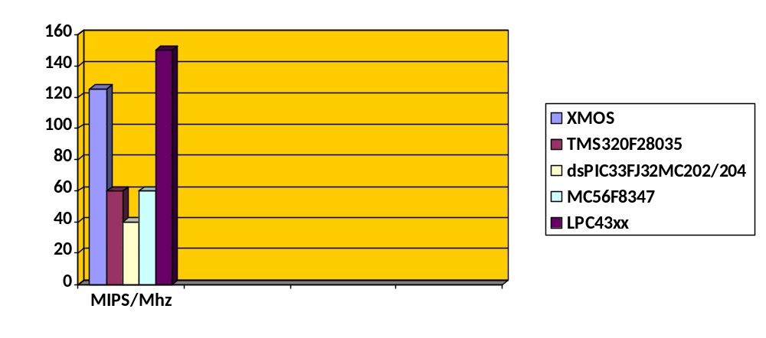

MULTIPLIER/MAC OPERATION

Device | MAC/MUL Instruction/Cycle
XMOS Core | 32x32 Bit (1 cycles with XS1-G4 core)
TMS320F28035 Core (Ti) | 32x32 Bit (1 cycle with CLA)
dsPIC33FJ32MC202/204 Core (Microchip) | 16x16 Bit (1 cycle)
MC56F8347 Core (Freescale) | 16x16 Bit (1 cycle)
LPC43xx Core (NXP) | 32x32 Bit (1 cycle)

Motor Control Application

Motor Control Required Interfaces

Device | XMOS Core | TMS320F28035 Core (TI) | DsPIC33FJ32MC202/204 Core (Microchip) | MC56F8347 Core (Freescale) | LPC43xx Core (NXP)
ADC synchronisation with PWM | Yes | Yes | Yes | Yes | Yes
Flash Memory Internal/External | External | Internal | Internal | Internal | External
ADC Internal/External | External | Internal & External | Internal & External | Internal & External | Internal & External
EEPROM Internal | No | No | No | No | No
SPI modules-Diagnostics & debugging | Yes | Yes | Yes | Yes | Yes
PWM modes | Centrally synchronised, Chopped PWM | Edge aligned, center aligned | Edge aligned, center aligned | Edge aligned, center aligned | Edge aligned, center aligned
Math functions library- Sine, Cosine, SQRT | Available | Available | Available | Available | Available
Quad Decoder modules for multi axis applications | 2 per core | One | One | Two | One
Capture module for custom made encoders | Possible | Yes | Yes | No | No
Multi-threading | Yes | No | No | No | No
Hard real time | Yes | No | No | No | No
Core | 1-2-4 | 1 and CLA | 1 | 1 | Dual core
Power supply voltage requirements | 2 | 1 | 1 | 1 | 1
Clock frequency internal /external | External | Internal & External | Internal & External | Internal & External | Internal & External
PWM reload | Single cycle | Half cycle, one /two cycle | Half /One cycle | Half/one cycle | TBD

PWM Resolution

Device | XMOS Core | TMS320F28035 Core | DsPIC33FJ32MC202/204 Core (Microchip) | MC56F8347 Core (Freescale) | LPC43xx Core (NXP)
Switching Frequency | 24,414 Hz | 5 KHz | 39.1 KHz | 20 KHz
PWM Resolution | 4096 (12 Bit) | 12.5 Bit | 11 Bit Edge Aligned | 11.5 Bit

Specific Motor Control application support

Device | XMOS Core | TMS320F28035 Core | DsPIC33FJ32MC202/204 Core (Microchip) | MC56F8347 Core (Freescale) | LPC43xx Core (NXP)
Dual Motor | Supported | Supports but only one QEI for encoder | Not supported | Supported | Not supported
Active Rectifier & Motor Control | Supported | Supported | Supported | Supported | Not supported
Stepper Motor | Supported | Supported | Supported | Supported | Supports but for limited PWM

PID Execution Time
Device | XMOS Core | TMS320F28035 Core | DsPIC33FJ32MC202/204 Core (Microchip) | MC56F8347 Core (Freescale) | LPC43xx Core (NXP)
Time (micro sec) | 3 micro second

FOC Execution Time
Device | XMOS Core | TMS320F28035 Core | DsPIC33FJ32MC202/204 Core (Microchip) | MC56F8347 Core (Freescale) | LPC43xx Core (NXP)
Time (micro sec)

Portability

Device | XMOS Core | TMS320F28035 Core | DsPIC33FJ32MC202/204 Core (Microchip) | MC56F8347 Core (Freescale) | LPC43xx Core (NXP)
Portability | Portable | Portable for processor but CLA code must be written in Assembly language | Portable with addition of some code for 16 bit compatibility | Portable with addition of some code for 16 bit compatibility | Portable

PWM Modes

Device | XMOS Core | TMS320F28035 Core | DsPIC33FJ32MC202/204 Core (Microchip) | MC56F8347 Core (Freescale) | LPC43xx Core (NXP)
Complementary /Independent | Supported | Supported | Supported | Supported | Supported

Peripherals

Device | XMOS Core | TMS320F28035 Core | DsPIC33FJ32MC202/204 Core (Microchip) | MC56F8347 Core (Freescale) | LPC43xx Core (NXP)
Timer/  Counter | Eight | Three | Three | Four | Four
Motor Control  PWM | 12 Ch | 7 | 6 Ch & 2 Ch | Two 6 Ch | 1
Quadrature  Encoder  Interface | 2 | 1 | 1 | 1 | 1
UART | 1 | 1 | 1 | 1 | 1
CAN | 1 | 1 | 1 | 1 | 1
EMAC (Mbps) | 10/100 | 10/100 | 10/100 | 10/100 | 10/100
SPI | 1 | 2 | 1 | 2 | 1
I/O Pins | 64 | 64 | 35 | 76 (GPIO) | 146 (GPIO)
I2C | 1 | 1 | 1 | 1 | 2

Features & Benefits of XMOS Core

- Multi Core (1, 2 or 4 cores in one chip) device option benefits low cost Multi axis Motor controllers
- Pin configurable for any type of peripheral leads to future flexibility for product design
- High MIPS feature provides high switching frequency for various motor controls
- Higher accuracy and resolution for position and speed control due to high resolution of PWM can be achieved
- Speed Measurement up to 30000 RPM with 1024 PPR encoder due to high system clock support
- Single development environment for various products leads to cost reduction
- Open source IDE and less cost for JTAG emulator(around 50 $)

Disadvantages of XMOS core
- In-build Logging mechanism not there in current version of XMOS –IDE
- XMOS IDE compiler takes more times to compile the new/modified code.
- External ADC module
- Internal Flash Memory and EEPROM is not there in the existing board
- 4bit and 8 bit port can’t be configured for one bit port
- External crystal oscillator is required for clock input

XMOS Core Application Development

Basic FOC algorithm

Thread1 | Thread 2 | Thread 3 | Thread 4
ADC read | Encoder & hall sensor | Speed controller, Iq, Id | Space vector & Communication
ADC read | Speed and position calculation | Clarke , park | Space vector & Communication

Two axis control with one core

Thread1 | Thread 2 | Thread 3 | Thread 4
ADC read 1 | Encoder1 & hall sensor1 | Speed controller1, Iq1, Id1 | Space vector1 & Communication1
ADC read 1 | Speed and position calculation1 | Clarke1 , park1 | Space vector1 & Communication1
ADC read 2 | Encoder2 & hall sensor2 | Speed controller2, Iq2, Id2 | Space vector2 & Communication2
ADC read 2 | Speed and position calculation2 | Clarke2, park2 | Space vector2 & Communication2

Active Front end and Motor control

Thread 1 | Thread 2 | Thread 3 | Thread 4
ADC read 1 | Encoder1 & Hall Sensor | Id, Iq controller for motor control | Space vector & Communication interface
ADC read 2 | Speed controller for motor and voltage controller for Active front end | Id, Iq controller for active front end

Medical application for two DC motors

Thread 1 | Thread 2
Encoder Module 1 & Encoder Module 2 | Speed control for DC Motor1
 | Position control for DC Motor2

Motor Control Board Support

Device | XMOS Core | TMS320F28035 Core | DsPIC33FJ32MC202/204 Core (Microchip) | MC56F8347 Core (Freescale) | LPC43xx Core (NXP)
Flash Memory (Kbyte) | 4 MB SPI Boot | 64 | 32 | 128 KB Program  8 KB Data | 1024
RAM (Kbyte) | 64 | 2 (L0) | 2 | 8 | 200
External Memory (Kbyte) | 256 Mega Bit | 6 (L1,L2,L3) | NA | NA | 16 Bit & 32 Bit wide
Multi-Core | 1,2 & 4 | 1 | 1 | 1 | 1 & 2
Multi-Thread | 8
Language | XC,C,C++ & Assembly | C, C++ & Assembly | C, C++ & Assembly | C, C++ & Assembly | C, C++ & Assembly
Dual Motor Control | Yes | No | No | Yes | No
ADC | 6 Ch 14 Bit &12 Ch 10 Bit | 12 Bit | 10 bit & 12 Bit | 4 Ch 12 Bit | Two 10 Bit
OS / RTOS | Windows/Linux | Windows/ RTOS support | Windows | Windows | Windows
License & Tool cost | Free | Payable | Payable | Payable | Payable
Package | BGA, LQFP, QFN | TQFP & LQFP | SPDIP, SOIC & SSOP | LQFP & 160 Map Ball Grid Array | LQFP208 & BGA180
IDE Awareness | Need Training | Need Training | Need Training | Need Training | Need Training

XMOS Motor Control Board Key Features

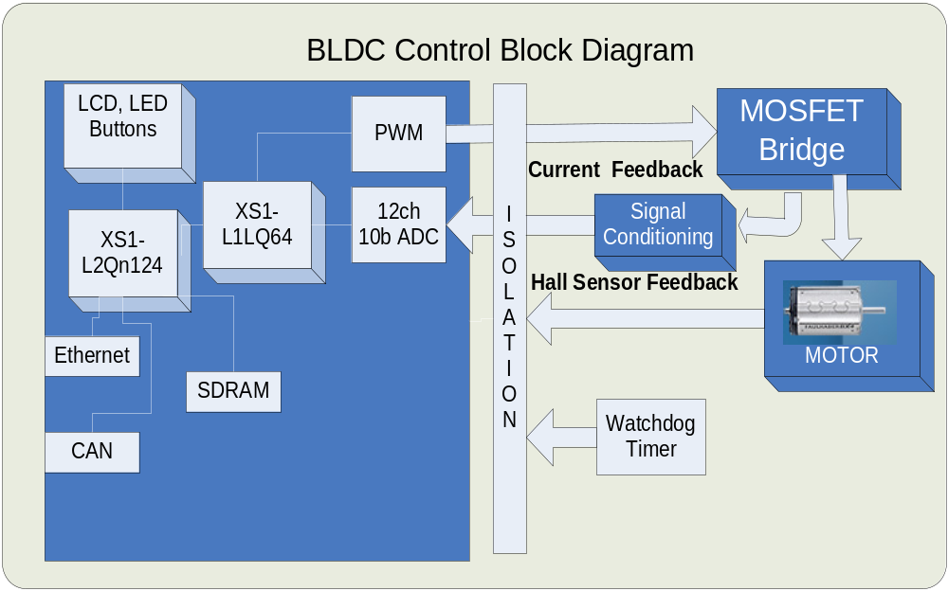
Figure1: BLDC Control Block Diagram
- Two XMOS XS1-L processors:
  - XS1-L1 500 MIPS processor handling three-phase BLDC motor control loops
  - XS1-L2 1000MIPS processor handling communication, logging and motion control
- Six-channel 14-bit 600KSPS ADC with individual sample/hold
- Two-channel hall effect encoder input
- Isolated power section supporting up to 24V and 10A total
- 7.7 Watt Faulhaber BLDC 24v motor
- 32MB of SDRAM
- General I/O including 12 channel 10bit ADC, Ethernet, CAN, LCD and GPIO
- Power supply

Glossary

Abbreviations | Full Form
ADC | Analog-to-Digital Converter
BLDC | Brushless Direct Current
Ch | Channel
CAN | Controller Area Network
EMAC | Ethernet Medium Access Control
FW | Firmware
I/O | Input / Output
I2C | Inter Integrated Circuit
SPI | Serial Peripheral Interface
UART | Universal Asynchronous Receive Transmit
GPIO | General Purpose Input Output
PWM | Pulse Width Modulation
FOC | Field Oriented Control
MIPS | Million Instructions per Second
PCB | Printed Circuit Board
L&T | Larsen & Toubro Limited
SQA | Software / System Quality Assurance
TBD | To Be Decided
SVM | Space Vector Modulation
USB | Universal Serial Bus
NA | Not Applicable

