EMS1558RS01 |  | 14-Feb-2011

BLDC Motor Control Platform Development
Requirement Specification
 | 1.2
 |  | E_RM021T/6.1/25-Jun-10
DOCUMENT HISTORY
Ver./ Rel. No | Release Date | Mod.By  Mod. Dt | Rev. By  Relevant Stakeholders  Rev. Dt. | Auth By  Auth Dt. | Remarks/ Revision details
1.0 | 03-Feb-2011 | VP, PS | VP,UM | RKM | Initial Release
1.0 | 03-Feb-2011 | 03-Feb-2011 | 03-Feb-2011 | 03-Feb-2011 | Initial Release
1.1 | 03-Feb-2011 | VP | VP,UM | RKM | Internal Reviewed Version
1.1 | 03-Feb-2011 | 03-Feb-2011 | 03-Feb-2011 | 03-Feb-2011 | Internal Reviewed Version
1.2 | 14-Feb-2011 | VP | VP, UM | RKM | Customer Reviewed Version
1.2 | 14-Feb-2011 | 14-Feb-2011 | 14-Feb-2011 | 14-Feb-2011 | Customer Reviewed Version

Table of contents

1.0 Requirements which need further elaborations 4
2.0 Introduction 4
2.1 Purpose of this project 4
2.2 Key success Factors 5
2.3 Stakeholders Reference 5
2.4 References 5
3.0 Project Descriptions 5
3.1 Project Overview 5
3.2 Block Diagram 6
3.3 Scope of the Project 6
3.4 Not in the scope of the Project 7
3.5 Product Functions / General Descriptions 7
3.6 Annual quantity/ prototype quantity 7
3.7 Expected product life 7
3.8 Similar System Information 7
3.9 System Environment 8
3.10 Tools / Software /components agreed to be supplied by the customer 8
3.11 Design and Implementation Constraints 8
3.12 Assumptions and Dependencies 8
4.0 Application Environment 9
4.1 Business Context 9
4.1.1 Environment 9
4.1.2 Functions 9
4.1.3 Problems / Risks to be watched for 9
4.2 Operational Concepts & Scenarios: 9
4.3 User Profiles 9
4.4 Cost 9
5.0 Details of requirements gathering process 10
5.1 Strategy / Process adopted for Requirements Gathering and Elicitation 10
6.0 Requirements Specifications 10
6.1 Software Requirements 10
6.1.1 Forward & Reverse Rotation of Motor (Phase 1) 10
6.1.2 Proof of Concept & Demo (Phase 1) 10
6.1.3 Motor Selection (Phase 1) 11
6.1.4 Matlab Modelling & Simulation (Phase 1) 11
6.1.5 Benchmarking (Phase 1) 12
6.1.6 Vector Control Algorithm with Hall Sensor Feedback (Phase 2) 12
6.1.7 Sensor less Vector Control Algorithm with/without Speed Control (Phase 3) 12
6.1.8 Kernel Requirements for developing application on RTOS (KSR) 13
6.1.9 Device Drivers Requirements (DDSR) 13
6.1.10 Software Features Requirements (FSR) 13
6.1.11 Memory (Software) (MSR) 13
6.1.12 Database Requirements (DBSR) 13
6.1.13 Communication Interface Software Requirements (CSR) 13
6.1.14 Peripheral Interface Software Requirements (PSR) 13
6.1.15 User Interface Requirements (UIR) 13
6.1.16 Application Software Requirements (ASR) 13
6.1.17 Other Software Requirements (OSR) 13
6.2 Hardware Requirements 14
6.2.1 Hardware Modification Based on Phase 1 Deliverables (Phase2) 14
6.2.2 Processor / Controller Requirements (PCSR) 14
6.2.3 Memory (Hardware) Requirements (HMR) 14
6.2.4 Communication Interface Hardware Requirements (CHR) 14
6.2.5 Peripheral Interface Hardware Requirements (PHR) 14
6.2.6 External Interface (Hardware) Requirements (EIHR) 14
6.2.7 Power Supply Requirements (PSHR) 14
6.2.8 Other Hardware Requirements (OHR) 14
6.2.9 Hardware Operating Condition Requirements (OCHR) 15
6.2.10 Hardware Installation Requirements (HIR) 15
6.2.11 PCB Requirements (PCB) 15
6.2.12 Any Other Product level features (Includes both H/W & S/W) – (OTHER) 15
6.3 General Requirements 15
6.3.1 Operational Requirements (OPR) 15
6.3.2 Product Standards Requirements (PSDR) 15
6.3.3 Mechanical/EMI EMC Requirements (EMI/EMC) 15
6.3.4 Security Requirements (SCR) 15
6.3.5 Reliability Requirements- (RLR) 15
6.3.6 Availability Requirements – (AVR) 15
6.3.7 Maintainability Requirements – (MTR) 15
6.3.8 Performance Requirements – (PFR) 15
6.3.9 Safety Requirements (SFR) 15
7.0 Deliverables & Acceptance Criteria 16
8.0 Test Strategy 16
9.0 Glossary 16

Requirements which need further elaborations

Sl. No. | Requirements on which more information is required | Requirements  Id ref. | Clarifications expected from customer | Assumptions | Target Date
1 | Hardware changes for motor selection (phase 2) | EMS1558HWR01 | Based on test results of phase 1 | Customer provides the feedback after seen the hardware changes
2 | PCB (Phase 2) | EMS1558HWR01 | NA | On completion of  Schematic, the PCB dimensions & other details shall be finalised.

Introduction
XMOS has developed a flexible motor control platform powered by XS1-L devices that is ideal for developing controllers and drives for any motor type. The platform includes a brushless DC (BLDC) controller which has supports of PWM generation, data logging and I/O including CAN interface, Ethernet, a graphics LCD for monitoring and a sample DSC control loop. The block diagram of BLDC Motor Control Platform is shown below.

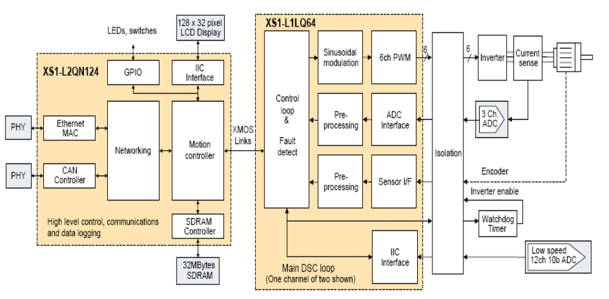
Figure 1: Block diagram of BLDC Motor Control Platform

Purpose of this project
The purpose could be split with major tasks such as:
- Modifications in HW and SW to run the motor on existing HW platform.
- Benchmarking against other motor control chip manufacturers to bring out advantages and disadvantages in the existing XMOS design.
- Coming up with new HW and SW design to support Encoders, Vector control and Sensor less motor control methods.

Key success Factors
- High Efficiency Multi Core, Multi-Threaded 32 Bit Processor
- 400 / 500 MIPS Core Device
- 8 Concurrent Processing Threads
- 64 user I/O Pins
- Complete understanding of the requirement

Stakeholders Reference
Project Manager : Upendra Mahida
Project Leader : Pradheepan
Software Developer : Srikanth Anandapu, Panshul Srivastava
Hardware engineer : Vasu, Prashanth
SQA : Jayashree

References

- Schematic Diagram for the existing board
- Motor control statement of work version 0v2
- Proposal for BLDC Motor Control platform development
- Emails

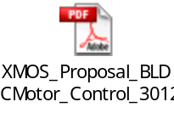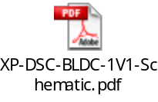

Project Descriptions

Project Overview
Design and develop Field Oriented Controller based on sensor less and with Encoder/ Hall Sensor feedback software for XMOS platform using XC language. A graphical user interface with minimum features to load tuning parameters will be provided by L&T.

Block Diagram

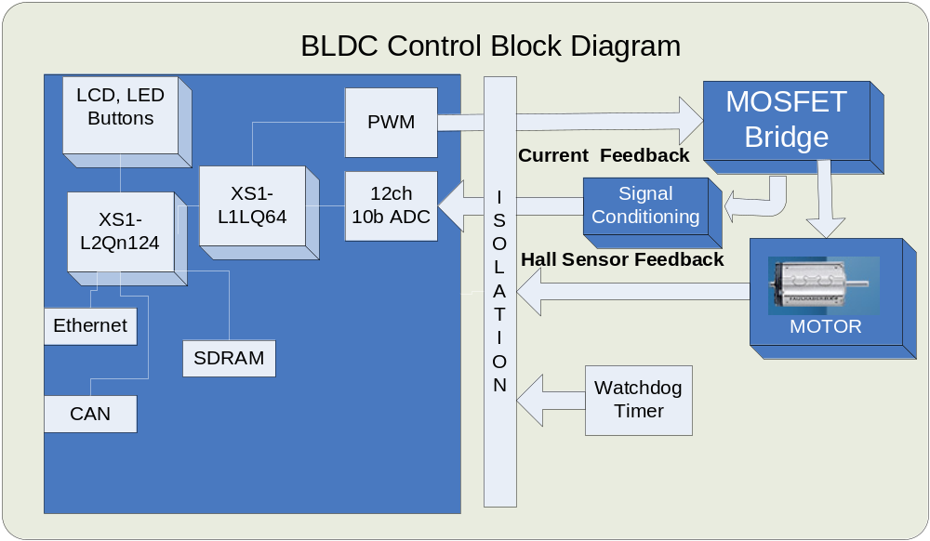
Figure 2: Block diagram of BLDC Motor Control

Scope of the Project
The scope of the project for phase 1 is listed below

- Motor selection

- Requirement specification preparation

- Matlab / Simulink modeling

- Demo : Source code development for motor spin & control with hall sensor feedback

- Preparation of System test plan

- Documentation for Benchmarking of XMOS core with other families of microcontroller based on XMOS based design

The scope of the project for phase 2 is listed below

- Design document preparation

- Freezing the Matlab / Simulink models

- Unit test plan preparation

- Source code development and unit testing

- Integration, System testing and test reports

- Graphical user interface design with minimum features

- Documentation and training to XMOS

The scope of the project for phase 3 is listed below

- Design and Development of various control schemes ( Position/Speed/Torque)

- Matlab modeling

- Design document preparation

- Unit test plan preparation

- Source code development & Unit testing

- Integration, System testing & test reports

- Documentation and training to XMOS

Not in the scope of the Project

- CAN Interface design , development & testing

- Ethernet Interface design, development & testing

Product Functions / General Descriptions
XMOS offers a motor control platform, enabling developers to deliver innovative and highly efficient motor control designs to customer. The XMOS motor control hardware platform provides dual-axis 3-phase motor control using an XS1-L1, and communications and logging subsystem using an XS1-L2. It includes a framework of control, processing and interfacing functions, to help designers quickly develop advanced motor drives entirely in high level software programming languages.

Annual quantity/ prototype quantity
NA

Expected product life
NA

Similar System Information
NA

System Environment
- The system is windows OS based and runs on XMOS IDE software

- Motor control evaluation boards

- Standard PC equipped with
- 1GB RAM
- Minimum 1 x USB
- MS Office/ MS Project / MS Excel

Tools / Software /components agreed to be supplied by the customer

- XMOS IDE

- XS1-L1/L2 devices hardware

- USB
- JTAG Interface HW / Emulator
- Power Supply -24V to 5V
- Motor control boards
- Motors
- Java based application for logging

Design and Implementation Constraints
XC Language understanding is required to design & implement BLDC motor control.

Assumptions and Dependencies

- Only one motor control shall be developed at concept phase

- Only Speed control mode will be developed in Concept Phase

- Field oriented control and SVM will be implemented

- Motor should have encoder & Hall sensor feedback.

- XC language and XTA training will be given by XMOS

- Required type of control will be speed control

- All hardware tools and development environment shall be provided by XMOS

- Communication interface requirements shall be given by XMOS

Application Environment

Business Context

Environment

NA

Functions

This product should be capable of performing the entire desired functionalities on the XMOS motor control platform.

Problems / Risks to be watched for

There might be the need to modify the control algorithms on XMOS motor control platform & Hardware failure which is provided by XMOS.

Operational Concepts & Scenarios:
NA

User Profiles
NA

Cost
NA

Details of requirements gathering process

Strategy / Process adopted for Requirements Gathering and Elicitation

- Conference call with customer every week
- Internal Discussions

Requirements Specifications
The Requirements Specifications have been divided into three categories

- Software Requirements
- Hardware Requirements and
- PCB Requirements

Software Requirements

Forward & Reverse Rotation of Motor (Phase 1)

Requirement Id. | EMS1558SWR01
Reference | BLDC_Motor_Control_Proposal.pdf, XP-DSC-BLDC-1V1-Schematic.pdf
Description | Source code implementation for forward & reverse rotation of motor with hall sensor feedback & commutation sequences
Criticality | Mandatory
Technical issues | NA
Risks | NA
Dependencies with other requirements | NA
Expected Results with acceptability limits, Wherever applicable | Forward & Reverse rotation of motor with minimum & maximum RPM
Method of Verification | System Testing
Method of Validation | Done by customer

Proof of Concept & Demo (Phase 1)

Requirement Id. | EMS1558SWR02
Reference | BLDC_Motor_Control_Proposal.pdf, XP-DSC-BLDC-1V1-Schematic.pdf
Description | Source code implementation, demonstration for motor spin and control with hall sensor feedback & verifying the commutation sequence
Criticality | Mandatory
Technical issues | NA
Risks | NA
Dependencies with other requirements | NA
Expected Results with acceptability limits, Wherever applicable | Motor spinning with hall sensor feedback
Method of Verification | System Testing
Method of Validation | Done by customer

Motor Selection (Phase 1)

Requirement Id. | EMS1558SWR03
Reference | BLDC_Motor_Control_Proposal.pdf, XP-DSC-BLDC-1V1-Schematic.pdf
Description | This is understanding of all motor benefits, advantages, disadvantages & select the best motor for encoders/hall sensor feedback, vector control & sensor less modules
Criticality | Mandatory
Technical issues | NA
Risks | NA
Dependencies with other requirements | NA
Expected Results with acceptability limits, Wherever applicable | Suitable for demo & customer approval
Method of Verification | System Testing
Method of Validation | Done by customer

Matlab Modelling & Simulation (Phase 1)

Requirement Id. | EMS1558SWR04
Reference | BLDC_Motor_Control_Proposal.pdf
Description | This is required for proof of concept (motor spinning & control)
Criticality | Mandatory
Technical issues | NA
Risks | NA
Dependencies with other requirements | This is needed to verify in order to run the motor for real time
Expected Results with acceptability limits, Wherever applicable | Motor spinning with hall sensor feedback
Method of Verification | Unit Testing
Method of Validation | Done by customer

Benchmarking (Phase 1)

Requirement Id. | EMS1558SWR05
Reference | BLDC_Motor_Control_Proposal.pdf, XP-DSC-BLDC-1V1-Schematic.pdf
Description | Prepare the benchmarking of XMOS core with other families of microcontroller based on XMOS based design. It includes parameters like Core MIPS, Cost, Peripherals, language support, Memory, IDE awareness, Architecture & etc for motor control application.
Criticality | Mandatory
Technical issues | NA
Risks | NA
Dependencies with other requirements | NA
Expected Results with acceptability limits, Wherever applicable | Suitable for demo & customer approval
Method of Verification | NA
Method of Validation | Done by customer

Vector Control Algorithm with Hall Sensor Feedback (Phase 2)

Requirement Id. | EMS1558SWR06
Reference | BLDC_Motor_Control_Proposal.pdf, XP-DSC-BLDC-1V1-Schematic.pdf
Description | Phase two task supports motor control platform with certain unique features incorporated. It supports Vector Control (FOC) Algorithm with hall sensor and encoder feedback & Speed control.
Criticality | Mandatory
Technical issues | NA
Risks | NA
Dependencies with other requirements | NA
Expected Results with acceptability limits, Wherever applicable | Dual motor spinning & control
Method of Verification | System Testing
Method of Validation | Done by customer

Sensor less Vector Control Algorithm with/without Speed Control (Phase 3)

Requirement Id. | EMS1558SWR07
Reference | BLDC_Motor_Control_Proposal.pdf, XP-DSC-BLDC-1V1-Schematic.pdf
Description | Phase three task supports dual motor platform with certain unique features incorporated. It supports Sensor less Vector Control Algorithm with or without speed control for dual motor applications.
Criticality | Mandatory
Technical issues | NA
Risks | NA
Dependencies with other requirements | NA
Expected Results with acceptability limits, Wherever applicable | Dual motor spinning & control
Method of Verification | System Testing
Method of Validation | Done by customer

Kernel Requirements for developing application on RTOS (KSR)

NA

Device Drivers Requirements (DDSR)

NA

Software Features Requirements (FSR)

NA

Memory (Software) (MSR)

NA

Database Requirements (DBSR)

NA

Communication Interface Software Requirements (CSR)

NA

Peripheral Interface Software Requirements (PSR)

NA

User Interface Requirements (UIR)

NA

Application Software Requirements (ASR)

NA

Other Software Requirements (OSR)

NA

Hardware Requirements

Hardware Modification Based on Phase 1 Deliverables (Phase2)

Requirement Id. | EMS1558HWR01
Reference | BLDC_Motor_Control_Proposal.pdf, XP-DSC-BLDC-1V1-Schematic.pdf
Description | Redesign the HW platform to make the platform more generic to demonstrate complex motion profiles thus exploring the power of the disruptive architecture of XMOS chip. The HW will support dual motor applications with encoder / hall sensor feedback, Vector control, Sensor less feedback and FOC algorithm for Speed and Torque Control
Criticality | Mandatory
Technical issues | NA
Risks | NA
Dependencies with other requirements | NA
Expected Results with acceptability limits, Wherever applicable | Dual motor spinning & control
Method of Verification | System Testing
Method of Validation | Done by customer

Processor / Controller Requirements (PCSR)

NA

Memory (Hardware) Requirements (HMR)

NA

Communication Interface Hardware Requirements (CHR)

NA

Peripheral Interface Hardware Requirements (PHR)

NA

External Interface (Hardware) Requirements (EIHR)

NA

Power Supply Requirements (PSHR)

NA

Other Hardware Requirements (OHR)

NA

Hardware Operating Condition Requirements (OCHR)

NA

Hardware Installation Requirements (HIR)

NA

PCB Requirements (PCB)

Refer section 1.0 Serial number: 2

Any Other Product level features (Includes both H/W & S/W) – (OTHER)

NA

General Requirements

Operational Requirements (OPR)

NA

Product Standards Requirements (PSDR)

NA

Mechanical/EMI EMC Requirements (EMI/EMC)

NA

Security Requirements (SCR)

NA

Reliability Requirements- (RLR)

NA

Availability Requirements – (AVR)

NA

Maintainability Requirements – (MTR)

NA

Performance Requirements – (PFR)

NA

Safety Requirements (SFR)

NA

Deliverables & Acceptance Criteria

Deliverables agreed  (Both Intermediate & Final) | Date of Delivery, Only if committed to the customer | Deliverable format | Acceptance Criteria |  | Remarks
Deliverables agreed  (Both Intermediate & Final) | Date of Delivery, Only if committed to the customer | Deliverable format | Task | Responsibility | Remarks
Requirement specification document | 03-Feb-2011 | Soft Copy | Review of the Customer | PL | Phase 1 deliverable
Concept code & Draft System Test Plan | 25-Feb-2011 | Soft Copy | Review of the Customer | PL | Motor control functionalities checked with faulhaber motor with hall sensor feedback

Note: Phase 2 & Phase 3 deliverables will be decided after phase 1 completion.

Test Strategy
Based on the analysis, system testing is to be done on the XMOS motor control platform.

Glossary
Abbreviations | Full Form
BLDC | Brush less Direct Current
FW | Firmware
FOC | Field Oriented Control
MIPS | Million Instructions per Second
PCB | Printed Circuit Board
L&T | Larsen & Toubro Limited
SQA | Software / System Quality Assurance
TBD | To Be Decided
SVM | Space Vector Modulation
USB | Universal Serial Bus
NA | Not Applicable

