CS500 Project 0
(ungraded)

Synopsis
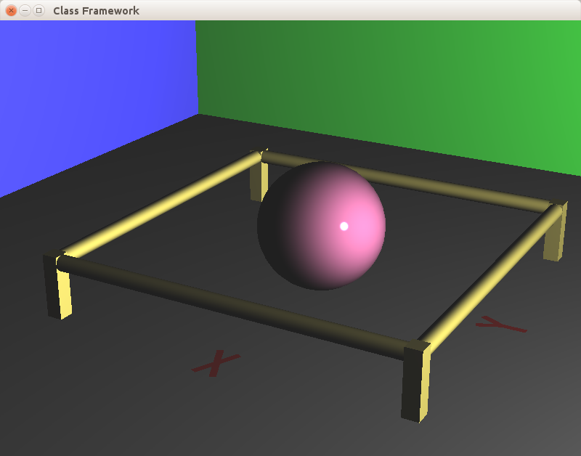The realtime window produced by the original framework. You will remove this code.
Prepare your framework for a semester of raytracing. The framework, as distributed, reads and parses a scene definition, and then provides a realtime interactive display of the contents. Your goal is to remove all realtime graphics, and replace it with code that saves all the parsed information in preparation for the actual raytracing which will commence with project 1.

Description
The framework contains a number of features which you can use to get started on the implementation of the raytracing algorithm quickly and as distraction-free as possible. This includes:
- A parser for our scene-description language (ReadScene in main.cpp). This is trivially extensible as the semester progresses.
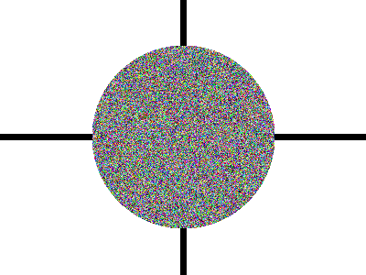The HDR image produced by the original framework. You will eventually replace this with a raytraced image.
- The choice of an HDR output file format (called RGBE or RADIANCE), and code to read and write such images (in rgbe.cpp). This will serve as the main output of the raytracer. I recommend luminance-hdr ( http://qtpfsgui.sourceforge.net/) for displaying such images. I may also supply a small convenient Python app to do the same.
- Code to generate and write a simple test image (seen at right).
- A single line OpenMP (http://openmp.org/wp/) #pragma that magically turns the y-loop into a multi-threaded loop.
- A choice of vector library for all vector/matrix/quaternion calculations. Its called GLM (see http://glm.g-truc.net/0.9.6/index.html).
- The Open Asset Import Library (http://assimp.sourceforge.net/), assimp for short, to read in mesh type models from any of 30+ file formats, and code (in readAssimpFile.cpp) that extracts the geometry and some material information from the resulting structure.
- A choice of a good quality random number generator (a Mersenne Twister implementation called MT19937-64) which is thread-safe (critical when using OpenMP). Call U01random(prng) to get a random number uniformly distributed in the range .
- The Eigen library which has, among a very large number of geometric objects and algorithms, a simple way to turn a list of geometric objects into a boundary-volume-hierarchy (BVH), and a traversal of the BVH which speeds up the raytracing algorithm by several orders of magnitude. All in about 25 lines of code.

Instructions
To get the bare-bones starting point for you raytracer, remove all the realtime drawing code. This has been made purposely easy:
- Remove the code and header files realtime.h and realtime.cpp, and both shader files realtime.vert and realtime.frag.
- From file raytrace.h, remove #include "realtime.h" and the declaration Realtime* realtime.
- From raytrace.cpp, remove the Realtime constructor call in Scene::Scene() .
- All other references to the “realtime” structure (all found in raytrace.cpp) are method calls on the Realtime structure for passing information about the scene as it's parsed. They mostly convert that information into OpenGL calls and pass it on to the GPU. You replace those calls with code that stores the information in the Scene structure in preparation for raytracing into it. The next section gives many details.

Details
The input file format consists of individual lines, each of which consists of a keyword followed by a number of parameters, usually all floats, but occasionally ending with a string Each line parsed from the scene file will be passed to the Scene structure through a call to Scene::Command:
void Scene::Command(const std::string c, const std::vector<double> f, const std::vector<std::string> strings)
Its three arguments are (1) the keyword string, (2) a vector<double> containing as many consecutive numbers as could be parsed, and (3) a vector<string> containing any remaining string parameters.

Your implementation of Scene::Command should examine the keyword to determine what information is being passed in, then store that information somewhere in the Scene structure. The Scene structure should be able to store the following data:
- Screen width and height
- Camera eye, orientation and ry information.
- A list of materials (either normal reflecting surface types or light emitting surface types).
- A list of geometric shapes (box, sphere, cylinder, and triangle to start with, but probably extend later). Each shape will be assigned the most recently defined material.
- A list of lights. That is, objects whose assigned material is a light emitter.
The (starting) list of commands and their parameters are:
- screen width height
- camera x y z qw qx qy qz ry // Eye vector, orientation quaternion, viewing ratio
- ambient r g b // Ambieht light color
- brdf r g b r g b alpha // Diffuse color, specular color, shininess
- light r g b // Light color/brightness
- sphere x y z r // Center and radius
- box bx by bz dx dy dz // Base corner point and diagonal vector
- cylinder bx by bz ax ay az r // Base point, axis vector, radius
- mesh qw qx qy qz s tx ty tz filename // Orientation quaternion, scale, translation, filename
- quat angle axis angle axis angle axis … // Prints a quaternion from product of axis rotations

The following structures and functions:
- Camera: A camera object will contain the eye point, the view orientation, and the ratio, and should be able to generate rays for all the pixels on the screen. (May be one sub-class of a generic camera class allowing for other camera types: stereo-pairs, panoramic, ...)
- Ray: A class defining a ray, initialized with a point and a unit length direction. It may be convenient to implement an eval method to compute a point on the ray from a parameter value.
- A base class Shape, and a number of sub-classes Sphere, Box, Cylinder, Triangle, ...: The base class will provide some bounding-box functionality (in Project 2), and each sub-class will provide a (virtual) intersect method to compute the intersection of a ray with the shape. Every Shape also needs to be created with a pointer/reference to a Material instance;
- Intersection: A record of a ray's intersection with a shape. This structure should record which Shape was hit, the parameter value of the intersection point, and the position and normal of the intersection. Later, if you intend to implement textures, this structure should also contain the texture coordinate of the intersection point.
- Material: A class for describing a Shape's surface properties of reflecting or emitting light. Implement two sub classes inherited from this, one for surface that reflect light (say BRDF with attributes for diffuse and specular color and shininess alpha) and another subclass for surfaces that emit light, (say Light, with an attribute for emitted RGB). You will need a method to differentiate the two sub-types (say isLight returning true or false).
- Scene: A structure to contain the screen width and height, one Camera object , a list of all Shape objects and another list of the just those shapes which emit light. (I suggest vector<Shape*> for both lists.)
- TraceRay(Scene, Ray): A function (or Scene method) which traces a single ray into the scene, tests for intersection with all objects in the scene and returns the front-most intersection (if any). This will be called once per pixel (for this project). In later projects, it will become recursive in order to generate and trace secondary reflective, refractive and shadow rays, and ultimately, it will be called some substantial portion of one trillion times for a single image. :^)

Test file shapetest.scn
screen 800 600
camera 5.553228 2.942755 2.900874 0.416981 0.279589 0.480987 0.718247 0.2
ambient 0.125000 0.125000 0.125000

# single light
light 4 4 4
sphere 1.900000 5.000000 2.000000 0.7

# grayish floor
brdf 0.600000 0.600000 0.600000 0.300000 0.300000 0.300000 1000
box -3.000000 -3.000000 -0.100000 6.000000 6.000000 0.100000

# green back wall
brdf 0.200000 0.900000 0.200000 0.300000 0.300000 0.300000 1000
box -3.000000 -3.000000 -0.100000 0.100000 6.000000 6.000000

# blue back wall
brdf 0.200000 0.200000 0.900000 0.300000 0.300000 0.300000 1000
box -3.000000 -3.000000 -0.100000 6.000000 0.100000 6.000000

# central purple sphere
brdf 0.800000 0.400000 0.600000 0.024000 0.012000 0.018000 2000
sphere 0.000000 0.000000 0.400000 0.4

# vaguely brass color on four cylindrical railings and rectangular posts
brdf 0.750000 0.700000 0.300000 0.187500 0.175000 0.075000 1000
box 1.100000 1.100000 0.000000 0.100000 0.100000 0.400000
cylinder 1.150000 1.150000 0.350000 -2.300000 0.000000 0.000000 0.05
box 1.100000 -1.100000 0.000000 0.100000 -0.100000 0.400000
cylinder 1.150000 -1.150000 0.350000 -0.000000 2.300000 0.000000 0.05
box -1.100000 -1.100000 0.000000 -0.100000 -0.100000 0.400000
cylinder -1.150000 -1.150000 0.350000 2.300000 0.000000 0.000000 0.05
box -1.100000 1.100000 0.000000 -0.100000 0.100000 0.400000
cylinder -1.150000 1.150000 0.350000 0.000000 -2.300000 0.000000 0.05

# red for two axis labels read from two PLY files.
brdf 0.9 0.1 0.1 0.000000 0.000000 0.000000 10
mesh 0.707 0 0 0.707 0.1 1.2 0.0 0.01 letterX.ply
mesh 1 0 0 0 0.1 0.0 1.2 0.01 letterY.ply

# Some commented out meshes you may enjoy. Google for others if you please.
brdf 0.70 0.70 0.50 0.1 0.1 0.1 10
#mesh 0.271 0.271 0.653 0.653 0.04 0.6 0.6 0.0 jeep1.3ds
#mesh 0 0 0.707107 0.707106 3.0 0.5 0.5 -0.1 bunny.ply
#mesh 0.271 0.271 0.653 0.653 0.01 0.5 0.5 0.0 dwarf.x

