CS500 Project 1

Synopsis
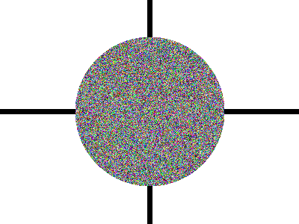Initial framework test image
Implement ray-casting as a first step toward a full featured ray-tracer. Start with Project 0 and the distributed framework for code and instructions on parsing the scene and writing out the computed image.

Instructions
Your ray-tracer executable should accept a scene filename (as command line argument for instance), read and parse the scene described in the file, build an internal representation of the scene, and then ray-cast it:
- For each pixel on the screen, generate a ray, from the eye through the pixel. Make sure to use OpenMP to parallelize the main Y loop.
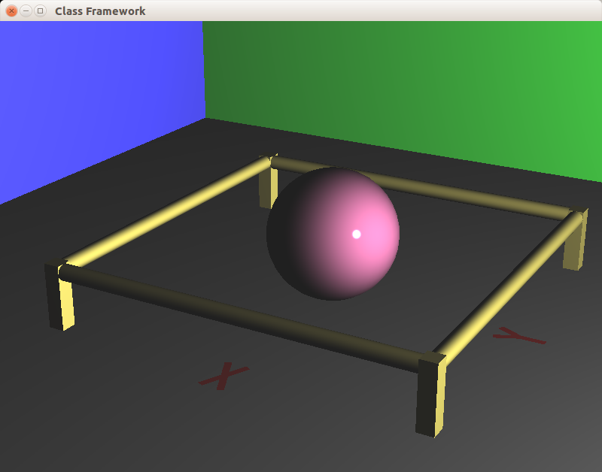Output of test scene. Your shapes should match exactly, but lighting may be very approximate.
- Find the ray's front-most intersection point with the scene's objects.
- Calculate a color for the intersection point. Make this as simple as you wish – We'll do proper lighting in the next project.)
- Write that color to the pixel for which the ray was generated.
Finally, write the image out in HDR format.

The ray-tracer should handle objects of type “sphere”, “box”, “cylinder”, and “triangle”. No reflections, refractions, or other typical ray tracing effects should be implemented yet.

What to submit
Submit a zip file containing your code and a project report. Your report should contain:
- Build and run instructions. If you have not changed this from the original framework just note such. If you have changed these things, be sure to supply detailed instructions.
- I brief description of the project and the particulars of you implementation.
- Screen captures showing that your program works. For this project, this could be as little as a single image, but later in the semester, it may take a number of carefully thought out images to demonstrate all the relevant features.
- A description of what each image shows. (Again, this is trivial for this project, but must be thought out carefully in later projects.)

