CS500 Project 4

Synopsis
Convert your ray-tracer into a far more capable path-tracer, for computing highly accurate solutions to the full lighting integral using Monte-carlo integration. This will allow, for this project, the accurate computation of many lighting situations: indirect lighting, reflections (both glossy and diffuse), transmissions (also both glossy and diffuse), soft shadows, and anti-aliasing. It will also open the door for many more lighting features in a future project: depth-of-field, motion-blur, rainbow/prism/diffraction effects, shaped lights, atmospheric scattering effects, sub-surface scattering, and more.

Instructions
The previous project's ray tracer needs the following changes to become a path tracer:
- Instead of a single pass through each pixel on the screen, the algorithm makes multiple passes across every pixel on the screen, averaging the results and occasionally writing the resulting image for viewing:
for pass=1 to forever:
for each y scanline: // multi-thread this loop as always
for each x pixel:
image[x,y] += TraceRay( ray from eye through pixel)
occasionally:
write image[x,y]/pass
- The function TraceRay will now iterate along a single non-branching path of rays accumulating light along its length instead of the previous project's “wide bush” of recursive rays accumulating light at a large number of terminal points. You might want to name this new version TracePath and save the TraceRay function unchanged. (I wish I had done this. :-)
- To use a BRDF with a path tracer, the BRDF needs to be enhanced with two new methods, one for sampling (i.e., choosing ray directions) and the other to calculate the probability of having chosen the direction.
- In order to explicitly connect a path to a light, we need a similar enhancement for lights. One method to sample a point on a light, and another to calculate the probability of having chosen that point.

Algorithm
The path tracing algorithm is on the next page. It loops along a path tracking importance as a product of factors along the way. Anytime any light is found explicitly (shadow rays toward some light) or implicitly (the extended path happens to hit a light) it multiplies the light by the importance factor and accumulates it int to the output color. The algorithm needs to call three functions to interact with the lights of the scene, and three functions to interact with reflective objects in the scene. These are: (Note, Points in the following are expected to know the object they are on and that object's normal at the point.)
Emissive objects (Lights):
- : Returns a random point on a random light
- : Returns probability of choosing P as a random light point.
- : Returns the light emitted from the light at point P.
Reflective objects:
- : Returns a random outgoing ray (diffuse, spec, or trans).
- : Returns the probability of choosing as a random outgoing ray.
- : Returns color ratio reflected by the BRDF from toward

Path tracing algorithm
(iterative with explicit light side branches)
PathTrace(initialRay):
C = (0,0,0) // Accumulated color for each light-carrying path found
W = (1,1,1) // Accumulated importance weight
P = TraceRay(initialRay) // Initial/current ray's intersection with scene
if P is NO-INTERSECTION-FOUND: return (0,0,0)
if P.isLight(): return P.obj->Radiance();

ωo = -initialRay.direction // Light output direction for P (Don't miss the minus sign here!)

while random() <= RussianRoulette: // Updates C, W, P, ωo on each iteration

// Compute explicit side branch to a random light point
L = SampleLight(scene) // Some point on some light
q = PdfLight(scene, L)
ωi = direction L-P
S = TraceRay( Ray(from P in direction ωi) ) // Shadow ray
if S == L: // That is, if shadow ray found L (may simplify to S.obj==L.obj)
G = GeometryFactor(P,L);
p = P.obj.bsdf.Pdf(ωo, P, ωi)*G*RussianRoulette
f = P.obj.brdf.Eval(ωo, P, ωi)
wMIS = q*q/(q*q+p*p);
C += L.obj->Radiance()*W*wMIS*G*f/q // Accumulate light times importance

// Extend path
ωi = P.obj.brdf.SampleBrdf(ωo, P) // Sample next direction ...
Q = TraceRay( Ray(from P in direction ωi) ) // … and trace ray
if Q is NO-INTERSECTION-FOUND: break

p = P.obj.brdf.PdfBrdf(ωo, P, ωi)*RussianRoulette
if (p < epsilon or p is NaN or Inf): break // Try epsilon=1e-6

f = P.obj.brdf.EvalBrdf(ωo, P, ωi)

// Advance to next iteration
W = W * f/p
p = p*GeometryFactor(P, Q)
P = Q
ωo = -ωi

// Has path hit a light (accidentally)
if P.isLight():
q = PdfLight(scene, P);
wMIS = p*p/(q*q+p*p)
C += P.obj->Radiance()*W*wMIS // Accumulate light times importance
break; // Don't extend path further

return C

Reductions
The algorithm can be greatly reduced and still produce fully accurate results, albeit slowly.

First reduction: Remove “Multiple Importance Sampling”
Remove the two wMIS factors, their calculations, and the (now unneeded) probability calculations.

Second reduction: Remove explicit side branch light calculation
This entire section can be removed, causing a huge speed reduction:
// Compute explicit side branch to a random light point
L = SampleLight(scene) // Some point on some light
...
C += L.obj->Radiance()*W*wMIS*G*f/q // Accumulate light times importance

GeometryFactor(a,b)
Intersection points and have points and and normals and respectively.
This calculates the effect of light leaving one point and striking the other point. It contains a usual cosine dot product at both ends, and a 1-over-distance-squared term for light falloff. The absolute values in the numerator factors allow the calculation to ignore the in/out direction of the normal.
Calculate and return .
That looks like a 4th power of distance in the denominator, but two of the factors cancel with the extra factors of distance in the numerator caused by the fact that in both dot products is not normalized.

Sampling a cone of random vectors
Carefully crafted calls to this SampleCone function can produce a cone of random vectors with any specific distributions around a given vector V. This will be used in several places:
// V is the center of the cone
// cTheta is the cosine of the desired vector's angle with N (range )
// Phi is the angle around V (range )
SampleCone(V, cTheta, Phi):
sTheta = sqrt(1- cTheta*cTheta) // Sine of Theta
k = vec3(sTheta*cos(Phi), sTheta*sin(Phi), cTheta) // Vector centered on Z
q = quatA2B(Zaxis,V) // Quat to rotate Z to V
return glm::roate(q, k) // k rotated to V's frame
Where quatA2B(A,B) computes the quaternion that rotates A to B:
vec3 R = glm::cross(A,B);
if (glm::dot(R,R)<1e-6)
if (dot(A,B) > 0.0) // Corrected!
return quat(1,0,0,0); // The identity rotation
else
return quat(0,1,0,0); // A 180 degree rotation
return glm::angleAxis( acos(glm::dot(A,B)/(glm::l2Norm(A)*glm::l2Norm(B))),
R/glm::l2Norm(R) );

Sampling a light:
For now, we will assume lights are spheres with a known center and radius. To compute a uniformly distributed random point on a spherical light:
double z = *2.0 – 1.0; // Random Z coordinate in range [-1,1]
double r = sqrt(1.0-z*z); // Radius at that z
double a = 2.0*PI*; // Random equatorial angle
N= normalized( vec3(r*cos(a), r*sin(a), z) );
P = center + N*radius;

PDF of a light sample:
The PDF for the above sample is the product of two probabilities for the choice of light and for the choice of a point across the visible area of the light:

Microfacet Models for Refraction
through Rough Surfaces
https://faculty.digipen.edu/~gherron/references/References/BRDF/EGSR07-btdf.pdf

Sampling a BRDF:
Sampling according to a BRDF is performed in two steps (with known probabilities).
- First, choose one of diffuse, reflective or transmissive categories. Make the choice with any probabilities you want. Here is one sensible choice based on the BRDF parameters , , and :
, , where
For a random number choose:
diffuse if
reflection if
transmission otherwise
- Sample a micro-facet around the normal N for some random numbers :
If you chose diffuse
If you choose reflection, sample a micro-facet normal and reflect:
If you chose transmission, sample a micro-facet normal and reflect:
(Same as reflection's .)
test radicand , and if negative
use above reflection for total internal reflection, otherwise
(Note: The sign(x) function above is defined by sign(x) = (x>=0) ? 1 : -1 )

PDF of BRDF sample:
The chosen above was generated by one of three choices, diffuse, reflection, or transmission, but could have been generated by more than one of those choices. So we sum all three probabilities weighted by the probability of each choice:
Return
where, probability of a diffuse :
probability of a reflection :

and probability of a transmission :
test radicand (same as above), and if negative just use , otherwise
Incorrect!

Corrected! (Difference is: and have been reversed in both and the denominator. )

Eval a micro-facet BRDF:
Any give combination of , , and , could produce a combination of diffuse, reflective, and transmission, so the evaluation is the sum of all three weighted by their relative probabilities.
WRONG! As originally stated, this equation is missing the N dot L!
Corrected!
Diffuse evaluation:

Reflection evaluation (the usual micro-facet specular portion):

Transmission evaluation (similar to specular, but with ):
evaluate the radicand (once more), and if negative just use, otherwise
Incorrect!

Corrected! (Difference is: and have been reversed in both and the denominator. )

D, G, and F
The paper lists three different possibilities for D and G. Here's the easiest.

F factor:
The Fresnel term can use the Schlick approximation as usual.

D factor:
The term can be the Phong cosine lobe:

and is the Phong roughness exponent.

G factor:
The term should be

G₁ factor:
where
and
and .
Beware roundoff errors in calculating the function:
The value of my round up to greater than 1.0 (it shouldn't but does). If so , return .
The calculation of may be zero. If so, don't divide by it, instead return .

Characteristic factor:
The so called characteristic function in the D and G terms is defined as
and implemented with a simple “if” statement.

Results
Full results, many iterations:
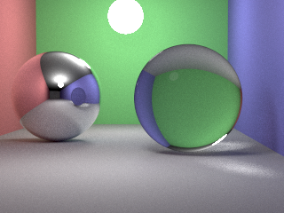
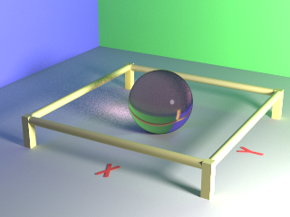

Full algorithm 500 iterations:
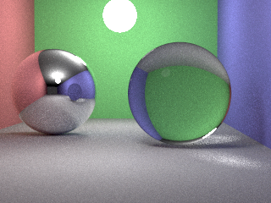
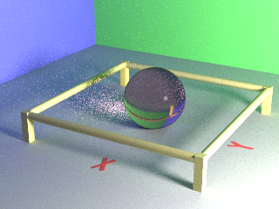

No MIS, 500 iterations:
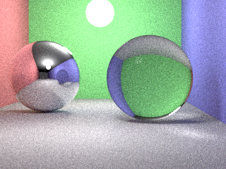
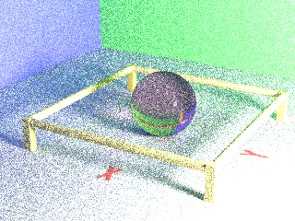

No explicit light paths, 500 iterations:
