**2021年12月大学英语四级考试真题（第3套）**

# Part I Writing (30 minutes)

**Directions: Suppose you have丿ust participated in a school project of collecting used books on campus. You are now to write a report about the project, which may include its aim, organizers, participants and activities. You will have 30 minutes to write the report. You should write at least** 120 **words but no more than** 180 **words.**

**Part II Listening Comprehension (25 minutes)**

说明：2021年12月大学英语四级考试全国共考了两套听力。 本套的听力内容与第二套相同，因此本套听力部分不再重复给出。

**Part III Reading Comprehension (40 minutes)**

## Section A

**Directions: In this section, there is a passage with ten blanks. You are required to select one word for each blank from a list of choices given in a word bank following the passage. Read the passage through carefully before making your choices, Each choice in the bank is identified by a letter. Please mark the corresponding letter for each item on Answer Sheet 2 with a single line through the centre. You may not use any of the words in the bank more than once.**

**Questions 26 to 35 are based on the following passage.**

**The sheets are damp with sweat. You're cold, but your heart is racing as if a killer just chased you down a dark street. It was just a nightmare, you tell yourself; there's nothing to be afraid of. But you're still filled with____lL.**

**Given how unsettling and haunting nightmares can be, is there a way for dreamers to D.__, or even turn off, these bad dreams as they happen?**

**Research is----1.L_, but some studies suggest that people who can master lucid dreaming-that is, the ab**山**ty to be____22__that a nightmare is happening and possibly even control it without waking up—may hold the ___J_Q__.**

**Nightmares are part of the human experience, especially for kids. Doctors___ll_don't consider occasional nightmares a problem. They can just be symptoms of a sleep disorder that can ____lL from an unpleasant experience, stress, or certain drugs.**

**To treat the disorder, there are a number of medicines and therapies that are backed by___TI__ research, according to the American Academy of Sleep Medicine,**

**which analyzed the available research on the treatment of nightmare disorder in a recent ;H___published in the Journal of Clinical Sleep Medicine**

**However, nightmares are complicated, and researchers are still struggling to understand them, said Dr. Rachel Salas, an expert on sleep disorders and an associate professor at Johns Hopkins Medicine in Baltimore. What we do know is that people___lL to have different kinds of nightmares at different points during the**

**sleep cycle.**

2021年12月英语四级真题第3套 第1页共 **8**页 **by:** UVOOC.COM

1. **amount I) mechanical**
2. **answer J) result C) avoid K) review**
3. **aware L) rigorous**
4. **depart M) tend**
5. **drastically N) timidity**
6. **fear 0) typically** 芒 **limited**

**Section B**

**Directions: In this section, you are going to read a passage with ten statements attached to it.**

**Each statement contains information given in one of the paragraphs. Identify the paragraph from which the information is derived. You may choose a paragraph more than once. Each paragraph is marked with a letter. Answer the questions by marking the corresponding letter on Answer Sheet 2.**

### Why it matters that teens are reading less

1. **Most of us spend much more time with digital media than we did a decade ago. But today 's teens have grown up with smartphones. Compared with teens a couple of decades ago, the way they interact with traditional media like books and movies is fundamentally different.**
2. **Analysis of surveys of over one million teens in the United States collected since 1976 reveals a major shift in how teens are spending their leisure time. Paper books are being**

**ignored, in favor of screens. D屯ital devices are changing other behaviors, too. More and more, young people choose spending time on their electronic devices over engaging in other activities, regardless of the type. Indeed, by 2016, the average American high school senior said they spent six hours a day writing text messages, on social media, and online during their free time. And that covers just three activities, and if other digital media activities were included, that estimate would no doubt rise.**

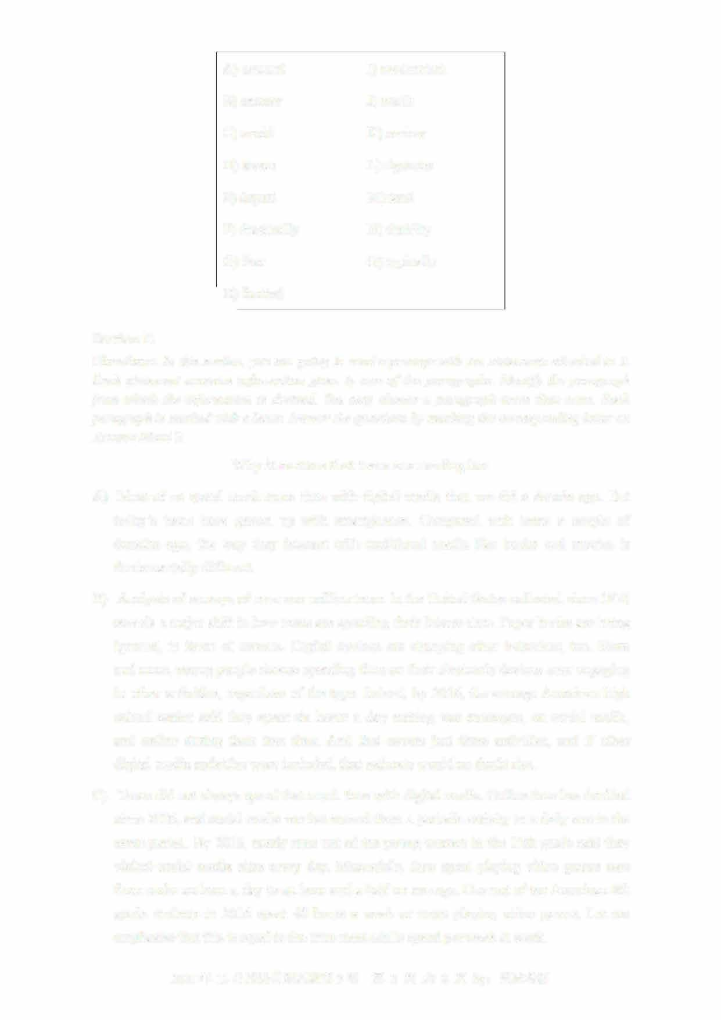

1. **Teens did not always spend that much time with digital media. Online time has doubled since 2006, and social media use has moved from a periodic activity to a daily one in the same period. By 2016, nearly nine out of ten young women in the 12th grade said they visited social media sites every day. Meanwhile, time spent playing video games rose from under an hour a day to an hour and a half on average. One out of ten American 8th**

**grade students in 2016 spent 40 hours a week or more playing video games. Let me emphasize that this is equal to the time most adults spend per week at work.**

* 1. 年 **12** 月英语四级真题第 **3套** 第 **2** 页共 **8** 页

1. If teens are spending so much time using electronic devices, does that mean they have to give up some other activities? Maybe not. Over the years, many scholars have insisted that time online does not necessarily take away time spent engaging with traditional media or on other activities. Some people, they argue, are just more interested in certain kinds of media and entertainment. Thus, using more of one type of media does not necessarily mean less of the other.
2. 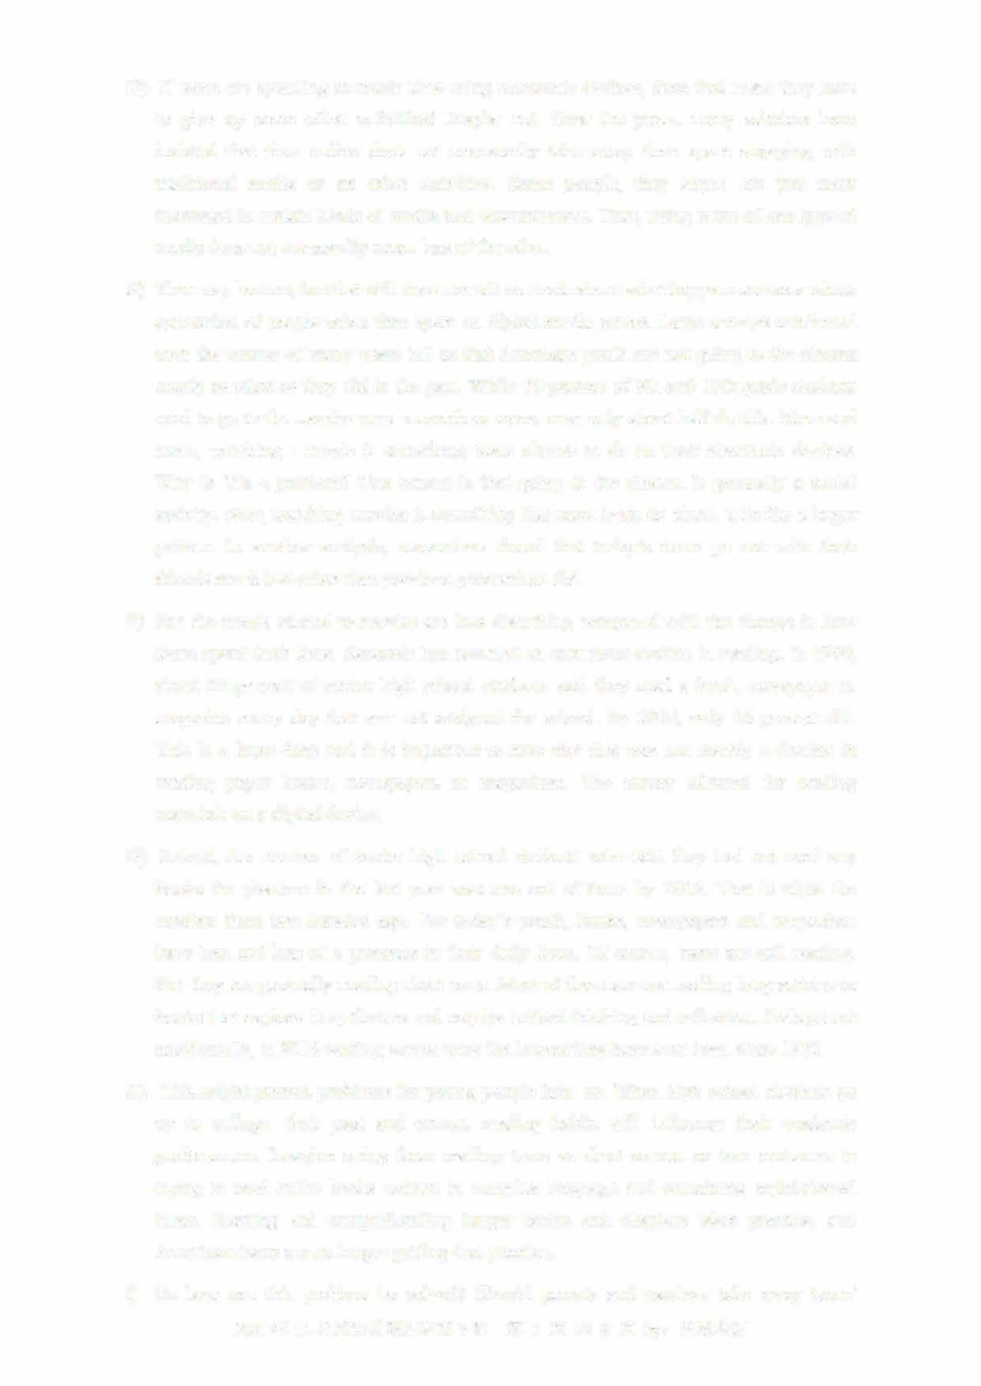That may be true, but that still does not tell us much about what happens across a whole generation of people when time spent on digital media grows. Large surveys conducted over the course of many years tell us that American youth are not going to the cinema nearly as often as they did in the past. While 70 percent of 8th and 10th grade students used to go to the movies once a month or more, now only about half do this. More and more, watching a movie is something teens choose to do on their electronic devices. Why is this a problem? One reason is that going to the cinema is generally a social activity. Now, watching movies is something that most teens do alone. This fits a larger pattern. In another analysis, researchers found that today's teens go out with their 扣ends much less often than previous generations did.
3. But the trends related to movies are less disturbing compared with the change in how teens spend their time. Research has revealed an eno皿ous decline in reading. In 1980, about 60 percent of senior high school students said they read a book, newspaper or magazine every day that was not assigned for school. By 2016, only 16 percent did. This is a huge drop and it is important to note that this was not merely a decline in reading paper books, newspapers or magazines. The survey allowed for reading materials on a digital device.
4. Indeed, the number of senior high school students who said they had not read any books for pleasure in the last year was one out of three by 2016. That is triple the number from two decades ago. For today's youth, books, newspapers and magazines have less and less of a presence in their daily lives. Of course, teens are still reading But they are generally reading short texts. Most of them are not reading long articles or books that explore deep themes and require critical thinking and reflection. Perhaps not accidentally, in 2016 reading scores were the lowest they have ever been since 1972.
5. This might present problems for young people later on. When high school students go on to college, their past and cu订ent reading habits will influence their academic performance. Imagine going from reading texts as short as one or two sentences to trying to read entire books written in complex language and containing sophisticated ideas. Reading and comprehending longer books and chapters takes practice, and American teens are no longer getting that practice.
6. So how can this problem be solved? Should parents and teachers take away teens'
   1. 年 12 月英语四级真题第 3 套 第 3 页共 8 页

smartphones and replace them with paper books? Probably not. Research has shown that smartphones are currently American teens' main form of social communication. This means that, without a smartphone, teens are likely to feel isolated from their peers

However, that does not mean teens need to use electronic devices as often as they do now. Data connecting excessive d屯ital media time to mental health issues suggests a limit of two hours a day of free time spent with screens, a restriction that will also allow time for other activities—like going to the movies with friends or reading longer, more complicated texts.

1. 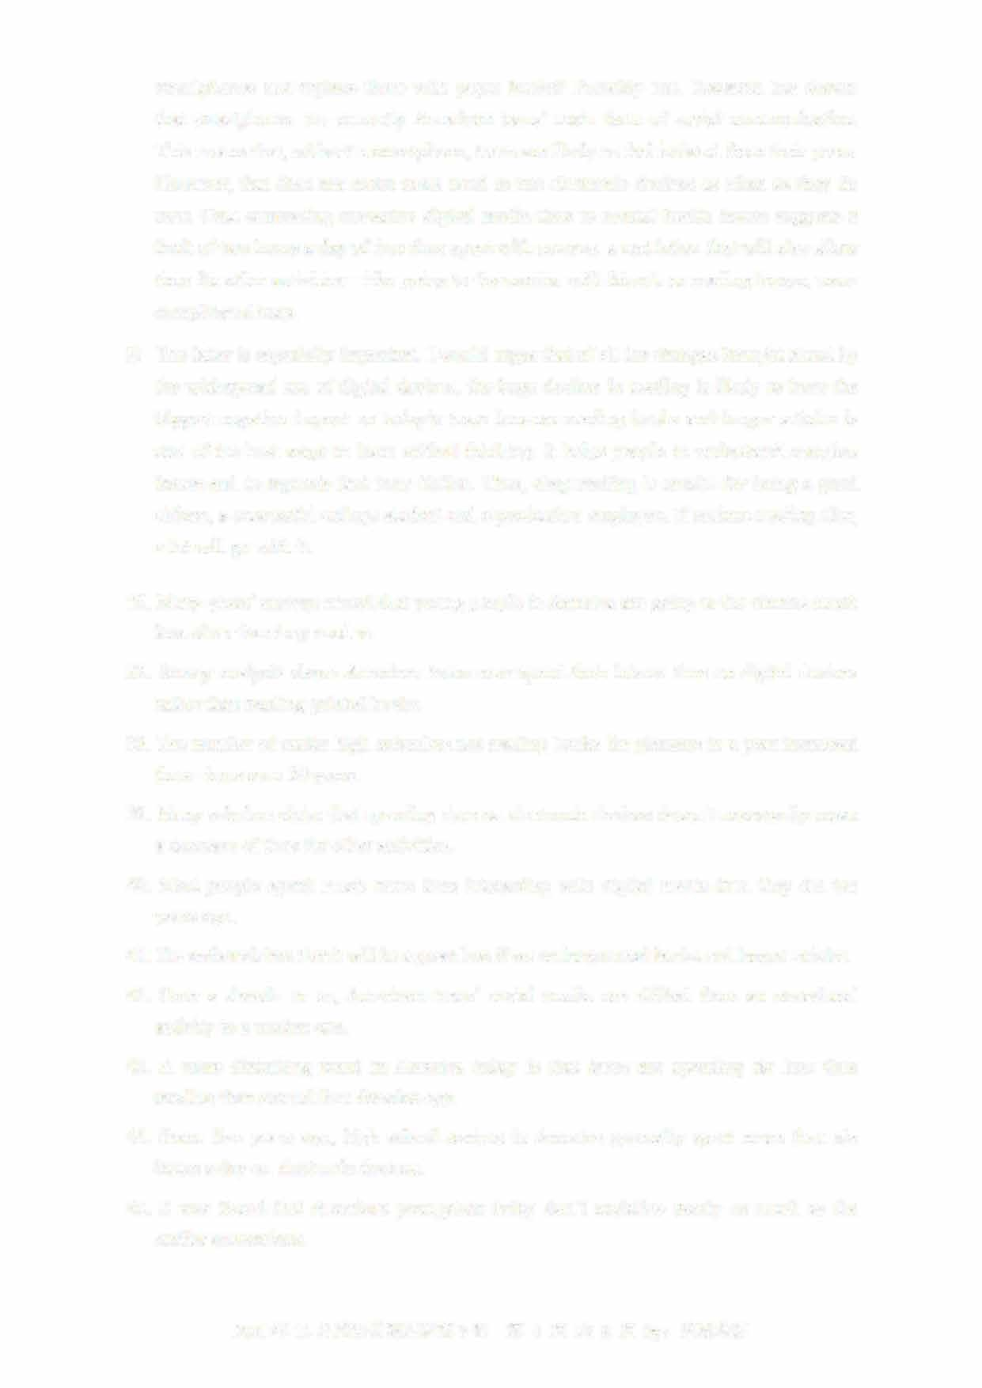The latter is especially important. I would argue that of all the changes brought about by the widespread use of digital devices, the huge decline in reading is likely to have the biggest negative impact on today's teens because reading books and longer articles is one of the best ways to learn critical thinking. It helps people to understand complex issues and to separate fact from fiction. Thus, deep reading is crucial for being a good citizen, a successful college student and a productive employee. If serious reading d比s, a lot will go with it.
2. Many years' surveys reveal that young people in America are going to the cinema muchless often than they used to.
3. Survey analysis shows American teens now spend their leisure time on digital devicesrather than reading printed books.
4. The number of senior high schoolers not reading books for pleasure in a year increasedthree times over 20 years.
5. Many scholars claim that spending time on electronic devices doesn't necessarily meana decrease of time for other activities.
6. Most people spend much more time interacting with d屯ital media than they did ten years ago.
7. The author claims that it will be a great loss if we no longer read books and longer articles.
8. Over a decade or so, American teens'social media use shifted from an occasional activity to a routine one.
9. A more disturbing trend in America today is that teens are spending far less time reading than around four decades ago.
10. Some five years ago, high school seniors in America generally spent more than six hours a day on electronic devices.
11. It was found that American youngsters today don't socialize nearly as much as the earlier generations.

2021年12月英语四级真题第3套 第4页共8页

Section C

Directions: There are 2 passages in this section. Each passage is followed by some questions or unfinished statements. For each of them there are four choices marked AJ, BJ, CJ and DJ You should decide on the best choice and mark the corresponding letter on Answer Sheet 2 with a single line through the centre.

Passage One

Questions 46 to 50 are based on the following passage.

Have you ever wondered how acceptable it is to hug or touch someone? While it may sound safe to avoid all physical contact so as not to offend anyone, the lack of touching 血ght imply cold attitudes or indifference in interpersonal relationships.

So, what should we do? The simple answer is to thoroughly learn unique cultural norms for physical contact. In nonverbal communication terminology (术语）， physical contact and the study of touching are generally referred to as haptics

Haptics in communication often suggest the level of intimacy. They are usually classified into two groups: high-contact and low-contact.

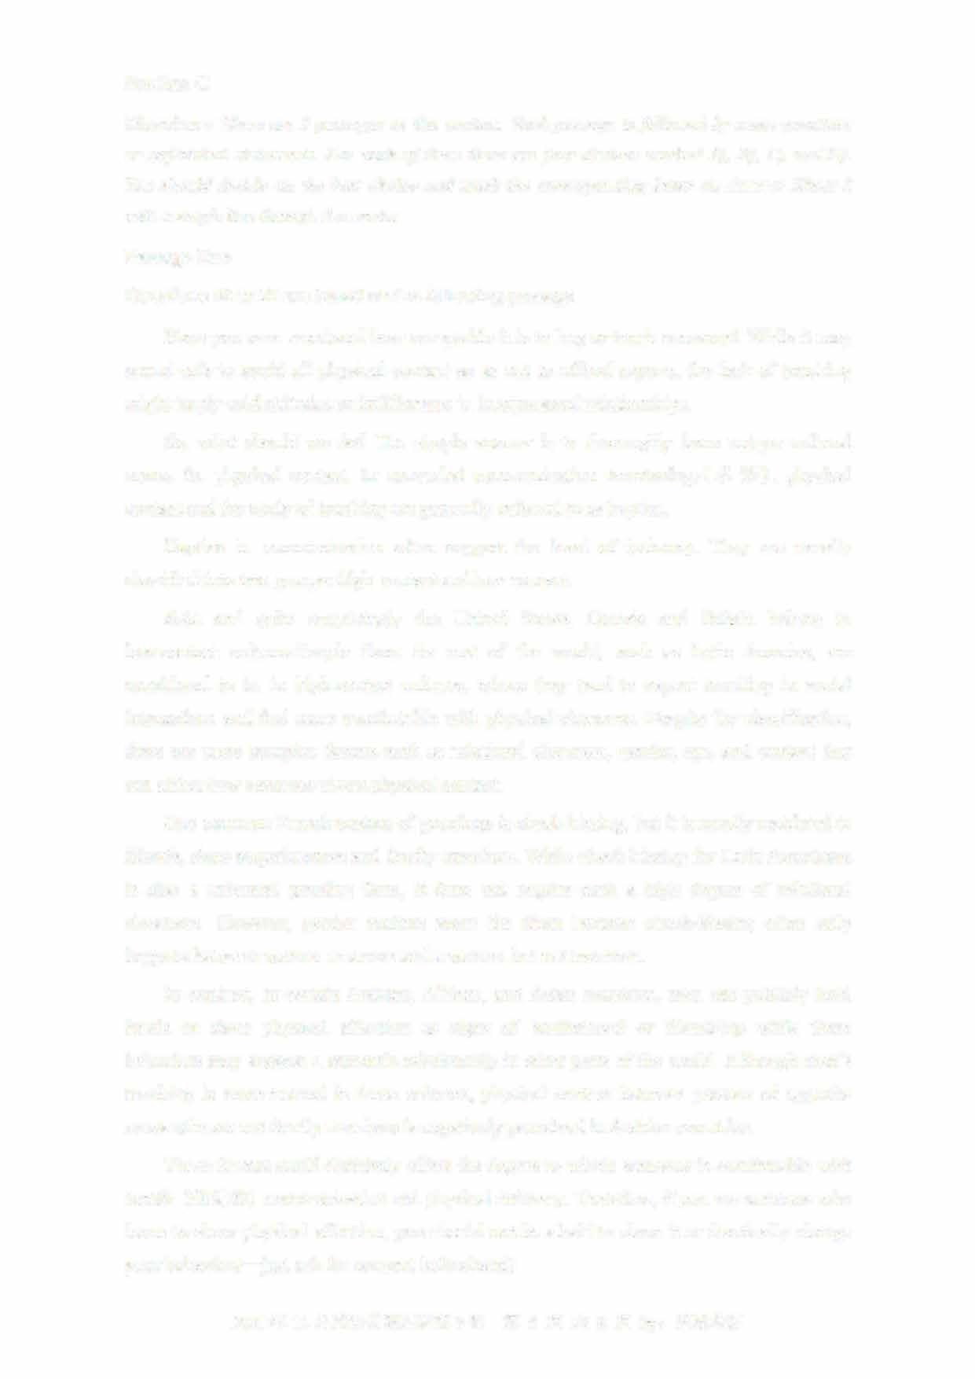Asia and quite surprisingly the United States, Canada and Britain belong to low-contact cultures.People from the rest of the world, such as Latin America, are considered to be in high-contact cultures, where they tend to expect touching in social interactions and feel more comfortable with physical closeness. Despite the classification, there are more complex factors such as relational closeness, gender, age, and context that can affect how someone views physical contact.

One common French custom of greetings is cheek-kissing, but it is mostly restricted to 加nds, close acquaintances and family members. While cheek-kissing for Latin Americans is also a universal greeting form, it does not require such a high degree of relational closeness. However, gender matters more for them because check-kissing often only happens between women or a man and a woman but not two men.

In contrast, in certain Arabian, African, and Asian countries, men can publicly hold hands or show physical affection as signs of brotherhood or friendship while these behaviors may suggest a romantic relationship in other parts of the world. Although men's touching is more normal in these cultures, physical contact between persons of opposite sexes who are not family members is negatively perceived in Arabian countries.

These factors could definitely affect the degree to which someone is comfortable with tactile （触觉的） communication and physical intimacy. Therefore, if you are someone who loves to show physical affection, you should not be afraid to show it or drastically change

— your behaviors just ask for consent beforehand!

2021 年 12 月英语四级真题第 3 套 第 5 页共 8 页

46. What does the author say in the first paragraph about physical contact? A) Its role in interpersonal relationships is getting increasingly important

1. It is becoming more acceptable to many who used to think it offensive
2. Its absence might suggest a lack of warmth in interpersonal relationshipsD) It might prompt different responses from people of different social backgrounds

4 7. What does physical contact in communication suggest?

1. What social class people belong to
2. How civilized the communicators are.
3. What family background people come from
4. How close the communicators' relationships are.
5. What do we learn about people in high-contact cultures?
   1. They are sensitive to the way people express their emotions
   2. They take touching as a cultural norm in social interactions.C) They attach great importance to close ties among people

D) They tend to be more open in interpersonal relationships

1. What do we learn about social customs in Arabian countries?
   1. Men can show friendship in public through physical affection
   2. Non-traditional romantic relationships are simply unacceptable
   3. Physical contact between unfamiliar people is negatively perceivedD) People of different ages and genders show affection in different ways
2. What does the author tell us to do concerning tactile communication?A) Lay emphasis on nonverbal communication.
   1. Learn to use appropriate body language first
   2. Pay attention to the differences between genders.
   3. Take other people's preference into consideration.

Passage Two

Questions 51 to 55 are based on the following passage.

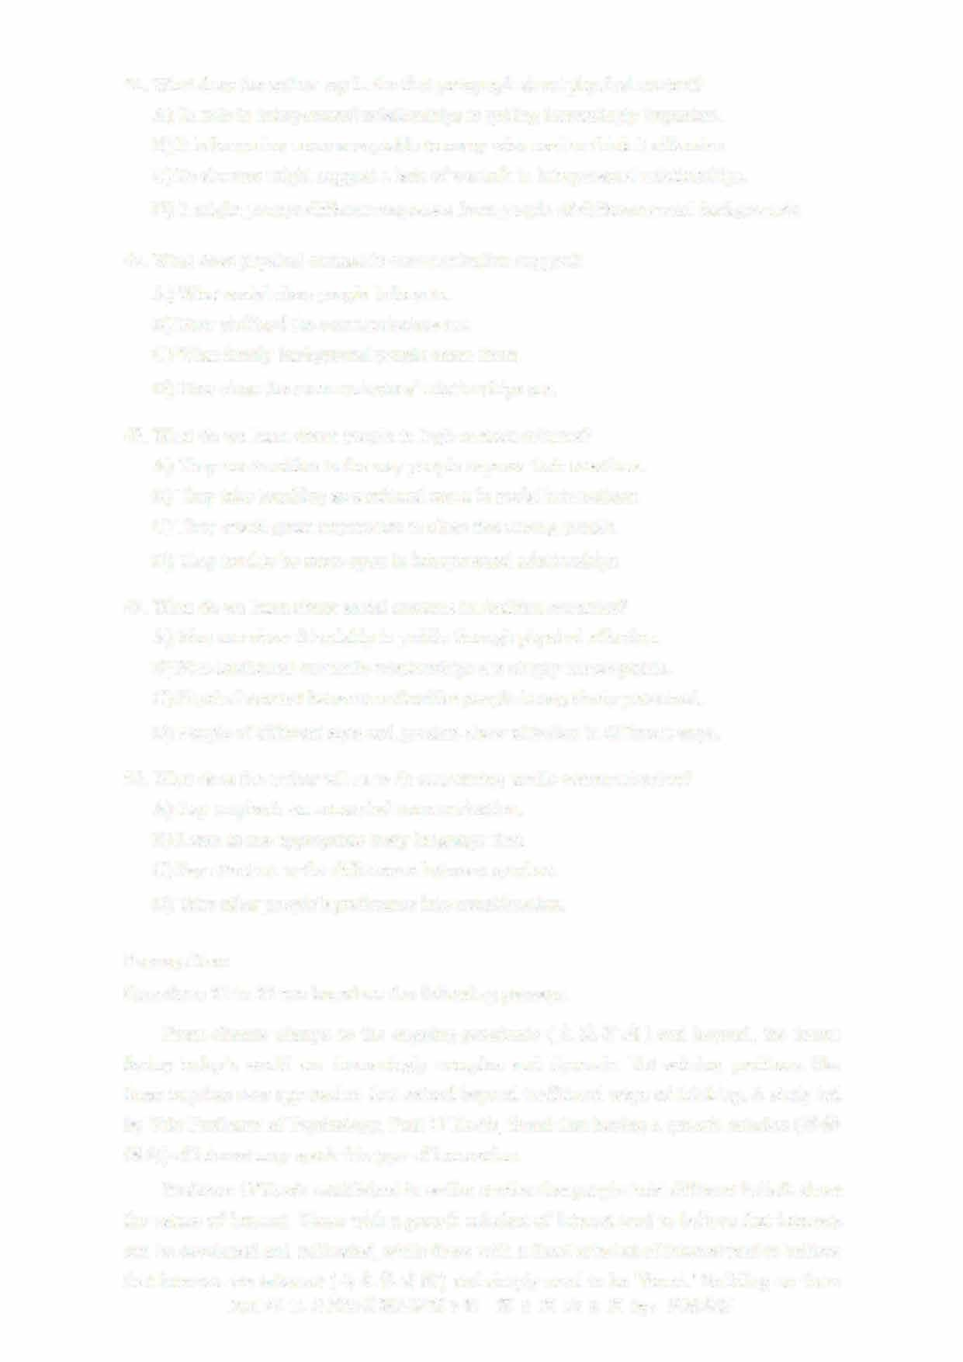From climate change to the ongoing pandemic (大流行病） and beyond, the issues facing today's world are increasingly complex and dynamic. Yet solving problems like these requires new approaches that extend beyond traditional ways of thinking. A study led by Yale Professor of Psychology, Paul O'Keefe, found that having a growth mindset（思维倾向） of interest may spark this type of innovation

Professor O'Keefe established in earlier stud比s that people hold different beliefs about the nature of interest. Those with a growth mindset of interest tend to believe that interests can be developed and cultivated, while those with a fixed mindset of interest tend to believe that interests are inherent （与生俱有的） and simply need to be 'found.'Building on these

2021年12月英语四级真题第3套 第6页共8页

findings, the latest research examined how a growth mindset of interest can boost integrative thinking across the traditional disciplinary boundaries of arts and sciences.

For example, in one task, research participants were instructed to create new college majors by combining two or more existing academic Arts or Science programs at the订 university. After coding and analyzing the ideas they generated, the team found that people with a growth mindset of interest were more likely to bridge programs across the arts and sciences to create new majors like computational economics rather than creating majors that drew from only one of those areas, like computational chemistry.

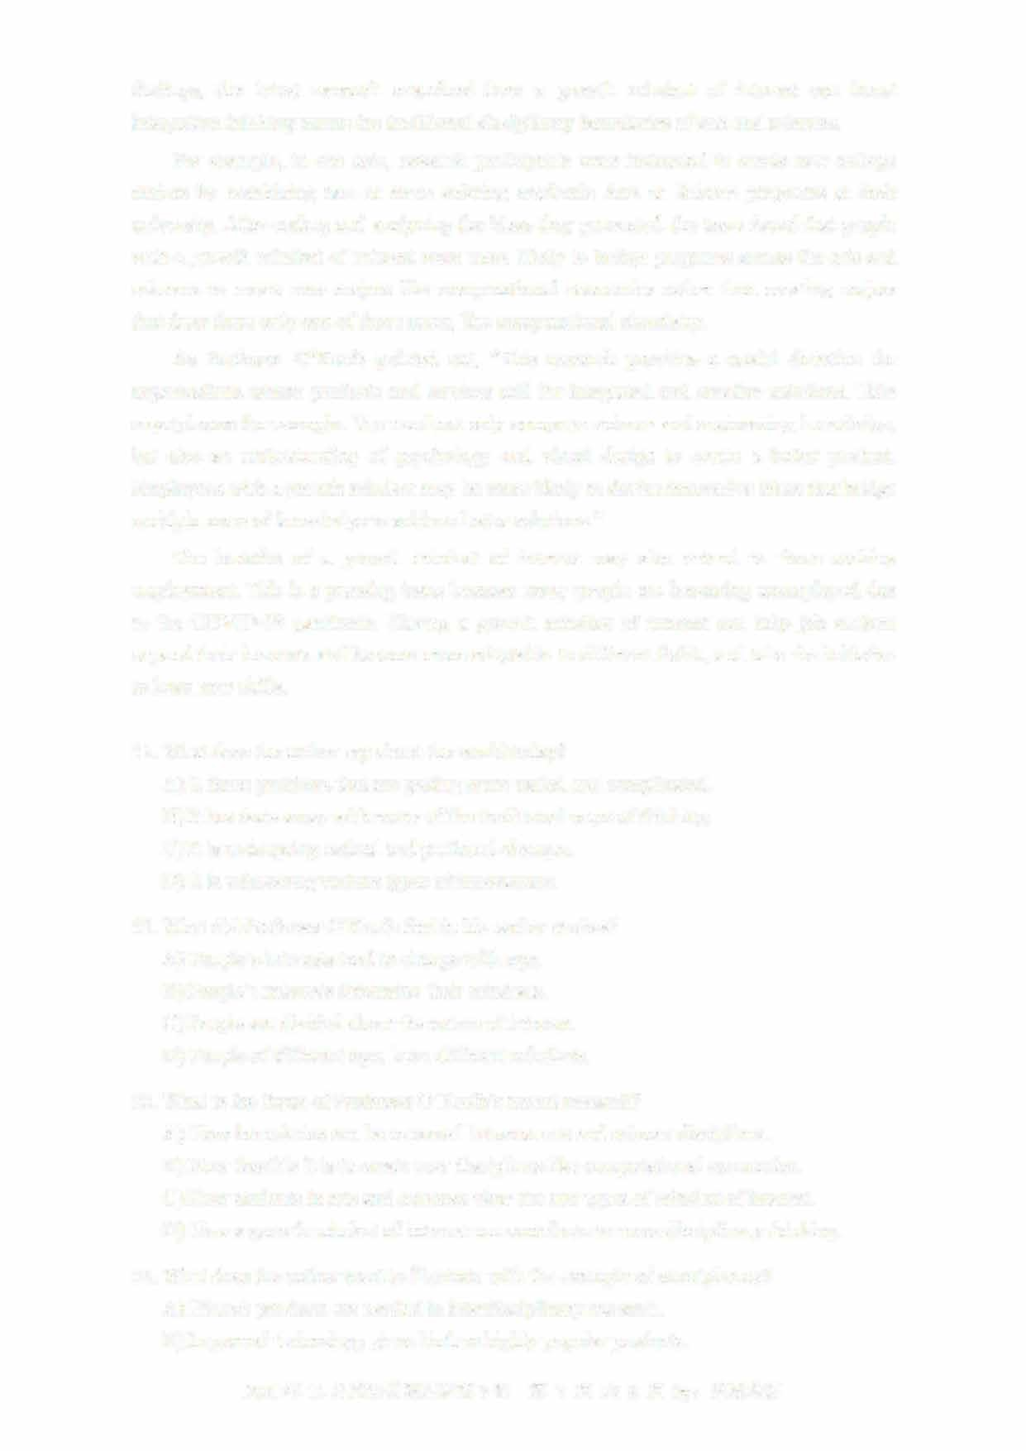As Professor O'Keefe pointed out, "This research provides a useful direction for organizations whose products and services call for integrated and creative solutions. Take smartphones for example. You need not only computer science and engineering knowledge, but also an understanding of psychology and visual design to create a better product Employees with a growth mindset may be more likely to devise innovative ideas that bridge multiple areas of knowledge to achieve better solutions."

The benefits of a growth mindset of interest may also extend to those seeking employment. This is a pressing issue because many people are becoming unemployed due to the COVID-19 pandemic. Having a growth mindset of interest can help job seekers expand their interests and become more adaptable to different fields, and take the initiative to learn new skills.

1. What does the author say about the world today?
   1. It faces problems that are getting more varied and complicated
   2. It has done away with many of the traditional ways of thinkingC) It is undergoing radical and profound changes

D) It is witnessing various types of innovations.

1. What did Professor O'Keefe find in his earlier studies?A) People's interests tend to change with age.
   1. People's interests determine their mindsets.
   2. People are divided about the nature of interest.
   3. People of different ages have different mindsets.
2. What is the focus of Professor O'Keefe's recent research?
   1. How boundaries can be removed between arts and science disciplines.
   2. How feasible it is to create new disciplines like computational economics
   3. How students in arts and sciences view the two types of mindset of interest.
   4. How a growth mindset of interest can contribute to cross-disciplinary thinking.
3. What does the author want to illustrate with the example of smartphones?A) Hi-tech products are needed in interdisciplinary research.

B) Improved technology gives birth to highly popular products

2021年12月英语四级真题第3套 第7页共8页



C) Making innovative products needs multidisciplinary knowledge

D) Hi-tech products can boost people's integrative thinking

55

. What is the author's suggestion to those who are seeking employment?

A) Leaming practical skills.

B) Broadening their interests.

C)

Staying safe in the pandemic.

D) Knowing their pressing issues

Part IV

Translation

(30

minutes)

Directions: For this part, you are allowed 30 minutes to translate a passage from Chinese into

English. You should write your answer on Answer Sheet 2.

卢

(

Duji

angyan)

坐落在成都平原西部的氓江上，

距成都市约

50

公里，

始建于公元

前三世纪。

它的独特之处在于无需用堤坝调控水流。

两千多年来，都江堰一直有效地发挥看防

共与灌溉作用，

使成都平原成为旱房保收的沃土和中国最重要的棵食产地之一。

都江堰工程

体现了我国人民与自然和谐共存的智慧，

是全世界年代最久、

仍在使用、

无坝控水的水利工

程。

2021年12

月英语四级真题第3套

第8页共8页