OWASP ZAP Assessment of
OWASP Juice Shop

Date | 31 August 2026
Environment | Kali Linux virtual machine in Oracle VirtualBox
Security Tool | OWASP ZAP 2.17.0
Target | OWASP Juice Shop running locally
Target Address | http://127.0.0.1:3000
ZAP Proxy | localhost:8080

Purpose: authorised cybersecurity training and vulnerability-scanning practice.

1. Overview
This report documents my practical use of OWASP ZAP against OWASP Juice Shop. The exercise did not begin as a straightforward scan. I first had to solve connectivity, proxying, localhost and ZAP scope problems before I could crawl and actively test the application. I have kept those unsuccessful steps in the report because they explain how I reached the final working setup and what I learned from the troubleshooting process.
I am still a beginner in web application security, so I have deliberately described the results at the level I currently understand them. Where ZAP did not generate a formal alert, I have not presented my own observation as a confirmed vulnerability. Instead, I distinguish between what the tool discovered, what I manually observed, and what I learned from interpreting the responses.

2. Objectives
- Configure Firefox so that ZAP could observe Juice Shop traffic.
- Define the authorised Juice Shop target in a ZAP context and scope.
- Use the AJAX Spider to discover application resources and endpoints.
- Review what the spider discovered before moving to active testing.
- Run an Active Scan against the authorised local target.
- Inspect interesting HTTP responses and record evidence.
- Explain the difference between discovery, active testing and ZAP alerts.

3. Lab Environment and Network Model
Juice Shop was running inside the same Kali VM as Firefox and ZAP. This became an important concept for me. The address 127.0.0.1 is the IPv4 loopback address: it points back to the same machine rather than to another computer on the internet. Juice Shop listened on port 3000, while ZAP listened as a proxy on port 8080.
Firefox → ZAP (127.0.0.1:8080) → Juice Shop (127.0.0.1:3000)
The local Juice Shop traffic therefore did not need to leave Kali or travel across the internet. Kali could still have internet access at the same time for unrelated external traffic. This is different from testing a remote target such as Acunetix Test ASP.NET, where ZAP must send the request out through Kali's network and VirtualBox NAT to the internet.

4. Background: Why I Used a Local Juice Shop
Before this exercise I had difficulty reaching the internet-hosted training targets. The wider troubleshooting session involved router connectivity, Kali routing, DHCP, NetworkManager, VirtualBox Bridged networking and DNS. The working Kali configuration was eventually changed to NAT and DNS resolution was restored. That network investigation is documented separately in my Kali Linux Network & DNS Troubleshooting report.
To continue the ZAP assignment without depending on the unreliable hosted Juice Shop instance, I ran OWASP Juice Shop locally in Kali. This gave me a controlled authorised target and also introduced me to the practical meaning of localhost.

5. Configuring Firefox to Pass Traffic Through ZAP
The first important distinction was between the target port and the proxy port. Juice Shop was the target on 127.0.0.1:3000. ZAP was not running on port 3000; its proxy listener was localhost:8080. Firefox therefore needed to send browser traffic to ZAP on port 8080.
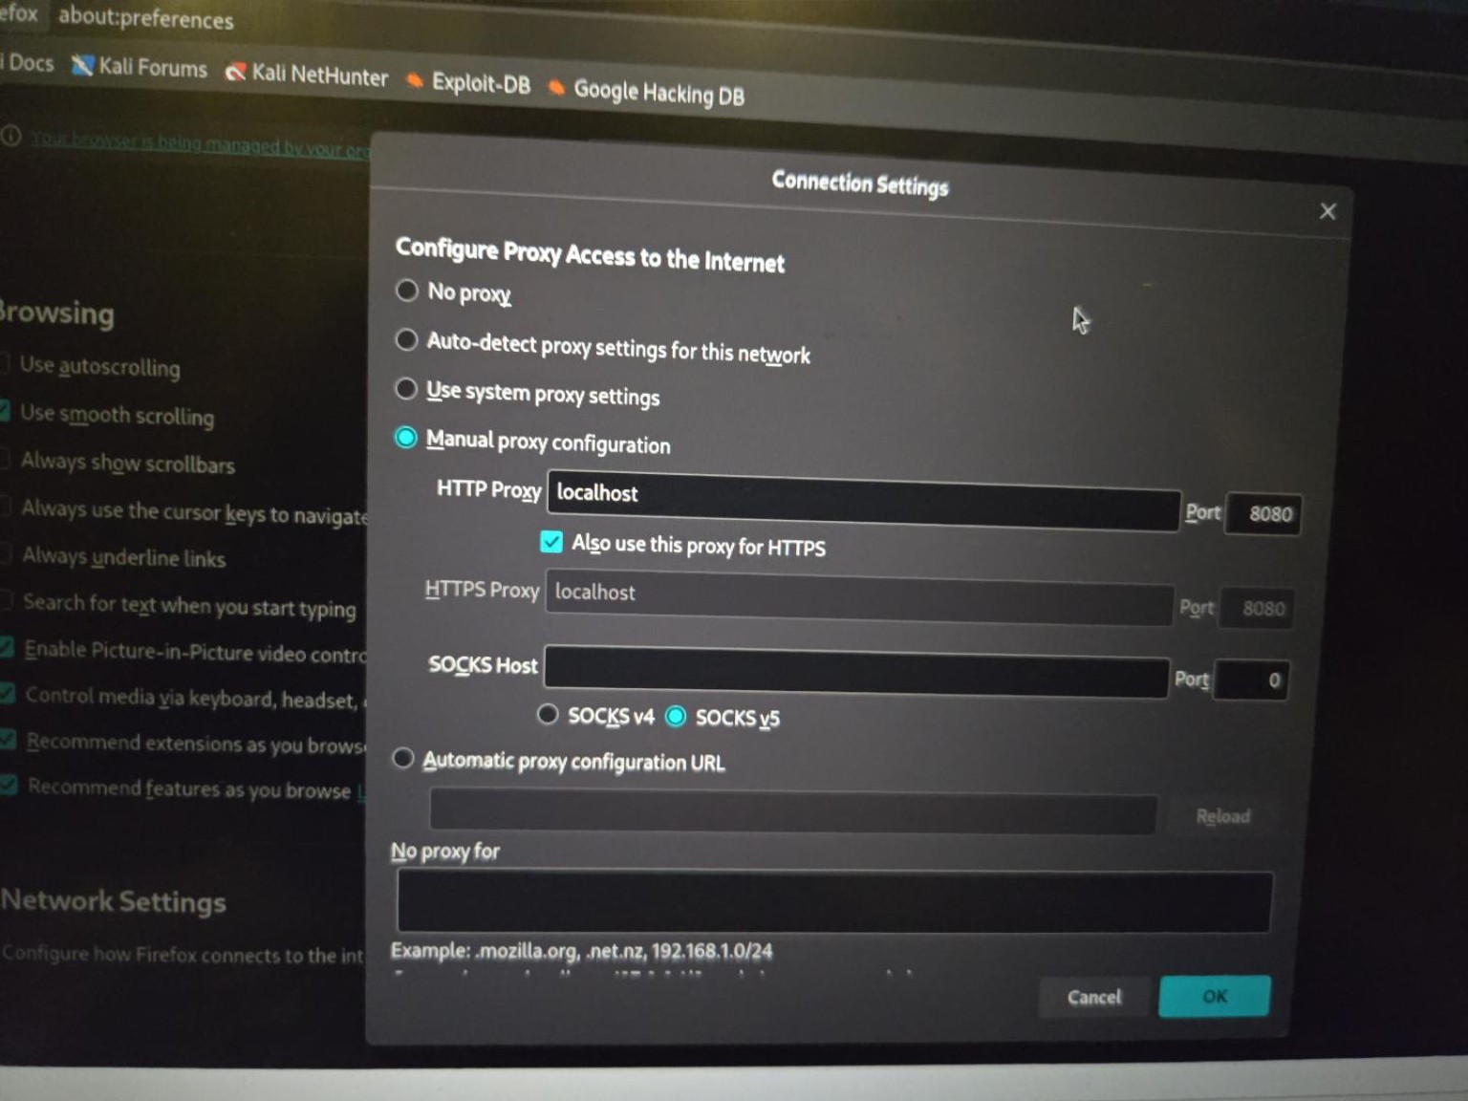
Figure 1. Firefox proxy configuration used during the lab. ZAP listened locally on port 8080.
This configuration means that ZAP can sit between Firefox and a web application, recording the requests Firefox sends and the responses returned by the application.

6. The Localhost Proxy Problem
Although Juice Shop loaded in Firefox, I initially had difficulty getting the local Juice Shop traffic to appear properly in ZAP. Firefox normally treats localhost specially and can bypass a configured proxy for loopback traffic. This was confusing because the website could be visible in Firefox while ZAP was not necessarily seeing the same traffic.
In Firefox I opened about:config and changed network.proxy.allow_hijacking_localhost from false to true. In practical terms, this allowed Firefox to send localhost traffic through the configured ZAP proxy rather than bypassing it.
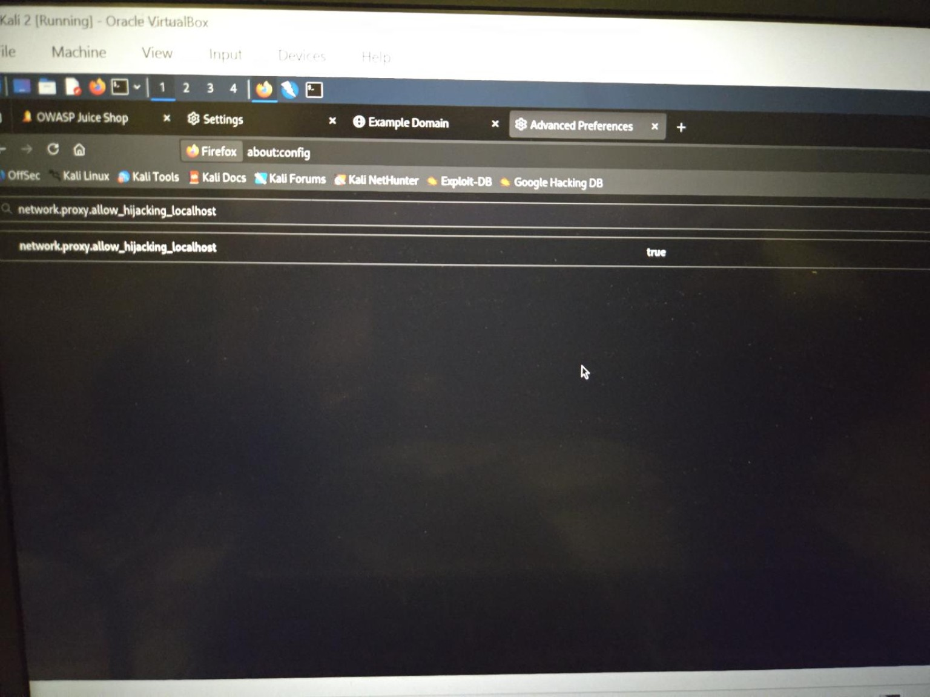
Figure 2. Firefox advanced configuration used to allow localhost traffic to pass through the proxy.
After this change, the Juice Shop site began populating ZAP's Sites tree. This was my confirmation that the proxy path was working for the local application.
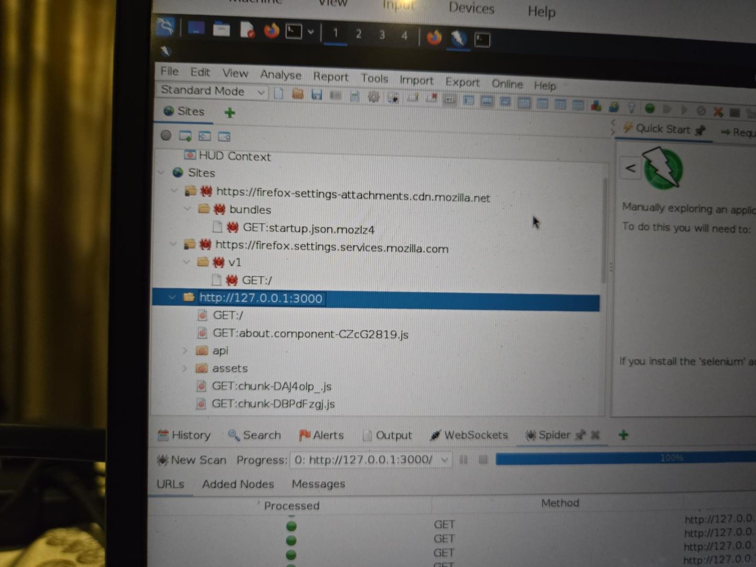
Figure 3. Juice Shop appearing in the ZAP Sites tree after localhost proxying was working.

7. Manual Exploration and Initial Discovery
I manually browsed parts of Juice Shop with the ZAP HUD active. This generated ordinary application traffic and allowed ZAP to begin building a picture of the site. I opened pages such as product information, reviews and the About page. This stage helped me understand that manual browsing and automated crawling complement each other: manual browsing creates realistic user traffic, while a spider can discover much more than I would click through myself.
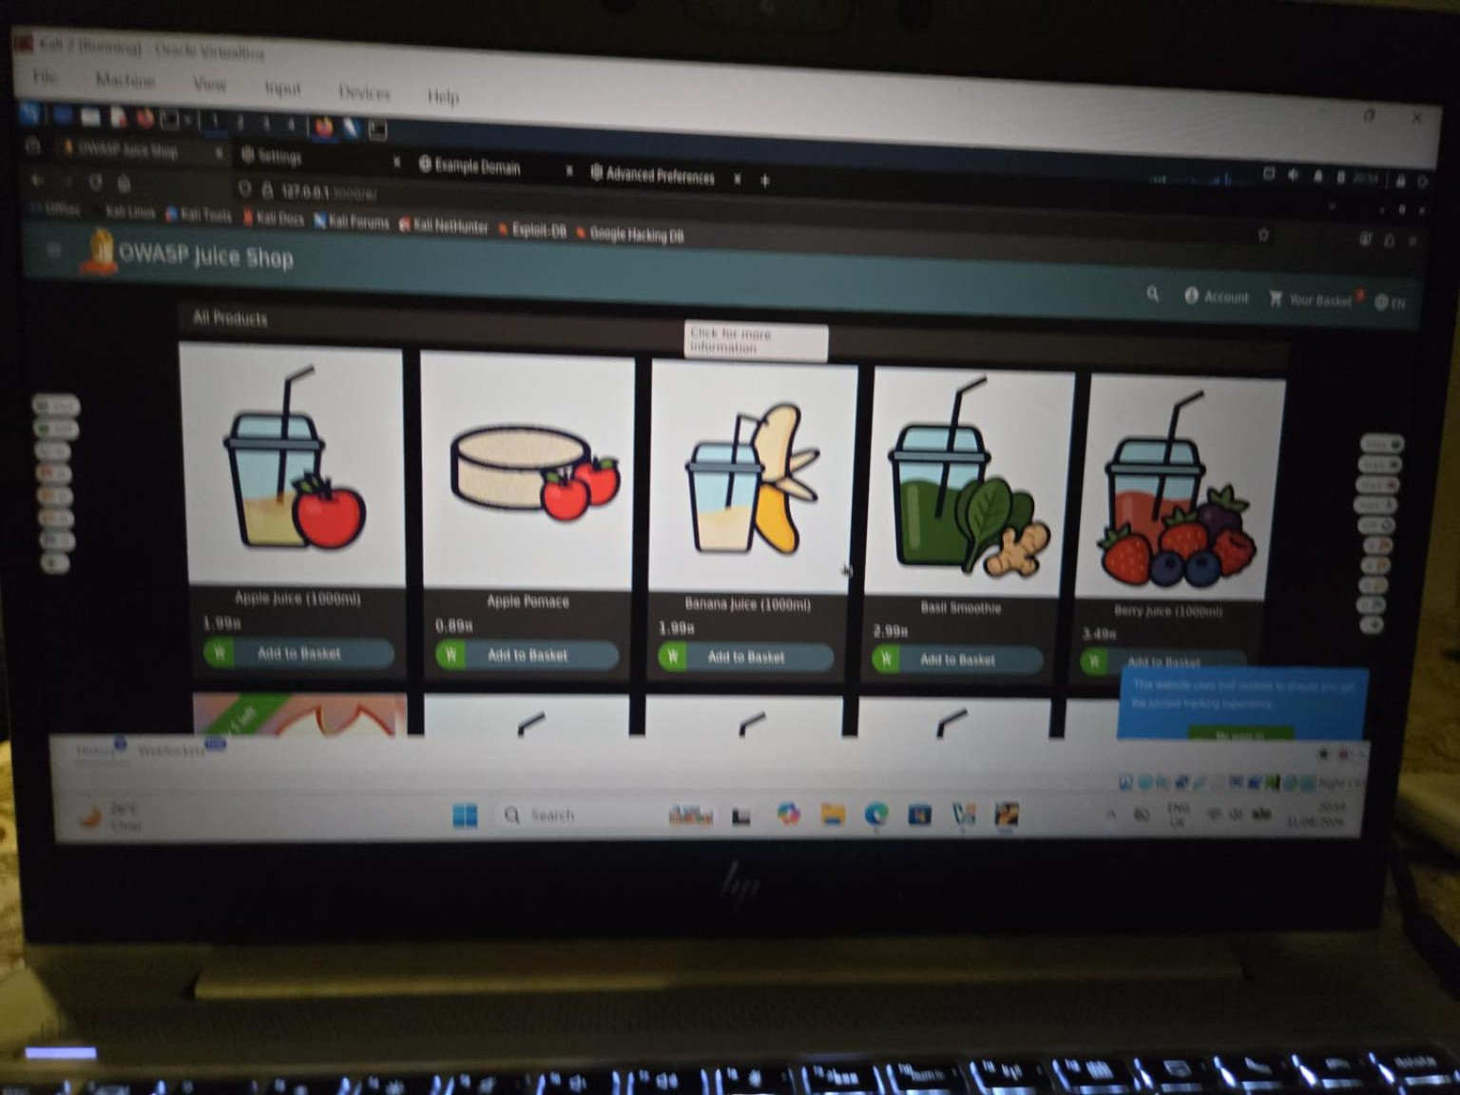
Figure 4. Local Juice Shop running with ZAP HUD controls visible during manual exploration.

8. Context and Scope
When I first tried to run the AJAX Spider, ZAP reported that the starting point was not in scope. This became a practical lesson in the difference between seeing a site and authorising ZAP to test it. A context groups information about an application, while scope tells ZAP which target is intentionally included for testing.
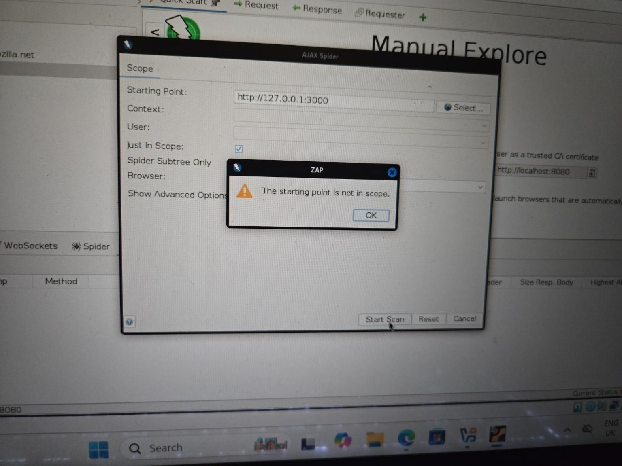
Figure 5. AJAX Spider warning that the starting point was not in scope.
I added the local Juice Shop target to a context. The include expression covered http://127.0.0.1:3000 and its subpaths. Once the context was in scope, ZAP offered the AJAX Spider and Active Scan actions for that target.
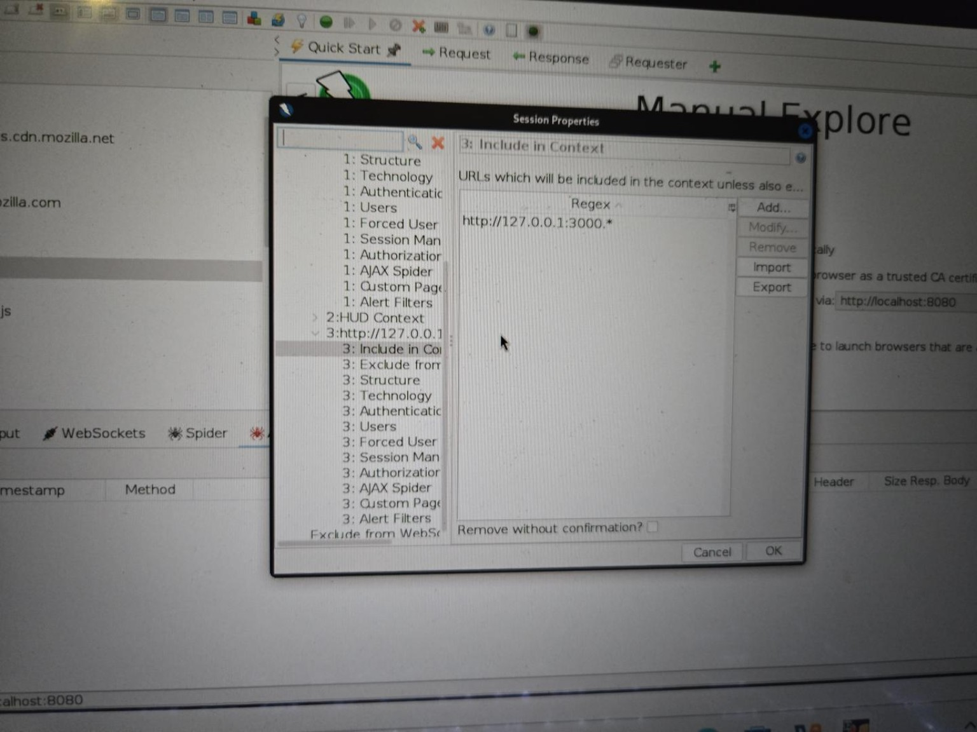
Figure 6. ZAP context configuration showing the local Juice Shop target included.
The scope boundary was also visible during crawling. External resources such as Mozilla or YouTube could appear because the application or browser referenced them, but ZAP marked them as out of context rather than treating them as authorised targets. This was useful because it demonstrated that scope is an ethical and technical control, not merely an organisational label.

9. AJAX Spider
I then launched the AJAX Spider against the Juice Shop context using Firefox Headless. The AJAX Spider is intended to crawl modern JavaScript-heavy applications by interacting with the application and discovering routes and resources that may not be obvious from a simple static page.
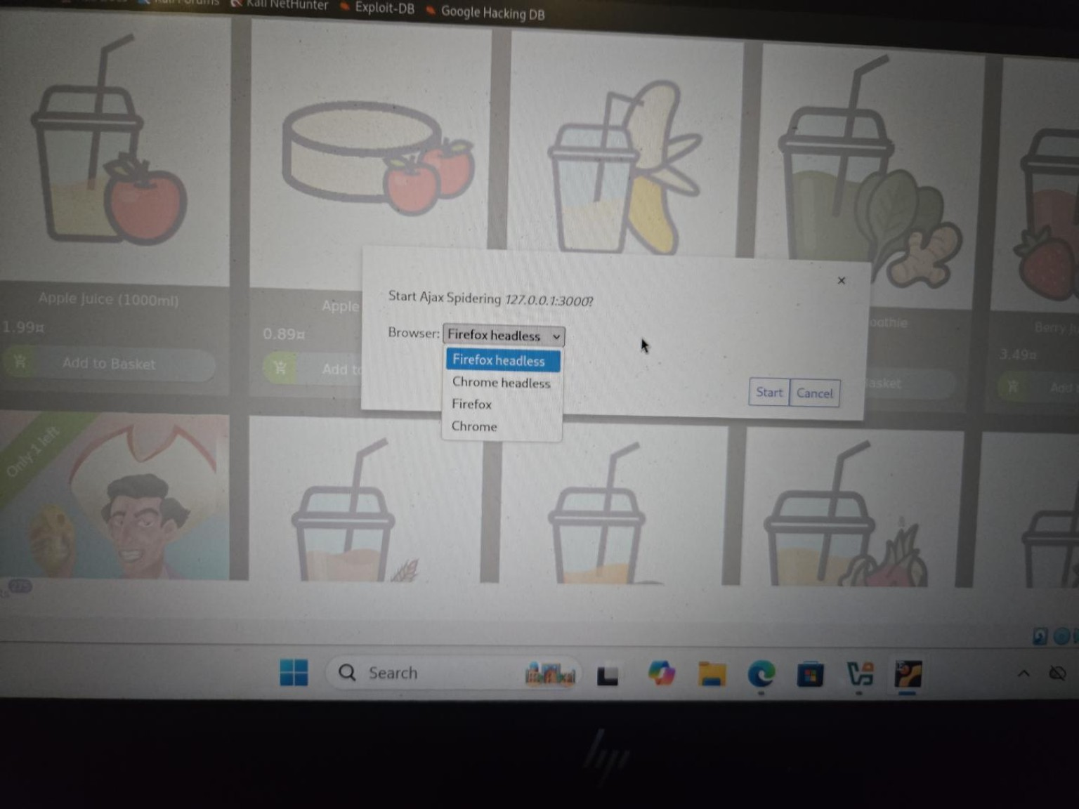
Figure 7. AJAX Spider configuration for the Juice Shop context.
The spider completed with 639 crawled URLs. During the crawl I saw a mixture of HTTP response codes, including 200 OK, 304 Not Modified, 403 Forbidden and 101 responses. I learned not to treat a status code by itself as a vulnerability. For example, a 304 means a cached resource has not changed, while a 403 means access was refused. Some 403 responses were specifically ZAP preventing out-of-scope crawling.
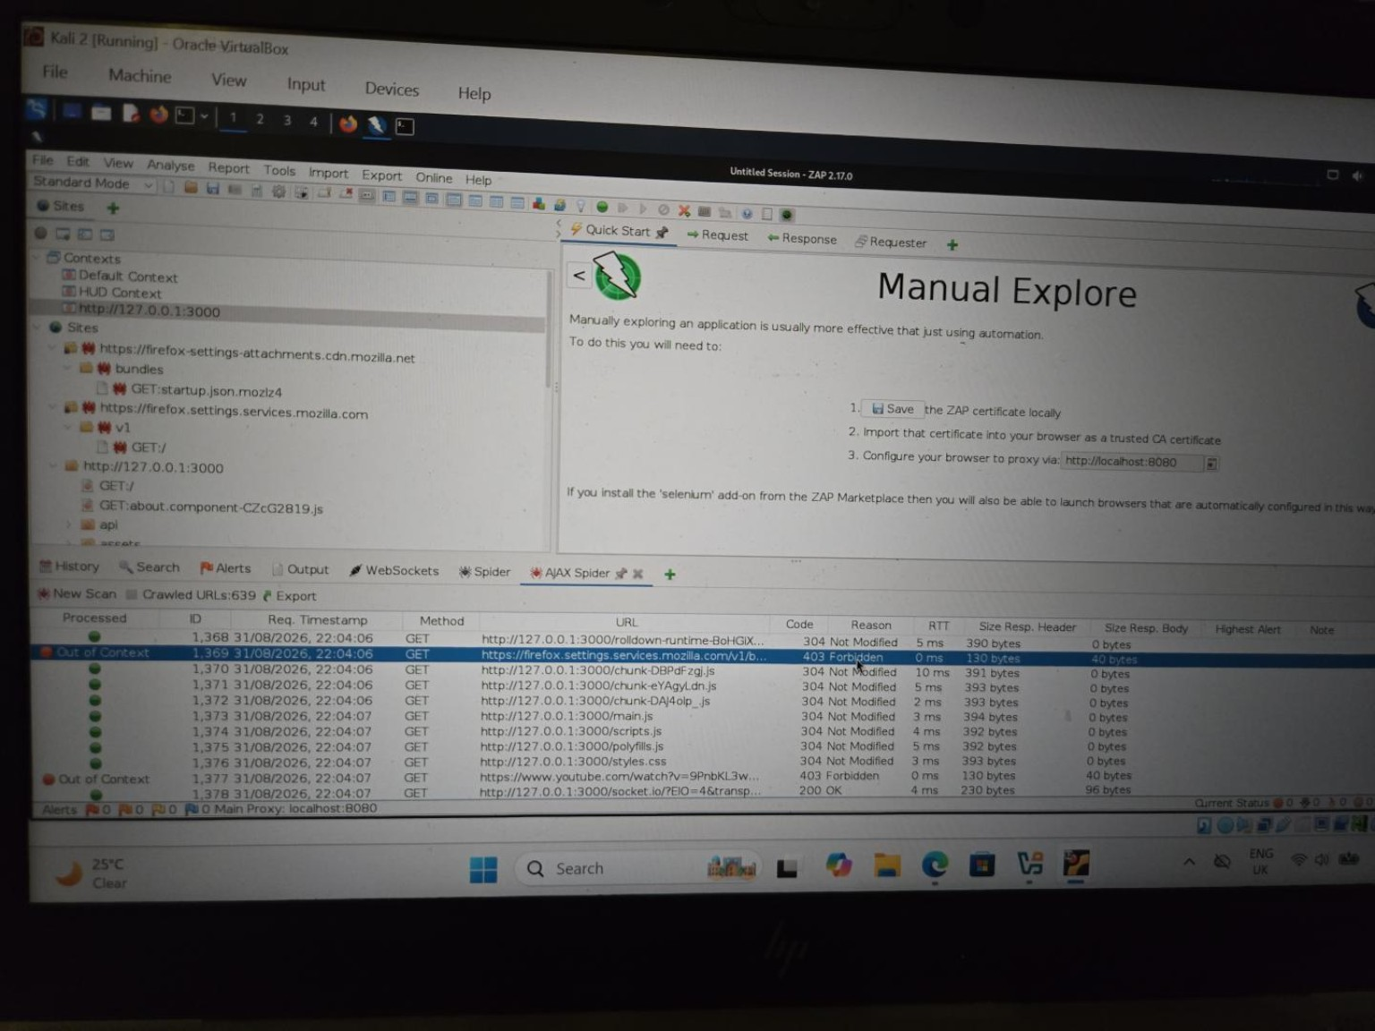
Figure 8. Completed AJAX Spider showing 639 crawled URLs and a mixture of response codes.

10. What the Spider Discovered
The Sites tree expanded considerably after crawling. I could see API-related paths such as Challenges, Feedbacks, Products and Quantities, as well as assets and other application resources. This was a clearer demonstration of attack-surface discovery than my manual browsing alone.
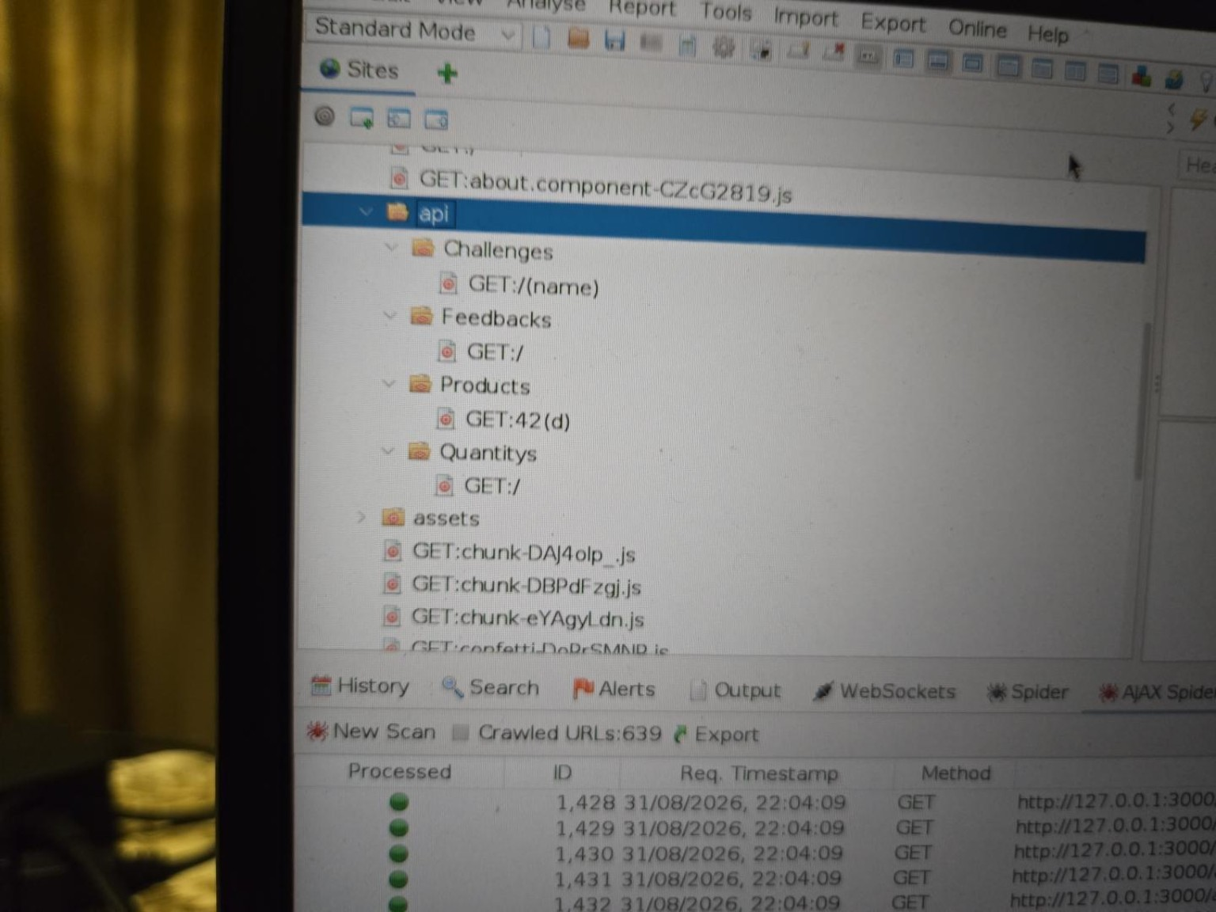
Figure 9. Examples of API resources discovered under the local Juice Shop target.
One especially interesting area was /ftp. ZAP exposed a list of retrievable-looking files and resources, including acquisitions.md, announcement_encrypted.md, coupons_2013.md.bak, encrypt.pyc, incident-support.kdbx, package-lock.json.bak, package.json.bak and suspicious_errors.yml. I did not assume that every file was a confirmed vulnerability simply because it existed. However, the filenames were worth investigating because backup files, database/password-manager files, compiled code and configuration-related material can potentially reveal information.
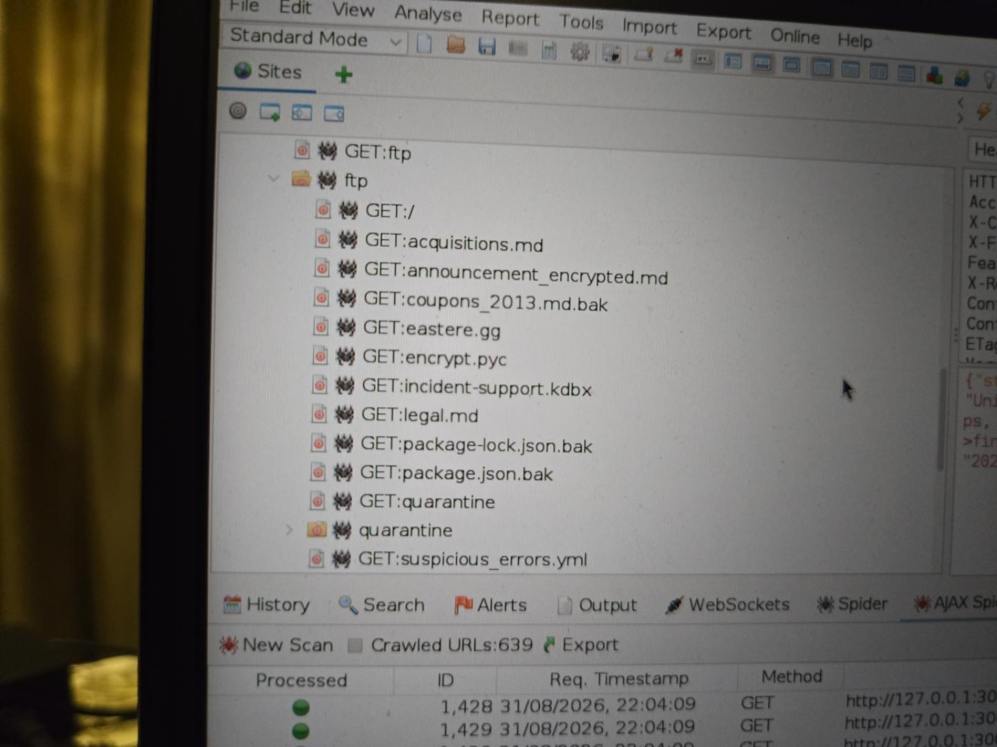
Figure 10. /ftp resources discovered during the Juice Shop crawl.
When I selected incident-support.kdbx, the response body appeared as unreadable binary data. This taught me that ZAP can display the raw response even when the resource is not a human-readable text file. I also opened announcement_encrypted.md and saw a long encoded/encrypted-looking body. At this stage I recorded these as discovered resources rather than claiming that I had decrypted or exploited them.

11. Active Scan
After discovery, I moved to Active Scan. The distinction I learned is: the AJAX Spider asks 'what is here?', while Active Scan asks 'what happens when I actively test what I found?'. Active scanning sends test requests and therefore should only be used against systems I am authorised to test.
The scan was started against the Juice Shop context using the Default Policy with recursion enabled. It completed at 100% after 84 requests. The number of Active Scan requests did not need to match the 639 crawled URLs one-for-one.
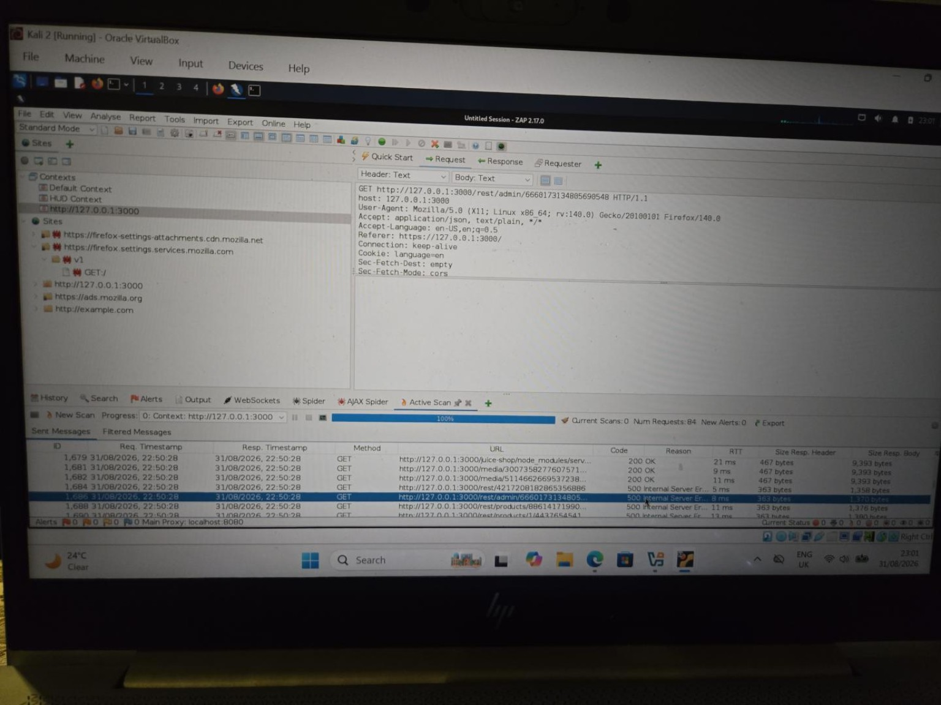
Figure 11. Completed Active Scan against the Juice Shop context.

12. Active Scan Observations
The Active Scan showed several response types, including 401 Unauthorized, 403 Forbidden and 500 Internal Server Error. Again, I did not treat the codes alone as vulnerabilities. I opened some of the 500 responses to see what the server had actually returned.
A request involving /rest/admin/... returned a 500 error and a JSON error response containing internal application paths and a sequence of code locations. I learned that this sequence is called a stack trace. My beginner-level understanding is that a stack trace is the application's trail showing where an error occurred in its code.
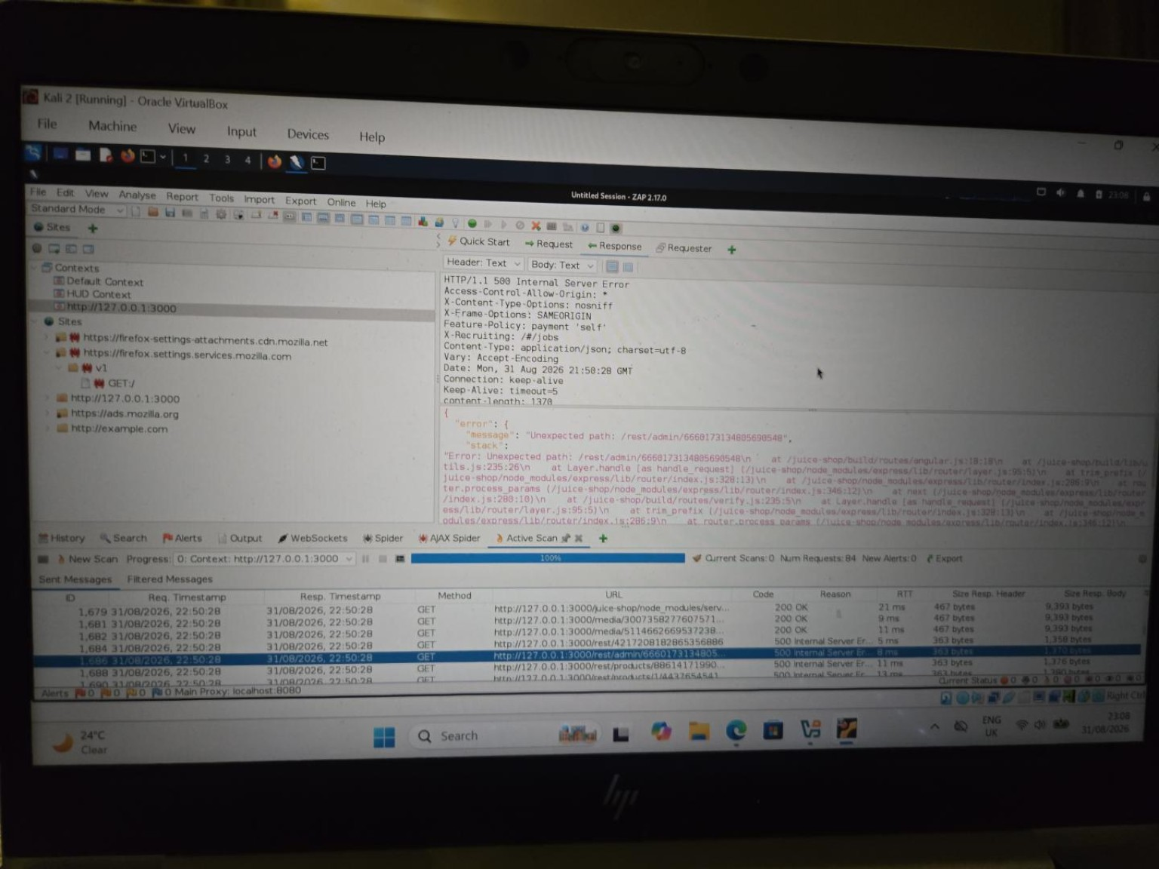
Figure 12. A 500 response from a /rest/admin/ request exposing internal error and code-path information.
I then checked a separate /rest/products/... 500 response and observed the same general pattern. This made the behaviour more interesting because it was not limited to one endpoint family.
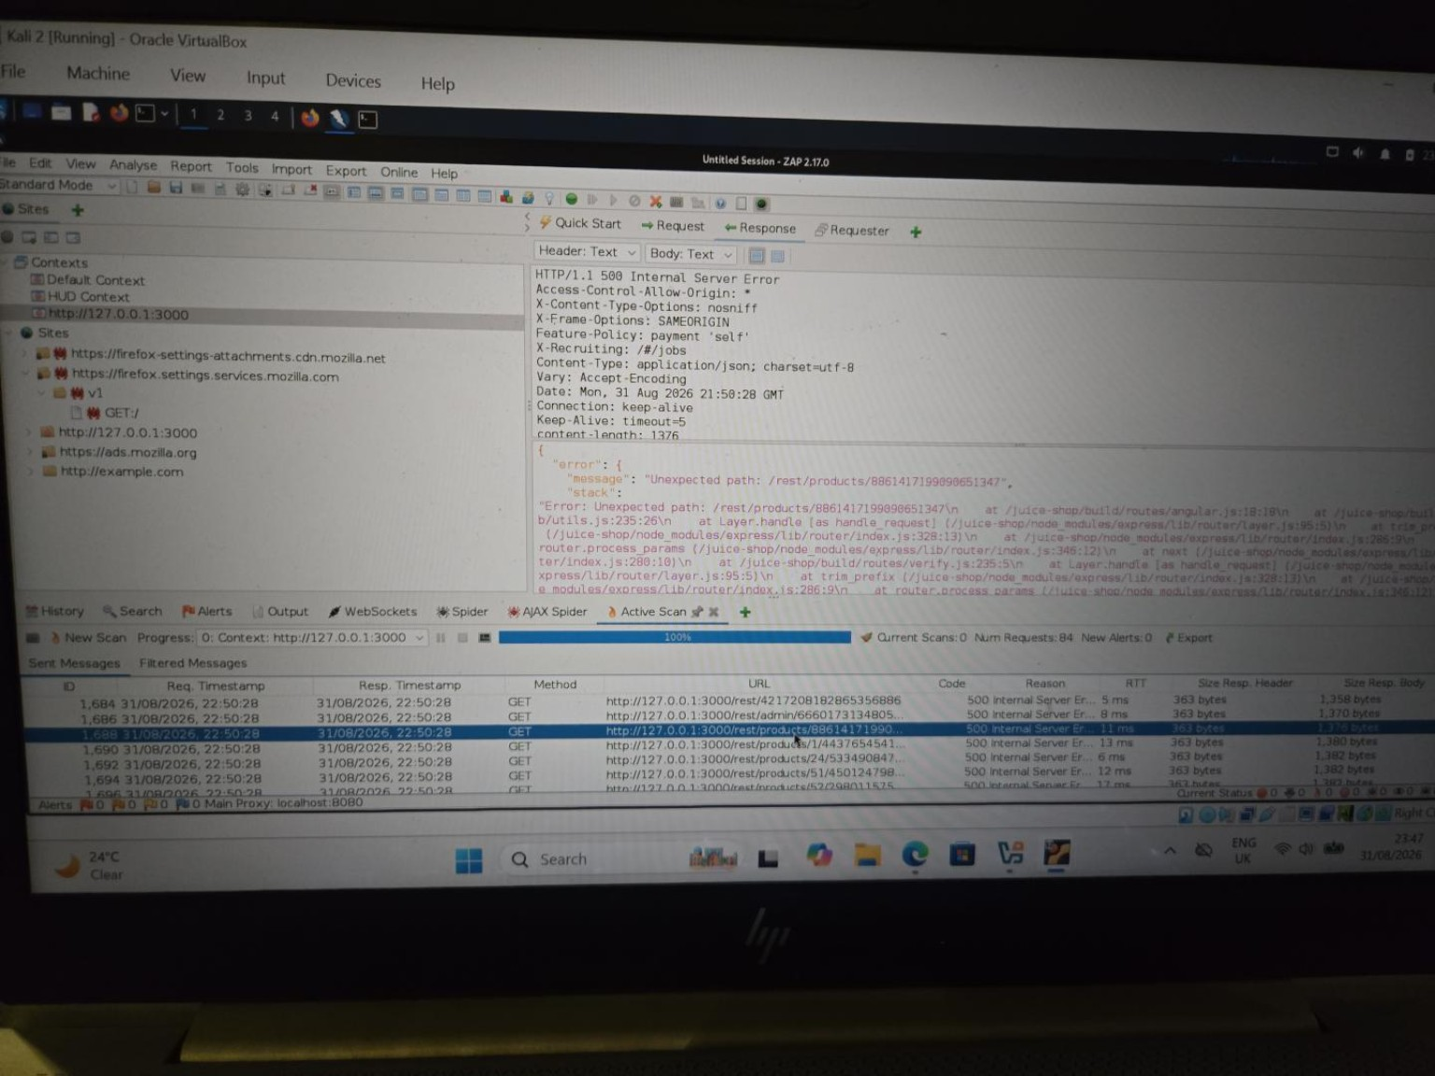
Figure 13. A second 500 response, this time under /rest/products/, showing similar internal error information.

13. Interpreting the 500 Responses
I would not describe the 500 status itself as the vulnerability. What interested me was that the application returned more technical detail than a normal user would need. The response showed internal application paths and framework/code information. From my current understanding, this may be an information-disclosure issue because technical error details can give an attacker more information about how an application is built.
I am deliberately using 'may be' here because ZAP did not create a formal alert for this observation during this scan. I manually noticed the behaviour by reading the response. A stronger professional assessment would normally require validation and a clearer demonstration of security impact.

14. ZAP Alerts: Why Zero Alerts Still Matters
The completed Active Scan displayed New Alerts: 0, and the Alerts pane remained empty. I initially expected Juice Shop to produce coloured vulnerability alerts similar to what I had previously seen while working with the Acunetix Test ASP.NET training site.
I learned that '0 alerts' does not mean '0 vulnerabilities'. It only means that this particular ZAP scan did not produce a formal alert from its automated scanning rules. A scanner can discover resources and generate unusual server behaviour without automatically classifying every observation as a vulnerability.
This also taught me not to rely on the scanner as the final authority. The workflow is discovery, testing, inspection and interpretation. Automated alerts are useful evidence, but they are not the whole assessment.

15. Findings / Evidence Summary
Observation | Location | Evidence | Status | My interpretation | Confidence
Large application attack surface | Local Juice Shop | AJAX Spider crawled 639 URLs | Observed | The spider found far more resources than manual browsing alone. | High
Interesting exposed resources | /ftp | Backup, .kdbx, .pyc, .md and related files visible | Observed | Potentially useful information; not all are automatically vulnerabilities. | High
Out-of-scope protection | External Mozilla/YouTube resources | 403 / Out of AJAX Spider scope | Observed | Scope prevented unrelated external resources from being treated as targets. | High
Verbose 500 error response | /rest/admin/... | 500 response with internal paths/stack trace | Observed; no ZAP alert | May disclose unnecessary technical information. | Medium
Repeated verbose 500 response | /rest/products/... | Similar 500 response with internal paths/stack trace | Observed; no ZAP alert | Shows the behaviour was not limited to one endpoint family. | Medium
Formal automated alerts | ZAP Alerts pane | New Alerts: 0 | No formal alerts | Does not prove the application is vulnerability-free. | High

16. Terms I Learned During the Exercise
localhost / 127.0.0.1: The same computer I am currently using. Traffic to the loopback address does not need to travel onto the internet.
Port: A numbered communication point used by a service. In this lab Juice Shop used 3000 and ZAP used 8080.
Proxy: A program placed between a client and server. ZAP received Firefox's requests, recorded or modified them, and forwarded them to Juice Shop.
Context: ZAP's grouping/configuration for a particular application being tested.
Scope: The boundary defining what I intentionally authorised ZAP to test.
Endpoint: A particular application/API location that can receive a request, such as a path under /rest or /api.
AJAX Spider: A crawler used to discover routes/resources in dynamic web applications.
Active Scan: ZAP actively sends test requests to look for vulnerable behaviour. It is different from simply observing traffic.
Stack trace: Technical error information showing the sequence/location of application code involved when an error occurred.
HTTP 500: The server encountered an internal error. The code itself does not automatically prove a vulnerability.

17. What I Learned
- A web application can be running locally even while the computer is also connected to the internet.
- 127.0.0.1 points back to the same machine; it is not a remote internet address.
- The ZAP proxy port and the target application's port are different things.
- Firefox can bypass localhost proxying, so a locally loaded page may not automatically be visible to ZAP.
- Seeing a site in ZAP is not the same as placing it in an authorised testing scope.
- AJAX Spider is primarily for discovery; Active Scan is for active vulnerability testing.
- HTTP status codes are evidence that must be interpreted in context rather than treated as vulnerability labels.
- A scanner can finish with zero formal alerts while still producing responses worth manually investigating.
- A student report should separate confirmed tool findings from my own observations and developing interpretation.

18. Limitations
This was a student lab assessment of a locally running Juice Shop instance, not a comprehensive penetration test. The results describe this local application build and the configuration used during the session. They should not be presented as findings against a live production deployment. The Active Scan produced 84 requests and zero formal ZAP alerts, so I would not claim that the scan exhaustively tested every one of the 639 crawled URLs or every possible authenticated application state.

19. Conclusion
The most important outcome of this exercise was not a list of automated alerts. I learned how the different parts of a ZAP assessment fit together: establish connectivity, proxy the browser, define the authorised context and scope, discover the attack surface, actively test it, inspect responses and then report only what the evidence supports.
The troubleshooting was therefore part of the assessment rather than wasted time. By the end of the session I could explain why Juice Shop on 127.0.0.1 did not require the internet, why Firefox needed a localhost proxy setting, why external resources were kept out of scope, what the AJAX Spider contributed, and why a completed Active Scan with zero formal alerts did not automatically mean that nothing interesting had happened.

Evidence Handling Note
The figures in this report are original photographs/screenshots from my authorised lab session. The visible target address is the private loopback address 127.0.0.1 and the ZAP proxy is localhost:8080. I did not recreate terminal or ZAP output for this report, and I did not alter the technical results shown in the evidence.

