# 1. Objectives

In this project, we will study a real network and specifically, we are going to study the properties of this network such as connectivity, degree distribution, and different ways to compute weighted network’s community, largest community and sub-community and overlapped community detection. This project serves as a good review of all previous projects and gives a good view of the real stuffs in our life.

# 2. Problems

## 2.1. Problem 1

As we construct the graph from given file as a directed graph, we found this graph is not connected. However, the giant connected component is very large, which comprises 10487 vertices out of 10501 of the whole graph.

## 2.2 Problem 2

Since the graph is directed, the in-degree and out-degree distribution of the graph are calculated separately, which are shown below as figure 2.1 and figure 2.2.

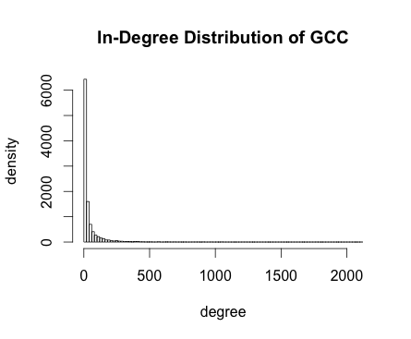

figure 2.1 in-degree distribution

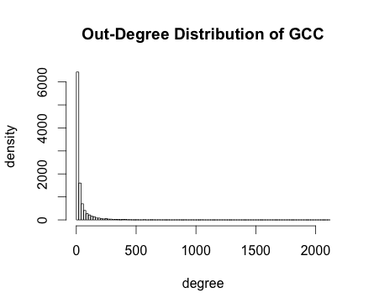

figure 2.1 out-degree distribution

## 2.3 Problem 3

We tested both option 1 and option 2 to get the community structure of the graph.

For option 1, we firstly converted the graph into an undirected graph and then used label propagation method to compute the community structure, which is shown as below in figure 3.1. The sizes of community are displayed in table 3.1 and the modularity of this model is 0.000102.

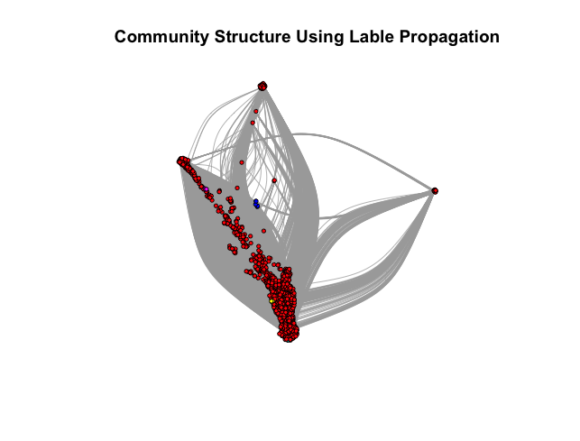

Figure 3.1 Community Structure using fast-greedy algorithm

|  |  |  |  |  |  |
| --- | --- | --- | --- | --- | --- |
| community | 1 | 2 | 3 | 4 | 5 |
| size | 10474 | 4 | 3 | 3 | 3 |

Table 3.1 sizes of communities of option 1

For option 2, we calculated the weight of two edges between two nodes as the square root of their product, which converted the directed graph into an undirected one. Then apply fast greedy algorithm and label propagation algorithm separately, which yields the community structure as shown in figure 3.2 and figure 3.3. The sizes of top communities of each model are shown in table 3.2 and table 3.3.

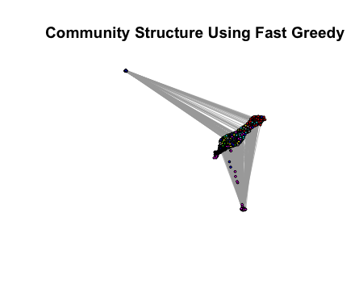

Figure 3.2 Community Structure using fast greedy algorithm

|  |  |  |  |  |  |  |  |  |
| --- | --- | --- | --- | --- | --- | --- | --- | --- |
| community | 1 | 2 | 3 | 4 | 5 | 6 | 7 | 8 |
| size | 1856 | 1666 | 1022 | 2266 | 731 | 1236 | 633 | 1077 |

Table 3.2 sizes of communities of option 2 using fast greedy method

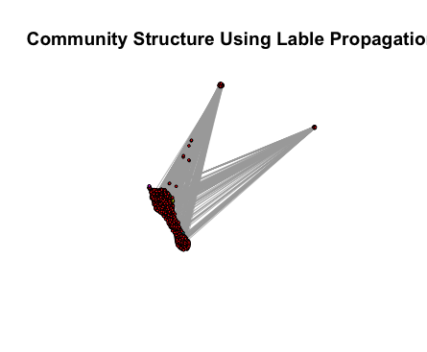

Figure 3.3 Community Structure using label propagation algorithms

|  |  |  |  |  |  |  |
| --- | --- | --- | --- | --- | --- | --- |
| community | 1 | 2 | 3 | 4 | 5 | 6 |
| size | 10467 | 2 | 4 | 5 | 6 | 3 |

Table 3.3 sizes of communities of option 2 using fast greedy method

We found the results are not similar between two models since fast greedy algorithm breaks the graph into more communities while the label propagation tends to extract a giant sub community. The modularity of label propagation model is 0.000177 while the top modularity of communities in fast greedy are all 0.329.

## 2.4 Problem 4

As we deleted those nodes not belonging to the max sub-community and reconstruct the giant sub-community, which has 2266 vertices, we could compute the community structure of this sub-community by using both fast greedy algorithm and label propagation algorithm. The modularity of the top communities of fast greedy method are all 0.359 while the modularity of label propagation is 0. This is consistent with what we get in problem 3. The structure determined by two algorithms are shown as following in figure 4.1 and figure 4.2.

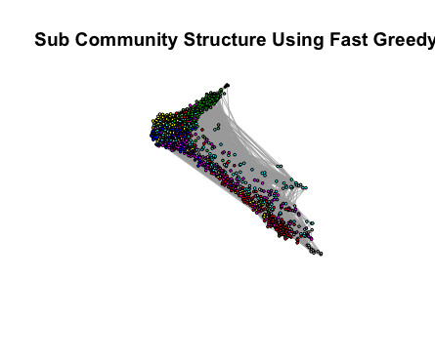

Figure 4.1 Sub Community Structure using fast-greedy algorithm

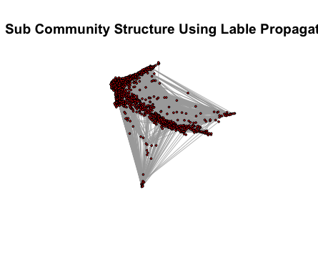

Figure 4.2 Sub Community Structure using label propagation algorithm

The result is consistent with the conclusion of problem 3, which is fast greedy algorithm tends to divide the graph into more small communities while label propagation algorithm tends to form less, in this sub-graph only one, communities.

2.5 Problem 5

We deleted the nodes not belonging to the community with size over 100 and calculate the modularity and sizes of the sub-communities. There are 8 such sub-communities we’ve found and their properties are shown through table 5.1 to table 5.8.

|  |  |  |  |  |  |  |  |  |  |  |
| --- | --- | --- | --- | --- | --- | --- | --- | --- | --- | --- |
| Sub-Community No.1 | | | | | | | | | | |
| Sub-community structure using fast greedy algorithm | | | | | | | | | | |
| Comm No. | **1** | **2** | **3** | **4** | **5** | **6** | **7** |  |  |  |
| Size | 244 | 452 | 413 | 490 | 84 | 136 | 37 |  |  |  |
| Modularity | 0.2249632 | | | | | | | | | |
| Sub-community structure using label propagation algorithm | | | | | | | | | | |
| Comm No. | **1** | | | | | **2** | | | | |
| Size | 1853 | | | | | 3 | | | | |
| Modularity | 0.001301893 | | | | | | | | | |

Table 5.1 sub-community 1 properties using two algorithms

|  |  |  |  |  |  |  |  |  |  |  |
| --- | --- | --- | --- | --- | --- | --- | --- | --- | --- | --- |
| Sub-Community No.2 | | | | | | | | | | |
| Sub-community structure using fast greedy algorithm | | | | | | | | | | |
| Comm No. | **1** | **2** | **3** | **4** | **5** | **6** | **7** | **8** | **9** |  |
| Size | 357 | 491 | 347 | 294 | 128 | 28 | 13 | 5 | 3 |  |
| Modularity | 0.3711271 | | | | | | | | | |
| Sub-community structure using label propagation algorithm | | | | | | | | | | |
| Comm No. | **1** | | | | | **2** | | | | |
| Size | 1663 | | | | | 3 | | | | |
| Modularity | 0.0002311537 | | | | | | | | | |

Table 5.2 sub-community 2 properties using two algorithms

|  |  |  |  |  |  |  |  |  |  |  |
| --- | --- | --- | --- | --- | --- | --- | --- | --- | --- | --- |
| Sub-Community No.3 | | | | | | | | | | |
| Sub-community structure using fast greedy algorithm | | | | | | | | | | |
| Comm No. | **1** | **2** | **3** | **4** | **5** | **6** | **7** | **8** | **9** | **10** |
| Size | 318 | 209 | 30 | 193 | 118 | 44 | 41 | 15 | 10 | 6 |
| Comm No. | **11** | **12** | **13** | **14** | **15** | **16** | **17** | **18** | **19** | **20** |
| Size | 6 | 4 | 3 | 3 | 3 | 11 | 4 | 4 |  |  |
| Modularity | 0.5128581 | | | | | | | | | |
| Sub-community structure using label propagation algorithm | | | | | | | | | | |
| Comm No. | **1** | **2** | **3** | **4** | **5** | **6** | **7** | **8** | **9** | **10** |
| Size | 677 | 223 | 13 | 9 | 13 | 13 | 14 | 4 | 6 | 8 |
| Comm No. | **11** | **12** | **13** | **14** | **15** | **16** | **17** | **18** | **19** |  |
| Size | 4 | 8 | 4 | 5 | 4 | 3 | 5 | 4 | 5 |  |
| Modularity | 0.3979645 | | | | | | | | | |

Table 5.3 sub-community 3 properties using two algorithms

|  |  |  |  |  |  |  |  |  |  |  |
| --- | --- | --- | --- | --- | --- | --- | --- | --- | --- | --- |
| Sub-Community No.4 | | | | | | | | | | |
| Sub-community structure using fast greedy algorithm | | | | | | | | | | |
| Comm No. | **1** | **2** | **3** | **4** | **5** | **6** | **7** | **8** |  |  |
| Size | 306 | 457 | 313 | 365 | 426 | 347 | 47 | 5 |  |  |
| Modularity | 0.3595153 | | | | | | | | | |
| Sub-community structure using label propagation algorithm | | | | | | | | | | |
| Comm No. | **1** | | | | | | | | | |
| Size | 2266 | | | | | | | | | |
| Modularity | 0 | | | | | | | | | |

Table 5.4 sub-community 4 properties using two algorithms

|  |  |  |  |  |  |  |  |  |  |  |
| --- | --- | --- | --- | --- | --- | --- | --- | --- | --- | --- |
| Sub-Community No.5 | | | | | | | | | | |
| Sub-community structure using fast greedy algorithm | | | | | | | | | | |
| Comm No. | **1** | **2** | **3** | **4** | **5** | **6** | **7** | **8** | **9** | **10** |
| Size | 60 | 247 | 138 | 56 | 55 | 50 | 74 | 16 | 11 | 4 |
| Comm No. | **11** | **12** | **13** | **14** | **15** |  |  |  |  |  |
| Size | 4 | 2 | 7 | 3 | 4 |  |  |  |  |  |
| Modularity | 0.3980826 | | | | | | | | | |
| Sub-community structure using label propagation algorithm | | | | | | | | | | |
| Comm No. | **1** | **2** | **3** | **4** | **5** | **6** | **7** | **8** | **9** |  |
| Size | 573 | 120 | 6 | 4 | 10 | 5 | 4 | 4 | 5 |  |
| Modularity | 0.2980612 | | | | | | | | | |

Table 5.5 sub-community 5 properties using two algorithms

|  |  |  |  |  |  |  |  |  |  |  |  |  |  |  |  |  |
| --- | --- | --- | --- | --- | --- | --- | --- | --- | --- | --- | --- | --- | --- | --- | --- | --- |
| Sub-Community No.6 | | | | | | | | | | | | | | | | |
| Sub-community structure using fast greedy algorithm | | | | | | | | | | | | | | | | |
| Comm No. | **1** | **2** | | **3** | | **4** | **5** | | **6** | | **7** | **8** | | **9** | |  |
| Size | 275 | 294 | | 184 | | 47 | 167 | | 66 | | 100 | 93 | | 10 | |  |
| Modularity | 0.3986121 | | | | | | | | | | | | | | | |
| Sub-community structure using label propagation algorithm | | | | | | | | | | | | | | | | |
| Comm No. | **1** | | **2** | | **3** | | | **4** | | **5** | | | **6** | | **7** | |
| Size | 1209 | | 9 | | 5 | | | 3 | | 3 | | | 3 | | 4 | |
| Modularity | 0．006987121 | | | | | | | | | | | | | | | |

Table 5.6 sub-community 6 properties using two algorithms

|  |  |  |  |  |  |  |  |  |  |  |
| --- | --- | --- | --- | --- | --- | --- | --- | --- | --- | --- |
| Sub-Community No.7 | | | | | | | | | | |
| Sub-community structure using fast greedy algorithm | | | | | | | | | | |
| Comm No. | **1** | **2** | **3** | **4** | **5** | **6** | **7** | **8** | **9** | **10** |
| Size | 162 | 64 | 153 | 65 | 60 | 50 | 38 | 12 | 7 | 3 |
| Comm No. | **11** | **12** | **13** | **14** | **15** | **16** |  |  |  |  |
| Size | 3 | 4 | 3 | 3 | 3 | 3 |  |  |  |  |
| Modularity | 0.4796647 | | | | | | | | | |
| Sub-community structure using label propagation algorithm | | | | | | | | | | |
| Comm No. | **1** | **2** | **3** | **4** | **5** | **6** | **7** | **8** | **9** | **10** |
| Size | 421 | 150 | 5 | 16 | 5 | 3 | 4 | 4 | 4 | 3 |
| Comm No. | **11** | **12** | **13** | **14** | **15** | **16** |  |  |  |  |
| Size | 3 | 3 | 3 | 3 | 3 | 3 |  |  |  |  |
| Modularity | 0.3452324 | | | | | | | | | |

Table 5.7 sub-community 7 properties using two algorithms

|  |  |  |  |  |  |  |  |  |  |  |
| --- | --- | --- | --- | --- | --- | --- | --- | --- | --- | --- |
| Sub-Community No.8 | | | | | | | | | | |
| Sub-community structure using fast greedy algorithm | | | | | | | | | | |
| Comm No. | **1** | **2** | **3** | **4** | **5** | **6** | **7** | **8** | **9** | **10** |
| Size | 190 | 253 | 145 | 153 | 75 | 49 | 88 | 80 | 16 | 6 |
| Comm No. | **11** | **12** | **13** |  |  |  |  |  |  |  |
| Size | 11 | 4 | 7 |  |  |  |  |  |  |  |
| Modularity | 0.5036454 | | | | | | | | | |
| Sub-community structure using label propagation algorithm | | | | | | | | | | |
| Comm No. | **1** | **2** | **3** | **4** | **5** | **6** | **7** | **8** | **9** | **10** |
| Size | 49 | 874 | 42 | 43 | 22 | 4 | 6 | 7 | 3 | 4 |
| Comm No. | **11** | **12** | **13** | **14** | **15** | **16** |  |  |  |  |
| Size | 5 | 4 | 3 | 4 | 4 | 3 |  |  |  |  |
| Modularity | 0.1914544 | | | | | | | | | |

Table 5.8 sub-community 8 properties using two algorithms

We could see that in a sub-community of a large graph, we could still find community structures of it. In addition, FG algorithm will get communities with relatively similar size, while LP tends to give us a giant one.

2.6 Problem 6

We used the community information we calculated in problem 3, plus additional functions in netrw to solve this problem. By generating the personalized page rank, we found the visiting probability of each node in the giant connected component. Then we picked those top 30 nodes with largest visiting probability and calculated M associated with them. Then the threshold was set to determine whether a node belonged to multiple communities. The threshold is very important, namely one may find many qualified nodes if the threshold is set as a small value while the other may find few nodes with a large threshold. The code is shown as below:

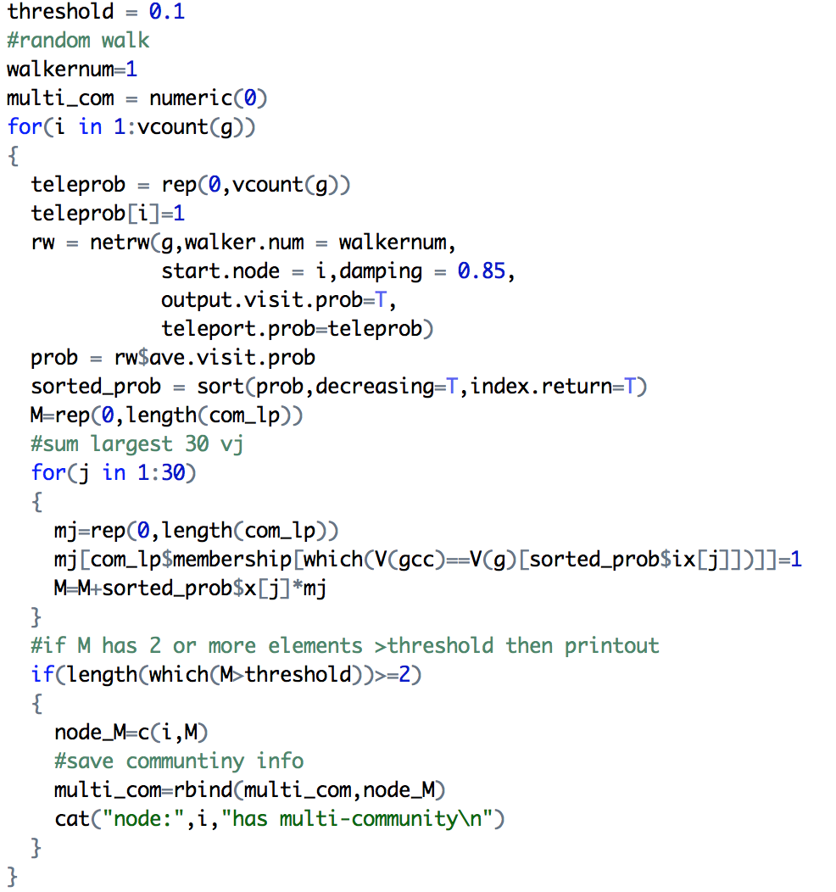

For fast greedy algorithm, after testing we set the threshold to be 0.2, which yielded 128 nodes belonging to multiple communities. And for label propagation algorithm, the threshold is relatively small, a threshold of 0.1 could lead to 24 qualified nodes. Those nodes are described in table 6.1 and table 6.2.

|  |  |  |  |  |  |  |  |  |  |
| --- | --- | --- | --- | --- | --- | --- | --- | --- | --- |
| Node belonging to multiple communities of fast greedy algorithm | | | | | | | | | |
| 68 | 149 | 151 | 726 | 868 | 1406 | 1507 | 1518 | 2106 | 2266 |
| 2356 | 2997 | 3768 | 3769 | 3879 | 3907 | 3969 | 4040 | 4161 | 4250 |
| 4297 | 4312 | 4356 | 4365 | 4407 | 4583 | 4586 | 4642 | 4665 | 4993 |
| 5095 | 5471 | 5648 | 5850 | 5902 | 5963 | 5997 | 6005 | 6315 | 6797 |
| 6803 | 6818 | 6825 | 6897 | 6914 | 6919 | 7007 | 7051 | 7082 | 7158 |

Table 6.1 some example nodes id using FG algorithm with threshold = 0.2

|  |  |  |  |  |  |  |  |  |  |
| --- | --- | --- | --- | --- | --- | --- | --- | --- | --- |
| Node belonging to multiple communities of label propagation algorithm | | | | | | | | | |
| 4687 | 7979 | 8915 | 10176 | 10177 | 10178 | 10179 | 10348 | 10349 | 10350 |
| 10351 | 10352 | 10401 | 10402 | 10403 | 10464 | 10465 | 10466 | 10468 | 10475 |
| 10476 | 10477 | 10486 | 10496 |  |  |  |  |  |  |

Table 6.2 nodes id using label propagation algorithm with threshold = 0.1

From the tables we see at least two interesting features. One is that the fast greedy algorithm has larger threshold and tends to have more nodes, which means it has more nodes belonging to multi-communities. This makes sense because fast greedy algorithm tends to make more sub-communities, which has been shown in previous problems. The second fact is that, those nodes sometimes appears in a contiguous manner, for example, nodes with id equals to 10177-10179, 10348-10352, 10401-10403 all appear in the set of label propagation algorithm. This indicates a spatial continuity of vertices.

# 3. Difficulty encountered

This graph is a good review of previous exercise and many of the operation has been seen before. However, it is not easy to do this task if given no indication, e.g. how to compute the community structure of a directed nodes. Also, the idea of using personalized PageRank to study to overlapped communities structures is awesome. And it’s hard to be thought out by one himself. Since the calculation of random walker needs the package of netrw, we have to switch system and environment to support this operation, which caused a little tricky problem. But generally this is acceptable. And we gained good view of real network structure by studying this project.