Use the NTIRE 2018 dataset and, particularly, the Train
and Validation Track 1 – bicubic x 8

We are upscaling an image
Select 2 methods of super-resolution to solve other inverse problems – deconvolution/deblurring or denoising.
Bonus marks will be given for implementation of a third method – comparative analysis of methods required

2 methods of 3 taught

- Model based and data driven – deep unfolding
- Gen AI – VAE, GAN, DIFFUSION – probs GAN
- IMPLICIT NEURAL REPRESENTATIONS

Pick 1 and 2

COMPARISON – QUANTATIVE– numerical performance metrics – research these? PSNR – higher va, SSIM, LPIPS
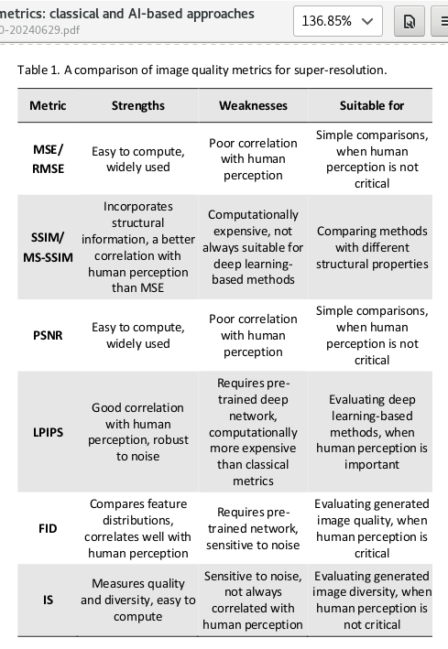
cite this

QUALITATIVE – visual quality and perceptual characteristics

BASIC COMPARISON – using DIV2K X 8 images refers to the LR versions of the original high quality DIV2K dataset images that have been created by downscaling them by a factor of 8

IMPACT OF NOISE DEGRADATION
CITE THIS - Generating realistic images as proposed in recent research [12,13] requires introducing
specific degradation techniques for training data. Such techniques include blur, JPEG
compression artifacts, artificial noise, cropping, padding, rotating, etc. These degradation
techniques are just a combination of different augmentations applied during training for
each image from the dataset. These techniques improve the quality of generated images in
super-resolution applications when input images might be blurry or noisy.

eg. in the MRI paper, it looks at removing noise to preprocess the data which is different

how much does noise degrade the SR model’s ability to upscale?

IMPACT OF DOWNSCALING
- When you downscale – a lower resolution image means model has much less pixel data and fewer high frequency details (textures, fine edges) to work with.

Methods:
DIP is prior based and unsupervised. Training – for every image in DIV2K validation set, you take one x8 LR image. Initialize a new DIP network with random weights and train the network for hundreds of iterations so that it reconstructs the x1 HR output
The PSNR/SSIM for DIP is the average performance achieved by this single image optimization process across all images
Going to use DEEP UNFOLDING – works by transforming the iterative steps of a traditional model based optimization algo such as ADMM into a fixed number of layers in a neural network
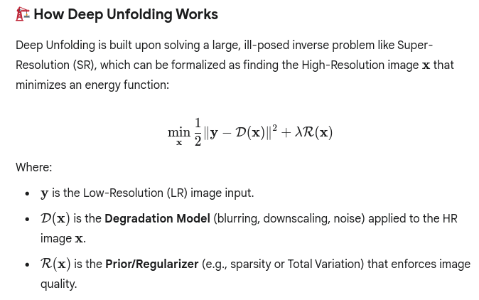

Then key stages are: iterative solver ADMM which consists of two main subproblems: data consistency step (ensures the reconstructed HR image when degraded remains faithful to the input LR Image y)
prior step (prior term) enforces image quality prior R(x)

uses DIV2K dataset in a supervised manner. trainHR image is the ground truth and the trainLR image is the input to the network. The network minimises the MSE between the final Kth layer output and the corresponding HR image

GAN is data driven, supervised. It needs a massive amount of data to learn a generalized prior. Use the entire DIV2K training set (LR, HR) paris. Rather than taking noise as input, the generator takes the LR image as input. The goal is not to create a brand new random image but to reconstruct a specific High resolution image that corresponds to the given LR Input. The LR image is the condition that guides generator to produce the correct output image content.
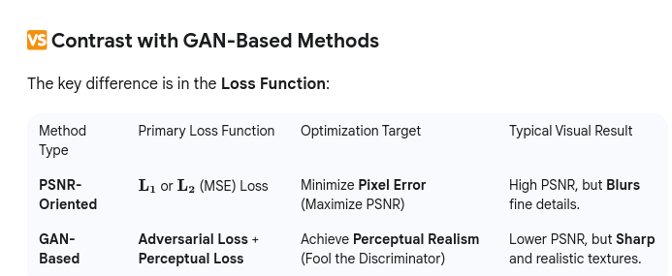

CHALLENGE – THIRD METHOD USING RELEVANT LITERATURE

REPORT STRUCTURE

1. Introduction
Describe briefly the image super-resolution task

2. Selected Methods
Justification of the selected methodologies

2.1. Method 1
Basic description with references

2.2. Method 2
Basic description with references

2.3. Optional Method 3
Basic description with references

3. Experimental Design
• Dataset and Metrics of Evaluation
dataset -
there is only one set of train data(HR images) and validation data (HR images) because the HR images are the GT content

All the LR Images (x2,x4,x8 downscaling factor) and degradation type (bicubic, realistic, mild, etc) are derived from the same 800 training HR images and 100 validation HR images)

Use the NTIRE 2018 dataset and, particularly, the Train
and Validation Track 1 – bicubic x 8

a downscaling factor of 8 reduces an images dimensions by 8

• Training

• Validation

• Qualitative and Quantitative Comparison of Methods

we can have qualitative results:
a) before applying any changes to

4. Conclusions

