**Design of fully automated low cost hydroponic system using LabVIEW and AVR microcontroller [Theory]**

<http://ieeexplore.ieee.org/document/8303091/all-figures>

**Abstract:**

The blooming development in hydroponics has demanded the need of a self-controlled automated hydroponics system. Presently there are not many tools available and the existing ones have significant shortcomings for using the real time information. In this paper, a method is proposed to effectively use the data in real time to influence the counteractive steps. The work aims to build a self-controlled automated system which will be in itself smart and intelligent by optimizing the use of present technology. The real time data will be imported from a low cost AVR microcontroller board and the NI **LabVIEW to monitor and automate the process in real time** and to send this data over the network for IoT applications. The control will be provided by the traditional PID controller tuning. The system has been rigorously tested which proves the validity of the work and is cost effectiveness in such a way that it can be successfully implemented worldwide and in the developing states of India.

**Unique functionality:**

low cost hydroponic system using LabVIEW and AVR microcontroller

self-controlled

**Advantages:**

* The whole setup was fully self-controlled and automated; no human intervention was required neither monitoring.
* The cultivation equipped with this system was rather productive than the cultivation without any automated system.
* The system has a user friendly interface, easy to control with real time data.
* The cost of the system was drastically reduced by using the microcontroller based DAQ card.
* *PID controller can be used for regulation of speed, temperature, flow, pressure and other process variables.
* 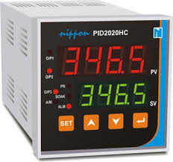

DAQ (Data acquisition involves gathering signals from measurement sources and digitizing the signals for storage, analysis, and presentation on a PC)

**Disadvantages:**

Work is on virtual environment.

Humidity and temperature

light

fan

temperature in kelvin and Celsius

temperature status

stop button

ph

Acidic pump

# Remote monitoring system for hydroponic planting media [study]

<http://ieeexplore.ieee.org/document/8288884/>

**Abstract:**

Hydroponics is a method of planting or cultivating plants without using soil but uses water, nutrients, and oxygen. It has advantages such as higher quantity and quality of production, cleaner, more efficient use of fertilizers and water, and also easier in pest and disease control. Hydroponics system requires precision, patience, and regular monitoring which is quite a challenge to conduct. Here we propose a monitoring system designed with PH sensor, Electro Conductivity Sensor, water temperature sensor, air temperature, Light Sensor, GSM / GPRS, Open Garden Shield, Open Garden Hydroponic, and Arduino Uno as main board or microcontroller. We found the results of number of leaves and plant height during the test for each plant as follows: **on the lettuce it has 6 leaves and 3.6 cm tall, for red spinach plants it has 6 leaves and 3.8 cm high, while in mustard plant pak choy, the number of leaves obtained is about 6 strands with height 4.2 cm**. Two weeks of testing on lettuce, red spinach, and mustard pak choy indicated that the sensor and the system were operating well.

**Unique functionality:**

Tested plant growth using open garden shield, open garden hydroponic and Arduino Uno

**Advantages:**

Storage of data from Arduino to the server using the help of GSM Shield, where Arduino will access API key and Feed ID from the server

**Disadvantage:**

ph sensor

electro conductivity

water temperature sensor

air temperature

light sensor

GSM / GPRS

open garden shield

arduino uno

# Hydroponics farming

<http://ieeexplore.ieee.org/document/8300782/figures>

**Abstract:\***

Agriculture is the heart of India's economic activity and our experience during the last 60 years has demonstrated the strong relationship between agricultural growth and economic wealth. The present agricultural system is a mix of outstanding achievements and missed opportunities in India. If India want to become powerful economically in the world, our agricultural productivity should be equal to those countries, which are currently rated as economic power of the world. We need a new and emerging technology which can improve continuously the productivity, profitability, quality of our major farming systems. One such technology used in India is the greenhouse technology. Although it is centuries old, it is new to India. In India, dependence on agricultural productivity and geographical conditions contribute majors to underdevelopment and poverty. These can be achieved by alternative new and latest technology of farming such as hydroponics. The goal of this project is to design and construct a hydroponic system which is fully automatic that can be integrated into the agricultural curriculum while introducing business skills.

**Unique Functionality:**

Fully automatic

solar panel for power source

**Advantages:**

Continuous power supply.

**Disadvantages:**

power source is climate dependent

arduino

solar panel

battery

temperature sensor

LDR

water /Nutrient solution level sensor

ph sensor

EC sensor

LCD

LED strip

cooling fan

water motor

GSM

Alarm and indicators

# System design and implementation automation system of expert system on hydroponics nutrients control using forward chaining method [Theory]

<http://ieeexplore.ieee.org/document/8284002/>

**Abstract:**

In this paper, **presented the design** of an embedded system that used to controlling nutrients content for hydroponics. The embedded system implanted artificial intelligence using Forward Chaining method to take the conclusion of nutrient condition. Embedded system also help users in measuring parameters needed by plant, calculate nutrient needs and the right conditions of nutrients, and determine the conclusion using forward chaining method. The embedded system developed by potential of hydrogen sensor, electrical conductivity sensor, temperature sensor and cooling fan, water pump

**Unique functionality:**

Automated Control using forward chaining (For example: If it is cold then I will wear a sweater. Here “it is cold is the data” and “I will wear a sweater” is a decision. It was already known that it is cold that is why it was decided to wear a sweater, this process is forward chaining.)

**Advantages:**

Use of forward chaining to make system intelligent

ph sensor

ec sensor

temperature sensor

cooling fan

water pump

# Control and monitoring of a stevia plantation in a hydroponic system [Study]

<http://ieeexplore.ieee.org/document/8276462/figures>

**Abstract:**

**This article presents how stevia can be grown in hydroponic crops**. A comparison of the different types of existing crops is made and the process for creating a prototype of a hydroponic greenhouse is shown. It also shows how Stevia contributes to improving the lives of diabetic people. Finally, the conclusions on the cultivation of Stevia in hydroponics are presented.

**Unique functionality:**

Study on Stevia (natural sweetener) Plantation. This is mainly due to its capacity to replace the sugar contents in food.

#### Advantages

The environmental variables can be controlled.

Irrigation systems can easily be implemented. It helps increasing the agricultural production.

It allows growing greater amounts of plants per unit area.

It offers the possibility to harvest all the year so out-of-the-season produce can be obtained.

Plants can be cultivated in regions with restrictive conditions.

Supplies and water are used more efficiently.

There is greater control of pests, weeds and diseases.

#### Disadvantages

A high initial investment.

clock module

DHT11

water pump

fan

resistors

aerator to oxygenate water

ethernet module

arduino

light bulb

# Hydroponic smart farming using cyber physical social system with telegram messenger

<http://ieeexplore.ieee.org/document/8267950/>

**Abstract:**

In the Cyber Physical Social System (CPSS), collaborative work between hydroponic farmers is now possible. With this new concept, hydroponic smart farming system that can be monitored online via Telegram Messenger is developed. The design that is created can monitor important parameters in the hydroponics system, such as light intensity, room temperature, humidity, pH, nutrient temperature, and Electrical Conductivity (EC). The prototype is designed using Raspberry Pi 3 that connects directly with sensors such as DHT11 module, LDR, pH sensor module, and EC sensor. Telegram BOT that allows to monitor sensors online via Telegram is also made. With the integration of the Physical System (Raspberry Pi, sensor) and Social System (Telegram Messenger) connected online via internet or cyber, the hydroponic system monitoring becomes more flexible.

**Unique Functionality:**

monitored online via Telegram Messenger is developed

**Advantages:**

Regular updates

**Disadvantages:**

Less Secured

Raspberry Pi 3

LDR,

DHT11,

pH,

EC,

temperature sensor modules

# Nutrient Film Technique (NFT) hydroponic monitoring system based on wireless sensor network [Study]

<http://ieeexplore.ieee.org/document/8263577/all-figures>

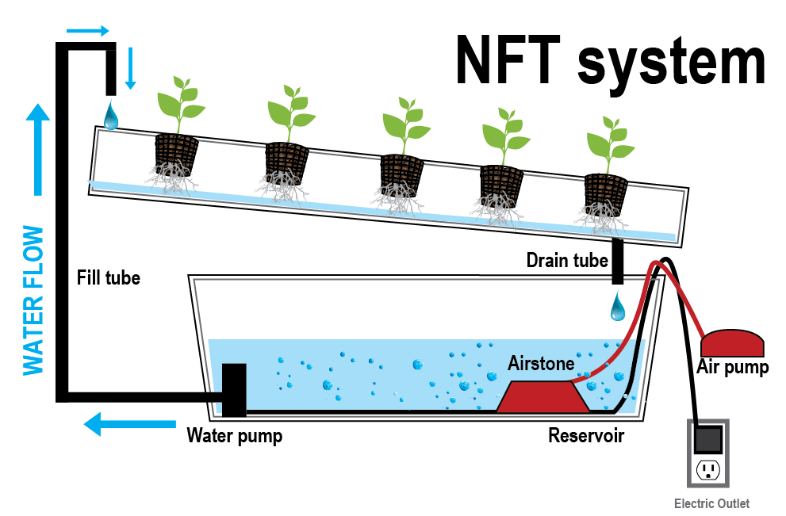

**Abstract:**

Hydroponic is one of the farming method without soil, but it uses water that contain nutrition. Nutrient solution is very important to define the successful of hydroponic cultivation. One of hydroponic technique is Nutrient Film Technique (NFT). System NFT uses nutrient solution to drain on the root area. pH level which is good for lettuce is 6.0-6.5, meanwhile the Electrical Conductivity (EC) level which is suggested is 0.8-1.2. Factor of pH and EC need to monitor 24 hours during the growth period. Hydroponic system requires wide area. However, in urban areas, the hydroponic green house can't get a wide area only in one place. This system is used to solve the problem in the real time monitoring lettuce cultivation hydroponic NFT. The method in this system contains communication, planning, modelling, construction, and socialization. The result **of experiment shows that pH sensor has an error level of difference is 0.4. There is an error of sensor Analog Electrical Conductivity Meter, that is 5.1 ms/cm.**

**Unique Functionality:**

Use of Nutrient Film technique.

Study of pH and EC sensor values (Error calculation)

**Advantages:**

Providing fresh water supply to roots through narrow stream

**Disadvantages:**

the roots will dry out if the circulation of nutrient solution is interrupted

electricity supply to the system is crucial

heavy roots in path can become obstruction

ph pro meter

DS18Bb20

HC-SR04

EC meter

servo

Gboard

xbeeS2c

SHT11

Dht11

Raspbery Pi 3

# Designing and implementing the Arduino -based nutrition feeding automation system of a prototype scaled nutrient film technique (NFT) hydroponics using total dissolved solids (TDS) sensor

<http://ieeexplore.ieee.org/document/8257697/figures>

**Abstract:**

Hydroponics is a new breakthrough in farming because it no longer uses soil as a planting medium, and uses water instead. In the hydroponic system, the fertilizer used is mixed into water, which is then referred to as hydroponic nutrition or nutrient solution. The nutrient concentration in the solution, which is then indicated by the electrical conductivity (EC), is very influential on crop production. The nutrient concentration usually mixed manually by combining the fertilizer and the water in the right amount. Therefore, through this research, a nutrition feeding automation system of a prototype scaled Nutrient Film Technique (NFT) hydroponics is prepared. The system is designed with a control center using the Arduino UNO R3 board. The system is equipped with GP2Y0A21 proximity sensor as a water level detector, TDS sensor as a detector of electrical conductivity of the nutrient solution, and servo motor as an opening device of the faucet in the nutrient container. The research resulted that the system is capable of performing water delivery automatically when the water level is less than the minimum level, and add the nutrients automatically when the nutrient solution concentration is below 800ppm.

**Unique functionality:**

Use of nutrient film technique, use of proximity sensor as water level sensor

**Advantages:**

Use of proximity sensor

Use of Nutrient film technique [fresh water supply to roots]

Use of Total dissolved solid sensor (water quality)

**Disadvantages:**

the roots will dry out if the circulation of nutrient solution is interrupted

electricity supply to the system is crucial

heavy roots in path can become obstruction

TDS Sensor

Arduino Uno R3

ProtoShield Uno R3

MG996R Servo

Faucet

NFT Hydroponic system

# A smart hydroponics farming system using exact inference in Bayesian network[Theory]

<http://ieeexplore.ieee.org/document/8229470/>

**Abstract:**

Smart farming is seen to be the future of agriculture as it produces higher quality of crops by making farms more intelligent in sensing its controlling parameters. Analyzing massive amount of data can be done by accessing and connecting various devices with the help of Internet of Things (IoT). However, it is not enough to have an Internet support and self-updating readings from the sensors but also to have a self-sustainable agricultural production with the use of analytics for the data to be useful. **This study developed a smart hydroponics system that is used in automating the growing process of the crops using exact inference in Bayesian Network (BN).** Sensors and actuators are installed in order to monitor and control the physical events such as light intensity, pH, electrical conductivity, water temperature, and relative humidity. The sensor values gathered were used to build the Bayesian Network in order to infer the optimum value for each parameter. A web interface is developed wherein the user can monitor and control the farm remotely via the Internet. Results have shown that the fluctuations in terms of the sensor values were minimized in the automatic control using BN as compared to the manual control. The yielded crop on the automatic control was 66.67% higher than the manual control which implies that the use of exact inference in BN aids in producing high-quality crops. In the future, the system can use higher data analytics and longer data gathering to improve the accuracy of inference.

**Unique Functionality:**

Connection to data analytic server (Bayesian Network).

Data sending to cloud.

Comparing sensor data between manual and automatic controls

**Advantages:**

Data analytic server can make system automation intelligent.

# Internet of things for planting in smart farm hydroponics style

[**http://ieeexplore.ieee.org/document/7859872/**](http://ieeexplore.ieee.org/document/7859872/)

**Abstract:**

Recently, the farmers gain more profits by producing the quality product. The effects of the global warming make more difficult planning in uncontrolled environment. On the other hand, the yield does not match customers' needs. For these reasons, planting in a greenhouse is easy to maintain and to control important factors such as light, temperature, and humidity. Using of sensors coming in a greenhouse as Wireless Sensor Networks System are one efficiency of technology used in agricultural development by sending data to the cloud and controlling values such as temperature, light, etc. The results of this study will be useful for the farmer and related organizations applying in the farm.

**Unique Functionality:**

Built for Green House Environment

Data sending to cloud.

**Advantages:**

Dedicated wireless sensor network.

**Disadvantages:**

Network Security

# Integrating scheduled hydroponic system

# [study]

[**http://ieeexplore.ieee.org/document/7887976/**](http://ieeexplore.ieee.org/document/7887976/)

**Abstract:**

Cultivation, adding up to an important aspect in GDP (Gross Domestic Produce), has been affected tremendously over the past few decades due to the use of chemicals. Due to rapid urbanization and industrialization, arable land under cultivation is decreasing enormously. Organic farming, being the need of the hour, is opted as one of the widely chosen methodology to overcome the prevailing problem in cultivation. Advancements in agriculture have proven to serve the cultivators in a number of ways. Cultivation of crops is being done at home, which consumes limited amount of space and cost. To bring in another technological advancement by breaking all barriers, for organic farming is the Hydroponics where consumption of space and water are way too minimal. Hydroponics is a method of growing plants purely using water and nutrients, without soil. The proposed hydroponic system is built upon the concepts of embedded system. The system facilitates the growth of multiple crops under a single controller. Necessary supplements for the crops are provided based on the inputs obtained from the pH sensor and the water level sensor used. The water and nutrient supply to the different varieties of crop is controlled and monitored at regular time intervals. **An efficient algorithm has been proposed for controlling all the functionalities**. Automation of the hydroponic system improves the efficiency and reduces manual work.

**Unique functionality:**

Use of efficient algorithm

**Advantages:**

Reduced manual work.

Automated System.

**Disadvantage:**

High Initial Investment required

Regular power supply needed

# DIY sensor-based automatic control mobile application for hydroponics

<http://ieeexplore.ieee.org/document/7519235/>

**Abstract:**

Hydroponics is a new popular technique of growing plants, especially in urban area, due to its many advantages over traditional soil based gardening. To apply affordable technology for managing and controlling hydroponics gardening, we developed a DIY sensor-based automatic control mobile application for hydroponics. The application enables automatic environmental control for hydroponics via different types of sensors including water temperature sensor, temperature and humidity sensor, and light intensity sensor. It also consists of the functions for planning, managing, as well as harvest data recording, of hydroponic gardening to fulfill the planting demands. The harvest data will be used for hydroponics planning in the next grow. In addition, users can monitor the plant growing progress remotely.

**Unique Functionality:**

Sensors Data Streaming to android app

Push Notification alert.

Camera streaming.

**Advantages:**

Live view of farm field.

Push Notification as alert

Use of Fan to control environment

**Disadvantages:**

Regular need for cloud service

camera streaming requires High Speed Internet Connection.

High cost for Initial setup

Raspberry Pi 2

Raspberry Pi camera

Relay

LED

FAN

Push Notification

Environment log

Mobile device

DHT22

BH1750FVI

DS18B20