OBJECT ORIENTED PROGRAMMING IN C PLUS PLUS MINI PROJECT REPORT
Campus Library Management System
Object-oriented case study and implementation in C Plus Plus 17

Submitted by | Ashutosh Kumar
UID | 25BCD10255
Section | 25BCD2'B'
Subject | Object Oriented Programming in C Plus Plus
Academic year | 2026–2027

Submitted for academic evaluation

1 Introduction
A campus library must keep track of different kinds of reading material and whether each item is available or issued. When records are maintained informally, a librarian may not know whether an item is already on loan, may accidentally assign the same identifier twice, or may lose status changes between sessions. This project models the catalogue as C++ objects and saves the records in a local text file.
The case study uses books and magazines as related item types. Both share identity, title, and availability, while each has its own detail: a book has an author and a magazine has an issue number. A menu-driven C++17 program supports adding, listing, issuing, and returning items. The focus is to show how OOP concepts organize a small application and make extension points explicit.

Case study context and system boundary
The user is a single librarian operating the program on one computer. The Library object owns the catalogue, validates operations, and persists records in library_data.txt. The current scope intentionally excludes borrower accounts, due dates, fines, reservations, and a multi-user database. These exclusions keep the implementation focused on object modeling and file handling.
Stakeholder / concern | Project response
Librarian | Uses a menu to add, list, issue, and return catalogue items.
Catalogue item | Has a positive unique ID, a title, a type, type-specific data, and availability.
Persistence | Each item is serialized to a pipe-separated line and reloaded at startup.
Reliability | Rejects duplicate IDs and invalid issue/return transitions; reports input errors.
Growth | A new item category can derive from LibraryItem and implement its virtual interface.

2 Objectives and Problem Statement

Problem statement
A small campus library needs a simple catalogue that distinguishes item types while applying the same operations to all items. Duplicating the common item fields and display logic in separate book and magazine code would make changes harder to maintain. The project therefore needs a shared abstraction, type-specific implementations, controlled state changes, and a basic persistence mechanism.

Objectives
- Represent the shared state of library items in a base class and specialize books and magazines through inheritance.
- Demonstrate encapsulation, abstraction, runtime polymorphism, composition, constructors, destructors, and exception handling.
- Add, list, issue, and return items while validating IDs and state transitions.
- Persist catalogue state to a text file and restore it when the program starts.
- Provide a reproducible console demonstration and explain how the class structure addresses the case study.

Requirements and assumptions
Type | Requirement / assumption
Functional | Add books and magazines; list catalogue; issue an available item; return an issued item; save and exit.
Data validation | Item IDs and issue numbers must be positive; IDs must be unique; title and author must be present.
Operational | C++17 compiler; one local user; library_data.txt is read/written in the process working directory.
Persistence format | Each line stores a type marker, ID, title, type-specific detail, and availability separated by vertical bars.

3 Modules, Tools, and Technologies

Application modules
Module | Responsibility
LibraryItem abstraction | Stores shared ID, title, and availability; exposes controlled access; defines the polymorphic item interface.
Book and Magazine | Provide type-specific data and override display-related and serialization behavior.
Library catalogue | Owns item objects, finds IDs, validates operations, loads records, and saves changes.
Menu and input | Reads choices and fields, handles invalid numeric input, and presents operation messages.
Persistence | Serializes each item to library_data.txt and reconstructs the correct derived type at startup.

Tools and technologies
- C++17 for classes, inheritance, virtual functions, smart pointers, exceptions, and standard containers.
- The C++ Standard Library: vector, memory, string, fstream, sstream, iostream, iomanip, and stdexcept.
- A C++ compiler such as g++ or clang++; VS Code or another editor; Terminal for compilation and execution.
- Optional browser dashboard files are included in the repository and share the same text data file through a local Python 3 server; the core OOP program runs independently in the terminal.

Object model and class relationships
LibraryItem is an abstract base class. Its private fields keep identity and availability inside the object, while public accessors and setAvailable provide controlled interaction. Pure virtual functions require every concrete item type to supply its type, extra detail, and serialization format. Book and Magazine inherit this common contract. Library stores unique_ptr<LibraryItem> objects in a vector, so it owns their lifetime and can call virtual functions without knowing each concrete type at every call site.
LibraryItem (abstract)
id, title, availability [private]
type() / extra() / serialize() [virtual]
△ △
│ │
Book Magazine
author [private] issue [private]
\ /
Library owns vector<unique_ptr<LibraryItem>>

OOP concepts applied to this case
Concept | Use in the implementation | Why it helps
Class and object | LibraryItem, Book, Magazine, and Library define types; each catalogue entry is an object. | Turns real catalogue entities and operations into program structures.
Encapsulation | LibraryItem keeps ID, title, and availability private; Library methods control issue/return. | Prevents unrelated code from directly changing item state.
Abstraction | LibraryItem has pure virtual type, extra, and serialize methods. | Defines what every item must provide without specifying all details.
Inheritance | Book and Magazine extend LibraryItem with author or issue number. | Shares common behavior while retaining type-specific data.
Polymorphism | A base-class pointer invokes derived overrides such as display details and serialization. | Allows one catalogue loop to process different item types.
Composition | Library owns a vector of unique_ptr<LibraryItem>. | The catalogue controls the lifetime and grouping of its items.
Constructor / destructor | Constructors initialize fields; virtual destructor supports safe cleanup through base pointers. | Ensures objects begin in a valid state and derived resources are destroyed safely.
Exception handling | Invalid or duplicate operations throw standard exceptions caught by the menu. | Reports errors without terminating the whole menu loop.
File handling | load() reconstructs objects; save() serializes them to disk. | Keeps catalogue changes after program exit.

Data design and operation flow
Each record is represented as TYPE|ID|TITLE|DETAIL|AVAILABLE. The first field B or M selects the concrete type during loading. The final value is 1 for available or 0 for issued. The vertical bar is a delimiter, so titles and author names should not contain that character. A successful change is saved immediately; selecting exit saves once more.
Start → Library constructor loads file → show menu → validate input
→ call catalogue operation → update object state → save file → repeat

4 Code with Outputs
Compile from the project folder with g++ -std=c++17 -Wall -Wextra -pedantic LibraryManagementSystem.cpp -o library and run ./library. On Windows, build library.exe and run .\library.exe. The sample below adds a book and magazine, lists them, issues the book, then displays the updated status.
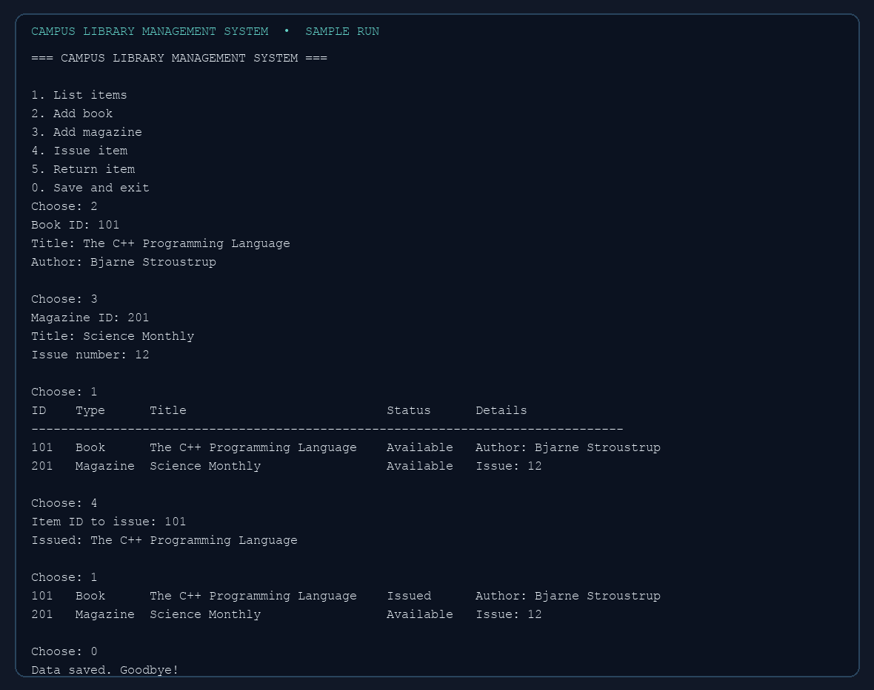
Figure 1. Console output from the checked-in sample session.

How the sample demonstrates the design
- The add operations construct Book and Magazine objects after validating their fields and unique IDs.
- Listing uses the base pointer collection; each object supplies its own type-specific details through virtual behavior.
- Issuing book 101 changes its availability through the Library operation and persists the new value.
- On the next launch, load() reads the stored marker and reconstructs the correct object with its prior availability.

Limitations and possible extensions
The application is intentionally a local single-user catalogue. It does not associate an issue with a borrower, calculate due dates or fines, or prevent simultaneous edits from multiple processes. The flat-file format is easy to inspect but has delimiter limitations and no transactional guarantees. Future work could add member and loan classes, due dates, search, input escaping, a database backend, and a role-aware dashboard.

5 Conclusion
The Campus Library Management System turns a small catalogue problem into a clear object-oriented design. Shared fields and operations live in an abstract base class, concrete item types supply specialized data, and the Library class composes and manages them. The runnable program demonstrates encapsulation, abstraction, inheritance, polymorphism, composition, exception handling, and persistence, while the sample output shows the state changes a user can observe.

References
- Bjarne Stroustrup, Programming: Principles and Practice Using C++, Addison-Wesley.
- cppreference.com, C++ language and standard library reference, https://en.cppreference.com/
- ISO C++ Core Guidelines, https://isocpp.github.io/CppCoreGuidelines/CppCoreGuidelines

Appendix A C++ Source Code
The complete source is supplied separately as LibraryManagementSystem.cpp and reproduced below for the hard-copy report.
#include <iostream>
#include <fstream>
#include <sstream>
#include <vector>
#include <memory>
#include <iomanip>
#include <limits>
#include <stdexcept>
#include <utility>
// Library Management System: demonstrates encapsulation, inheritance,
// abstraction, runtime polymorphism, composition, and file handling.
class LibraryItem {
private:
int id_;
std::string title_;
bool available_;
public:
LibraryItem(int id, std::string title, bool available = true)
: id_(id), title_(std::move(title)), available_(available) {}
virtual ~LibraryItem() = default;
int id() const { return id_; }
const std::string& title() const { return title_; }
bool available() const { return available_; }
void setAvailable(bool value) { available_ = value; }
virtual std::string type() const = 0; // abstract interface
virtual std::string extra() const = 0;
virtual std::string serialize() const = 0;
virtual void display() const {
std::cout << std::left << std::setw(6) << id_ << std::setw(10) << type()
<< std::setw(32) << title_ << (available_ ? "Available" : "Issued")
<< " " << extra() << '\n';
}
};
class Book : public LibraryItem {
std::string author_;
public:
Book(int id, std::string title, std::string author, bool available = true)
: LibraryItem(id, std::move(title), available), author_(std::move(author)) {}
std::string type() const override { return "Book"; }
std::string extra() const override { return "Author: " + author_; }
std::string serialize() const override {
return "B|" + std::to_string(id()) + "|" + title() + "|" + author_ + "|" + (available() ? "1" : "0");
}
};
class Magazine : public LibraryItem {
int issue_;
public:
Magazine(int id, std::string title, int issue, bool available = true)
: LibraryItem(id, std::move(title), available), issue_(issue) {}
std::string type() const override { return "Magazine"; }
std::string extra() const override { return "Issue: " + std::to_string(issue_); }
std::string serialize() const override {
return "M|" + std::to_string(id()) + "|" + title() + "|" + std::to_string(issue_) + "|" + (available() ? "1" : "0");
}
};
class Library {
std::vector<std::unique_ptr<LibraryItem>> items_; // composition
const std::string dataFile_ = "library_data.txt";
LibraryItem* find(int id) const {
for (const auto& item : items_) if (item->id() == id) return item.get();
return nullptr;
}
static std::vector<std::string> split(const std::string& line) {
std::vector<std::string> fields; std::stringstream ss(line); std::string part;
while (std::getline(ss, part, '|')) fields.push_back(part);
return fields;
}
public:
Library() { load(); }
void load() {
std::ifstream in(dataFile_); if (!in) return;
std::string line;
while (std::getline(in, line)) {
try {
auto f = split(line); if (f.size() != 5) continue;
int id = std::stoi(f[1]); bool available = (f[4] == "1");
if (f[0] == "B") items_.push_back(std::make_unique<Book>(id, f[2], f[3], available));
else if (f[0] == "M") items_.push_back(std::make_unique<Magazine>(id, f[2], std::stoi(f[3]), available));
} catch (...) { /* Ignore malformed records and continue loading. */ }
}
}
void save() const {
std::ofstream out(dataFile_);
if (!out) throw std::runtime_error("Could not write library_data.txt");
for (const auto& item : items_) out << item->serialize() << '\n';
}
void addBook(int id, const std::string& title, const std::string& author) {
if (id <= 0 || title.empty() || author.empty()) throw std::invalid_argument("ID, title and author are required; ID must be positive.");
if (find(id)) throw std::invalid_argument("An item with that ID already exists.");
items_.push_back(std::make_unique<Book>(id, title, author)); save();
}
void addMagazine(int id, const std::string& title, int issue) {
if (id <= 0 || title.empty() || issue <= 0) throw std::invalid_argument("Positive ID and issue number and a title are required.");
if (find(id)) throw std::invalid_argument("An item with that ID already exists.");
items_.push_back(std::make_unique<Magazine>(id, title, issue)); save();
}
void list() const {
if (items_.empty()) { std::cout << "No items in the library yet.\n"; return; }
std::cout << std::left << std::setw(6) << "ID" << std::setw(10) << "Type" << std::setw(32) << "Title" << "Status Details\n";
std::cout << std::string(80, '-') << '\n';
for (const auto& item : items_) item->display(); // virtual call
}
void issue(int id) {
auto* item = find(id); if (!item) throw std::invalid_argument("Item ID not found.");
if (!item->available()) throw std::invalid_argument("That item is already issued.");
item->setAvailable(false); save(); std::cout << "Issued: " << item->title() << '\n';
}
void returnItem(int id) {
auto* item = find(id); if (!item) throw std::invalid_argument("Item ID not found.");
if (item->available()) throw std::invalid_argument("That item is already available.");
item->setAvailable(true); save(); std::cout << "Returned: " << item->title() << '\n';
}
};
int readInt(const std::string& prompt) {
int value;
while (true) {
std::cout << prompt;
if (std::cin >> value) { std::cin.ignore(std::numeric_limits<std::streamsize>::max(), '\n'); return value; }
std::cout << "Please enter a whole number.\n";
std::cin.clear(); std::cin.ignore(std::numeric_limits<std::streamsize>::max(), '\n');
}
}
std::string readText(const std::string& prompt) {
std::string text; std::cout << prompt; std::getline(std::cin, text); return text;
}
int main() {
Library library;
std::cout << "=== CAMPUS LIBRARY MANAGEMENT SYSTEM ===\n";
while (true) {
std::cout << "\n1. List items\n2. Add book\n3. Add magazine\n4. Issue item\n5. Return item\n0. Save and exit\n";
int choice = readInt("Choose: ");
try {
if (choice == 0) { library.save(); std::cout << "Data saved. Goodbye!\n"; break; }
else if (choice == 1) library.list();
else if (choice == 2) {
int id = readInt("Book ID: ");
std::string title = readText("Title: ");
std::string author = readText("Author: ");
library.addBook(id, title, author);
} else if (choice == 3) {
int id = readInt("Magazine ID: ");
std::string title = readText("Title: ");
int issue = readInt("Issue number: ");
library.addMagazine(id, title, issue);
}
else if (choice == 4) library.issue(readInt("Item ID to issue: "));
else if (choice == 5) library.returnItem(readInt("Item ID to return: "));
else std::cout << "Choose one of the listed options.\n";
} catch (const std::exception& e) { std::cout << "Error: " << e.what() << '\n'; }
}
return 0;
}

