Mini Project
Case Study: Air Quality Analysis
Air pollution across Indian cities, 2015 to 2020
Python: Pandas, NumPy, Matplotlib, Seaborn, SciPy, scikit-learn
Name: ____________________________
Roll No.: ________________________
Course / Section: _________________
Submission date: ____________________

1. Problem Statement
Air pollution is a serious public-health problem in India. To reduce it, we first need to understand where and when it is worst, which pollutants drive it, and whether it is changing over time.
This case study investigates: How do air pollutants vary over time and across cities? The analysis covers AQI trends, pollutant correlation and seasonal analysis. Three extra questions are also examined: did the 2020 COVID-19 lockdown change PM2.5 levels, are seasonal differences statistically significant, and can tomorrow's PM2.5 be predicted?

2. Dataset Description
Dataset: "Air Quality Data in India (2015 - 2020)" (file city_day.csv), published on Kaggle by Rohan Rao and compiled from Central Pollution Control Board (CPCB) monitoring records. It contains one row per city per day: 29,531 records and 16 columns, covering 26 cities from 2015-01-01 to 2020-07-01.
Column | Type | Description
City, Date | Text, Date | Monitoring city and day
PM2.5, PM10 | Numeric | Fine and coarse particulate matter (µg/m³)
NO, NO2, NOx, NH3 | Numeric | Nitrogen compounds and ammonia (µg/m³)
CO | Numeric | Carbon monoxide (mg/m³)
SO2, O3 | Numeric | Sulphur dioxide and ozone (µg/m³)
Benzene, Toluene, Xylene | Numeric | Volatile organic compounds (µg/m³)
AQI | Numeric | Air Quality Index for the day
AQI_Bucket | Categorical | Good, Satisfactory, Moderate, Poor, Very Poor, Severe

Columns added during analysis: Year, Month, Season (Winter Dec-Feb, Summer Mar-May, Monsoon Jun-Sep, Post-monsoon Oct-Nov).

3. Data Cleaning Using Pandas
Issue | Found in raw data | Fix applied
Missing values | Highest: Xylene 61.3%, PM10 37.7%, NH3 35.0%, Toluene 27.2%, Benzene 19.0% | Short gaps (up to 7 days) filled by interpolation within each city (PM2.5: 737 values filled). Longer gaps left empty and ignored by each calculation.
Duplicate records | 0 repeated city-date rows | drop_duplicates() on City and Date
Incorrect data types | Date stored as text (0 unreadable dates) | pd.to_datetime() and pd.to_numeric()
Inconsistent values | AQI_Bucket text with stray spaces or different capitalisation; missing buckets | strip() and title-case; 0 missing buckets rebuilt from the AQI value using official bands
Impossible values | None found | Negative readings set to missing. High spikes were kept because they are real pollution events.

After cleaning: 29,531 rows. The cleaned file is saved as data/city_day_clean.csv.
Code excerpt:
df["Date"] = pd.to_datetime(df["Date"], errors="coerce")
df = df.drop_duplicates(subset=["City", "Date"])
df.loc[df[c] < 0, c] = np.nan
df[c] = df.groupby("City")[c].transform(lambda s: s.interpolate(limit=7, limit_area="inside"))

4. Data Analysis Using NumPy & Pandas

4.1 Mean, median and standard deviation
Variable | Mean | Median | Std. dev.
PM2.5 | 67.35 | 48.34 | 65.16
PM10 | 118.37 | 95.63 | 91.44
NO2 | 28.22 | 21.35 | 24.39
SO2 | 15.0 | 9.21 | 19.24
CO | 2.23 | 0.89 | 6.91
O3 | 34.3 | 30.61 | 21.74
AQI | 166.46 | 118.0 | 140.7

Using NumPy directly, mean PM2.5 is 67.35 µg/m³ with a standard deviation of 65.16. The standard deviation is large compared with the mean, which shows that pollution levels swing widely from day to day.

4.2 Grouping and aggregation
Cities with at least a year of AQI records were ranked by mean AQI (19 cities qualify). The ten highest:
City | Mean AQI | Days of data
Ahmedabad | 452.1 | 1,334
Delhi | 259.5 | 1,999
Patna | 240.8 | 1,459
Gurugram | 225.1 | 1,453
Lucknow | 218.0 | 1,893
Talcher | 172.9 | 698
Jorapokhar | 159.3 | 771
Brajrajnagar | 150.3 | 713
Kolkata | 140.6 | 754
Guwahati | 140.1 | 495

Mean PM2.5 by season:
Season | Mean PM2.5 | Median PM2.5
Winter | 100.1 | 74.6
Summer | 56.6 | 44.3
Monsoon | 38.7 | 30.9
Post-monsoon | 91.7 | 67.7

Yearly PM2.5 (average of city means; each city-year needs at least 100 days of data):
Year | Mean PM2.5 | Cities included
2015 | 75.1 | 6
2016 | 88.1 | 9
2017 | 83.8 | 11
2018 | 67.9 | 17
2019 | 57.6 | 23
2020 | 43.7 | 26

4.3 Sorting and filtering
Sorting by mean AQI gives Ahmedabad (452.1) as the most polluted city and Thiruvananthapuram (75.9) as the cleanest. Filtering for days rated Poor, Very Poor or Severe shows they make up 26.0% of all records; the city with the largest share is Ahmedabad (81.9% of its days).
AQI category | City-days | Share (%)
Good | 1,341 | 5.4
Satisfactory | 8,224 | 33.1
Moderate | 8,829 | 35.5
Poor | 2,781 | 11.2
Very Poor | 2,337 | 9.4
Severe | 1,338 | 5.4

4.4 Correlation
Correlation of each pollutant with AQI (Pearson, using available data):
Pollutant | Correlation with AQI
PM10 | 0.8
CO | 0.68
PM2.5 | 0.66
NO2 | 0.54
SO2 | 0.49
NOx | 0.48
NO | 0.44
Toluene | 0.28
NH3 | 0.25
O3 | 0.2
Xylene | 0.13
Benzene | 0.04

The strongest pair of pollutants is PM2.5 and PM10 (r = 0.83). PM2.5 and PM10 have a Spearman correlation of 0.873.

4.5 Statistical tests
Test | Result | p-value
Kruskal-Wallis: PM2.5 across four seasons | H = 6423.9 | < 0.001
Spearman: PM2.5 vs PM10 | rho = 0.873 | < 0.001
Wilcoxon signed-rank: city PM2.5, lockdown window 2019 vs 2020 (19 cities) | 55.0 to 33.9 (-38.3%) | < 0.001

A p-value below 0.05 is conventionally treated as statistically significant. Non-parametric tests were used because pollution data is heavily skewed, not normally distributed.

4.6 Prediction model
A random forest regression model predicts the next day's PM2.5 using today's PM2.5, PM10, NO2, CO, O3 and the month. Rows up to 2020-01-23 were used for training (14,154 rows) and later rows for testing (3,532 rows), so the model is judged on dates it has never seen.
Model | R² | MAE (µg/m³)
Baseline: tomorrow = today | 0.742 | 8.81
Random forest | 0.726 | 9.57

Feature importance: PM2.5 0.909, PM10 0.027, NO2 0.021, CO 0.017, O3 0.017, Month 0.009.

5. Data Visualization

5.1 Matplotlib
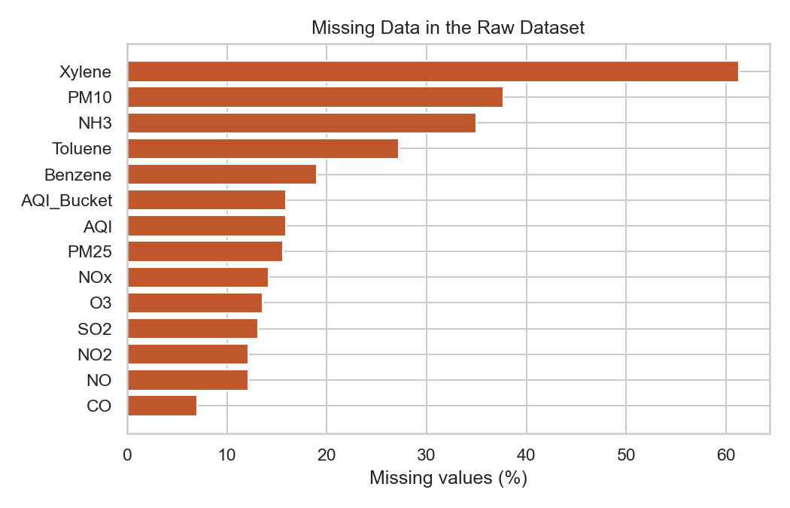
Figure 1: Bar chart: percentage of missing values per column in the raw data
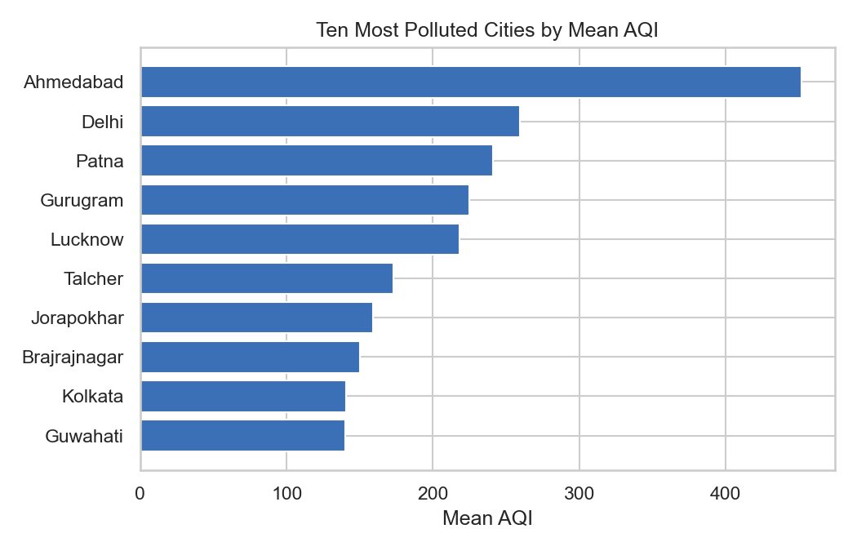
Figure 2: Bar chart: ten cities with the highest mean AQI
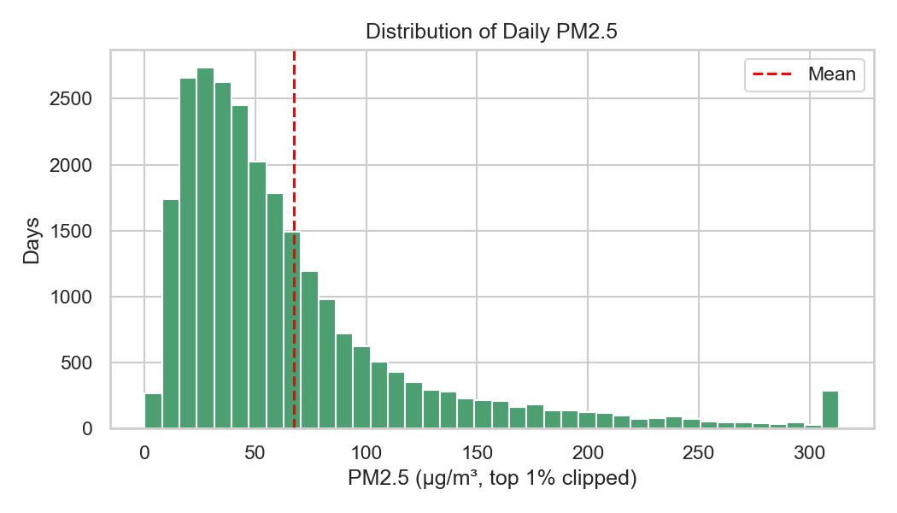
Figure 3: Histogram: distribution of daily PM2.5 readings
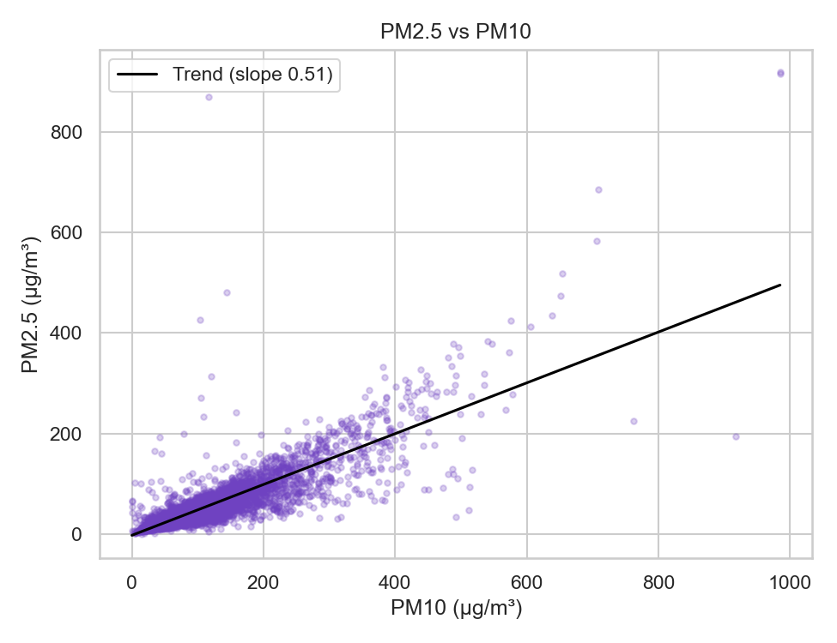
Figure 4: Scatter plot with trend line: PM2.5 against PM10
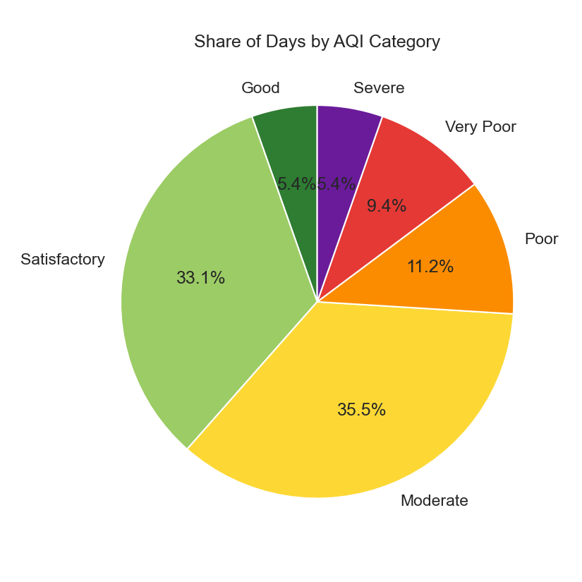
Figure 5: Pie chart: share of city-days in each AQI category
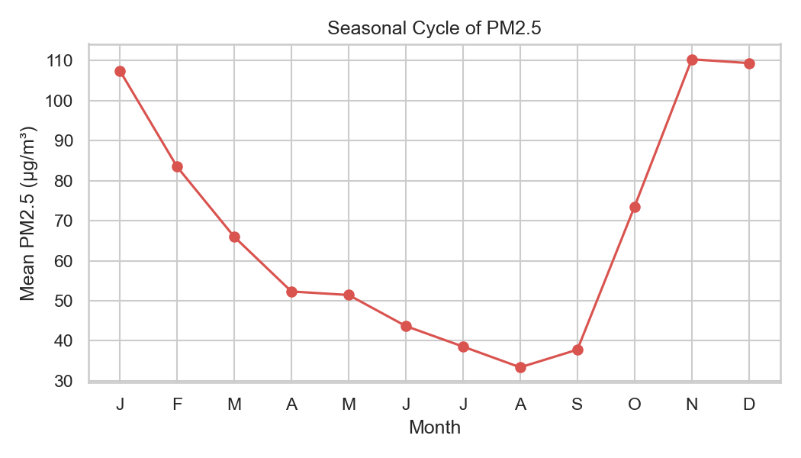
Figure 6: Line chart: mean PM2.5 by calendar month (all cities)
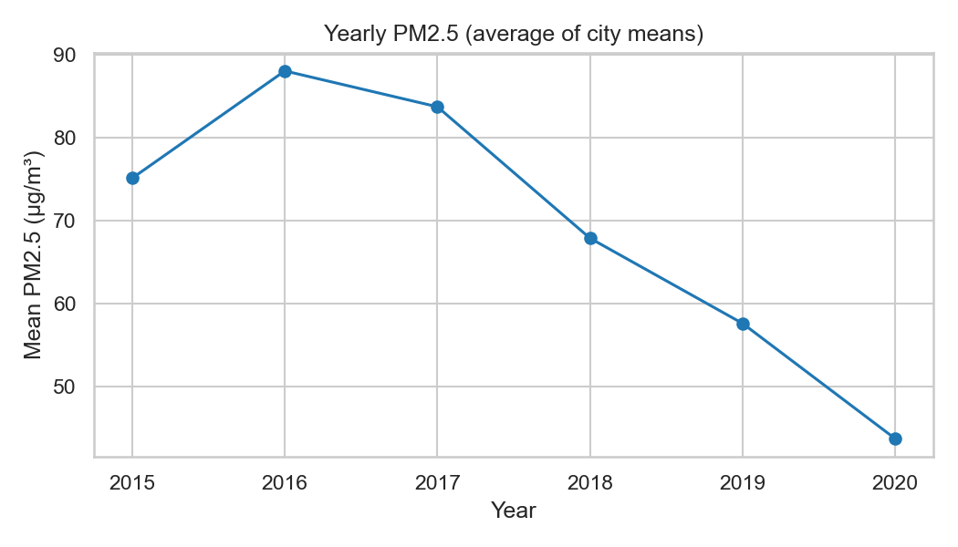
Figure 7: Line chart: yearly mean PM2.5 (2020 covers only part of the year)

5.2 Seaborn
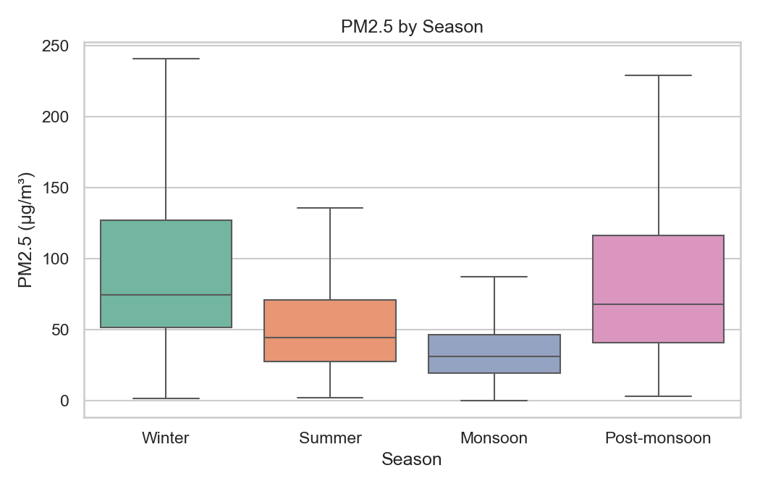
Figure 8: Box plot: PM2.5 by season (outliers hidden for readability)
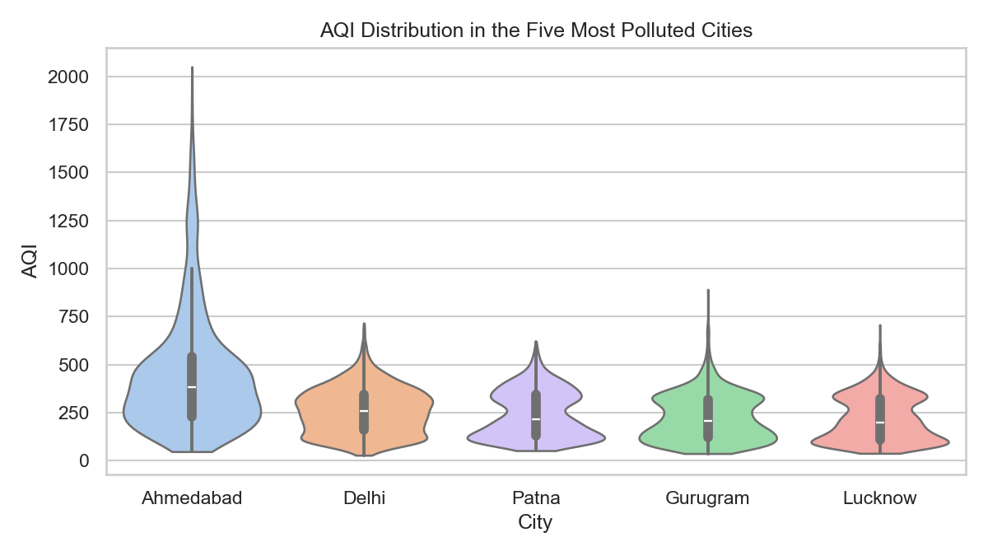
Figure 9: Violin plot: AQI distribution in the five most polluted cities
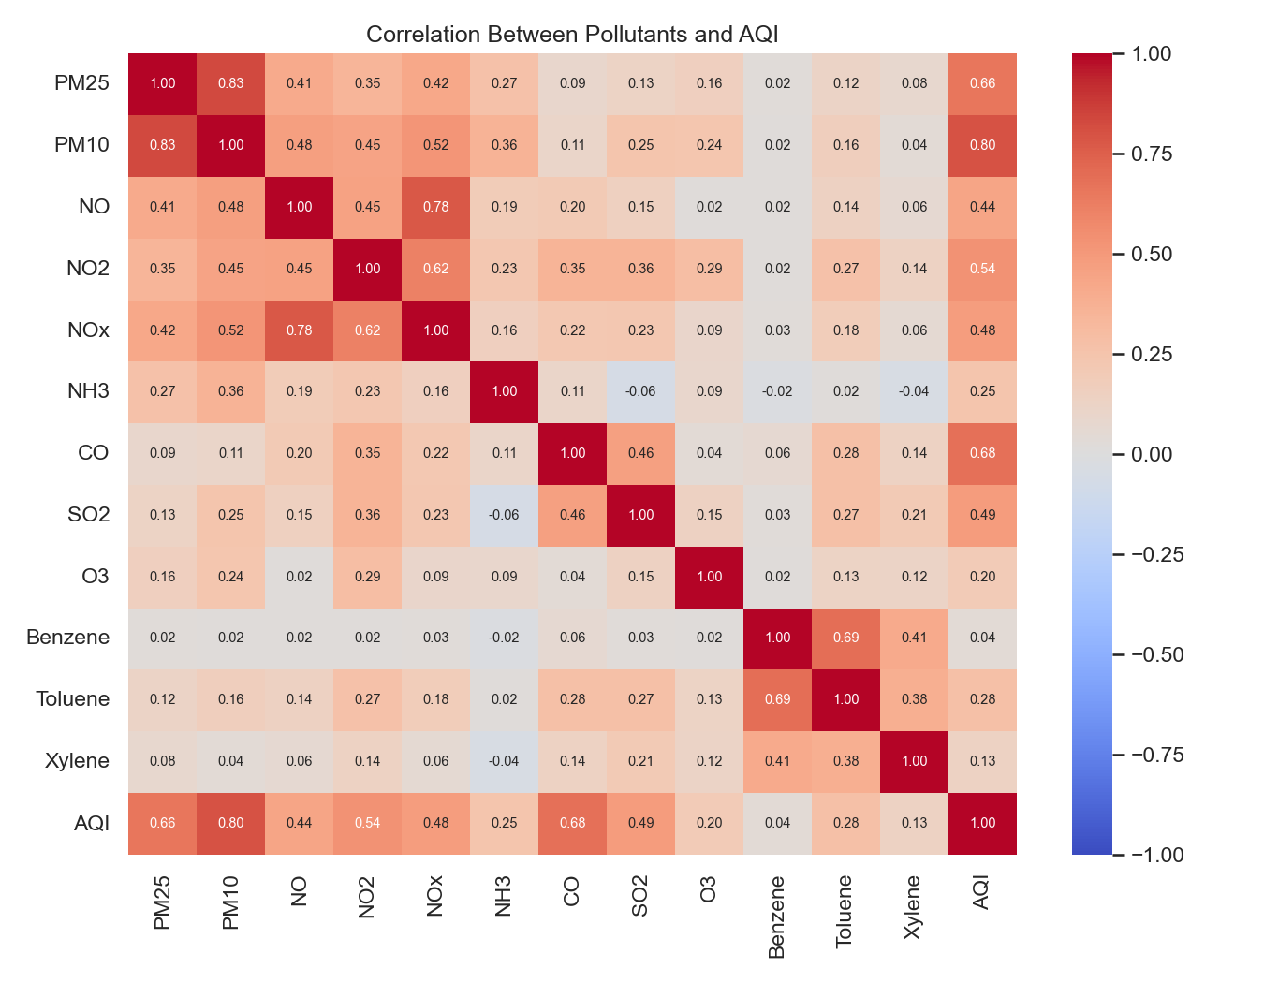
Figure 10: Heatmap: correlation matrix of pollutants and AQI
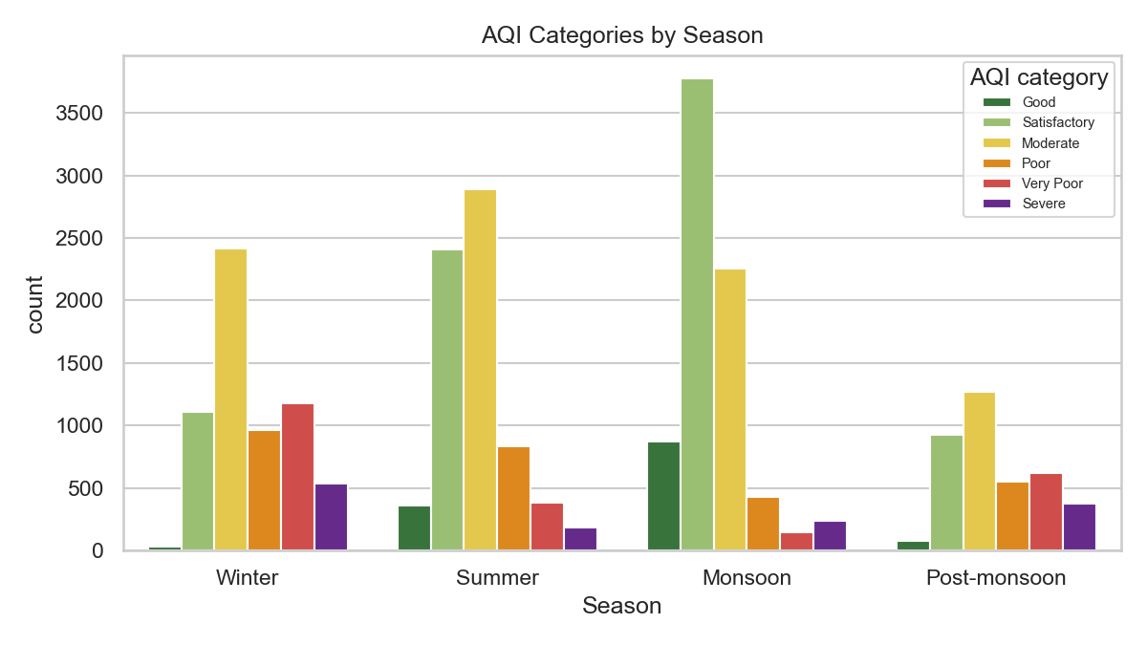
Figure 11: Count plot: number of days in each AQI category, by season
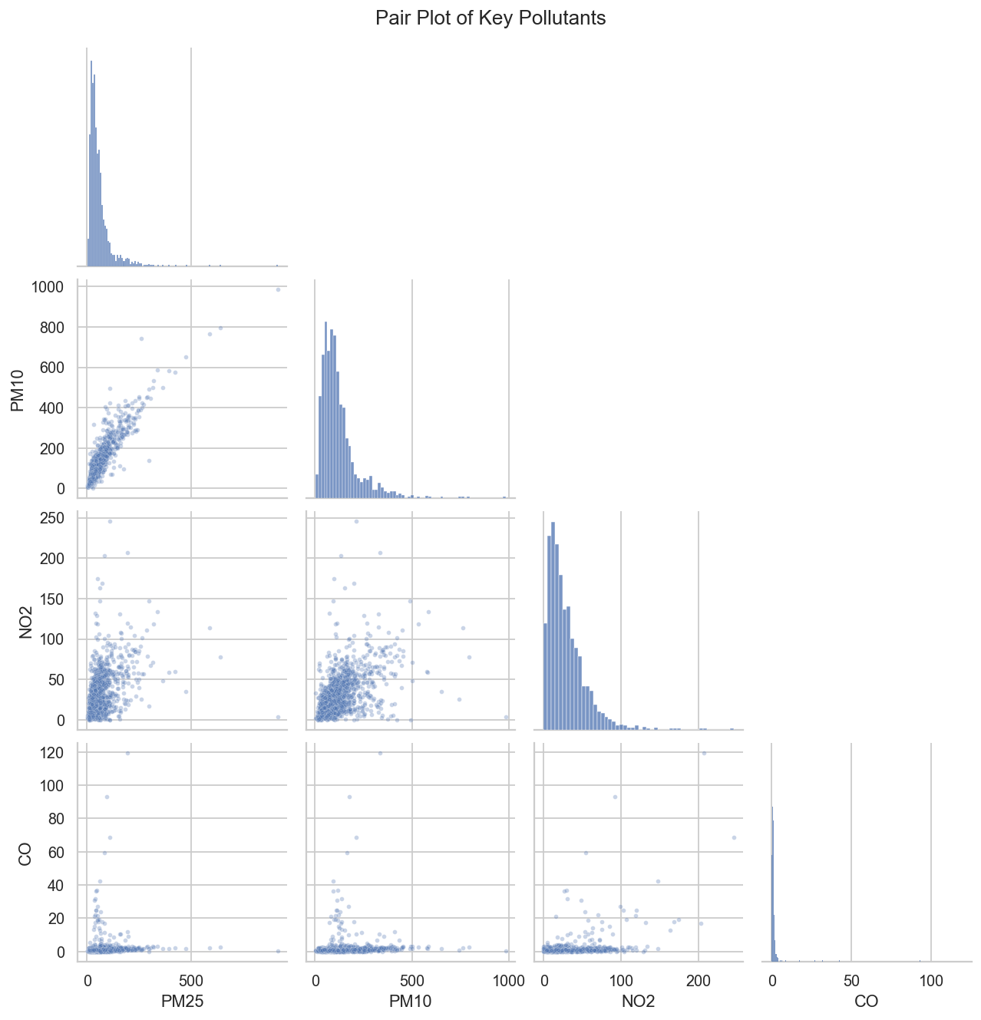
Figure 12: Pair plot: PM2.5, PM10, NO2 and CO
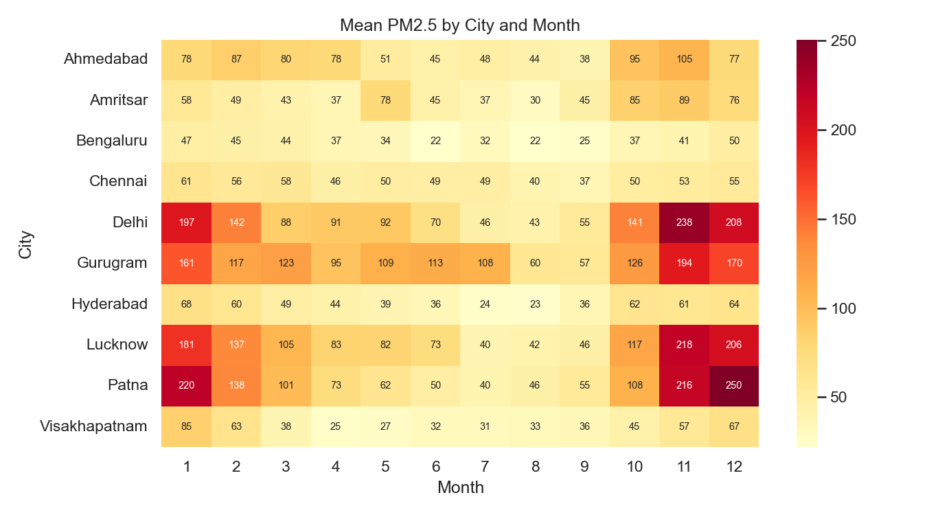
Figure 13: Heatmap: mean PM2.5 by city and month (ten cities with most data)

5.3 Lockdown and model charts
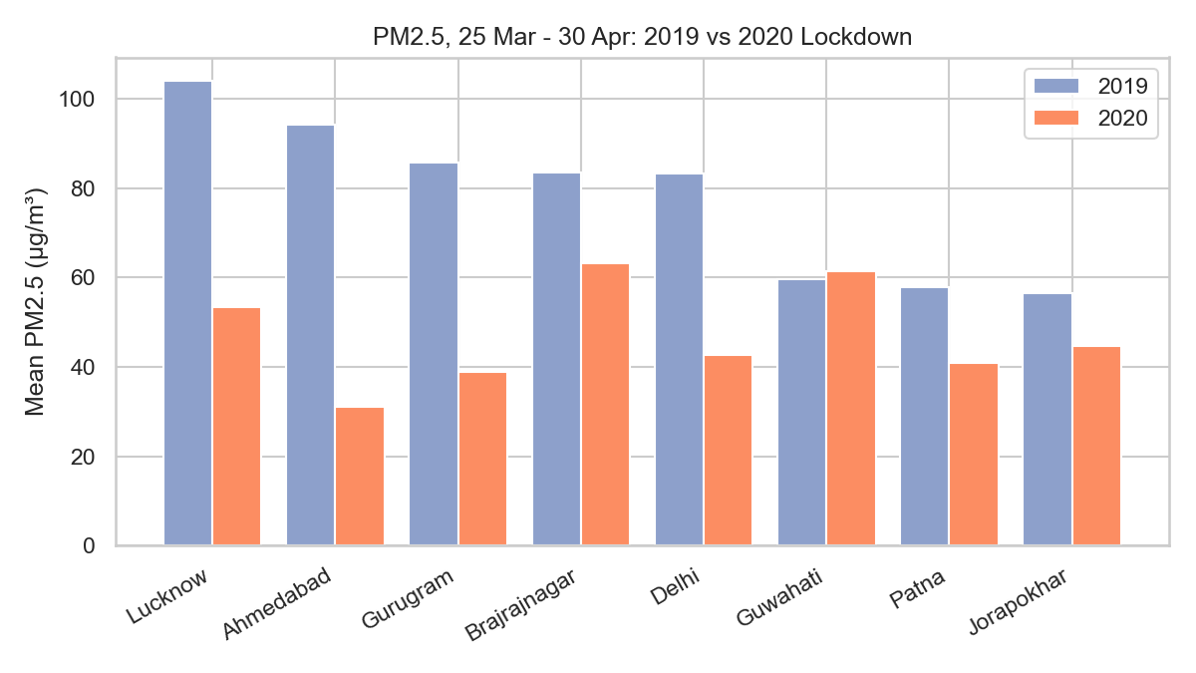
Figure 14: Grouped bar chart: PM2.5 in the lockdown window, 2019 vs 2020
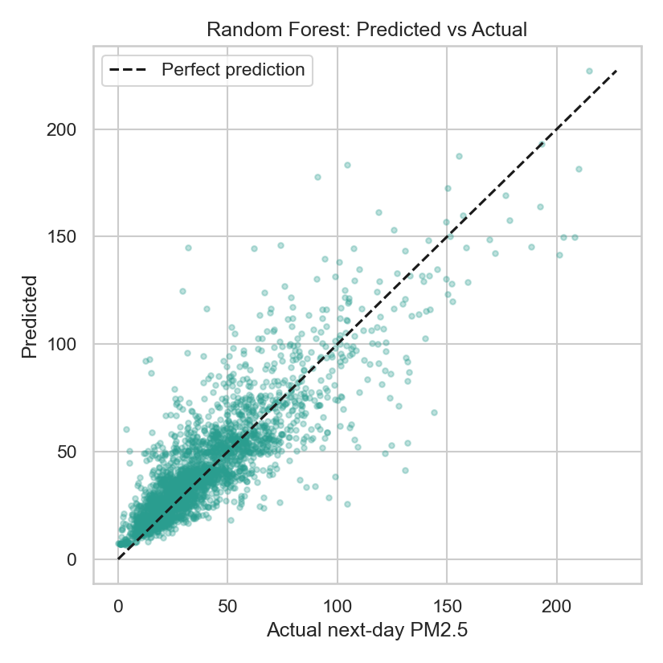
Figure 15: Scatter plot: predicted against actual next-day PM2.5 on the test set

6. Findings
- 26.0% of all city-days fall in the Poor, Very Poor or Severe AQI categories, while only 5.4% are rated Good.
- Ahmedabad has the highest mean AQI (452.1) among the 19 cities with at least a year of data, while Thiruvananthapuram has the lowest (75.9). Ahmedabad has the largest share of Poor-or-worse days (81.9%).
- Pollution varies with the season: mean PM2.5 is highest in Winter and lowest in Monsoon, a 2.58x difference. The worst month on average is November and the best is August.
- The seasonal difference is statistically significant (Kruskal-Wallis H = 6423.9, p < 0.001).
- AQI is most strongly correlated with PM10 (r = 0.8), followed by CO (r = 0.68) and PM2.5 (r = 0.66).
- PM2.5 and PM10 move together (Spearman rho = 0.873), and the median PM2.5 reading is about 47% of the PM10 reading on the same day.
- Average PM2.5 across cities was 75.1 µg/m³ in 2015 and 43.7 µg/m³ in 2020 (the final year is partial). The number of reporting cities changes over the years, so this trend should be read cautiously.
- In the COVID-19 lockdown window (25 Mar - 30 Apr), mean PM2.5 fell by 38.3% compared with the same dates in 2019 (55.0 to 33.9 µg/m³; 17 of 19 cities improved). A Wilcoxon signed-rank test on city means shows this is significant (p < 0.001).
- A random forest predicts next-day PM2.5 with R² = 0.726 and MAE = 9.57 µg/m³ on unseen later dates, compared with R² = 0.742 and MAE = 8.81 for the simple 'tomorrow equals today' baseline.

7. Conclusion
Winter has the highest PM2.5 levels and Monsoon the lowest, a 2.58x difference (Kruskal-Wallis p < 0.001). 26.0% of recorded city-days were Poor or worse, and Ahmedabad was the most polluted city on average (mean AQI 452.1). AQI follows particulate matter most closely.
The prediction model did not beat the simple 'tomorrow equals today' baseline, which suggests day-to-day PM2.5 is mostly explained by today's PM2.5 alone.
Limitations: the dataset has many missing values (only short gaps were filled), monitoring stations differ between cities and years, and the analysis shows association, not cause. Weather data such as wind and rainfall would improve both the analysis and the model.
Source code, data and charts are available in the accompanying GitHub repository.

