ICT in Building Design Course, Master Degree in ICT4SS, Politecnico di Torino

ICT in Building Design Project Report 2021/2022

Professors

Giacomo Chiesa, Lorenzo Bottaccioli

Student Group #No 2

Lorenzo Giai Pron, Davron Khamidov, Abdurasul Bobonazarov

**Table of Contents**

1. Introduction and Objectives
2. Sensitivity Analysis
   1. Methodology
   2. Building Design
   3. Parameter Optimization
   4. Analysis of Energy Demand
   5. Energy Signature
3. Prediction model
   1. Literature Review
   2. Simulation Data
   3. Model description and Training
   4. Results

**1. Introduction**

Our Project is divided in two parts, in the first part (**Section 2**) we will perform the energy simulation of a building and try to understand how its Heating/Cooling demands vary as we vary certain building characteristics. In the second part (**Section 3**) we will take real weather data and use it to simulate the internal building temperature, which we will then use as a “mock” sensor to implement a system, based on ML, that predicts the building temperature of each hour.

**2. Sensitivity Analysis**

In this section we will introduce the sensitivity analysis performed on our case test building, describe the parametrization and discuss the results**. Section 2.1** will briefly describe the tools utilized and the main aims of the analysis. In **Section 2.2** we will introduce the building we performed our analysis on, **Section 2.3** will list what parameters are varied in the analysis. Finally, **Sections** **2.4** and **2.5** will present the results and give some brief comments.

**2.1 Methodology**

The main scope of the analysis will be to investigate the behaviour of the energy consumption of the building (Heating and Cooling demands) as different building parameters are varying. We utilize **energyPlus**(<https://energyplus.net/>) to perform the energy simulation of the building, this program takes as input a weather file (with **.epw** extension) that describes the climate of the building’s area, and an **IDF** file, which describes a building layout, materials and occupation schedules.

We use **DesignBuilder** (<https://designbuilder.co.uk/>) to view and customize our building, and to generate the IDF file needed for energyPlus. We then use the python library **eppy** (https://pypi.org/project/eppy/) to navigate the IDF file and adjust the necessary building characteristics for the sensitivity analysis. We use the same .epw file for all simulations, which describes the weather of Torre Pellice (the location of our building) and provide hourly readings of weather characteristics (such as temperature, wind, solar radiation etc..).

**2.2 Building Design**

For our analysis we shall use a two stories residential building located in the town of Torre Pellice (Turin, Italy). The space is divided in the following way: A ground floor split between an office space (*figure 3*) composed of a studio and a circulation zone, and a larger living space (*figure 1*) composed of bedroom, kitchen, bathroom, lounge and common circulation zones. On the first floor there is another living space (*figure 4*) composed of two bedrooms, a bathroom and a circulation zone.

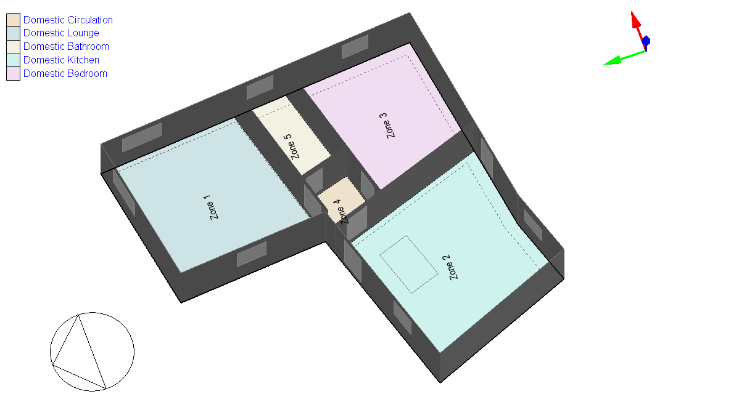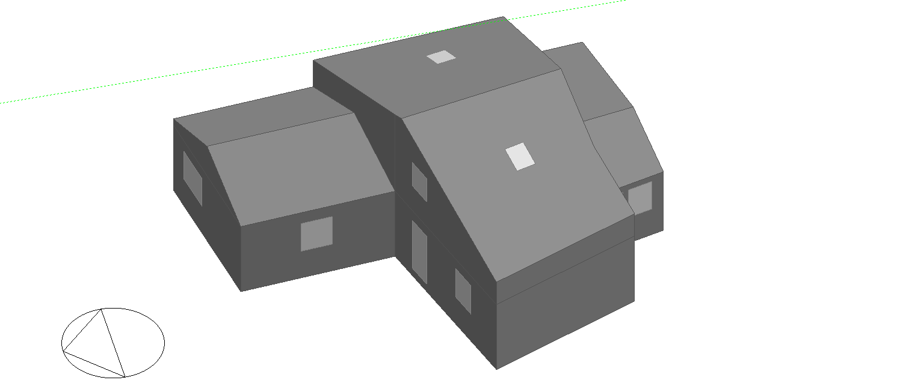

Figure : Ground floor, Apartment Figure : Outside View

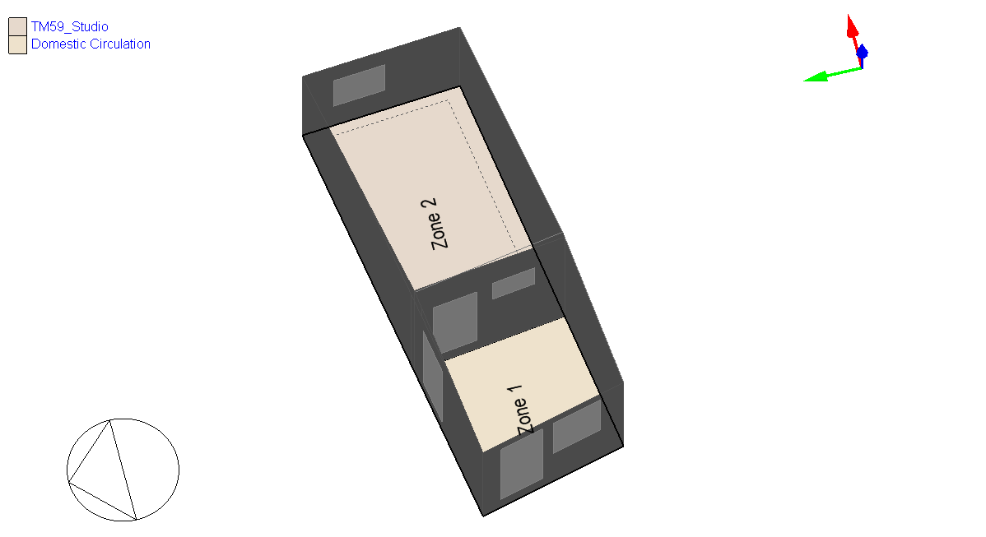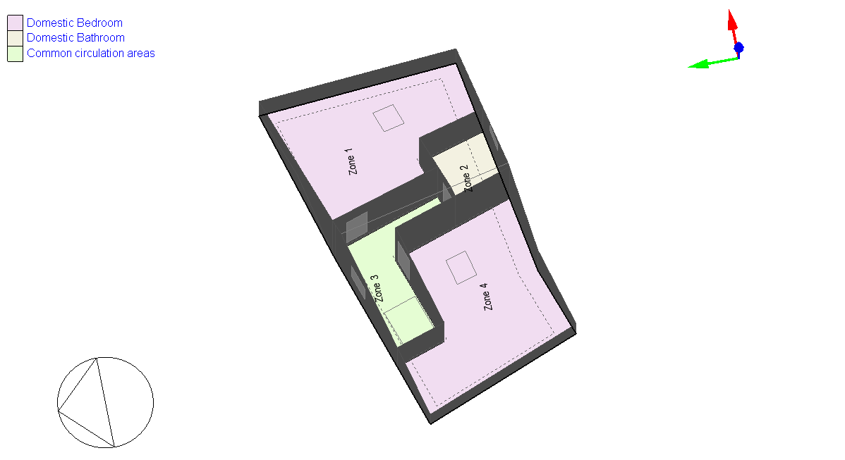

Figure : Ground Floor, Office space Figure : First Floor, Apartment

For scheduling we define two main periods, **Summer Period** which goes from the 30th of April to the 14th of October and **Winter Period** which covers the rest of the year. The building’s heating system has a setpoint at 20°C and will be active only during the Winter Period, whereas the Cooling system has a setpoint of 26 °C and will only be active during the Summer Period. In addition to the Cooling system, natural ventilation will be active (with a set ACH = 6) but only if the temperature is 18°C or higher. Shading on the outside windows will also be enabled, with an external temperature setpoint of 24°C and solar irradiation setpoint of 120 W/m². Both the natural ventilation and shading will be turned off in some cases during our parametrical analysis, as explained in the following section.

**2.2 Parameter Optimization**

The goal of our analysis is to study the variation of the energy demand as we vary a subset of building parameters. The most influential factor of a building’s energy demand is its external insulation, as such we will vary both the U-Value of the external walls, by changing the thickness of its insulation layer (, as seen in equation 1) and the U-Value of external windows, by employing single, double and triple-glazing.

* Rj is the thermal resistance of the layer j
* **is the thickness of the layer i**
* is the thermal conductivity of the layer i
* = is the surface resistance of the internal surface
* = is the external resistance of the external surface

Equation :U value of opaque surfaces



From equation 1, we see that the U-value of a wall surface is inversely proportional to the sum of the thicknesses of its layers, thus by increasing such value we can decrease the overall U-value of the wall.

*Figure 5* shows a cross-section of the building’s outer wall, we change its U-value by varying the thickness of the MW Stone Wool material (its main insulator) taking a range that varies from 0 cm to 35 cm (with 2,5 cm increments).

We will also vary the U-value of envelope openings by varying the glazing level of external windows, we will consider the three following **window configurations:**

Figure : Cross-section of the envelope’s outer wall

* **Single**: A single 3mm Clear glass panel.

U-value = 5,894 W/m²K

* **Double**: Two 3mm Clear glass panels, with a 13 mm Air layer in between.

U-value = 2,716 W/m²K

* **Triple**: Three 3mm Clear glass panels with two 13mm Air layers in between.

U-value = 1,757 W/m²K

Additionally, we will turn off natural ventilation and shading to observe its effect on Cooling demands, once again we consider three configurations:

* **Full:** Both natural ventilation and window shading are active.
* **No ventilation:** Natural ventilation is disabled and window shading is active
* **No ventilation-shading:** Both window shading and natural ventilation are disabled

To recap we will focus our parametrization on 4 variables:

* **U-value of external walls:** Varied by changing the insulator thickness
* **U-value of windows:** Varied by changing their glazing
* **Ventilation:** Varied by turning it on or off completely
* **Shading:** Varied by turning it on or off completely

The target value of our sensitivity analysis will be the energy demand of the building (Q), which will be split between Heating Demand (active mostly in winter) and Cooling Demand (active mostly in summer). The following section will introduce the results of the simulations.

**2.4 Analysis of Energy Demand**

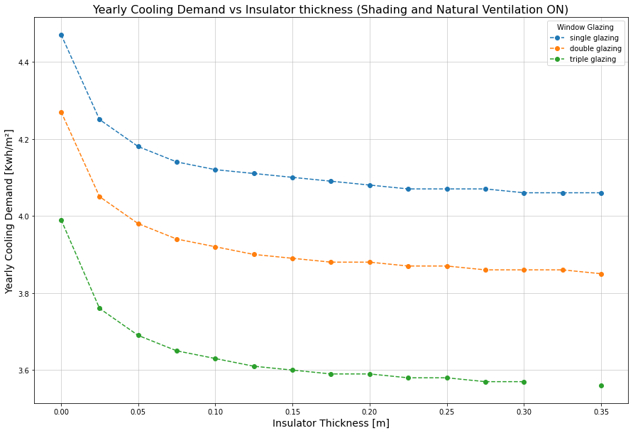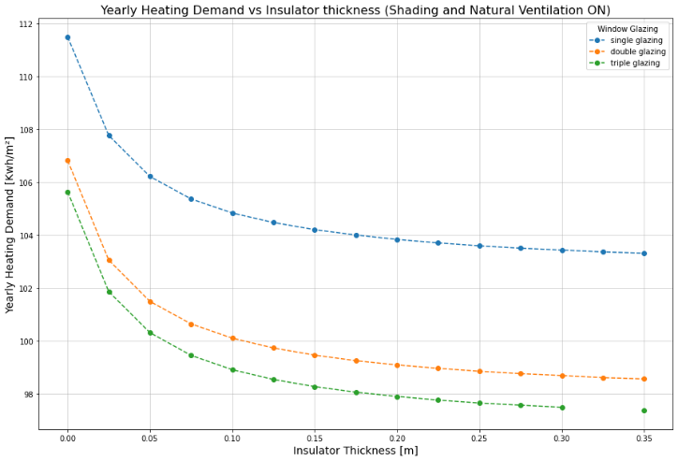After generating 9 different IDF files (3 glazing types x 3 vent/shading configurations), we perform a series of simulations one each of them, varying the insulation of the external walls. *Figure 6* and *Figure 7* show the Heating and Cooling demands for the case where both shading and ventilation were enabled (Note: the value for thickness = 32.5 cm is missing due to a simulation bug).

Figure 6: Heating demand sensitivity

Figure 7: Cooling demand Sensitivity

As expected, there is a large gap between the single glazing case (which has no air gap) and the double-glazing case (which has an air gap in between the panes) as those two window configurations have a large difference in U value (as seen in section 2.3). The behaviour of the energy demand as we vary the insulation thickness is as expected, with a thicker insulation layer, we have a lower U value for the external walls and thus a higher thermal insulation provided by the envelope.

Air Ventilation and Window shading have a meaningful impact only on the cooling of the envelope, as the ventilation allows the flow of cool air whereas the shading reduces the external heat due to radiation. As such when analysing cases with shading and ventilation turned off, we will only consider the Cooling demand graphs.

*Figure 8* shows the graph of the Cooling demand when both ventilation and shading are turned off, whereas *Figure 9* shows the Cooling demand when only the ventilation is turned off. Comparing graphs in *Figures 7*, *8* and *9* we see that turning off natural ventilation almost doubles the energy needed for cooling the building. On the other the effect of turning off shading has much less of an impact.

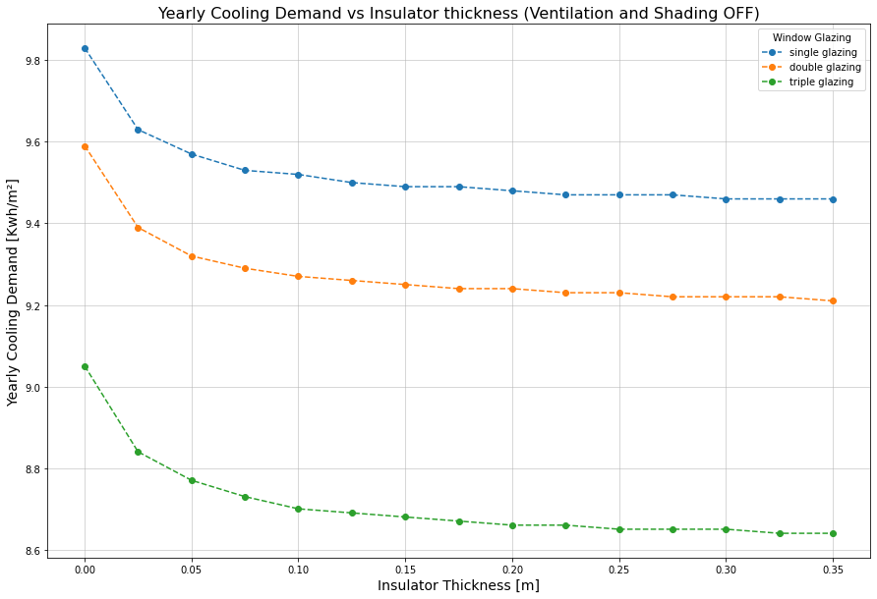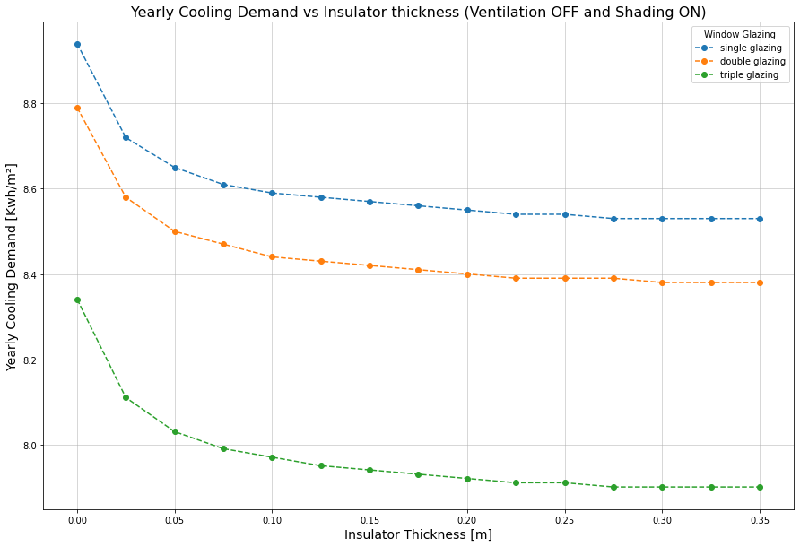

Figure 9: Cooling demand sensitivity (Ventilation disabled and Shading enabled)

(

In general, we have a minimum in energy demand with maximum wall insulation thickness and window triple glazing, which is indeed the expected results as this maximizes the U value of the envelope’s external walls and openings, maximizing overall insulation and thus minimizing the energy expenditure to achieve thermal comfort.

Figure 8: Cooling demand sensitivity (Ventilation and Shading disabled)

(

**2.5 Energy Signature**

In this section we will compute the energy signature of a single building configuration, we will use best performing building in term of cooling and heating demand, which has the following set of parameters:

* Wall insulator thickness d = 35 cm
* Triple window glazing
* Natural ventilation and window shading enabled

Our goal is to compute the Heat loss factor K of the building (as shown in equation 2), which relates Power consumed (in our case we will split between Heating and Cooling) with the external temperature.

Equation : Energy Signature (external T)

To approximate K we will employ a single variate regression (using the Least Squares method) taking the building Dry Bulb external temperature as the regressor variable and the Heating/Cooling Q demand as the regressand.

Starting with the Heating demand we find K = -0.2906 W/°C, the correlation is weak if we consider hourly values (R-squared = 0.511, *figure 10*) but it improves when we group them up as daily averages (R-squared = 0.849, *figure 11*). This is likely due to the fact that hourly values are influenced by environmental variables and intrinsic component characteristic that don’t have a direct linear correlation to external temperature, these components are averaged out when we consider daily consumption and as such, we obtain a stronger correlation.

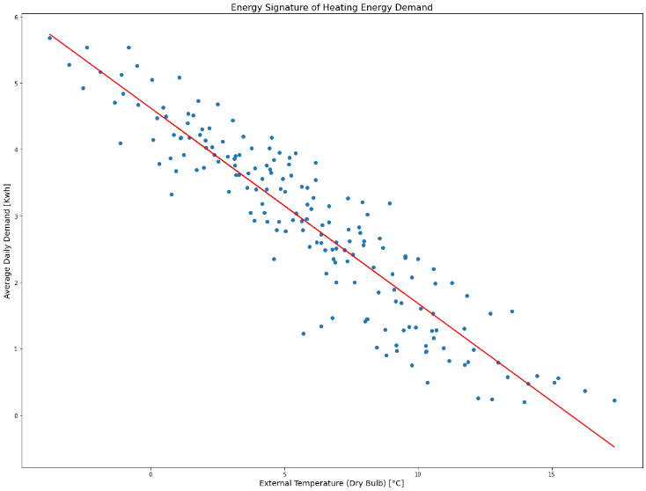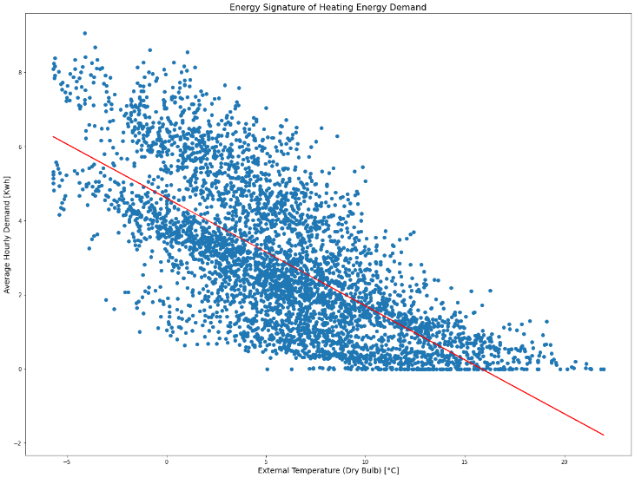

Figure 10: Scatter plot of daily Heating demand versus Figure 11: Scatter plot of hourly Heating demand versus

If we attempt the same with Cooling Demand (so mostly summer consumption) we obtain K = 0.1013 W/°C, however as seen from *Figures 12* and *13* there is little correlations between the Cooling Demand and the external temperature (we obtain an R-value of 0.302 for hourly values and 0.522 for the daily ones. We have a much worse performance with respect to the heating case because a single variate regression on the temperature is not enough to adequately obtain the Energy Signature of the building when it comes to cooling demand. Cooling needs have a strong dependence on factors other than external temperature, such as solar irradiation. Therefore, a way to improve this result would be to perform a multi-variate linear regression, adding for example solar irradiation as a second regressor variable.

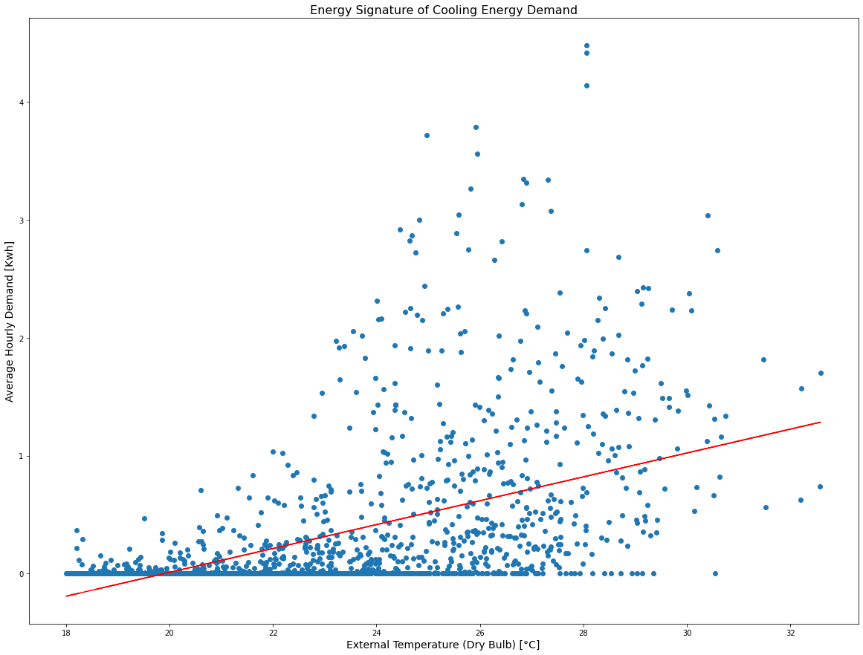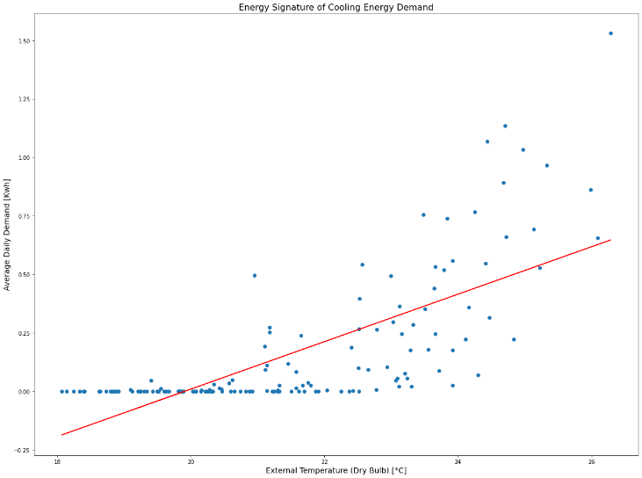

Figure 12: Scatter plot of hourly Cooling demand versus Figure 13: Scatter plot of daily Cooling demand versus

**3. Prediction model**

In this section we will describe how we built an ML model to predict the internal temperature of the building, using the temperature readings of previous hours as input.

**Section 3.1** will introduce a literature review on AI models that predict environmental parameters, **Section 3.2** will describe the dataseet used to train and test our model, **section 3.3** will explain the model chosen and how we tuned it. Finally, **section 3.4** will show the results and the model performance.

**3.1 Literature review**

Many research have been conducted in recent years on energy use and forecasts in the building sector. Regarding the deep learning aspect, various models have been analyzed in the literature to predict environmental parameters in cold places.

To forecast the energy consumption and optimize energy use, Abdoulaye Camara [1] in U.S. used two approaches, namely the statistical approach (SARIMA) and Neural Networks approach (ANN) and compare them to find the best model for forecasting. Comparison shows that although the performance of ANN model is better than SARIMA model using the error measurement, statistical significance test showed that there is no significant difference between the actual values and predicted values of the two models, because the actual and forecast values of the developed forecasting models are quite close.

Marjan Ilbiegi [2] presented a deep learning neural network. Several artificial neural network (ANN) using multi-layer perceptron (MLP) models were trained to tested the needed energy, which was then optimized using the Genetic Algorithm technique of the Galapagos plugin. The main results demonstrate that system improvement can reduce energy consumption by around 35%.

Forecasts the energy demand of various user clusters by getting the energy use of approximately 600 households via smart meters that capture data every 30 minutes [3]. The Long Short-Term Memory model has been shown to be effective for medium-term (15-day) and short-term (3-day) forecasting. Peak energy demand estimate results in a 3.15% inaccuracy.

Tae-Young Kim, Sung-Bae Cho [4] proposes a CNN-LSTM neural network that effectively predict the housing energy consumptions. Their experiments have shown that the CNN-LSTM neural network, which combines convolutional neural network (CNN) and long short-term memory (LSTM), can extract complex features of energy consumption. The concept behind the model is to implement a convolutional neural network (CNN), whose function is to pre-process the sequences of the various features before feeding the LSTM layer that will estimate temporal correlation.

**3.2 Simulation Data**

To obtain training data for our model we perform several simulations using energyPlus with the same IDF file used for section 2.5. However, using the same weather file for each simulation would give very similar and thus unrealistic results, as such we will have to use a different weather file for each run. We chose to take historical weather forecast data from years 2021,2020,2019 and 2018 to compute four yearly simulations of our building, the source of the data is [www.wunderground.com](http://www.wunderground.com) and the forecast is taken from the weather station ITORINOP2, located in Pinerolo which a location near Torre Pellice (as the station in Torre Pellice lacked crucial solar irradiation data).

From the simulation results we will retrieve the internal temperature Tin of the building as the mean of the temperatures of each zone, we will then build a ML model to try and predict the Tin at each hour, using as features the readings of the previous *h* hours.

**3.3 Model description and Training**

Long Short Term Memory Network is an advanced RNN. It is capable of handling the vanishing gradient problem faced by RNN. RNNs remember the previous information and use it for processing the current input. The shortcoming of RNN is, they can not remember Long term dependencies due to vanishing gradient. LSTMs are explicitly designed to avoid long-term dependency problems.

An LSTM network composed of a cell state and three gates (Figure 14). The cell state in LSTM helps the information to flow through the units without being altered by allowing only a few linear interactions. Each unit has an input, output and a forget gate which can add or remove the information to the cell state. Thanks to the regulation obtained with the three gates, the vanishing gradient problem is overcome.

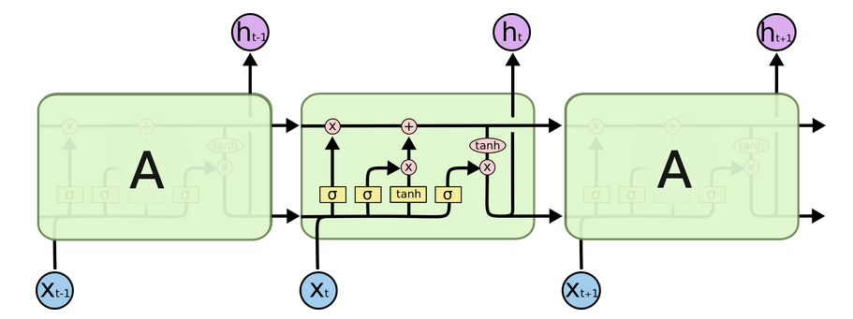

Figure 14: LSTM network model

A Convolution neural network (CNN) is a neural network that has one or more convolutional layers and are used mainly for image processing, classification, segmentation and also for other auto correlated data.

A CNN-LSTM model is a combination of CNN layers that extract the feature from input data and LSTMs layers to provide sequence prediction. Overall architecture of the proposed network shown on Figure 15.

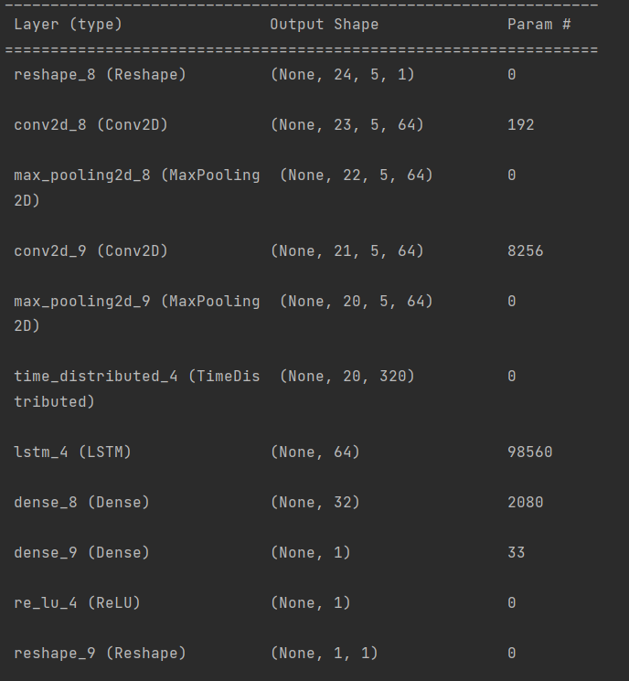

Figure 15: CNN-LSTM architecture

We decided to implement the (CNN-LSTM) model proposed by researchers in [4] that performed the best after examining previous works in Section 3.1.

The CNN-LSTM is used to predict the average internal temperature (T_in) of the building by using the last h sensor readings as inputs. We obtain our dataset of average internal temperatures by extracting from 'Zone Operative Temperature' columns of the ePlus output, and calculating their average. As a training dataset we choose simulation data of 2018, 2019, 2020 and for testing data set the simulation data of 2021.

Using our data, we define two arrays, Y, the regressand array, contains all temperature readings, ordered according to their timestamp. X the feature array, is defined as an array of arrays each containing h temperature readings. Such that the array X[i] at position i, will contain exactly the h previous temperature readings of the temperature reading stored in Y[i] (position i of array Y).

Data was normalized using the "min-max normalization" method. We also selected samples at random from training sets to create the validation set. These training, and validation sets need to evaluate a loss function.

We then performed different training cycles (each of 30 epochs) by varying the hyperparameter h, going from h=6 previous readings to h=144 previous readings.

**3.4 Results**

Figure 16 shows the model performance as function of h, as we can see using the past 24 hours of data showed the best performance for predicting the next hour. As such, h=24 was our choice for this hyperparameter. Figure 17 shows the predicted temperature data of our model(h=24), together with the real data, we can observe that in most cases prediction and sensor reading are close and follow the same trend. We take a closer look at the predicted in Figure 18, which shows the prediction for the month of September, predicted data follows the trend of the original data. Table 1 also gives a summary of our final model’s performance.

|  |  |
| --- | --- |
| MAE (°C) | 0.1422 |
| RMSE (°C) | 0.1891 |

Table 1: Performance metrics on the prediction of the mean indoor temperature

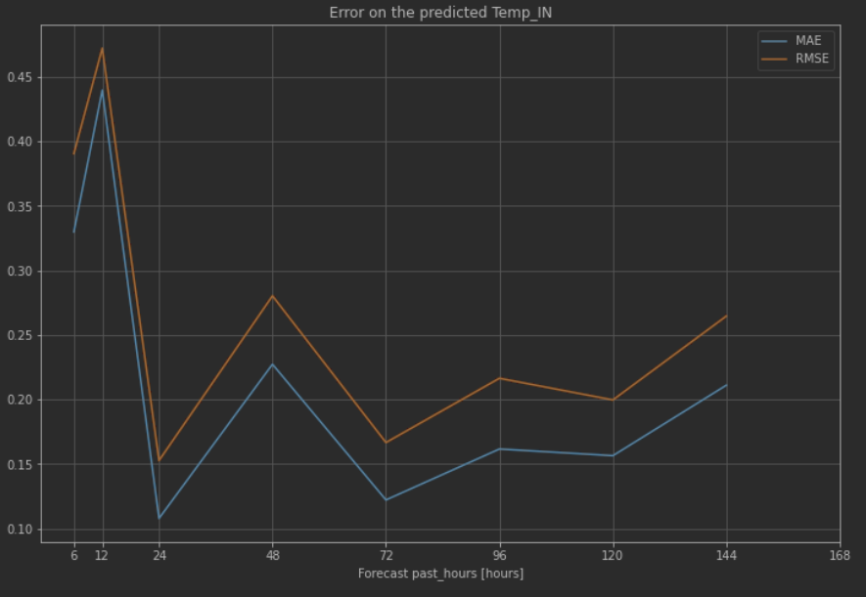

Figure 16: Error on the predicted Temp In

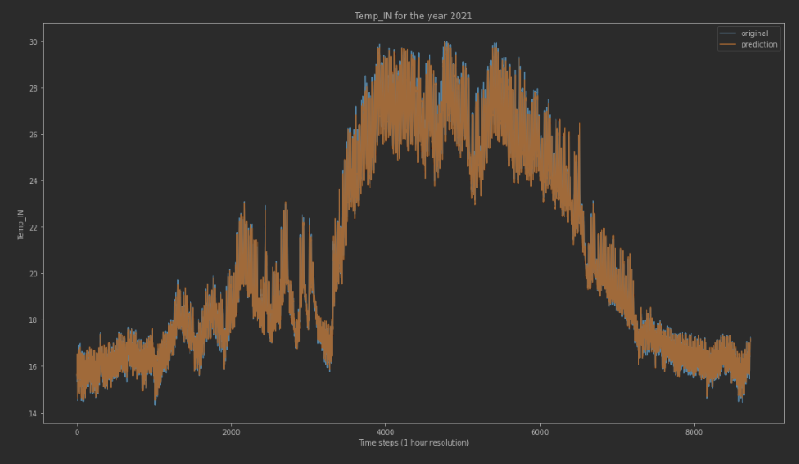

Figure 17: Original and Predicted Indoor temperature for 2021

Figure 18: Original and Predicted Indoor temperature for September 2021

**References**

[1] Abdoulaye Camara1, Wang Feixing1 and Liu Xiuqin. Energy Consumption Forecasting Using Seasonal ARIMA with Artificial Neural Networks Models. International Journal of Business and Management; Vol. 11, No. 5; 2016

[2] Marjan Ilbeigi, Mohammad Ghomeishi, and Ali Dehghanbanadaki. Prediction and optimization of energy consumption in an office building using artificial neural network and a genetic algorithm. Sustainable Cities and Society, 61(May):102325, 2020.

[3] Nameer Al Khafaf, Mahdi Jalili, and Peter Sokolowski. Application of deep learning long short-term memory in energy demand forecasting. In International Conference on Engineering Applications of Neural Networks, pages 31–42. Springer, 2019.

[4]. Kim, T.-Y. & Cho, S.-B. Predicting residential energy consumption using CNN-LSTM neural networks. Energy 182, 72–81 (2019).