***The World Islamic Sciences and Education University***

جامعة العلوم الاسلامية العالمية

Faculty of Information Technology

كلية تكنولوجيا المعلومات



GRADUATION PROJECT

**Title**

**WISE grades system using Blockchain**

**Students**

Ala’a Ali Shebli 3190601023

Mohammad Ibrahim Abudayeh 3170605216

Rashed Ihab Alsafadi 3190606073

Suhaib Sameer Katout 3190606051

**Supervisor**

Dr. Waleed Ameen

SEMESTER I

2022/202

# Acknowledgement

# Abstract

Blockchain is a chain of blocks that store information with digital signatures in a decentralized and distributed network. At WISE university, the current grading system database is a system that stores the students’ grades. Also, the instructors need to add grades for the students in their sections and the Head of Department will have to approve those grades then the Dean will have to approve them as well. The current database system lacks built-in auditing and backup features, making it necessary to hire an auditor and invest in additional hardware for backup solutions, both of which are costly but important for data availability, integrity, and security. A grading system that is based on blockchain is proposed using SDLC methodology to implement a new WISE grading system using Blockchain technology to secure the data, utilizing smart contracts for auditing to reduce costs and using AWS cloud for backing up the database. The project uses multiple tools such as Ganache Network, Truffle Suite framework, AWS cloud, PhpStorm, programming languages like HTML, CSS, PHP, Solidity, SQL, JavaScript, Visual Studio and MySQL. This enables the instructors, Head of Departments, and the Dean to store the grades in a blockchain as an additional layer of security for the grades. The added grades can be audited by smart contracts instead of hiring auditors which reduces the cost, effort, and time. Performance and security have also increased. Besides, an interview has been held to evaluate our application, results show high acceptance regarding the idea.

Contents

Acknowledgement I

Abstract I

List of Figures III

List of Tables IV

List of Abbreviations V

Chapter 1: INTRODUCTION 1

1.1 Overview 2

1.2 Problem Statement 2

1.3 Project objectives 2

1.4 Research Strategy (Framework) 3

1.5 Scope (boundary) 3

1.6 Gantt chart 4

1.7 Project outline 4

CHAPTER 2: LITERATURE REVIEW 5

2.1 Overview 6

2.2 Related Work 6

2.2.1 Electronic Healthcare Data Record Security Using Blockchain and Smart Contract[1] 6

2.2.2 Issues and challenges faced by the other project 9

2.3 Summary 9

CHAPTER 3: METHODOLOGY 10

3.1 Overview 11

3.2 Feasibility Study 11

3.4 Methodology process 12

3.4.1 Collected requirements 12

3.4.2 Requirements 13

3.4.2.1 Functional requirements 13

3.4.2.2 Non-Functional requirements 14

3.4.3 Methodology process phases 14

3.4.4 Tools 15

CHAPTER 4: DESIGN MODELS 16

4.1 Overview 17

4.2 Context diagram-0 17

4.3 Data flow Diagram-1 18

18

4.4 Use Case Diagram 19

4.5 ER Diagram 20

4.6 Relational Model 21

21

CHAPTER 5: EXPERIMENTS AND RESULTS 22

5.1 Overview 23

5.2 Testing methodologies 23

5.2.1 Unit Testing Results 23

5.2.1.1 Login 23

24

5.2.1.2 Dashboards 25

5.2.1.3 Adding a block 27

27

5.2.2 Integration Testing Results 29

5.2.3 System Testing Results 29

5.2.4 Acceptance System Results 29

5.3 Discussion and evaluation 29

CHAPTER 6: CONCLUSION AND FUTURE WORKS 30

6.1 Overview 31

6.2 Summary about the project 31

6.3 Achieved objectives 31

6.4 Main contributions of the work 31

6.5 Limitation 31

6.6 Future Work 31

References: 32

# List of Figures

Figure 1.1: Software Development Life Cycle methodology 3

Figure 2.1: Homepage of the similar system 6

Figure 2.2: Admin Panel 7

Figure 2.3: The process of adding a doctor with the hash 7

Figure 2.4: Hash of the data 8

Figure 4.1: Context Diagram-0 17

Figure 4.2: Data flow Diagram-1 18

Figure 4.3: Use Case Diagram 19

Figure 4.4: ER Diagram 20

Figure 4.5: Relational Model 21

Figure 5.1: Dean’s Login 23

Figure 5.2: Head of Department’s login 24

Figure 5.3: Doctor’s login 24

Figure 5.4: Dean’s dashboard 25

Figure 5.5: Head of Department’s dashboard 25

Figure 5.6: Doctor’s dashboard 26

Figure 5.7: Dashboard for adding a block 27

Figure 5.8: Confirming to add a block 28

# List of Tables

Table 1.1: Periods of time for each phase. 4

Table 3.1: Feasibility study. 11

Table 3.2: Risk assessment matrix 12

Table 3.3: Functional requirements 13

Table 3.4: Non-functional requirements 14

Table 5.1: Index page 29

# List of Abbreviations

WISE: The World Islamic Sciences and Education University  
SDLC: System Development Lifecycle  
AWS: Amazon Web Services  
HTML: Hyper Text Markup Language  
CSS: Cascading Style Sheets  
PHP: Hypertext Preprocessor   
SQL: Structured Query Language  
GUI: Graphical User Interface  
MFA: Multi-Factor Authentication   
ER diagram: Entity Relational Diagram

# Chapter 1: INTRODUCTION

## Overview

The World Islamic Sciences and Education University (WISE) uses a database for the grading system and since the system should be confidential using blockchain technology will be much better than using only the database.

Blockchain technology is a high-security method and one of its properties is the distributed ledger technology that enables the secure functioning of a decentralized digital base. It’s used to save the data inside blocks and when they get filled, they will be closed, covered, and hashed using a specific mathematical problem. Also, when there is another data to be entered another block is made and closed then they will be linked together forming a chain.

## Problem Statement

A centralized database is basically a type of database that is stored, located as well as maintained at a single location only. At WISE, the current grading system database is a system that stores the students’ grades. Also, the administrator gives permission for the instructor to insert the grades for the students. Then the Head of Department approves the grades, and the Dean will approve them as well. Nevertheless, the database does not provide a full auditing service for the data. To ensure data integrity and availability, an auditor should be hired to do it, which adds an extra cost. Additionally, the database does not provide a backup solution, servers must be purchased and then install the database on them to build a backup of the database. Also, there must be a mechanism to provide protection and security, by permitting information to be accessed only by properly authorized users.

## Project objectives

1. To propose a new application for WISE grading system using Blockchain.
2. Using Blockchain technology to secure the grading system data.
3. Using smart contracts instead of auditing which reduces the cost.
4. Using AWS cloud to back up the grading system database.

## Research Strategy (Framework)

The SDLC methodology will be used to document the project as in Figure1.1.

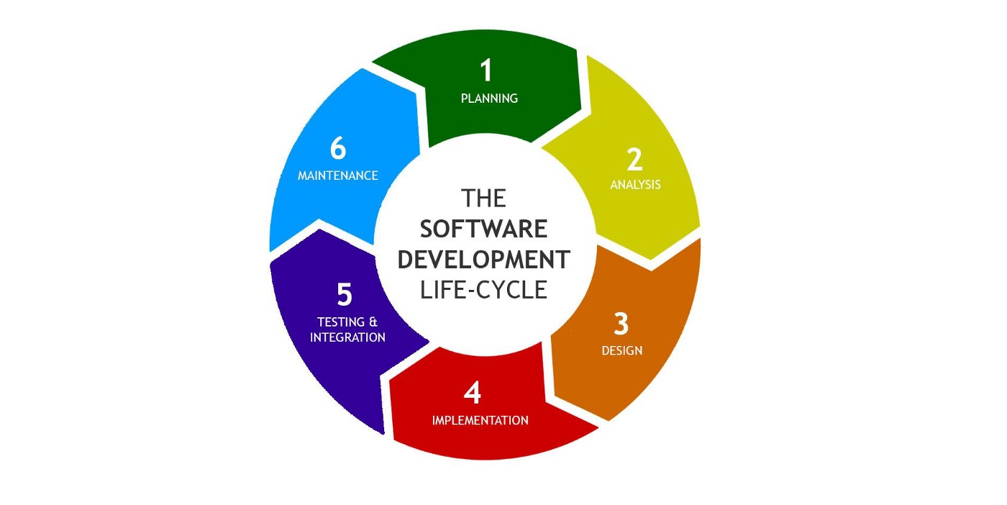Figure 1.1: Software Development Life Cycle methodology

## Scope (boundary)

The project aims to develop the security of the grading system database in WISE. The instructors will be the ones who enter the students' grades in the database, then the grades will go directly to the faculty dean who will put them inside the blockchain.

## Gantt chart

The phases of SDLC and the expected period of time for each phase as shown in Table 1.1.

Table 1.1: Periods of time for each phase.

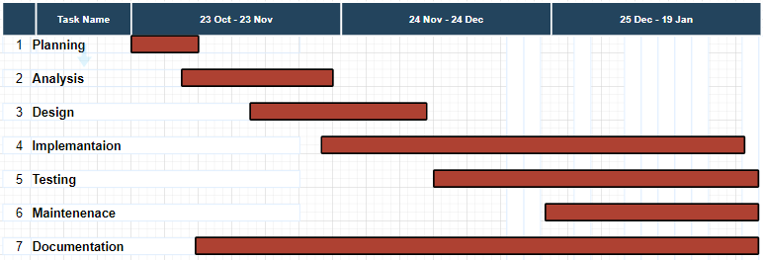

## Project outline

Chapter 2: Comparing the Blockchain technology with the existing database to reach a conclusion that the Blockchain is better and more secure than the Database.

Chapter 3: Feasibility study and what methodology will be used in the project. Also, the functional and non-functional requirements will be mentioned.

Chapter 4: Show how the system works by a set of diagrams in a clear and simple way as well as showing how to use the system.

Chapter 5: The implementation and evaluation part will be mentioned and explained of how the technology is going to work.

Chapter 6: This chapter will contain the conclusion of the project and the future work and improvement of it.

# CHAPTER 2: LITERATURE REVIEW

## 2.1 Overview

This chapter talks about similar sites to the database of WISE that uses database and upgraded it into blockchain for storing the data, as well as the issues and challenges that faced the similar projects.

## 2.2 Related Work

A similar project that has a local hosted database and upgraded it to use blockchain.

### 2.2.1 Electronic Healthcare Data Record Security Using Blockchain and Smart Contract[1]

An electronic health record (EHR) is a technology that allows you to keep track of your health information. It keeps computerized records of several healthcare organizations. Records are exchanged via enterprise-wide data systems as well as other networking technologies and exchanges as in Figure 2.1.



Figure 2.1: Homepage of the similar system

Admins can add doctors and patients to the system, as well as delete current users, using the admin interface. The administrator has their own unchangeable and inaccessible account in this system, which has the authority to create and delete users as in Figure 2.2.

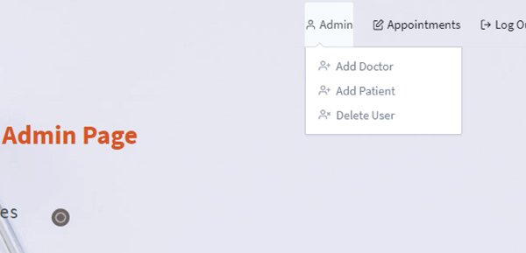

Figure 2.2: Admin Panel

Shows the doctor registration module where you need to fill in the details of a doctor such as name; date of birth; email ID; mobile number; doctor’s ID, which is an account address from city; state; and specialty as in Figure 2.3.

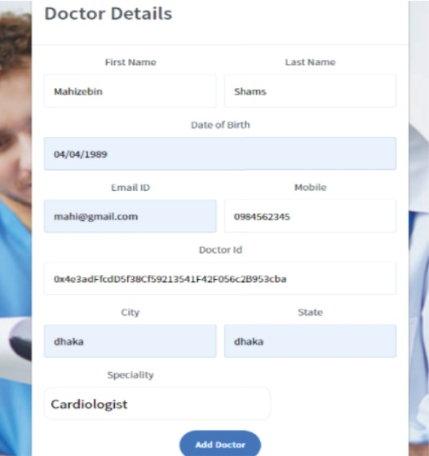

Figure 2.3: The process of adding a doctor with the hash

Shows account hash, which allows users to use a browser to access a decentralized system without having a full node of the blockchain as in Figure 2.4.

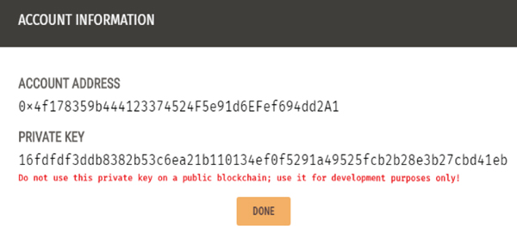

Figure 2.4: Hash of the data

A blockchain is essentially a distributed database of records or public ledger of all transactions or digital events that have been executed and shared among participating parties. Each transaction in the public ledger is verified by consensus of a majority of the participants in the system. And, once entered, information can never be erased. The blockchain contains a certain and verifiable record of every single transaction ever made. Bitcoin, the decentralized peer-­to­-peer digital currency, is the most popular example that uses blockchain technology[4].

A smart contract is a set of commands that can be used to carry out any transaction on the blockchain. When users send transactions, this piece of code is run. They operate directly on the blockchain, rendering them impervious to manipulation and modification. Smart contracts deploy the Solidity programming language to program any form of activity on the blockchain. The programmers can compile the required operations after they have been programmed. They could then be run and deployed on the Ethereum blockchain after being compiled. JavaScript is a programming language that implements Ethereum’s Solidity language for writing smart contract code[1].

The blockchain is an emerging technology. Because of its efficiency and functionality, it is widely considered to have revolutionary application prospects. As a supporting part of the data structure, the hash function is important for ensuring the availability and security of the blockchain. To evaluate the security of blockchain technology it is important to analyze several security criteria of the hash functions used in the blockchain[5].

### 2.2.2 Issues and challenges faced by the other project

In [1], they use the Ethereum main network which is expensive. However, in this proposed system the BNB smart chain will be used instead of the Ethereum main since it’s cheaper.

While in [2], they have the facility for multiparty authentication. It means any organization can access the data from this system and utilize it as they want. While in our proposed system it is managed by only WISE, making it difficult to reach information about the students.

## 2.3 Summary

In this chapter, we have discussed the blockchain, the hash that the blockchain uses, and the smart contract and the issues that faced the other projects and their solutions that we will use in our proposed system.

# CHAPTER 3: METHODOLOGY

## 3.1 Overview

We are going to talk about the methodology used in this proposed project, which is the SDLC that is used as the methodology process and the feasibility study for the project. Also, the requirements functional and non-functional ones will be mentioned in this chapter.

## 3.2 Feasibility Study

A feasibility study for the project is shown in table 3.1.

Table 3.1: Feasibility study.

|  |  |
| --- | --- |
| **Items** | **Cost** |
| Renting AWS cloud to save the data as a backup and create an elastic IP to create instances and virtual machines | 50$ Per year |
| PhpStorm IDE to write the code using it | 250$ Per year |

**3.3 Risk Analysis**

A risk assessment for some threats that could face the system as shown in table 3.2.

Table 3.2: Risk assessment matrix

|  |  |  |  |  |
| --- | --- | --- | --- | --- |
| **Threat** | **Vulnerability** | **Assets and Consequence** | **Risk** | **Solution** |
| Data will be uploaded on cloud  **Tolerable** | Resources will be publicly shared  **Tolerable** | Data loss  **Tolerable** | **Tolerable** | The data will be encrypted. |
| Service unavailable  **Tolerable** | Bugs  **Tolerable** | Users can not use the system  **Tolerable** | Potential loss of 1200$ per year  **Trivial** | Create multi-instance on cloud to guarantee system to keep working on AWS |
| Unauthorized access  **Tolerable** | Weak password  **Tolerable** | Access on AWS cloud  **Tolerable** | **Trivial** | Configure strong password policy and use MFA for each user. |

## 3.4 Methodology process

### 3.4.1 Collected requirements

We have planned an interview with the database supervisor Dr. Abdullah Alzaqebah to ask him about the proposed system if it will help the university with the security of its grading system database and if it’s trusted to use such technology like blockchain and saving the data on AWS cloud as a backup and his answers was that they would love to move along with the technology to add more layers of security for the database starting with the grading system to store them in a blockchain and a secure encrypted backup in AWS cloud.

### 3.4.2 Requirements

### 3.4.2.1 Functional requirements

The functional requirements are listed below in table 3.3.

Table 3.3: Functional requirements

|  |  |  |
| --- | --- | --- |
| **Instructor** | **Head of Department** | **Dean** |
| The instructor will have an account to view the classes that he teaches. | The Head of Department will be able to view the instructors in his division. | The Dean will view the instructors. |
| The instructor can enter the students grades for his students in each class. | The Head of Department will be able to see the classes of the instructor. | The Dean will add a block for the grades after the Heads of Departments approve them. |
| After entering the grades for each student and save them in the database. | The division head will confirm the grades of the students in his division that the instructor has already saved in the database. | After adding the block from the dean for the grades, the grades will be stored in a blockchain. |

### 3.4.2.2 Non-Functional requirements

The non-functional requirements are listed below in table 3.4.

Table 3.4: Non-functional requirements

|  |  |
| --- | --- |
| **Security** | All the data inside the blockchain is encrypted and secured against any unauthorized activity. |
| **Maintainability** | The system and the data are stored in an AWS cloud |
| **Performance** | The data can be altered by authorized people. |
| **Usability** | Easy to use the application |

### 3.4.3 Methodology process phases

1. Planning: In the planning stage, we built a team and evaluated the project conditions by determining the cost and time. We thought of this Idea and Dr. Waleed supported it, who provided us with the project requirements and other ideas that is helping us throughout our work. of building a secure database for WISE grading system using Blockchain. We work on the project daily and using the ideas that we were given.
2. Analysis: We identified the problem that storing the grades on a database without securing it is not safe, we are providing and analyzing possible solutions to determine the best solution to the problem and considering the use of the users of the system that it meets the expectations. We have analyzed and identified the resources needed to build the project.
3. Design: We built a Graphical User Interface (GUI) for the instructor, division head, and the dean to complete each individual task for each of them using the GUI, we designed it using HTML, CSS, Bootstrap, JavaScript.
4. Implementation: In the implementation phase we worked on the system using PHP and MySQL to build the code using Visual Studio and creating the databases tables and linking them to the web application.
5. Testing: We are currently testing the project at every phase before completing it to avoid any error when it is fully implemented and starts working.
6. Maintenance: In this phase, the website is completely created and implemented. Also, it will be reviewed by our mentor to check what else we should maintain.

### 3.4.4 Tools

* Ganache Network
* Truffle Suite framework
* AWS cloud
* Google Scholar
* Microsoft Office 365
* PhpStorm
* MySQL
* Programming languages: HTML, CSS, PHP, Solidity, SQL, and JavaScript
* Visual Studio

# CHAPTER 4: DESIGN MODELS

## 4.1 Overview

In this chapter, the diagrams such as Diagram level 0, Data Flow Diagram level 1, Use Case Diagram, Entity Relational Diagram, and the Relational Model.

## 4.2 Context diagram-0

The context diagram is a basic overview for the proposed system as shown below in Figure 4.1.

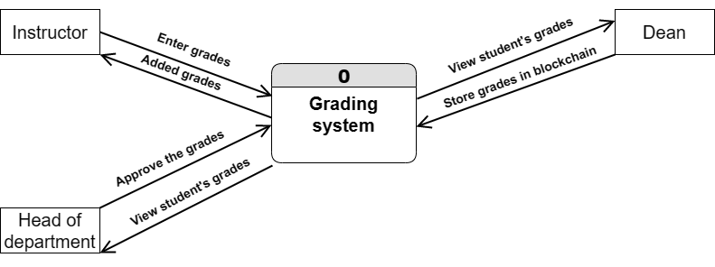

Figure 4.1: Context Diagram-0

## 4.3 Data flow Diagram-1

The diagram shows a detailed overview of how the project works as shown below in Figure 4.2.

Figure 4.2: Data flow Diagram-1

## 4.4 Use Case Diagram

The diagram defines the actors of the system and functionality of the system and the functional requirements as shown below in Figure 4.3.

Figure 4.3: Use Case Diagram

## 4.5 ER Diagram

Entity Relational Diagram is a graphical representation that depicts relationships among people, objects, places, or events within an Information Technology system as shown below in Figure 4.4.

Figure 4.4: ER Diagram

## 4.6 Relational Model

The relational model is an approach to manage data using a structure as shown below in Figure 4.5.

## 

Figure 4.5: Relational Model

# CHAPTER 5: EXPERIMENTS AND RESULTS

## 5.1 Overview

In this chapter, we will talk about testing the system, and check satisfies the requirement or not.

## 5.2 Testing methodologies

## 5.2.1 Unit Testing Results

## 5.2.1.1 Login

The concerned users who are the Dean, Head of Department, and the doctor will have to login to their accounts by entering the correct credentials and based on the privilege for each user it will redirect the user to the account as shown in Figure 5.1, 5.2, and 5.3.

Figure 5.1: Dean’s Login

Figure 5.2: Head of Department’s login

Figure 5.3: Doctor’s login

## 5.2.1.2 Dashboards

After logging in the accounts, the dashboard for each user is different for each one, and the dashboards will be shown in Figure 5.4, 5.5, 5.6.

Figure 5.4: Dean’s dashboard

Figure 5.5: Head of Department’s dashboard

Figure 5.6: Doctor’s dashboard

## 5.2.1.3 Adding a block

A dashboard that shows an action button to add the grade of a student inside a block as shown in Figure 5.7.

Figure 5.7: Dashboard for adding a block

An E-wallet that shows details of the gas fees to add a block and to confirm to add the block as shown in Figure 5.8.

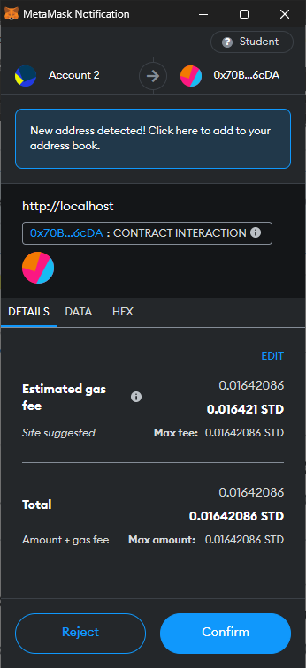

Figure 5.8: Confirming to add a block

## 5.2.2 Integration Testing Results

Some of the errors that were faced during coding as shown in Table 5.1.

Table 5.1: Index page

|  |  |  |
| --- | --- | --- |
| **Errors** | The problem of understanding the graduation project based on the grading system of the university. | Linking Pages |
| **Fixed** | Planning interviews with people working on the database in the university. | Include statements and link them correctly |

## 5.2.3 System Testing Results

After integrating the system and testing it, we tested the system as a whole to make sure that the system works fine, to verify the system meets the requirements.

## 5.2.4 Acceptance System Results

## 5.3 Discussion and evaluation

We have achieved all the requirements and objectives of the system that was mentioned at the beginning of the project.

# CHAPTER 6: CONCLUSION AND FUTURE WORKS

## 6.1 Overview

This chapter shows the future works for the proposed project, a summary about it, main contributions of the project, and the limitations.

## 6.2 Summary about the project

The project is about using a blockchain to store and secure the grades inside blocks and having a backup for the database in AWS cloud to reduce the cost of auditing.

## 6.3 Achieved objectives

The objective was to propose a new application for WISE grading system using Blockchain and we have proposed the blockchain to be used with the database to secure the grades. Also, smart contracts are used in the proposed system to reduce the cost of auditing. Furthermore, having a backup for the database in AWS cloud.

## 6.4 Main contributions of the work

The project aims to maintain the integrity and securing the data by using blockchain technology, storing the data inside blocks, and hashing them. Also, having a backup for the data using AWS cloud services.

## 6.5 Limitation

It was difficult to learn a programming language because it has limited resources which is Solidity. Also, connecting between solidity and an E-wallet, E-wallet with backend. Furthermore, searching for a network for the blockchain that its gas fees are almost stable and one of the lowest prices with a better performance than some of the networks. We have solved multiple problems while writing programming languages which led to making us more efficient while writing code.

## Future Work

1. Storing the grades in the blockchain by sections and not individually.
2. Auto storing grades in the blockchain when the dean confirms the grades to auto.

## References:

[1]. Nishi, Farjana Khanam, Mohammad Monirujjaman Khan, Abdulmajeed Alsufyani, Sami Bourouis, Punit Gupta, and Dinesh Kumar Saini. "Electronic Healthcare Data Record Security Using Blockchain and Smart Contract." *Journal of Sensors* 2022 (2022).

[2]. Gupta, Mehul. "PR Wallet-Based Blockchain Access Protocol to Secure EHRs." In *Blockchain and IoT Integration*, pp. 65-76. Auerbach Publications, (2021).

[3]. Kim, Min Gyu, Ah Ra Lee, Hwi Jun Kwon, Ji Woong Kim, and Il Kon Kim. "Sharing medical questionnaries based on blockchain." In *2018 IEEE International Conference on Bioinformatics and Biomedicine (BIBM)*, pp. 2767-2769. IEEE, 2018.

[4]. Bitcoin, Beyond. "BlockChain Technology." *Tech. Rep2015* (2015).

[5]. Wang, Maoning, Meijiao Duan, and Jianming Zhu. "Research on the security criteria of hash functions in the blockchain." In *Proceedings of the 2nd ACM Workshop on Blockchains, Cryptocurrencies, and Contracts*, pp. 47-55. 2018.