

**PineconePi Watch**

**Instruction set & user guide**

Chengsen Dong

G20841536

Electronic Systems Applications

EL2205

Zhijie Ding

14/04/2021

*I confirm that the present assignment is all my own work and the source of any information and material I have used (including the Internet) has been fully identified and properly acknowledged as required in the School guidelines I have received.*

*Signed: Chengsen Dong*

Table of Contents

1. How to use PineconePi Watch 3

1.1 Self-test 3

1.2 Use the toggle switch to control the device 4

1.3 Viewing sensor data 4

1.4 View device data on the web page 5

1.5 Update device firmware 6

1.6 Battery indicator and charging 6

2. Troubleshooting Guide 7

2.1 Self-test failed 7

2.2 Graphical interface cannot be displayed 8

2.3 Unable to get sensor value 8

2.4 Web page access failed 8

2.5 Unable to start device 8

# How to use PineconePi Watch

## Self-test

After PineconePi Watch is turned on, it will start the initialization of each peripheral in turn. At the same time, after completing the initialization of the peripheral, the device will also detect the online status of the peripheral. If the initialization of the peripheral and the online detection of the peripheral are completed, a blue X will be drawn on the corresponding peripheral position on the TFT screen. If there is an error in this process, a blue X will not be drawn on the corresponding peripheral position on the TFT screen. This power-on self-test operation helps users check out the abnormal parts of the device, and facilitates users to troubleshoot problems.

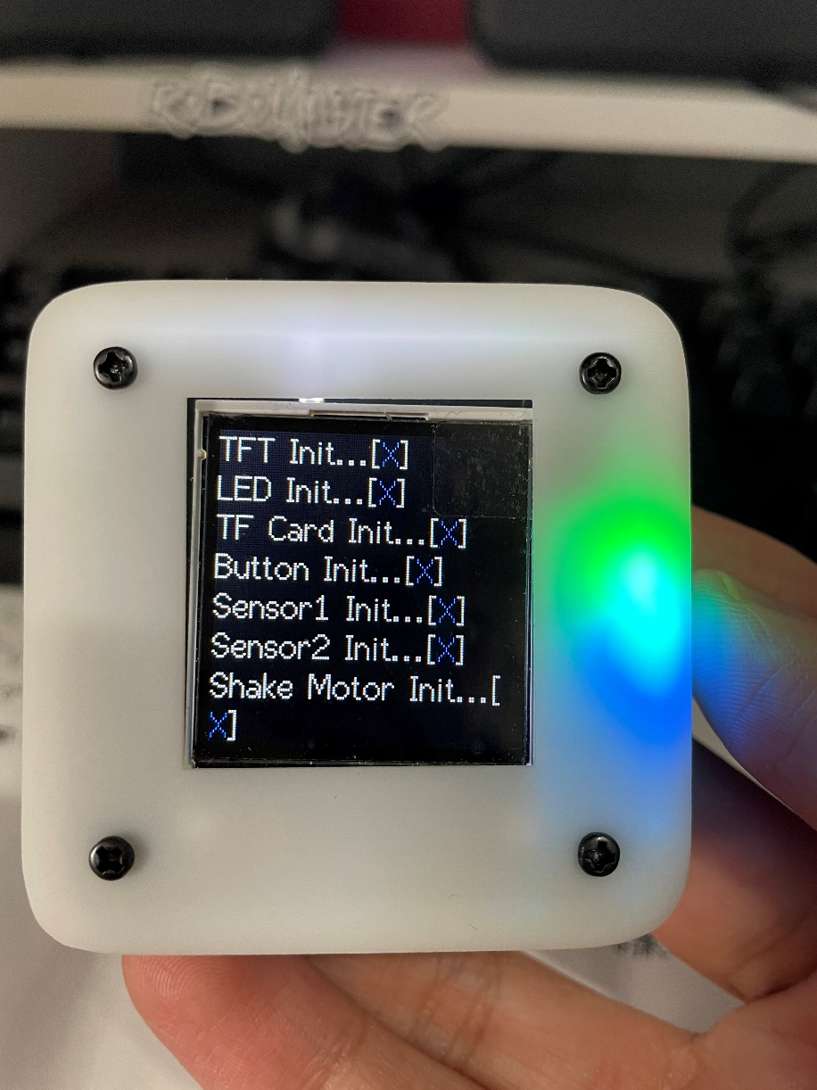

Figure 1 Power-on self-test

## Use the toggle switch to control the device

There is a 3-state toggle switch in the upper left corner of the PineconePi Watch. This toggle switch is used to allow the user to control the device to collect the required sensor data. The control logic of the toggle switch is as follows: when the toggle switch is moved down, the device jumps to the next interface; when the toggle switch is moved up, the device jumps to the previous interface; when the toggle switch is pressed, The device enters the secondary menu interface of the current interface.

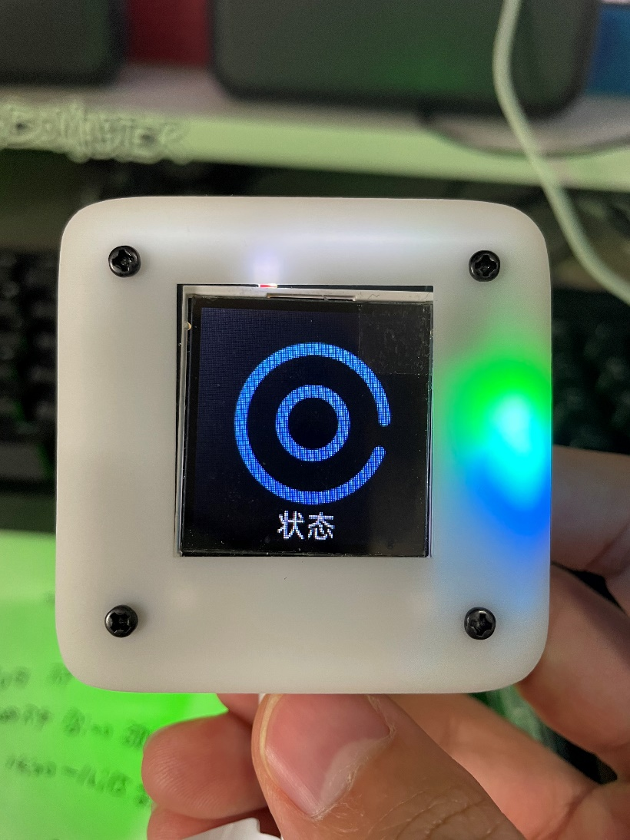

Figure 2 Toggle switch control equipment

## Viewing sensor data

To facilitate the reading of sensor values, I put all sensor data on the 8th interface for display. At the same time, in order to enable the sensor data to be transmitted to the MQTT server through the WIFI hotspot connected when the machine is turned on, and to display the sensor data on the Web page. I added NTP time service to the 8th interface to synchronously detect the WIFI connection. If the Dongba District (Beijing) time can be displayed normally on the 8th interface, it proves that the device has been connected to the Internet at this time.

In the 8th interface, the highest blood pressure, lowest blood pressure, heart rate, body temperature will be displayed; X-axis angle and acceleration; Y-axis angle and acceleration; Z-axis angle and acceleration.

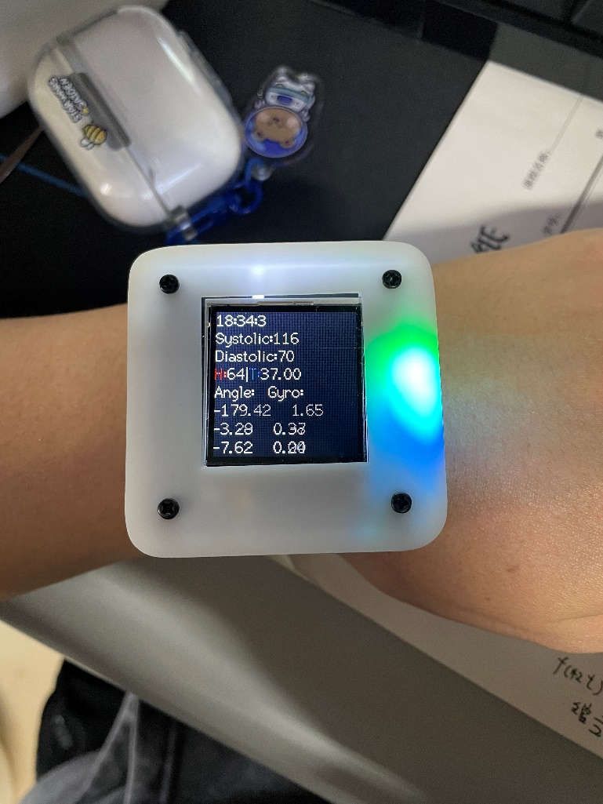

Figure 3 View of sensor data

## View device data on the web page

When the device is on the 8th interface, the device will send the collected sensor data to the MQTT server. At the same time, the web server Django script that has been running will display the data monitored from MQTT to the web page (web page address: www.chiselos.com:8080/device/). Every time the web page is refreshed, the device will report the latest sensor data to the MQTT server, and this latest data will be used to update the data displayed on the web page.

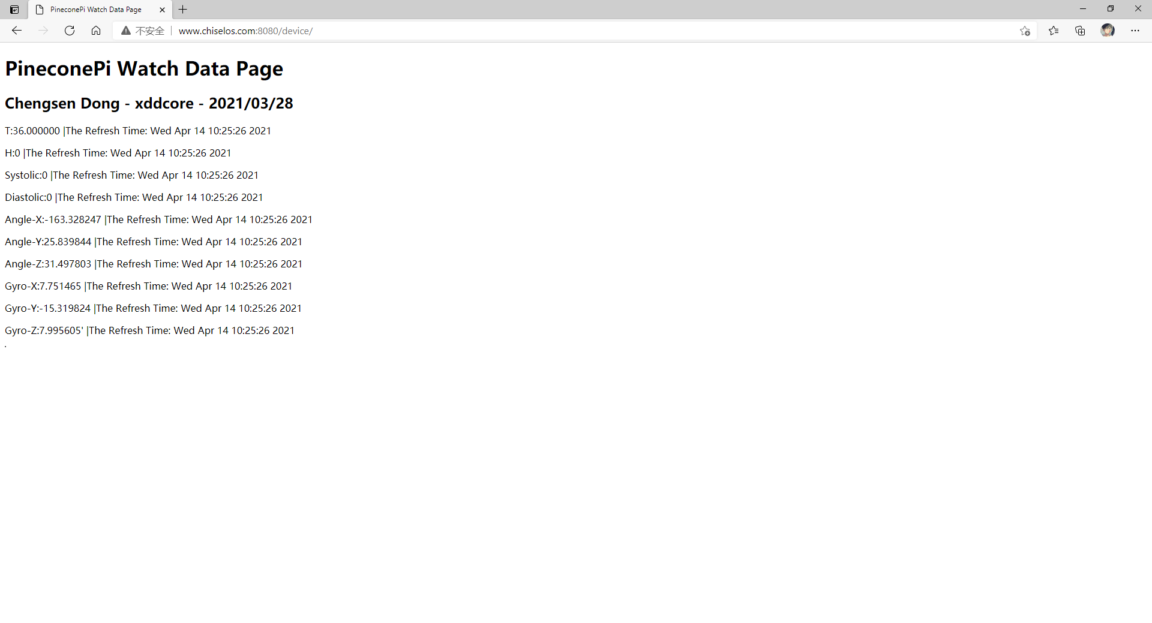

Figure 4 Web page data view

## Update device firmware

PineconePi Watch comes with an automatic firmware download circuit inside. When updating the firmware, you only need to connect the device and the computer through a TYPE-C cable. Then you can download the compiled .bin program file to the device. At the same time, the device also supports an over-the-air upgrade (OTA) function. As long as the device is connected to the Internet, it can compare its firmware version number with the firmware version number on the server. If the device version number is lower than the server version number. The device will automatically download the latest firmware from the server to the device TF card, and then the device will burn the firmware in the TF card into the ESP32 on-chip FLASH.

## Battery indicator and charging

There are 4 power indicator lights on the PCB at the bottom of the PineconePi Watch, and each LED light represents 25% of the power. For example, when the power is 50%-75%, 2 LEDs will light up; when the power is 75%-100%, 3 LEDs will light up; when the power reaches 100%, there will be 4 LEDs Glow.

PineconePi Watch has a powerful IP5306 power management chip inside. Just connect the TYPE-C cable to the 5V DC power supply and you can start charging the device. When the device is charging, the corresponding power LED light will flash to indicate. When it is full, the LED light will no longer flash.

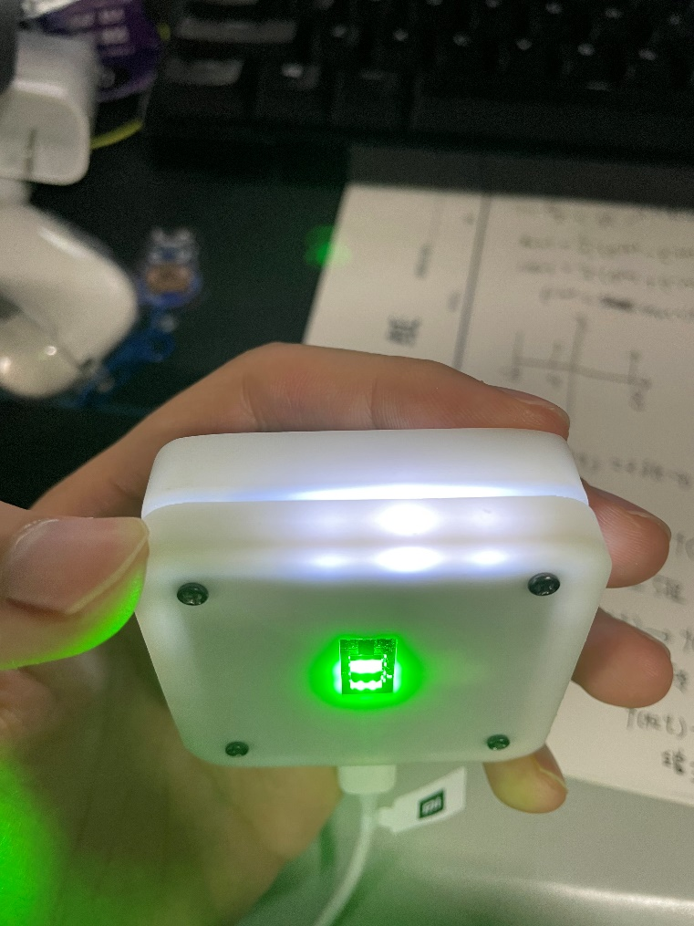

Figure 5 Power and charging indication

# Troubleshooting Guide

Due to the complexity of this equipment, the following failures occur when in use, please return it to me for repair. The following failure guide only helps users to know the cause of the failure:

## 2.1 Self-test failed

When an error occurs in the device's self-test, please troubleshoot the fault in the following ways:

1. Sensor1 self-detection error. Possible reasons for this error:

1. ICM 6-axis gyroscope sensor is not connected

2. Sensor2 self-test error. Possible reasons for this error:

1. STC8 coprocessor is not working

2. STC8 coprocessor

## 2.2 Graphical interface cannot be displayed

When the graphical interface of the device cannot be displayed, the possible reasons for this error:

1. The TF card with system file resources is not inserted

2. TF insertion appears loose

3. The TF card does not contain system file resources

## 2.3 Unable to get sensor value

When the device cannot display sensor data on the 8th interface, the possible reasons for this error are:

1. The device is not connected to WIFI

2. WIFI cannot connect to the Internet

3. NTP time service failed

4. Sensor failure

## 2.4 Web page access failed

When the web page cannot be accessed, the possible reasons for this error:

1. The access URL is incorrectly entered

2. The web server is not working

3. Web server failure

## 2.5 Unable to start device

When the device fails to start, the possible reasons for this error:

1. The internal lithium battery power of the device is exhausted

2. Equipment failure

3. The equipment power management circuit works abnormally