GET : Localhost/crime – will retrieve all crimes in the database

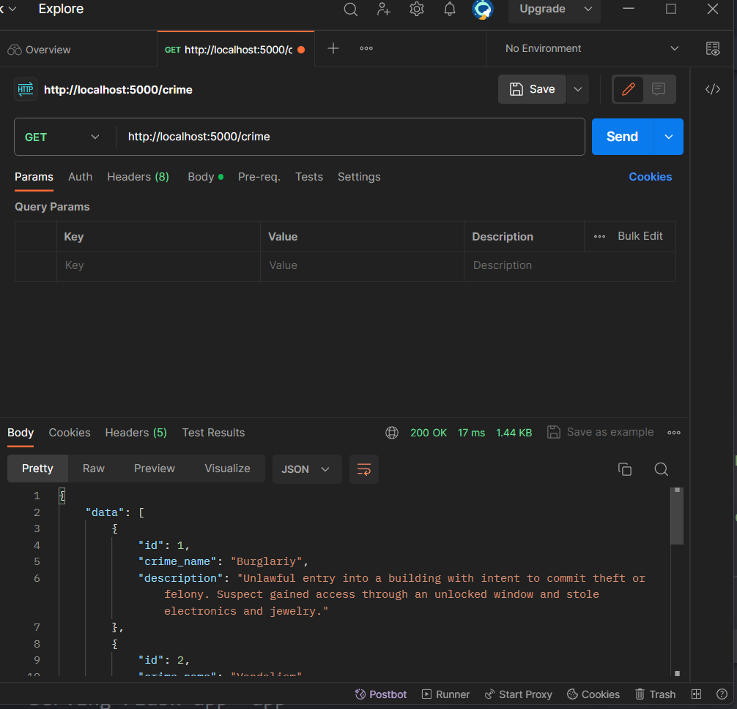

POST: Localhost/crime – will create a new crime to database

Before POST

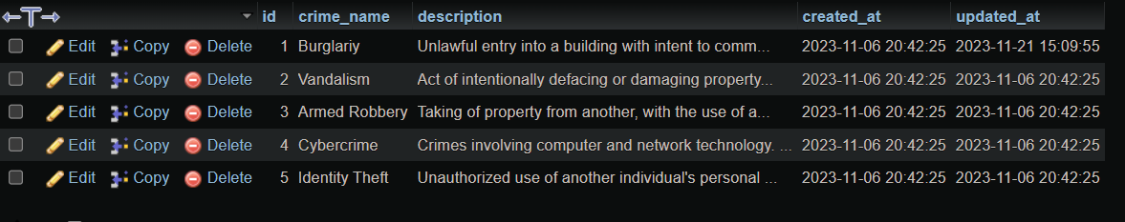

Within POST

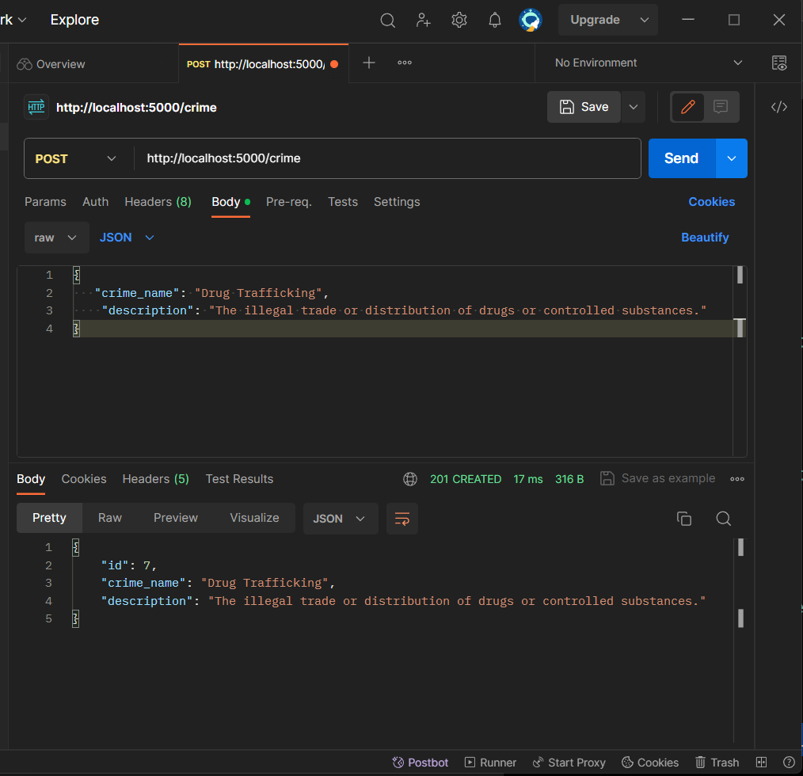

After POST

PUT: Localhost/crime/<int:id> – will update specific crime in the database

Before update Id 7

Within Update ID 7

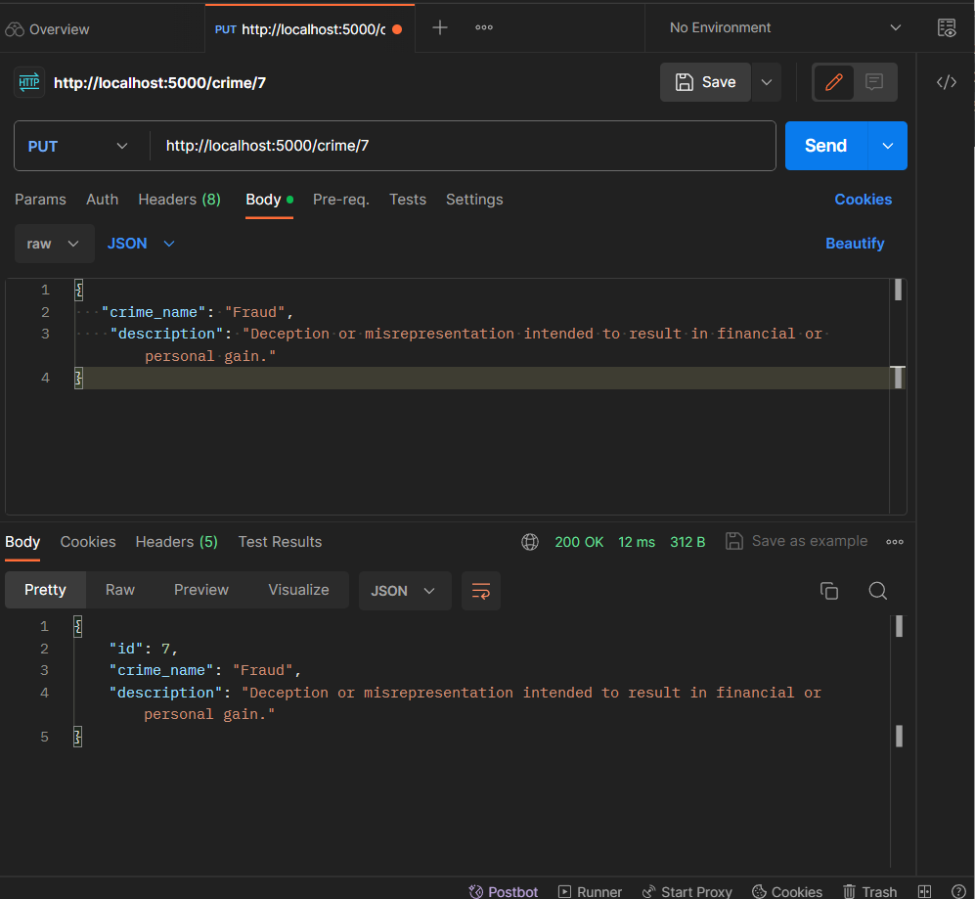

After Update using PUT

DELETE: Localhost/crime/<int:id> – will DELETE specific crime in the database

Before delete ID 7

Within DELETE ID 7 using POST method

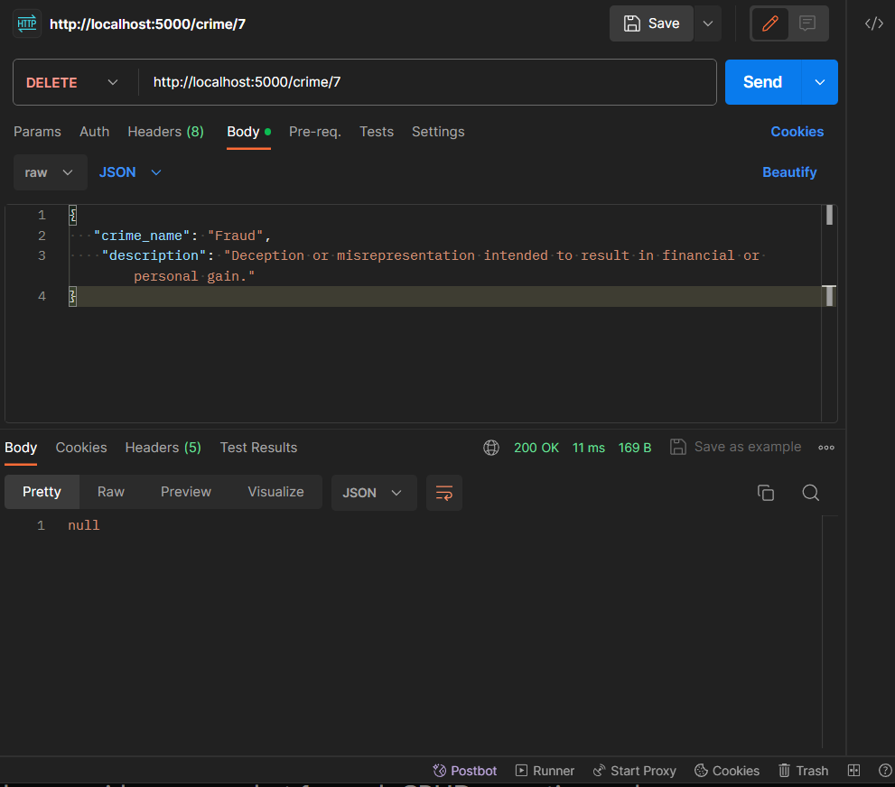

After DELETE ID 7 using delete method

GET: Localhost/cell – will retrieve all cell in the database

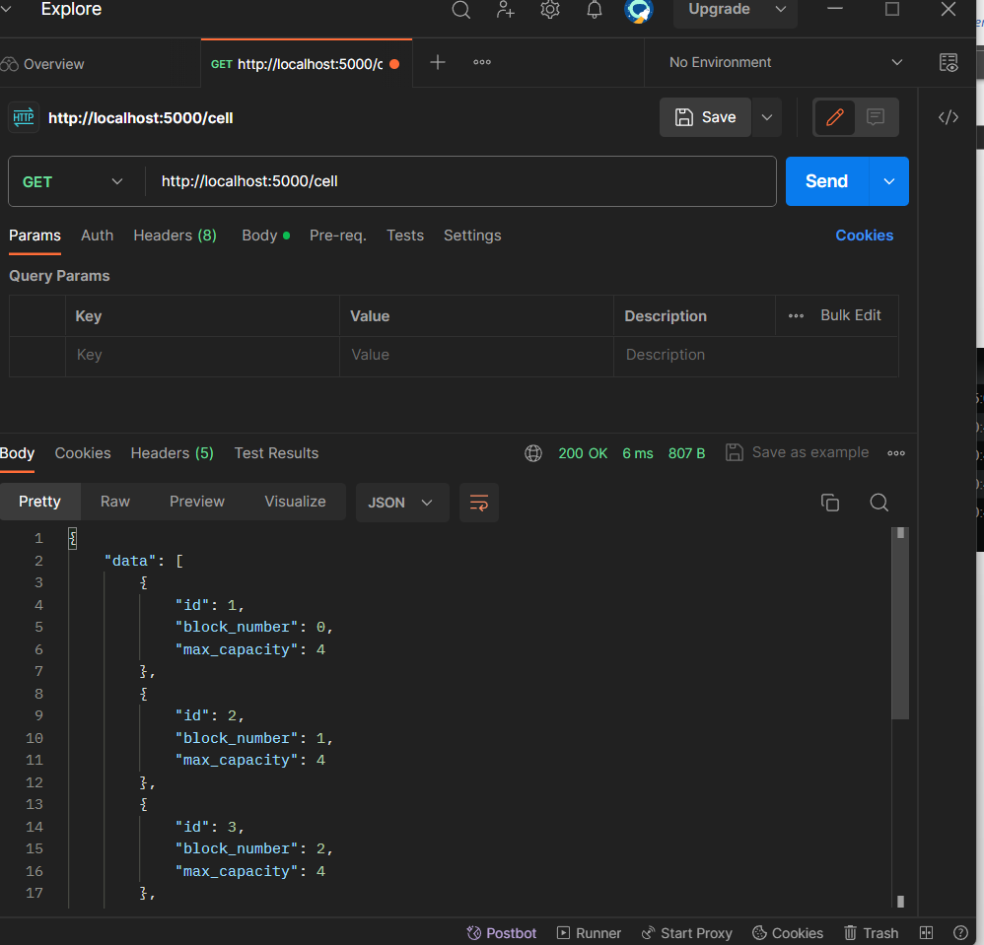

POST: Localhost/cell – will create a new cell in database

Before POST in database

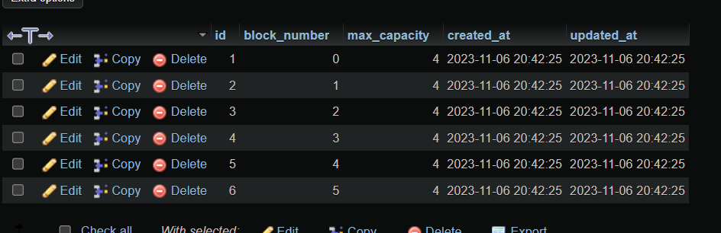

Within POST in cell table

After POST in database

PUT: Localhost/cell/<int:id> – will update specific cell in the database

Before PUT In database

Within PUT using put method

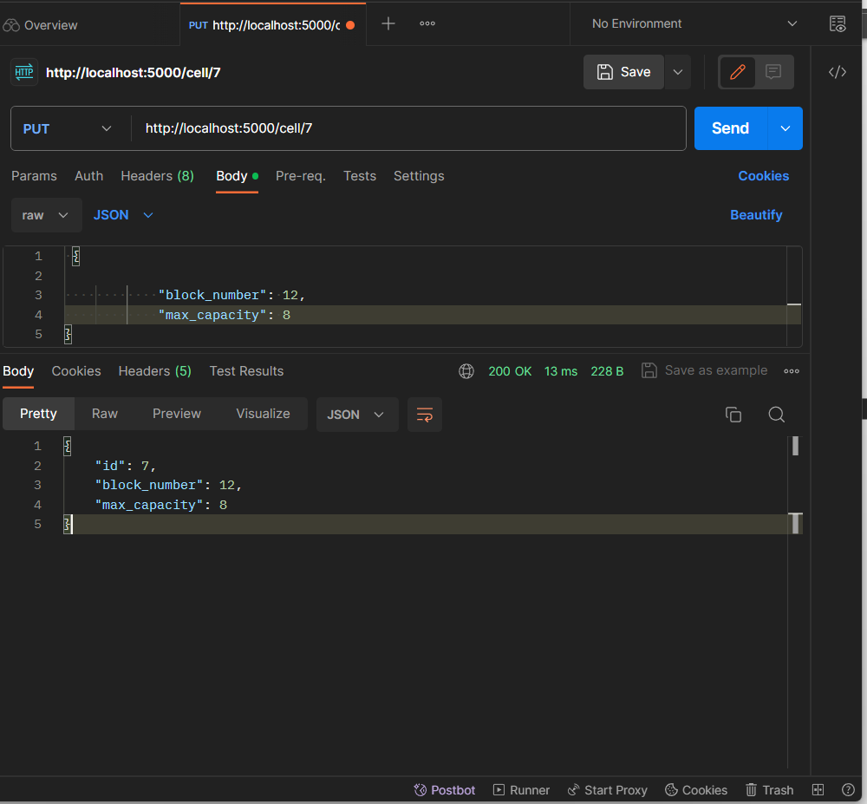

After PUT method in Database

Delete: Localhost/cell/<id> – will delete a specific cell in database based on id

Before deleting Id 7

Within delete id 7 using DELETE Method

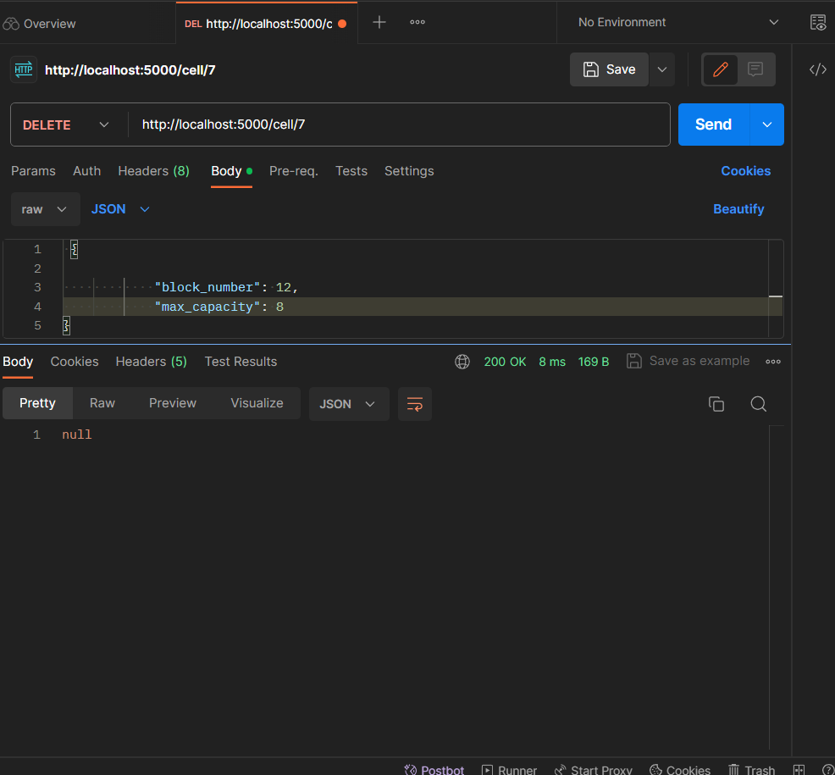

After delete in database

GET: Localhost/prisoner – will retrieve all prisoner data in database

POST: Localhost/prisoner – will create a prisoner data in database

Before POST in database

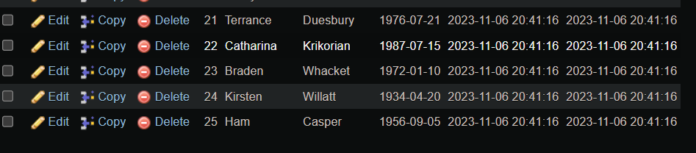

Within POST data in database

After POST in database

Put: Localhost/prisoner/<id> – will update specific prisoner in database

Before updating prisoner id 51

Within Updating prisoner ID 51

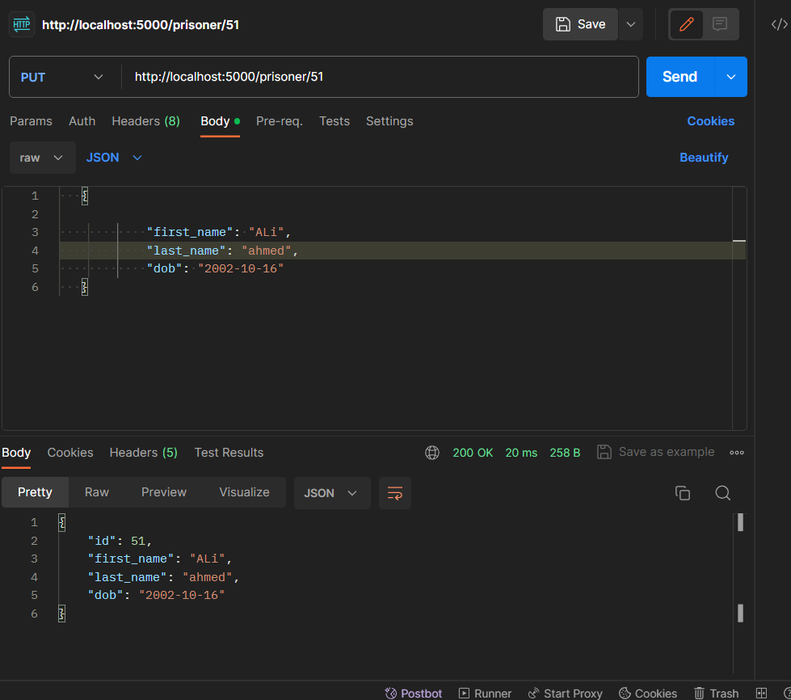

After updating in the database

GET: Localhost/prcrime – will retrieve all the prisoner crimes in database

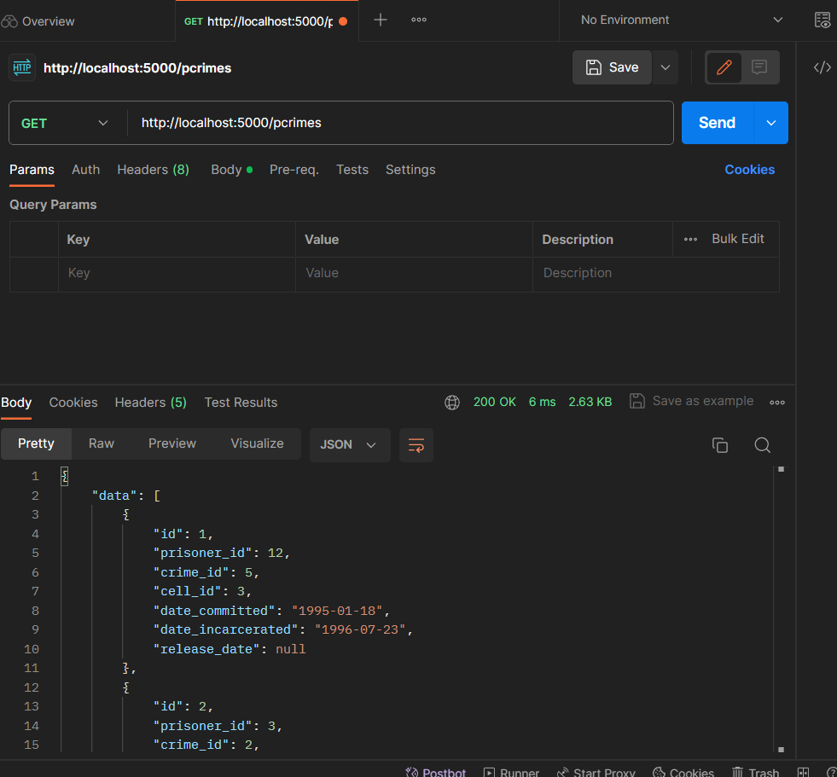

POST: Localhost/prcrine – will will create a new crime for a prisoner in database

Before creating a prisoner crime

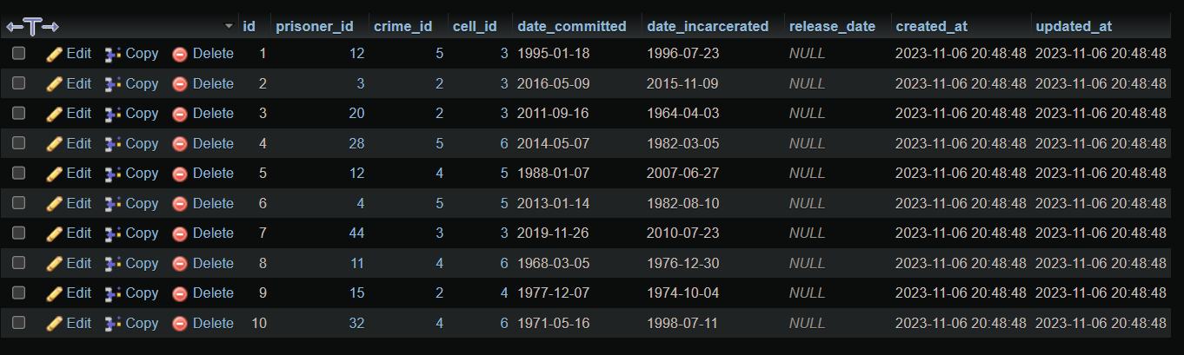

Within creating a a prisone crime in database

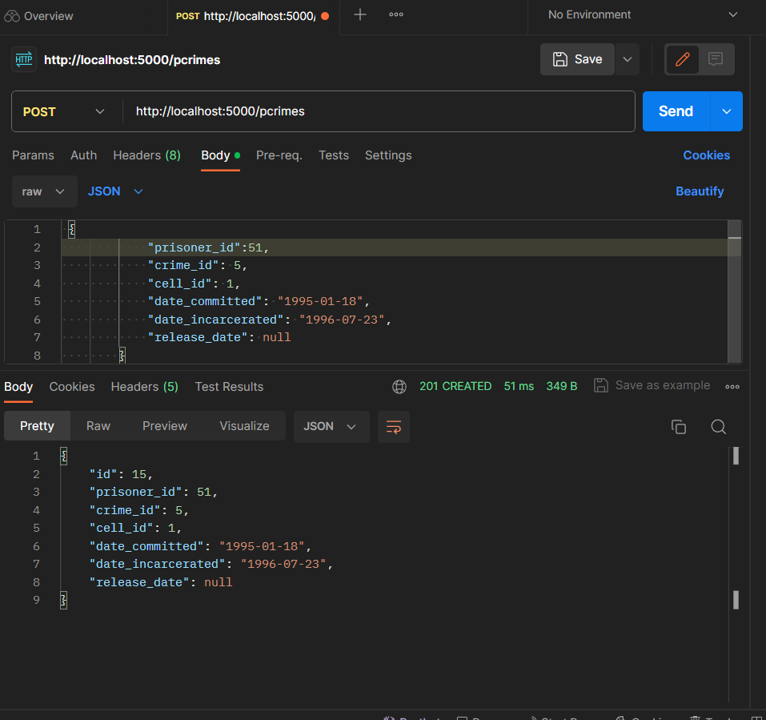

After creating a prisoner crime data in database

PUT: Localhost/prcrime/<id> – will update a prisoner crime data release date

Before updating in database id of 15

Within updating the release date of id 15

After updating in database id

