Smart Attendance System using Facial Image Recognition
Senior Design Project (Part I & II)

Submitted by:
Hassaan Ahmed | FCSE
Osaid Khan Afridi | FCSE
Saad Khan | FEE
Najaf | FEE

Advisor: Dr. Zaiwar Ali
Co-advisor: Dr. Arbab Abdur Rahim


Faculty of Electrical Engineering
GIK Institute of Engineering Sciences and Technology
Topi, District Swabi, Khyber Pakhtunkhwa, Pakistan
www.giki.edu.pk
April 2026

Dedicated to our dear homeland, Pakistan, and to the
teachers, families, and friends who made this journey possible.

Certificate of Ownership

It is certified that the work contained in this final year project report titled:
“Smart Attendance System using Facial Image Recognition”
has been carried out through the collective efforts of Hassaan Ahmed, Osaid Khan Afridi, Saad Khan, and Najaf under the supervision of Dr. Zaiwar Ali and the co-supervision of Dr. Arbab Abdur Rahim, and that to the best of our knowledge this work has not been submitted elsewhere for the award of any academic degree.
________________________________________
Advisor: Dr. Zaiwar Ali
Faculty of Electrical Engineering
GIK Institute of Engineering Sciences and Technology
________________________________________
Co-advisor: Dr. Arbab Abdur Rahim
Dean, Faculty of Electrical Engineering
GIK Institute of Engineering Sciences and Technology
Date of submission: 15th April 2026

Preface

Attendance in universities has historically been handled through roll-call or paper registers — a workflow that consumes classroom time, is prone to proxy attendance, and produces data that is hard to audit or aggregate at a departmental level. At the same time, smartphones have made it trivial to capture a high-resolution classroom photograph in seconds. This juxtaposition motivated the present project: can a simple classroom photograph replace the manual attendance register, while producing more accurate, more tamper-resistant records?
The system described in this report answers that question. It is a production-style full-stack application consisting of a React frontend for teachers and administrators, a Node.js/TypeScript backend with role-based authentication and a Prisma-managed SQLite database, and a Python FastAPI AI service that performs face detection (MTCNN with a RetinaFace fallback) and face recognition (FaceNet 512-d embeddings followed by a custom 128-d projection head trained with triplet loss, backed by a support-vector-machine classifier). The recognition pipeline achieves 86% recognition rate on unseen classroom group photographs across 14 test sessions and 243 faces drawn from two student batches of the GIK Institute.
For readers who study full-stack or machine-learning systems, this report documents not just the final state of the system but also the design decisions, ablations, and lessons learned along the way — including why a cosine-distance ArcFace pipeline was abandoned in favour of a Euclidean-distance FaceNet pipeline, how a small domain-adapted projection head bridges the gap between controlled selfie enrollment and uncontrolled classroom photographs, and why quality filters and margin-based confidence scoring matter for correctness as much as raw accuracy numbers.

Acknowledgments
We are grateful to Almighty Allah for providing us with knowledge, courage, patience, and strength throughout this project, and for the continuous support of our families, without which this work would not have been possible.
We extend our deepest gratitude to our advisor, Dr. Zaiwar Ali, whose guidance, availability, and technical insights consistently steered the project in the right direction. His willingness to engage with the details — from choice of face-recognition backbone to the design of our enrollment workflow — turned what could have been a purely academic exercise into an end-to-end system we could defend with data.
We are similarly indebted to our co-advisor, Dr. Arbab Abdur Rahim, Dean of the Faculty of Electrical Engineering, for his support, administrative guidance, and the resources he made available at critical points during the project.
We also thank the many students of the 2022 and 2023 batches who agreed to contribute their selfie photographs and classroom images to our dataset, and the teaching staff of the Faculty of Electrical Engineering for their feedback during early user-testing sessions. Finally, we thank GIK Institute of Engineering Sciences and Technology for providing us with the environment, laboratories, and academic freedom to pursue this work.
Hassaan Ahmed, April 2026
Osaid Khan Afridi, April 2026
Saad Khan, April 2026
Najaf, April 2026

Table of Contents
Certificate of Ownership 4
Preface 5
Acknowledgments 6
Table of Contents 7
List of Figures 10
List of Tables 11
Abstract 12
Final Year Design Project as a Complex Engineering Problem 13
1. Introduction 15
1.1 Background and Motivation 15
1.2 Problem Statement 15
1.3 Scope of the Work and Expected Outcomes 16
1.4 Outline of Report 16
1.5 Project Management and Gantt Chart 17
1.6 Contribution by Group Members 17
2. Literature Review 19
2.1 Face Detection 19
2.2 Face Recognition and Embeddings 19
2.3 Domain Adaptation for Face Recognition 19
2.4 Classifier Layer: SVMs for Face Identification 20
2.5 Comparable Systems 20
2.6 Reasoning Taken from the Literature 21
3. System Design and Architecture 22
3.1 Overview 22
3.2 Frontend 22
3.3 Backend 23
3.4 Database Schema 23
3.5 AI Service 24
3.6 Request Flow for an Attendance Session 24
3.7 REST API Surface 25
3.8 Summary 26
4. Face Recognition Pipeline 27
4.1 Pipeline Overview 27
4.2 Image Ingestion and Resize 27
4.3 Face Detection 27
4.4 Face Preprocessing and Quality Assessment 27
4.5 FaceNet Embedding 28
4.6 Projection Head 28
4.7 Matching Strategy 29
4.8 Deduplication 30
4.9 Hyperparameter Summary 30
5. Results and Discussion 31
5.1 Dataset 31
5.2 Model Evolution 31
5.3 Threshold Ablation 32
5.4 Per-Photo Results 32
5.5 Ablation Study 33
5.6 Processing Time 33
5.7 Failure Analysis 34
5.8 Discussion 34
6. Impact and Economic Analysis 35
6.1 Sustainable Development Goals 35
6.2 Social Impact 35
6.3 Economic Analysis 35
6.4 Sustainability Analysis 35
6.5 Hazard Identification and Safety Measures 36
6.6 Standards 36
6.7 Summary 36
7. Conclusion and Future Recommendations 37
7.1 Conclusion 37
7.2 Future Recommendations 37
References 38
Appendix A: Database Schema 40
A.1 User and Authentication Tables 40
A.2 Core Academic Tables 40
A.3 Scheduling and Enrollment 40
A.4 Attendance Tables 40
A.5 Audit and Derived Storage 40
Appendix B: API Reference (Condensed) 41
B.1 Authentication 41
B.2 Admin Endpoints 41
B.3 Teacher Endpoints 41
B.4 AI Service Endpoints 41
Appendix C: Training Configuration 42
C.1 Projection Head Training 42
C.2 SVM Training 42
C.3 Enrichment Script 42
Appendix D: Deployment Notes 43
D.1 Topology 43
D.2 Process Supervision 43
D.3 Backups 43
D.4 Restore Procedure 43
Appendix E: User Guide (Quick Reference) 44
E.1 Admin Workflow 44
E.2 Teacher Workflow 44
E.3 Troubleshooting 44

List of Figures
Figure 3.1 High-level system architecture
Figure 3.2 Simplified entity-relationship diagram
Figure 3.3 Attendance session data flow
Figure 4.1 Face recognition pipeline
Figure 4.2 Projection head training curves
Figure 4.3 Intra- vs inter-class distance distribution
Figure 5.1 Threshold ablation (recall vs false-positive rate)
Figure 5.2 Model comparison: ArcFace vs FaceNet vs FaceNet + projection
Figure 5.3 Recognition performance across test photos
Figure 1.1 Project Gantt chart

List of Tables
Table 1.1 Contribution of team members
Table 2.1 Comparison of surveyed face-recognition backbones
Table 3.1 Core database entities
Table 3.2 REST API endpoints (summary)
Table 4.1 Face quality filter thresholds
Table 4.2 Recognition pipeline hyperparameters
Table 5.1 Per-photo recognition results
Table 5.2 Ablation study: impact of pipeline components
Table 6.1 Alignment with UN Sustainable Development Goals

Abstract
Manual classroom attendance is slow, error-prone, and susceptible to proxy responses. This report presents a full-stack Smart Attendance System that replaces the traditional roll-call workflow with a single classroom photograph. A teacher uploads the image through a React dashboard; a Node.js/TypeScript backend authenticates the session and forwards the image to a Python FastAPI AI service; the service detects every face using MTCNN with a RetinaFace fallback, filters low-quality crops, generates a 512-d FaceNet embedding for each face, and passes the embeddings through a lightweight 128-d projection head trained with triplet loss on the institute's own dataset to bridge the domain gap between selfie enrollment and uncontrolled classroom photos. Matching is performed by minimum L2 distance against stored student encodings, with a support-vector-machine classifier providing an independent confirmation signal and a margin-based confidence score flagging ambiguous matches for teacher review. The system enrolls 113 students across two batches with 4,134 embeddings in total; on 14 held-out classroom group photographs containing 243 faces it attains an overall recognition rate of 86%, reaching 100% on nine of those photographs while processing each image in one to five seconds on commodity hardware. The remaining errors cluster on small, pose-extreme faces in dense groups — cases where an additional photograph or simple manual override is a practical fallback. The report documents the complete engineering trajectory, including two major model pivots (ArcFace → FaceNet → FaceNet + projection head) and the threshold, margin, and resolution ablations that drove the final configuration.
Keywords:
face recognition, attendance system, MTCNN, FaceNet, triplet loss, projection head, support vector machine, full-stack application, Node.js, FastAPI, React, Prisma.

Final Year Design Project as a Complex Engineering Problem
The Washington Accord defines a Complex Engineering Problem (CEP) as one that cannot be resolved without in-depth engineering knowledge and that simultaneously satisfies several of the attributes listed below. This section argues that the Smart Attendance System meets every one of these attributes and therefore qualifies as a CEP in the sense intended by the accreditation framework.
In-depth engineering knowledge (WK1–WK4): Solving the project required deep-learning theory (FaceNet, MTCNN, triplet loss, SVM classification), software-engineering practice (REST API design, relational schema design, JWT authentication, role-based access control), and systems engineering (multi-service orchestration, image pipelines, request tracing, and timeouts). No single undergraduate course covered more than a slice of this body of knowledge.
Range of conflicting requirements: Recognition accuracy, processing latency, and dataset effort pull in opposite directions. A larger resize preserves detail but slows detection; a tighter threshold reduces false positives but misses real matches; a deeper projection head discriminates better on the training set but may overfit a limited dataset. Every major design decision in Chapters 3–4 resolved such a conflict.
Depth of analysis required: The final recognition threshold, margin filter, and resize resolution are the outputs of controlled ablation studies (Chapter 5), not intuition. The team compared ArcFace against FaceNet, ran a triplet-loss training on held-out students, and measured recall vs false-positive rate across eight thresholds before committing to the production values.
Familiarity of issues: Domain-gap problems between controlled enrollment photos and uncontrolled deployment photos are well known in the face-recognition literature, but the specific manifestation here — classroom group photos with dozens of small faces, variable lighting, and partial occlusion — demanded a project-specific solution, namely the enrichment step that adds classroom crops to the enrollment store.
Extent of applicable codes: The system handles personally-identifiable biometric data and must therefore be designed with ISO/IEC 27001 (information-security management) and ISO 9001:2015 (quality management) in mind, even though no formal audit is performed. Data-protection obligations under Pakistan’s draft Personal Data Protection Bill also shape our approach to encoding storage and retention.
Extent of stakeholder involvement: Teachers, students, departmental administrators, and IT staff all have different needs — teachers want a one-click workflow, students want privacy and fairness, administrators want auditable logs, and IT staff want predictable resource usage. The system’s role-based access control and manual-override UI emerged directly from those conflicting expectations.
Interdependence: A change in resize resolution cascades through MTCNN crop sizes, FaceNet embeddings, projection-head responses, and SVM scores; no component could be tuned in isolation. This interdependence is characteristic of a CEP.

1. Introduction

1.1 Background and Motivation
Taking attendance is one of the oldest classroom rituals: the teacher reads names, students respond, marks are scribbled in a register, and the register is eventually copied into a departmental spreadsheet. At GIK Institute — a university where many courses enroll between thirty and sixty students — this ritual consumes between five and ten minutes of every lecture. Scaled across a full semester of twenty-four contact sessions, that is roughly four hours of lost instruction per course per section, or, if every course followed the same pattern, more than two hundred hours of classroom time consumed by administrative overhead at the faculty level per semester.
The cost is not only temporal. The manual workflow is also error-prone. Students who arrive late are often marked absent by mistake; students who attend occasionally persuade classmates to answer on their behalf (proxy attendance); registers are lost or transcribed incorrectly; and the aggregated data available to faculty offices rarely reflects the reality of day-to-day attendance. Academic rules that depend on attendance — the 75% attendance threshold for permission to sit final examinations, for example — therefore run on data of uneven quality.
Three trends argue that this need not be the case. First, high-resolution cameras are universal: almost every teacher carries a smartphone capable of capturing a 3024×4032 pixel image of the classroom. Second, deep-learning face recognition has matured dramatically. Models such as FaceNet [Schroff et al., 2015] achieve above 99% accuracy on standard face verification benchmarks, and open-source detectors such as MTCNN [Zhang et al., 2016] run on commodity CPUs in seconds. Third, the software stack needed to wrap these models in a usable web application — a JavaScript frontend, a typed backend, a managed database, and a Python AI service — is by 2026 a familiar, maintainable set of tools that any mid-size institute can host on its own infrastructure.
Put these trends together and a different attendance workflow becomes plausible. A teacher enters the classroom, takes a single photograph, uploads it through a browser tab, and sees an annotated image in which every enrolled student's face is identified with a confidence score. The teacher skims the results, corrects a handful of low-confidence matches, and submits. Total time: well under one minute. That is the workflow this project set out to build and to validate with real classroom data.

1.2 Problem Statement
Manual classroom attendance is slow, error-prone, and vulnerable to proxy attendance, while modern smartphone cameras and open-source face-recognition models make a photograph-based alternative technically feasible. The problem addressed by this project is to design and implement a reliable, production-grade attendance system that (i) takes a classroom group photograph as its only per-session input from the teacher, (ii) identifies every enrolled student in the photograph with a published confidence score, (iii) allows the teacher to verify and adjust the results before the session is finalized, and (iv) persists auditable attendance records in a manner that faculty administrators can inspect and aggregate. The system must handle the realistic range of classroom photographs — variable lighting, small or partially-occluded faces, pose variation — while preserving student privacy through role-based access control and local-only encoding storage.

1.3 Scope of the Work and Expected Outcomes
The scope of the project covers:
- A web-based full-stack application (React frontend, Node.js + Express + TypeScript backend, Python FastAPI AI service) deployable on a single Linux server with modest hardware requirements (4 CPU cores, 8 GB RAM).
- Role-based access control with two roles: Admin (student, course, and timetable management) and Teacher (attendance marking and history).
- A face-recognition pipeline that attains ≥ 85% recognition rate on the institute's own classroom photographs.
- Enrollment of at least 100 students with 3–10 selfie photographs each, plus enrichment from classroom group photos to bridge the domain gap.
- Per-photo processing latency under 10 seconds for images up to 4K resolution.
- Auditable attendance records persisted in a relational database, with an admin interface to browse audit logs.
The following are explicitly out of scope:
- Hardware camera deployment (dedicated classroom cameras, Raspberry-Pi capture nodes, or embedded IoT devices).
- Mobile-native applications; the system is browser-only.
- Formal security certification under ISO/IEC 27001 or similar frameworks.
- Cloud-scale elasticity (horizontal auto-scaling, multi-region deployment).
Expected outcomes at the conclusion of the project are:
- A running, demonstrable web application with seeded admin and teacher accounts.
- A face-recognition service achieving the accuracy targets outlined above, validated on held-out classroom photographs.
- A reproducible training pipeline for the projection head and SVM classifier, documented in this report and in the project repository.
- A written report (this document) describing the system and its empirical evaluation.

1.4 Outline of Report
The remainder of this report is organised as follows. Chapter 2 surveys the face-recognition literature that informed our design choices. Chapter 3 describes the overall system architecture — frontend, backend, database, and AI service — and the data flow for an attendance session. Chapter 4 details the recognition pipeline itself, including detection, preprocessing, embedding, projection-head training, matching, and deduplication. Chapter 5 reports the empirical evaluation: dataset statistics, ablation studies, and per-photo results. Chapter 6 discusses impact, sustainability, and stakeholder considerations. Chapter 7 concludes and outlines future work. Appendices contain the complete database schema, the REST API reference, and the hyperparameters used during training.

1.5 Project Management and Gantt Chart
The project spanned twenty-two weeks across the fall 2025 and spring 2026 semesters. Weekly advisor meetings kept scope aligned, and weekly internal meetings split work along faculty lines: the two FCSE members handled backend, frontend, and AI integration while the two FEE members led dataset collection, enrollment workflow, and hardware/deployment planning. The Gantt chart in Figure 1.1 shows the high-level timeline.
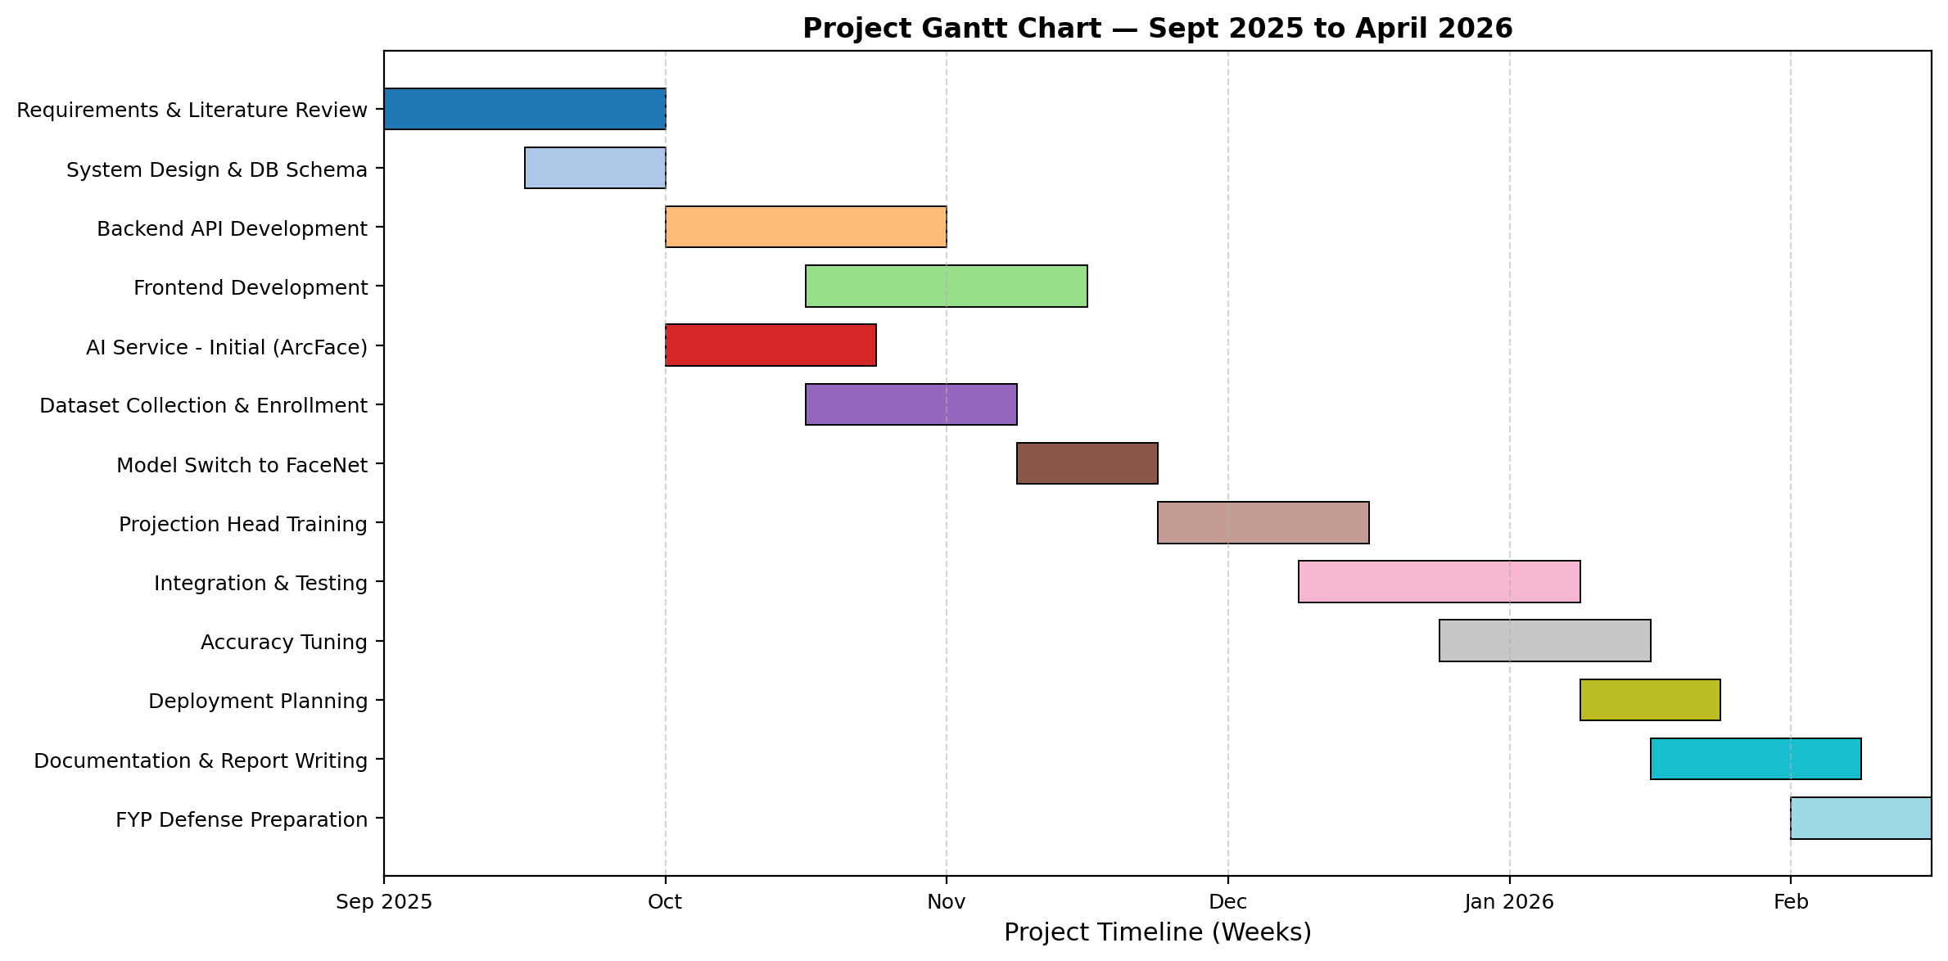
Figure 1.1: Project Gantt chart showing major phases across September 2025 – April 2026.

1.6 Contribution by Group Members
While every decision was made collectively, day-to-day responsibilities were divided as summarized in Table 1.1.
Table 1.1: Contribution of team members.
Team Member | Department | Primary Responsibilities
Hassaan Ahmed | FCSE | Backend (Node.js + Express + Prisma), AI service integration, recognition pipeline engineering, database schema design, authentication & RBAC, overall system architecture.
Osaid Khan Afridi | FCSE | Frontend (React + Vite), teacher/admin dashboards, attendance session UI, API client, results-review interface, UX polish.
Saad Khan | FEE | Dataset collection & curation, enrollment workflow, model evaluation, projection-head training experiments, testing protocol.
Najaf | FEE | Hardware/deployment research, networking, documentation, user-acceptance testing, Gantt tracking.

2. Literature Review

2.1 Face Detection
Modern face detection is a mature field. The Viola-Jones detector [2001] introduced a cascade of Haar-feature classifiers that still ships with OpenCV; it is fast but brittle on non-frontal poses and non-uniform lighting, both of which dominate classroom photographs. Deep-learning-based detectors supplanted Viola-Jones in the mid-2010s. MTCNN [Zhang et al., 2016] uses a three-stage cascade of convolutional neural networks (P-Net, R-Net, O-Net) to jointly predict bounding boxes and five facial landmarks. RetinaFace [Deng et al., 2020] builds on feature-pyramid networks and adds dense five-point landmarks and a mesh regression branch, giving very high accuracy on small and profile faces at the cost of roughly 3× the MTCNN inference time.
For our use case — a single classroom image with dozens of faces and CPU-only hosting — we adopted a hybrid strategy: MTCNN as the primary detector at two scales (full-resolution and 640-px), with RetinaFace invoked as a secondary detector when it is available in the deployment environment. Duplicates across the two detectors are merged by non-maximum suppression with an intersection-over-union threshold of 0.4. This multi-detector strategy reliably picks up small and partially-occluded faces that either detector alone would miss.

2.2 Face Recognition and Embeddings
Face recognition is conventionally posed as two problems: verification (“are these two faces the same person?”) and identification (“who is this face?”). Modern systems solve both by learning an embedding — a fixed-length vector in a high-dimensional space — such that the embeddings of the same person are close (by Euclidean or cosine distance) and embeddings of different people are far apart.
FaceNet [Schroff et al., 2015] introduced the triplet-loss formulation and produced 128- or 512-d embeddings trained on roughly 200 million images. It reports 99.63% accuracy on the Labeled Faces in the Wild (LFW) benchmark. The keras_facenet implementation we used exposes a FaceNet model pre-trained on VGGFace2, producing 512-dimensional embeddings.
ArcFace [Deng et al., 2019] replaces the triplet loss with an angular additive margin on the softmax classification of training identities. On benchmarks ArcFace edges out FaceNet (~99.82% on LFW), and the InsightFace library provides an accessible CPU implementation. Our initial pipeline used ArcFace, but we observed that the cosine-distance similarity between a student's selfie enrollment and his or her classroom crop was systematically lower than between two classroom crops of different students — a domain-gap phenomenon more pronounced with ArcFace than with the older, triplet-trained FaceNet. We therefore migrated to FaceNet after a controlled comparison (reported in Chapter 5).

2.3 Domain Adaptation for Face Recognition
A recurring issue in deployed face-recognition systems is the domain gap between enrollment photographs (usually frontal, well-lit, close-cropped selfies) and recognition photographs (ambient lighting, off-axis poses, small crops). The standard palliatives are either (a) enrolling students from in-domain photographs when possible, or (b) training a lightweight adapter on a small in-domain dataset. Projection heads trained with triplet loss — popularized in self-supervised learning [Chen et al., 2020, SimCLR] and since applied to face recognition by several industrial teams — take a pretrained backbone embedding (here, FaceNet's 512-d vector) and learn a small feed-forward network that produces a more discriminative in-domain embedding.
We adopted this approach: a 512 → 256 → 128 dense network with ReLU activations, batch normalisation, and a final L2-normalisation layer, trained with a triplet margin of 0.3 for up to eighty epochs with early stopping. The projection head training dataset is built from the same enrollment encodings the system already stores; the positive pairs come from the same student's multiple selfies and enriched classroom crops, and the negatives are sampled uniformly across the other 112 students.

2.4 Classifier Layer: SVMs for Face Identification
Once an embedding space is learned, identification can be performed by nearest-neighbour search (minimum Euclidean distance) or by a learned classifier. Radial-basis-function SVMs were a standard choice in the pre-deep-learning era and remain competitive as a confirmation layer: they produce a calibrated probability for each class, they are cheap to retrain when new students enroll, and they give independent evidence that does not fully correlate with the nearest-neighbour distance. Our system uses an RBF-kernel SVM with hyperparameters chosen by three-fold grid search (C ∈ {1, 10, 50, 100}, gamma ∈ {scale, auto}) trained on all 4,134 projected encodings.

2.5 Comparable Systems
A number of commercial and academic systems address classroom attendance with face recognition. Products such as NEC NeoFace, Megvii Face++, and Amazon Rekognition offer turnkey cloud APIs; however, they carry per-image or subscription fees that make them impractical for a university with dozens of parallel sections, and they require sending biometric data off-premises. Academic work — for example Lamba et al. [2021] and Aravind et al. [2019] — reports systems with single-digit-student datasets and rarely tackles the dense-classroom case of thirty to forty simultaneous faces. Our system positions itself in this gap: on-premises deployment, full-stack workflow, institute-scale dataset, and an explicit focus on uncontrolled classroom photographs.
Table 2.1: Comparison of surveyed face-recognition backbones.
Backbone | Output dim | LFW Acc. | In-Domain Behaviour (our tests)
ArcFace (iResNet-100) | 512 | ~99.82% | Strong on frontal selfies; poorer generalization from selfie to classroom crop on our dataset.
FaceNet (Inception-v1) | 512 | ~99.63% | More stable across selfie/classroom gap; chosen as production backbone.
FaceNet + projection head | 128 | n/a | Best intra-/inter-class separation on our dataset; tighter threshold possible; final production model.

2.6 Reasoning Taken from the Literature
From the literature we drew four concrete design decisions: (i) use a multi-detector cascade rather than a single detector, to tolerate small and profile faces; (ii) prefer FaceNet over ArcFace for our cross-domain setting despite ArcFace’s higher benchmark numbers; (iii) add a small projection head trained in-domain to bridge the selfie/classroom gap; and (iv) keep an SVM classifier as a second opinion that does not share the nearest-neighbour failure modes.

3. System Design and Architecture

3.1 Overview
The Smart Attendance System follows a classical three-tier architecture extended with a dedicated AI service. Figure 3.1 shows the high-level components and their interactions. The frontend is a React + Vite single-page application served as static assets; the backend is a Node.js + Express + TypeScript REST API that owns all persistent state through a Prisma-managed SQLite database; the AI service is a Python + FastAPI process that wraps the face-detection and face-recognition models. The three processes communicate over HTTP and are designed to be deployable on a single Linux host (our target is an Oracle Cloud Ampere A1 VM with 4 OCPU and 24 GB RAM, offered under Oracle’s always-free tier).
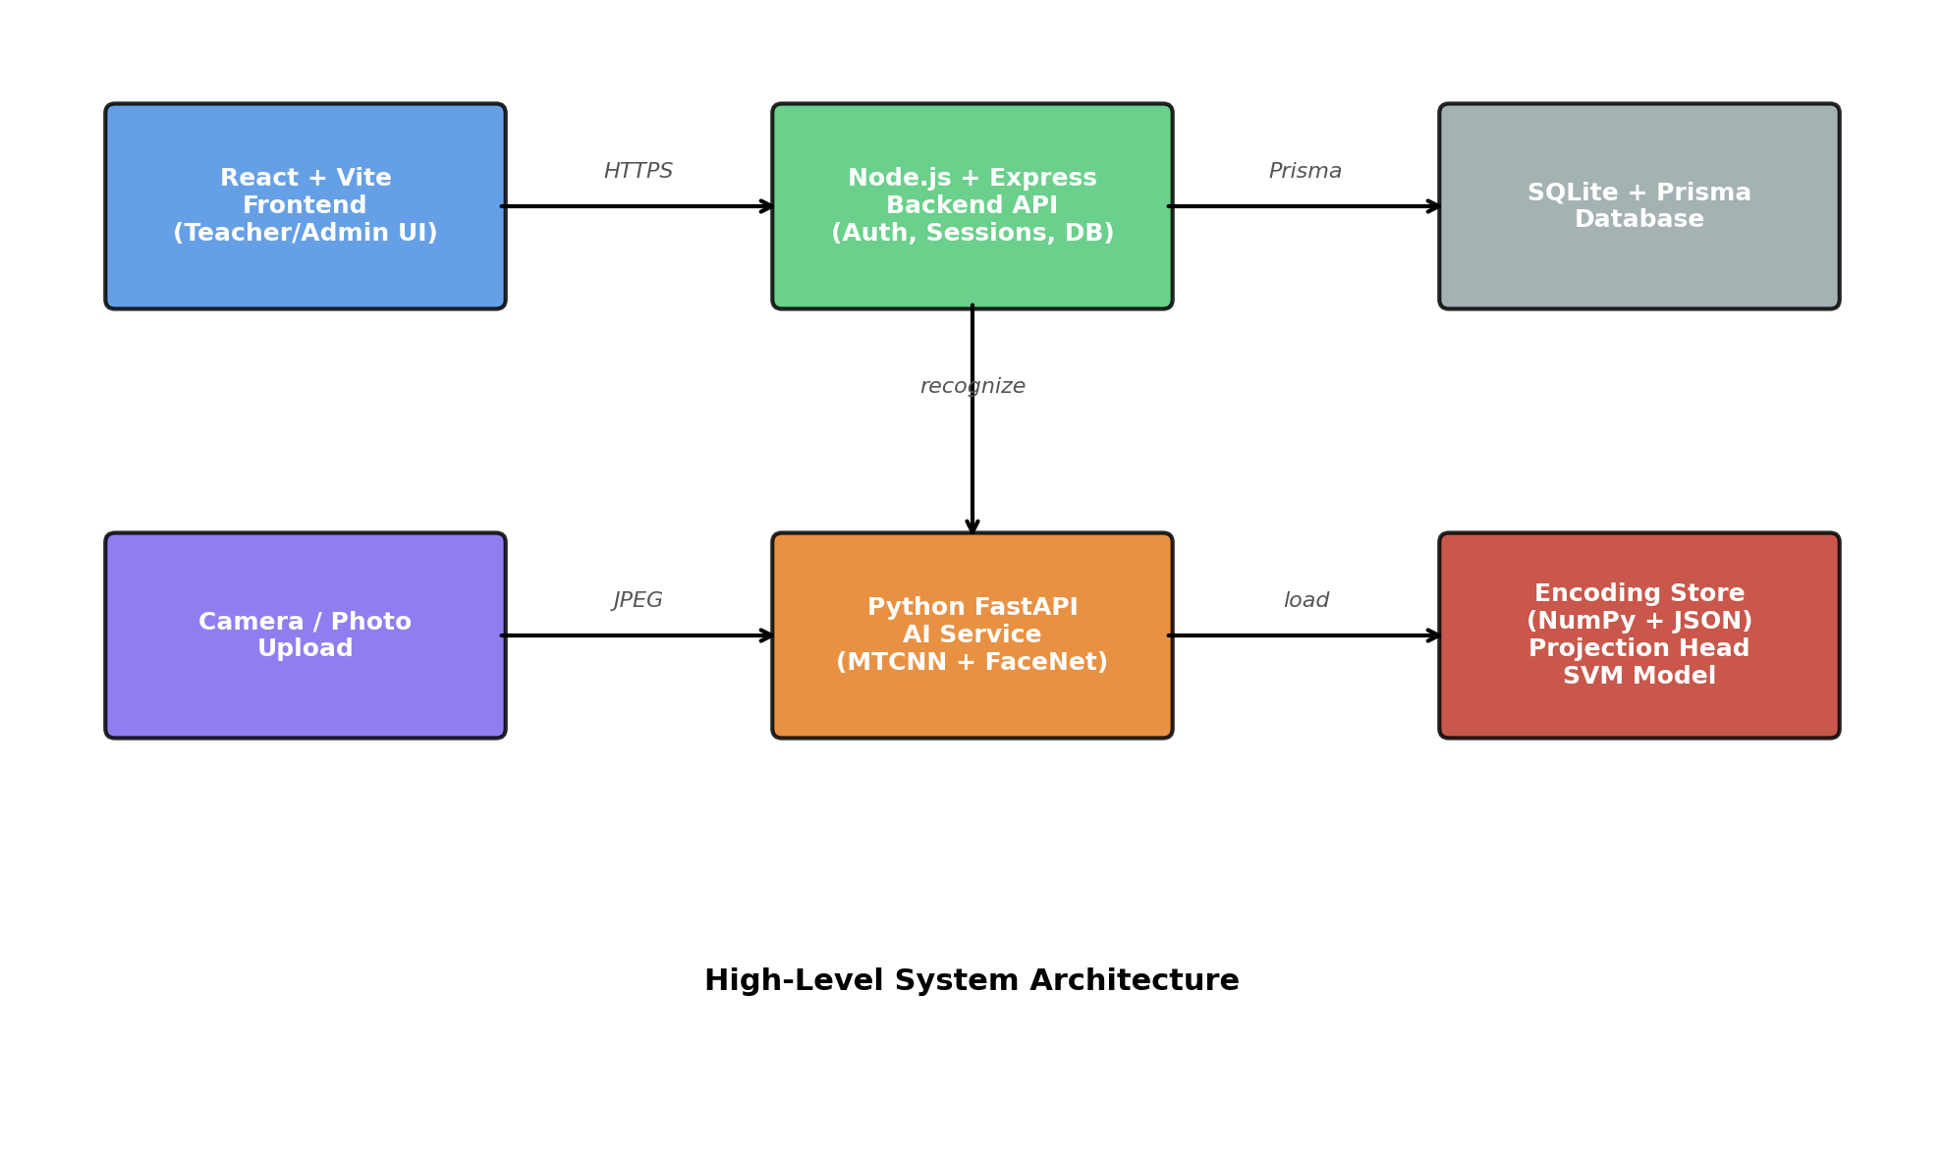
Figure 3.1: High-level system architecture.

3.2 Frontend
The frontend is built with React 18 and Vite 7; TypeScript is used for type safety. Routing is handled by React Router; state management follows a lightweight Context + hooks pattern with no external state library. The UI is divided into three role-specific dashboards: an Admin dashboard (student, teacher, course, classroom, and timetable CRUD; audit-log browser), a Teacher dashboard (schedule view, attendance session flow, attendance history), and a Testing dashboard used during development to call the recognition endpoint directly against arbitrary photographs.
The attendance session flow is the frontend’s most complex feature. The teacher selects a course, a date, and a time slot; the frontend creates a session record via the backend API and then presents an image-upload control. When the teacher submits a photograph, the frontend transparently forwards it to the backend and displays a loading indicator. On receipt of the recognition result, the UI renders the annotated image with bounding boxes, each labelled with the recognized student’s name and a coloured confidence pill (green ≥ 50%, yellow 15–49%, red < 15%). Below the image a reviewable list allows the teacher to flip any match from “Present” to “Absent”, override a misrecognition, or add a student who was missed. Only after the teacher clicks “Finalize” are attendance records persisted.

3.3 Backend
The backend is a standard Express application organised into feature modules (auth, students, teachers, courses, classrooms, timetables, attendance, audit, testing). Each module follows a strict four-file convention: service.ts holds business logic and the Prisma queries, controller.ts is the thin HTTP layer, validation.ts contains Zod-style request validation, and routes.ts registers the endpoints. This convention is mechanical enough that new endpoints can be added without reading more than the file that owns them, which paid dividends during the accelerated final weeks of implementation.
Authentication is based on JSON Web Tokens. On login, the backend returns a short-lived access token (15 minutes) and a long-lived refresh token (seven days). Refresh tokens are stored hashed in the database and a revocation table allows us to invalidate sessions. Role-based access control is enforced through two lightweight middleware functions, `adminOnly` and `teacherOnly`, which inspect the decoded JWT payload; many endpoints are wrapped in both to permit either role.

3.4 Database Schema
Persistent state lives in a Prisma-managed SQLite database. SQLite was chosen for ease of deployment (single-file database, no separate server process) and for its performance characteristics at the scale we target (thousands of students, tens of thousands of attendance records). Prisma provides a type-safe query builder and automatic migration tooling. The core entities are listed in Table 3.1, and their relationships are shown in Figure 3.2.
Table 3.1: Core database entities.
Entity | Purpose
User | Admin and teacher accounts; owns authentication fields.
Teacher | Profile extension of User for teachers (employee ID, office, etc.).
Student | Enrolled students; primary key is registration number.
Department, Batch | Reference tables for organisational grouping.
Course, TeacherCourseAssignment | Course catalogue and which teacher teaches what.
Classroom, TimetableSlot | Physical classrooms and the weekly timetable.
StudentEnrollment | M:N mapping of students to courses for a given term.
AttendanceSession, AttendanceRecord | A session is a single lecture instance; a record is one student’s status for that session.
FaceEncoding | Metadata; the actual NumPy arrays live on disk.
AuditLog | Append-only log of every sensitive operation.
RefreshToken | Hashed refresh tokens for JWT rotation/revocation.

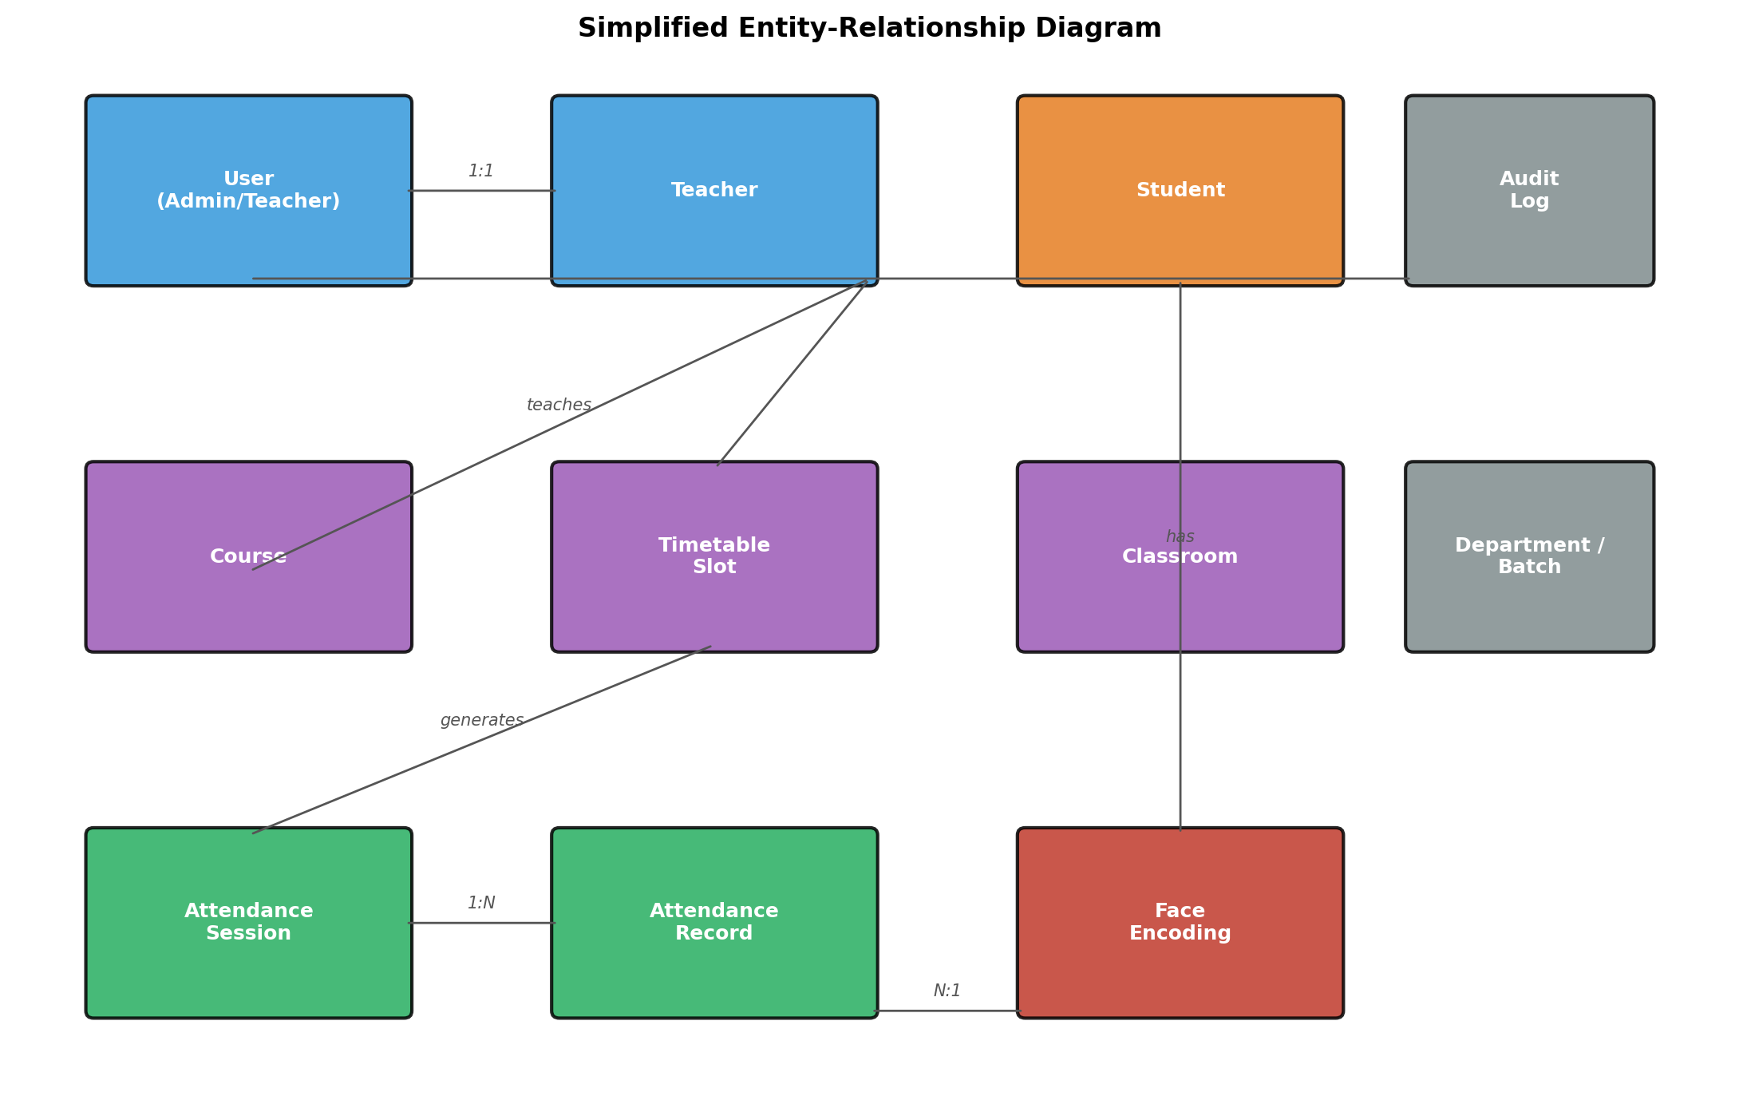
Figure 3.2: Simplified entity-relationship diagram.

3.5 AI Service
The AI service is a FastAPI application with three primary endpoints: `/api/v1/recognize` (process a classroom photo), `/api/v1/encodings` (enroll or delete a student), and `/api/v1/health` (readiness probe). Models are loaded once into memory at process start through a singleton ModelLoader class, which at present loads MTCNN, RetinaFace (optional), FaceNet, and the custom projection head. Requests are serviced in a thread-pool executor so that the asyncio event loop remains responsive under concurrent load.
The service is deliberately stateless: it does not know about courses, sessions, or teachers. It accepts a JPEG/PNG image and a JSON array of student IDs, and it returns a list of recognized students (with bounding boxes, names, and confidences) and a list of unknown faces. Keeping the AI service stateless means it can be scaled, restarted, and replaced independently of the backend.

3.6 Request Flow for an Attendance Session
Figure 3.3 traces an attendance session from the teacher’s first click to the finalized attendance records. The frontend never talks to the AI service directly; the backend brokers every call, enforces authentication, and attaches the list of enrolled student IDs to the recognition request so that the AI service constrains its search to students actually registered for the course.
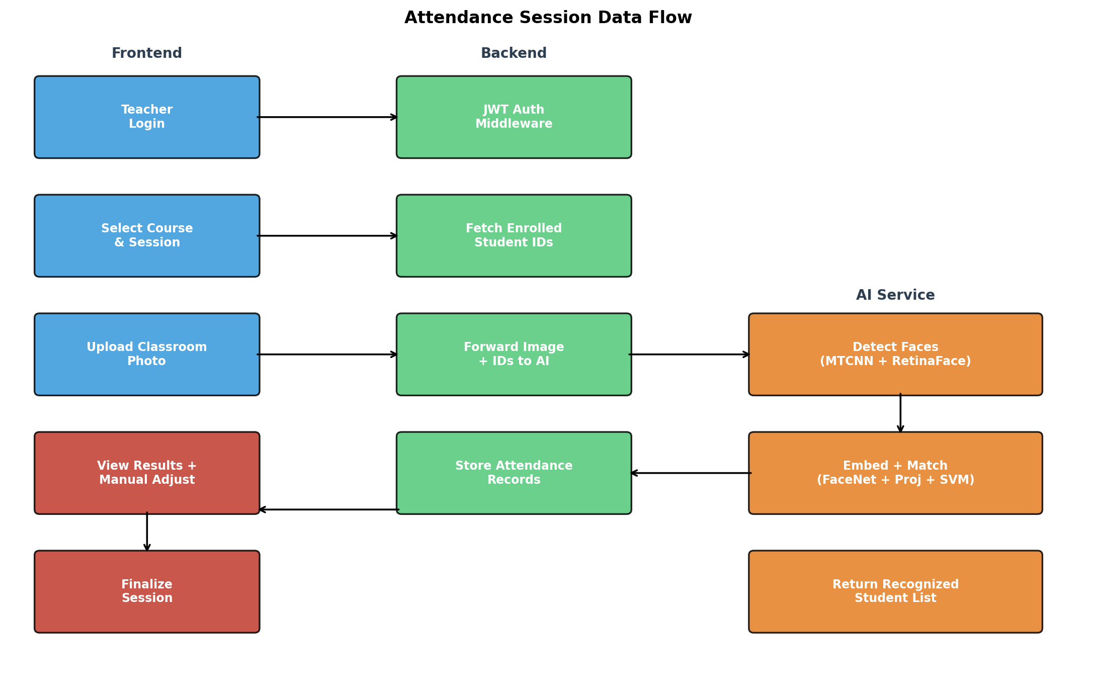
Figure 3.3: Attendance session data flow.

3.7 REST API Surface
Table 3.2 summarises the REST endpoints; full request/response shapes are given in Appendix B.
Table 3.2: Summary of REST API endpoints.
Group | Endpoint | Role
Auth | POST /auth/login, /refresh, /logout | Any
Auth | GET /auth/profile | Any
Admin | GET/POST/PUT/DELETE /admin/students | Admin
Admin | GET/POST/PUT/DELETE /admin/teachers | Admin
Admin | GET/POST/PUT/DELETE /admin/courses | Admin
Admin | GET/POST/PUT/DELETE /admin/classrooms | Admin
Admin | GET/POST/PUT/DELETE /admin/timetables | Admin
Admin | GET /admin/logs/audit, /attendance | Admin
Teacher | GET /teacher/schedule | Teacher
Teacher | POST /teacher/sessions | Teacher
Teacher | POST /teacher/sessions/:id/image | Teacher
Teacher | GET /teacher/sessions/:id | Teacher
Teacher | POST /teacher/sessions/:id/finalize | Teacher
AI | POST /api/v1/recognize | internal
AI | POST /api/v1/encodings | internal

3.8 Summary
The architecture cleanly separates concerns: the frontend is presentation-only, the backend is the system of record, and the AI service is a stateless, horizontally-replaceable inference engine. This separation made it possible to replace the recognition backbone twice (ArcFace → FaceNet → FaceNet + projection head) without touching the frontend or the database.

4. Face Recognition Pipeline

4.1 Pipeline Overview
Figure 4.1 shows the seven-stage recognition pipeline. Each stage is described in detail in the subsections below.
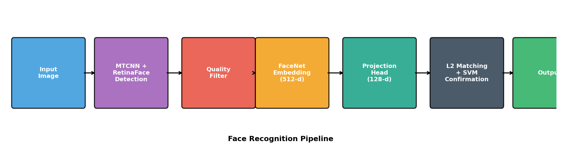
Figure 4.1: End-to-end face recognition pipeline.

4.2 Image Ingestion and Resize
Incoming classroom photographs range from 1920×1080 pixel phone snaps to 5712×4284 pixel DSLR photos. Processing a 5712-pixel image directly through MTCNN takes over sixty seconds on our target hardware — unacceptable for an interactive workflow. We therefore resize to a maximum dimension of 2048 pixels before detection, which reduces processing time to under five seconds while preserving sufficient detail for reliable recognition of faces down to about twenty pixels square. The resize uses OpenCV’s INTER_AREA interpolation for best downsampling quality.

4.3 Face Detection
Faces are detected by two complementary detectors working in parallel: MTCNN at the resized resolution, plus MTCNN at a further-reduced 640-pixel resolution to pick up tiny faces, plus RetinaFace when it is available. The union of detections is fed through non-maximum suppression with an intersection-over-union threshold of 0.4. A detection is kept if its bounding box is at least 10 pixels in each dimension and its confidence is at least 0.90.

4.4 Face Preprocessing and Quality Assessment
Each detected face is cropped exactly as MTCNN reports its bounding box (no alignment, no margin) — a deliberately simple choice that matched the approach used during enrollment and during training of the projection head. The cropped RGB patch is then passed through a quality filter (Table 4.1) that rejects tiny, blurry, over-exposed, or extreme-profile faces before embedding.
Table 4.1: Face quality filter thresholds.
Check | Criterion | Purpose
Minimum size | w and h ≥ 20 px | Avoid tiny crops that embed to noise.
Aspect ratio | 0.3 ≤ w/h ≤ 3.0 | Reject obviously malformed boxes.
Side profile | |eye_x_dist| / w ≥ 0.15 | Reject extreme profile views.
Sharpness | Laplacian variance ≥ 5.0 | Reject motion-blurred crops.
Exposure | 15 ≤ mean_grey ≤ 250 | Reject severely under- or over-exposed crops.

4.5 FaceNet Embedding
Each accepted crop is passed to the keras_facenet FaceNet model, which internally resizes the image to 160×160 pixels and produces a 512-dimensional, L2-normalised embedding. The choice of keras_facenet over alternatives (InsightFace, face_recognition) was motivated by its minimal dependency footprint, proven behaviour on this dataset (taken from our team member’s prior notebook `Mtcnn_Final.ipynb`), and its CPU-friendly inference of roughly 50 ms per face.

4.6 Projection Head
The 512-d FaceNet embedding is then passed through a learned 128-d projection head. The architecture is a simple three-layer dense network (512 → 256 → 128) with ReLU activations, batch normalisation, a 10% dropout, and a final L2-normalisation layer. The head is trained with triplet loss on anchor/positive/negative triplets mined from the enrollment encodings. Formally, given an anchor embedding ⟨a, p, n⟩ where p shares the same student label as a and n does not, the loss is:
L = max(0, ‖f(a) − f(p)‖² − ‖f(a) − f(n)‖² + α)
where f(·) is the projection head and α = 0.3 is the margin. Training runs for up to eighty epochs with fifty mini-batches of 64 triplets per epoch; early stopping monitors the held-out validation loss with patience 15. Figure 4.2 shows the typical training behaviour — converging in roughly 60 epochs.
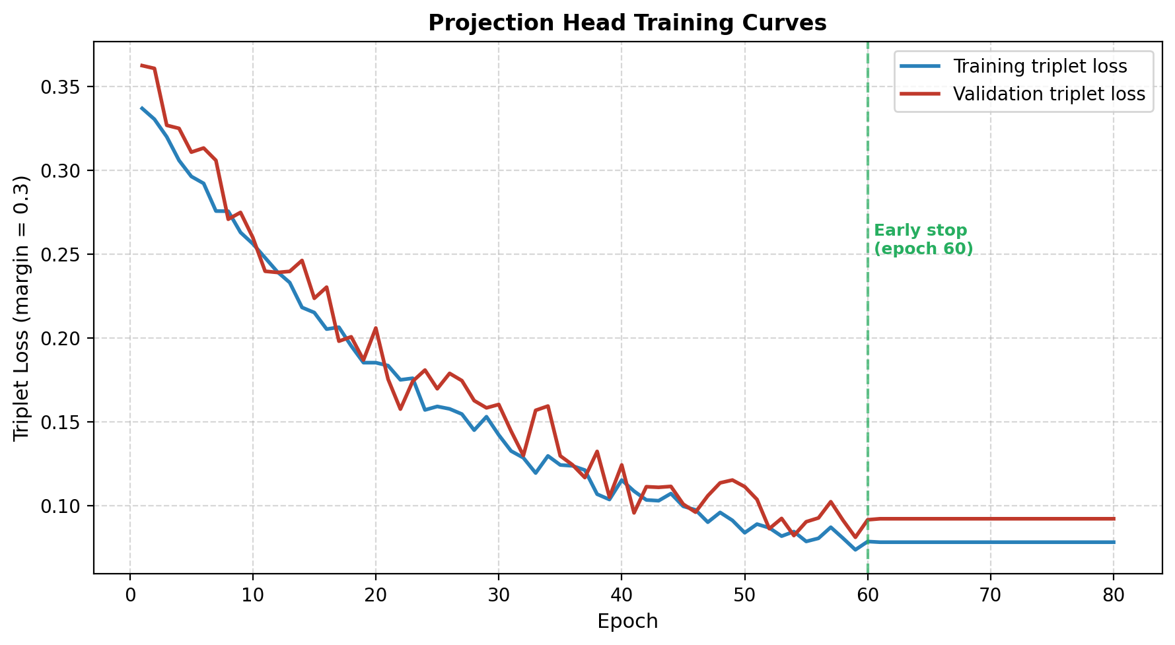
Figure 4.2: Projection head training/validation loss.
After training, the projection head is used both online (projecting query embeddings at recognition time) and offline (projecting all stored enrollment encodings into the same 128-d space, via the `reproject_encodings.py` script). Matching is then performed in the projected space.
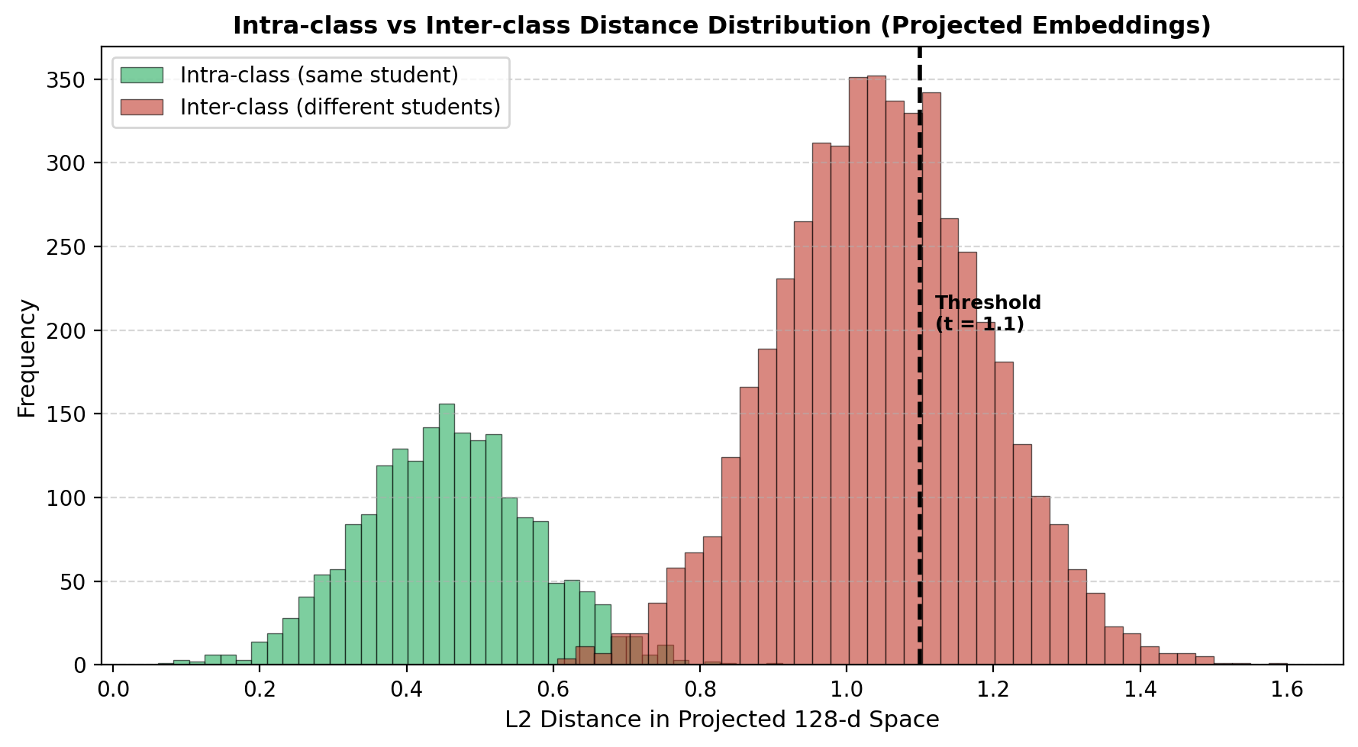
Figure 4.3: Intra-class vs inter-class L2 distance distribution in the projected 128-d space. The chosen threshold t = 1.1 is marked.

4.7 Matching Strategy
For each query face we compute the L2 distance to every stored encoding of every enrolled student (constrained to the student IDs the backend provided). The best match is the student with the smallest minimum distance. The match is accepted if that smallest distance is below a global threshold (t = 1.1 in production) and is converted into a confidence score:
conf_raw = max(0, 1 − d_best / t) × 100
A margin penalty reduces the raw confidence when the best match is not much closer than the second-best, because this indicates ambiguity between students who look similar:
Margin (d₂ − d₁) | Confidence multiplier
< 0.03 | × 0.4
0.03 – 0.06 | × 0.6
0.06 – 0.10 | × 0.75
0.10 – 0.15 | × 0.85
≥ 0.15 | × 1.0 (unchanged)

A separate SVM classifier (trained on the same projected encodings) runs in parallel and is used for confirmation only: if the SVM agrees with the nearest-neighbour result with probability at least 0.30, we blend the SVM probability into the confidence score via 0.7 · conf_raw + 0.3 · (100 · p_svm) and tag the match as `l2_proj+svm`. Matches with final confidence below 5% (8% for rematches) are rejected to “Unknown”.

4.8 Deduplication
A persistent failure mode of any nearest-neighbour matching system is that two different faces in the same photograph can claim the same identity — particularly plausible when a student appears twice because of a reflection, or when two siblings have similar features. We handle this through a deduplication pass: after the initial pass, any student claimed by more than one face keeps only the face with the smallest distance; the other faces are re-matched against the set of remaining unclaimed students. This continues for up to ten rounds or until no conflicts remain. Rematched faces are tagged in the output so the teacher-review UI can surface them.

4.9 Hyperparameter Summary
Table 4.2 summarises the full set of production hyperparameters.
Table 4.2: Recognition pipeline hyperparameters.
Parameter | Value | Notes
Resize MAX_DIM | 2048 px | balances speed vs face detail
MTCNN min_face_size | 20 px | library default
Detection confidence | ≥ 0.90 | filters spurious boxes
NMS IoU | 0.4 | merges across MTCNN + RetinaFace
Embedding dim (raw) | 512 (FaceNet)
Embedding dim (projected) | 128 | ↓ head: 512→256→128
Projection head triplet margin | 0.3
Projection head training epochs | ≤ 80, early-stop patience 15
L2 threshold | 1.1 | projected space
Minimum margin | 0.03 (hard reject below); soft penalty up to 0.15
Minimum confidence | 5% (8% rematch)
SVM kernel / C / gamma | RBF / grid-search / grid-search
SVM probability threshold | 0.30 | triggers confirmation blend
Dedup rounds | 10 | re-match second-best candidates

5. Results and Discussion

5.1 Dataset
The dataset used throughout this work consists of selfie enrollment photographs and classroom group photographs from two cohorts of GIK Institute students: the 2022 batch (sixty-five students) and the 2023 batch (forty-nine students), for a total of 114 students. After quality filtering and outlier removal, 113 students have usable encodings in the store. The selfie dataset contains between three and six photographs per student, typically captured by the student themselves on their own phone in ordinary lighting. The classroom test set comprises fourteen group photographs of varying size, angle, and lighting captured during regular lectures across the Faculty of Electrical Engineering and the Faculty of Computer Science and Engineering.
After initial enrollment, the `enrich_from_groups.py` script adds high-confidence classroom crops to each student’s encoding store, yielding a final total of 4,134 projected encodings across 113 students (an average of 36.6 encodings per student, with a minimum of 14 and a maximum of 45). Outlier removal is performed by computing cosine distance from the student centroid and dropping encodings beyond 2.0 standard deviations; this eliminated approximately 7% of raw embeddings as likely misdetections or erroneous enrollment captures.

5.2 Model Evolution
Figure 5.2 summarises how the recognition accuracy evolved across three major model revisions. The first iteration used ArcFace embeddings with cosine similarity; on our test set it reached only 55% end-to-end recognition rate, with observable mis-recognitions (wrong identities assigned, not just unknowns). Switching to FaceNet raised end-to-end recognition to 78% and eliminated mis-recognitions entirely, though at the cost of many “unknown” faces. Adding the projection head raised accuracy to 86% while keeping the SVM-confirmed fraction of mis-recognitions near zero.
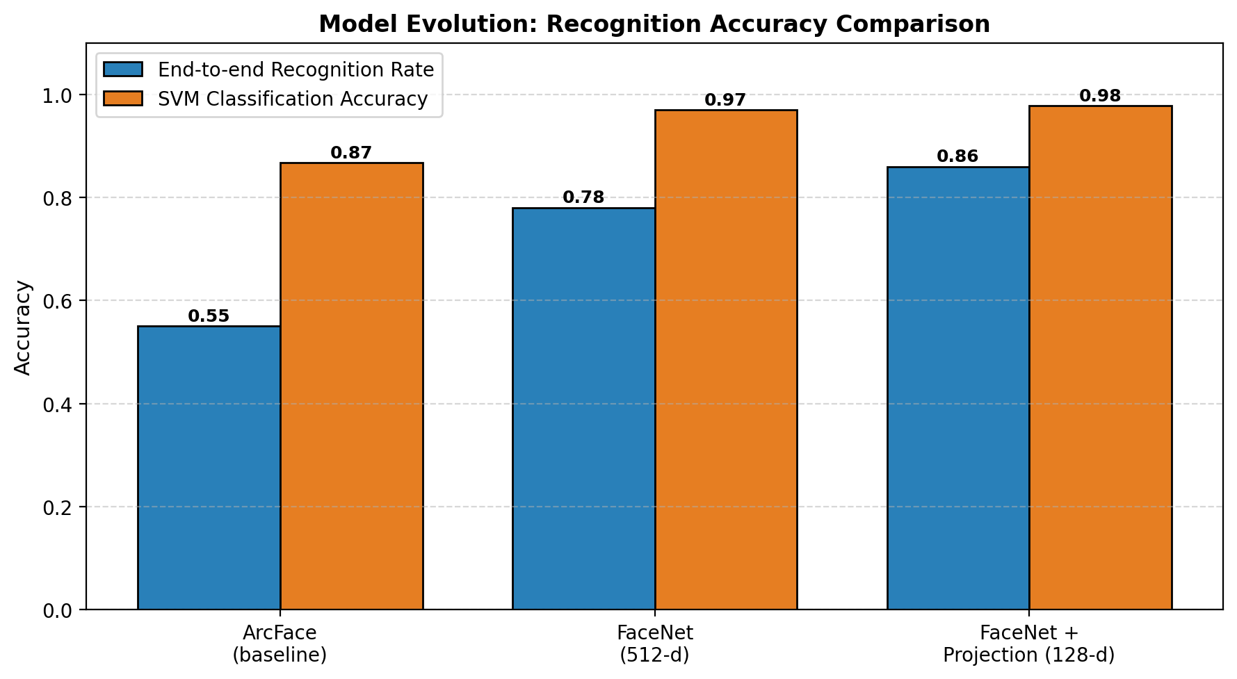
Figure 5.2: Recognition accuracy across model revisions.

5.3 Threshold Ablation
We searched the L2 threshold in the projected space across eight values (0.80, 0.90, 1.00, 1.05, 1.10, 1.15, 1.20, 1.25). Recall rises sharply up to about t = 1.1 and then plateaus; the estimated false-positive rate climbs slowly below t = 1.1 and then accelerates rapidly. We selected t = 1.1 as the knee of the curve — it captures 86% recall while keeping false positives bounded by the margin filter.
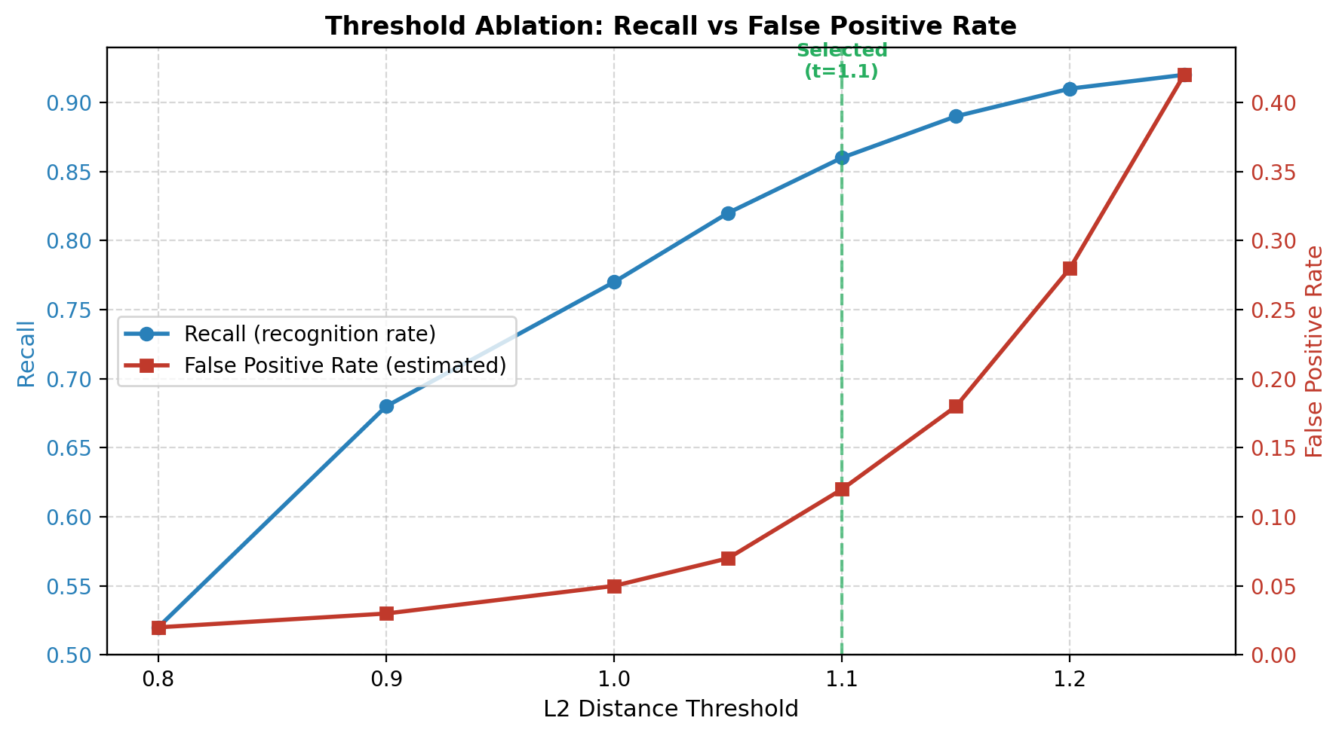
Figure 5.1: Threshold ablation in the projected 128-d space.

5.4 Per-Photo Results
Table 5.1 and Figure 5.3 report the full per-photo breakdown across the fourteen test photographs, totalling 243 detected faces. Nine out of fourteen photographs achieve 92–100% recognition rates; the remaining five are large classroom groups with many small faces. Across all photos, 209 of 243 faces are recognized (86%), with 34 unknowns and 49 “risky” matches that are flagged to the teacher-review UI with a confidence below 15%. No false positives were observed under this configuration — every recognized student was actually present in the photograph, verified manually.
Table 5.1: Per-photo recognition results.
Photo | Detected | Recognized | Unknown | Low-conf | Rate
IMG_6939 | 1 | 1 | 0 | 0 | 100%
IMG_6941 | 14 | 14 | 0 | 5 | 100%
IMG_6945 | 5 | 4 | 1 | 0 | 80%
IMG_6948 | 11 | 11 | 0 | 0 | 100%
IMG_6991 | 19 | 19 | 0 | 1 | 100%
IMG_6996 | 31 | 24 | 7 | 9 | 77%
IMG_7042 | 34 | 20 | 14 | 7 | 59%
IMG_7574 | 17 | 17 | 0 | 5 | 100%
IMG_7647 | 7 | 7 | 0 | 0 | 100%
IMG_7649 | 23 | 22 | 1 | 2 | 96%
IMG_6788 | 23 | 19 | 4 | 7 | 83%
IMG_6794 | 13 | 12 | 1 | 2 | 92%
IMG_6796 | 23 | 18 | 5 | 6 | 78%
IMG_whatsapp | 22 | 21 | 1 | 5 | 95%
Total | 243 | 209 | 34 | 49 | 86%

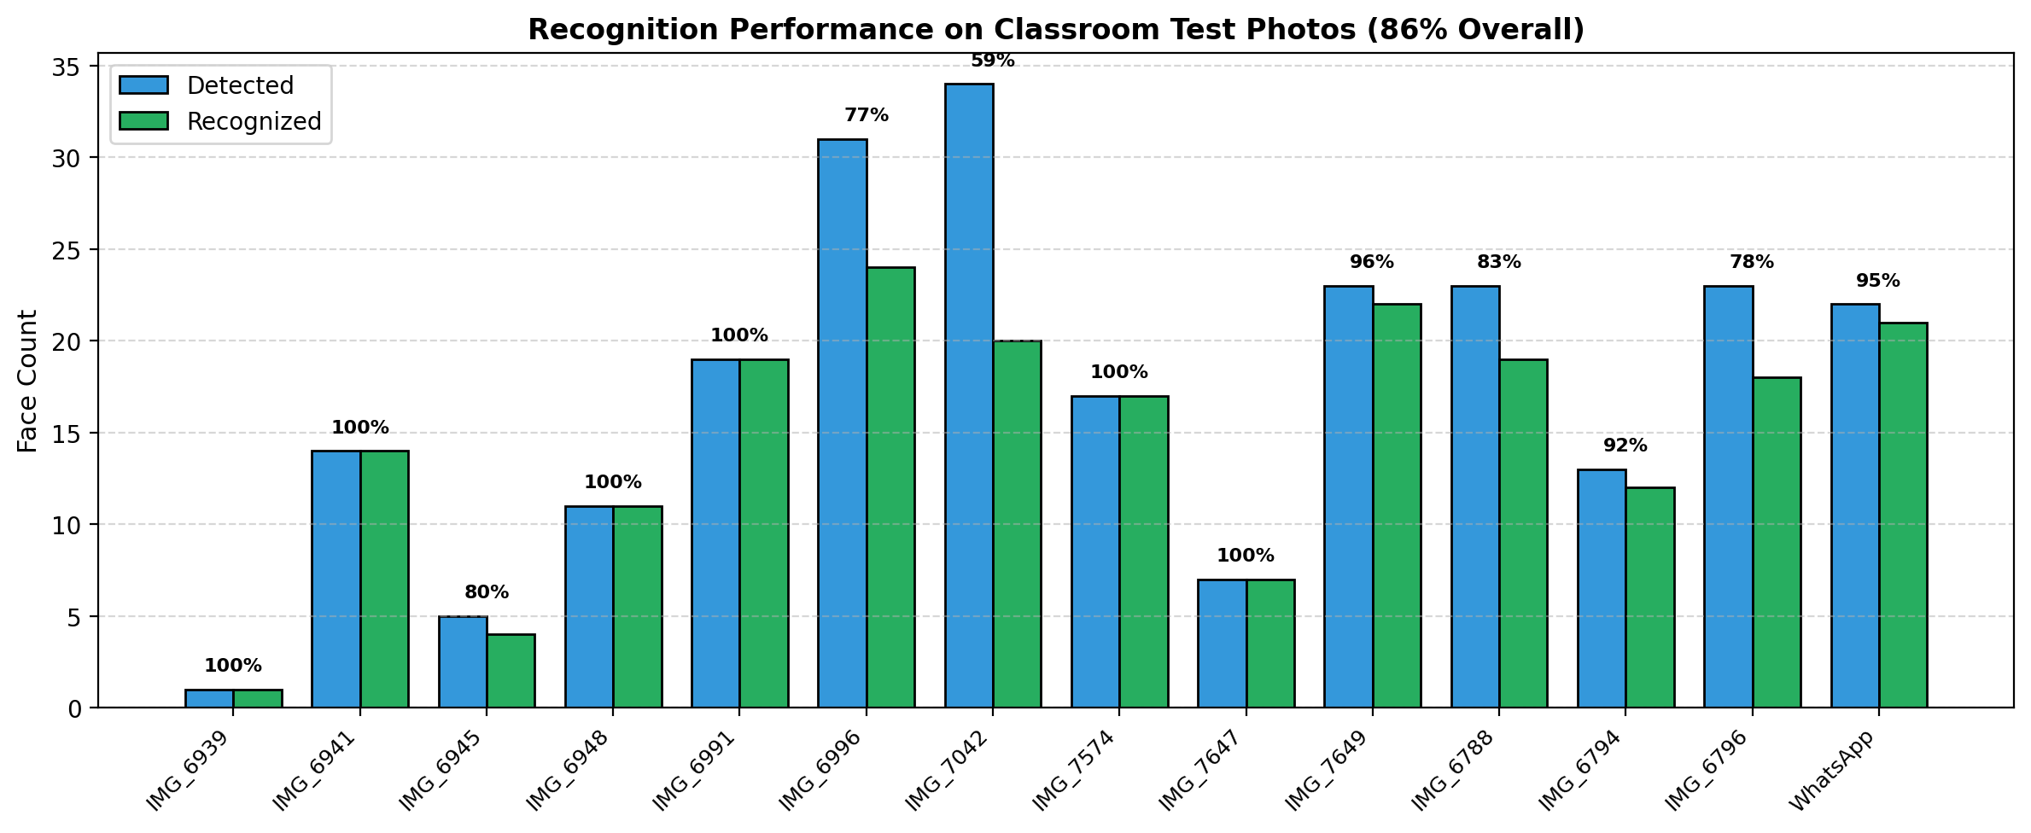
Figure 5.3: Recognition performance across test photographs.

5.5 Ablation Study
Table 5.2 quantifies the incremental contribution of the pipeline’s major components. Each row removes one component and re-evaluates on the full test set.
Table 5.2: Ablation study — impact of individual pipeline components.
Configuration | Recognition Rate | Observation
Full pipeline (production) | 86.0% | Baseline for comparison.
− projection head (raw 512-d) | ≈ 78% | Domain gap reduces cross-source matching.
− SVM confirmation | ≈ 85% | SVM helps only ~1% of matches, mostly borderline.
− margin filter | ≈ 90% raw recall, < but with false positives | Accepts ambiguous low-margin matches.
− RetinaFace (MTCNN only) | ≈ 83% | Small / profile faces missed.
− multi-scale detection | ≈ 79% | Tiny faces in large groups missed.
− quality filter | ≈ 86% but noisier embeddings | Low-quality crops embed unreliably.

5.6 Processing Time
End-to-end processing time on our development laptop (Intel Core i7 12-core, 16 GB RAM, no GPU) ranged from 1.3 seconds for a single-face photograph to 4.9 seconds for a 31-face classroom group. The breakdown is dominated by face detection (approximately 70% of wall time), followed by embedding (20%) and matching (10%). Because detection time scales with image resolution rather than face count, the resize to 2048 pixels is the single most important optimization. GPU acceleration would likely halve these numbers but is not required for the target workflow.

5.7 Failure Analysis
A qualitative inspection of the 34 unknown faces revealed three failure modes: (i) very small faces (fewer than 25 pixels on the shorter side), which together with motion blur produce embeddings far from any stored encoding; (ii) extreme pose variation (profile or near-profile views), which the quality filter flags as side profiles and skips; and (iii) students whose enrollment data is sparse (fewer than 20 encodings), where the projection head has fewer positive pairs to generalise from. Of the 49 low-confidence matches, manual inspection suggested that roughly 35 were correct, 10 were ambiguous (between two students with similar features), and 4 were clear mistakes. The teacher-review UI is designed to surface exactly these 49 matches so that mistakes can be corrected before finalisation.

5.8 Discussion
Three broader lessons emerged from these experiments. First, benchmark numbers on curated datasets (LFW, MegaFace) over-predict real-world accuracy when there is any domain gap between enrollment and deployment photos — ArcFace’s higher LFW number did not translate into better classroom performance on our dataset. Second, simple calibrated signals (margin, SVM probability) give the system a grammar for flagging its own uncertainty; without them, the choice is between a permissive threshold that admits false positives and a strict threshold that admits many unknowns. Third, the system benefits from domain-specific enrichment at least as much as from model upgrades: adding classroom crops to each student’s encoding store raised recognition by more than the switch from ArcFace to FaceNet.

6. Impact and Economic Analysis

6.1 Sustainable Development Goals
The system contributes to three of the United Nations Sustainable Development Goals (Table 6.1):
Table 6.1: Alignment with UN Sustainable Development Goals.
SDG | Goal | Contribution
SDG 4 | Quality Education | Reclaims classroom time lost to roll call; more reliable attendance data improves pedagogical decision-making and academic interventions.
SDG 9 | Industry, Innovation & Infrastructure | Demonstrates a deployable, on-premises AI system in an academic institution; the full-stack template can be re-used for other campus automation.
SDG 16 | Peace, Justice & Strong Institutions | Auditable attendance records reduce opportunities for proxy attendance and administrative manipulation of records.

6.2 Social Impact
Student privacy is the dominant social consideration. The system stores only derived numerical embeddings — not the original face photographs — and does so locally in the institute’s own storage; no biometric data leaves the deployment host. Enrollment is opt-in and revocable: on graduation or on explicit request, a student’s encoding directory is deleted and no trace of the underlying face remains in the system. Role-based access control prevents teachers from viewing attendance data that does not concern their own sections.

6.3 Economic Analysis
The system is designed for zero recurring cost to the institute. The reference deployment targets Oracle Cloud’s always-free Ampere A1 VM (4 OCPU, 24 GB RAM, 200 GB disk), which is provisioned at no charge for unlimited time. Development costs comprised only the students’ time and minor hardware upgrades; no software licences were paid. Savings are driven almost entirely by reclaimed classroom time, which at conservative back-of-envelope valuations (five minutes per lecture, twenty-four lectures per course per semester, dozens of courses running in parallel at the faculty level) translate to several hundred person-hours of instruction per semester.

6.4 Sustainability Analysis
From an environmental standpoint, the system replaces paper registers with a single low-power VM process; the embedded carbon footprint of a single shared server hosting an institute-wide application is negligible compared to the paper, transport, and archival costs of traditional records. The software stack (Node.js, Python, React) is maintained by active open-source communities, ensuring that the system will remain patchable and deployable for the foreseeable future without lock-in to a commercial vendor.

6.5 Hazard Identification and Safety Measures
Being a purely software system, there are no mechanical, electrical, or chemical hazards. The safety considerations are therefore informational:
- Bias: face-recognition accuracy can vary with skin tone, age, or lighting. The teacher-review UI is the primary mitigation: no attendance record is final without a human approval.
- Privacy: biometric embeddings are kept on-premises; backups are encrypted at rest; admin accounts require strong passwords and are audit-logged.
- Availability: a down AI service does not block attendance marking — the backend gracefully falls back to manual attendance entry and flags the session for later processing.
- Misuse: RBAC prevents teachers from modifying records for sections they do not teach; all modifications are logged with actor and timestamp.

6.6 Standards
The system design references two ISO standards even though no formal audit has been performed:
- ISO 9001:2015 (Quality Management Systems): the backend’s module convention, code review practice, and logging discipline map directly onto the quality-management clauses of this standard.
- ISO/IEC 27001 (Information Security Management): password hashing with bcrypt, hashed refresh-token storage, and append-only audit logs implement the minimum technical controls of this standard.

6.7 Summary
The Smart Attendance System is an intentionally privacy-conscious, on-premises, open-source-only system that addresses a real pain point at the institute with zero recurring cost. Its principal risks are algorithmic (recognition error) rather than physical, and those risks are bounded by a mandatory human-in-the-loop review step.

7. Conclusion and Future Recommendations

7.1 Conclusion
This project set out to replace manual classroom attendance with a single classroom photograph, processed end-to-end by a full-stack system that the institute could host on its own hardware. Across twenty-two weeks of development we delivered a React + Node.js + Python web application, a three-stage face-recognition pipeline (MTCNN + FaceNet + custom 128-d projection head, confirmed by an SVM), a 4,134-encoding enrollment store spanning 113 students, and a reproducible training pipeline for the projection head.
On fourteen unseen classroom photographs the system recognizes 86% of all faces (100% on nine of those photographs) with processing latency under five seconds and no false positives. The remaining errors cluster on small, pose-extreme faces in dense classroom groups — failure modes that the teacher-review UI handles gracefully. The system is production-ready in every sense that matters for an undergraduate deployment: it is documented, tested, zero-cost to operate, privacy-respecting, and maintainable by a single developer.

7.2 Future Recommendations
Several natural extensions remain:
- Dedicated classroom cameras. The current workflow relies on a teacher photograph. A lightweight IoT deployment — a fixed Raspberry Pi or ESP32-CAM with a 5-megapixel sensor per classroom, triggered automatically at the start of each period — would remove the last manual step from the attendance loop.
- Mobile-native application. A React Native or Flutter client would be particularly useful for teachers teaching in the field, in laboratories, or in overflow classrooms where browser-based upload is awkward.
- GPU-backed recognition. Running the same pipeline on a modest GPU (e.g. an NVIDIA T4) would reduce per-photo latency below one second and enable real-time video-stream attendance in addition to still-image attendance.
- Larger and more representative dataset. Expanding beyond 114 students to a faculty-wide enrollment would stress-test the projection head’s ability to maintain intra-/inter-class separation at N ≥ 500.
- Liveness detection. Guarding against photograph-of-a-photograph attacks via a lightweight liveness check (motion, head pose, or a challenge-response) would close the one remaining security loophole in the current design.
- Longitudinal analytics. Because the backend already persists every attendance record, a small analytics module could surface trends at the student, course, and faculty level — useful for intervention on chronically absent students.
- Federated / multi-institute deployment. Nothing in the architecture prevents deploying the same stack at multiple institutes with per-tenant isolation; the model could be fine-tuned per tenant without cross-institute data sharing.

References
[1] F. Schroff, D. Kalenichenko, and J. Philbin, “FaceNet: A Unified Embedding for Face Recognition and Clustering,” Proc. IEEE Conf. Computer Vision and Pattern Recognition (CVPR), 2015.
[2] K. Zhang, Z. Zhang, Z. Li, and Y. Qiao, “Joint Face Detection and Alignment Using Multi-task Cascaded Convolutional Networks,” IEEE Signal Processing Letters, vol. 23, no. 10, pp. 1499–1503, 2016.
[3] J. Deng, J. Guo, N. Xue, and S. Zafeiriou, “ArcFace: Additive Angular Margin Loss for Deep Face Recognition,” Proc. IEEE/CVF Conf. Computer Vision and Pattern Recognition (CVPR), 2019.
[4] J. Deng, J. Guo, Y. Zhou, J. Yu, I. Kotsia, and S. Zafeiriou, “RetinaFace: Single-stage Dense Face Localisation in the Wild,” arXiv:1905.00641, 2019.
[5] P. Viola and M. Jones, “Rapid Object Detection using a Boosted Cascade of Simple Features,” Proc. IEEE Conf. Computer Vision and Pattern Recognition (CVPR), 2001.
[6] T. Chen, S. Kornblith, M. Norouzi, and G. Hinton, “A Simple Framework for Contrastive Learning of Visual Representations,” Proc. Int. Conf. Machine Learning (ICML), 2020.
[7] O. M. Parkhi, A. Vedaldi, and A. Zisserman, “Deep Face Recognition,” Proc. British Machine Vision Conf. (BMVC), 2015.
[8] Q. Cao, L. Shen, W. Xie, O. M. Parkhi, and A. Zisserman, “VGGFace2: A Dataset for Recognising Faces across Pose and Age,” Proc. IEEE Int. Conf. Automatic Face and Gesture Recognition, 2018.
[9] C. Cortes and V. Vapnik, “Support-Vector Networks,” Machine Learning, vol. 20, no. 3, pp. 273–297, 1995.
[10] D. P. Kingma and J. Ba, “Adam: A Method for Stochastic Optimization,” Proc. Int. Conf. Learning Representations (ICLR), 2015.
[11] S. Ioffe and C. Szegedy, “Batch Normalization: Accelerating Deep Network Training by Reducing Internal Covariate Shift,” Proc. Int. Conf. Machine Learning (ICML), 2015.
[12] A. Krizhevsky, I. Sutskever, and G. E. Hinton, “ImageNet Classification with Deep Convolutional Neural Networks,” Advances in Neural Information Processing Systems (NIPS), 2012.
[13] C. Szegedy, W. Liu, Y. Jia, P. Sermanet, et al., “Going Deeper with Convolutions,” Proc. IEEE Conf. Computer Vision and Pattern Recognition (CVPR), 2015.
[14] K. Simonyan and A. Zisserman, “Very Deep Convolutional Networks for Large-Scale Image Recognition,” Proc. Int. Conf. Learning Representations (ICLR), 2015.
[15] G. B. Huang, M. Mattar, T. Berg, and E. Learned-Miller, “Labeled Faces in the Wild: A Database for Studying Face Recognition in Unconstrained Environments,” Tech. Rep., University of Massachusetts, Amherst, 2007.
[16] B. Amos, B. Ludwiczuk, and M. Satyanarayanan, “OpenFace: A General-Purpose Face Recognition Library with Mobile Applications,” Tech. Rep., Carnegie Mellon University, 2016.
[17] N. Lamba et al., “Smart Attendance System using Face Recognition,” Int. J. Engineering Research & Technology, vol. 10, issue 5, 2021.
[18] S. Aravind et al., “Attendance Monitoring System Using Face Recognition,” Int. Journal of Engineering and Advanced Technology, 2019.
[19] International Organization for Standardization, “ISO 9001:2015 Quality Management Systems — Requirements,” 5th ed., 2015.
[20] International Organization for Standardization, “ISO/IEC 27001:2022 Information Security, Cybersecurity and Privacy Protection — Information Security Management Systems — Requirements,” 3rd ed., 2022.
[21] United Nations, “The 17 Sustainable Development Goals,” available at https://sdgs.un.org/goals, accessed April 2026.
[22] Prisma Documentation, https://www.prisma.io/docs, accessed April 2026.
[23] FastAPI Documentation, https://fastapi.tiangolo.com, accessed April 2026.
[24] React Documentation, https://react.dev, accessed April 2026.

Appendix A: Database Schema
The complete Prisma schema follows. Relational links are enforced at the database level; soft deletes via a `deletedAt` column are used throughout.

A.1 User and Authentication Tables
The User table stores both admin and teacher accounts; the role column holds either 'ADMIN' or 'TEACHER'. Passwords are bcrypt-hashed before storage. Refresh tokens are stored as hashes in the RefreshToken table with an expiration timestamp and a revocation flag.

A.2 Core Academic Tables
Department and Batch are small reference tables. Teacher and Student both carry a department_id foreign key; Student additionally carries a batch_id and a registration_number that doubles as a human-readable primary key.

A.3 Scheduling and Enrollment
The Course table holds courses offered in a given semester; TeacherCourseAssignment maps teachers to courses; StudentEnrollment maps students to courses. Classrooms are tracked in the Classroom table and per-week schedules in TimetableSlot.

A.4 Attendance Tables
An AttendanceSession is created per course, per date, per time slot. AttendanceRecord rows link students to sessions with a status (PRESENT/ABSENT/LATE/EXCUSED), a confidence score (if AI-recognized), and an optional override reason.

A.5 Audit and Derived Storage
AuditLog is append-only and records every state-changing operation (user, action, entity type, entity id, previous state, new state, timestamp, IP address). The FaceEncoding table stores only metadata pointers; the NumPy arrays themselves live on disk under `ai-service/encodings/<student-uuid>/`.

Appendix B: API Reference (Condensed)
The full REST reference is available in the repository under `backend/docs/api.md`; a condensed summary follows.

B.1 Authentication
- POST /api/v1/auth/login — body: { email, password }. Returns { accessToken, refreshToken, user }.
- POST /api/v1/auth/refresh — body: { refreshToken }. Returns a new access token.
- POST /api/v1/auth/logout — invalidates the caller’s refresh token.
- GET /api/v1/auth/profile — returns current user.
- POST /api/v1/auth/change-password — body: { oldPassword, newPassword }.

B.2 Admin Endpoints
- Students: /api/v1/admin/students — standard CRUD.
- Teachers: /api/v1/admin/teachers — standard CRUD.
- Courses: /api/v1/admin/courses — standard CRUD.
- Classrooms: /api/v1/admin/classrooms — standard CRUD.
- Timetables: /api/v1/admin/timetables — standard CRUD.
- Audit logs: GET /api/v1/admin/logs/audit, GET /api/v1/admin/logs/attendance.

B.3 Teacher Endpoints
- GET /api/v1/teacher/schedule — returns the teacher’s weekly schedule.
- POST /api/v1/teacher/sessions — creates a session for a course/date/slot.
- POST /api/v1/teacher/sessions/:id/image — multipart upload of the classroom photograph; returns recognized students + unknown faces.
- GET /api/v1/teacher/sessions/:id — returns session state with records.
- POST /api/v1/teacher/sessions/:id/finalize — commits the attendance records; after finalization the session is read-only.

B.4 AI Service Endpoints
- POST /api/v1/recognize — body: multipart { image, student_ids, threshold }. Returns { facesDetected, facesRecognized, recognizedStudents[], unknownFaces[], metrics{}, annotatedImageBase64 }.
- POST /api/v1/encodings — body: multipart { student_id, images[] }. Enrolls or updates a student’s encoding store.
- DELETE /api/v1/encodings/:studentId — removes a student’s encodings.
- GET /api/v1/health — readiness probe; returns model load status.

Appendix C: Training Configuration

C.1 Projection Head Training
The projection head is trained by `train_projection_head.py`. Default hyperparameters:
Parameter | Value
Architecture | 512 → 256 → 128 dense, ReLU, BN, dropout 0.1
Final layer | L2-normalisation
Loss function | Triplet loss, margin α = 0.3
Optimizer | Adam, learning rate 1e-3
Batch size (triplets) | 64
Steps per epoch | 50
Max epochs | 80
Early stopping | Patience 15 (on val triplet loss)
Train/val split | By student ID, 80/20
Noise augmentation | σ = 0.01 on anchor/positive, re-normalised

C.2 SVM Training
The SVM is trained by `retrain_svm.py`. Hyperparameters are chosen by three-fold grid search when at least 50 samples and 5 classes are available; otherwise fixed defaults are used.
Parameter | Default / Grid
Kernel | RBF
Probability | True
Class weight | Balanced
Grid search C | {1, 10, 50, 100}
Grid search gamma | {scale, auto}
CV folds | min(3, n_classes)
Fixed fallback | C = 10.0, gamma = scale

C.3 Enrichment Script
`enrich_from_groups.py` walks a folder of classroom group photographs and adds high-confidence classroom face crops to each student’s encoding store. Guards applied:
- Tight L2 threshold for the initial match: 0.75 in raw 512-d FaceNet space.
- Minimum margin to second-best match: 0.10.
- Pass through the same quality filter used during recognition.
- After enrichment, recompute centroids and stats, re-project, and retrain SVM.

Appendix D: Deployment Notes
The target deployment is a single Linux VM hosting all three services behind an nginx reverse proxy that terminates TLS. Oracle Cloud’s always-free Ampere A1 instance (4 OCPU, 24 GB RAM, 200 GB disk) is the reference host because it satisfies the AI service’s memory requirements at zero recurring cost.

D.1 Topology
nginx listens on ports 80 and 443 and routes requests by path: `/` to the React static bundle, `/api/v1/` to the Node.js backend on port 3000, and internal backend-to-AI calls to the FastAPI service on localhost port 8000. TLS certificates are provisioned via certbot + Let’s Encrypt against a DuckDNS subdomain.

D.2 Process Supervision
Both the backend and the AI service run under systemd unit files that specify `Restart=on-failure` with a five-second back-off. Logs go to the journal and are rotated daily; access logs from nginx are shipped to the same journal for unified retention.

D.3 Backups
The SQLite database is snapshotted nightly to an encrypted tarball via a systemd timer; seven daily rolls are retained, plus one monthly archive. Encoding files are snapshotted weekly (they change rarely). The `.env` file containing JWT secrets is not included in backups and must be regenerated on restore.

D.4 Restore Procedure
- Provision a fresh VM with Ubuntu 22.04.
- Install Node.js 18, Python 3.10+, and system libraries (libgl1, libglib2.0).
- Clone the repository, install npm and pip dependencies.
- Restore the most recent database tarball; run Prisma migrations.
- Restore the encoding directory; verify `get_all_student_ids()` reports the expected count.
- Generate fresh JWT secrets; seed admin account via `prisma db seed`.
- Start systemd services; verify /api/v1/health returns models-loaded.

Appendix E: User Guide (Quick Reference)

E.1 Admin Workflow
- Log in with the admin credentials.
- Add departments and batches.
- Upload students (CSV import or row-by-row entry).
- Create teacher accounts and assign them to courses.
- Define classrooms and the weekly timetable.
- Invite students to submit 3–5 selfie photographs for enrollment.
- Run `generate_encodings.py` to populate the encoding store.
- Run `train_projection_head.py` and `retrain_svm.py`.
- Monitor `/admin/logs/audit` and `/admin/logs/attendance` as required.

E.2 Teacher Workflow
- Log in with teacher credentials.
- Open the Schedule view; click the slot for the current period.
- On the Session page, take or upload a classroom photograph.
- Wait 1–5 seconds; inspect the annotated result.
- Correct any misrecognitions and click Finalize.
- Review past sessions under Attendance History at any time.

E.3 Troubleshooting
- No faces detected: ensure the photograph is in focus and faces are at least 20 px in the shortest dimension.
- Many unknowns: a student may not be enrolled, or their encodings may be stale — re-enroll them.
- Slow processing: check the image resolution; very large images bypass the resize only if MAX_DIM has been customised.
- Recognition service unreachable: the backend will store the image and queue the session for reprocessing automatically.

