Rotary Inverted Pendulum Using PID Control
Senior Design Project (Part I & II)
EE481& EE 482

Submitted by:

Abdul Ghani
Hassan Albana
Samar Islam
2021008 – FEE
2021219 – FEE
2021566 – FEE

Advisor: Dr. Memoon Sajid


Faculty of Electrical Engineering
GIK Institute of Engineering Sciences and Technology
Topi, District Swabi, Khyber Pakhtunkhwa, Pakistan. www.giki.edu.pk

May 2025

Dedicated to our dear homeland, Pakistan!

Certificate of Ownership

It is certified that the work contained in this final year project report

“Design and Development of Controls Lab Trainer System Like Quanser Qube Servo 3 With Real Time MATLAB Interfacing”

has been carried out through the collective efforts of Abdul Ghani, Hassan Albana, and Samar Islam under the supervision of Dr. Memoon Sajid, using various information sources such as research papers, books, internet, and expert opinion.

Abdul Ghani | 2021008
Hassan Albana | 2021219
Samar Islam | 2021566

Advisor: Dr. Memoon Sajid
Faculty of Electrical Engineering GIK Institute
Dr. Arbab Abdur Rahim
Dean Faculty of Electrical Engineering,
GIK Institute of Engineering Sciences and Technology

Date of submission: 14th May 2025

Preface

For students studying control systems, this final year project report explains the Rotary inverted pendulum project as a controls lab trainer and addresses control theory and stability analysis concepts. To better comprehend and apply the theory they learn in the classroom, undergraduate students require visual aids. Every student will have personal access to the RIP prototype thanks to the project's inexpensive and readily available components.

Acknowledgments
We are grateful to Almighty Allah for providing us with knowledge, courage, and strength as well as for continuously supporting us while we worked on this project. Throughout this lengthy journey, he has never abandoned us and has consistently led us in the correct direction. We couldn't have gone a single step without His assistance and blessings. We ask Him to ease our future journey and enable us to contribute to the betterment of humanity.
May Allah lead and assist every one of us in this life as well as the next.
Abdul Ghani, May 2025

Hassan Albana, May 2025
Samar Islam, May 2025

Contents

Nomenclature ix
List of Tables xii
Abstract 1
Final Year Design Project as a Complex Engineering Problem 2
- Introduction 3
  - Background and Motivation 3
  - Problem Statement 4
  - Scope of the work and expected outcomes 5
  - Outline of report 5
  - Project management and Gantt chart 6
  - Contribution by group members 6
- Literature Review 9
  - Project Literature Review 9
  - Reasoning taken from the Literature 11
- Design and Analysis 13
  - Design Methodology 13
    - Configuration 13
    - Electronics 14
- Motor 14
- Feedback Sensors 15
- Motor Driver 15
- Power Source 15
  - Governing Equations/ Mathematical Modelling 16
    - Assumptions and Linearization 17
    - Transfer Function of Motor 17
    - Jeq Derivation 20
    - Frequency Calculations 22
    - Clock Cycles 23
    - State Space Model 23
  - Geometric Modelling and Design 25
  - Standards 26
    - ISO 9001:2015 (en) Quality Management System 26
  - Summary 26
- Physical Model Development and Testing 27
  - Integration and Instrumentation 27
    - Electronic Integration 27
    - Model Assembly 27
  - Testing/Experimental Procedure 29
    - System Testing 29
    - Position Control 29
    - Speed Control 30
    - Inverted Pendulum Model 30
  - Summary 31
- Results and Discussions 32
  - Results 32
    - Motor Transfer Function 32
    - System Transfer Function 32
    - Position Control 32
    - Speed Control 34
    - Destabilization controller 35
    - Stabilization Control 36
    - Mode Control 37
  - Analysis and Discussions Results 37
    - Motor Transfer Function 37
    - System Transfer Function 37
    - Position Control 37
    - Speed Control 39
    - Destabilization Controller 39
    - Stabilization Controller 39
    - Mode Controller 39
  - Summary 39
- Impact and Economic Analysis 41
  - Sustainable Development Goals 41
  - Social Impact 42
  - Sustainability Analysis 42
  - Experimental Impact 42
  - Sustainable development goals 42
  - Hazard Identification and Safety Measures 42
  - Summary 43
- Controls Lab Experiments 44
  - Lab # 01 Position & Speed Control on Simulink 44
    - Objective 44
    - Introduction 44
    - Mathematical Modelling of DC motor: 44
    - PID Gains for Position Control: 48
    - Simulation Results: 50
  - 7.2 Lab # 02 Position Control Implementation on Hardware 52
    - Objective 52
    - Introduction 52
    - Connecting hardware with Simulink 52
    - Motor Driver: 52
    - Simulation Results: 54
- Conclusion and Future Recommendations 55
  - Conclusions 55
  - Future Recommendations 55
References 56

 | Nomenclature
RIP | Rotary Inverted Pendulum
PID | Proportional Integral Derivative
DOF | Degree of Freedom
PD | Proportional Derivative
OS | Overshoot
Jeq | Equivalent Inertia of the system
us | Microsecond

List of Figures
Figure 1: Project Gantt Chart 6
Figure 2: Rotary Inverted Pendulum Model 13
Figure 3: Arduino Mega 8-bit Microcontroller 14
Figure 4: 25GA370 DC Gear Motor 14
Figure 5: Feedback Sensors 15
Figure 6: L298N Dual H Bridge Driver 15
Figure 7: 12V Wall Adapter 16
Figure 8: Simplified model of the rotary inverted pendulum system 16
Figure 9: Schematic diagram of DC motor 17
Figure 10: Schematic showing Distance of all components of RIP from the center of Rotation . 21 Figure 11: Physical Model of Rotary Inverted Pendulum 25
Figure 12: DC Gear Motor 28
Figure 13: Pendulum Arm 28
Figure 14: Gear and Belt 29
Figure 15: Position Control Simulation result without PID Controller 33
Figure 16: Position Control Simulation result with PID Controller 33
Figure 17: Speed Control Simulation result without PID Controller 34
Figure 18: Speed Control Simulation result with PID Controller 35
Figure 19: SIMULINK file of Destabilization Control 36
Figure 20: SIMULINK file of Stabilization Control 36
Figure 21: Mode Control 37
Figure 22: Position control on step input 38
Figure 23: Position control on sinusoidal input 38
Figure 24: DC Motor equivalent circuit 44
Figure 25: Block diagram of a dc motor (armature-controlled) system 45
Figure 26: SIMULINK blocks required for implementation 47
Figure 27: Final Modelling of DC Motor 47
Figure 28: Simulink file of Position Control 48
Figure 29: Simulink file of Speed Control 48
Figure 30: Position Control Simulation result without PID Controller 50

Figure 31: Position Control Simulation result with PID Controller 50
Figure 32: Speed Control Simulation result without PID Controller 51
Figure 33: Speed Control Simulation result with PID Controller 51
Figure 34: Motor Driver blocks in Simulink 53
Figure 35: Code inside the Function Block of Driver 53
Figure 36: Schematic Diagram for Position Control 54
Figure 37: Results for the position control of motor on Trainer Board 54

List of Tables
Table 1: Contributions in project by each member 7
Table 2: Typical Configuration of the System 20
Table 3: Masses and Required Dimensions of all Components of RIP 21
Table 4: SGD table of the project. 41
Table 5: Motor Constants 46
Table 6: Relationships between PID Gains 48
Table 7: PID gains for Position Control (Unsolved) 49
Table 8: PID gains for Position Control (Solved) 49

Abstract
The inverted pendulum is a control application that plays a fundamental role in various technologies such as missiles, aircraft, and satellite control. It involves receiving input and adjusting parameters to achieve a desired response. The goal of this project is to design an inverted pendulum as a tool for learning about stability and control theory. The design process follows the research and development method, comprising requirements analysis, design, implementation, and evaluation. The design of the inverted pendulum involves both mechanical and electronic components, as well as source code. Controlling the inverted pendulum is a well-known control engineering problem that works especially well in the classroom and in the laboratory. This paper presents a rotary inverted pendulum system that is designed specifically for undergraduate students to learn about feedback control. The objective of the control system is to move the pendulum from its hanging-down position to an upright position and maintain it there stably. The control strategy is divided into three sub-controllers: the destabilizing controller, the stabilizing controller, and the mode controller. The destabilizing controller is used to oscillate the pendulum back and forth until it gains enough energy to break free from the hanging-down position and reach the upright position. The stabilizing controller then takes over to maintain the pendulum in the upright position, while also being able to reject small disturbances. The mode controller determines when to switch between the destabilizing and stabilizing controllers. The effectiveness of the proposed control strategy has been verified through simulations and experiments, and a student assessment survey has shown that this modularized approach helps students better understand control theory.
Keywords: Rotary Inverted Pendulum, Proportional-Integral-Derivative, Nonlinear Control.

Final Year Design Project as a Complex Engineering Problem
It is to certify here that the final year design project (FYDP) entitled “Rotary Inverted Pendulum Using PID Control” is categorized as a complex engineering problem (CEP) based on the preamble (in-depth engineering knowledge) and involvement of the following attributes.
- Depth of Knowledge required
- Depth of analysis required
- Familiarity of issues
- Interdependence

The above-listed attributes are thoroughly assessed after conducting a meeting on September 21, 2020, with the following final-year students.

1) Aima Rehman | 2018054
2) Arham Tariq | 201075
3) Zain Ul Islam Siddiqui | 2018516

This project is going to be conducted in the Spring semester 2022 and Fall semester 2022. Further, it is submitted that the proposed idea is worthy, and the required efforts are up to the level of a final-year design project.

Dr. Memoon Sajid SDP Advisor Date:

Introduction

Background and Motivation
The inverted pendulum control may be regarded a very excellent example in control engineering since it can be used to demonstrate a current theory of control. It is an excellent model for the attitude control of a space booster rocket and satellite, an autonomous aircraft landing system, aircraft stabilization in turbulent airflow, ship cabin stability, etc. This model may also serve as a starting point for stabilizing robots. Controlling the inverted pendulum is more difficult since it is a highly nonlinear, open-loop unstable system. Due to its inherent nonlinearity, it is a fascinating topic from a control standpoint.
One must have a thorough understanding of the system and perform precise tuning in order to use common control methods like 2DOF PID controllers, FSF controls, and LQRs at the appropriate level of performance. On the other hand, a differential equation-based description of an accurate mathematical model of the process is sometimes quite difficult to achieve. Furthermore, the use of these control approaches on a robotic platform with more than one stage of a system may lead to highly challenging stabilization and very crucial control parameter design.
The proportional, integral, and differential controller (PID controller) is a standard kind of control loop feedback mechanism that is often used in industrial control systems. It is contingent on the values of three distinct parameters: the proportional, the integral, and the derivative parameters. The proportional value determines the response based on the current error, the integral value determines the response based on the sum of the most recent errors, and the derivative value determines the response based on the rate at which the errors are changing.
The process or plant is ultimately controlled by applying a weighted sum of the three parameters that have been measured. Due to its basic construction, tuning the PID controller to achieve the desired overshoot, settling time, steady state error, etc. of the system behavior is not a simple task. On the basis of this problem, numerous PID control approaches are presented, including the I-PD control system and the 2 DOF PID control system [1] [2]. The degree of freedom of a control system in which transfer functions may be altered independently is determined by the number of closed-loop transfer functions.
Hybrid control techniques, which combine elements of both linear and nonlinear control, have also been proposed for the control of RIPs. These techniques offer the benefits of both linear and nonlinear control and can provide improved performance compared to either approach alone.
A rotary inverted pendulum is a type of mechanical system that consists of a pivoting arm with a mass at the end. The arm is mounted on a rotating platform, and the system is designed to maintain the vertical orientation of the mass despite external forces and perturbations. The dynamics of the rotary inverted pendulum system are governed by a set of equations that describe the motion of the pendulum arm and its attached mass. These equations consider factors such as the mass and moment of inertia of the arm, the gravitational force acting on the mass, and the torques applied to the system by external forces.
The control of the rotary inverted pendulum is a difficult task, as the system is highly unstable and prone to oscillations. To maintain the vertical orientation of the pendulum, the controller must apply precise and timely torques to the system to counteract the effects of external forces and disturbances. There are various control strategies that can be used to control the rotary inverted pendulum, including feedback control, feedforward control, and adaptive control. These strategies use sensors, actuators, and algorithms to monitor and control the motion of the system in real-time, allowing it to maintain its vertical orientation and stay stable.
Overall, the rotary inverted pendulum is a complex and challenging mechanical system that presents a significant control problem. It is an important subject of study in the fields of control engineering and robotics and continues to be an active area of research and development.

Problem Statement
Current control system trainers, such as the Quanser Qube Servo 3, are often prohibitively expensive and not readily accessible to educational institutions operating under tight budget constraints. This creates a significant barrier to providing practical, hands-on learning experiences in control systems. There is a clear need for a cost-effective, flexible alternative that offers comparable functionality for instructional and training purposes. Moreover, many existing trainers lack seamless real-time interfacing with widely used platforms like MATLAB, thereby limiting their effectiveness for advanced learning, experimentation, and research. To address these challenges, the objective is to design and develop a low-cost, user-friendly control system trainer that features real-time MATLAB integration, enabling enriched, hands-on education in control systems.

Scope of the work and expected outcomes
Here are some potential scopes and outcomes of this project:
- Scope: The scope of this project encompasses the design, development, and testing of a low-cost, user-friendly control system trainer aimed at enhancing educational outcomes in control systems engineering. The trainer will replicate key functionalities of high-end commercial systems, such as the Quanser Qube Servo 3, while maintaining affordability to suit institutions with limited financial resources. It will support real-time interfacing with MATLAB/Simulink, allowing students and educators to perform a wide range of experiments, simulations, and control algorithm implementations. PID, state-space, and adaptive control are just a few of the control strategies that can be accommodated by the modular and adaptable system. Additionally, detailed documentation, experiment manuals, and MATLAB integration guides will be provided to facilitate easy adoption in academic environments. The project does not include the development of advanced hardware manufacturing processes or commercial-scale production, focusing instead on a prototype suitable for educational and instructional use.
- Expected outcomes:
  - Enhanced accessibility of control systems education for institutions with limited budgets.
  - Development of a fully functional, low-cost control system trainer suitable for academic use.
  - Capability to perform fundamental and intermediate control experiments, such as PID control and system identification.
  - Real-time integration with MATLAB/Simulink for interactive learning and experimentation.
  - Improved hands-on learning experience for students through practical implementation of control algorithms.
  - Comprehensive user manual and experiment guide to support instructors and learners.
  - Design of software and hardware that can be customized and expanded upon in the future

Outline of report
The first chapter covers introductory parts of the report. It starts with the Research of Rotary Inverted Pendulum which states the facts about the effectiveness of using RIP in educational role to help students better understand and visualize dynamic stability. Using literature reviews and previous research to help us get right to our goal. Secondly, in the second chapter of the report we have discussed the basics of the RIP model, the base calculations, our requirements and how to optimize this project. The tradeoffs for the system and each component’s integration, along with microcontrollers clock cycles calculation.
Finally in the third part of the report, we have discussed comprehensive analysis of different parts of RIP. Various equations are given that were used to calculate parameters of motors and mechanical construction. Moreover, we have stated a short-summarized experiment that can be performed by the proposed apparatus.

Project management and Gantt chart
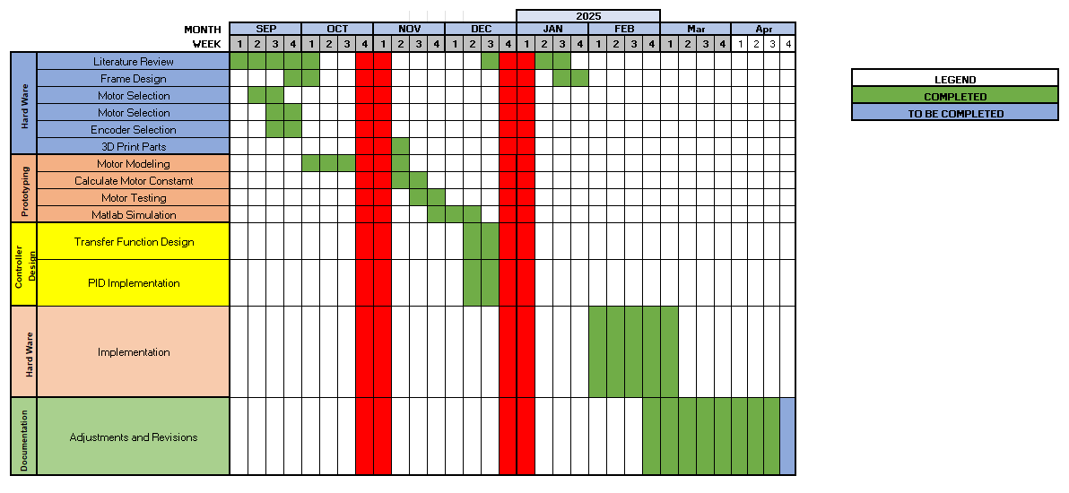
Figure 1: Project Gantt Chart

Contribution by group members
The work carried out on the project was equally divided and carried out. Following table shows the work contribution of the group members.
Table 1: Contributions in project by each member

Sr no. | Tasks | Sub-tasks | Assigned to
1 | Hardware Selection | Body selection | Samar
 |  | Motor Selection | Samar
 |  | Controller Selection | Ghani
 |  | Potentiometer Selection | Samar
 |  | 3D printed parts | Ghani
 |  | Assembly | Samar
2 | System Modelling | Motor modelling | Hassan
 |  | Motor Constants | Hassan
 |  | Position control | Hassan/Ghani
 |  | Closed loop system | Hassan/Ghani
 |  | Speed control | Hassan/Ghani
 |  | Hardware Testing | Ghani/Samar
 |  | Software Testing | Ghani/Hassan
3 | Rotary Inverted Pendulum | Transfer function Modelling | Hassan/Samar
 |  | Mechanical calculations | Hassan
 |  | Destabilization Controller | Ghani/Samar
 |  | Stabilization controller | Hassan/Ghani
 |  | PID Calculations | Hassan
 |  | Controller Integration | Ghani/Hassan
 |  | FYP report | Samar
 |  | Data Gathering | Samar

4 | Documentation | Presentations | Hassan
 |  | A0 Poster | Samar
 |  | Lab Experiments | Ghani

Literature Review

Project Literature Review
A The rotary inverted pendulum (RIP) is a classic example of an inherently unstable system and has been extensively studied in control engineering and robotics due to its rich dynamics and relevance to real-world applications. This literature review aims to synthesize existing research on the modeling, simulation, destabilization, and stabilization of rotary inverted pendulum systems.
Accurate modeling of RIP systems is essential for understanding their dynamics and designing effective control strategies. Early analytical models can be traced back to Euler in 1750, who utilized differential equations to describe pendulum motion. Subsequently, Lagrange and Hamilton developed more sophisticated analytical models based on classical mechanics, incorporating system constraints and external forces to better approximate the dynamics under certain assumptions \ [3].
More recent developments have emphasized numerical modeling approaches, which offer greater flexibility and precision in simulating complex behaviors. To better represent the system, finite element and finite difference methods have been used. A notable example is the Euler–Bernoulli beam model, which has been widely adopted for dynamic analysis of RIP systems \ [4].
When studying RIP systems, simulation provides a platform for testing various control strategies and analyzing system responses under various conditions. Popular simulation tools include MATLAB, Simulink, and Adams. One of the key challenges in this context is the accurate representation of non-idealities such as friction and damping forces, which significantly affect system stability and are often difficult to model precisely \[5].
- Destabilization Factors
While the RIP is inherently unstable, several additional factors can exacerbate its instability:
      - External Disturbances: Environmental influences such as wind or structural vibrations can cause oscillations and drive the system away from equilibrium if not adequately compensated \[6].
      - Parametric Uncertainties: Variations in system parameters like mass or stiffness introduce unpredictability, potentially leading to degraded performance or instability \[7].
      - Actuator Limitations: Constraints such as limited torque or bandwidth can hinder the system’s ability to reject disturbances or respond to control inputs effectively \[8].

- Control Strategies for Stabilization
Numerous control strategies have been developed to stabilize RIP systems, broadly categorized into passive and active control:
- Passive Control: Utilizes mechanical elements such as springs and dampers. While simple and low-cost, these methods often lack the flexibility and precision required for high-performance applications.
- Active Control: Includes a wide range of sophisticated stabilization methods, such as: PID Control: A widely used control technique due to its simplicity and effectiveness. One study modeled the Quanser QUBE-Servo 2 using the Euler–Lagrange method, designed a nonlinear model in MATLAB-Simulink, and implemented a PID controller that demonstrated robust performance under disturbance conditions \[9].
- Fuzzy Logic Control: fuzzy logic-based controller was shown to offer faster response times and superior stability compared to conventional PID controllers, particularly in handling nonlinearities and uncertainties \[10].
- Comparative Approaches: Research comparing destabilizing and stabilizing controllers revealed that while the former can rapidly bring the pendulum to an upright position, they are less effective in maintaining long-term stability. Stabilizing controllers, on the other hand, offer more robust and sustained control \[11].
- LQR and Switching Control: An integrated control strategy combining Linear Quadratic Regulator (LQR) and Sliding Mode Control (SMC) has been proposed. This hybrid approach ensures stability at both low and high velocities and improves robustness via a disturbance observer \[12].
- Adaptive Control: Leveraging the Lyapunov stability criterion, adaptive control strategies have been designed to handle parameter variations and uncertainties. Such controllers can estimate unknown parameters and adapt to dynamic changes, enhancing both stability and tracking performance \[13].
- Sliding Mode Control: SMC techniques, underpinned by Lyapunov-based formulations, have been successfully applied to counteract disturbances and maintain system stability even with uncertain parameters \[14].

Reasoning taken from the Literature
In this paper, we present a control design and implementation for a rotary inverted pendulum system that is designed for undergraduate students to learn about feedback control in a laboratory setting. The goal of the control system is to take the pendulum from its hanging-down position and stabilize it upright. To achieve this, we decompose the controller into three sub-controllers: a destabilizing controller, a stabilizing controller, and a mode controller.
The destabilizing controller is used to oscillate the pendulum back and forth until it has built up enough energy to break free from the stable hanging-down position and reach the unstable upright position. The stabilizing controller kicks in at this point, attempting to keep the pendulum upright while also rejecting minor disturbances. The mode controller determines when to switch between the destabilizing and stabilizing controllers.
We have verified the effectiveness of our control strategy through both simulation and experimental results. In general, this control's design and implementation are useful for teaching undergraduates about feedback control. There were multiple instances of researchers using different components to achieve similar results with slight variations in control analogy. Instead of using Arduino microcontrollers some researchers used STM32 microcontrollers whereas some utilized rotary encoders rather than potentiometers. Each had a different approach to RIP design. Our major task was to design it as simple as possible using devices easily available.

Design and Analysis

Design Methodology
The design process began by identifying the specific requirements of the project. After establishing the project needs, an in-depth literature review was conducted by analyzing various research articles and papers related to our project scope. Upon thorough evaluation, the most relevant information was extracted, summarized, and compiled into a reference document. The alignment with the most recent technologies was then ensured by comparing this information to the most recent software and hardware. Following the research phase, we proceeded to select suitable apparatus and components for the project. A detailed market analysis was carried out to identify cost-effective yet durable components that can withstand regular student use in a laboratory environment.

Configuration
The Rotary Inverted Pendulum was selected for the project due to its robustness and compact size. The RIP configuration was chosen because it makes complex modeling easier for students to understand.
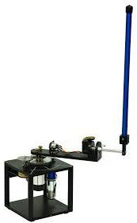

Figure 2: Rotary Inverted Pendulum Model

Electronics
- Microcontroller
The core processing unit of this project is the Arduino Mega, an 8-bit microcontroller. It serves as the central control element, responsible for interfacing sensors and actuators. The Arduino Mega is used in conjunction with MATLAB/Simulink software, enabling real-time data acquisition, system modeling, and control implementation. This integration facilitates seamless communication between hardware and software, allowing for efficient testing and validation of control strategies.

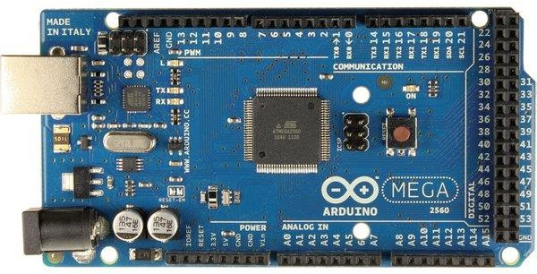

Figure 3: Arduino Mega 8-bit Microcontroller

Motor
For the Rotary Inverted Pendulum (RIP) model, a robust and responsive DC motor is required to ensure quick reaction time and adequate initial torque. Based on our design specifications, a minimum torque of 0.2 Nm is essential. To meet this requirement, the HWZ020 DC motor was selected. This motor delivers a rated torque of approximately 0.66 kgf·cm (0.065 Nm) and a locked rotor torque of 6.6 kgf·cm (0.65 Nm), which comfortably exceeds the minimum torque threshold.
In addition to its performance, the HWZ020 motor offers a compact size ideal for laboratory applications, and it includes an integrated hall encoder for precise position feedback. The motor’s high gear reduction ratio (1:20) allows for accurate control at lower speeds, making it particularly suitable for control system experiments involving real-time feedback and stabilization tasks.

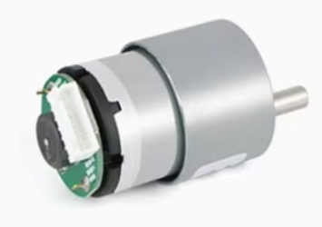

Figure 4: 25GA370 DC Gear Motor

Feedback Sensors
Feedback sensors used for this application is 360 degrees turn potentiometer for industrial application. Which is robust and accurate up to 0.1 ohms.

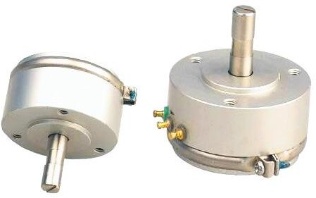

Figure 5: Feedback Sensors

Motor Driver
To control the HWZ020 DC motor effectively, the IBT-2 motor driver module, based on the BTS7960 dual full-bridge driver, has been selected. This module is capable of handling high current loads up to 43A, making it suitable for driving motors that require significant startup torque or fast directional switching — as is the case in a Rotary Inverted Pendulum (RIP) system.

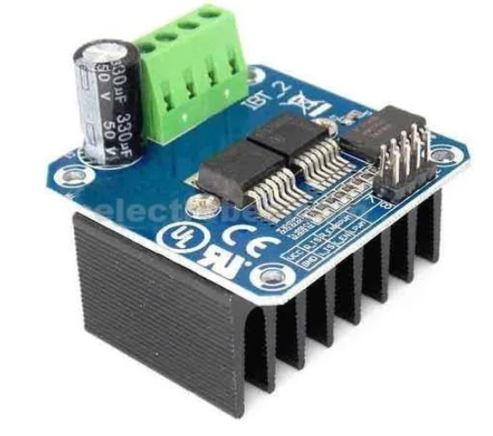
Figure 6: L298N Dual H Bridge Driver

Power Source
The RIP system requires 12V 1.5A of power, which can be supplied by any 12V wall adapter on the market..


Figure 7: 12V Wall Adapter

Governing Equations/ Mathematical Modelling
The system comprises of a rotary arm and a pendulum. Where motor arm is actuated by the DC motor with the objective of balancing the pendulum while it is in the inverted position. Figure depicts a schematic representation of the RIP system. The pendulum is attached to the motor arm by a shaft. The pendulum's movement is tracked by a potentiometer mounted on the shaft. The pendulum is displaced with an angle α while the direction of θ is in the x-direction of this illustration.

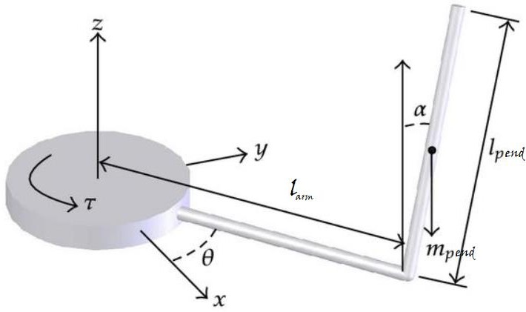
Figure 8: Simplified model of the rotary inverted pendulum system

Assumptions and Linearization
        - The system is initially in an equilibrium state therefore the initial conditions of the system are zero.
        - The pendulum does not deviate from the vertical by more than a few degrees to meet the linear model conditions.
        - A little perturbation may be applied to the pendulum.
        - As per the design specifications, the settling time, Ts, must be shorter than 0.5 seconds, or Ts 0.5secs
        - The maximum overshoot value for the system is 10%, or Ts = 10%.

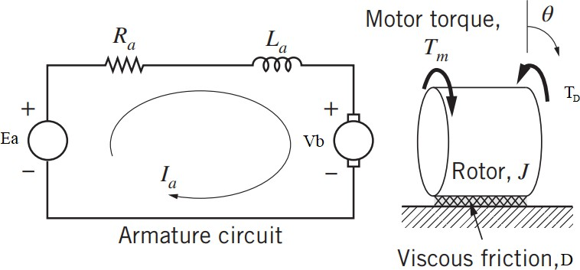
Transfer Function of Motor

Figure 9: Schematic diagram of DC motor
A schematic diagram of the DC motor is shown in the figure above. The armature circuit consists of the voltage source Ea, the armature coil inductance La (as a result of the windings), the armature resistance Ra, and the back-emf Vb. Note that the reverse emf is represented by a voltage source symbol with positive and negative terminals that oppose the positive (clockwise) flow of armature current Ia. The mechanical component of the DC motor is depicted to the right of the armature circuit. It consists of the rotor's moment of inertia J, viscous friction coefficient D, and motor torque Tm (from the current–magnetism interaction). Note that angular rotation of the rotor in the clockwise direction corresponds to positive armature current Ia and positive motor torque Tm. For rotational system:
Summing torques on the rotor (with a positive clockwise convention) and applying Newton’s second law yields
𝔈 ∑ 𝑇 = 𝑇_{𝑚} − 𝑇_{𝐷} = 𝐽𝜃̈

𝑇_{𝑚} = 𝑇_{𝐷} + 𝐽𝜃̈
Where viscous friction torque and motor torque are given by following expressions

𝑇_{𝐷} = 𝐷𝜃̇ 𝑎𝑛𝑑 𝑇_{𝑚} = 𝐾_{𝑡}𝐼_{𝑎}

The constant 𝐾_{𝑡}
is typically called the motor-torque constant and has units of ^{𝑁𝑚}. Manufacturers
𝐴

of DC motors often provide the motor-torque constant 𝐾_{𝑚} in catalogs summarizing motor specifications.
𝐾_{𝑡}𝐼_{𝑎} = 𝐽𝜃̈ + 𝐷𝜃̇ = 𝐽𝑠²𝜃 + 𝐷𝑠𝜃 = 𝜃(𝐽𝑠² + 𝐷𝑠)
𝜃(𝐽𝑠² + 𝐷𝑠)

For electrical system:
𝐼𝑎 =
𝐾_{𝑡}

We can derive the complete mathematical model of the DC motor by applying Kirchhoff’s laws to the armature circuit and Newton’s laws to the mechanical rotor. To begin, we use Kirchhoff’s voltage law around the loop, moving clockwise
𝐸_{𝑎} − 𝐼_{𝑎}𝑅_{𝑎} − 𝐿_{𝑎}𝐼_{𝑎}𝑠 − 𝑉_{𝑏} = 0
Where back emf is given by:

𝑉_{𝑏} = 𝐾_{𝑏}𝜃̇ = 𝐾_{𝑏}𝜃𝑠

The constant 𝐾_{𝑏}
is typically called the back-emf constant and has units of ^{𝑉𝑠} .
𝑟𝑎𝑑

𝐸_{𝑎} = 𝐼_{𝑎}𝑅_{𝑎} + 𝐿_{𝑎}𝐼_{𝑎}𝑠 + 𝐾_{𝑏}𝜃𝑠

𝐸_{𝑎} = (
𝜃(𝐽𝑠² + 𝐷𝑠)

𝐾_{𝑡}
) 𝑅_{𝑎} + 𝐿_{𝑎}𝑠 (
𝜃(𝐽𝑠² + 𝐷𝑠)

𝐾_{𝑡}
) + 𝐾_{𝑏}𝜃𝑠

𝐸_{𝑎} =

𝜃
𝜃( (𝐽𝑠² + 𝐷𝑠)(𝑅_{𝑎} + 𝐿_{𝑎}𝑠) + 𝐾_{𝑏}𝐾_{𝑡}𝑠)

𝐾_{𝑡}

𝐾_{𝑡}

𝐸 = 𝜃( (𝐽𝑠² + 𝐷𝑠)(𝑅 + 𝐿 𝑠) + 𝐾 𝐾 𝑠)

𝑎 𝑎 𝑎
𝜔 𝑠𝐾_{𝑡}
𝑏 𝑡

𝐸 = 𝜃( (𝐽𝑠² + 𝐷𝑠)(𝑅 + 𝐿 𝑠) + 𝐾 𝐾 𝑠)
𝑎 𝑎 𝑎 𝑏 𝑡

The following table shows the typical configuration of the system.
Table 2: Typical Configuration of the System

Constants | Value | Unit
Resistance(R) | 4.286 | 𝑜ℎ𝑚
Torque Constant (KT) | 0.1797 | 𝑁𝑚  𝐴
Back EMF Constant (KB) | 0.2087 | 𝑉𝑠  𝑟𝑎𝑑
Motor Velocity Constant (KV) | 44.5 | 𝑟𝑎𝑑𝑠
 | 424.9 | 𝑉  𝑟𝑝𝑚
 |  | 𝑉
Viscous Damping Coefficient (BEQ) | 0.000020572 | 𝑁𝑚𝑟𝑎𝑑  𝑠
JEQ (without pendulum) | 0.22775x10⁻³ | 𝑘𝑔𝑚²
JEQ (with pendulum) | 0.86562x10⁻³
Motor efficiency (𝜼𝒎) | 0.54
Belt-gear efficiency (𝜼𝒃𝒈) | 0.82
Equivalent viscous damping coefficient (𝑩𝒆𝒒) | 0.000020572 | 𝑟𝑎𝑑  𝑁𝑚.  𝑠𝑒𝑐
Geared motor gear ratio (𝑲𝒈) | 1:20

𝜔 0.1449
𝐸 = (8.3 × 10⁻⁶)𝑠² + 0.0117𝑠 + (3.405 × 10⁻³)
      - Jeq Derivation
For the calculation of equivalent moment of inertia following schematic is used where moment of inertias of all the components of the RIP system with respect to the motor shaft.

Figure 10: Schematic showing Distance of all components of RIP from the center of Rotation

The following table is the list of the terminology used in the derivations of 𝐽_{𝑒𝑞} system model.

Table 3: Masses and Required Dimensions of all Components of RIP

Component | Mass (kg) | Diameter OR length (meters) | Width (meters)
gear | mg = 0.07 | dg = 9x10⁻³ | -
Shaft 1 | ms1 = 0.05 | ds1 = 6x10⁻³ | -
Shaft 2 | ms2 = 0.045 | ds2 = 5x10⁻³ | -
Motor arm | marm = 0.028 | larm = 122x10⁻³ | warm = 23.5x10⁻³
potentiometer | mpm = 0.1 | dpm = 36.5x10⁻³ | -
pendulum | mpend = 0.026 | lpend = 140x10⁻³ | -

1 1
𝐽 = 𝑚 𝑑² = (0.07)(9 × 10⁻³)² = 7.088 × 10⁻⁷𝑘𝑔_𝑚²
𝑔 8 𝑔 𝑔 8

1
𝐽 = 𝑚
𝑑² = 1 (0.05)(6 × 10⁻³)² = 2.25 × 10⁻⁷𝑘𝑔_𝑚²

𝑠1 8

1
𝐽
𝑠1

2

𝑠1 8

1
( )(

−3)2

−7 2

𝑠2 = 8 𝑚𝑠2𝑑𝑠2 = 8
POTENTIOMETER
0.045
5 × 10
= 1.406 × 10
𝑘𝑔_𝑚

𝐽 1 2
1
( )(
−3)2
−7 2

𝑝𝑚 = 8 𝑚𝑝𝑚𝑑𝑝𝑚 = 8
0.1
36.5 × 10

1
= 166.531 × 10
𝑘𝑔_𝑚

[(𝑙² + 𝑤² ) + 𝑟²] = 1
𝐽𝑎𝑟𝑚 = 12 𝑚𝑎𝑟𝑚

0.028 × [((122 × 10⁻³)² + (23.5 × 10⁻³)²) + (50.7 × 10⁻³)²]

𝑎𝑟𝑚
𝑎𝑟𝑚

12
= 420.157 × 10⁻⁷𝑘𝑔_𝑚²
𝑝𝑚 𝑐𝑝𝑚

𝐽𝑐𝑝𝑚
= 𝑚
𝑟² = 0.1 × (100 × 10⁻³)² = 10000 × 10⁻⁷𝑘𝑔_𝑚²

𝐽𝑐𝑠1
= 𝑚
𝑟² = 0.05 × (114.35 × 10⁻³)² = 6537.96 × 10⁻⁷𝑘𝑔_𝑚²

𝐽_{𝑐}𝑝
𝑠1 𝑐𝑠1
= 𝑚
𝑟² = 0.026 × (128.7 × 10⁻³)² = 4306.5 × 10⁻⁷𝑘𝑔_𝑚²

𝐽_{𝑐} = 𝐽_{𝑐}𝑝𝑚
𝑝 𝑐𝑝
+ 𝐽_{𝑐}𝑠1
+ 𝐽_{𝑐}𝑝
= 20844.46 × 10⁻⁷𝑘𝑔_𝑚²

𝐽_{𝑒𝑞} = 2𝐽_{𝑔} + 𝐽_{𝑠2} + 𝐽_{𝑠1} + 𝐽_{𝑝𝑚} + 𝐽_{𝑎𝑟𝑚} + 𝐽_{𝑐} = 2.1449 × 10⁻³𝑘𝑔_𝑚² till motor arm

𝑝𝑒𝑛𝑑𝑢𝑙𝑢𝑚 𝑚𝑜𝑚𝑒𝑛𝑡 𝑜𝑓 𝑖𝑛𝑒𝑟𝑡𝑖𝑎 = 𝐽_{𝑝}
1
= 𝑚_{𝑝} 3
𝑙2

𝐽_{𝑝}
= 1 (0.026)(140 × 10⁻³)² = 1698.667 × 10⁻⁷𝑘𝑔_𝑚²
3

Frequency Calculations
Oscillation frequency of the pendulum

𝜔𝑝 = (√3𝑔) = (√3∗9.81) = 9.59 𝑟𝑎𝑑
4𝐿 4∗0.08 𝑠

For reliable operation close loop response should be

Where 1 𝑟𝑎𝑑 = 0.1592
𝑠
𝜔𝑛 = 4 ∗ 𝜔𝑝 = 38.36
𝑟𝑎𝑑

𝑠

38.36
𝑟𝑎𝑑

𝑠
= 6.10 𝐻𝑧

Clock Cycles
Arduino microcontroller operated at 16MHz frequency. For our RIP system we require 4.7Hz. Arduino clock divided by prescaler
16𝑒⁶/125³ = 80
Since prescaler of 80 does not exists we use 128 for clock to be within 200k(max ADC clock)
16𝑒⁶/128 = 125𝑒³
We can only achieve 125kHz clock for ADC. Now dividing clock with 13 clock cycles for one ADC conversion we get the frequency for sampling.
13 ∗ 1.0/(125e3) = 104us

State Space Model
1
104𝑒−6 = 9600 𝐻𝑧

The following state-space representation of the complete system is obtained from a research paper where a system similar to this was modelled by using other methods [11].
0 1 0 0 ⎡ 0 ⎤
𝜃̇ ⎡0 0 0 1⎤ 𝜃 ⎢ 0 ⎥

𝛼 ⎢ 𝑏𝑑
𝑐𝐺
⎥ 𝛼
𝜂𝑚𝜂𝑏𝑔𝐾𝑇𝐾𝐵
⎢𝑐 ⎥

[ ] = ⎢0
𝜃 ⎢
− 0⎥ [ ] +
𝐸 𝐸 ⎥ 𝜃 ⎢
𝑅_{𝑎}𝐸
𝐸_{𝑎}
⎥

𝛼̈ ⎢
𝑞𝑑
𝑏𝐺
⎥ 𝛼̇
⎢𝑏 𝜂𝑚𝜂𝑏𝑣𝐾𝑇𝐾𝐵⎥

0 𝐸 − 𝐸 0]
[
[ 𝑅_{𝑎}
𝐸 ]

𝑌(𝑠) = 𝐶(𝑆𝐼 − 𝐴)⁻¹𝐵 + 𝐷
𝑢(𝑠)

𝑚 𝑙2
16 𝑚𝑝𝑒𝑛𝑑𝑔𝑙𝑝𝑒𝑛𝑑

Here, 𝑎 = 𝐽_{𝑒𝑞} + ^{𝑎𝑟𝑚} ^{𝑎𝑟𝑚} , 𝑏 = 𝑚_{𝑎𝑟𝑚}𝑙_{𝑝𝑒𝑛𝑑}𝑙_{𝑎𝑟𝑚}, 𝑐 =
4

3𝑚𝑝𝑒𝑛𝑑𝑙𝑝𝑒𝑛𝑑
, 𝑑 =
, 𝐸 = 𝑎𝑐 −
2

𝜂𝑚𝜂 𝐾 𝐾 𝐾2−𝐷 𝑅
𝑏², 𝐺 = ^{𝑏𝑔} ^{𝑇} ^{𝐵} ^{𝑔} ^{𝑒𝚐} ^{𝑎}. Where 𝜂 , 𝜂 , 𝐵 , and 𝐾 are motor efficiency, belt-pulley

𝑅𝑎
𝑚 𝑏𝑔
𝑒𝑞 𝑔

efficiency, equivalent viscous damping coefficient, and geared motor gear ratio respectively. Putting all the values in the above matrix equation

[
𝜃̇ | 0 | 1 | 0 | 0 | 𝜃 | 0
𝛼̇] = 0 0 0 1] 𝛼] + [ 0
[ [
𝜃̈ | 0 | 81.58 | −10.4 | 0 | 𝜃̇ | 46.4

𝛼̈ 0 63.5 −23.2 0 𝛼̇
𝚹
] 𝐸_{𝑎} 60.42

𝑌 = [1 0 0 0 𝛼 0

0 1 0
] ∗ [ ̇ ] + [
] 𝑉𝑚

0 𝚹 0
𝛼̇

𝜃

𝐸_{𝑎}

𝑎

𝐸_{𝑎}
46.4𝑠² − 483
= 𝑠⁴ + 10.7𝑠³ − 63.5𝑠² − 1402
60.42𝑥𝑠² − 483
= 𝑠⁴ + 10.7𝑠³ − 63.5𝑠² − 1402

Geometric Modelling and Design

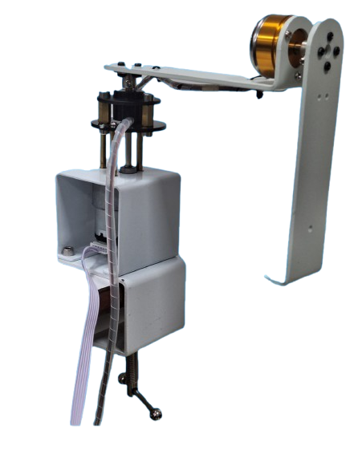
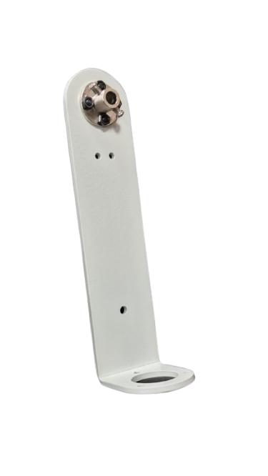
Figure 11: Physical Model of Rotary Inverted Pendulum

Standards

ISO 9001:2015 (en) Quality Management System
This project was carried out with keeping in mind the quality standards of ISO 9001.

Summary
This project focuses on the development of a cost-effective and user-friendly Rotary Inverted Pendulum (RIP) system for educational and experimental purposes in control systems engineering. To overcome the limitations of expensive commercial trainers like the Quanser Qube Servo 3, a custom RIP setup is designed using readily available, low-cost components without compromising performance and functionality.
The core hardware includes the HWZ020 DC motor, chosen for its compact size and sufficient torque output, along with an integrated Hall encoder for precise feedback. Motor control is achieved using the IBT-2 motor driver module, which supports high current (up to 43A) and provides reliable bidirectional control via PWM signals. The system is powered and controlled by an Arduino Mega microcontroller, interfaced with MATLAB/Simulink to allow real-time modeling, simulation, and controller implementation.
Through careful component selection, literature-backed modeling, and robust design, the system aims to provide a hands-on learning platform for students to understand dynamic modelling, instability, and control of nonlinear systems using modern tools and techniques.

Physical Model Development and Testing

Integration and Instrumentation

Electronic Integration
- Interface of Potentiometer with Arduino: A potentiometer is connected to the Arduino Mega microcontroller through its analog input pins 23 and 24.

- Motor Driver with Arduino: The motor driver is connected to the Arduino microcontroller as an output link between the motor and the system. It is capable of variable speed and direction control and can handle up to 5A of current.

- Integration of Microcontroller with MATLAB: In order to communicate and exchange inputs and outputs between MATLAB and Arduino, certain drivers and packages must be installed in MATLAB using the "add hardware support packages" tab.

Model Assembly
The rotary inverted pendulum operates efficiently with only a few components. With the use of 3D printed parts and a straightforward design, the proposed RIP model can be easily assembled.

- Motor



Figure 12: DC Gear Motor

- Pendulum Arm


Figure 13: Pendulum Arm

Testing/Experimental Procedure

System Testing
Tests were conducted on the assembled hardware to ensure that all moving parts were functioning properly. Once those tests were passed, the motor driver was given a steady signal in both the clockwise and counterclockwise directions to verify the movement of the motor. After confirming the correct polarity of the motor driver, the feedback potentiometers were checked by connecting them to the Arduino's ADC pins and rotating the pendulum arm to see the input readings. These tests were performed to ensure that the system was ready for further testing and programming. The belt and gear mechanism were then calibrated for optimal tension and smooth movement. To ensure that the belt and gear mechanism worked correctly, the motor arm potentiometer was adjusted for proper placement.

Position Control
The project requires precise movements, so it is crucial to have accurate position control. This helps to maintain the rigid movements of the motor arm and improve control over the system. Position control was implemented using Simulink and MATLAB 2021b on a simulation. We used the Nicholas Ziegler method and a PID tuner app within MATLAB to determine the motor transfer function and obtain the PID values. Once we achieved the highest accuracy in position control on
the simulation, we moved on to implementing it on hardware. Some slight tuning of the PID values
was necessary to account for real losses.

Speed Control
In order to implement the speed control algorithm on Simulink, we had to remove the horizontal arm and pendulum from the motor and disconnect the feedback wires for the pendulum. Once this was done, we were able to use the motor arm's feedback potentiometer to measure the speed of the motor. Speed control is crucial in an inverted pendulum system as it allows us to predict and stabilize the pendulum's movement by monitoring the rate of change in its position.

Inverted Pendulum Model
The rotary inverted pendulum system is controlled by three sub controllers: the destabilizing controller, stabilizing controller, and mode controller. The destabilizing controller causes the pendulum to oscillate until it has enough energy to move out of its stable hanging position and into the unstable upright position. The stabilizing controller is activated to stabilize the pendulum in the upright position. The mode controller determines when to switch between the destabilizing and stabilizing controllers.
- Destabilization Controller
The destabilizing controller's main function is to push the rotating arm in a way that moves the pendulum away from its stable hanging position. By vigorously moving the rotating arm back and forth, it is possible to swing the pendulum upward. Therefore, the first step in this process is to design a position controller that can move the rotating arm to achieve the destabilizing objective. The design of the destabilizing, stabilizing, and mode controllers will be discussed in the following sections.
- Stabilization Controller
The purpose of the stabilizing controller is to keep the pendulum in an upright position, even when there are small disruptions. By providing the positions of both the pendulum and the rotating arm as input, it is possible to calculate the necessary control signal using both positions. If the pendulum is nearly upright, two PD controllers can be implemented to maintain its position and also mitigate disturbances to a certain degree.
- Mode Controller
The mode controller serves to monitor the pendulum's position and initiate the switching between the stabilizing and destabilizing controllers. If the pendulum is close to the upright position (within 10 degrees), the mode controller will activate the stabilizing controller to maintain the pendulum's upright position. However, if the pendulum deviates from the upright position by more than 10 degrees, the mode controller will activate the destabilizing controller to bring the pendulum back to the upright position.

Summary
This chapter covers the construction and operation of an inverted pendulum system, including the moving parts and calibration of inputs and outputs. It also covers the process of building a RIP trainer board and using it as a laboratory trainer. In addition, the chapter discusses electronics and control theory, including the step-by-step procedure for constructing and operating a rotary inverted pendulum model. The project is divided into three main sections: position control, speed control, and inverted pendulum, which is further divided into destabilization, stabilization, and mode controllers.

Results and Discussions

Results

Motor Transfer Function
The foundational step involves determining the motor's transfer function using data provided in the manufacturer's datasheet. Essential motor constants like the back EMF constant and torque constant can be derived by analyzing the torque-speed characteristics. Accurately identifying these parameters is crucial, as it enables the precise modeling of the system in later stages of the project.

System Transfer Function
To simulate the response of the inverted pendulum system, a complete transfer function is essential. As outlined in Section 3.2.6, all mechanical components were mathematically modeled and simplified into a transfer function and a corresponding state-space representation. These models serve as the foundation for accurate system simulation and controller design.
𝜽̇ 𝟎 𝟎 𝟏 𝟎 𝜽 𝟎
𝜶̇] = [𝟎 𝟎 𝟎 𝟏] [𝜶] ∗ [ 𝟎 ] ∗ 𝑽𝒎
𝜽̈ 𝟎 𝟖𝟏. 𝟓𝟖 −𝟏𝟎. 𝟒 𝟎 𝜽̇ 𝟒𝟔. 𝟒
𝜶̈ | 𝟎 | 𝟔𝟑. 𝟓 | −𝟐𝟑. 𝟐 | 𝟎 | 𝜶̇ | 𝟔𝟎. 𝟒𝟐

[

Position Control
After deriving the motor transfer function, the next step involves tuning the PID controller for the system operating in position control mode. The goal is to ensure a fast and accurate response to the desired position input. During implementation, communication between the Arduino and MATLAB via serial interface introduced a noticeable delay between input reception and output execution.
The position control logic was implemented in Simulink using a block diagram, where the motor's behavior was represented by a transfer function block. A constant value, representing the desired angular position in degrees, served as the input. Physical markings on the apparatus were used to indicate angular positions, with a reference mean position chosen as the zero point. By adjusting a slider connected to the constant block, users could command the motor arm to rotate by a specified number of degrees, allowing real-time observation of system response.

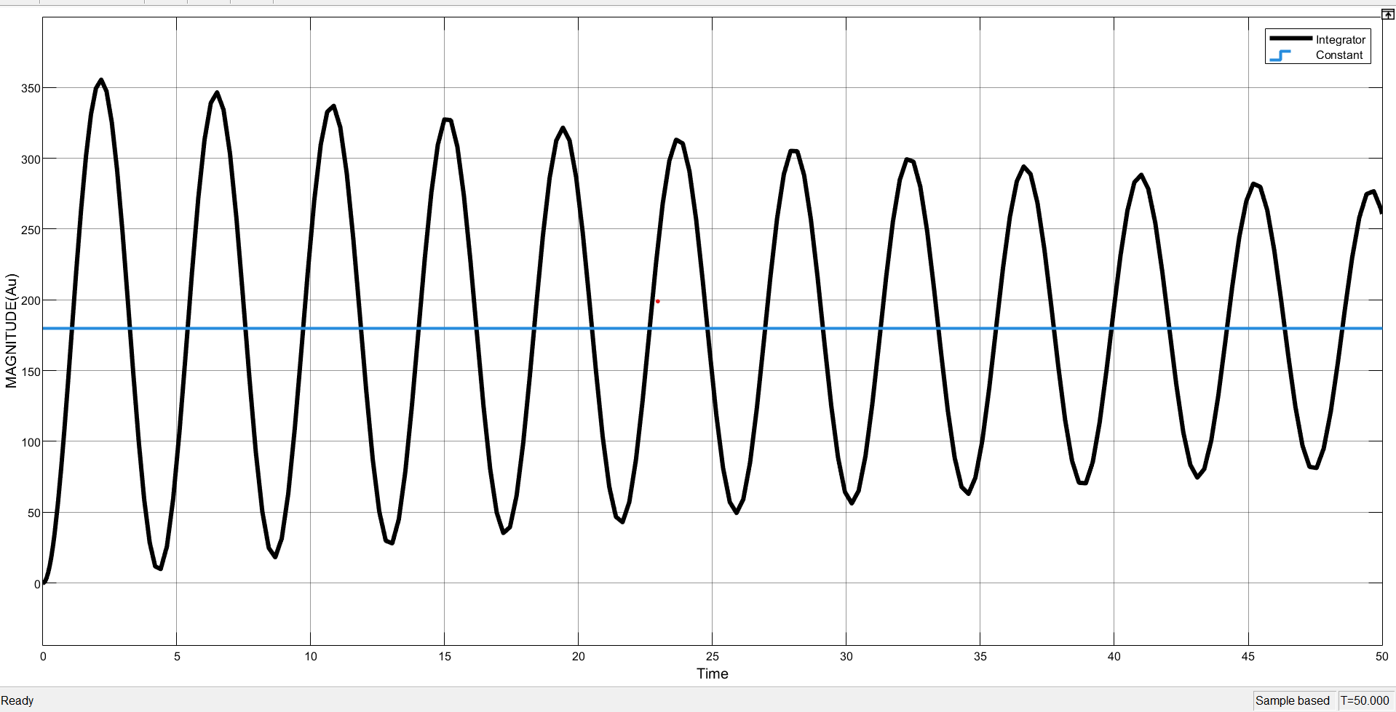
Figure 15: Position Control Simulation result without PID Controller
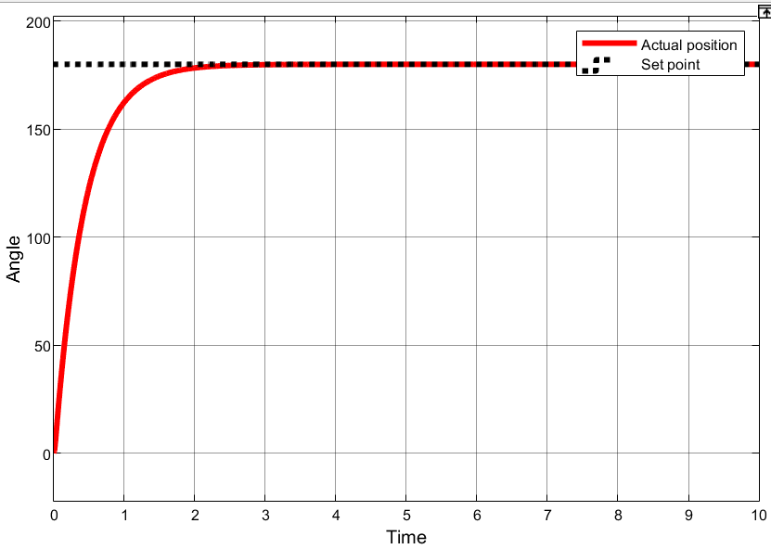

Figure 16: Position Control Simulation result with PID Controller

Speed Control
Second part of this project is to be able to control and simulate speed control mechanism using the existing hardware. Now to measure speed, derivative of positional input is needed with respect to time. A model was developed by utilizing past research papers and articles. Motor transfer function was fed input of a constant speed while putting out a steady response. Later the transient response was tuned through PID tuning methods such as root locus and Nicholas Ziegler we also used PID tuner app to further calibrate out values of Kp, Kd, Ki.
It is observed that the motor transfer function only outputs the positional value which is to be integrated (1/S) to obtain speed value. Once integrated its output is shown in the fig.
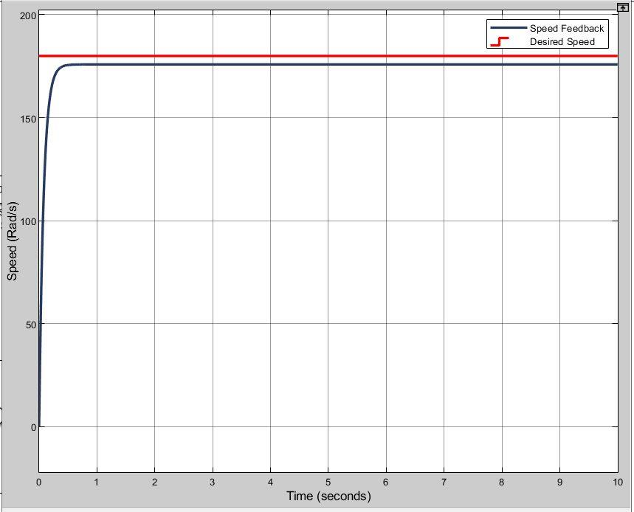
Figure 17: Speed Control Simulation result without PID Controller

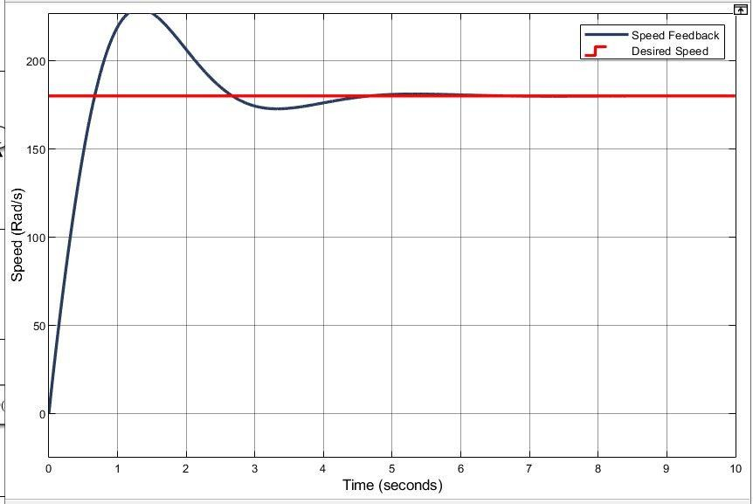

Figure 18: Speed Control Simulation result with PID Controller

Destabilization controller
The destabilization controller is responsible for swinging the pendulum into the upright position by oscillating the motor arm in a controlled back-and-forth motion. This is typically achieved using a bang-bang control strategy, which applies maximum effort in either direction to generate the required momentum. The pendulum gradually gains energy through these oscillations until it reaches the upright position, within a small angular range near vertical.
In an inverted pendulum system, it is critical that the pendulum is brought upright in a smooth and controlled manner, allowing sufficient time for the stabilization controller to take over. The destabilization controller manages both the horizontal movement of the motor arm and the vertical motion of the pendulum, which is tracked using a potentiometer. In order to facilitate the pendulum's ascent to the upright configuration, two PID controllers work in tandem, continuously monitoring and adjusting based on the position and speed of both components.

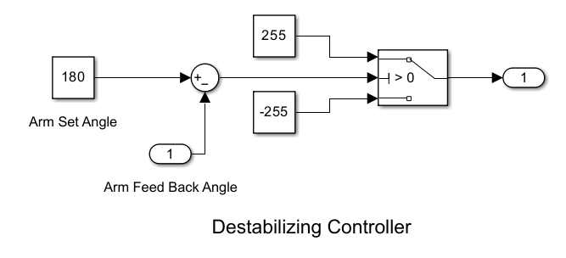

Figure 19: SIMULINK file of Destabilization Control

Stabilization Control
The stabilization controller functions similarly to the destabilization controller but with the primary objective of maintaining the pendulum in its upright position. It receives input as the difference between the angular positions of the motor arm (θ) and the pendulum (α). This difference is used to compute the control signal required to keep the pendulum balanced.
The stabilization controller operates as a cascade system, where the inner loop maintains the motor arm’s position and the outer loop focuses on stabilizing the pendulum. This hierarchical control structure ensures precise coordination—first aligning the motor arm to the reference position and then using that alignment to actively stabilize the pendulum. Once the pendulum reaches an upright position, the controller maintains it within a narrow range, even in the presence of disturbances, ensuring sustained stability of the system.
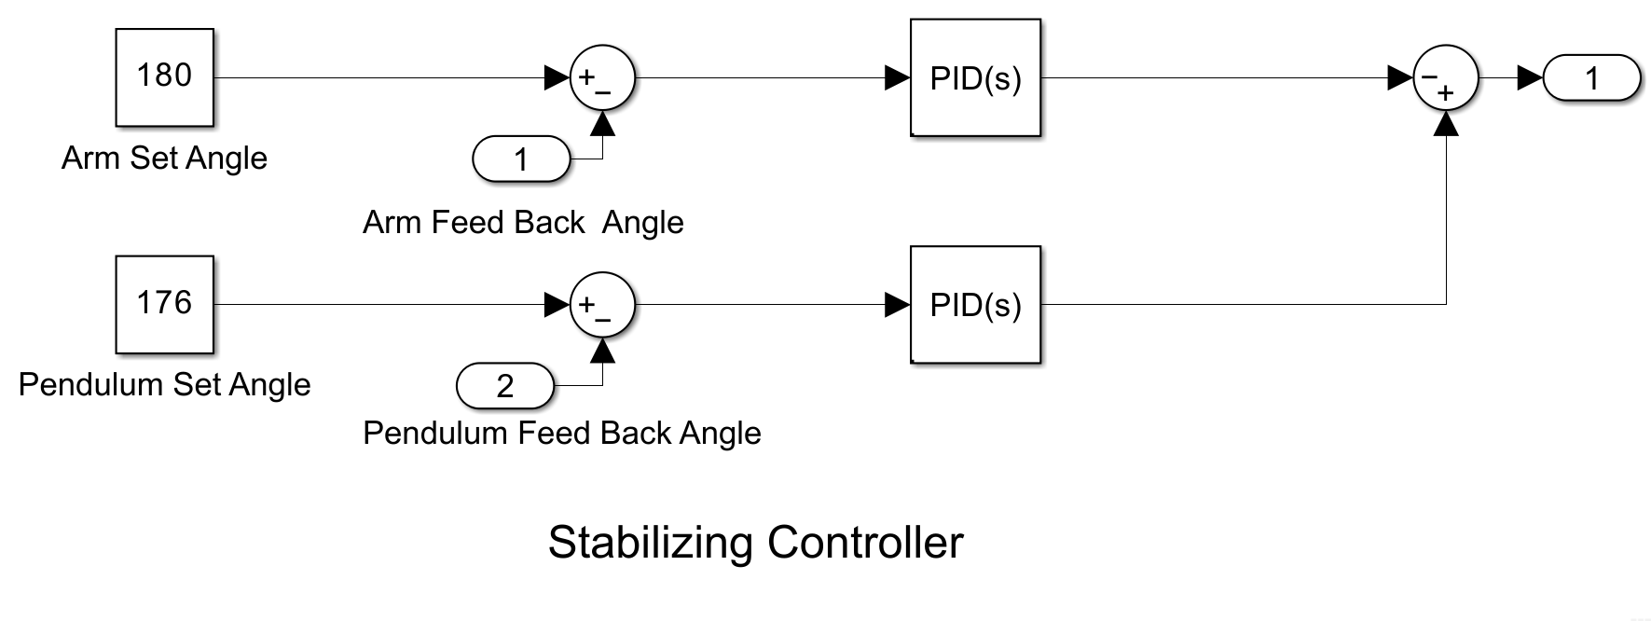

Figure 20: SIMULINK file of Stabilization Control

Mode Control
The mode control acts as a supervisory controller responsible for managing the transition between the destabilization and stabilization phases. It continuously monitors the state of the pendulum and determines the appropriate control mode based on its position.
When the pendulum moves within a predefined threshold near the upright position, the mode control detects this condition and seamlessly switches control from the destabilization controller to the stabilization controller. This ensures that once the pendulum is near vertical, the system transitions smoothly into stabilization to maintain balance and prevent oscillations. The mode control plays a critical role in achieving a coordinated and responsive control architecture for the inverted pendulum system.
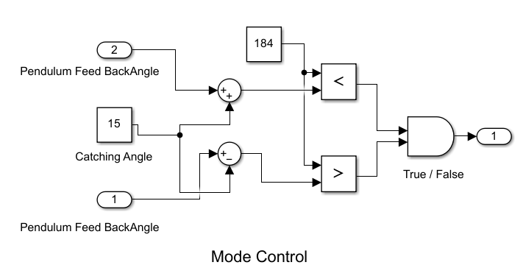

Figure 21: Mode Control

Analysis and Discussions Results

Motor Transfer Function
This function forms the foundation of the entire system, as all subsequent modeling depends on accurately characterizing the motor. A DC geared motor is ideal for this application due to its torque characteristics and ease of control.
To derive the motor's transfer function, the manufacturer's datasheet provides essential parameters such as rated torque, current, speed, and voltage. These values are used to calculate motor constants like the back EMF constant and torque constant. By substituting these into standard motor equations, the transfer function is obtained. This transfer function, as referenced in the relevant section, serves as the basis for further simulation and control design.

System Transfer Function
Several iterations were carried out to accurately determine the system’s complete transfer function, as it required highly precise calculations of inertia and equivalent moment of inertia (Jeq) to effectively model the dynamics. In addition to the mechanical components, electrical parameters also had to be modeled accurately to ensure consistency and minimize potential errors during the plant linearization process.
Once all mechanical elements — from the pendulum to the motor arm — were reduced and reflected to the motor shaft, the motor's transfer function was integrated with the mechanical model. This comprehensive model was then further developed into a state-space representation by following methodologies outlined in relevant research literature, forming a complete and accurate mathematical representation of the system.

Position Control
To ensure accurate and precise position control, it is essential to rely on the motor model developed earlier. This model is integrated within a transfer function block, which is then tested with various PID parameter values for performance analysis. The experiment also involves testing the motor model with different motor arm sizes and motor types to investigate how variations in the size and weight of the motor arm impact system behavior.

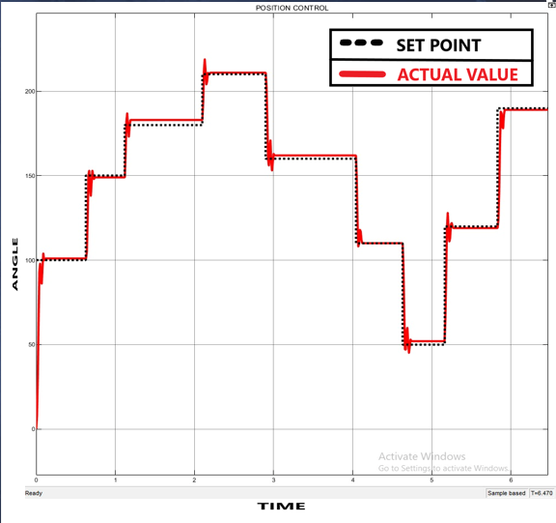

Figure 22: Position control on step input

Speed Control
To achieve steady speed readings, potentiometer values must be recorded at each step change. When the Arduino's analog value changes, the system needs to be able to tell. The Simulink model will use interrupts to monitor and capture changes in the potentiometer readings.

Destabilization Controller
Several tests were conducted in destabilization mode, and the readings were logged to evaluate how frequently and accurately the system responds to the designed model. It was observed that within 3 seconds, the pendulum successfully reached the upright position, demonstrating that the system was modeled with high precision and accuracy.
The destabilization controller drives the motor based on inputs from both feedback potentiometers, primarily relying on the pendulum's positional value. The main objective is to bring the pendulum within a range of 10 to 350 degrees from the inverted 180-degree position.

Stabilization Controller
Stabilization is the most critical aspect of the system, working in a manner similar to the destabilization controller. It relies on the pendulum’s alpha degrees as the primary input, with the motor arm’s theta degrees serving as the secondary input.
Additionally, the system was tested with different pendulum sizes and masses to assess its durability and adaptability.

Mode Controller
Mode controller works in simple fashion, that is to select between destabilization and stabilization controllers which works when the pendulum is within desired range.

Summary
This chapter outlines the procedures used to obtain the results discussed above. Multiple iterations of each test were conducted to ensure stable and reliable readings. Prior to every test, the apparatus was thoroughly inspected to confirm it was in optimal condition, with all moving parts checked for any looseness.
For speed and position control, the motor arm and the pendulum were removed to minimize mechanical slack and ensure smoother motion. In contrast, the stabilization and destabilization of the Rotary Inverted Pendulum (RIP) posed the greatest challenge. Tuning a PID controller for a complex, nonlinear system necessitates partial linearization, which introduces discrepancies between the physical setup and the modeled system. The system of equations governing the RIP was linearized, resulting in deviations between the actual apparatus and the software-based state-space model. The linearized system model had to be used to carefully adjust the PID parameters in order to correct these irregularities.

Impact and Economic Analysis

Sustainable Development Goals
Following Table explains how the project supports the achievement of the Sustainable Development Goals (SDGs).
Table 4: SGD table of the project.

S.  No. | Title | Compliance  (Y/N) | Remarks
1 | No poverty | N | -
2 | Zero hunger | N | -
3 | Good health/wellbeing | Y | The project uses safe and environmentally friendly materials with no toxic waste
4 | Quality education | Y | Development and Research in prototype manufacturing
5 | Gender equality | N | -
6 | Clean water and sanitation | N | -
7 | Affordable and clean energy | N | -
8 | Decent work and economic growth | Y | The project is one for the future and has room for improvement
9 | Industry, innovation, and infrastructure | Y | This project enables and encourages innovation and development at student level
10 | Reduced Inequalities | N | -
11 | Sustainable Cities and Communities | N | -
12 | Responsible consumption and production | Y | Manufacturing of RIP prototype utilities safe and environmentally friendly components and materials.
13 | Climate action | N | -
14 | Life below water | N | -
15 | Life on land | Y | Little to no waste produced.
16 | Peace, Justice, and strong institutions | N | -
17 | Partnerships for the goals | N | -

Social Impact
Our project aims to develop an apparatus for students to practice and learn in practical way the concepts of controls and stability. An inverted pendulum system is widely used in labs across almost every engineering institute as it covers a broad spectrum of real-world applications. Out project will help enable young engineers to visually see the results of their mathematical calculations based on any subject.
This project will create an impact by bringing a very important tool within reach of every student thus enabling them to better learning through visualization.

Sustainability Analysis
This project was aimed at 3 main factors. Easy availability of manufacturing material or components, low cost and easy user interface. And this section includes all three aspects. The project uses 3d printed parts for its motor arm and pendulum joints which are nowadays very easy to obtain and are sturdy for such a project. Secondly easy availability of materials, every component used in project is easily available anywhere within Pakistan. Lastly easy user interface as to make students want to use such a lab equipment. By utilizing easy Simulink block diagram interface in combination with addons packages Arduino and MATLAB interface becomes very easy.

Experimental Impact
Such a project is designed to have zero carbon footprint, keeping in mind the low precision and high reliability of components. By using environmentally friendly and recyclable materials, project is almost carbon free.

Sustainable development goals
This project aims towards achieving multiple SDG goals. To do that, it was must to choose materials for body construction and electrical components easily available on large scale such that any institute or individual can construct. Innovative ideas help revolutionize existing technologies, our design uses innovative design to optimize system size and efficiency.

Hazard Identification and Safety Measures
To take care of student safety this project was made with light weighted parts and limited movement to avoid any mishap from happening. The project incorporates a failsafe mechanism

such as positional limit. The motor arm cannot exceed beyond set limit ultimately making sure system doesn’t go rouge while testing. Along with that no explosive components have been used all components are logic level consuming a total of 8W of power, which is harmless. Construction is made of acrylic and wood to keep its weight light and easy to move around.
Certain safety measures are required while using RIP system is to keep system proportional gain below stated safe limit. As increasing the gain more than the limit can cause rapid to and fro movement and can cause damage to the operator or the assembly.

Summary
This chapter describes the environmental aspects and effects of this project. All the aspects are discussed in detail the sole purpose is to provide a better alternative to electrical engineering students in understanding concepts of control engineering. The impact this project will have on academics is much greater in comparison to its total costs. It best viable solution in comparison to highly expensive already available market solutions. This solution provides simpler, effective and cheap solution in comparison to other market available solutions.

Conclusion and Future Recommendations

Conclusions
Keeping the problem statement and expected outcomes in mind (Chapter 1), our goals were achieved. We managed to design the methodology and working principle for Position control, speed control destabilization controller and managed to get them working as they should. The only remaining hurdle we the stabilization controller. Which was developed but not completed. Overall, we managed to design lab experiments for our project which are stated within this report.

Future Recommendations
After the analysis and results of current work, following are the future recommendations:
- Explore different control strategies and techniques for achieving stable inverted pendulum control, such as LQR control, and model predictive control.
- Conduct experiments to compare the performance of different control strategies under various operating conditions, such as different load conditions and disturbance inputs.
- Embedded electronics can be implemented to avoid complicated wiring and have a single PCB mounted electronics, including microcontroller and motor driver.
- Usage of slip rings for potentiometer mounted on motor arm, this will remove unnecessary wires that may get tangled making the system safer.
- Integrate a IOT based setup to allow remote access to students.
- Hardware in loop (HIL) to be implemented, this will make system response faster and provide a project that can be separated from a desktop computer or a laptop.
- Investigate the effects of different plant parameters, such as pendulum length and base stiffness, on the control performance and stability.
- Conduct experiments to compare the performance of different control strategies under various operating conditions, such as different load conditions and disturbance inputs.
- Conduct further research on the use of the modular control system for other applications, such as multi-input multi-output systems or nonlinear systems.

References

[1] | T. S. Y. B. F. K. Masanori Yukitomo, "A Two Degrees of Freedom PID Control System, its Features and Applications," in Asian Control Conference, 2005.
[2] | M. A. a. H. Taguchi, "Two-Degree-of-Freedom PID Controllers," International Journal of Control, Automation, and Systems, vol. 1, no. 4, 2009.
[3] | L. Meirovitch, Methods of Analytical Dynamics, Courier Corporation, 2010.
[4] | Al-Nashash, 2018.
[5] | K. Y. Y. N. Kaixuan Guan, "Virtual-mass-ellipsoid Inverted Pendulum Model and Its Applications to 3D Bipedal Locomotion on Uneven Terrains," in IEEE/RSJ International Conference on Intelligent Robots and Systems (IROS), Macau, 2019.
[6] | J.-K. K. J.-K. K. K. H. C. L. K. H. J. W. P. J.B. Jang, "Experimental study of friction pendulum system to improve the seismic capacity of transformer," ResearchGate, 2008.
[7] | W. Liao, Z. Liu, S. Wen, S. Bi and D. Wang, "Fractional PID based stability control for a single link rotary inverted pendulum," in International Conference on Advanced Mechatronic Systems (ICAMechS), Beijing, 2015.
[8] | X. P. L. S. S. G. a. C. L. B. Chen, "Adaptive fuzzy control of a class of nonlinear systems by fuzzy approximation approach," in NUS Libraries, IEEE Transactions on Fuzzy Systems, Singapore, 2012.
[9] | A. K. J. T. U. G. M. S. A. M. Adharsh Lal M, "Stabilization of Rotary Inverted Pendulum using PID Controller," in IEEE, Ernakulam, 2021.
[10] | Z. M. M. n. A. Mohd Fairus Abdollah, "Fuzzy modeling and control of rotary inverted pendulum system using LQR technique," in IOP Conference Series Materials Science and  Engineering 53(1), 2013.

[11] | M. A. A.A. Shafie, "Modeling and Control of a Rotary Inverted Pendulum Using Various Methods, Comparative Assessment and Result Analysis," in IEEE International Conference on Mechatronics and Automation, Xi'an, China, 2010.
[12] | T. Z. F. J. Q. S. Jingwen Huang, "Control of Rotary Inverted Pendulum Using Model-Free Backstepping Technique," in IEEE Access PP(99):1-1, Beijing, , 2019.
[13] | A.-C. H. Yung-Feng Chen, "Adaptive control of rotary inverted pendulum system with time- varying uncertainties," in Nonlinear Dynamics 76(1):95-102, Taipei, 2013.
[14] | M. T. M. A. S. Mojtaba Ahmadieh Khanesar, "Sliding mode control of Rotary Inverted Pendulm," in IEEE Xplore, Control & Automation, 2007. MED '07. Mediterranean  Conference, Athens, 2007.

