

**VILNIUS UNIVERSITY**

**ŠIAULIAI ACADEMY**

BACHELOR PROGRAMME SOFTWARE ENGINEERING

**Object-Oriented Programming testing report No. 3**

student : Mykola Onishchuk

Leacture: Donatas Dervinis, Assist. Prof., Dr.

Šiauliai, 2024

Testing report 3

Mykola Onishchuk

Here we can enter interval for calculating Collatz. After we’ll see an output.

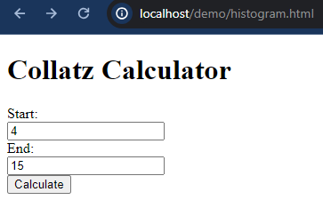

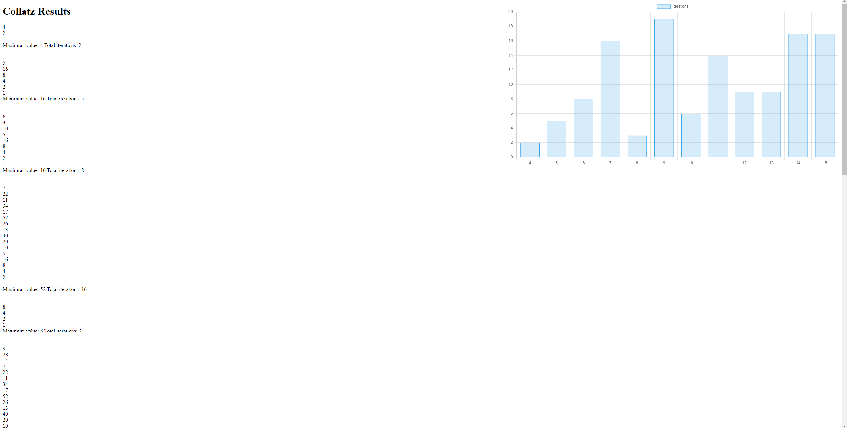

I used library “Chart.js” for building histograms on the webpage.

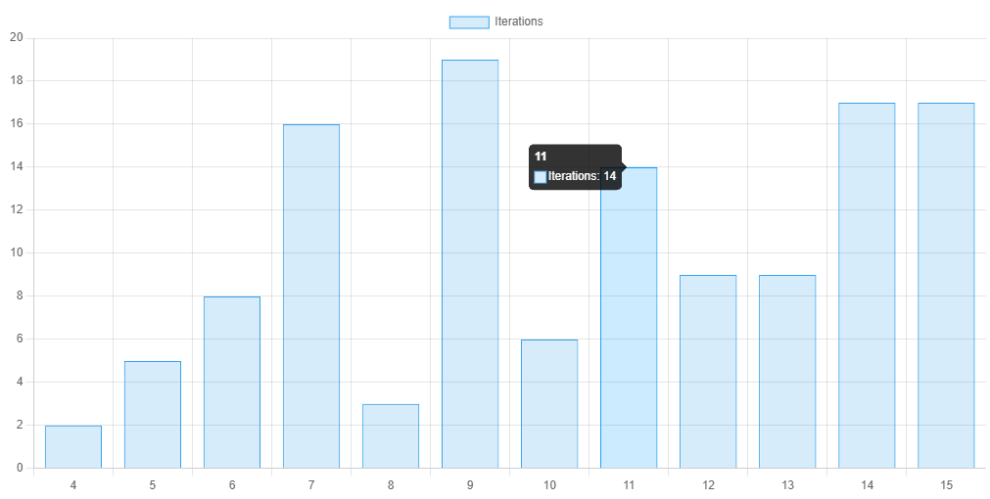  
  
  
Here’s my UML diagram for my classes.

