CSE 201 Project High Level Design Document

## Team Member Names

Zhizhe Han, Claire O’Neil, Quinn Miller, Zhiyi Ye

## Team Project Title

Story-Time

### Project Description

Story time is an application that allows users to rate and share their opinion about the various story components and characters in fictional stories.  These stories can be told in movies, TV shows, video games, books, comic books, or any type of literature.  Each story will have a page in which its components and characters along with their average ratings and thoughts are displayed.  The site will contain members and admins.  Admins add stories requested by members while members rate and review them.

## Overall Design Description

Story Time is a desktop application with object oriented design. It contains user interface, backend, front end, and database.

## UML Diagram 1

**Class Diagram** gives the relationships between each class.

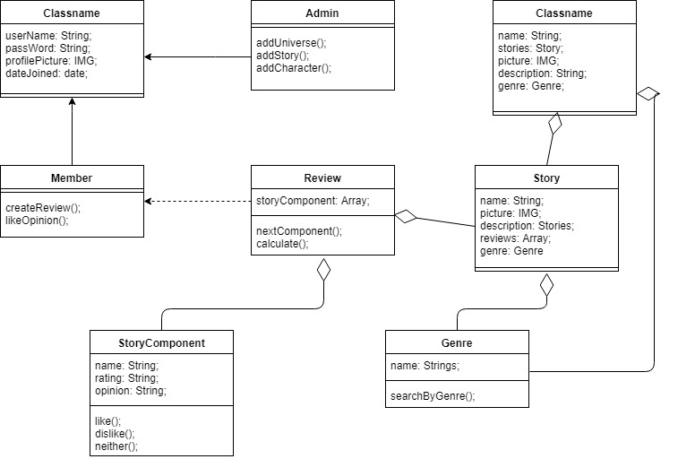

## UML Diagram 2

<Include a short text description of what the UML diagram is showing and then cut and paste your UML diagram here. Use a minimum of 1 class diagram, 2 Use Cases and 2 Sequence diagrams. You are not required to do the OPT and ALT cases in the Sequence diagrams.>

***Repeat the UML Diagram sections as many times as you want to show your UML diagrams.***