PROJECT REPORT

**MPLS route management**

Leone Giuseppe, 10518770

Petocchi Alessandro, 10661410

Sodano Marco, 10495166

Villa Veronica, 10503254

**SOURCE CODE**

Imported libraries

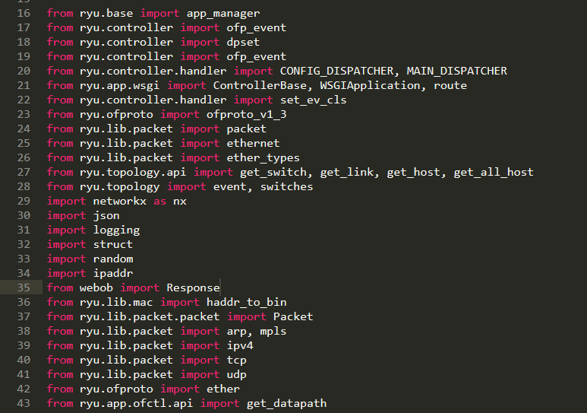

Variable definitions

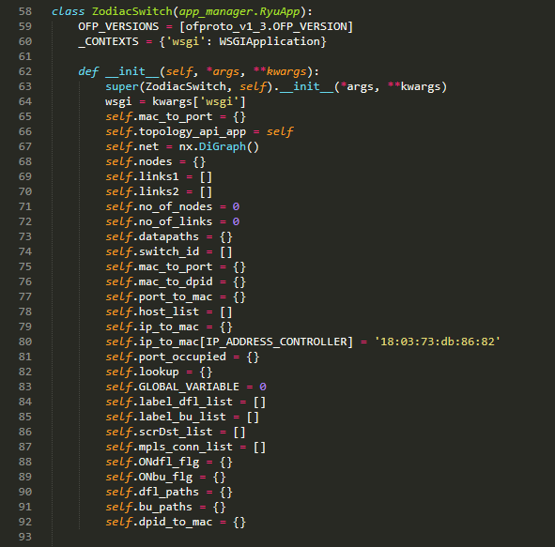

Default rule definition for all switches of the network. No buffering, the whole packet is forwarded to the controller

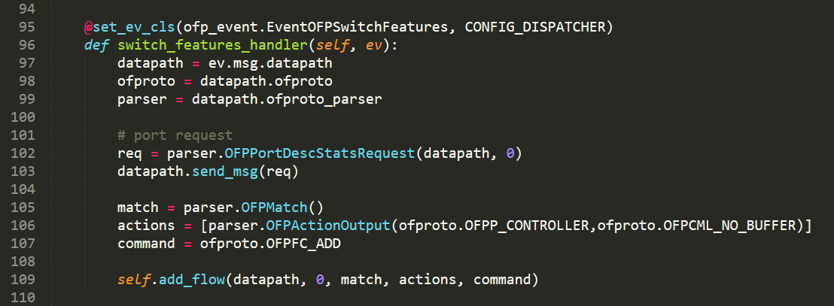

Rule installation function

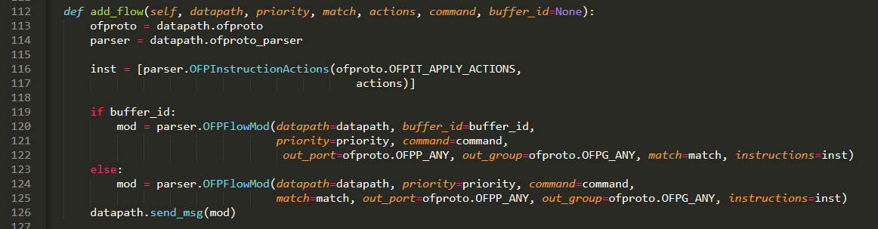

Definition of MPLS default rules for source and destination nodes. With push MPLS command, the label is attached on the packet. Label is then removed by pop MPLS command.

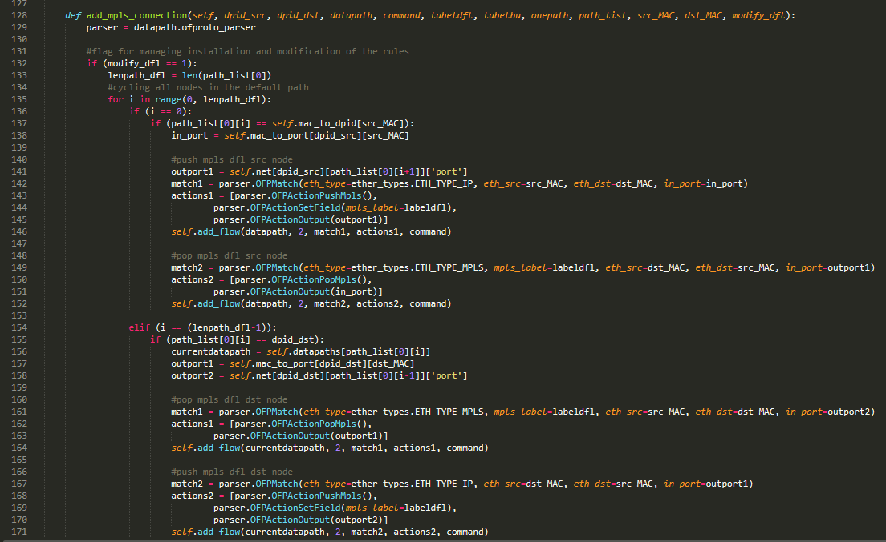

MPLS default rules definition for intermediate nodes: packet is forwarded according to its label.

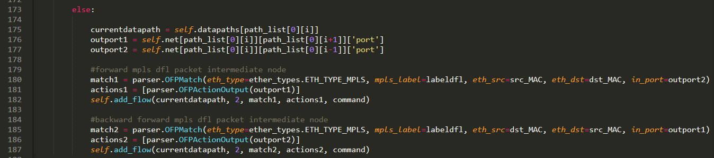

Definition of MPLS backup rules for source and destination nodes. With push MPLS command, the label is attached on the packet. Label is then removed by pop MPLS command.

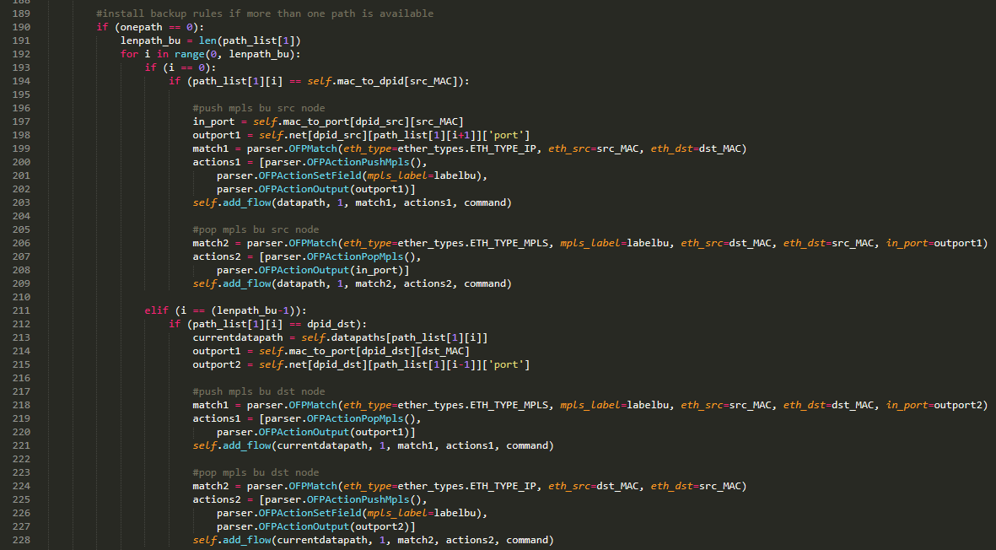

MPLS backup rules definition for intermediate nodes: packet is forwarded according to its label.

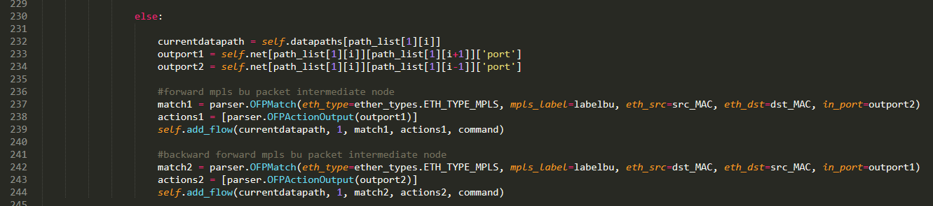

ARP delivery function.

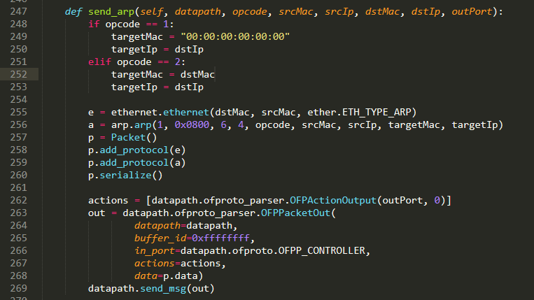

Packet in handler: controller extracts packet fields.

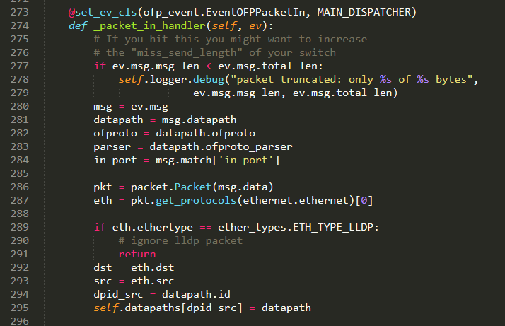

Topology and MAC learning

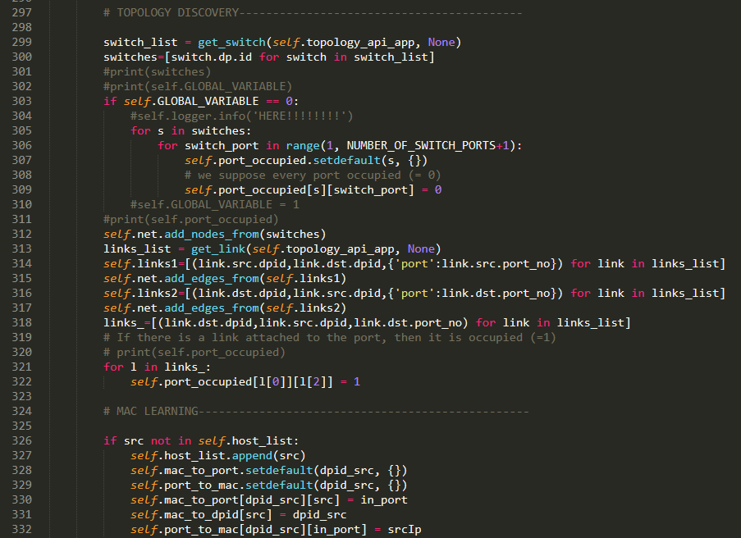

ARP management

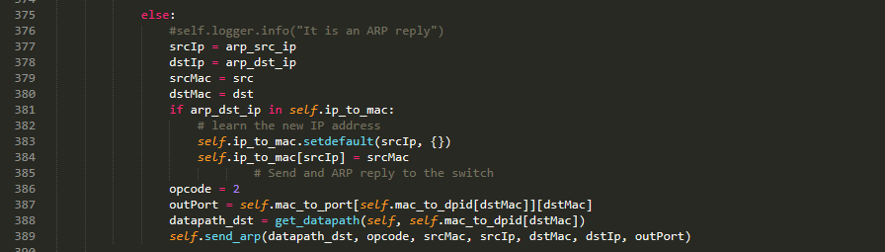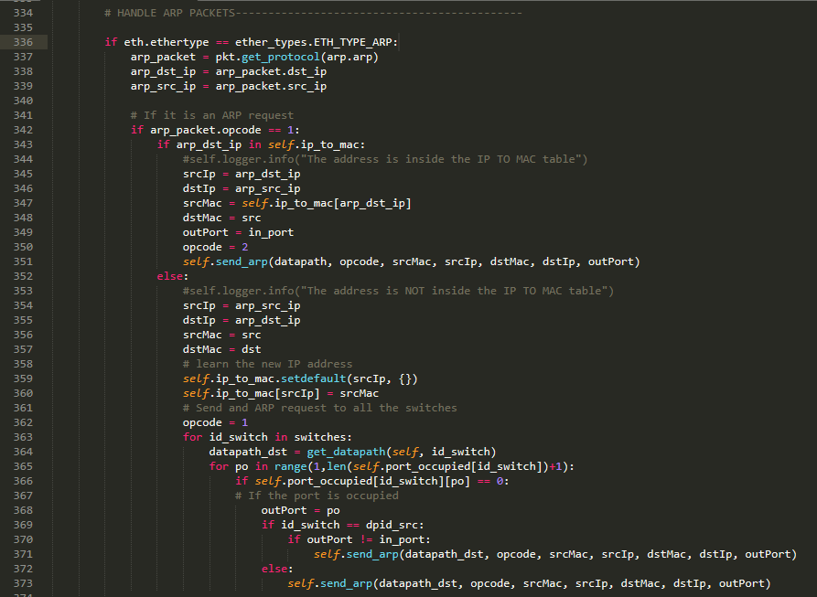

IP packets management:

