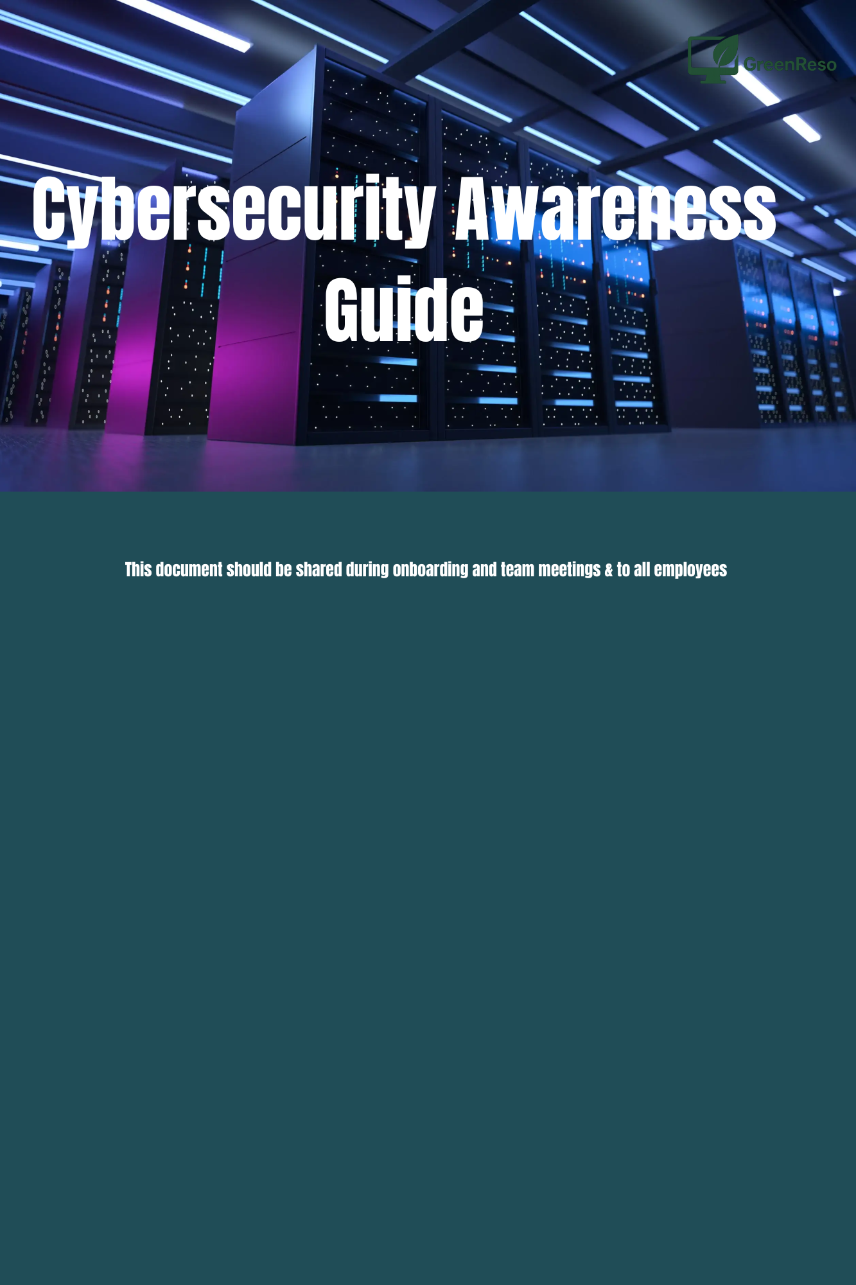

At GreenReso, we handle sensitive data daily, including customer information, innovation projects, and financial data. Protecting this information is a shared responsibility. This guide summarizes the main digital risks and provides clear practices to adopt in daily work.

Common Cybersecurity Threats

Phishing
Fraudulent emails or messages impersonating trusted sources to steal credentials or install malware.
How to respond: Verify sender, avoid clicking suspicious links, and report any suspicious emails to IT support.

Ransomware
Malware that encrypts files and demands payment.
Prevention: Avoid opening unknown attachments or downloading software from untrusted sources.

Weak or Stolen Passwords
Passwords that are easy to guess or reused across services.
Best practice: Use strong, unique passwords for each account and store them securely.

Malware
Viruses, trojans, or spyware that compromise systems or steal data.
Prevention: Install software only from approved sources and maintain antivirus protection.

Social Engineering
Manipulation techniques to extract information or gain access.
Prevention: Verify identities, do not share passwords, and report suspicious behavior.

Unsecured Wi-Fi Networks
Public or unprotected networks can allow attackers to intercept data.
Prevention: Avoid public Wi-Fi, use mobile data or a company VPN, and confirm network names.

Data Breach and Information Leakage
Unintentional or malicious disclosure of confidential information.
Prevention: Lock workstations, verify email recipients, and secure sensitive documents.

Insider Threats
Security risks from employees, whether intentional or accidental.
Prevention: Follow access policies, report unusual behavior, and maintain proper access controls.

Outdated Software and Systems
Unpatched systems are vulnerable to known exploits.
Prevention: Apply updates promptly and support migration to modern operating systems (e.g., Windows 11).

Physical Security Breaches
Unauthorized access to devices, offices, or documents.
Prevention: Secure equipment, restrict visitor access, and store or shred sensitive documents.

2. Daily Security Practices
- Lock your workstation when leaving.
- Keep your workspace organized and free of visible confidential documents.
- Use strong, unique passwords and change them if compromised.
- Only install IT-approved software.
- Verify email senders and recipients before opening attachments.
- Store documents on company-approved platforms like Google Drive for example, not personal USB drives.
- Avoid unsecured Wi-Fi networks and use VPN when necessary.
- Report suspicious activity to IT support immediately.

3. Incident Response
- Suspicious link clicked: Disconnect, contact IT, change passwords from a secure device.
- Lost device: Inform IT and manager, lock device remotely, change passwords.
- Abnormal activity: Contact IT if files change unexpectedly, unknown programs run, or unusual messages appear.
- Wrong recipient email: Notify IT and your manager, request deletion, document the incident.

4. Security Review Checklist
- Lock computer before leaving desk.
- Check emails for suspicious links or senders.
- Keep files on secure company platforms.
- Store or shred sensitive documents.
- Install software updates promptly.

5. Key Facts
- Most security incidents involve human error.
- 1 in 99 emails is phishing.
- Ransomware attacks occur frequently and can cause serious damage.
- Strong passwords significantly reduce account compromise risk.

Report any suspicion immediately. False alarms are better than unreported incidents.

