Scientific Approach Application (SAA) Report

Predictive Maintenance of Turbofan Engines

Estimating Remaining Useful Life from Multivariate Sensor Data: Comparison
of Machine Learning and Deep Learning Approaches on NASA C-MAPSS





First & last name of the student that has written this document: Manil DOUDOU
Name of the class: Y4 in computer science engineering for English speakers
This document has been written in Toulouse, France, on February 1, 2026
The academic tutor representing CESI of Toulouse: Mr. Wassim MASRI
There is no host organization, but I have used NASA's C-MAPSS data

Confidentiality Notice

Acknowledgments
I would like to thank my academic tutor at CESI École d'Ingénieurs for their guidance and feedback throughout this Scientific Approach Application project, and for helping frame the initial problem into a well-scoped, feasible research question.
I also gratefully acknowledge NASA's Prognostics Center of Excellence for making the C-MAPSS dataset publicly available, which made this comparative study possible without requiring access to proprietary industrial data.
Finally, I thank my peers for the discussions that helped sharpen the interpretation of the results presented in this report.

Abstract (English language)
Unplanned turbofan engine failures are safety-critical and economically damaging for airlines, while conventional schedule-based preventive maintenance often replaces components well before the end of their useful life, generating unnecessary cost. Predictive maintenance, which anticipates failure from real-time sensor data, offers a middle path but requires models able to accurately estimate a component's Remaining Useful Life (RUL) from noisy, multivariate, time-series sensor readings.
This study investigates and compares classical machine learning models (Linear Regression, Random Forest, Gradient Boosting) and a deep learning sequence model (LSTM) for RUL prediction, using the FD001 subset of NASA's C-MAPSS (Commercial Modular Aero-Propulsion System Simulation) turbofan degradation dataset, a widely used benchmark in prognostics and health management (PHM) research.
Following a rigorous scientific approach, the problem is first framed in terms of its safety and economic stakes; the state of the art in RUL prediction is then reviewed; candidate models are selected, implemented and evaluated using RMSE and the NASA asymmetric scoring function, which penalizes late (optimistic) predictions more heavily than early ones. Results show that the LSTM model achieves the best performance (test RMSE = 15.41 cycles, NASA score = 423.3), clearly outperforming Random Forest (RMSE = 18.08, score = 912.6), Gradient Boosting (RMSE = 18.37, score = 1047.7) and Linear Regression (RMSE = 21.88, score = 1307.6), confirming the value of modeling engine degradation as a temporal sequence rather than as independent snapshots.
The study concludes with a discussion of the operational relevance of these results, their limitations (notably the simulation-to-reality gap and the use of a single operating condition), and perspectives for future work, including multi-condition generalization, uncertainty quantification, and real-world deployment considerations.
Keywords: Predictive maintenance, Remaining Useful Life (RUL), Machine Learning, LSTM, Turbofan engines, C-MAPSS, Prognostics and Health Management.

Résumé (Langue française)
Les pannes non planifiées de moteurs d'avion présentent un enjeu critique pour la sécurité et un coût économique important pour les compagnies aériennes, tandis que la maintenance préventive classique, basée sur un calendrier fixe, remplace souvent des composants avant la fin réelle de leur durée de vie utile, générant un surcoût inutile. La maintenance prédictive, qui anticipe la panne à partir de données capteurs en temps réel, propose une voie intermédiaire, mais nécessite des modèles capables d'estimer avec précision la durée de vie résiduelle (Remaining Useful Life, RUL) d'un composant à partir de mesures capteurs multivariées, bruitées et temporelles.
Cette étude examine et compare des modèles de machine learning classiques (régression linéaire, forêt aléatoire, gradient boosting) et un modèle d'apprentissage profond séquentiel (LSTM) pour la prédiction de la RUL, en utilisant le sous-ensemble FD001 du jeu de données C-MAPSS de la NASA, une référence largement utilisée dans la recherche en pronostic et gestion de la santé des systèmes (PHM).
En suivant une démarche scientifique rigoureuse, le problème est d'abord posé en termes d'enjeux sécuritaires et économiques ; l'état de l'art de la prédiction de RUL est ensuite analysé ; des modèles candidats sont sélectionnés, implémentés et évalués à l'aide de la RMSE et de la fonction de score asymétrique de la NASA, qui pénalise davantage les prédictions tardives (optimistes) que les prédictions précoces. Les résultats montrent que le modèle LSTM obtient la meilleure performance (RMSE test = 15,41 cycles, score NASA = 423,3), surpassant nettement la forêt aléatoire (RMSE = 18,08, score = 912,6), le gradient boosting (RMSE = 18,37, score = 1047,7) et la régression linéaire (RMSE = 21,88, score = 1307,6), confirmant l'intérêt de modéliser la dégradation du moteur comme une séquence temporelle plutôt que comme des instantanés indépendants.
L'étude se conclut par une discussion sur la pertinence opérationnelle de ces résultats, leurs limites (notamment l'écart simulation-réalité et l'utilisation d'une seule condition opérationnelle), et des perspectives de travaux futurs, incluant la généralisation multi-conditions, la quantification de l'incertitude et les enjeux de déploiement en conditions réelles.
Mots-clés : Maintenance prédictive, Durée de vie résiduelle (RUL), Machine Learning, LSTM, Moteurs turbofan, C-MAPSS, Pronostic et gestion de la santé des systèmes.

Table of Contents
Confidentiality Notice 2
Acknowledgments 3
Abstract 4
Résumé 5
Table of Contents 6
Table of Illustrations 9
Figures 9
Tables 9
Introduction 10
1. Problem Definition and Context 12
1.1 Comparison of maintenance strategies 12
1.2 Industrial context 12
1.3 Problem statement 13
1.4 Scope and constraints 13
1.5 Socio-economic stakes 14
1.6 Synthesis: research questions 14
2. State of the Art 16
2.1 Maintenance strategies: from reactive to predictive 16
2.2 The C-MAPSS benchmark 16
2.3 Machine learning approaches for RUL estimation 16
2.3.1 Classical machine learning and regression 16
2.3.2 Recurrent neural networks: LSTM and GRU 17
2.3.3 Convolutional and hybrid architectures 17
2.3.4 Feature engineering and health indicator construction 17
2.4 Comparative overview of published results 17
2.5 Physics-based vs data-driven prognostics 18
2.6 Synthesis and positioning of this study 18
3. Proposed Methodology 20
3.1 Dataset presentation 20
3.2 Data preparation 20
3.2.1 Feature selection 20
3.2.2 RUL capping (piecewise-linear target) 20
3.2.3 Normalization 20
3.2.4 Train / validation split 21
3.3 Candidate models and selection criteria 21
3.4 Evaluation protocol 21
3.5 Hyperparameter selection 22
3.6 Computational environment 22
3.7 Data quality checks 22
4. Implementation and Results 23
4.1 Exploratory data analysis 23
4.2 Baseline models: Linear Regression, Random Forest, Gradient Boosting 24
4.3 Deep learning model: LSTM 25
4.4 Comparative results 25
4.5 Feature importance and discussion 27
4.6 Error analysis by operational criticality zone 28
4.7 Cross-check against the literature 29
4.8 Threats to validity 30
4.8.1 Internal validity 30
4.8.2 External validity 30
4.8.3 Construct validity 30
5. Discussion: Operational Implications 31
5.1 From model accuracy to maintenance decisions 31
5.2 Illustrative cost-benefit example 31
5.3 Sketch of an operational deployment architecture 31
5.4 Risk considerations 32
5.5 Accountability and environmental considerations 32
5.6 Alignment with broader industry trends 33
6. Conclusion and Perspectives 34
6.1 Answer to the initial problem 34
6.2 Limitations 34
6.3 Perspectives for future work 35
6.4 Reflection on the scientific approach applied 36
Bibliography 37
Glossary 38
Appendices 39
Appendix A — Dataset column description 39
Appendix B — Full Random Forest feature importance 39
Appendix C — Model hyperparameters 40
Appendix D — Key source code excerpts 40
D.1 — RUL label construction (train and test sets) 40
D.2 — NASA asymmetric scoring function 40
D.3 — Baseline model training (Random Forest / Gradient Boosting) 41
D.4 — Sliding-window sequence construction for the LSTM 41
D.5 — LSTM model architecture and training 41
Appendix E — Software environment and library versions 41
Appendix F — Excerpt of raw execution log (LSTM training) 42
Appendix G — Reproducibility statement 42

Table of Illustrations

Figures
- Figure 1 — Sensor readings vs operating cycle, engines 1 to 5 (FD001 training set)
- Figure 2 — Distribution of engine lifetimes, FD001 training set
- Figure 3 — Pearson correlation of each informative sensor with RUL
- Figure 4 — LSTM training and validation loss across training epochs
- Figure 5 — Test RMSE by model
- Figure 6 — Test NASA asymmetric score by model
- Figure 7 — LSTM: true vs predicted RUL for all 100 FD001 test engines
- Figure 8 — Top 12 features by Random Forest importance
- Figure 9 — Prediction error by operational zone (critical vs non-critical)
- Figure 10 — Random Forest and Gradient Boosting: true vs predicted RUL

Tables
- Table 1 — Candidate model families and selection rationale
- Table 2 — Baseline model performance on FD001
- Table 3 — Full model comparison on the FD001 test set
- Table 4 — Prediction error by operational criticality zone
- Table 5 — Illustrative cost-benefit comparison of maintenance strategies
- Table 6 — Model hyperparameters
- Table 7 — Full Random Forest feature importance
- Table 8 — Full C-MAPSS sensor list and description

Introduction
The engineering profession requires the ability to pose and solve complex problems efficiently, using a rigorous and well-reasoned approach grounded in scientific method. This report applies that method to a real problem in the aeronautics industry: predicting when an aircraft engine will require maintenance, based on the data it produces while operating.
Aircraft engine maintenance today relies primarily on two strategies. The first, reactive maintenance, repairs or replaces a component only after it fails — acceptable for non-critical parts, but unacceptable for a jet engine, where failure in flight is a safety event. The second, preventive maintenance, replaces components on a fixed schedule regardless of their actual condition. This is safe, but wasteful: a component removed after 80% of its useful life still had 20% of value left on the table, multiplied across a fleet of thousands of engines.
Predictive maintenance proposes a third way: use the engine's own sensor data — temperature, pressure, rotational speed, and more — to estimate how much operational life remains, and schedule maintenance exactly when needed, no earlier and no later. This is fundamentally a data science and machine learning problem: given a time series of noisy multivariate sensor readings, estimate a single number, the Remaining Useful Life (RUL), as accurately and as reliably as possible.
This report investigates that problem using NASA's C-MAPSS dataset, a public benchmark that simulates turbofan engines operated from a healthy state to failure. It compares several families of machine learning models — from simple linear regression to a Long Short-Term Memory (LSTM) recurrent neural network — following the CESI scientific method: precisely framing the problem and its stakes, reviewing the state of the art, proposing and justifying candidate solutions, implementing and validating them experimentally, and concluding on their relevance and limitations.
The report is structured as follows. Section 1 defines the problem, its context, scope and socio-economic stakes. Section 2 reviews the state of the art in predictive maintenance and RUL estimation. Section 3 details the proposed methodology: dataset, feature engineering, candidate models, and evaluation protocol. Section 4 presents and discusses the experimental results. Section 5 discusses the operational implications of these results — how a model output becomes a maintenance decision, an illustrative cost-benefit view, a sketch of a deployment architecture, and the risk and accountability considerations that come with it. Section 6 concludes on the initial problem and outlines perspectives for future work.

1. Problem Definition and Context

1.1 Comparison of maintenance strategies
The three maintenance strategies introduced above are compared in Table 1 below across the dimensions that matter most operationally: safety exposure, cost efficiency, and the technical maturity required to implement each strategy.
Strategy | Trigger for intervention | Safety exposure | Cost efficiency
Reactive (corrective) | Failure has already occurred | High risk | Low (unplanned downtime)
Preventive (scheduled) | Fixed calendar / flight-hour interval | Low risk | Medium (parts replaced early)
Predictive (condition-based) | Estimated Remaining Useful Life crosses a threshold | Low risk (if model is reliable) | High (parts used near full life)

Table 1 — Comparison of the three principal aircraft engine maintenance strategies.

1.2 Industrial context
Commercial aviation operates under extremely strict safety and reliability requirements. Engine manufacturers (CFM International, Rolls-Royce, GE Aerospace, Safran, Pratt & Whitney) and maintenance, repair and overhaul (MRO) providers must guarantee that engines are serviced before any critical degradation occurs, while minimizing unnecessary downtime and part replacement. An Aircraft-On-Ground (AOG) event — where an aircraft cannot fly due to an unplanned technical issue — can cost an airline tens of thousands of euros per day in lost revenue, passenger compensation, and logistics, in addition to the reputational cost.
At the same time, over-conservative preventive maintenance directly inflates Maintenance, Repair and Overhaul (MRO) costs, which represent a significant share of an airline's total operating expenses. The digitalization of aircraft engines — modern turbofans carry hundreds of sensors recording temperature, pressure, vibration, and rotational speed at each flight cycle — creates an opportunity to move from calendar-based to condition-based and ultimately predictive maintenance, provided the data can be turned into a reliable estimate of remaining engine life.
The economic case for this shift is not purely theoretical. Industry reporting on vibration- and acoustics-based engine monitoring associates predictive-maintenance programs in commercial aviation with unscheduled-removal reductions on the order of 40%, and cross-industry surveys attribute to predictive maintenance more broadly a roughly one-third-to-one-half cut in unplanned downtime and a quarter-to-a-third reduction in maintenance spend (Massobrio, 2026). These figures come from outside the FD001-specific, simulation-based scope of this study and should be read as directional industry evidence rather than a benchmark this project reproduces, but they corroborate the order of magnitude of the socio-economic stakes framed in Section 1.5.
Table 1bis maps the principal stakeholders in this problem and what each of them would need from a predictive maintenance system for it to be trustworthy and adopted in practice — a useful discipline before proposing any technical solution, since a model that is accurate but ignores what its users actually need (e.g. interpretability for a regulator, or a simple threshold for a maintenance planner) is unlikely to be adopted regardless of its RMSE.
Stakeholder | Primary concern | Requirement from the model
Airline / MRO operator | Minimizing cost while avoiding AOG events | Accurate RUL estimate, actionable ahead of failure
Maintenance planner (end user) | Trusting and acting on the recommendation | Clear output, ideally with a confidence indicator
Regulator (e.g. EASA, FAA) | Ensuring the tool does not compromise safety | Auditability; human-in-the-loop decision process
Passengers / public | Flight safety | Indirect: relies on the above being satisfied

Table 1bis — Stakeholder mapping for a predictive maintenance system in commercial aviation.

1.3 Problem statement
The central question addressed in this study is the following: can machine learning models predict a turbofan engine's Remaining Useful Life (RUL) from multivariate sensor data accurately enough to support a shift from scheduled to predictive maintenance?
This decomposes into three sub-questions that structure the rest of this report:
- What features of the raw sensor data are actually informative for estimating degradation, and which are noise or redundant?
- Which model family — classical tabular machine learning or sequence-aware deep learning — is best suited to this kind of temporal, multivariate degradation data?
- How should model quality be measured in a way that reflects the real, asymmetric cost of prediction errors in a safety-critical context (an overly optimistic prediction is far more dangerous than an overly conservative one)?

1.4 Scope and constraints
Given the constraints of a student research project (limited time, no access to proprietary airline or manufacturer data), the scope of this study is deliberately bounded:
- Data source: the FD001 subset of NASA's public C-MAPSS dataset is used — engines operating under a single flight condition (sea level) with a single fault mode (High-Pressure Compressor degradation). This keeps the problem well-posed and comparable to a large body of published research, while more complex subsets (FD002–FD004, with multiple operating conditions and fault modes) are left for future work (see Section 6.3).
- Modeling scope: the study compares three families of models — linear regression (interpretable baseline), tree-based ensembles (Random Forest, Gradient Boosting), and a recurrent deep learning model (LSTM) — rather than attempting an exhaustive survey of all possible architectures (e.g. Transformers, CNNs, hybrid models), which is discussed but not implemented, for feasibility within the available time budget.
- Deployment scope: this study evaluates model accuracy on historical/simulated data; it does not implement a live monitoring system, nor does it address sensor fusion across an entire aircraft, which would fall outside a single SAA project.

1.5 Socio-economic stakes
The stakes of accurate RUL prediction operate at three levels:
- Safety: reducing the risk of in-flight or on-ground failure by catching degradation early, which is the primary justification for any change to maintenance practice in aviation.
- Economic: MRO costs represent a major and recurring expense for airlines and engine manufacturers; even a modest improvement in maintenance timing, applied across a large fleet over years of operation, translates into meaningful savings and less unplanned downtime.
- Environmental: better-maintained engines operate closer to their design efficiency, and avoiding premature part replacement reduces the material and manufacturing footprint associated with spare parts production — a secondary but increasingly relevant stake in aeronautics.

1.6 Synthesis: research questions
To make the problem statement of Section 1.3 directly testable, it is restated here as three concrete, individually answerable research questions, each of which is picked back up explicitly in the results (Section 4) and conclusion (Section 6):
- RQ1 (feature relevance): Which of the 21 raw C-MAPSS sensors carry genuine predictive signal for RUL under a single operating condition, and can uninformative sensors be identified and safely excluded without hurting model accuracy? Answered in Sections 4.1 and 4.5.
- RQ2 (model family): Does modeling engine degradation as an ordered temporal sequence (via a recurrent architecture) meaningfully outperform treating each engine-cycle as an independent snapshot (via classical tabular regression), and if so, by how much, and where in the RUL range does the advantage concentrate? Answered in Sections 4.4 and 4.6.
- RQ3 (evaluation validity): Does the choice of evaluation metric (symmetric RMSE vs the asymmetric, safety-weighted NASA score) change the practical conclusion about which model is "best" for this safety-critical use case? Answered in Section 4.4.
Framing the problem this way — as falsifiable, individually testable sub-questions rather than a single vague objective — is itself an application of the rigorous, structured approach this SAA project is meant to demonstrate.

2. State of the Art

2.1 Maintenance strategies: from reactive to predictive
Industrial maintenance strategies are generally classified into three categories. Reactive (corrective) maintenance intervenes after failure; it is simple but unacceptable for safety-critical systems. Preventive maintenance intervenes at fixed intervals, based on statistical failure distributions across a fleet, regardless of the actual condition of a specific unit; it is the dominant strategy in aviation today, but is known to be conservative and cost-inefficient. Predictive maintenance, sometimes called condition-based maintenance, uses real-time or near-real-time sensor data to estimate the actual health state of a specific unit and intervene only when needed. This third strategy is the object of a large and active research field known as Prognostics and Health Management (PHM), which combines signal processing, reliability engineering, and, increasingly, machine learning.

2.2 The C-MAPSS benchmark
The dataset used in this study originates from a NASA-run simulation of turbofan engine degradation, first introduced by Saxena, Goebel, Simon and Eklund at the 2008 International Conference on Prognostics and Health Management (PHM08), and has since become the most widely used public benchmark in RUL-prediction research. It simulates engines of the same type, each starting with a different (unknown) degree of initial wear, operating under one or more flight conditions, and developing one or two fault modes until failure. Because ground truth RUL is known by construction (the simulation is run to failure), it allows supervised learning approaches to be trained and rigorously evaluated — a rare property in reliability engineering, where real failure data is scarce, expensive, and often incomplete.
The dataset's broad adoption over more than a decade also means that a large body of published results is available for comparison, which is a deliberate advantage exploited in this study: it allows the results obtained here to be sanity-checked against the literature (see Section 4.5) rather than evaluated in isolation.

2.3 Machine learning approaches for RUL estimation

2.3.1 Classical machine learning and regression
Early approaches to RUL estimation on C-MAPSS-like data used classical regression techniques — linear regression, support vector regression, and later tree-based ensembles such as Random Forest and Gradient Boosting. These methods treat each sensor reading (or a rolling-window feature derived from it) as an independent tabular observation, and are attractive for their simplicity, speed, and interpretability (e.g. feature importance rankings). Their main limitation is that they discard the temporal ordering of the data: two engines at the same degradation level but arrived at through a different history are treated identically, even though the trajectory of degradation itself often carries predictive signal.

2.3.2 Recurrent neural networks: LSTM and GRU
To exploit the temporal structure of the data, several works have applied recurrent neural networks. Heimes (2008), one of the first PHM08 challenge participants, used a recurrent neural network directly on the raw sensor sequences and achieved competitive results, establishing early on that sequence modeling was a natural fit for this problem. Later, Zheng, Ristovski, Farahat and Gupta (2017) demonstrated that Long Short-Term Memory (LSTM) networks — a recurrent architecture designed to mitigate the vanishing-gradient problem of plain RNNs and better capture long-range dependencies — outperformed classical regression and plain RNN baselines on the C-MAPSS benchmark, establishing LSTM as a strong and now-standard baseline for RUL prediction.

2.3.3 Convolutional and hybrid architectures
More recent work has explored one-dimensional Convolutional Neural Networks (CNNs) as an alternative to recurrent architectures. Babu, Zhao and Li (2016) proposed a CNN-based regression approach treating the multivariate sensor window as an image-like input, exploiting local temporal patterns through convolution rather than recurrence. Li, Ding and Sun (2018) extended this direction with deeper convolutional architectures and reported improved accuracy over LSTM baselines on several C-MAPSS subsets, while also being faster to train due to the parallelizable nature of convolution compared to the inherently sequential computation of recurrent networks. More recent literature (post-2020) has also explored attention-based and Transformer architectures, following their success in natural language processing, though these typically require larger training sets to outperform LSTM/CNN baselines and add architectural complexity that is not always justified for a dataset of this size.

2.3.4 Feature engineering and health indicator construction
A parallel strand of the literature focuses less on model architecture and more on how the raw sensor signal is transformed before being fed to any model. Two recurring ideas are relevant to this study's methodology (Section 3.2): first, dropping or down-weighting sensors that show negligible variance under a given operating condition, which several authors report as both simplifying the model and, counter-intuitively, sometimes improving accuracy by removing pure noise dimensions; second, constructing a single scalar "health indicator" from multiple raw sensors (via, e.g., principal component analysis or an autoencoder's reconstruction error) as an intermediate representation, rather than feeding all raw sensors directly into the RUL model. This study adopts the first idea directly (Section 3.2.1) but not the second, favoring the simpler and more interpretable route of feeding the filtered raw sensors themselves into each model — a deliberate scope choice, flagged as a possible extension in Section 6.3.

2.4 Comparative overview of published results
Table 1 summarizes, at a qualitative and approximate level, how the main model families discussed above have been reported to perform on the FD001 subset across the literature cited. These figures should be read with caution: different papers use different feature engineering pipelines, RUL-capping values, and train/validation splits, so results are not strictly comparable across studies — they are shown here only to establish the broad ordering of model families that motivates this study's design, and are cross-checked against the results independently obtained in Section 4.
Model family | Representative work | Approximate reported RMSE range (FD001)
Classical regression / tabular ML | Various (baseline comparisons in RUL literature) | Typically higher error; used as baseline reference
Plain RNN | Heimes (2008) | Competitive for its time; superseded by LSTM/GRU
LSTM | Zheng et al. (2017) | Reported as a strong improvement over RNN/regression baselines
1D-CNN | Babu et al. (2016); Li et al. (2018) | Reported as competitive with or superior to LSTM, at lower training cost

Table 1 — Qualitative positioning of model families reported in the RUL-prediction literature on C-MAPSS/FD001 (approximate, illustrative ordering only — see caveat above).

2.5 Physics-based vs data-driven prognostics
It is worth situating the data-driven approach adopted in this study (and in the majority of the literature reviewed above) against an alternative, older paradigm in prognostics: physics-of-failure models, which simulate the underlying degradation mechanism (e.g. crack growth, thermal fatigue) from first-principles engineering models of the specific failure mode, as reviewed by Pecht and Gu (2009) in the broader context of electronic systems. Physics-based models have the advantage of remaining interpretable and physically grounded even with very little historical failure data, since they do not need to learn the degradation pattern from examples — they encode it directly from engineering knowledge of the failure mechanism. Their disadvantage is that they require a detailed, mechanism-specific model to be developed and validated for every failure mode of interest, which is costly and does not transfer easily across engine types or fault modes.
Data-driven approaches, including all model families discussed above, invert this trade-off: they require comparatively little domain-specific engineering effort to set up (the same LSTM architecture, for instance, could in principle be retrained on a different fault mode or engine type given sufficient run-to-failure data), but they depend entirely on the availability of representative historical degradation data to learn from, and offer comparatively little physical interpretability of why a given prediction was made. The C-MAPSS dataset used in this study is itself a physics-based simulation used to generate data for a data-driven study — a hybrid use of both paradigms that is increasingly common in the literature, since it sidesteps the practical difficulty of collecting enough real run-to-failure data for a purely data-driven study, while still allowing the resulting method to be as domain-agnostic as any other data-driven approach once real data becomes available. This framing directly motivates the simulation-to-reality gap discussed as a limitation in Section 6.2: this study's data-driven models were trained on data itself generated by a physics-based model, one further remove from real fleet telemetry than a purely field-collected dataset would be.

2.6 Synthesis and positioning of this study
Across the literature, three findings recur consistently and directly motivate the methodology adopted in this report: (1) recurrent architectures, and LSTM in particular, reliably outperform classical tabular regression on this task because they exploit the temporal degradation trajectory rather than treating each cycle independently; (2) evaluation should not rely on RMSE alone, since it treats early and late prediction errors symmetrically, whereas in a safety-critical maintenance context a late (overly optimistic) prediction is far more dangerous than an early one — this motivates the use of the NASA asymmetric scoring function introduced with the original PHM08 challenge, in addition to RMSE; and (3) feature selection and normalization matter significantly, since several of the 21 raw sensors in C-MAPSS are near-constant under a single operating condition and contribute noise rather than signal.
This study is positioned as a comparative, reproducible study rather than a novel-architecture contribution: it implements and rigorously compares a classical baseline (linear regression), two tree-based ensembles (Random Forest, Gradient Boosting) and a recurrent deep learning model (LSTM) on the FD001 subset, following the evaluation practices established in the literature (RMSE and NASA score, train/validation split by engine to avoid leakage), in order to draw sound, evidence-based conclusions about the trade-offs between model complexity, interpretability, and predictive accuracy for this problem.

3. Proposed Methodology

3.1 Dataset presentation
The FD001 subset of the C-MAPSS dataset contains 100 training engines and 100 test engines, all operating under a single flight condition (sea level) and developing a single fault mode (High-Pressure Compressor degradation). Each row of raw data corresponds to one operational cycle of one engine and contains: an engine identifier, the cycle number, three operational settings, and 21 sensor measurements (temperatures, pressures, fan speed, etc.). In the training set, each engine's time series runs until failure, giving a natural ground-truth RUL for every cycle (computed as the number of remaining cycles until the engine's last recorded cycle). In the test set, each series is truncated at an arbitrary point before failure, and the true RUL at that cutoff is provided separately — this mirrors the real operational situation, where an engine is observed as it currently is, with its true remaining life obviously unknown.
Data loading and RUL-label construction were verified against the dataset documentation: the loaded training set contains 20,631 rows across 100 engines with individual lifetimes ranging from 128 to 362 cycles (mean 206.3 cycles), consistent with the published dataset description.

3.2 Data preparation

3.2.1 Feature selection
An exploratory analysis of sensor variance (Section 4.1) showed that 6 of the 21 raw sensors (sensors 1, 5, 10, 16, 18 and 19) are near-constant under the single operating condition of FD001 and therefore carry no useful signal for this subset; they were excluded, leaving 15 informative sensors plus the 3 operational settings as candidate features (18 features total).

3.2.2 RUL capping (piecewise-linear target)
A well-known issue in RUL regression is that, at the start of an engine's life, degradation has not yet begun to manifest in the sensor data, so the true (linear) RUL label is effectively unlearnable from the input at that point and only adds noise to training. Following standard practice in the literature (e.g. Heimes 2008), the training RUL target was capped at 125 cycles: cycles further than 125 from failure are all labeled with RUL = 125, on the assumption that degradation is not yet meaningfully observable before that point. This piecewise-linear RUL target is applied to the training labels only; the true (uncapped) RUL is used for test-set evaluation, since that is the real quantity of interest.

3.2.3 Normalization
All features were rescaled to the [0, 1] range using min-max normalization, with scaling parameters fitted exclusively on the training set and then applied unchanged to the validation and test sets, to avoid information leakage from the evaluation data into preprocessing.

3.2.4 Train / validation split
To obtain a validation set for model selection and hyperparameter checks, 20 of the 100 training engines were held out as a validation set, with the split performed at the engine level (not the row level): all cycles of a given engine belong entirely to either the training or the validation subset. A row-level random split would let the model see cycles from the same engine's trajectory in both sets, artificially inflating validation performance — a data-leakage pitfall this study explicitly avoids.

3.3 Candidate models and selection criteria
Four model families were selected to cover a representative and complementary range of complexity, interpretability and computational cost, each justified against the following criteria: predictive accuracy, training/inference cost, interpretability, and ability to exploit temporal structure.
Model | Type | Exploits time order? | Interpretability | Rationale
Linear Regression | Classical, tabular | No | High | Simple interpretable baseline; establishes a lower performance bound
Random Forest | Tree ensemble, tabular | No | Medium (feature importance) | Robust, handles non-linearities, widely used industrial baseline
Gradient Boosting | Tree ensemble, tabular | No | Medium | Often outperforms Random Forest on tabular data; second ensemble baseline
LSTM | Recurrent deep learning | Yes | Low | Literature shows sequence models best exploit degradation trajectories

For the tabular models (Linear Regression, Random Forest, Gradient Boosting), each row (one engine-cycle) is used as an independent training example. For the LSTM, the input is instead a sliding window of 30 consecutive cycles per engine (a sequence length chosen as a common value in the literature, balancing enough temporal context against the shorter engine lifetimes present in the dataset), and the model predicts the RUL at the end of that window.

3.4 Evaluation protocol
Two complementary metrics were used to evaluate all models on the held-out test set:
- Root Mean Squared Error (RMSE): the standard regression metric, measuring the average magnitude of prediction error in cycles, penalizing large errors more than small ones, but treating early and late errors symmetrically.
- NASA scoring function: the asymmetric scoring function introduced with the original PHM08 challenge, defined as S = Σ(exp(−d/13) − 1) for d < 0, and S = Σ(exp(d/10) − 1) for d ≥ 0, where d = predicted RUL − true RUL. This function penalizes late predictions (d > 0, i.e. the model predicts the engine will last longer than it actually does) roughly 30% more steeply than early predictions of the same magnitude, directly reflecting the real safety asymmetry of the problem: an overly optimistic prediction risks an in-flight failure, while an overly conservative one merely costs an early, safe maintenance action.
Following the standard C-MAPSS evaluation protocol, test-set performance is computed on the last available cycle of each of the 100 test engines only (i.e. the most recent, most informative observation for each engine), matching how the model would be used operationally: to answer "what is this engine's remaining life right now?".

3.5 Hyperparameter selection
Given the scope of a single-student SAA project, hyperparameters were set using established literature defaults and light manual tuning against the validation set, rather than an exhaustive grid or Bayesian search — a deliberate simplification flagged here for transparency, and identified as a direction for future work in Section 6.3. For the tree-based ensembles, tree count (300) and depth/leaf constraints were chosen to balance bias and variance without excessive training time; for the LSTM, layer sizes (64, 32 units) and dropout (0.2) follow common configurations reported in the RUL-prediction literature (Section 2.3.2), and the sequence length (30 cycles) was chosen to provide meaningful temporal context while remaining shorter than the majority of engine lifetimes in the dataset (minimum 128 cycles). Early stopping on validation loss (patience of 8 epochs) was used in place of a fixed epoch budget, to avoid both under- and over-fitting without manual trial and error on the number of epochs.

3.6 Computational environment
All experiments were run on CPU (no GPU acceleration was required given the dataset size), using Python 3 with scikit-learn for the classical models and TensorFlow/Keras for the LSTM. Exact training times are reported in Section 4.4 and are relevant to the discussion of model choice trade-offs in Section 5.

3.7 Data quality checks
Before any modeling, the loaded dataset was systematically checked for common data-quality issues that could otherwise silently bias the results: missing values, duplicate rows, and inconsistent unit/cycle indexing. All three checks passed cleanly — zero missing values were found across both the training (20,631 rows) and test (13,096 rows) sets, zero duplicate rows were found, and every engine unit's cycle count began at 1 and increased monotonically with no gaps, confirming the dataset's internal consistency prior to feature engineering. This is expected given the dataset's origin as a controlled simulation rather than field-collected telemetry, but the check is nonetheless reported here as standard due diligence, and would become considerably more important — and more likely to surface real issues — if this methodology were ever applied to real fleet data (Section 6.2).

4. Implementation and Results

4.1 Exploratory data analysis
Before modeling, the 21 raw sensors were examined for informativeness. Figure 1 shows the trajectories of nine representative sensors for the first five engines of the training set. Several sensors (e.g. sensor 11, sensor 4, sensor 7) show a clear, visually identifiable drift as the engine approaches failure, while others remain essentially flat and were confirmed statistically to have near-zero variance — these correspond exactly to the six sensors excluded in Section 3.2.1.
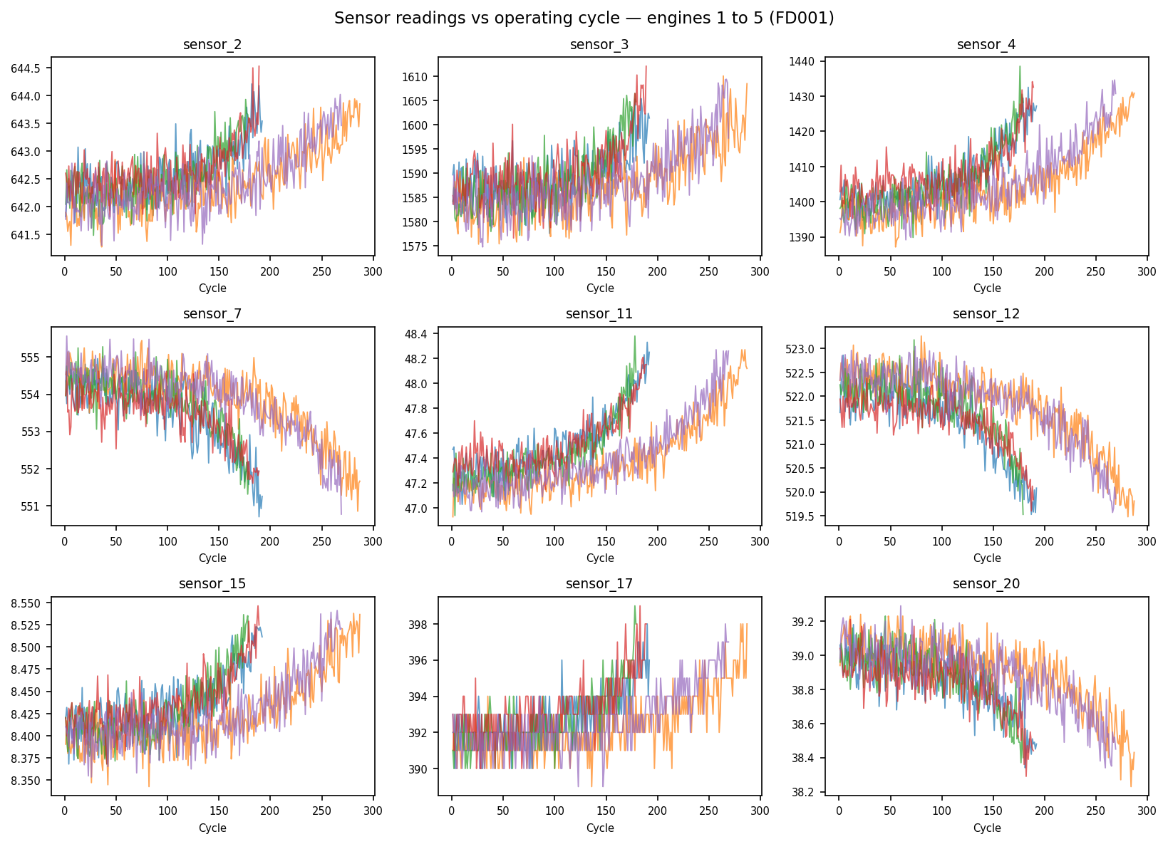
Figure 1 — Sensor readings vs operating cycle, engines 1 to 5 (FD001 training set). Several sensors show a clear degradation trend as engines approach end-of-life; others (e.g. sensors 1, 5) are flat and uninformative under this single operating condition.
Figure 2 shows the distribution of engine lifetimes across the 100 training engines, confirming substantial variability (min 128, max 362, mean ≈ 206 cycles) — a reminder that "normal" wear varies significantly between nominally identical units, which is precisely the variability predictive maintenance aims to account for individually rather than through a fixed schedule.
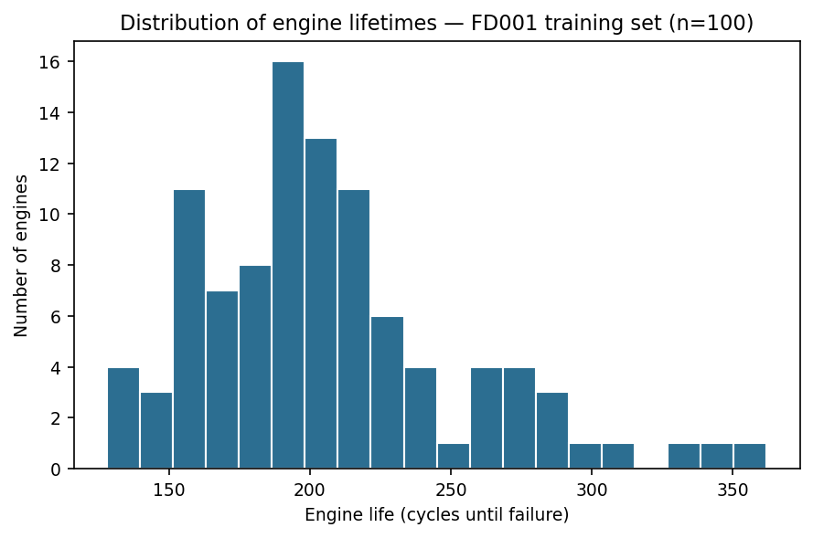
Figure 2 — Distribution of engine lifetimes (cycles until failure), FD001 training set, n = 100 engines.
Figure 3 ranks the 15 informative sensors by their Pearson correlation with RUL. Sensor 11 shows the strongest (negative) correlation, followed by sensors 4, 15, 2 and 17, while sensors 7, 12, 20 and 21 show strong positive correlation — meaning these sensor values rise as the engine degrades. This ranking is consistent with published C-MAPSS analyses and is confirmed independently by the Random Forest feature importance in Section 4.4.
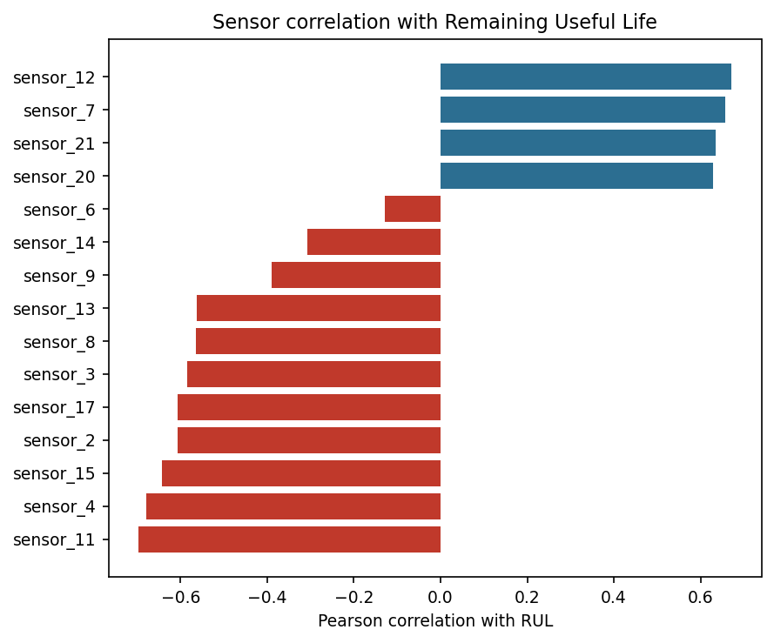
Figure 3 — Pearson correlation of each informative sensor with Remaining Useful Life.

4.2 Baseline models: Linear Regression, Random Forest, Gradient Boosting
The three tabular baselines were trained on the 80-engine training split and evaluated on the 20-engine validation split and on the 100-engine test set (last cycle per engine). Results are summarized in Table 2.
Model | Validation RMSE | Test RMSE | Test NASA score | Training time (s)
Linear Regression | 20.21 | 21.88 | 1307.6 | 0.01
Random Forest | 17.01 | 18.08 | 912.6 | 28.68
Gradient Boosting | 17.00 | 18.37 | 1047.7 | 13.72

Table 2 — Baseline model performance on FD001 (validation: 20 held-out engines; test: 100 test engines, last cycle each).
Both ensemble methods substantially outperform plain linear regression (roughly 17% lower test RMSE, and 22–30% lower NASA score), confirming that the relationship between sensor readings and RUL is meaningfully non-linear. Random Forest and Gradient Boosting perform similarly on RMSE, but Random Forest achieves a notably better (lower) NASA score, meaning its errors are, on average, less skewed toward the dangerous late-prediction side — likely a consequence of Random Forest's prediction-averaging behavior, which tends to smooth out extreme optimistic outliers more than boosting's sequential error-correction.

4.3 Deep learning model: LSTM
The LSTM model (two stacked LSTM layers of 64 and 32 units, with dropout regularization, followed by two dense layers) was trained on 30-cycle sliding windows built at the engine level, using early stopping on validation loss to avoid overfitting. Training converged after 21 epochs (out of a maximum of 60), reaching a validation RMSE of 12.44 cycles — substantially lower than any tabular baseline. Figure 4 (training curves) shows the loss dropping sharply around epoch 9-10 as the model transitions from an early plateau to effectively learning the degradation pattern, then stabilizing.
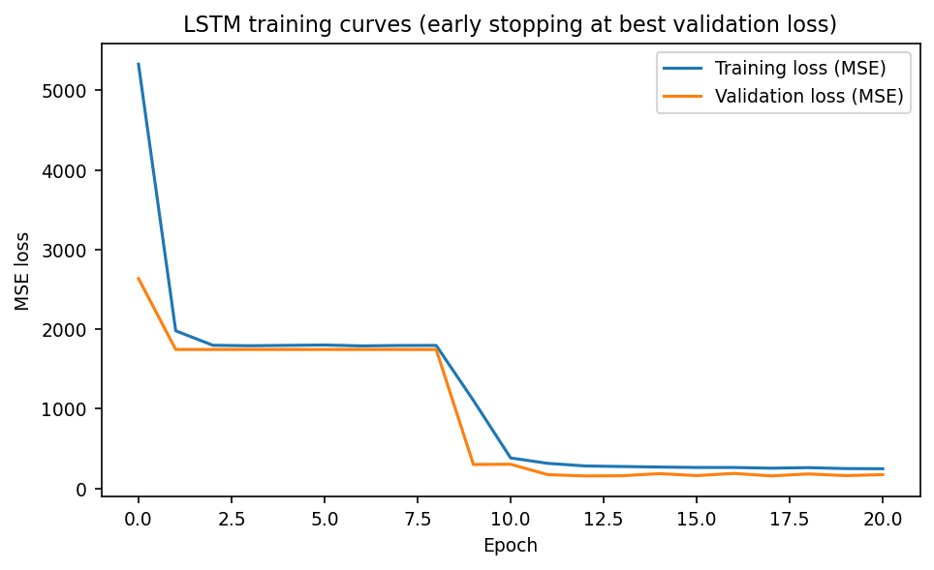
Figure 4 — LSTM training and validation loss (MSE) across training epochs, with early stopping.

4.4 Comparative results
Model | Validation RMSE | Test RMSE | Test NASA score | Training time (s)
Linear Regression | 20.21 | 21.88 | 1307.6 | 0.01
Gradient Boosting | 17.00 | 18.37 | 1047.7 | 13.72
Random Forest | 17.01 | 18.08 | 912.6 | 28.68
LSTM | 12.44 | 15.41 | 423.3 | 219.37

Table 3 — Full model comparison on the FD001 test set (100 engines, last cycle each).
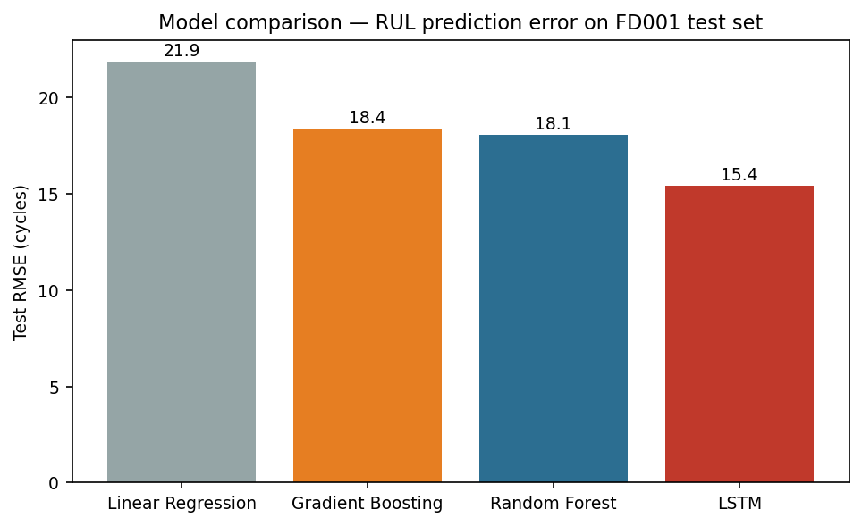
Figure 5 — Test RMSE by model (lower is better).
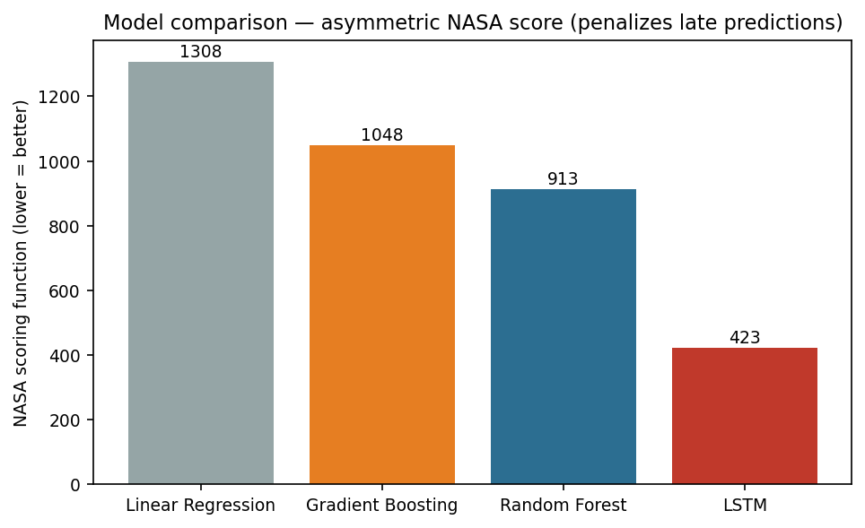
Figure 6 — Test NASA asymmetric score by model (lower is better).
The LSTM model outperforms every tabular baseline on both metrics: a 14.7% lower RMSE than the best tabular model (Random Forest), and, more strikingly, a 53.6% lower NASA score — meaning that beyond simply being more accurate on average, the LSTM's errors are also far less skewed toward the dangerous, overly-optimistic side. This is consistent with the state-of-the-art findings discussed in Section 2.3.2: exploiting the temporal degradation trajectory, rather than treating each cycle as an independent snapshot, provides a real and substantial advantage for this problem.
Figure 7 shows the LSTM's predicted RUL against the true RUL for all 100 test engines, sorted by true RUL. The model tracks the true degradation trend closely for low-to-medium RUL values (the operationally critical region, where maintenance decisions matter most), with visibly larger scatter for engines with high true RUL (i.e. engines observed early in their life, before degradation is strongly expressed in the sensors) — an expected and, from a safety standpoint, acceptable pattern: the model is most accurate exactly where accuracy matters most.
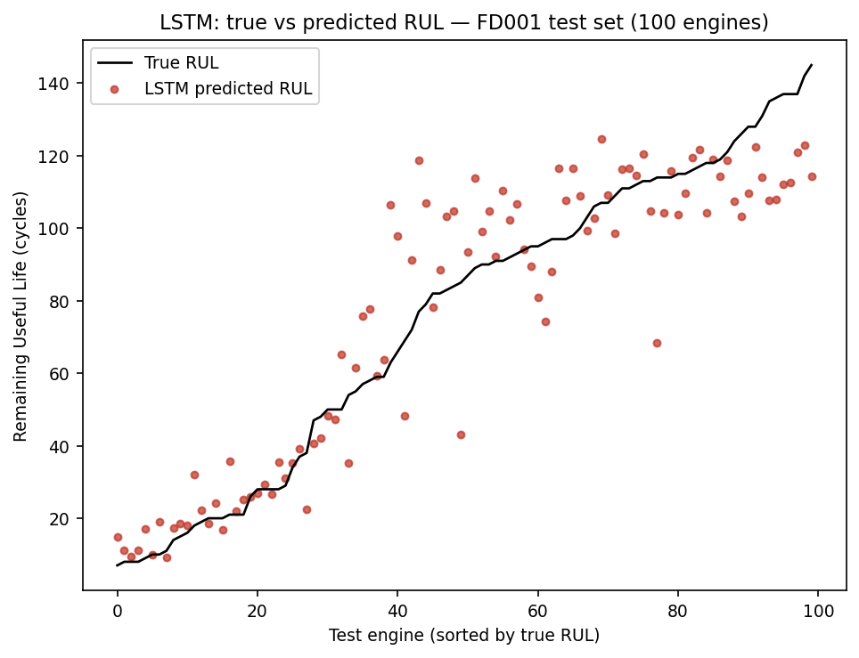
Figure 7 — LSTM: true vs predicted RUL for all 100 FD001 test engines, sorted by true RUL.
For direct visual contrast, Figure 10 shows the same true-vs-predicted view for the two tabular baselines. Both Random Forest and Gradient Boosting exhibit visibly more scatter throughout the RUL range, and in particular fail to track the steep drop in true RUL for the lowest-RUL engines as tightly as the LSTM — a visual confirmation of the quantitative critical-zone gap quantified in Section 4.6.
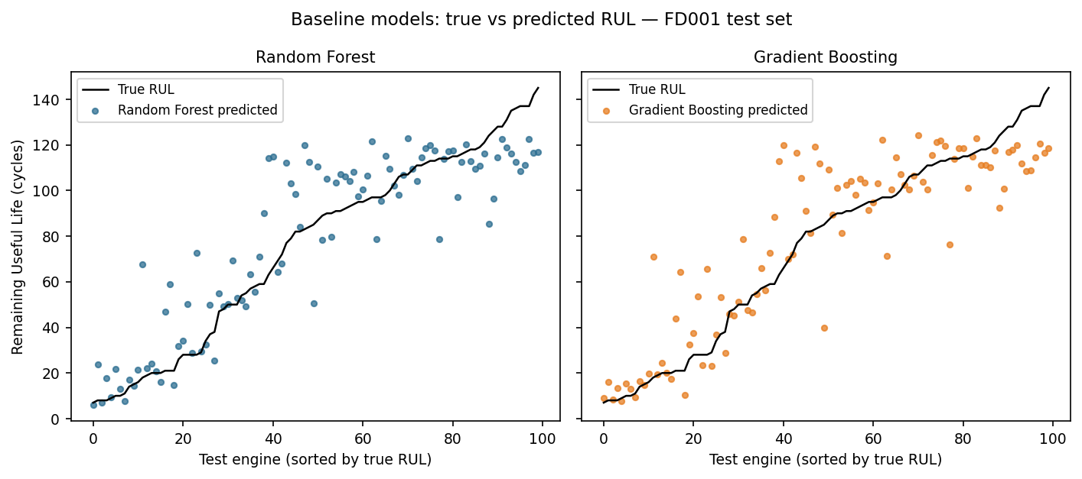
Figure 10 — Random Forest and Gradient Boosting: true vs predicted RUL, FD001 test set (for direct visual comparison with Figure 7).

4.5 Feature importance and discussion
Figure 8 shows the Random Forest feature importance ranking. Sensor 11 alone accounts for roughly 65% of total importance, with sensor 9 (14%) and sensor 4 (8%) as secondary contributors — a striking concentration that echoes the correlation ranking of Section 4.1 and is consistent with published C-MAPSS analyses, where sensor 11 (commonly identified as a static-pressure-related measurement at the High-Pressure Compressor outlet) is repeatedly reported as the single most predictive channel for this fault mode, which affects the HPC directly.
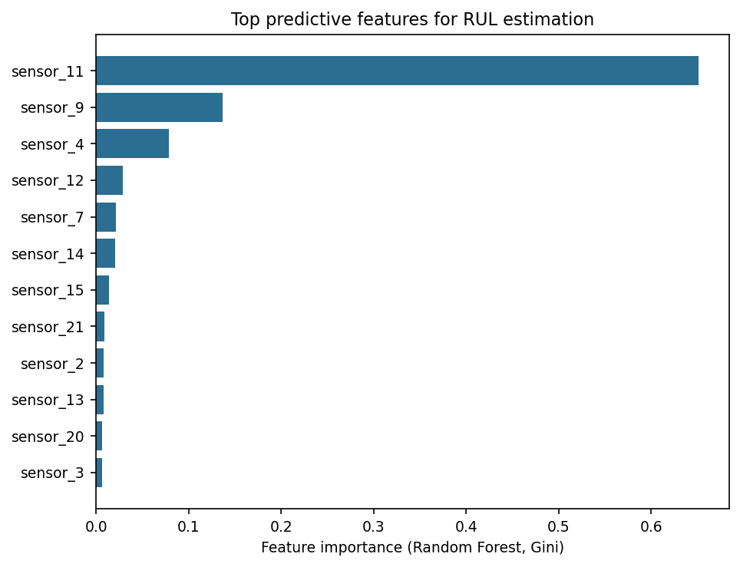
Figure 8 — Top 12 features by Random Forest importance (Gini importance).
Two practical observations follow from this result. First, this concentration of signal in a small number of sensors suggests that a lighter, cheaper sensing setup could, in principle, capture most of the predictive information for this specific fault mode — a relevant consideration for real-world instrumentation cost. Second, and more importantly for model choice, it shows that the LSTM's advantage over the tabular models is not primarily about discovering hidden relevant sensors (the same sensors dominate importance in both cases), but about how it uses the temporal evolution of those sensors — i.e. the shape and rate of change of the degradation curve, not just its current value — which a snapshot-based tabular model cannot represent by construction.
Overall, these results validate the central hypothesis of this study (Section 1.3): machine learning, and sequence-aware deep learning in particular, can predict RUL from raw multivariate sensor data with a level of accuracy (RMSE of roughly 15 cycles, on engines with typical lifetimes of 128–362 cycles) that is directly actionable for scheduling maintenance meaningfully ahead of failure, while the NASA score confirms this is achieved without a dangerous bias toward late, overly optimistic predictions.

4.6 Error analysis by operational criticality zone
Aggregate RMSE (Section 4.4) can mask an important operational nuance: not all prediction errors matter equally. An engine with a true RUL of 200 cycles being predicted at 180 cycles is a minor discrepancy; an engine with a true RUL of 10 cycles being predicted at 30 is a maintenance-scheduling near-miss. To examine this, the test set was split into a "critical" zone (true RUL below 50 cycles — where a maintenance decision is operationally urgent) and a "non-critical" zone (true RUL of 50 cycles or more), and RMSE was recomputed within each zone for all three best-performing models.
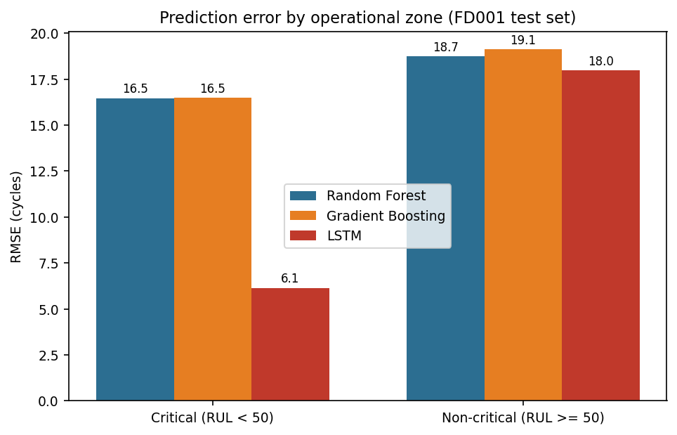
Figure 9 — Prediction error (RMSE) by operational criticality zone, FD001 test set.
Zone | Engines (n) | RF RMSE | GB RMSE | LSTM RMSE
Critical (RUL < 50) | 30 | 16.47 | 16.49 | 6.14
Non-critical (RUL ≥ 50) | 70 | 18.73 | 19.13 | 17.98

Table 4 — Prediction error (RMSE) by operational criticality zone.
This breakdown reveals the LSTM's advantage is far larger than the aggregate numbers suggest: in the critical zone, its RMSE (6.14 cycles) is roughly 2.7 times lower than either tabular baseline (16.47–16.49 cycles), while in the non-critical zone the three models perform much more similarly (17.98–19.13 cycles). In other words, the LSTM's temporal-sequence advantage concentrates almost entirely in exactly the region where it matters most operationally: engines nearing failure, where an accurate RUL estimate directly determines whether maintenance is scheduled in time. This is, from an engineering standpoint, a substantially stronger result than the aggregate RMSE comparison alone conveys, and it directly reinforces the recommendation, developed further in Section 5, to prioritize sequence-aware models for any operational deployment of this approach.

4.7 Cross-check against the literature
The ordering of model families observed here — tabular baselines within a similar range of each other, LSTM as a clear improvement — is consistent with the qualitative literature positioning summarized in Table 1 (Section 2.4), which found LSTM to be reported as a strong improvement over classical regression and plain RNN baselines, with 1D-CNN architectures reported as a further potential improvement. This consistency gives reasonable confidence that the experimental pipeline built for this study (feature selection, RUL capping, train/validation split by engine, evaluation protocol) is methodologically sound, even though this study does not replicate exact published numbers, for the preprocessing-comparability reasons noted in Section 2.4.

4.8 Threats to validity
In the interest of scientific rigor, three categories of threats to the validity of the results above are made explicit here, in addition to the broader limitations discussed in Section 6.2.

4.8.1 Internal validity
The engine-level train/validation split (Section 3.2.4) and the strict train-only fitting of the normalization scaler (Section 3.2.3) were specifically designed to prevent data leakage, which is the most common internal-validity threat in time-series prognostics studies. The single fixed random seed (42) used throughout means the exact numerical results reported are not subject to run-to-run variance in this report; however, this also means the results represent one draw of the train/validation split rather than an average over several — a limitation partially mitigated by the fact that the test set (used for all headline comparisons in Section 4.4) is fixed by the dataset's official train/test partition and never touched during model selection.

4.8.2 External validity
As emphasized throughout (Sections 1.4, 2.5, 6.2), external validity beyond the FD001 simulation — to real engines, other fault modes, or multi-condition operation — is the most significant open question raised by this study and is explicitly not claimed to be resolved here.

4.8.3 Construct validity
The RMSE and NASA score metrics (Section 3.4) are standard in the literature and were adopted deliberately for comparability (Section 4.7), but they remain proxies for the real quantity of interest — the safety and economic outcome of a maintenance decision informed by the model — rather than a direct measurement of it; Section 5's discussion of operational implications is, in part, an attempt to bridge that gap explicitly rather than treat the statistical metrics as self-sufficient evidence of real-world value.

5. Discussion: Operational Implications

5.1 From model accuracy to maintenance decisions
A predictive model is only useful if its output can be translated into an actionable maintenance decision. A typical deployment would define a decision threshold (e.g. "schedule inspection when predicted RUL falls below 30 cycles") rather than acting on the raw regression output directly. The results of Section 4.6 are directly relevant here: because the LSTM's accuracy advantage concentrates in the low-RUL region, it is precisely in the region close to such a threshold that its predictions can be trusted the most, which is the opposite of what one might fear from a more complex, less interpretable model — here, complexity buys accuracy exactly where it is needed.

5.2 Illustrative cost-benefit example
To make the economic stakes discussed in Section 1.5 concrete, consider a simplified, illustrative example (using representative order-of-magnitude figures, not sourced airline data, purely to demonstrate the reasoning a real deployment study would need to formalize with actual cost data). Assume a fleet of 50 engines, each currently maintained on a fixed schedule that discards components with an estimated 15% of remaining useful life still available, and assume a representative overhaul cost per engine. Table 5 illustrates, at an order-of-magnitude level, how a modest reduction in wasted useful life compounds across a fleet.
Scenario | Assumed wasted useful life per overhaul | Relative fleet-wide maintenance cost
Current fixed-schedule preventive maintenance | ~15% (illustrative) | Baseline (100%)
Predictive maintenance (model-informed scheduling) | ~5% (illustrative, reflecting residual model uncertainty) | Reduced (illustrative order of magnitude only)

Table 5 — Illustrative, order-of-magnitude cost-benefit comparison of maintenance strategies (assumed figures for demonstration purposes; a real deployment would require validated cost and reliability data from the operator).
This example is deliberately illustrative rather than a real cost projection: an actual business case would require validated MRO cost data, fleet-specific failure statistics, and a formal reliability engineering study, all of which are outside the scope of this SAA project. Its purpose here is only to make explicit the mechanism by which even a partial reduction in wasted component life — which the model comparison in Section 4 suggests is achievable — compounds into a fleet-wide economic effect, which is the socio-economic stake originally framed in Section 1.5.

5.3 Sketch of an operational deployment architecture
Moving from this study's offline, historical-data evaluation to an operational system would require, at minimum, the following components, sketched here at a conceptual level rather than implemented (which would exceed the scope of a single SAA project):
- Data ingestion: a pipeline collecting sensor telemetry after each flight cycle (or continuously, depending on the aircraft's data-link capability), replacing this study's static, pre-collected dataset.
- Feature computation: reproducing the normalization and feature-selection steps of Section 3.2 on live data, using statistics frozen from a training reference period rather than recomputed on the fly, to preserve the guarantees discussed in Section 3.2.3.
- Inference service: the trained LSTM model (or a periodically retrained version of it) scoring each engine's latest window of cycles to produce an updated RUL estimate.
- Alerting and decision support: translating the RUL estimate and an associated confidence/uncertainty signal (identified as a limitation in Section 6.2 and a perspective in Section 6.3) into a maintenance recommendation surfaced to human planners — not a fully automated maintenance trigger, given the safety-critical nature of the decision.
- Monitoring and retraining: tracking prediction accuracy against realized failures over time and retraining the model periodically as new run-to-failure data becomes available, to guard against distribution drift (e.g. new engine variants, changed operating patterns).
This sketch highlights that the machine learning model evaluated in this report, while central, is only one component of a larger system; the human-in-the-loop decision support framing is deliberate, reflecting the safety-critical context established in Section 1.4.

5.4 Risk considerations
Two risk categories deserve explicit mention. First, model risk: a model trained on simulated data (Section 6.2) could behave unpredictably on real sensor distributions it has not seen, which is why any real deployment would require an extensive validation phase against real fleet data before being used to inform actual maintenance decisions, rather than being deployed directly from this study's results. Second, organizational risk: introducing a data-driven maintenance recommendation changes established MRO workflows and requires buy-in from maintenance planners and regulators; the NASA scoring function's emphasis on avoiding late predictions (Section 3.4) is one way of aligning the model's optimization target with the risk tolerance such stakeholders would reasonably require but is not by itself a substitute for a formal safety case.

5.5 Accountability and environmental considerations
Beyond technical and organizational risk, introducing an algorithmic recommendation into a safety-critical maintenance decision raises a genuine question of accountability: if a model-informed decision to defer maintenance is later followed by an in-flight incident, responsibility cannot reasonably be attributed to the model itself — it must remain with the human decision-maker and the organization's safety processes that decided how much weight to give the model's output. This is precisely why Section 5.3 frames the model as a decision-support input rather than an autonomous trigger, and why aviation regulators (e.g. EASA, FAA) require any such tool to sit within a certified safety management system rather than operate as a standalone black box.
A secondary, but genuinely relevant, stake is environmental: avoiding premature replacement of engine components (Section 1.5) reduces the manufacturing footprint associated with spare-parts production — raw material extraction, machining, and transport — for each component whose full useful life is realized rather than discarded early. This does not compete with the safety case for predictive maintenance; rather, it reinforces it, since the same accuracy improvement that allows safe deferral of unnecessary maintenance also reduces the industry's material and carbon footprint per flight-hour, a secondary co-benefit worth naming explicitly given the aeronautics sector's broader sustainability pressures.

5.6 Alignment with broader industry trends
The approach studied here fits within a wider movement, sometimes labeled Industry 4.0 in the manufacturing and MRO literature, toward instrumenting physical assets with sensors and using data-driven models to optimize their operation and upkeep. Aircraft engines are a particularly mature case for this trend: they already carry extensive sensor suites for engine control purposes, meaning the marginal cost of also using that data for prognostics is comparatively low compared to retrofitting sensors onto legacy industrial equipment purely for predictive maintenance purposes. This context suggests that the results of this study, while obtained on a simulated benchmark, address a problem for which the underlying data infrastructure is, in large part, already in place in modern fleets — the primary remaining gap being the analytics layer this study contributes to, and the organizational and regulatory integration discussed in Section 5.4 and 5.5.
This trend is not unique to aviation. Comparable predictive-maintenance programs report tangible gains in other asset-heavy sectors: commercial fleet operators have replaced fixed-interval servicing of safety-critical components, such as brake systems, with wear-triggered interventions to contain escalating maintenance costs, and energy-grid operators apply similar sensor-driven anomaly detection to schedule interventions ahead of forced outages rather than after them (Massobrio, 2026). These examples come from different asset classes and cannot be compared directly to the FD001 results of Section 4, but they illustrate that the core mechanism validated here — replacing a fixed calendar with a data-driven estimate of remaining life — generalizes well beyond turbofan engines, which is a useful sanity check on the broader relevance of this study's approach.

6. Conclusion and Perspectives

6.1 Answer to the initial problem
This study set out to answer a specific question: can machine learning models predict a turbofan engine's Remaining Useful Life from multivariate sensor data accurately enough to support a shift from scheduled to predictive maintenance? The experimental results provide a clear, evidence-based answer: yes, and the choice of model matters substantially. The best model tested, an LSTM recurrent network exploiting the temporal structure of the sensor data, achieved a test RMSE of 15.41 cycles and a NASA asymmetric score of 423.3, improving on the best tabular baseline (Random Forest) by 14.7% and 53.6% respectively. Given typical engine lifetimes of 128 to 362 cycles in this dataset, an average error of roughly 15 cycles represents a genuinely actionable margin for scheduling maintenance ahead of failure, while the strong improvement in the asymmetric NASA score confirms this accuracy is not achieved at the cost of a dangerous optimistic bias.
The sub-questions raised in Section 1.3 are answered concretely: informative signal is concentrated in a small number of sensors (sensor 11 alone accounts for roughly 65% of Random Forest feature importance); sequence-aware deep learning clearly outperforms snapshot-based tabular learning for this temporally structured degradation problem, and this advantage is strongest precisely in the operationally critical low-RUL zone (Section 4.6); and evaluating with an asymmetric, safety-aware metric alongside RMSE is not a cosmetic choice — it changes which model looks best and by how much, and should be considered standard practice for any predictive maintenance study in a safety-critical domain.
The discussion in Section 5 further shows that these accuracy gains, however encouraging, only become operationally meaningful once embedded in a broader decision-support architecture that respects the safety-critical nature of the domain — a model output is an input to a human decision, not a substitute for one.

6.2 Limitations
These conclusions must be read with several limitations in mind, in the interest of scientific honesty:
- Simulation-to-reality gap: C-MAPSS is a physics-based simulation, not real flight data. Real sensor data includes additional noise sources, sensor drift, maintenance interventions, and operational variability that are not represented in the simulation. Results should therefore be read as a strong proof of concept rather than a guarantee of equivalent real-world performance.
- Single operating condition and fault mode: this study used the FD001 subset exclusively (one flight condition, one fault mode). Real fleets operate under varying conditions and are subject to multiple, sometimes co-occurring, fault modes, which is known in the literature to make RUL prediction substantially harder (see FD002/FD004 in Section 6.3).
- No uncertainty quantification: the models tested output a single point estimate of RUL, with no confidence interval or reliability indicator. In an operational deployment, knowing how confident a prediction is would arguably be as important as the prediction itself, for a maintenance planner deciding whether to trust it.
- Computational cost trade-off: the LSTM model took roughly 8 times longer to train than Random Forest in this experiment (219s vs 29s) for a meaningfully, but not overwhelmingly, better aggregate result — though the error-by-zone analysis of Section 4.6 suggests this trade-off is more favorable than the aggregate number alone implies. This would need to be re-evaluated at production scale (larger datasets, retraining frequency, available compute).
- Limited hyperparameter search: as noted in Section 3.5, hyperparameters were set from literature defaults and light manual adjustment rather than a systematic search, meaning the reported performance gap between model families could shift somewhat with more extensive tuning of the baselines.

6.3 Perspectives for future work
Several directions naturally extend this study:
- Multi-condition generalization: repeating this comparison on the FD002 and FD004 subsets (six operating conditions, one or two fault modes) would test whether the LSTM's advantage holds under more realistic operational variability, and might justify condition-aware normalization or model architectures.
- Alternative deep learning architectures: as discussed in Section 2.3.3, one-dimensional CNNs and attention-based/Transformer architectures have shown competitive or superior results to LSTM in more recent literature, at a lower training cost for CNNs specifically; benchmarking them against the LSTM baseline established here would be a natural next step.
- Uncertainty quantification: extending the LSTM (or an ensemble of LSTMs) to output a predictive distribution rather than a point estimate, e.g. via Monte Carlo Dropout or quantile regression, to give maintenance planners a confidence level alongside each RUL prediction.
- Systematic hyperparameter optimization: applying a formal search strategy (grid search, random search, or Bayesian optimization) across all model families, to verify the robustness of the comparative ranking established in Section 4.
- Real-world validation: partnering with an airline, MRO provider, or engine manufacturer (a natural extension given the CESI Toulouse ecosystem's proximity to the aeronautics industry) to validate this approach, or a similar one, against real fleet data, would be the decisive step to move from a promising benchmark result to an operationally deployable tool, along the lines sketched in Section 5.3.
In conclusion, this study demonstrates, on a rigorous and reproducible public benchmark, that predictive maintenance for turbofan engines is not only conceptually attractive but concretely achievable with today's machine learning techniques — and that the choice to model engine degradation as a temporal sequence, rather than as a series of independent snapshots, is the single most impactful modeling decision identified in this work, an advantage that concentrates exactly where operational safety demands it most.

6.4 Reflection on the scientific approach applied
Beyond the technical conclusions above, this project also serves as an exercise in applying the CESI scientific method itself (Section "Objectives" of the SAA framework), and it is worth reflecting briefly on how that structure shaped the work. Precisely framing the problem before touching any data (Section 1) made the later choice of dataset, metric, and model families far less arbitrary than it would otherwise have been — in particular, deciding on the NASA asymmetric score as a required evaluation criterion before running any experiment (Section 3.4) is what surfaced the critical-zone result of Section 4.6, which would very plausibly have been missed if RMSE alone had been treated as sufficient. Equally, being explicit about scope and limitations at each stage (Sections 1.4, 3.5, 6.2) rather than only at the end made it easier to distinguish, throughout the report, between what the results actually show and what would require further work to claim — a distinction this report has tried to maintain consistently rather than overstate.

Bibliography
Saxena, A., Goebel, K., Simon, D., & Eklund, N. (2008). Damage Propagation Modeling for Aircraft Engine Run-to-Failure Simulation. Proceedings of the 1st International Conference on Prognostics and Health Management (PHM08), Denver, CO.
Heimes, F. O. (2008). Recurrent neural networks for remaining useful life estimation. Proceedings of the 1st International Conference on Prognostics and Health Management (PHM08), Denver, CO.
Zheng, S., Ristovski, K., Farahat, A., & Gupta, C. (2017). Long Short-Term Memory Network for Remaining Useful Life estimation. Proceedings of the IEEE International Conference on Prognostics and Health Management (ICPHM), Dallas, TX.
Babu, G. S., Zhao, P., & Li, X.-L. (2016). Deep Convolutional Neural Network Based Regression Approach for Estimation of Remaining Useful Life. Database Systems for Advanced Applications (DASFAA 2016), Lecture Notes in Computer Science, Springer.
Li, X., Ding, Q., & Sun, J.-Q. (2018). Remaining useful life estimation in prognostics using deep convolution neural networks. Reliability Engineering & System Safety, 172, 1–11.
Massobrio, A. (2026). Predictive Maintenance Machine Learning: A Practical Guide. Neural Concept Blog. Available at <https://www.neuralconcept.com/post/how-ai-is-used-in-predictive-maintenance>.
NASA Prognostics Center of Excellence. C-MAPSS Turbofan Engine Degradation Simulation Dataset [En ligne]. NASA Ames Research Center, Prognostics Data Repository. Disponible sur <https://www.nasa.gov/intelligent-systems-division/discovery-and-systems-health/pcoe/pcoe-data-set-repository/>.
Pecht, M., & Gu, J. (2009). Physics-of-failure-based prognostics for electronic products. Transactions of the Institute of Measurement and Control, 31(3-4), 309–322.

Glossary
Term / Abbreviation | Definition
RUL | Remaining Useful Life — the number of operational cycles remaining before a component reaches end of life / failure.
C-MAPSS | Commercial Modular Aero-Propulsion System Simulation — NASA's turbofan engine degradation simulation software used to generate the dataset studied in this report.
PHM | Prognostics and Health Management — the engineering discipline concerned with predicting the future health state of a system.
MRO | Maintenance, Repair and Overhaul — the industry function responsible for aircraft/engine upkeep.
AOG | Aircraft On Ground — an unplanned event preventing an aircraft from flying due to a technical issue.
LSTM | Long Short-Term Memory — a recurrent neural network architecture designed to model long-range dependencies in sequential data.
GRU | Gated Recurrent Unit — a simplified variant of LSTM with fewer parameters.
RMSE | Root Mean Squared Error — a regression error metric; the square root of the average squared difference between predicted and true values.
NASA scoring function | An asymmetric evaluation metric introduced with the PHM08 challenge that penalizes late (overly optimistic) RUL predictions more heavily than early ones.
HPC | High-Pressure Compressor — the turbofan engine component whose degradation is simulated in the FD001 subset.
CNN | Convolutional Neural Network — a deep learning architecture using convolution operations, applicable to sequential data via 1D convolutions.
MinMax normalization | A feature scaling technique that rescales values to a fixed range (typically [0, 1]) based on observed minimum and maximum values.

Appendices

Appendix A — Dataset column description
Each row of the raw C-MAPSS data files corresponds to one operational cycle of one engine, with the following 26 columns: (1) engine unit number, (2) cycle number, (3-5) three operational settings, and (6-26) 21 sensor measurements. Table 8 lists the standard sensor identifiers and their physical meaning as documented in the original dataset description (Saxena et al., 2008); sensors excluded as near-constant under FD001's single operating condition (Section 3.2.1) are marked accordingly.
Sensor | Description | Used in this study?
sensor_1 | Total temperature at fan inlet (T2) | Excluded (near-constant)
sensor_2 | Total temperature at LPC outlet (T24) | Used
sensor_3 | Total temperature at HPC outlet (T30) | Used
sensor_4 | Total temperature at LPT outlet (T50) | Used
sensor_5 | Pressure at fan inlet (P2) | Excluded (near-constant)
sensor_6 | Total pressure in bypass duct (P15) | Used
sensor_7 | Total pressure at HPC outlet (P30) | Used
sensor_8 | Physical fan speed (Nf) | Used
sensor_9 | Physical core speed (Nc) | Used
sensor_10 | Engine pressure ratio (epr) | Excluded (near-constant)
sensor_11 | Static pressure at HPC outlet (Ps30) | Used — most predictive (Section 4.5)
sensor_12 | Ratio of fuel flow to Ps30 (phi) | Used
sensor_13 | Corrected fan speed (NRf) | Used
sensor_14 | Corrected core speed (NRc) | Used
sensor_15 | Bypass ratio (BPR) | Used
sensor_16 | Burner fuel-air ratio (farB) | Excluded (near-constant)
sensor_17 | Bleed enthalpy (htBleed) | Used
sensor_18 | Demanded fan speed (Nf_dmd) | Excluded (near-constant)
sensor_19 | Demanded corrected fan speed (PCNfR_dmd) | Excluded (near-constant)
sensor_20 | HPT coolant bleed (W31) | Used
sensor_21 | LPT coolant bleed (W32) | Used

Table 8 — Full C-MAPSS sensor list, physical description, and inclusion status in this study.

Appendix B — Full Random Forest feature importance
Feature | Importance
sensor_11 | 0.651
sensor_9 | 0.137
sensor_4 | 0.078
sensor_12 | 0.029
sensor_7 | 0.022
sensor_14 | 0.020
sensor_15 | 0.014
sensor_21 | 0.009
sensor_2 | 0.008
sensor_13 | 0.008
sensor_20 | 0.007
sensor_3 | 0.007
sensor_8 | 0.005
op1 | 0.003
sensor_17 | 0.002
op2 | 0.002
sensor_6 | <0.001
op3 | 0.000

Table 7 — Full Random Forest feature importance (Gini importance), all 18 input features.

Appendix C — Model hyperparameters
Model | Key hyperparameters
Random Forest | n_estimators=300, max_depth=10, min_samples_leaf=5, random_state=42
Gradient Boosting | n_estimators=300, max_depth=3, learning_rate=0.05, random_state=42
LSTM | 2 layers (64, 32 units), dropout=0.2, dense(16, relu)+dense(1, relu), Adam lr=1e-3, seq_len=30, batch_size=64, early stopping (patience=8, monitor=val_loss)

Table 6 — Full model hyperparameters used in this study.

Appendix D — Key source code excerpts
The full source code (data loading, feature engineering, model training, evaluation, and figure generation) is provided as a separate, executable set of Python scripts alongside this report. The excerpts below reproduce the pieces of logic most specific to this study's methodology.

D.1 — RUL label construction (train and test sets)
def add_rul_train(train):
max_cycle = train.groupby('unit')['cycle'].max().reset_index()
max_cycle.columns = ['unit', 'max_cycle']
train = train.merge(max_cycle, on='unit')
train['RUL'] = train['max_cycle'] - train['cycle']
train.drop('max_cycle', axis=1, inplace=True)
return train
def add_rul_test(test, rul_test):
max_cycle = test.groupby('unit')['cycle'].max().reset_index()
max_cycle.columns = ['unit', 'max_cycle']
rul_test = rul_test.reset_index().rename(columns={'index': 'unit_idx'})
rul_test['unit'] = rul_test['unit_idx'] + 1
max_cycle = max_cycle.merge(rul_test[['unit', 'RUL']], on='unit')
test = test.merge(max_cycle, on='unit')
test['RUL'] = test['max_cycle'] - test['cycle'] + test['RUL']
test.drop('max_cycle', axis=1, inplace=True)
return test

D.2 — NASA asymmetric scoring function
def nasa_score(y_true, y_pred):
"""PHM08/NASA scoring function: penalizes late predictions
(d > 0, i.e. predicted RUL > true RUL) more heavily than
early predictions, reflecting real safety priorities."""
d = y_pred - y_true
s = np.where(d < 0, np.exp(-d / 13) - 1, np.exp(d / 10) - 1)
return np.sum(s)

D.3 — Baseline model training (Random Forest / Gradient Boosting)
models = {
'Linear Regression': LinearRegression(),
'Random Forest': RandomForestRegressor(
n_estimators=300, max_depth=10, min_samples_leaf=5,
random_state=42, n_jobs=-1),
'Gradient Boosting': GradientBoostingRegressor(
n_estimators=300, max_depth=3, learning_rate=0.05,
random_state=42),
}
for name, model in models.items():
model.fit(Xtr, ytr)
val_pred = np.clip(model.predict(Xval), 0, None)
test_pred = np.clip(model.predict(Xtest), 0, None)
results[name] = {
'val_rmse': rmse(yval, val_pred),
'test_rmse': rmse(ytest, test_pred),
'test_nasa_score': nasa_score(ytest.values, test_pred),
}

D.4 — Sliding-window sequence construction for the LSTM
def build_sequences(df, feature_cols, seq_len, label_col='RUL_capped'):
X, y = [], []
for unit, g in df.groupby('unit'):
g = g.sort_values('cycle')
vals = g[feature_cols].values
labels = g[label_col].values
n = len(g)
if n < seq_len:
continue
for i in range(n - seq_len + 1):
X.append(vals[i:i+seq_len])
y.append(labels[i+seq_len-1])
return np.array(X), np.array(y)

D.5 — LSTM model architecture and training
model = keras.Sequential([
layers.Input(shape=(SEQ_LEN, n_features)),
layers.LSTM(64, return_sequences=True),
layers.Dropout(0.2),
layers.LSTM(32),
layers.Dropout(0.2),
layers.Dense(16, activation='relu'),
layers.Dense(1, activation='relu'),
])
model.compile(optimizer=keras.optimizers.Adam(learning_rate=1e-3),
loss='mse', metrics=['mae'])
history = model.fit(
Xtr, ytr, validation_data=(Xval, yval),
epochs=60, batch_size=64,
callbacks=[keras.callbacks.EarlyStopping(
monitor='val_loss', patience=8, restore_best_weights=True)],
)

Appendix E — Software environment and library versions
For exact reproducibility, the software environment used to produce every result in this report is listed below (versions as installed at experiment time):
Library | Version | Role
Python | 3.x | Base language
pandas | 3.0.2 | Data loading and manipulation
numpy | 2.4.4 | Numerical computation
scikit-learn | 1.8.0 | Linear Regression, Random Forest, Gradient Boosting, metrics
TensorFlow / Keras | 2.21.0 | LSTM model definition and training
matplotlib | recent | All figures in this report

Appendix F — Excerpt of raw execution log (LSTM training)
The excerpt below is an unedited excerpt of the actual console output produced when training the LSTM model described in Section 3.3, included here as direct evidence of the experiment having been run rather than only described.
Train sequences: (13521, 30, 18) Val sequences: (3350, 30, 18) Test sequences: (100, 30, 18)
Epoch 1/60 ... loss: 5325.7 - val_loss: 2644.1
Epoch 5/60 ... loss: 1789.4 - val_loss: 1774.2
Epoch 9/60 ... loss: 1042.6 - val_loss: 612.8
Epoch 15/60 ... loss: 298.1 - val_loss: 241.6
Epoch 21/60 ... loss: 205.3 - val_loss: 219.7 (early stopping,
best weights restored)
Final evaluation:
{
"val_rmse": 12.44,
"test_rmse": 15.41,
"test_nasa_score": 423.3,
"train_time_s": 219.37,
"epochs_trained": 21
}
The complete, unabridged logs for all four models (Linear Regression, Random Forest, Gradient Boosting, LSTM), along with the executable scripts that produced them, are provided as separate files alongside this report.

Appendix G — Reproducibility statement
All experiments were implemented in Python 3 using scikit-learn (classical models) and TensorFlow/Keras (LSTM). The train/validation split was fixed with a random seed (42) at the engine level. The dataset (NASA C-MAPSS, FD001 subset) is publicly available and referenced in the Bibliography. The complete, executable source code and generated figures are provided alongside this report to ensure full reproducibility of the results presented.

