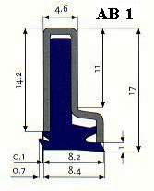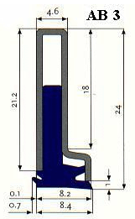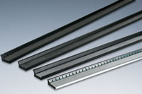

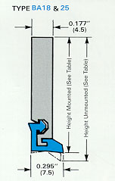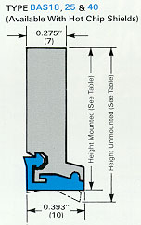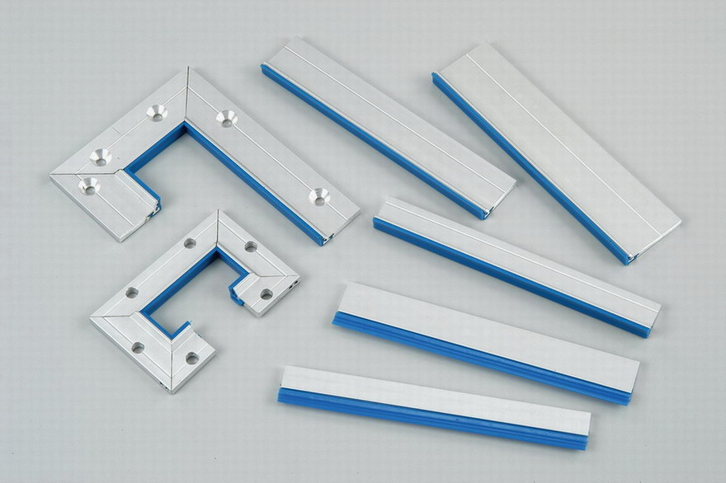

METAL BONDED Way WIPER SERIES: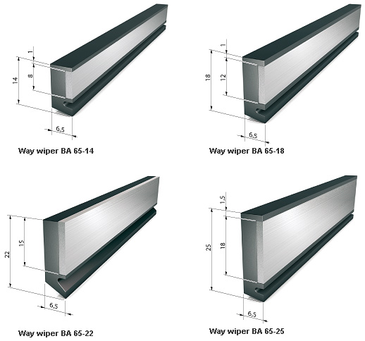

WIPER LIP FOR TELESCOPIC COVER.:
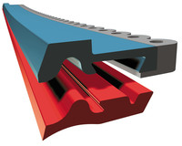 C SERIES RED PU LIP FOR TELESCOPIC COVER
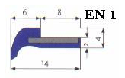

SHINDE ENGINEERING
162, S.T WORKSHOP RD., DAPODI, PUNE – 411012, MAHARASHTRA.
MOB: (Mr. Nilesh)9822552614, , EMAIL:shinde_engg@yahoo.co.in
Web:shindeengineering.in

WITH REFERENCE TO THE ABOVE PICTURES OF WIPERS FOLLOWING ARE THE LOWEST RATES:-

1) AB1 WIPER WITH CASING = RS.795 FOR 500mm LENGTH
2) AB1 WIPER LIP ONLY = RS.265 FOR 500mm LENGTH(rs.450 for polyurethane) rs.500 for casing
3) AB3 WIPER WITH CASING = RS.895 FOR 500mm LENGTH
4) AB3 WIPER LIP ONLY = RS.295 FOR 500mm LENGTH

5) BA18 WIPER WITH CASING = RS.1950 FOR 1000mm LENGTH
6) BAS18 WIPER WITH CASING = RS.2350 FOR 1000mm LENGTH
7) BA25 WIPER WITH CASING = RS.2450 FOR 1000mm LENGTH
8) BAS25 WIPER WITH CASING = RS.2750 FOR 1000mm LENGTH

9) EN 1 (FOR TELESCOPIC COVER) = RS.390=00 FOR 500mm length
Size: 8mm width x 2mm thk x 500mm L

10) EN 2 (FOR TELESCOPIC COVER) = RS.950=00 FOR 500mm length
Size: 12mm width x 3mm thk x 1250mm L

11) EN (FOR TELESCOPIC COVER) 5MMTHK X 1250L X14MM= Rs.1050=00EACH

12) BA 65-25 = Rs.680=00 for 500mm length

13)C SERIES PU RED LIP FOR TELESCOPIC COVER = RS. 580 PER METER.

TERMS: 1. 18% GST. / HSN 8466.93.00 / GSTN NO: 27BBGPS9478C1Z4,/ PAN: BBGPS9478C.
3. DELIVERY – MIN. TWO days AFTER CONFIRMED P.O.
4. PAYMENT – Against proforma invoice.
5. INSTALLATION TO BE DONE BY YOUR SIDE.

Yours sincerely,

NILESH SHINDE,
SHINDE ENGINEERING
MOBILE NO. : 9822552614

