GDIPlusPlot Design
——2D Graph ActiveX Control
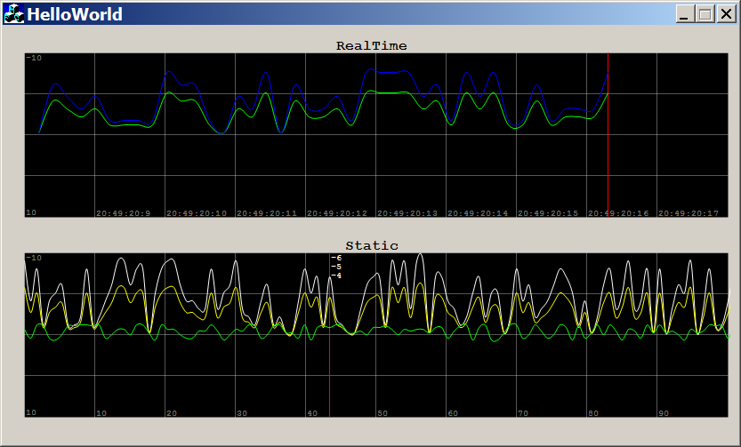

Introduction 介绍
This is a simple OCX control, which allows you to plot two-dimensional data. Despite ProEssentials developed by Gigasoft Co., Ltd, there is no out-of-the-box control that provides simple and straightforward 2D data visualization based on GDI+. The NtGraph ActiveX control by Nikolai Teofilov inspired me to write my own control, mostly because I wanted to customize the source code when needed. Over time, the functionality of the ActiveX control became more elaborate, and finally I made decision to publish what I have in hand under LGPL v3 license.
该控件是个简单的OCX（对象类别扩充组件），可以绘2维图。除了Gigasoft公司开发的ProEssentials，没有简单实用的基于GDI+的控件。Nikolai Teofilov开发的NtGraph控件激励着我写一个这样的控件，就可以根据用户的需求修改源代码。逐步的，该ActiveX控件变得完美，最后我决定用LGPL v3许可证发布它。

What Can It Do? 它可以做什么？
The control is able to plot a large number of points and updating one or more plots on the graph with new data, replacing the old plot with the new plot. Multiple plots with individual properties such as color, visible could be customized at runtime.
该控件可以绘大量的点并且可以使用新数据更新一个或多个点，用新的点替代老的点。每个波形图具有独立的属性，比如颜色、是否可视，这些属性可以实时更新。

How to use the control 如何使用该控件
To use this OCX control, embed it in an application that supports the use of OCX controls. Microsoft Visual Basic applications, Office applications and applications created with the Microsoft Developer Studio`s AppWizard can support the use of OCX controls. There are two files required to use this control. They are:
- GDIPlusPlot.ocx——The GDIPlusPlot controls code and data.
- gdiplus.dll——The GDI+ dynamic linker library by Microsoft.
将该控件嵌在支持OCX控件的应用程序中。微软VB、Office、使用VS开发的应用程序都可以使用它。这里有两个文件：
- GDIPlusPlot.ocx——GDIPlusPlot控件；
- gdiplus.dll——微软的GDI+动态链接库；

Before the ActiveX control can be used in your application, it must be registered as a COM Component in the system registry. This is a self registering control. This means that to register the control in the system registry you only need to have an application load the control and call the control`s exported function DllRegisterServer. You can use the REGSVR32 utility or have your setup program do this.
该控件需要注册成COM组件。可以使用系统自带的REGSVR32工具来注册它。

How to use the REGSVR32 utility?

如何使用REGSVR32工具
Copy GDIPlusPlot.ocx to your directory and type:
将GDIPlusPlot.ocx拷贝到某个目录下，在终端下输入：
regsvr32 GDIPlusPlot.ocx
regsvr32 /u GDIPlusPlot.ocx (Unregister server) 卸载控件

Customizing the Control 自定义控件
You can include the control in your project by following the standard steps for ActiveX controls:
可以在项目中使用该控件：
- Create MFC Dialog project or MDI/SDI project with View class derived from CFormView
创建MFC对话框项目或MDI/SDI项目，其中View类需要派生于CFormView；
- Choose menu Project|Add To Project|Components and Controls...
选择菜单Project -> Add To Project -> Components and Controls…
- Open the Registered ActiveX Control gallery
打开已注册的ActiveX控件的文件夹
- Choose the GDIPlusPlot Control and click Insert
选择GDIPlusPlot控件并单击Insert
- Visual C++ will generate the class CGDIPlusPlot
VC++将生成CGDIPlusPlot类
- Then you can define variable of the type as CGDIPlusPlot.
然后就可以定义CGDIPlusPlot类型的变量

For example, set X axis` xTime is TRUE, caption is “RealTime” 例如，设置该控件X轴为实时移动、标题为RealTime……
m_GDIPlusPlot1.SetXTime(TRUE);
m_GDIPlusPlot1.SetCaption("RealTime");
m_GDIPlusPlot1.SetXLabel("");
m_GDIPlusPlot1.SetYLabel("");

Load data into ActiveX control 往该控件中加载数据：
m_GDIPlusPlot1.AddElement(0);
m_GDIPlusPlot1.PlotY(pValue, 0);

GDIPlusPlot Properties 属性
BSTR caption;
boolean xTime;
BSTR xLabel;
BSTR yLabel;
short interval;
BSTR annolabel;
boolean xTrack;

Methods 接口
void PlotXY(double xValue, double yValue, short index);
void SetRange(double xMin, double xMax, double yMin, double yMax);
void PlotY(double newValue, short index);
void ClearGraph();
void AddElement(short color);
void IsElementVisible(short index, boolean visible);
void SetXCursorPos(double xValue);
double GetQuadrantWidth();

Graph Layer 图层
There are at least 5 layers in this simple control, such as ActiveX control background layer, quadrant layer, axis scale layer, 2D plot layer and cursor layer.
该控件中至少包含了5层，控件背景层、象限层、坐标刻度层、2维图层和游标层。

Abstract data type 抽象数据类型
Points matrix 点阵
typedef struct element_s
{
short index;
Gdiplus::Color color;
BOOL visible;
std::list<point_t> pointlist;
} element_t;

Point 点
typedef struct point_s
{
double x;
double y;
} point_t;

