(e) testIrisSelection is compared below:
population size:80
replacement rate:0.7
mutation rate:0.1
Max generations:500
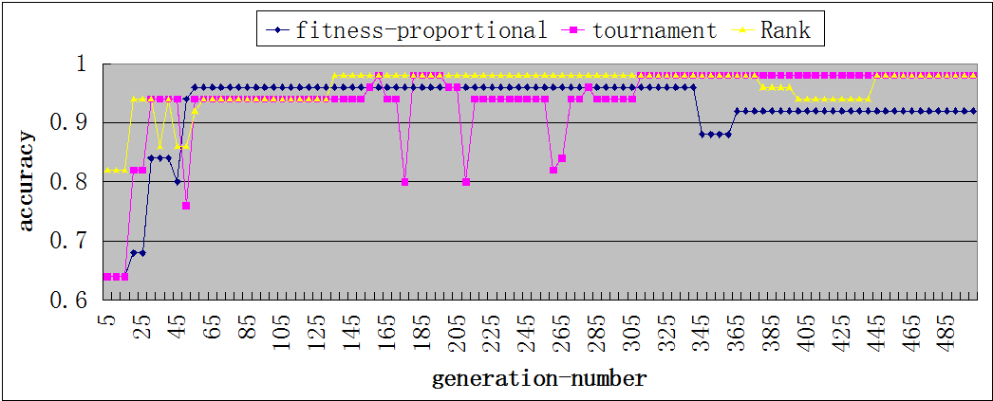
We can see that before 65 generations, in three strategies, none of them converges.For tournament,the accuracy gets some minimal peaks.And finally all of them reach to the accuracy bigger than 90%.

(same graph as above but in the first 100 generations)
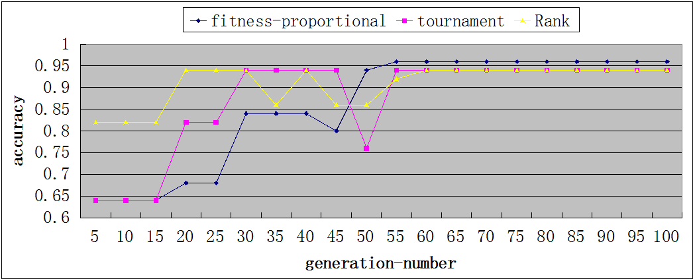
From this part, we can see it more clearly. Before generation 30, three of them still improve the accuracy. After 30 generation, they reach a local max and finally reach the global max at 55 generation. From this diagram, we can see that, the more generations is not better. A certain number of generation will get a probable accuracy result,which save the time cost.

(f)
population size:100
mutation rate:0.1
fitness threshold:0.95
Max generations:500
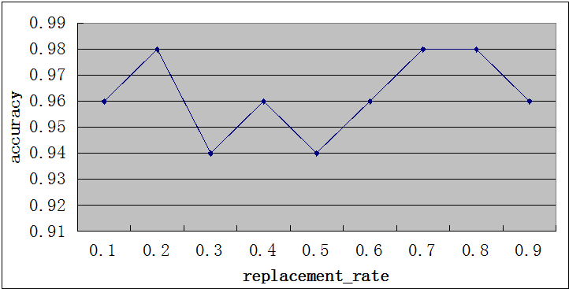
From this diagram,it is hard to say what the trend it is. But technique, the high replacement rate(not too high) the better accuracy will be. If all the population do the corrsover process, some good hypotheses may be changed. So that is the reason why when we set the rate as 0.9, the accuracy decreases a little bit.

