Nguyễn Xuân Đức
2280600735
22DTHC3
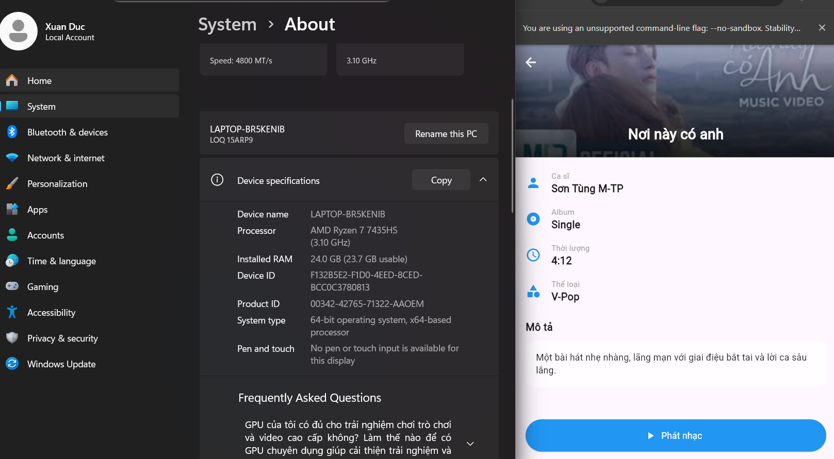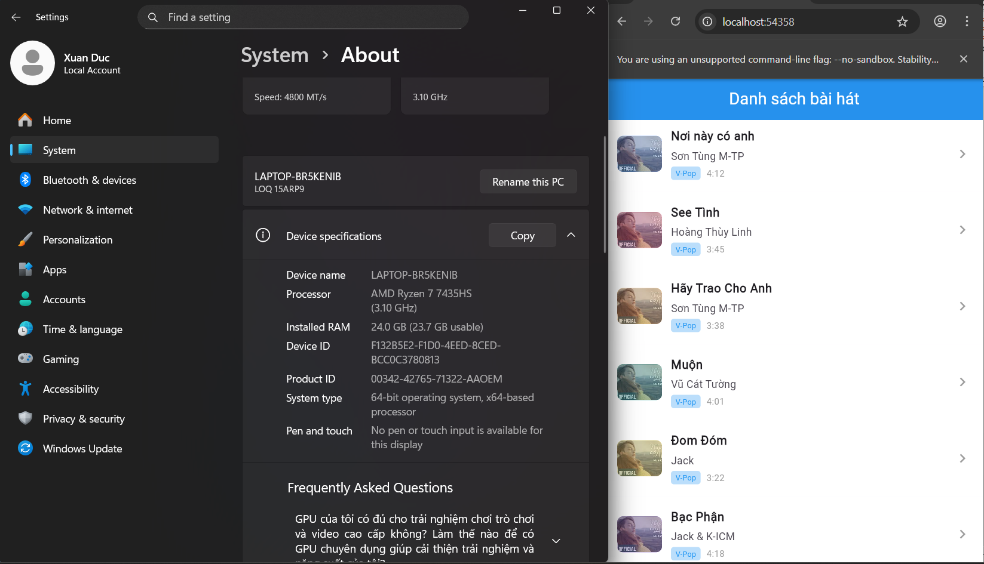
import 'package:flutter/material.dart';

void main() {
runApp(
const MaterialApp(
debugShowCheckedModeBanner: false,
// CHỌN MÀN HÌNH CHẠY:
home: MusicListScreen(), // Màn hình 1: Danh sách bài hát
//home: SongDetailScreen(), // Màn hình 2: Chi tiết bài hát 1
),
);
}

// =======================================================
// MÀN HÌNH 1: DANH SÁCH BÀI HÁT (KHÔNG CHUYỂN TRANG)
// =======================================================
class MusicListScreen extends StatelessWidget {
const MusicListScreen({super.key});

@override
Widget build(BuildContext context) {
return Scaffold(
appBar: AppBar(
title: const Text(
'Danh sách bài hát',
style: TextStyle(color: Colors.white),
),
backgroundColor: Colors.blue,
centerTitle: true,
),
body: ListView(
children: const [
SongItem(
title: "Nơi này có anh",
artist: "Sơn Tùng M-TP",
time: "4:12",
color: Colors.blueAccent,
imagePath: "assets/images/1.jpg",
),
SongItem(
title: "See Tình",
artist: "Hoàng Thùy Linh",
time: "3:45",
color: Colors.pinkAccent,
imagePath: "assets/images/1.jpg",
),
SongItem(
title: "Hãy Trao Cho Anh",
artist: "Sơn Tùng M-TP",
time: "3:38",
color: Colors.orangeAccent,
imagePath: "assets/images/1.jpg",
),
SongItem(
title: "Muộn",
artist: "Vũ Cát Tường",
time: "4:01",
color: Colors.teal,
imagePath: "assets/images/1.jpg",
),
SongItem(
title: "Đom Đóm",
artist: "Jack",
time: "3:22",
color: Colors.yellow,
imagePath: "assets/images/1.jpg",
),
SongItem(
title: "Bạc Phận",
artist: "Jack & K-ICM",
time: "4:18",
color: Colors.deepPurple,
imagePath: "assets/images/1.jpg",
),
],
),
);
}
}

class SongItem extends StatelessWidget {
final String title;
final String artist;
final String time;
final Color color;
final bool isActive;
final String imagePath; // ảnh riêng cho từng bài

const SongItem({
super.key,
required this.title,
required this.artist,
required this.time,
required this.color,
this.isActive = false,
this.imagePath = "assets/images/1.jpg", // mặc định nếu không truyền
});

@override
Widget build(BuildContext context) {
return Container(
color: isActive ? Colors.grey[200] : Colors.white,
child: ListTile(
contentPadding: const EdgeInsets.symmetric(horizontal: 16, vertical: 8),
leading: Container(
width: 60,
height: 60,
decoration: BoxDecoration(
color: color,
borderRadius: BorderRadius.circular(8),
image: DecorationImage(
image: AssetImage(imagePath),
fit: BoxFit.cover,
opacity: 0.8,
),
),
),
title: Text(
title,
style: const TextStyle(fontWeight: FontWeight.bold, fontSize: 16),
),
subtitle: Column(
crossAxisAlignment: CrossAxisAlignment.start,
children: [
const SizedBox(height: 4),
Text(artist, style: const TextStyle(fontSize: 14)),
const SizedBox(height: 4),
Row(
children: [
Container(
padding: const EdgeInsets.symmetric(
horizontal: 6,
vertical: 2,
),
decoration: BoxDecoration(
color: Colors.blue[100],
borderRadius: BorderRadius.circular(4),
),
child: const Text(
"V-Pop",
style: TextStyle(fontSize: 10, color: Colors.blue),
),
),
const SizedBox(width: 8),
Text(
time,
style: const TextStyle(fontSize: 12, color: Colors.grey),
),
],
),
],
),
trailing: const Icon(Icons.keyboard_arrow_right, color: Colors.grey),
// KHÔNG CÓ SỰ KIỆN GIỮA HAI TRANG NÊN onTap ĐỂ TRỐNG
onTap: null,
),
);
}
}

class SongDetailScreen extends StatelessWidget {
const SongDetailScreen({super.key});

@override
Widget build(BuildContext context) {
const String songTitle = "Nơi này có anh";
const String songArtist = "Sơn Tùng M-TP";
const String coverImagePath = "assets/images/1.jpg";
const Color coverColor = Colors.blueAccent;

return Scaffold(
extendBodyBehindAppBar: true,
appBar: AppBar(
backgroundColor: Colors.transparent,
elevation: 0,
leading: IconButton(
icon: const Icon(Icons.arrow_back, color: Colors.white),
onPressed: () => Navigator.pop(context),
),
),
body: SingleChildScrollView(
child: Column(
crossAxisAlignment: CrossAxisAlignment.start,
children: [
Stack(
alignment: Alignment.bottomCenter,
children: [
Container(
width: double.infinity,
height: 200,
decoration: BoxDecoration(
color: coverColor,
image: const DecorationImage(
image: AssetImage(coverImagePath),
fit: BoxFit.cover,
opacity: 0.8,
),
),
),
Container(
height: 200,
decoration: BoxDecoration(
gradient: LinearGradient(
begin: Alignment.topCenter,
end: Alignment.bottomCenter,
colors: [
Colors.transparent,
Colors.black.withOpacity(0.8),
],
),
),
),
const Positioned(
bottom: 20,
child: Text(
songTitle,
style: TextStyle(
color: Colors.white,
fontSize: 22,
fontWeight: FontWeight.bold,
),
),
),
],
),

const SizedBox(height: 20),

Padding(
padding: const EdgeInsets.symmetric(horizontal: 20),
child: Column(
children: const [
_InfoRow(Icons.person, "Ca sĩ", songArtist),
SizedBox(height: 16),
_InfoRow(Icons.album, "Album", "Single"),
SizedBox(height: 16),
_InfoRow(Icons.access_time, "Thời lượng", "4:12"),
SizedBox(height: 16),
_InfoRow(Icons.category, "Thể loại", "V-Pop"),
],
),
),

const SizedBox(height: 24),

const Padding(
padding: EdgeInsets.symmetric(horizontal: 20),
child: Text(
"Mô tả",
style: TextStyle(fontWeight: FontWeight.bold, fontSize: 16),
),
),

const SizedBox(height: 10),

Padding(
padding: const EdgeInsets.symmetric(horizontal: 20),
child: Container(
padding: const EdgeInsets.all(16),
decoration: BoxDecoration(
color: Colors.white70,
borderRadius: BorderRadius.circular(12),
),
child: const Text(
"Một bài hát nhẹ nhàng, lãng mạn với giai điệu bắt tai và lời ca sâu lắng.",
style: TextStyle(fontSize: 14),
),
),
),

const SizedBox(height: 50),

Padding(
padding: const EdgeInsets.symmetric(horizontal: 20),
child: SizedBox(
width: double.infinity,
height: 50,
child: ElevatedButton.icon(
icon: const Icon(Icons.play_arrow),
label: const Text("Phát nhạc"),
onPressed: () {},
style: ElevatedButton.styleFrom(
backgroundColor: Colors.blue, // Màu nền nút
foregroundColor: Colors.white, // Màu chữ & icon
shape: RoundedRectangleBorder(
borderRadius: BorderRadius.circular(30),
),
),
),
),
),

const SizedBox(height: 30),
],
),
),
);
}
}

// Widget hiển thị dòng thông tin
class _InfoRow extends StatelessWidget {
final IconData icon;
final String label;
final String value;

const _InfoRow(this.icon, this.label, this.value, {super.key});

@override
Widget build(BuildContext context) {
return Row(
children: [
Icon(icon, color: Colors.blue),
const SizedBox(width: 16),
Column(
crossAxisAlignment: CrossAxisAlignment.start,
children: [
Text(
label,
style: const TextStyle(color: Colors.grey, fontSize: 12),
),
Text(
value,
style: const TextStyle(fontSize: 16, fontWeight: FontWeight.bold),
),
],
),
],
);
}
}

