Lab2 report

## **Assignment 1** Use the Sobel operator to calculate the horizontal first-order derivative. Ensure you capture and visualize the negative filter response values by using appropriate datatypes.

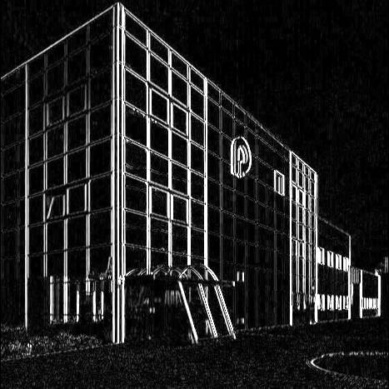

## **Assignment 2** Create a 15x15 DoG filter using the workflow below

## **Assignment 3** Filter rays.png with a well chosen DoG filter so that in the resulting image, the edges of the yellow strips stand out (you will need to take the absolute value of the responses).

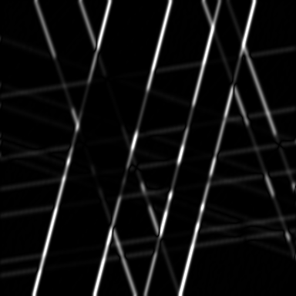

## **Question 1** What happens when your filter goes "across the border" of the image?

**Answer:** The parameter borderType sets the pixel extrapolation method. The enum BorderTypes consists of various possible actions at the border. The default value BORDER_DEFAULT is used in this case. It’s the same as BORDER_REFLECT_101 and it reflects the values in this way gfedcb|abcdefgh|gfedcba, where | denotes the boundaries.

## **Assignment 4** Apply Canny edge detection with thresholds chosen so that the edges of all strips are detected.

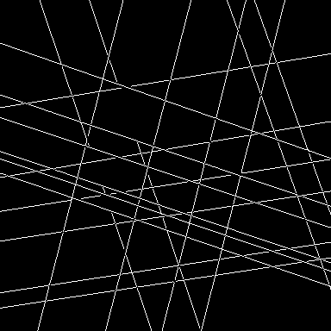

## **Assignment 5** Apply Canny edge detection so that you get the four edges of the painting, and as few other edges as possible. It is inevitable that you find other edges however.

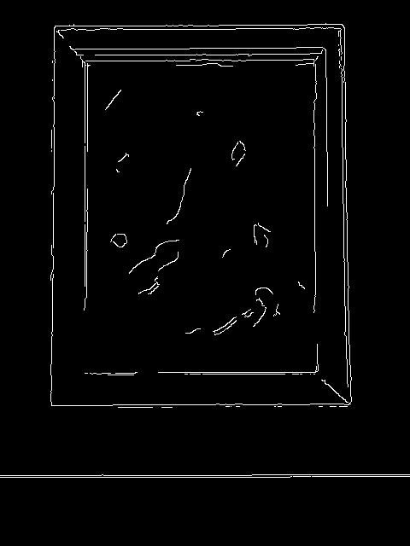

## **Assignment** 6 Apply HoughLines to the result of Assignment 5 and visualize the lines on the original image (use the line function). It is normal too get too many lines, since you cannot get the Canny result perfect.

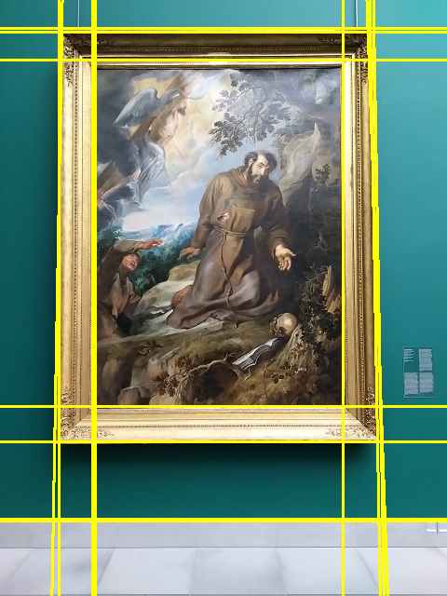

## **Assignment 7** Detect Harris corners in shot1.png and shot2.png and visualize them side by side.

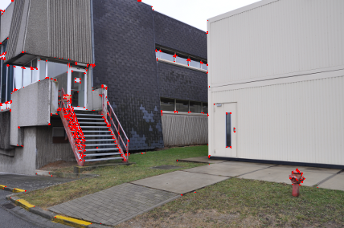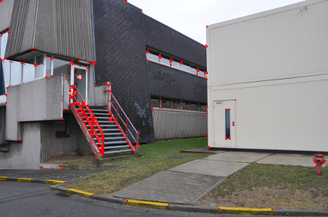

## **Question 2** Name two kinds of problems you foresee in trying to match these corners.

**Answer:**

1)The second image is shot from a different position. This creates two different lines of sight. A part of the center of the image, like the rectangular window can not be seen in the second image. This phenomenon is called parallax and can create problems with matching the corners.

2) Another problem is that the difference in position results in different geometric constraints like length of borders and angles of corners.

## **Assignment 8** Detect ORB features in each of the two original images, calculate the ORB descriptors for them, and match the descriptors between the two images. Visualize the 32 best matches.

