**Wei Liang** **SP17**

**CST 2309-E286**

**Lab#12**

**Prof. Sancar Avcioglu March 27, 2017**

**Lab#12- Source Codes Only: [Results located via Google Docs]**

[**Lab12 Video Via Google Docs**](https://drive.google.com/file/d/0B0hoB3qxh9XLUm81VTlQVjd6Y1k/view?usp=sharing) **[Ctrl + Left Click]**

**Q1:**

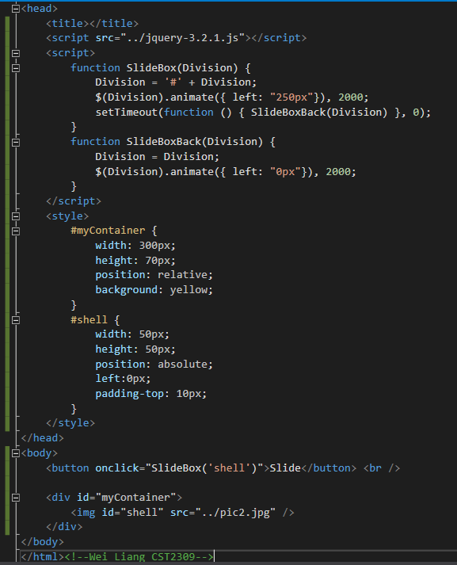

**Q2:**

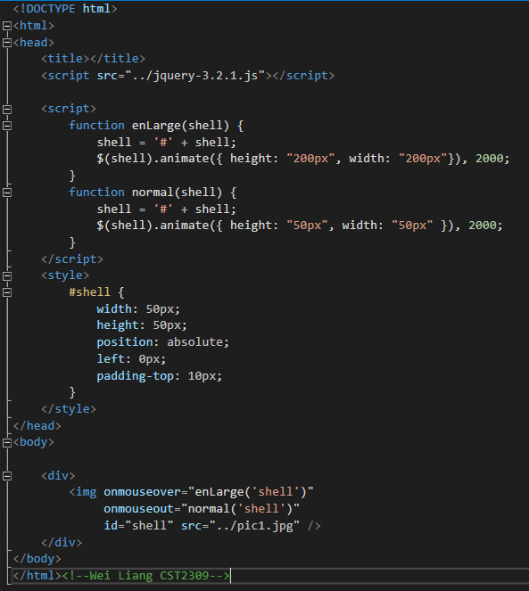

**Q3: (Changed time interval to 1000ms to speed up video process)**

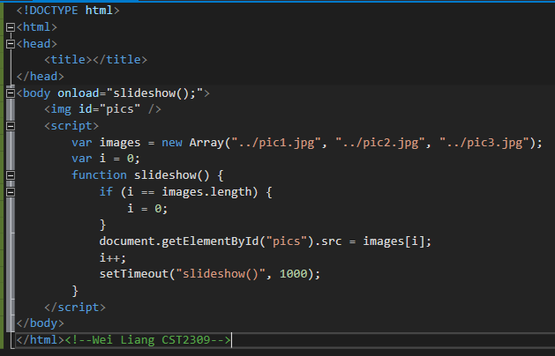

**Q4:**

