**Wei Liang** **SP17**

**CST 2309-E286**

**JS2Dynamic**

**Prof. Sancar Avcioglu April 23, 2017**

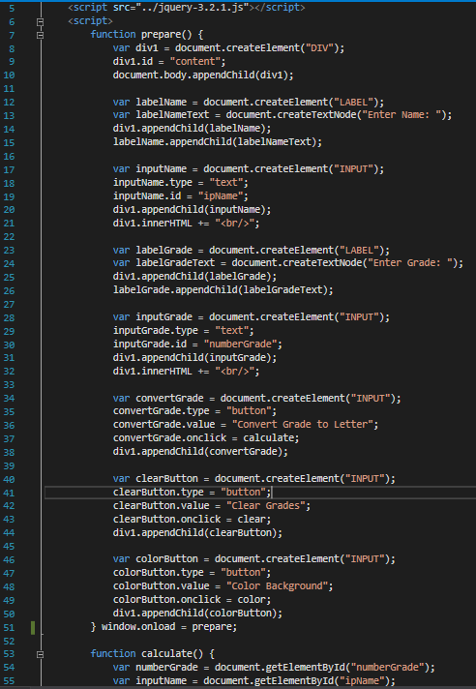

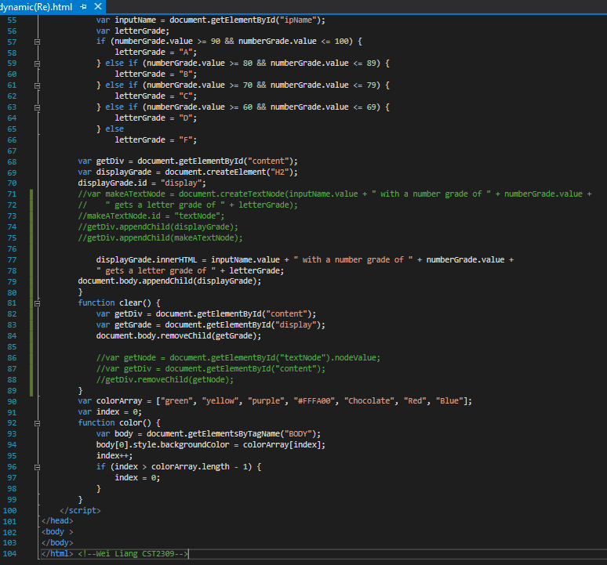

**Results @:**

[**Google Drive [Video]**](https://drive.google.com/file/d/0B0hoB3qxh9XLelViQTNxZHcteXM/view?usp=sharing)