**Wei Liang** **SP17**

**CST 2309-E286**

**JS3**

**Prof. Sancar Avcioglu April 25, 2017**

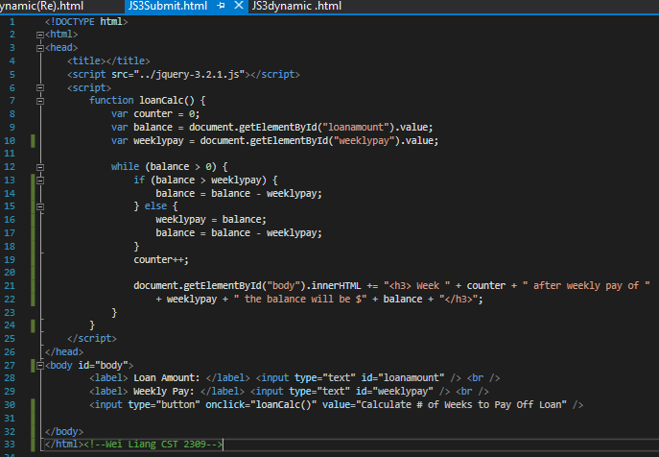

**Video Via Google Drive:**

**Link @:** [**Click Here**](https://drive.google.com/file/d/0B0hoB3qxh9XLenFnejdhck0xcFU/view?usp=sharing)