**Wei Liang** **SP17**

**CST 2309-E286**

**JS3Dynamic**

**Prof. Sancar Avcioglu May 1, 2017**

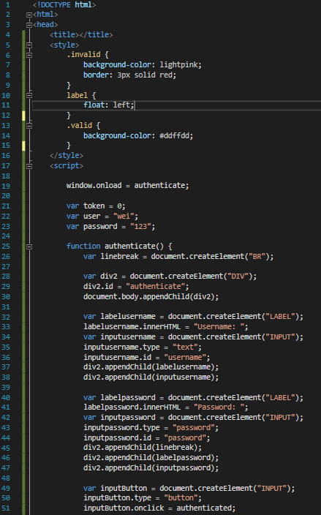

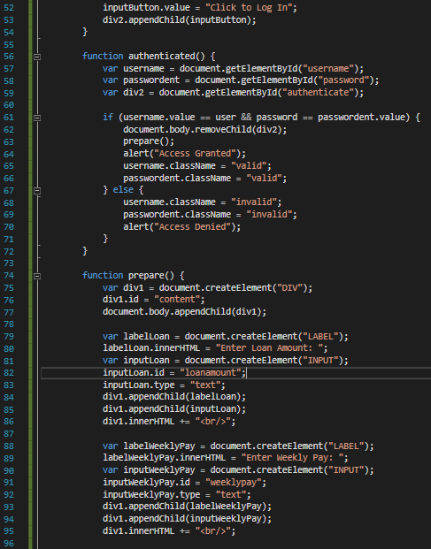

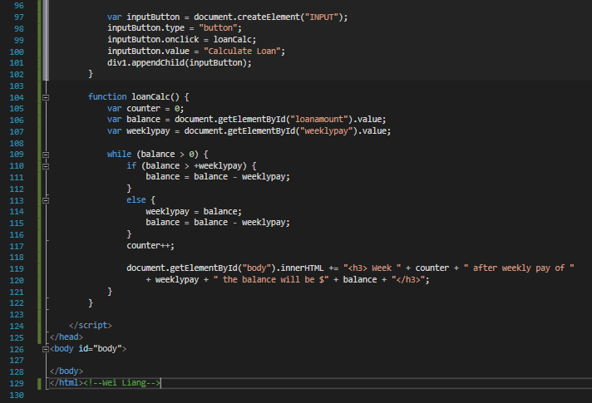

**Results @ Google Drive:**

**Link Here:** [**JS3 Dynamics Via G Drive**](https://drive.google.com/file/d/0B0hoB3qxh9XLZDg2SVpHbDh6WkU/view?usp=sharing)