**Wei Liang** **SP17**

**CST 2309-E286**

**JS3b**

**Prof. Sancar Avcioglu May 3, 2017**

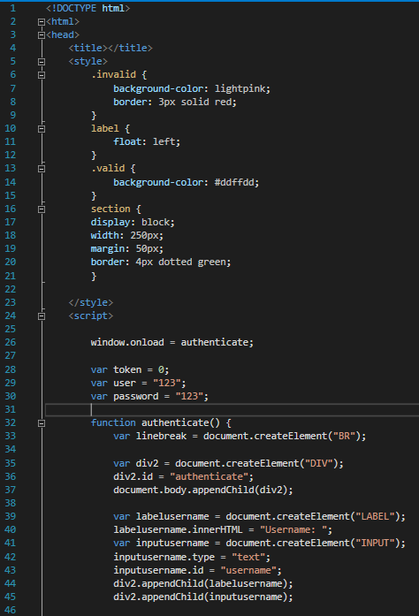

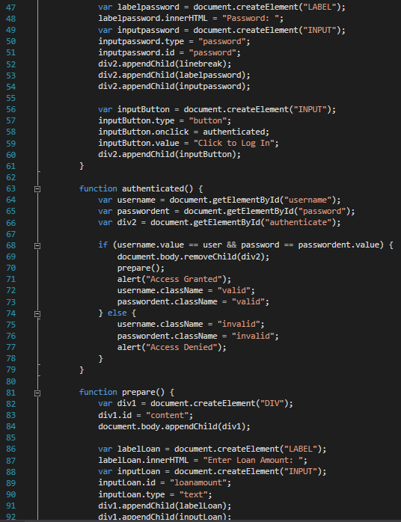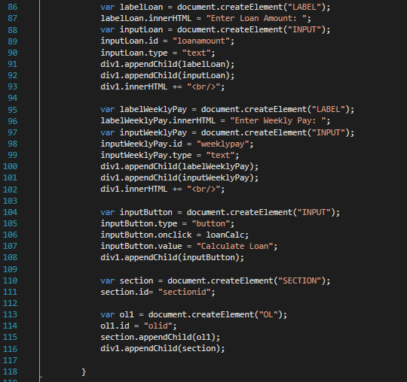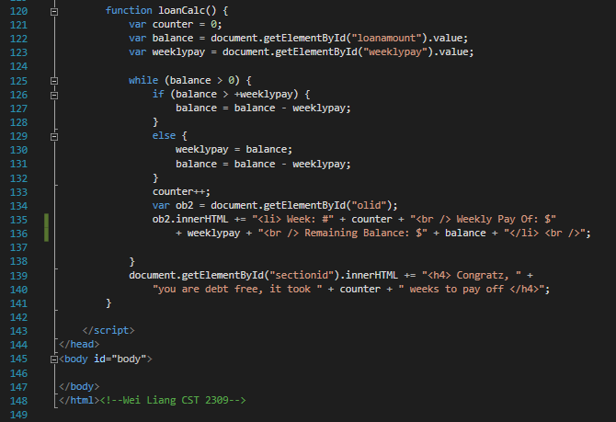

**Results on Google Drive:**

**Link @:** [**JS3b**](https://drive.google.com/file/d/0B0hoB3qxh9XLT3FXYjBpZlZzNWM/view?usp=sharing)