**Wei Liang** **SP17**

**CST 2309-E286**

**JS5**

**Prof. Sancar Avcioglu May 17, 2017**

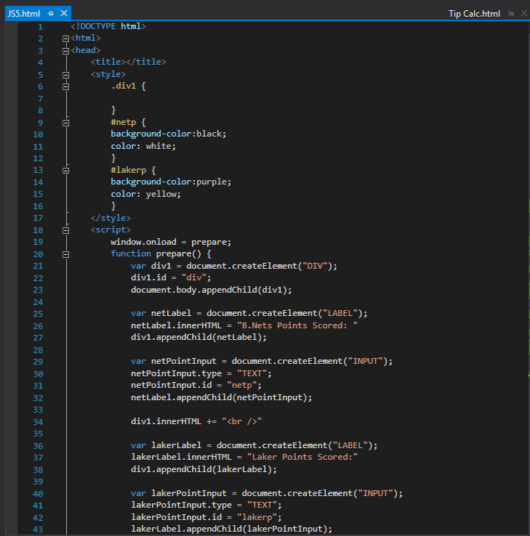

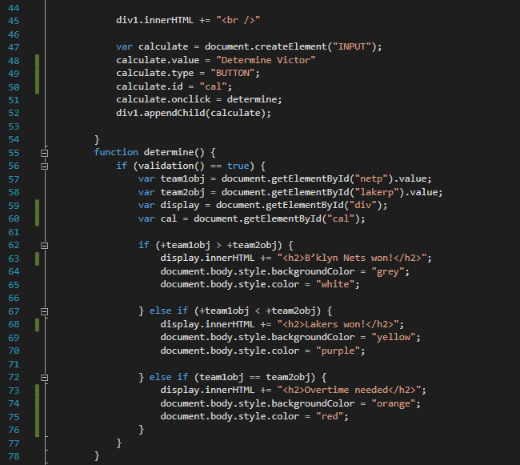

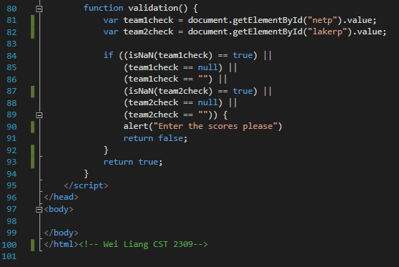

**Results Via Google Drive:** [**Link**](https://drive.google.com/file/d/0B0hoB3qxh9XLckQycHUwZl9tU2M/view?usp=sharing)