MPEG-D Dynamic Range Control Reference Software: Installation and Use

Apple, Inc. and Fraunhofer IIS

Revision | Date | Author | Comments | Corresponding SVN revision
1.0 | 01/06/2014 | Frank Baumgarte | Initial draft | 84831
1.1 | 01/07/2014 | Frank Baumgarte | Minor update | 84838
1.3 | 02/19/2014 | Frank Baumgarte | Added third verification test | 193 (MPEG SVN)
1.4 | 03/26/2014 | Frank Baumgarte | Updated references for RM2 | 215 (MPEG SVN)
1.5 | 05/14/2014 | Frank Baumgarte | Added verification test. | 253 (MPEG SVN)
1.6 | 05/27/2014 | Frank Baumgarte | Updated screen shot. | 272 (MPEG SVN)
2.0 | 06/25/2014 | Bernhard Neugebauer | Update after refactoring | 316 (MPEG SVN)
2.1 | 08/07/2014 | Bernhard Neugebauer | Encoder update | 373 (MPEG SVN)
2.2 | 08/22/2014 | Michael Kratschmer | Minor update | 426 (MPEG SVN)
2.3 | 11/05/2014 | Michael Kratschmer | Minor update | 528 (MPEG SVN)
2.4 | 01/26/2015 | Michael Kratschmer | Minor update | 591 (MPEG SVN)
2.5 | 04/02/2015 | Michael Kratschmer | Updates for RM5 | 692 (MPEG SVN)
2.6 | 11/20/2015 | Michael Kratschmer | Updates for RM6 | 843 (MPEG SVN)
2.7 | 03/18/2016 | Michael Kratschmer | Updates for RM7 | 925 (MPEG SVN)
2.8 | 07/27/2016 | Michael Kratschmer | Updates for DAM | 982 (MPEG SVN)
2.9 | 11/18/2016 | Michael Kratschmer | Updates for Study on DAM | 1020 (MPEG SVN)
2.10 | 11/11/2022 | Daniel Fischer (Dolby) | Update build instructions

Contents
MPEG-D Dynamic Range Control Reference Software: Installation and Use 1
1 Introduction 2
2 Disclaimer 2
3 Installation 2
3.1 Encoder installation 2
3.2 Decoder installation 3
3.3 Scripts for compiling 3
4 Test data 3
4.1 Encoder test data 3
4.2 Decoder test data 4
5 Installation testing 5
5.1 Step-by-step tests 6
5.2 Scripts for testing 10
6 Features 11
7 Using the software 11
8 Modules of DRC decoder 11
8.1 DRC Selection Module 11
8.2 Gain Decoder Module 11
8.3 Downmix Module 11
8.4 Loudness Normalizer Module 11
8.5 Peak Limiter Module 11
9 Known Issues and missing features 11
10 References 11

Introduction
This software is a reference implementation of the Dynamic Range Control tool according to ISO/IEC 23003-4:2015 and ISO/IEC 23003-4:2015/AMD1, the IS text and the Amendment 1 text of MPEG-D DRC. Additionally, the software implements the DRC related specification of ISO/IEC 23008-3:2015, the IS text of MPEG-H 3D Audio.

The package contains a DRC tool encoder and decoder. The encoder part is informative. It takes a file with DRC gain values as input and produces a bitstream based on a selected configuration. The encoder contains an efficient conversion of PCM encoded DRC gain values into a spline encoded representation. The decoder takes the bitstream and an audio file as inputs and produces an audio file as output.

Please refer to the MPEG-4 File Format reference software for support of the File Format (ISO/IEC 14496-12) syntax of MPEG-D DRC. This software package currently supports only the in-stream syntax.

Disclaimer
The use of this software is at your own risk. Any damage it may cause is not the responsibility of the proponents of this software.

Installation
The software is written in ANSI C. Platform and compiler independent build configurations can be generated using cmake (https://cmake.org/). The software has several configuration options listed in the table below:
Option | Description | Default
AMD1 | Enable “v1” features and syntax (can not be used in conjunction with MPEGH) | On
MPEGH | Enable “h0” features and syntax (can not be used in conjunction with AMD1) | Off
LOUDNESS_LEVELING | Enable loudness-leveling extension | On
NODE_RESERVOIR | Enable node reservoir | Off
WRITE_FRAMESIZE | For debugging only (not in conjunction with MPEGH) | Off
CONFORMANCE | Generate conformance targets | On

Configuration options are passed to cmake during the generation step.
> cmake [ -DOPT_1=VAL_1 [ ..., -DOPT_N=VAL_N ] </path/to/source/dir>

Note that options are persistent, i.e., must be overridden explicitly. For example, generating MPEG-H (AMD1 is enabled per default and therefore explicitly disabled below):
> # Create and change into build folder
> mkdir build && cd build
> # Generate project files (e.g., Makefiles, MSVC solutions, etc.)
> cmake -DMPEGH=1 -DAMD1=0 ..
> # Build the project
> cmake --build .

Targets
Targets can be run individually by:
> cmake --build </path/to/build> --target <tgt>

Target | Category
drcToolDecoder | Build
drcToolEncoder | Build
uniDrcBitstreamDecoderCmdl | Build
uniDrcGainDecoderCmdl | Build
uniDrcInterfaceDecoderCmdl | Build
uniDrcSelectionProcessCmdl | Build
encode | Test
decode | Test
start_all | Test
check_conformance | Conformance
start_all_conformance | Conformance

To run conformance targets, create a new folder conformanceData in the reference software root and unzip the archive conformanceData.zip into this directory.

For some generators (e.g., Makefiles) all targets can be listed by:
> cmake --build </path/to/build> --target help

Encoder installation
After building the target drcToolEncoder (or the complete project tree) the encoder executable should appear in modules/drcToolEncoder/bin/<platform>/drcToolEncoder. The path to the executable is called ENCODER_PATH in the following.

Decoder installation
After building the target drcToolDecoder (or the complete project tree) the decoder executable should appear in modules/drcToolDecoder/bin/<platform>/drcToolDecoder.
The path to the executable is called DECODER_PATH in the following.

Optionally, the decoder module for DRC selection can be installed as a separate executable by building the target “uniDrcSelectionProcessCmdl” of the project in modules/uniDrcModules/uniDrcSelectionProcessCmdl/make for Windows or macOS.

Scripts for compiling
The encoder and decoder software can alternatively be installed by executing the batch file scripts/compile.bat on Windows, or by executing the bash script scripts/compile.sh on unix-based platforms. Optionally, the encoder and decoder can be installed with an extended feature set as specified in MPEG-D DRC Amendment 1 (ISO/IEC 23003-4:2015/AMD1) or with an extended feature set as specified in MPEG-H 3D Audio (ISO/IEC 23008-3:2015). Please see script content for further details.

Test data
The software package contains test data files that can be used to verify the installation on a little-endian platform.

Encoder test data
The input data files for the encoder are located in the path modules/drcTool/drcToolEncoder/TestDataIn, called ENC_TEST_IN.
The data is given in float32 little-endian format at a sample rate of 48 kHz.

Filename | Description
DrcGain1vector.wav | Single PCM gain sequence at a sample rate of 48kHz
DrcGain1vector.dat | Same as DrcGain1vector.wav in float32 format but without header
DrcGain3vectors.wav | Three interleaved PCM gain sequences at a sample rate of 48kHz
DrcGain3vectors.dat | Same as DrcGain3vectors.wav in float32 format but without header
DrcGain4vectors.wav | Four interleaved PCM gain sequences at a sample rate of 48kHz
DrcGain4vectors.dat | Same as DrcGain4vectors.wav in float32 format but without header
DrcGain7vectors.wav | Seven interleaved PCM gain sequences at a sample rate of 48kHz
DrcGain7vectors.dat | Same as DrcGain7vectors.wav in float32 format but without header
DrcGain8vectors.wav | Eight interleaved PCM gain sequences at a sample rate of 48kHz
DrcGain8vectors.dat | Same as DrcGain8vectors.wav in float32 format but without header
DrcGain1vector_AMD1.wav | Single PCM gain sequence at a sample rate of 48kHz
DrcGain1vector_AMD1.dat | Same as DrcGain1vector_AMD1.wav in float32 format but without header
DrcGain1vectorA_AMD1.wav | Single PCM gain sequence at a sample rate of 48kHz
DrcGain1vectorA_AMD1.dat | Same as DrcGain1vectorA_AMD1.wav in float32 format but without header
DrcGain3vectors_AMD1.wav | Eight interleaved PCM gain sequences at a sample rate of 48kHz
DrcGain3vectors_AMD1.dat | Same as DrcGain3vectors_AMD1.wav in float32 format but without header

The reference output bitstream files are located in modules/drcTool/drcToolEncoder/TestDataOut, called ENC_TEST_OUT.
They were encoded on macOS. When encoding on other platforms, the resulting bitstreams may slightly differ.

Filename | Description
DrcGain1.bit | DRC gain bitstream of the first test
loudnessInfoSet1.bit  uniDrcConfig1.bit  uniDrcGain.bit | Loudness information bitstream, DRC configuration bitstream and DRC gain bitstream (split bitstream version of the first test)
DrcGain1_ld.bit | DRC gain bitstream of the first test (low-delay mode)
DrcGain2.bit | DRC gain bitstream of the second test
DrcGain3.bit | DRC gain bitstream of the third test
DrcGain4.bit | DRC gain bitstream of the fourth test
DrcGain5.bit | DRC gain bitstream of the fifth test
DrcGain6.bit | DRC gain bitstream of the sixth test
DrcGain1_AMD1.bit | uniDrc payload including parametric DRC configuration (AMD1 syntax)
DrcGain2_AMD1.bit | uniDrc payload including parametric DRC configuration (AMD1 syntax)
DrcGain3_AMD1.bit | DRC gain bitstream including parametric DRC configuration (AMD1 syntax)
DrcGain4_AMD1.bit | uniDrc payload including time-domain EQ (AMD1 syntax)
DrcGain5_AMD1.bit | uniDrc payload including time-domain EQ (AMD1 syntax)
DrcGain6_AMD1.bit | uniDrc payload including sub-band EQ (AMD1 syntax)
DrcGain7_AMD1.bit | uniDrc payload including parametric DRC and parametric limiter configuration (AMD1 syntax)
DrcGain8_AMD1.bit | uniDrc payload including shaping filters and target characteristics (AMD1 syntax)
DrcGain9_AMD1.bit | uniDrc payload including shaping filters (AMD1 syntax)
DrcGain10_AMD1.bit | uniDrc payload including multi-band DRC in the QMF domain (AMD1 syntax)
DrcGain11_AMD1.bit | uniDrc payload including shaping filters and gain scaling (AMD1 syntax)
DrcGain12_AMD1.bit | uniDrc payload including multi-band DRC in the QMF domain with gain scaling (AMD1 syntax)
DrcGain13_AMD1.bit | uniDrc payload with loudness metadata only (AMD1 syntax)
DrcGain14_AMD1.bit | uniDrc payload with DRC metadata only (AMD1 syntax)
mpegh3daLoudnessInfoSet1.bit  mpegh3daUniDrcConfig1.bit  mpegh3daUniDrcGain1.bit  mpegh3daDownmixMatrixSet1.txt | Loudness information bitstream, DRC configuration bitstream, DRC gain bitstream and DownmixMatrixSet() parameters of the first MPEG-H 3D Audio syntax test.
mpegh3daLoudnessInfoSet2.bit  mpegh3daUniDrcConfig2.bit  mpegh3daUniDrcGain2.bit  mpegh3daDownmixMatrixSet2.txt | Loudness information bitstream, DRC configuration bitstream. DRC gain bitstream and DownmixMatrixSet() parameters of second MPEG-H 3D Audio syntax test.
mpegh3daLoudnessInfoSet3.bit  mpegh3daUniDrcConfig3.bit  mpegh3daUniDrcGain3.bit  mpegh3daDownmixMatrixSet3.txt | Loudness information bitstream, DRC configuration bitstream, DRC gain bitstream and DownmixMatrixSet() parameters of the third MPEG-H 3D Audio syntax test.
mpegh3daLoudnessInfoSet4.bit  mpegh3daUniDrcConfig4.bit  mpegh3daUniDrcGain4.bit  mpegh3daDownmixMatrixSet4.txt | Loudness information bitstream, DRC configuration bitstream, DRC gain bitstream and DownmixMatrixSet() parameters of the fourth MPEG-H 3D Audio syntax test.

Decoder test data
The input audio data files for the decoder are located in modules/drcTool/drcToolDecoder/TestDataIn, called DEC_TEST_IN:
Filename | Description
audio2chSines.wav | 2-channel audio file with a full-scale 440Hz tone
audio5chSines.wav | 5-channel audio file with a full-scale 440Hz tone
audio2chMusic.wav | 2-channel audio file with music excerpt
audio2chSweep.wav | 2-channel sine sweep, identical in all channels
audio5chSweep.wav | 5-channel sine sweep, identical in all channels
audio2chNoise.wav | 2-channel white noise
audio8chNoise.wav | 8-channel white noise
audio5chSinesWN.wav | 5-channel, sine wave followed by white noise
audio5chSinesWN QMF64* | 5-channel, QMF sub-band signal representing sine waves followed by white noise
audio5chConst_QMF64* | 5-channel QMF sub-band signal with constant values
audio2chSines_QMF64* | 2-channel QMF sub-band signal representing sine waves
audio2chSines_STFT256* | 5-channel STFT sub-band signal representing sine waves
audio5chSinesWN STFT256* | 5-channel, STFT sub-band signal of sine wave followed by white noise

The reference output data files are located in modules/drcTool/drcToolDecoder/TestDataOut, called DEC_TEST_OUT:
Filename | Description
audioOut1.wav | 2-channel audio file with a 440Hz tone modulated by a sine
audioOut1_ld.wav | 2-channel audio file with a 440Hz tone modulated by a sine (low-delay mode decoding)
audioOut1_QMF64_real*,  audioOut1_QMF64_imag* | 2-channel audio file with a 440Hz tone modulated by a sine (64-band QMF domain decoding)
audioOut1_STFT256_real*  audioOut1_STFT256_imag* | 2-channel audio file with a 440Hz tone modulated by a sine (256-band STFT domain decoding according to ISO/IEC 23008-3:2015/AMD3)
audioOut2.wav | Similar content as audioOut1.wav but with fade-in and fade-out and clipping prevention
audioOut3.wav | 5-channel audio signal. Each channel starts with a sine tone at a constant frequency. The frequency increases with channel number. The remaining signal is noise. Different gain sequences, multi-band DRC, and fading is applied.
audioOut4.wav | 4-channel audio signal. Each channel starts with a sine tone at a constant frequency. The frequency increases with channel number. The remaining signal is noise. Different gain sequences and multi-band DRC is applied. Ducking is applied to the first 3 channels.
audioOut5.wav | 5-channel audio signal. Each channel starts with a sine tone at a constant frequency. The frequency increases with channel number. The remaining signal is noise. Ducking is applied to the first 4 channels with two independent gain sequences.
audioOut1_AMD1.wav | 2-channel audio signal with parametric DRC on both channels.
audioOut2_AMD1.wav | 2-channel audio signal with two independent parametric DRCs on each channel.
audioOut3_AMD1.wav | 2-channel audio signal with parametric DRC on first channel and regular DRC on second channel.
audioOut4_AMD1.wav | Time-domain EQ applied to a 2-channel sine sweep
audioOut5_AMD1.wav | Time-domain EQ applied to channel 1 to 4 of a 5-channel sine sweep. Channel 2 and 3 are in one EQ channel group. All channels are phase aligned.
audioOut6_AMD1_QMF64* | Sub-band EQ with spline representation applied to a constant QMF sub-band signal with 5 channels.
audioOut7_AMD1.wav | 2-channel audio signal with parametric DRC before downmix and parametric limiter after downmix.
audioOut8_AMD1.wav | Dynamic shaping filters and target characteristics applied to 2-channel noise signal.
audioOut9_AMD1.wav | Dynamic shaping filters and target characteristics applied to 8-channel noise signal.
audioOut10_AMD1_QMF64* | Multi-band DRC in QMF domain applied to constant QMF coefficients of signal with 5 channels.
audioOut11_AMD1.wav | DRC with shaping filters applied to 2-channel noise signal.
audioOut12_AMD1_QMF64* | Multi-band DRC applied in QMF domain to constant QMF coefficients of 2-channel signal.
audioOut13_AMD1.wav | Target loudness applied to 2-channel noise signal.
audioOut14_AMD1.wav | DRC with shaping filters applied to 2-channel noise signal.

Installation testing
The executables can be validated on a little endian platform using the provided reference data in the TestDataIn and TestDataOut directories.

Step-by-step tests
The first test includes encoding of a single DRC gain sequence and decoding. Perform the following steps from the command line:
- cd ENCODER_PATH
- drcToolEncoder 1 ENC_TEST_IN/DrcGain1vector.dat DrcGain1.bit
- cd DECODER_PATH
- drcToolDecoder
–if DEC_TEST_IN/audio2chSines.wav
–ib ENC_TEST_OUT/DrcGain1.bit
–of DEC_TEST_OUT/audioOut1.wav
–cp 1
The outputs DrcGain1.bit and audioOut1.wav should match the files in the respective TestDataOut folders. The audio output waveform shows the modulation pattern of the DRC gain sequence as illustrated in the figure.
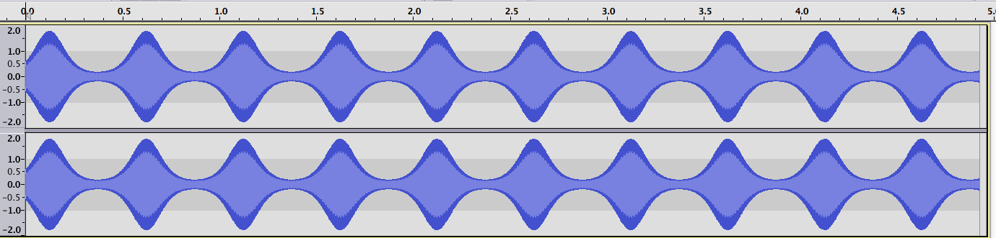
To run the first test in low-delay mode, perform the following steps:
- cd ENCODER_PATH
- drcToolEncoder 1_ld ENC_TEST_IN/DrcGain1vector.dat DrcGain1_ld.bit
- cd DECODER_PATH
- drcToolDecoder
–if DEC_TEST_IN/audio2chSines.wav
–ib ENC_TEST_OUT/DrcGain1_ld.bit
–of DEC_TEST_OUT/audioOut1_ld.wav
–cp 1 –dm 1
The outputs DrcGain1_ld.bit and audioOut1_ld.wav should match the files in the respective TestDataOut folders.
To run the first test with subband domain interfaces (QMF64) at the decoder, perform the following steps:
- cd ENCODER_PATH
- drcToolEncoder 1 ENC_TEST_IN/DrcGain1vector.dat DrcGain1.bit
- cd DECODER_PATH
- drcToolDecoder
–if DEC_TEST_IN/audio2chSines.wav
–ib ENC_TEST_OUT/DrcGain1.bit
–of DEC_TEST_OUT/audioOut1_QMF64
–cp 1 –dt 2
The outputs audioOut1_QMF64_real.qmf and audioOut1_QMF64_imag.qmf represent the real and imaginary part of the 64-band QMF domain and should match the files in the respective TestDataOut folders. The respective file format can be generated and transformed with the QMF example application in the tools/qmflib subfolder.
The outputs audioOut1_STFT256_real.qmf and audioOut1_STFT256_imag.qmf represent the real and imaginary part of the 256-band STFT domain according to ISO/IEC 23008-3:2015/AMD3 and should match the files in the respective TestDataOut folders. The respective file format can be generated and transformed with the FFT example application in the tools/fftlib subfolder.
The second test will encode three DRC sequences and apply them to the audio signal. To run this test, perform the following steps:
- cd ENCODER_PATH
- drcToolEncoder 2 ENC_TEST_IN/DrcGain3vectors.dat DrcGain2.bit
- cd DECODER_PATH
- drcToolDecoder
–if DEC_TEST_IN/audio2chSines.wav
–ib ENC_TEST_OUT/DrcGain2.bit
–of DEC_TEST_OUT/audioOut2.wav
–cp 1
The outputs DrcGain2.bit and audioOut2.wav should match the files in the respective TestDataOut folders. The audio output waveform shows the modulation pattern as in test 1, but additionally has clipping prevention and fade-in and out as illustrated in the figure.
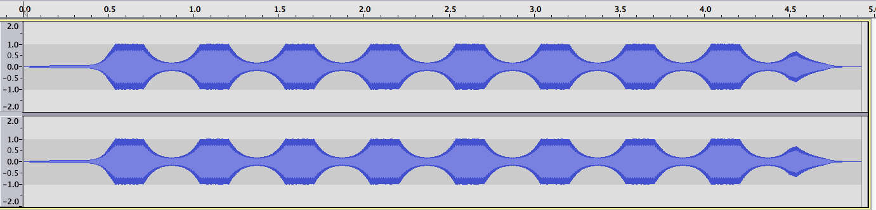
The third test will encode four DRC sequences and apply them to the audio signal. One sequence is a 4-band DRC. To run this test, perform the following steps:
- cd ENCODER_PATH
- drcToolEncoder 3 ENC_TEST_IN/DrcGain7vectors.dat DrcGain3.bit
- cd DECODER_PATH
- drcToolDecoder
–if DEC_TEST_IN/audio5chSinesWN.wav
–ib ENC_TEST_OUT/DrcGain3.bit
–of DEC_TEST_OUT/audioOut3.wav
–cp 1
The outputs DrcGain3.bit and audioOut3.wav should match the files in the respective TestDataOut folders. The audio output waveform shows different DRC effects in different channels. The third channel has only fading applied to it.
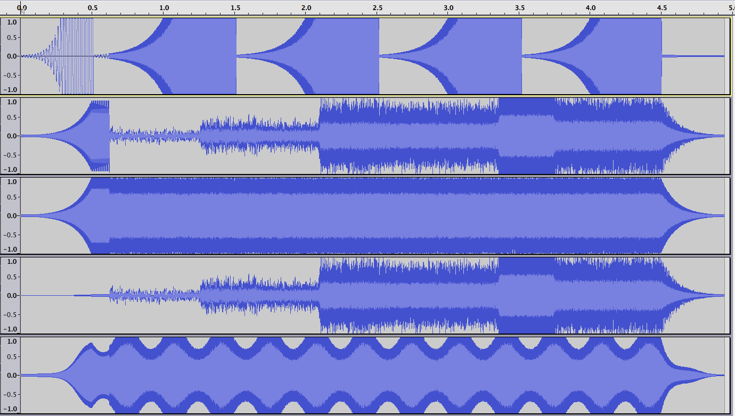
Test 4 uses a more complex DRC feature request for DRC selection at the decoder side. Various gain sequences are encoded and the desired DRC set is found by the selection process. Ducking is applied to all except the last channel. To run this test, perform the following steps:
- cd ENCODER_PATH
- drcToolEncoder 4 ENC_TEST_IN/DrcGain7vectors.dat DrcGain4.bit
- cd DECODER_PATH
- drcToolDecoder
–if DEC_TEST_IN/audio5chSinesWN.wav
–ib ENC_TEST_OUT/DrcGain4.bit
–of DEC_TEST_OUT/audioOut4.wav
–cp 2 –oc 4
The outputs DrcGain4.bit and audioOut4.wav should match the files in the respective TestDataOut folders. The audio output waveform shows different DRC effects in different channels. The dynamic range compression and ducking is applied to channel 1…3. Channel 4 acts as a narration channel without ducking.
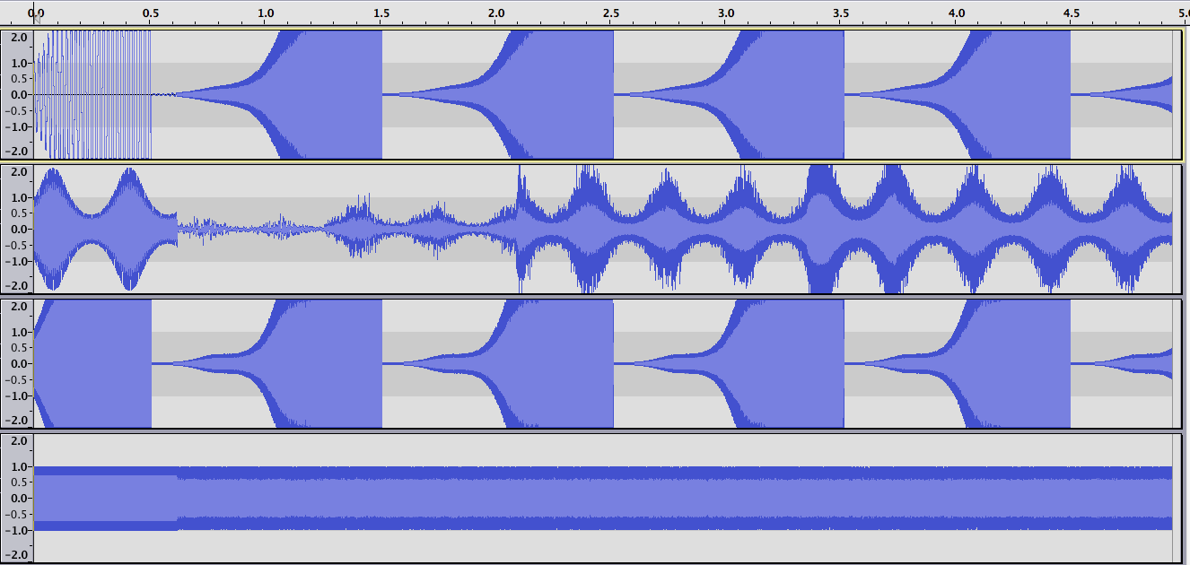
Test 5 applies a DRC set with “Duck self” effect that includes two independent gain sequences. To run this test, perform the following steps:
- cd ENCODER_PATH
- drcToolEncoder 6 ENC_TEST_IN/DrcGain8vectors.dat DrcGain6.bit
- cd DECODER_PATH
- drcToolDecoder
–if DEC_TEST_IN/audio5chSinesWN.wav
–ib ENC_TEST_OUT/DrcGain6.bit
–of DEC_TEST_OUT/audioOut5.wav
–cp 34 –oc 5
The outputs DrcGain6.bit and audioOut5.wav should match the files in the respective TestDataOut folders. The audio output waveform shows different DRC effects in different channels. Gains are applied to channel 1…4. Channel 5 acts as a narration channel without ducking.
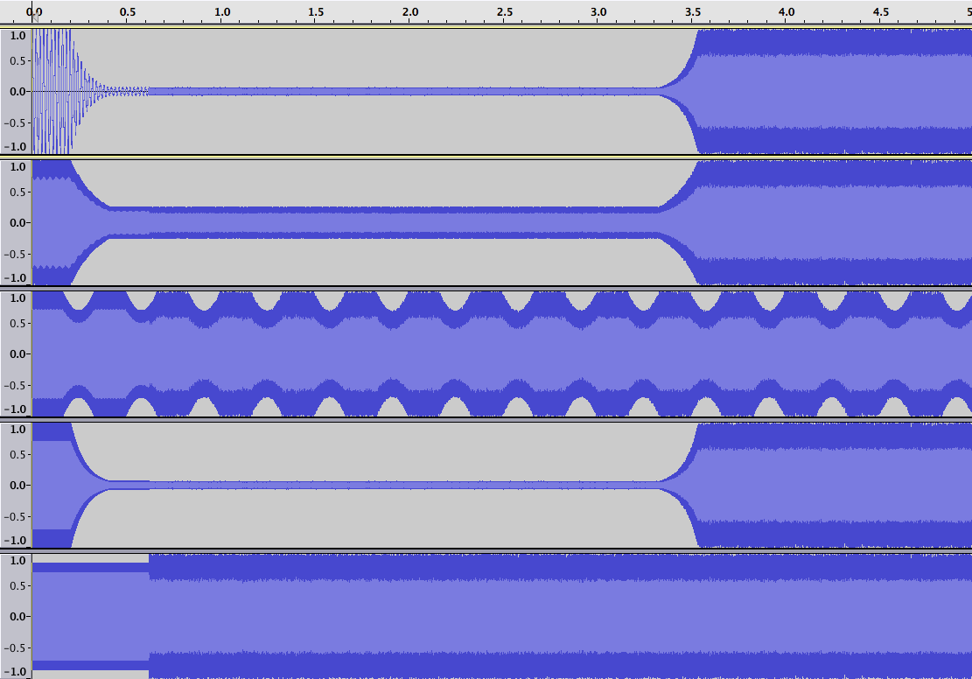

Scripts for testing
On Windows, all encoder tests can be started at once using the batch file scripts/encode.bat, and all decoder tests can be started using scripts/decode.bat.
The corresponding shell scripts for unix-based operating systems are scripts/encode.sh and scripts/decode.sh. The first argument of this script is a string containing information about the platform and the configuration. Currently, the following strings are supported:

- Darwin64_Debug
- Darwin64_Debug_Xcode
- Lin64_Debug

For other platforms and/or configurations, the script has to be adapted so that the appropriate path names are used.

Within the scripts for decoding, optional code for comparison of the output files can be activated by setting the variable “compare” to “yes”. If activated, the output files in the directory modules/drcTool/drcToolDecoder/outputData are compared to the reference files in modules/drcTool/drcToolDecoder/TestDataOut. For this comparison, the tool CompAudio from the AFsp package [1] has to be present in the system path.

For verification of the DRC selection process separate scripts are available that output text files with the selected DRC sets and signal characteristics for various different DRC requests and bitstreams. On Windows, the DRC selection test can be started using scripts/test_selectionProcess.bat. On unix-based operating systems, the DRC selection test can be started using the shell script scripts/test_selectionProcess.sh. The output is compared to reference files located in modules/uniDrcModules/uniDrcSelectionProcessCmdl/TestDataOut.

Note that all compile and test scripts can be started in all available modes at once by using the batch file scripts/start_all.bat on Windows and by using the shell script scripts/start_all.sh on unix-based operating systems. Please see script content for further details.

Features
The DRC encoder supports encoding multiple DRC sequences, in-stream DRC configuration information, including loudness information.
The DRC decoder supports multiple DRC sequences, in-stream DRC configuration information, and loudness information. It can apply up to three DRC sets, when two of them depend on each other and the third is a fading or ducking DRC. The gains are applied to a time domain audio signal including multi-band DRC. The gains can be applied to channel groups.
Alternatively, DRC gains can be also applied in the sub-band domain (QMF or STFT).
Regarding the features included in Amendment 1, the DRC encoder fully supports the enhanced in-stream syntax including parameter quantization. The DRC decoder fully supports parsing of the enhanced syntax. For DRC processing, it supports parametric DRC, target DRC characteristics, and dynamic EQ in the time domain. Loudness EQ is supported as specified, i.e. the acoustical levels for loudness EQ can be generated. Generic equalization is supported in the time domain and in sub-bands.
A DRC interface codec is included that supports the efficient transmission of control parameters into the DRC decoder.

Decoder Delay Handling
The DRC decoder absorbs significant algorithmic delay of the audio signal by default. Dependent on the MPEG-D DRC bitstream and the specific DRC decoder configuration, the following significant delay sources can be present:
- Peak limiter (Annex G)
- Parametric DRC (AMD1 only)
- EQ (AMD1 only)
- Delay line in case of constant delay decoding (AMD1 only)
Following figure shows a block diagram of the reference DRC decoder including delay sources, where variables are defined as follows:
- eqDelay: processing delay of active equalization tool instance.
- parametricDrcDelay: processing delay of active parametric DRC tool instance.
- delayLineDelay: additional delay for constant delay decoding (see below).
- peakLimiterDelay: processing delay of active peak limiter tool.

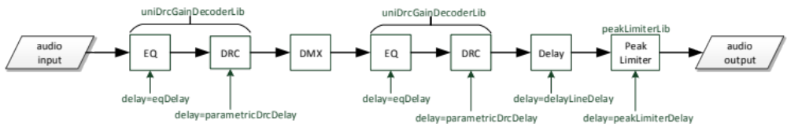
Note that the WAV reader appends zeros at the end and the WAV writer absorbs invalid output samples at the beginning to achieve a full absorption of processing delay. There are two command line options for controlling the delay behavior of the DRC decoder:
- “-cd” == constant delay: This mode emulates a DRC decoder with constant delay, which should be used in case dynamic DRC and/or EQ set switching is allowed.
- “-ado” == absorb delay off: This mode allows for disabling algorithmic delay absorption. Note that this option serves debugging purposes only.

Using the software
The DRC encoder has a complete uniDrc() bitstream writer that is controlled by one of the configureEncX() functions. Custom bitstreams can be generated by modifying one of these functions. Please see the IS text and the Amendment 1 text of MPEG-D DRC and the IS text of MPEG-H 3D Audio for valid configurations. There is nothing else to configure in the encoder. Note that the generated bitstreams might not be identical for different encoding platforms due to rounding differences in the spline encoding. Known issues and missing features:
- The decoder does not support DRC gain application in mixed domains.
- The current reference data only verifies a limited feature set of MPEG-D DRC. An extended data set and conformance streams will be subject of future software deliveries.
- Support of DRC configuration changes according to Section 6.8 of the final IS text of MPEG-D DRC are not supported by the current software implementation.

References
- McGill University, Telecommunications & Signal Processing Laboratory, “AFsp Programs and Routines”,
http://www-mmsp.ece.mcgill.ca/Documents/Software/Packages/AFsp/AFsp.html
Download:
http://www-mmsp.ece.mcgill.ca/Documents/Downloads/AFsp

