Vidzeme University of Applied Sciences
Faculty of Engineering

Python OOP and UML
group 07

practical work #2

Valmiera, 2026

CONTENT
1 Content 4
2 Context 4
3 Target audience 4
3.1 Lower-level income of society 4
3.2 People looking to save money on produce 4
4 Functionality 4
4.1 Discount comparison 4
4.2 Brochure comparison 5
4.3 User submitted discounts 5
4.3.1 Browsing 5
4.3.2 Submitting 5
5 Main application 5
6 Use case diagram 6
7 Python 7
7.1 Star drawing function 7
7.1.1 Algorithm 7
7.2 Graph drawing function 8

Document versions
Version | Status / Changes | Date | Author
1.0 | Improved functionality description, add use case diagram | 09.11.2026 | Valters Pauls Graudiņš
1.1 | Added python function descriptions | 09.11.2026 | Daniels Uskāns

Contacts and responsible (-s)
Name Surname | Department | Position | Contact information (e-mail)
Jānis Vilks | Group #7 | Coordinator | Janis.vilks@va.lv
Valters Pauls Graudiņš | Group #7 | Member | valterspauls.graudins@va.lv
Daniels Uskāns | Group #7 | Member | daniels.uskans@va.lv

Content

GOAL. Description of application for UML modelling.

Context

It is time consuming to find the best on-sale prices for produce in the stores in your area.

Target audience

Lower-level income of society

Lower-level income of society, that cannot afford to buy high-tier produce at the full price.

People looking to save money on produce

People that think that buying expensive produce is just a waste of money, and just like to save on produce.

Functionality

Discount comparison

A user can browse and compare various discounts from various stores. These discounts are gathered from store websites and display detailed information about the discounted items. The user can select the city the stores have to be in and exclude certain stores they do not like, as well as filter the items by various parameters.

Brochure comparison

The user can browse image-based brochures loaded from various store websites, subject to the same store filtering as in the discount comparison section. Being able to view the brochures side-by-side helps the user to more quickly decide which store offers the best brochure exclusive discounts.

User submitted discounts

Browsing
The user can browse discounts submitted by other users, also subject to the same filtering as in 4.1. The user can also give thumbs up or down based on the validity of the discount or add tags like “item out of stock”, which other users will be able to see and filter.

Submitting
The user can submit new discounts to the user submitted discounts section. To ensure high-quality submissions the user has to submit a picture of the price tag, the store and location where the discount is applicable, as well as input the name, price and discount of the item.

Main application

Finding the best on-sale prices for produce when making a shopping list, so that you can save money by not buying higher tier produce at full price, and at the same time saving time on looking at all the sales brochures.

Use case diagram
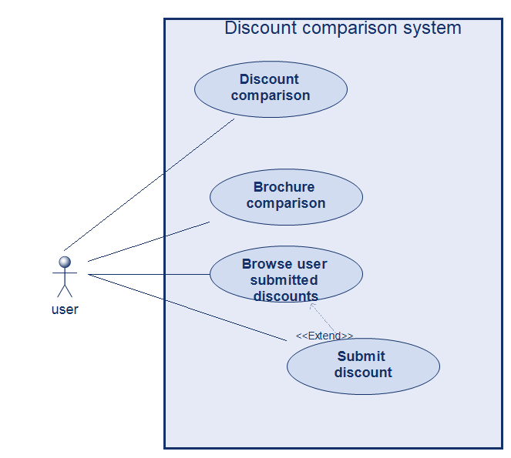

Python

Star drawing function

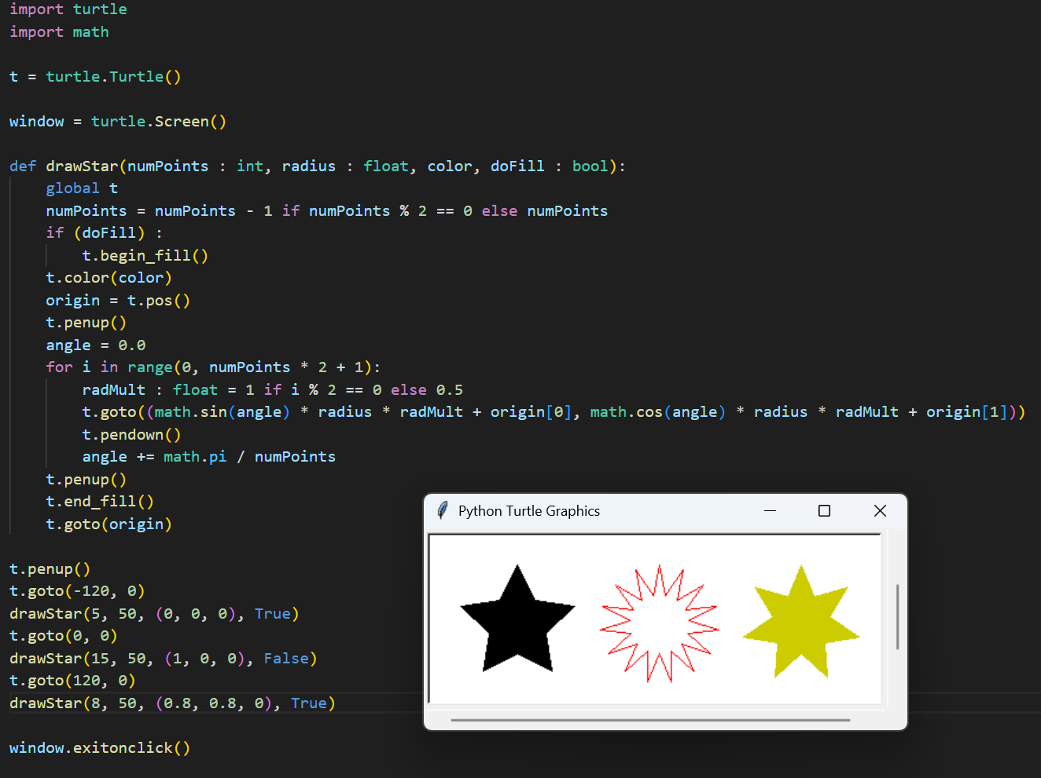
This script draws three stars in a row using Python's turtle. The drawStar function lets you choose how many points the star has, how big it is, what color it is and whether it is filled in. The stars are black, red and yellow. The windows will stay open until you click on it.

Algorithm
- The function ensures that the numPoints value is odd by subtracting 1 if it is even
- The function starts the fill if necessary and selects the color
- The function calculates a point on a circle based on an angle, changing the radius of the circle if the step is odd to create valleys that make the shape of the star
- The function returns the turtle to its position before the function was started, and ends the fill

Graph drawing function

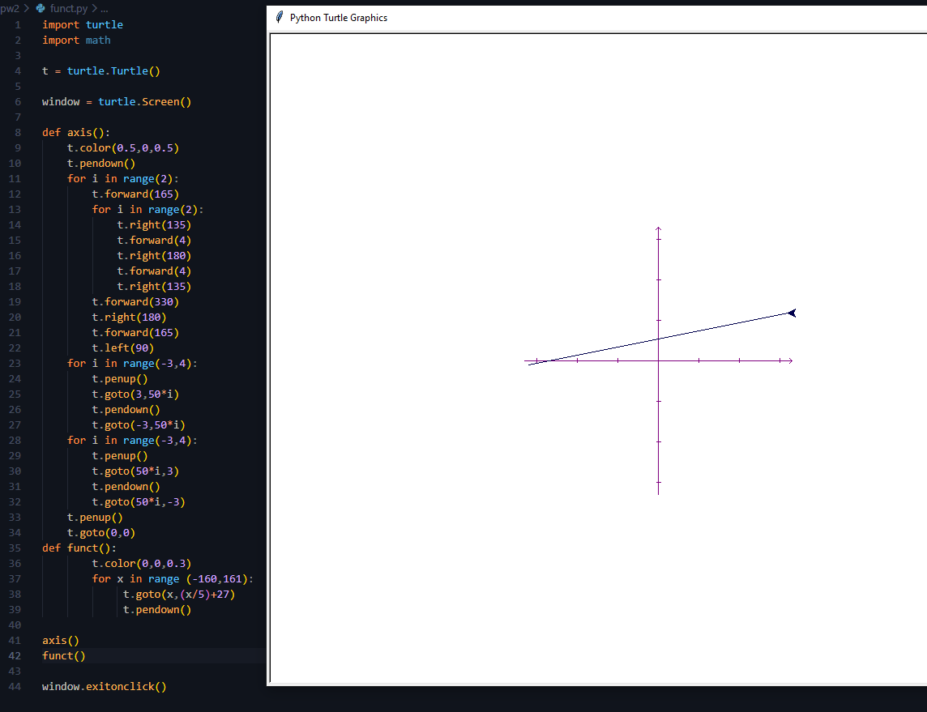

This script uses Python's turtle to draw a coordinate system and a straight line function on it. The axis function draws the purple x and y axes with arrows and small tick marks. The funct function draws the line y=x/5+27 in dark blue. The window will stay open until you click on it.
- Algorithm
Axis
- The function selects the purple color and puts the pen down;
- It draws each axis from the origin 165 steps outward, adds a small arrowhead at the end, then moves back through the origin to the other end;
- It turns the turtle left by 90° so the second axis is drawn perpendicular to the first;
- It draws a short tick mark every 50 steps along both axes, moving the turtle with the pen up between the marks;
- It lifts the pen and returns the turtle to the origin (0, 0)
Funct
- The function selects the dark blue color;
- It goes through every x value from -160 to 160;
- For each x, it calculates y with the formula x/5 + 27 and moves the turtle to that point;
- The pen is put down after the first point, so the points are connected into a line

