**Job seeker end issues:-**

When the user clicks on the apply job button then the user automatically should be redirected to the job seeker login page not in **the employer or job seeker** page.

**Developer Comment:** Done

**Tester Comment:** Have you created a new login page when a jobseeker is applying on job?.

**Tester Comment:- Issue in job detail page. I am not able to open the job detail page. See video link:-** <https://drive.google.com/file/d/1XYoqczbt4bEZnTE7qtGAvNk_Ve365Q4m/view>

**Developer Comment:** Issue Solved

Jobseekers should be notified when a jobseeker successfully applies for the job through email or SMS.

**Developer Comment:** Additional Point Need to discuss with ma’am

Job seekers should have the option to upload resumes on the edit profile page.

**Developer Comment:** Done

**Tester Comment:** I am not able to view the edit page. See video link: <https://drive.google.com/file/d/1psKb4Prl-5TmJfqni4rXDV7EYRi94hk-/view>

**Tester Comment:- Upload resume field is displayed but when we submit the edit form then display error message**.

**Developer Comment:** Please ask your developer to set permission access. This is not my issue, this is a 777 permission issue.

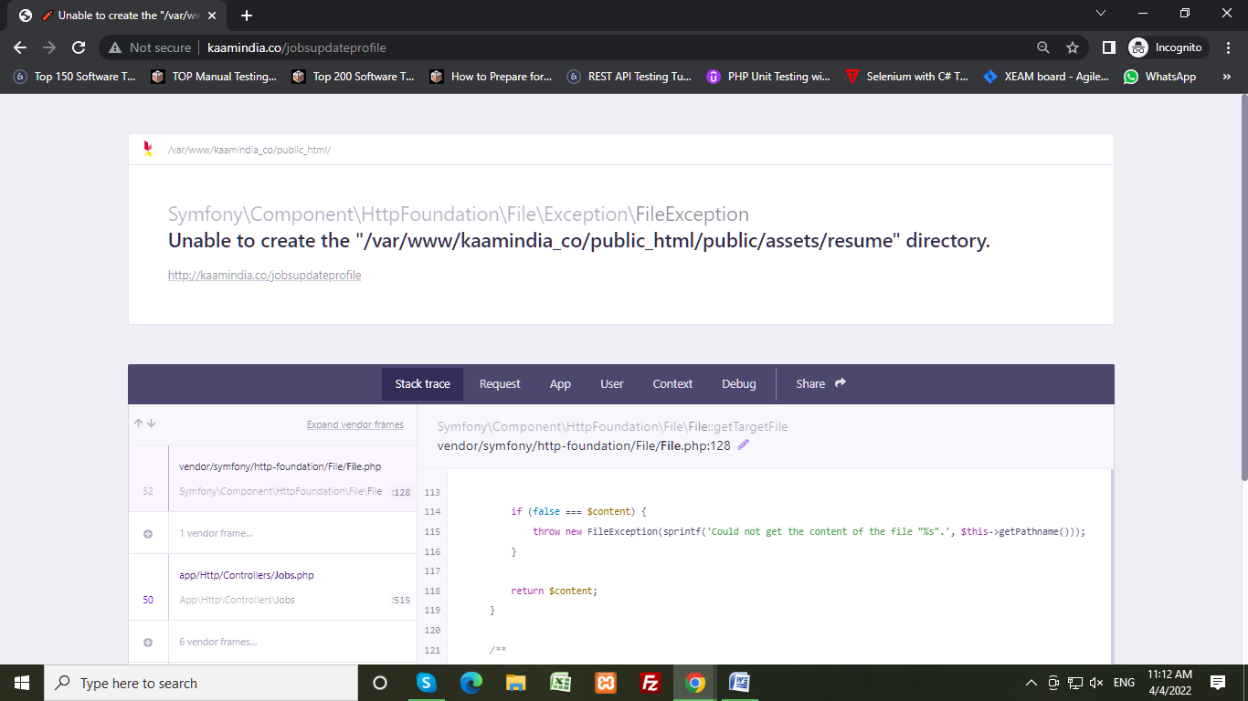

**New Errors**

1. When we submit edit form of jobseeker then display **Unable to create the "/var/www/kaamindia_co/public_html/public/assets/resume" directory.** error message.

**Developer Comment:** Please ask your developer to set permission access. This is not my issue, this is a 777 permission issue.



1. Display error when we click on a job in the job listing page. Please see video link:-<https://drive.google.com/file/d/1XYoqczbt4bEZnTE7qtGAvNk_Ve365Q4m/view>

**Developer Comment:** Issue Solved

1. Error when we registered as a jobseeker. Please see video link: <https://drive.google.com/file/d/1j1x9yRd_hNQMX-gDsmpI0Snxg-liX0Cw/view>

**Developer Comment:** Please ask your developer to set permission access. This is not my issue, this is a 777 permission issue.

1. Incorrect alignment jobs should be displayed in 2x5 patterns.

**Developer Comment:** Issue Solved

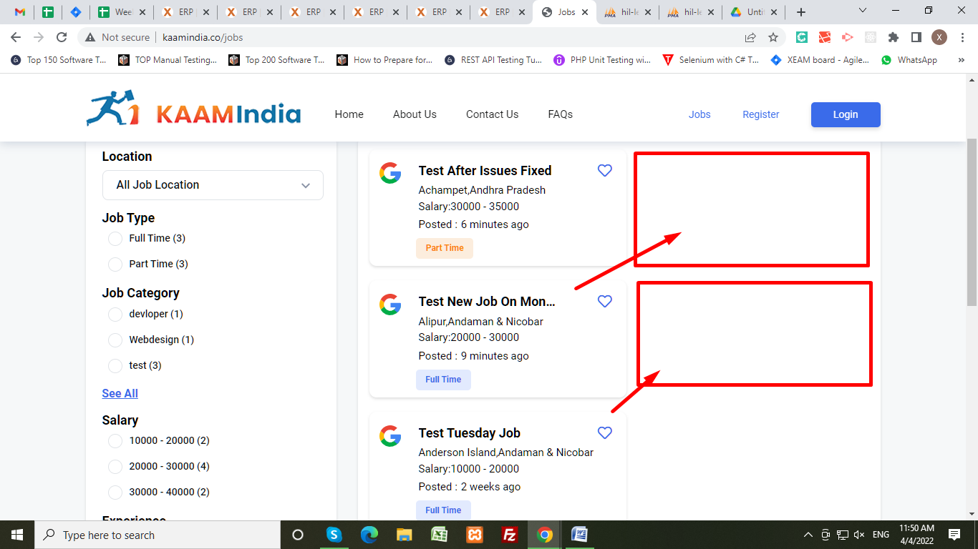

**Employer end issues:-**

No confirmation email received when the employer registered successfully.

**Developer Comment:** Additional Point Need to discuss with ma’am

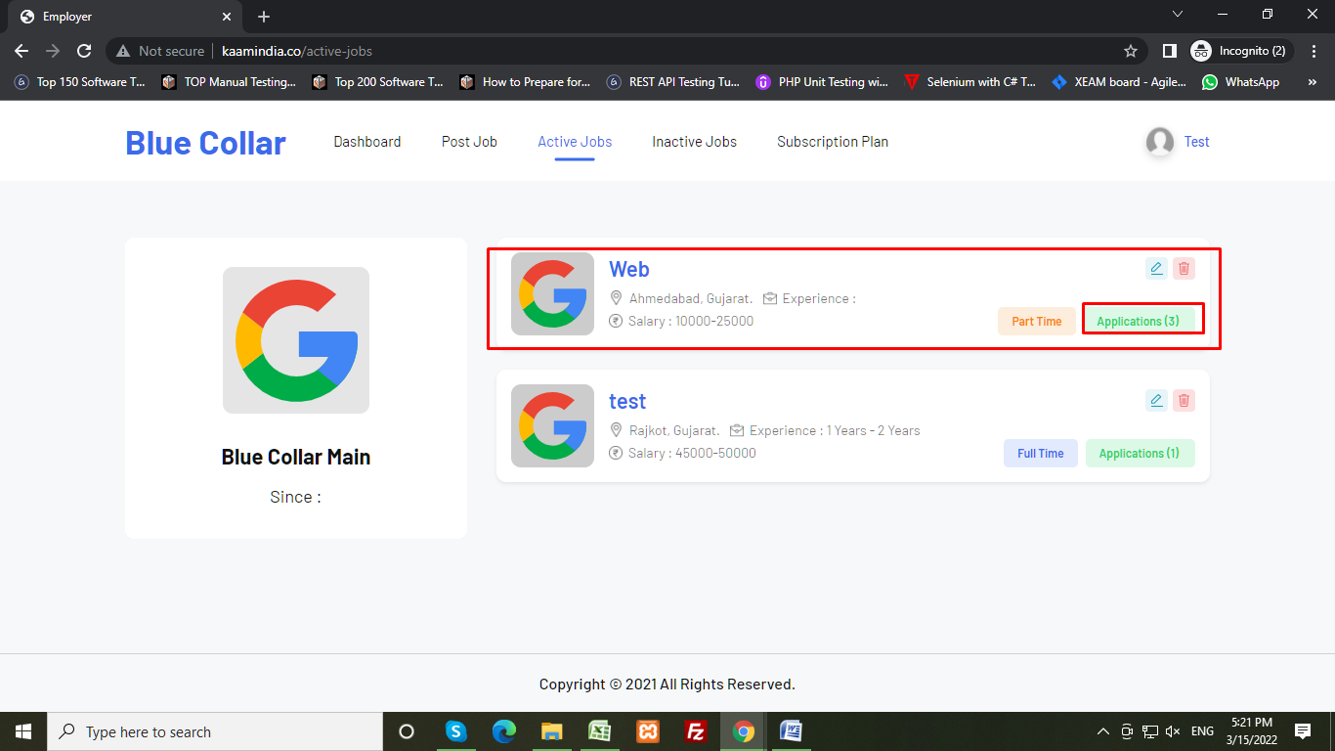

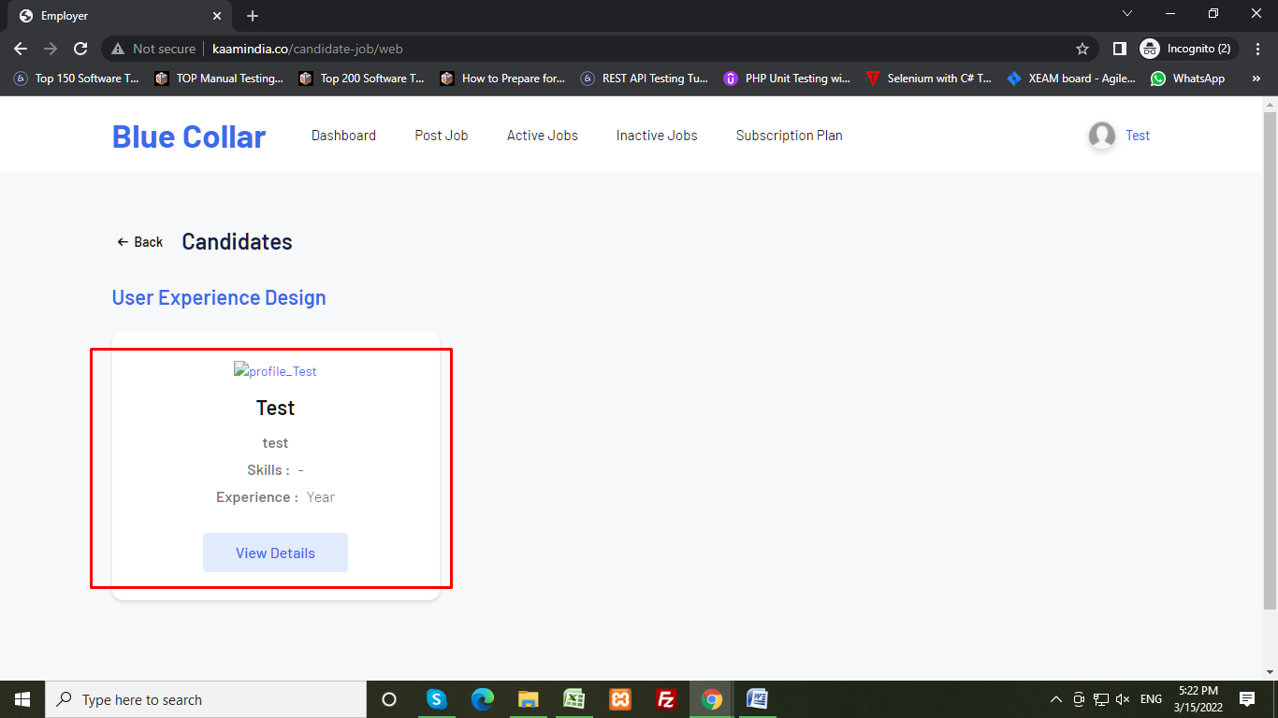

Designing issue in post job page. Experience section does not align properly. Both options display in the gender field.

Tester Comment: - issue not fixed, **both** options display in gender section yet. If the **Both** option for Gender field then Change the text **Both** to All.

**Developer Comment:** Issue Solved.

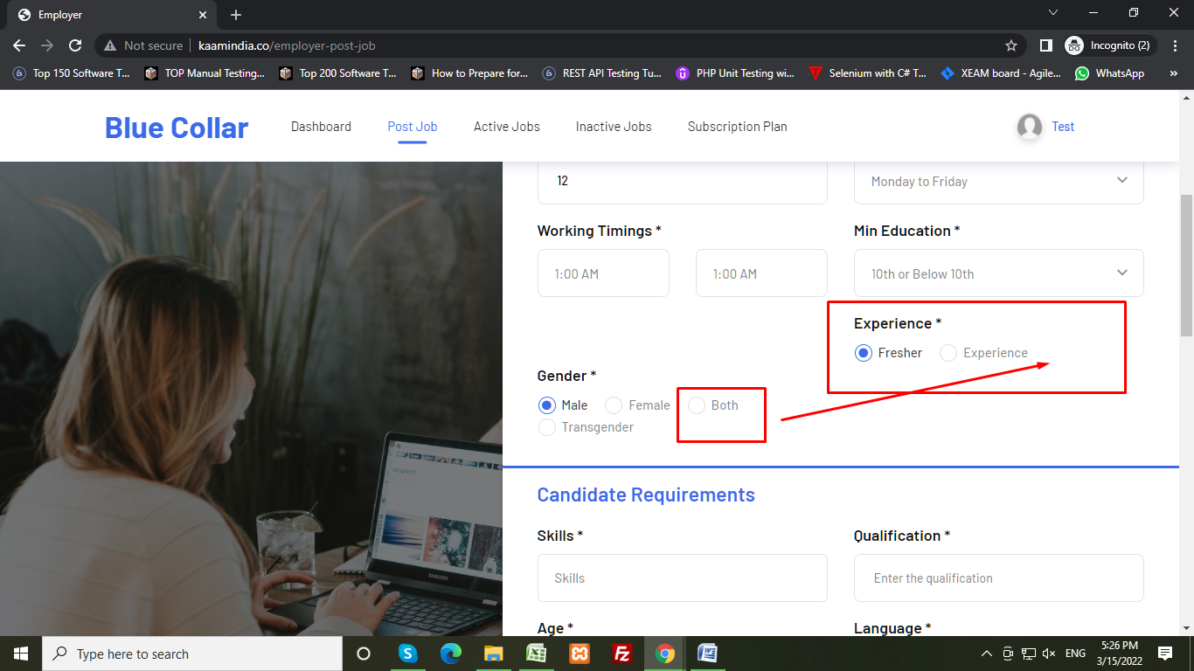

In the job post page when we select the personal info in job detail contact information then in the job detail page personal info will be displayed not contact person info. See attached screenshot for more details.

**Tester Comment:** - Not able to test this issue because the job detail page is not working.

**Developer Comment:** Issue Solved.

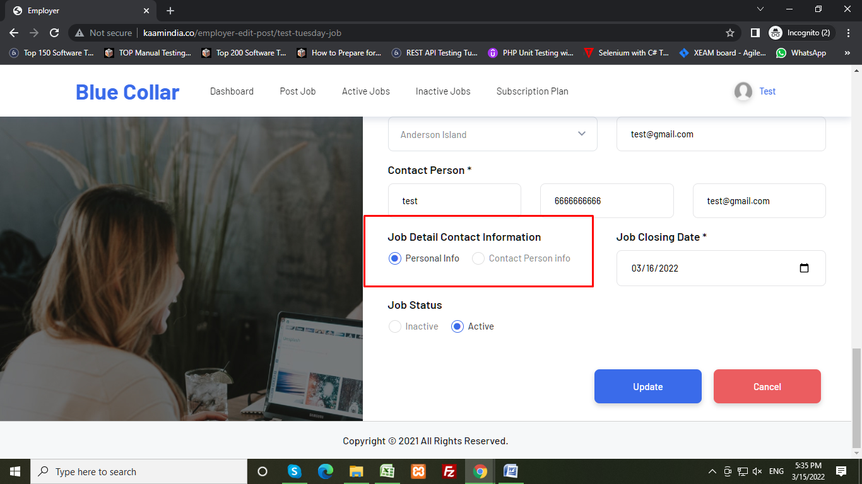

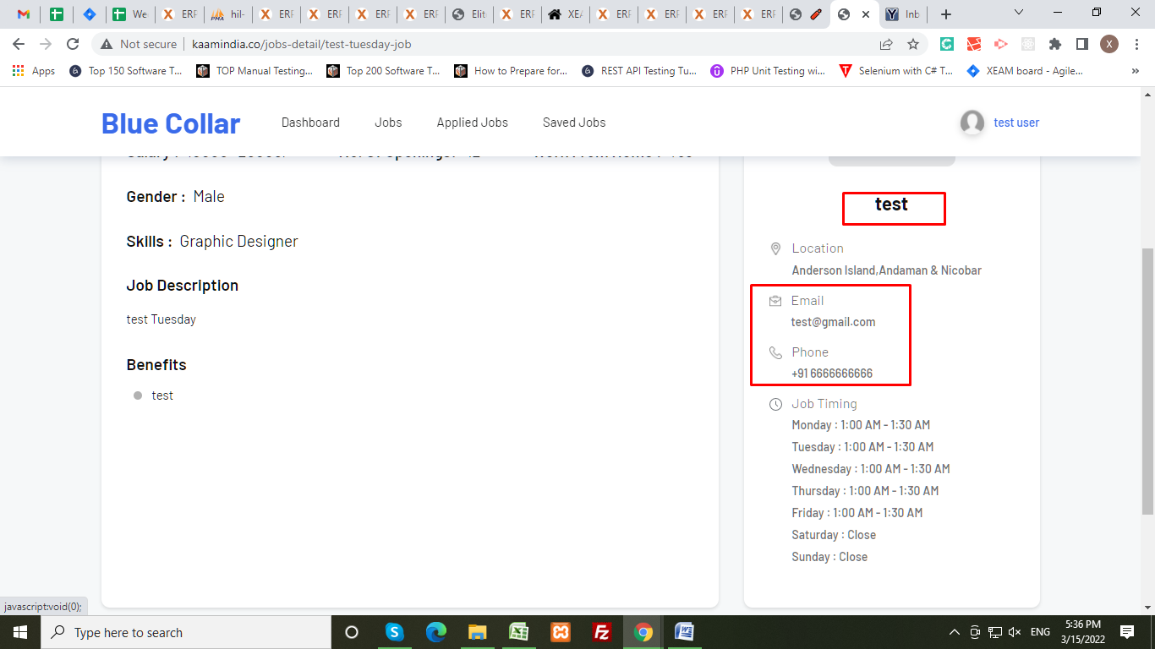

Newly applied jobseeker’s details not found in employer end. When we open applications for a job through an employer.

**Developer Comment:** I solved this issue under the “candidate-job” page. By shortening Desc.

**Tester Comment:**- Not able to test this issue because the job detail page is not working.

Not able to check download resume functionality.

**Developer Comment:** Issue Solved.

**Tester Comment:** - Not able to view the download resume option when we open the job applicant listing page or job applicant detail page.

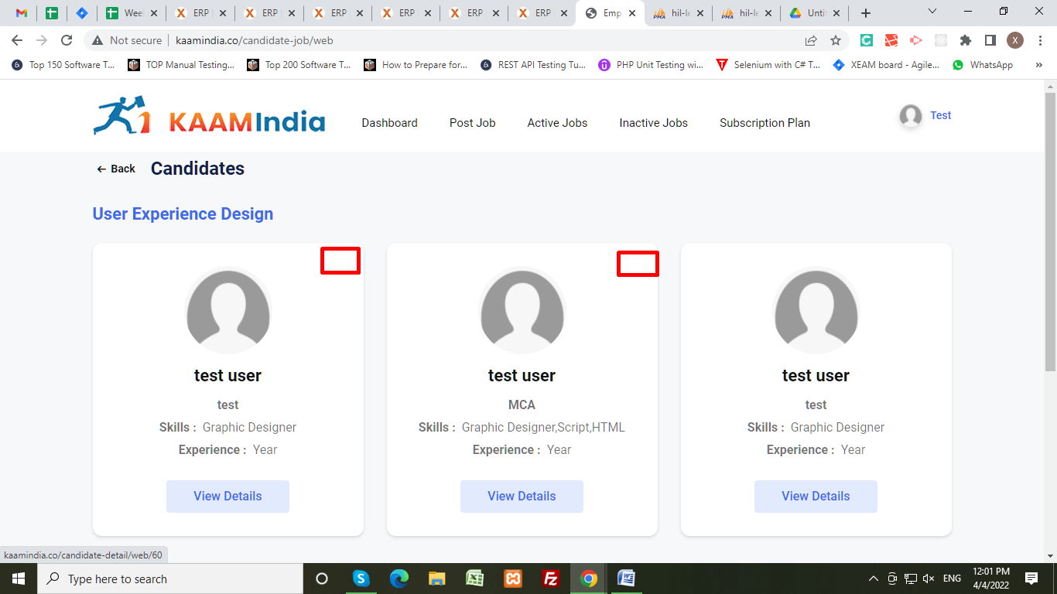

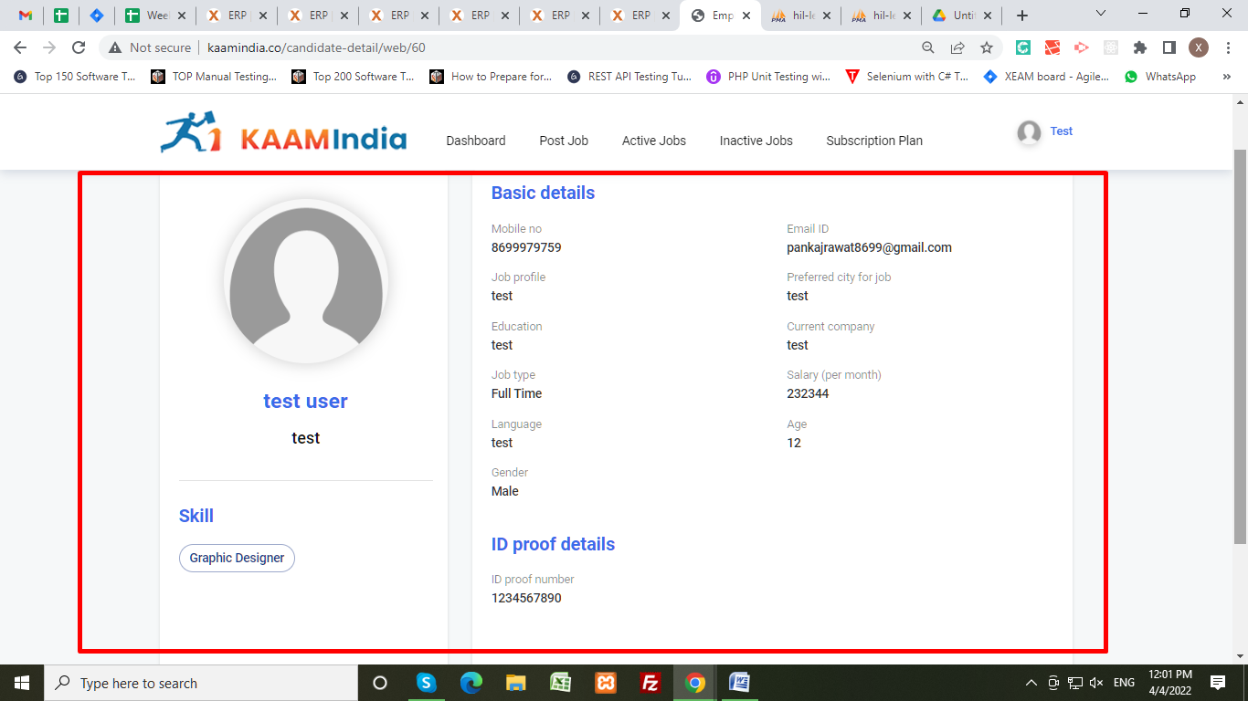

Since date not display in active and inactive jobs listing page.

**Developer Comment:** Issue Solved.

**Tester comment:**- I am talking about Since date not talking about job closing date. See attached screenshot. Since the date should be the Employer registrations date. Already discussed earlier.

