Index

Contents

Enabling chat log 2

Generating the bind files 4

Using the bind files 6

Badges detection 9

Trouble shooting 12

# Enabling chat log

First thing first.

For this to work, you need to enable chat log in game.

This is easily done by using this option:

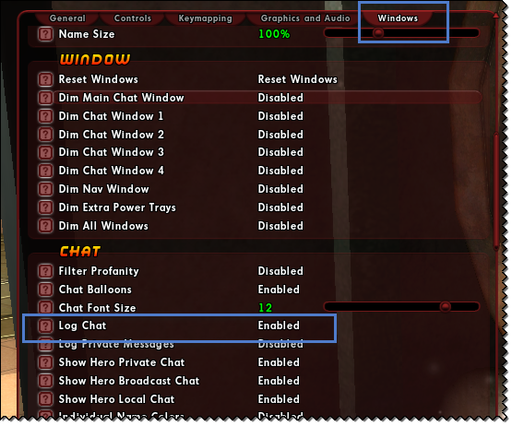

The whole thing works on monitoring the chat log file.

You have to enable it on each character, as it does not seem to be a global setting.

The first time you enable it on a character, you need to relog.

That extra step is to make sure the message below is registered in the log file:

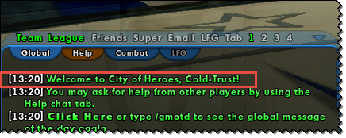

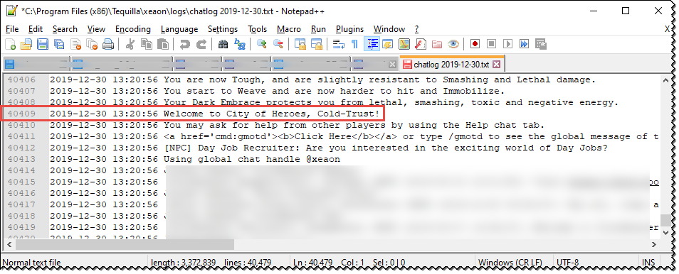

This is important for the log file processing.

It allows, to make sure it starts reading entries up to that line. And no other lines before that.

# Generating the bind files

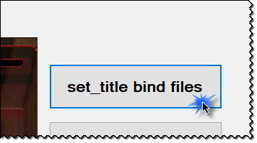

Start by selecting a folder where the bind files will reside:

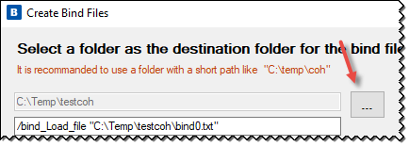

You need a folder with a short path.

For instance, “C:\temp\testcoh”

It is important you selected a short path, because this path is repeated in the file itself:

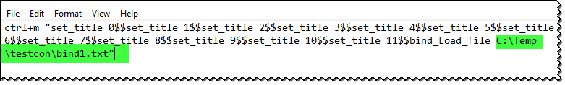

A long path might result in the next bind file not to be loaded.

Once the path has been selected, you can click on the “Generate bind files” button.

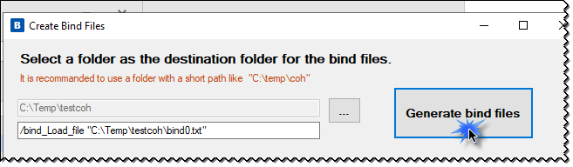

This will create 200 files on the specified folder.

Each file process 12 “set_titles”.

It would be easier to only have 1 file for all ~1500 ish badges, but this does not seem to be working.

The current version, work with 12 set titles a file over 200 files.

Which is 0 to 2400.

In a future version, we could refine the process and catalogue the ~1500 ish proper set titles.

Some are greater than 1600…

The current version is a proof of concept, therefore not perfect.

This will also create a command line for you, with the given path in it:

C:\Users\FROBER~1.000\AppData\Local\Temp\SNAGHTML389cfc0a.PNG

Select the text and copy it in to the clipboard (use CTRL+C or the context menu).

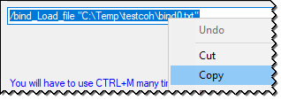

# Using the bind files

In game, copy the command line into the chat window, and press enter:

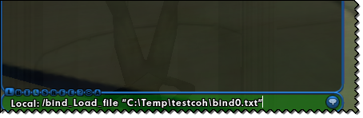

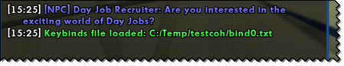

From there, use the CTRL+M bind to process all the 200 files.

Do this many time (200 ish times).

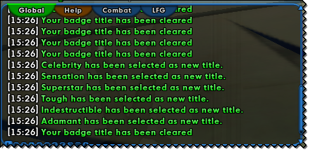

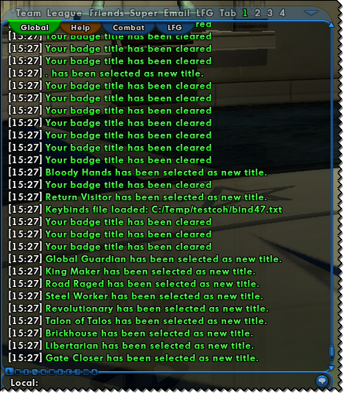

You can leave CTRL pressed and only press M, many times, in a few seconds.

Do this until you see this message:

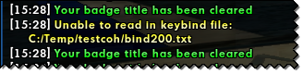

200 times is a lot, but if you press CTRL+M rapidly it takes less than a minute.

The objectives, is to have those entries:

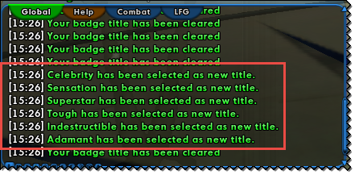

Inside the log file:

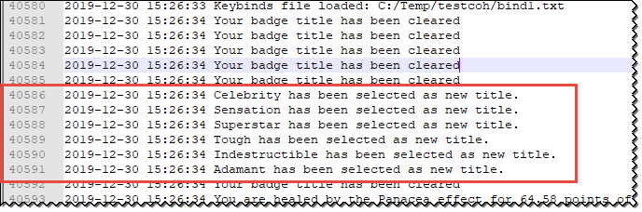

# Badges detection

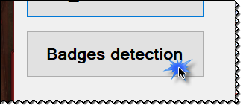

Start by selecting the path where CoH is installed:

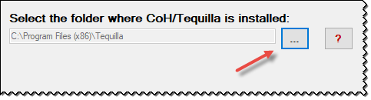

You can validate which folder to select, from the Tequila launcher:

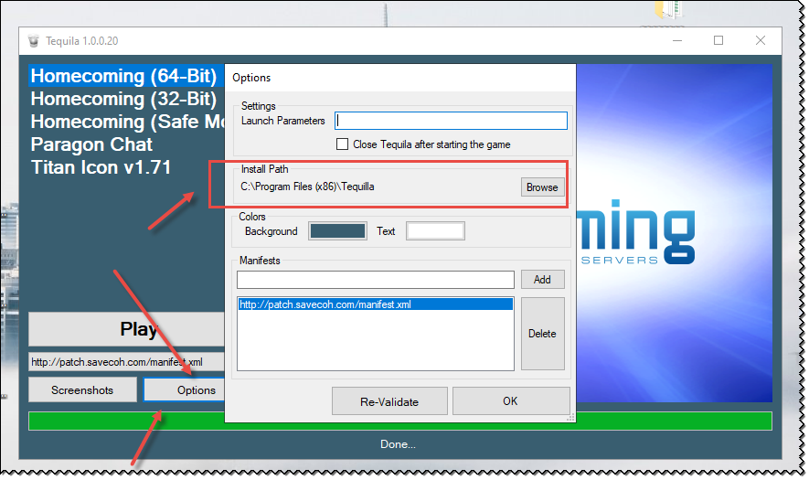

From there, select the account from the list and click on the “Scan log file…” button:

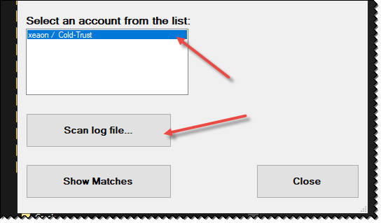

After this process the “Show Matches” screen is displayed:

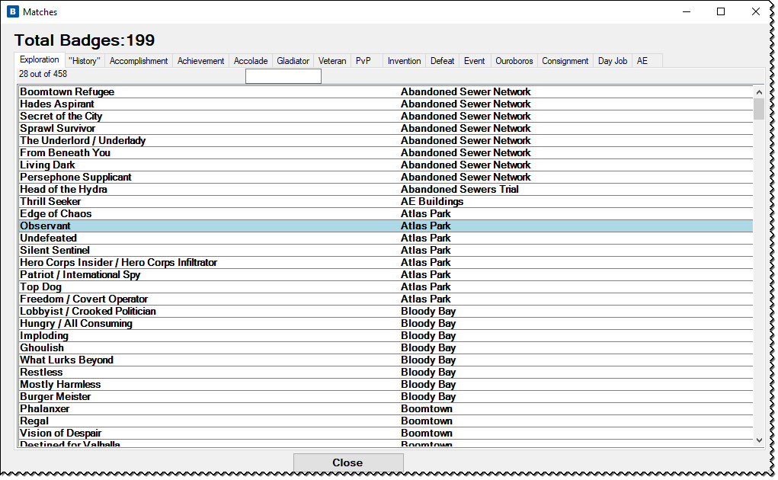

Found badges are highlighted in blue.

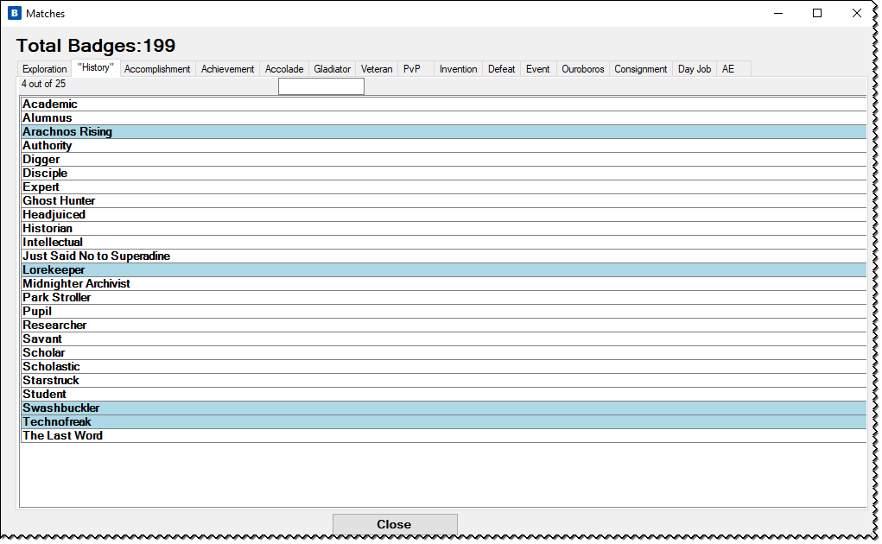

If everything works properly, you should have an exact match with the inn game count:

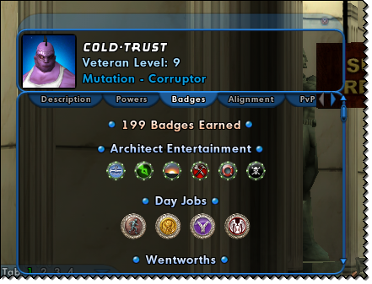

Also, this should be working with players that have more than one account:

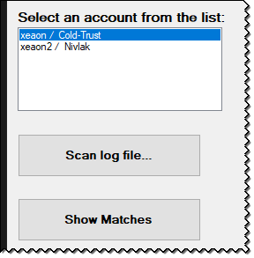

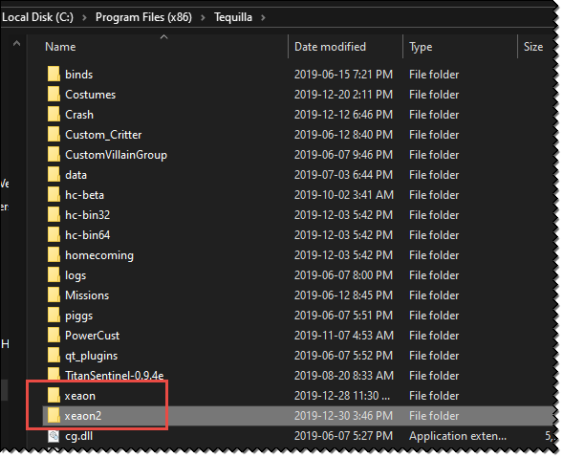

# Trouble shooting

It is possible there is some badge name in the RawDate files, that need tuning.

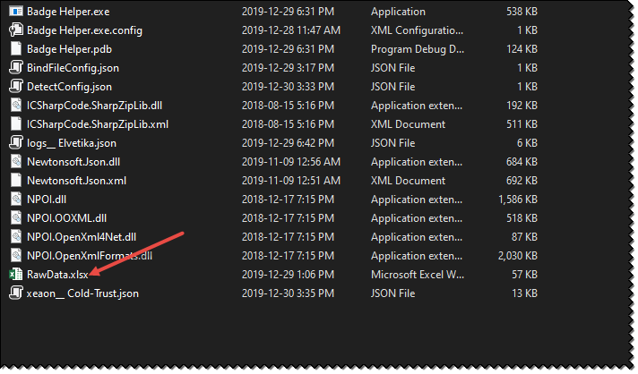

If it’s the case, try to locate which category there is a discrepancy.

From there do a run down from in game and search in the tool.

For instance, if the “Gladiator” category seems to be the culprit:

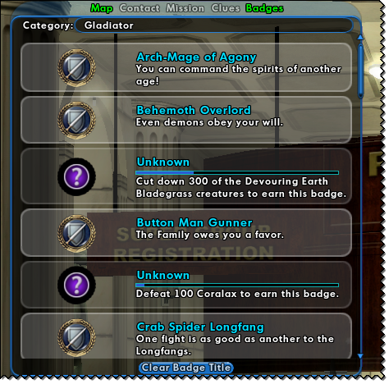

Search badge by badge, to see if in blue in the tool:

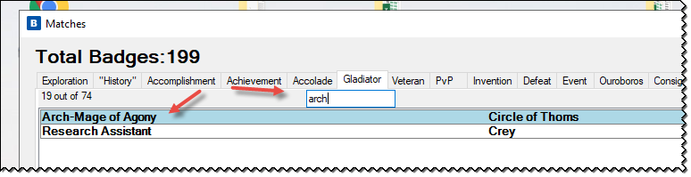

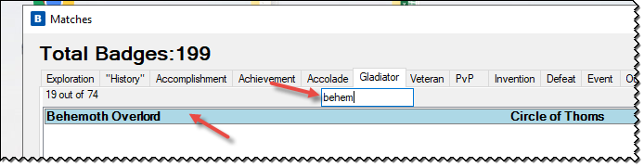

Hopefully, you don’t need to do this.