SOWgen.ai

UI Screenshots Documentation
Generated on: January 12, 2026

Introduction
This document provides a comprehensive visual overview of the SOWgen.ai application. SOWgen.ai is an enterprise-grade web application designed to streamline how Xebia creates, manages, and approves Statement of Work (SOW) documents for migration and training services. The platform combines intelligent automation with professional design to deliver an exceptional experience for both clients and internal staff.

Table of Contents
- 1. Login Page - Client View
- 2. Login Page - Xebia Team View
- 3. Services Dashboard
- 4. SOW Generation Method Selection
- 5. SOW Form - Basic Information
- 6. SOW Form - Migration Configuration
- 7. User Profile
- 8. Xebia Admin Dashboard

1. Login Page - Client View

The main login page for client users. Clients can enter their email address and organization name to access the platform and create SOWs. The page features a clean, modern design with the Xebia branding and highlights three key value propositions: Accelerate, Automate, and Scale.
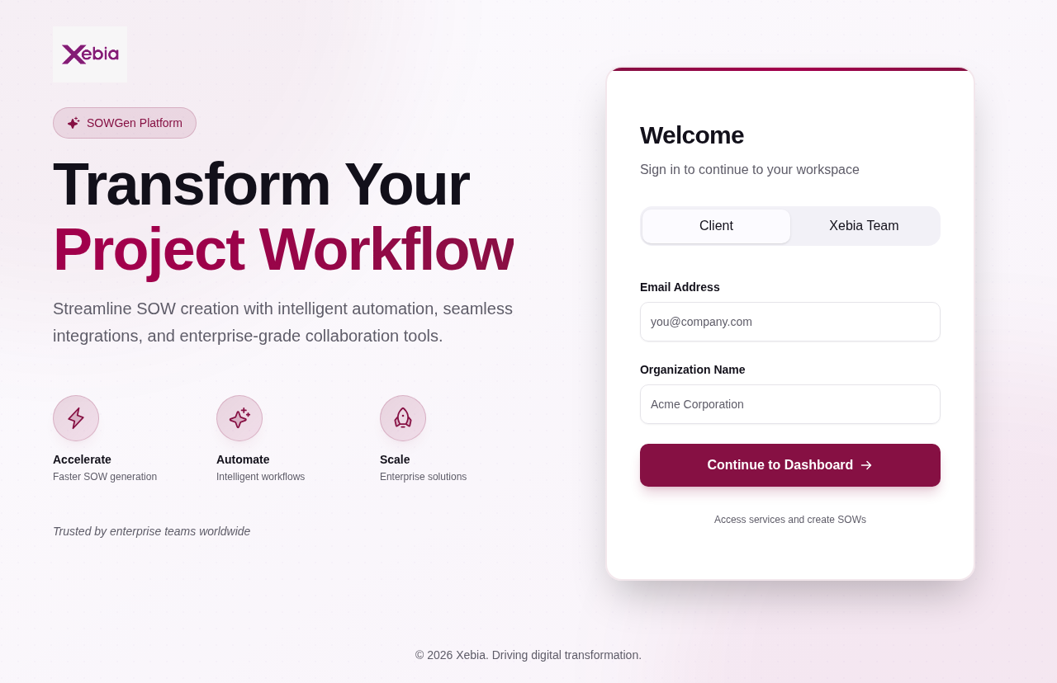

2. Login Page - Xebia Team View

The login page for Xebia team members (administrators and approvers). Xebia staff can sign in using their Xebia email address to access the admin dashboard and manage all SOWs across the platform.


3. Services Dashboard

The main dashboard clients see after logging in, displaying all available platform services. Users can select from various SCM platforms (GitHub, GitLab, Bitbucket, Azure DevOps, etc.) and cloud platforms (AWS, GCP, Azure, Terraform) to generate SOWs. The page includes a search bar and category filter for easy navigation, along with information about the benefits of automated platform integration.


4. SOW Generation Method Selection

After selecting a platform (e.g., GitHub), users choose between two SOW generation methods: Manual Entry or Automated Import (recommended). The page displays the migration path visualization showing the 7-stage journey from source to target platform, including Discovery & Analysis, Initial Setup, Repo Migration, CI/CD Migration, CI/CD Implementation, Team Training, and Support & Documentation. Integration details are provided at the bottom.
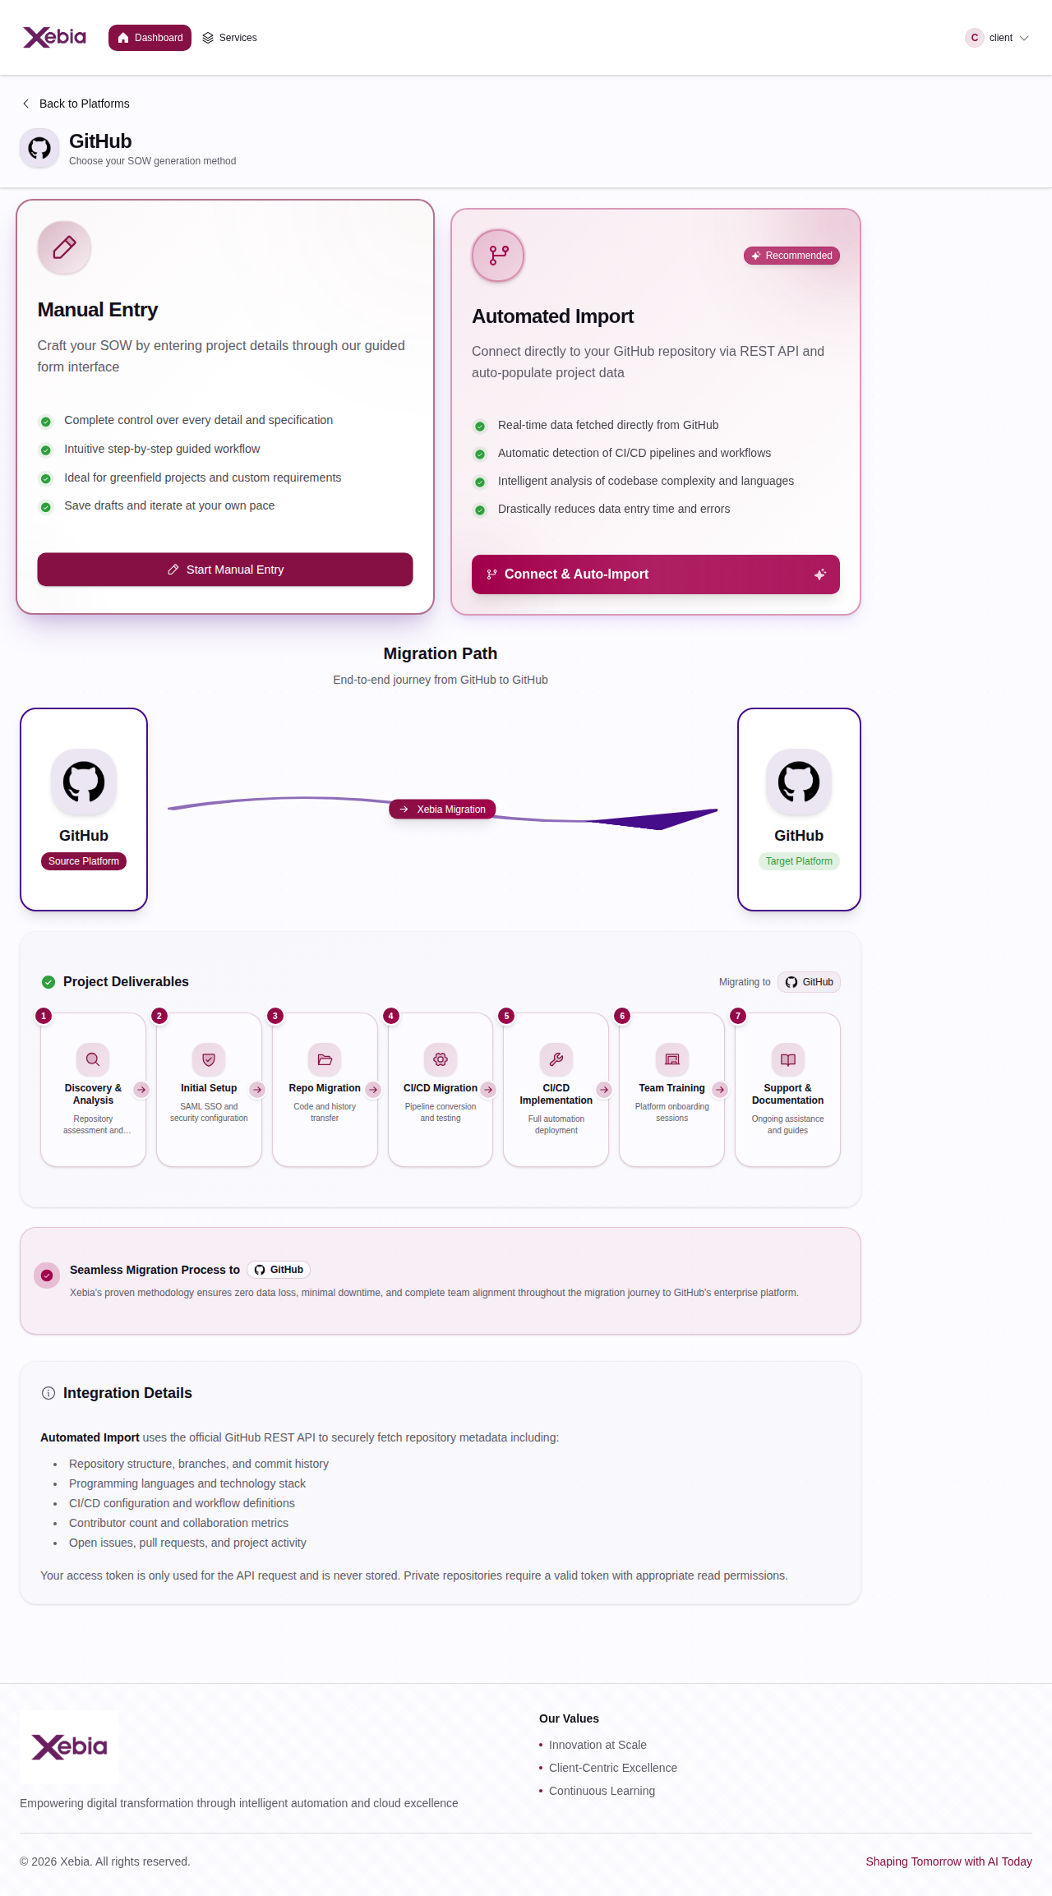

5. SOW Form - Basic Information

The SOW creation form where users enter basic project information including project name, description, and select which services are required (Migration Services and/or Training Services). The form features auto-save functionality and allows users to save drafts or submit for approval. This view shows the initial project configuration tab.
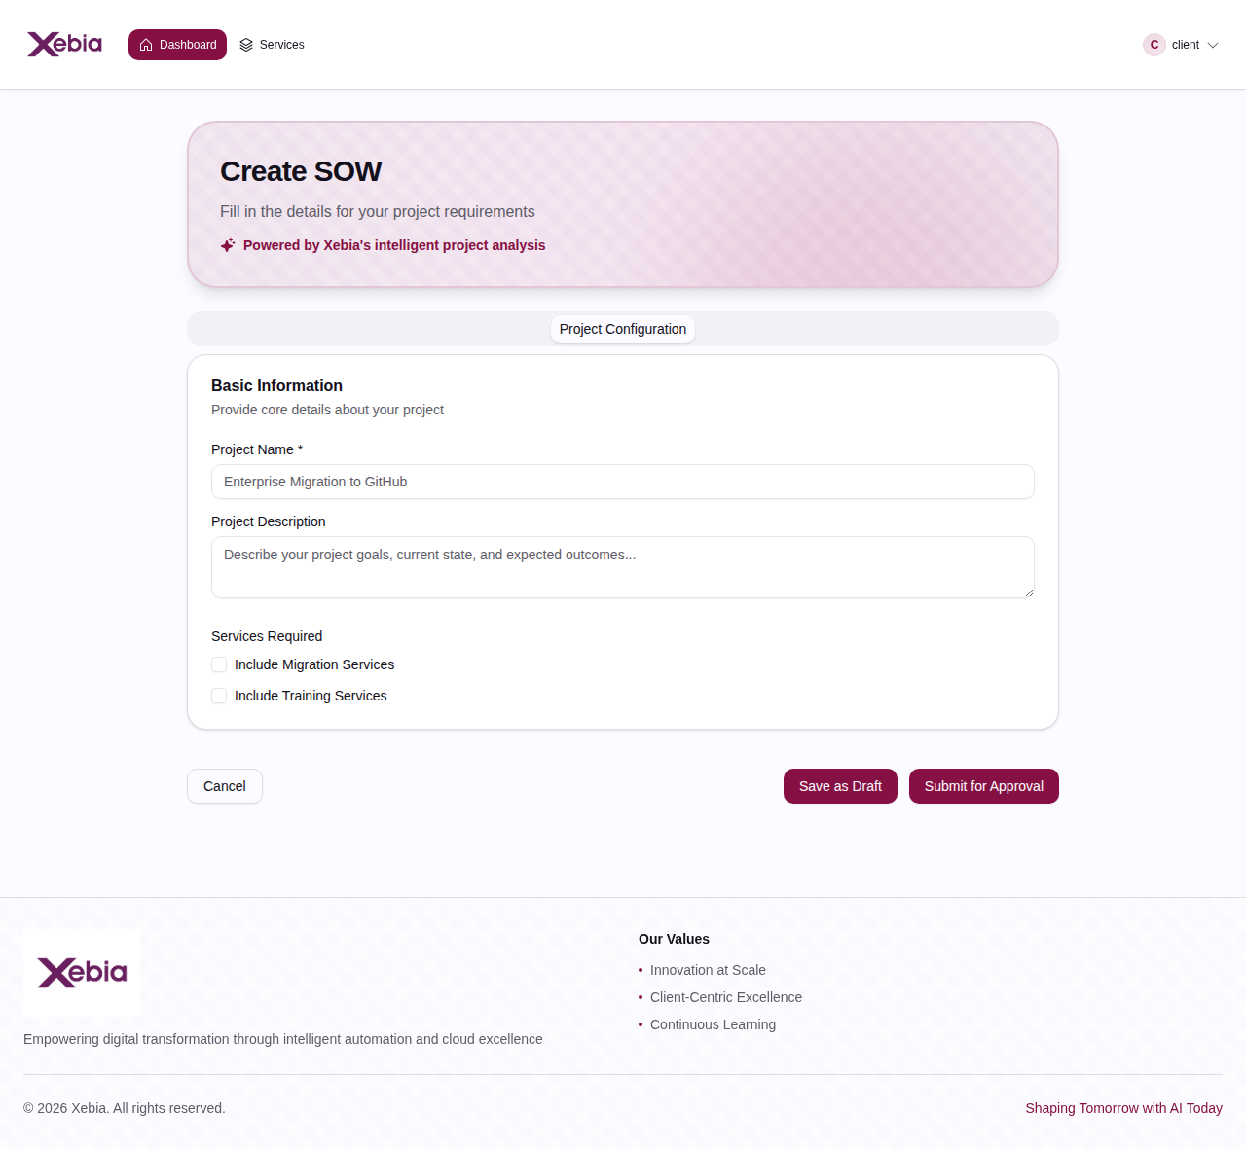

6. SOW Form - Migration Configuration

When Migration Services are selected, this section appears showing detailed migration configuration options. Users can select the GitHub migration type (Classic, EMU, or GHES), specify the number of users to migrate, and view the complete migration path diagram. The form includes repository inventory fields (total repositories, public/private counts, size metrics, programming languages) and an option to include CI/CD migration. The interactive migration path shows all 7 stages of the migration process with visual indicators.
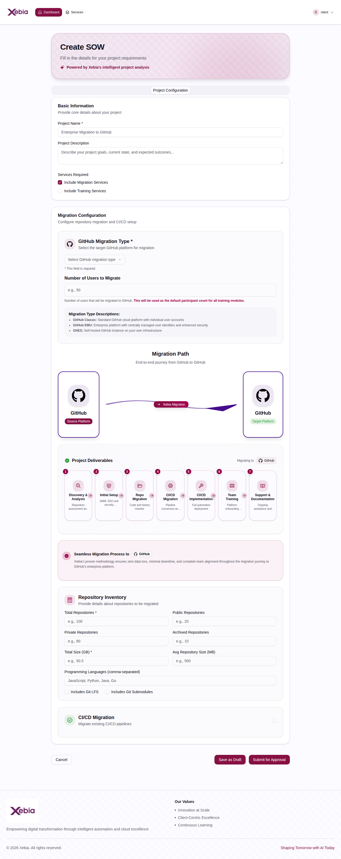

7. User Profile

The user profile modal displays personal information including name, email, organization, user ID, and account type. Users can view their profile information and access the edit profile functionality. The profile shows an avatar with user initials and provides a clean interface for managing account details.
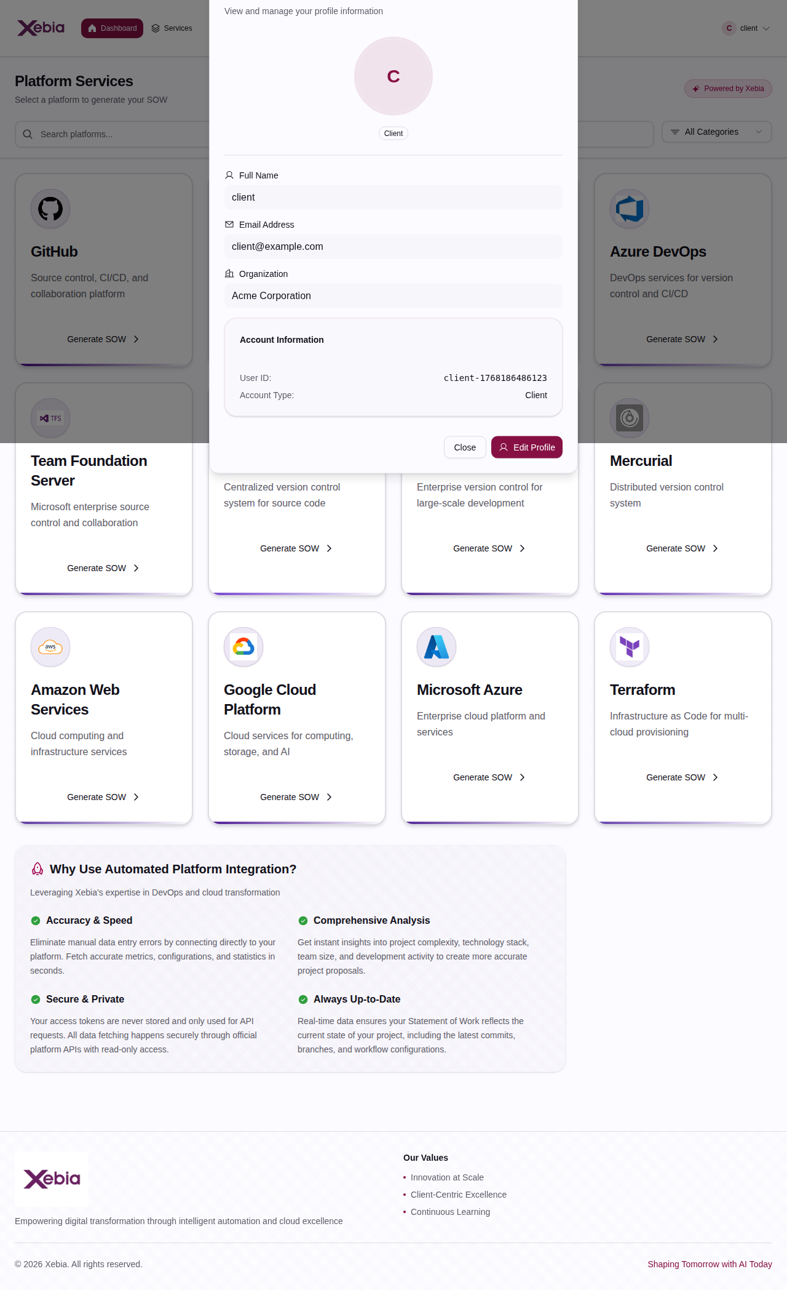

8. Xebia Admin Dashboard

The comprehensive analytics dashboard for Xebia administrators, displaying key metrics including Total SOWs, Approved SOWs, Pending Reviews, and Average Approval Time. The dashboard features interactive charts showing SOW Status Distribution, Monthly SOW Creation trends, SOWs by Client, and a Recent Changes widget. This provides Xebia staff with data-driven insights to monitor and optimize the SOW pipeline.
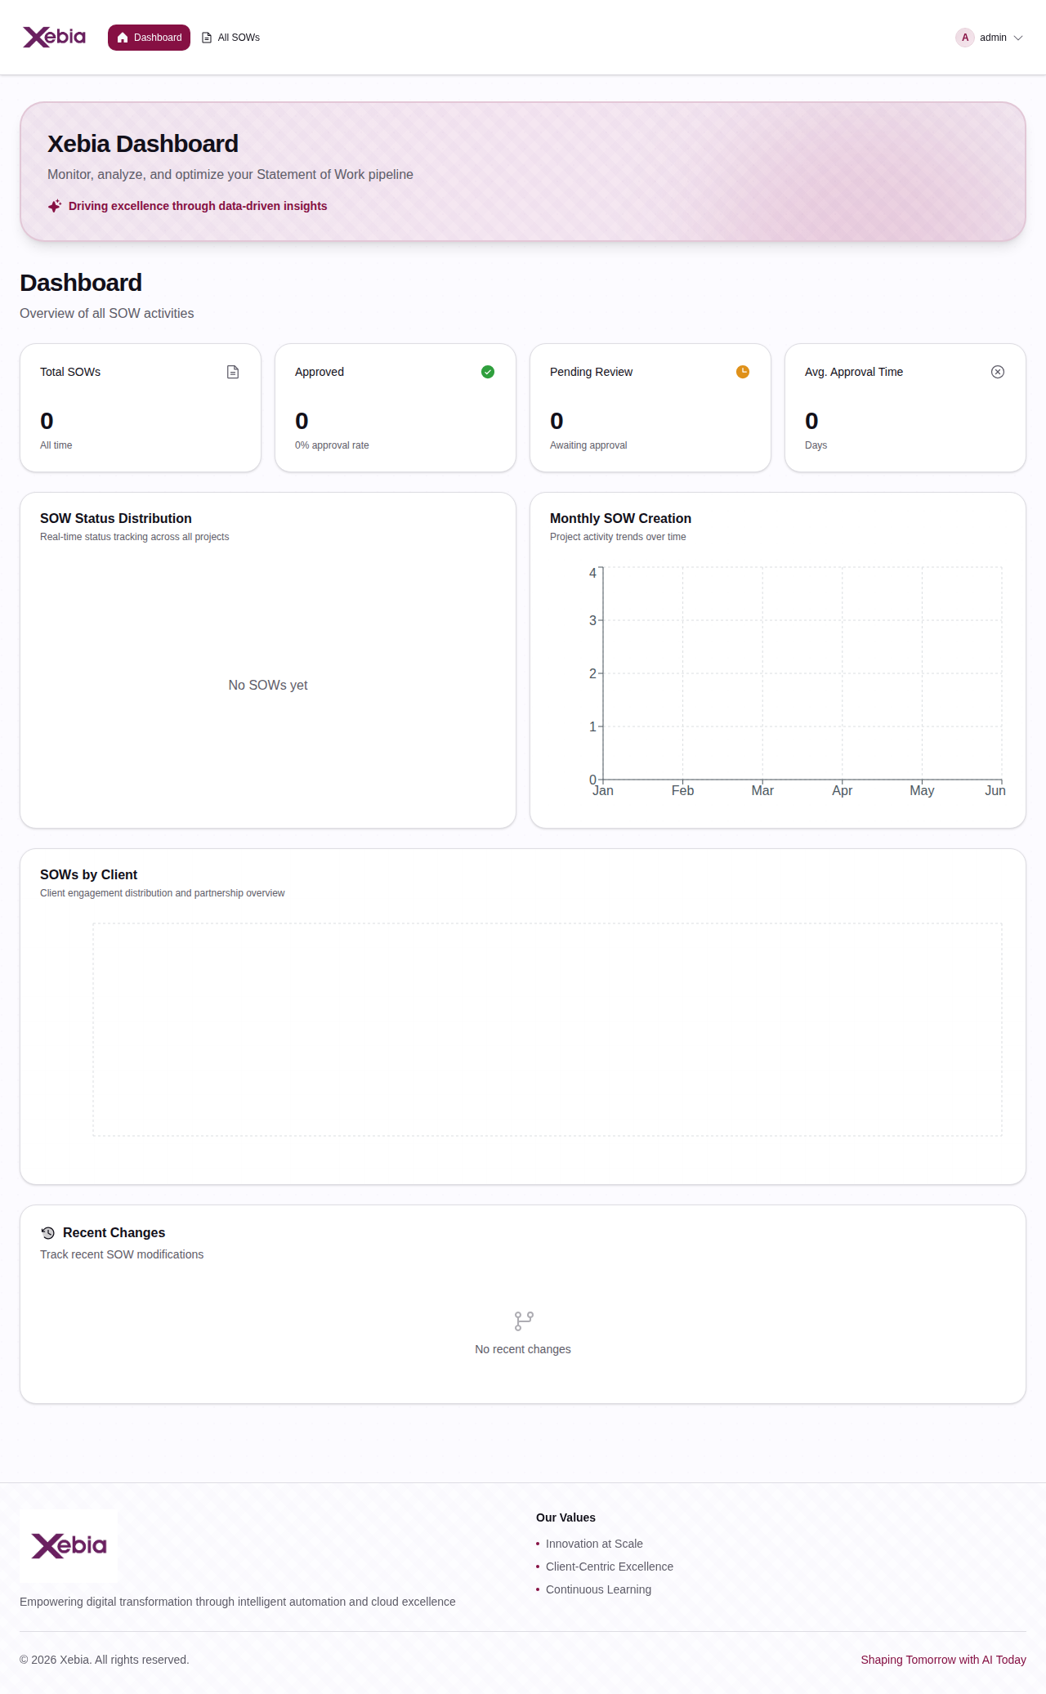

Conclusion
This documentation provides a complete visual overview of the SOWgen.ai application, showcasing its intuitive user interface, comprehensive features, and professional design. The platform successfully combines intelligent automation with enterprise-grade functionality to streamline the SOW creation and management process for both clients and Xebia staff.

For more information, visit: https://github.com/xebia/SOWgen.ai

