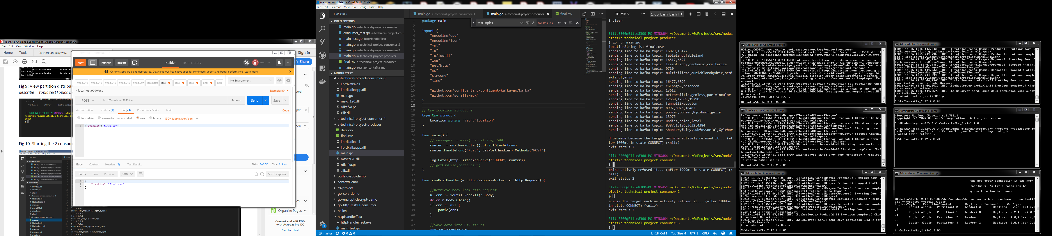

Fig 1: Producer main.go file showing the POST endpoint that gives the CSV file location

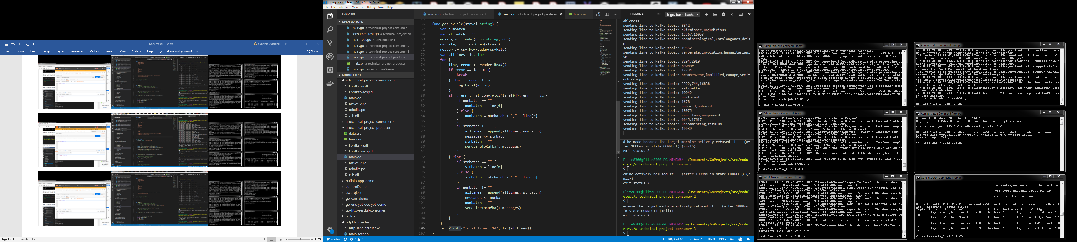

Fig 2: getCsvFile() method that gets the file, parses it and batches up integers and strings before sending it to Kafka topic

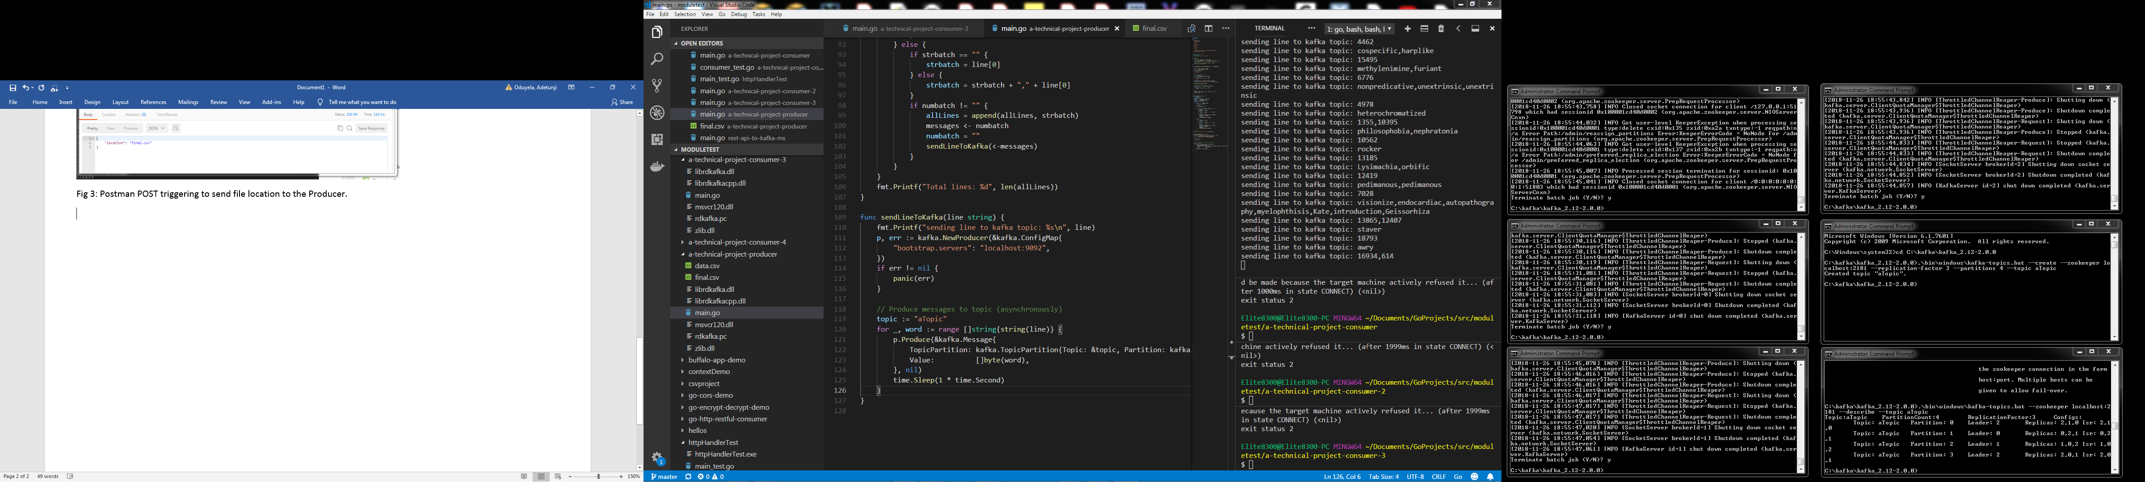

Fig 3: sendLineToKafka() method that sends batched values to Kafka topic. Note that the values sent are unsorted batched up integer values or string values.



Fig 4: Postman POST triggering to send file location to the Producer.

