Nodes Discovery

P2P Network : It is a distributed network architecture composed of participants that interact directly with network participants without the need of centralized coordination instances

There are several methods to locate other clients. The primary method is a list of nodes from a previous connection to the network. This works very well for everything but your first connection or a connection after a very long period of disconnection.

IRC Addresses Discovery

Internet Relay Chat (IRC) is an application layer protocol that facilitates communication in the form of text. The chat process works on a client/server networking model.

Bitcoin clients (version < 0.6.x) used to use IRC Bootstrapping to discover other clients by default. In addition to learning and sharing its own address, the node learned about other node addresses via specific IRC channels
After learning its own address, a node encoded its own address into a string to be used as a nickname. Then, it randomly joined an IRC channel named between #bitcoin00 and #bitcoin99. Then it issued a WHO command. The thread read the lines as they appeared in the channel and decoded the IP addresses of other nodes in the channel. It did this in a loop, forever, until the node was shutdown.
Protocol code :
https://github.com/bitcoin/bitcoin/blob/847593228de8634bf6ef5933a474c7e63be59146/src/irc.cpp

DNS Seed

DNS Seeds are used to identify a set of nodes to connect to wen starting. Once connected, the nodes exchange addresses of other nodes they are connected to in order to. The seeds are run by volunteers using a multitude of mechanisms to ensure the returned seeds represent a good sample of nodes currently online. The seeds aim to return nodes that are currently online and reachable.

Our recommendation

for security and trust reasons, we recommend the second method of DNS seed because:
-The list of ip addresses provided by the DNS server is assured and verified
-We can not verify the authenticity of IP addresses retrieved from IRC channels

How does DNS seed work?

1. The client will call DNS Seed to have a list of IP addresses of his closest nodes
2. Connecting to a discovered peer is done by sending a “version ” message containing the client’s protocol information. Then both nodes send “ verack ” to indicate the connection has been established.
3. The client can send “getaddr” message to gather additional ip addresses
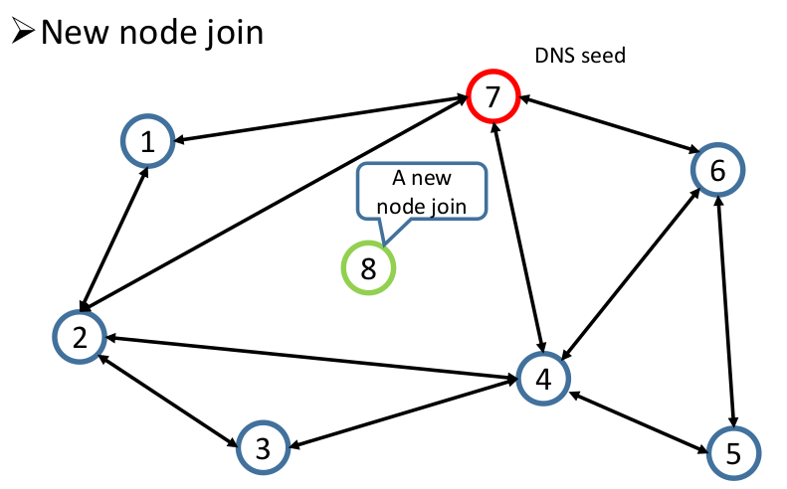

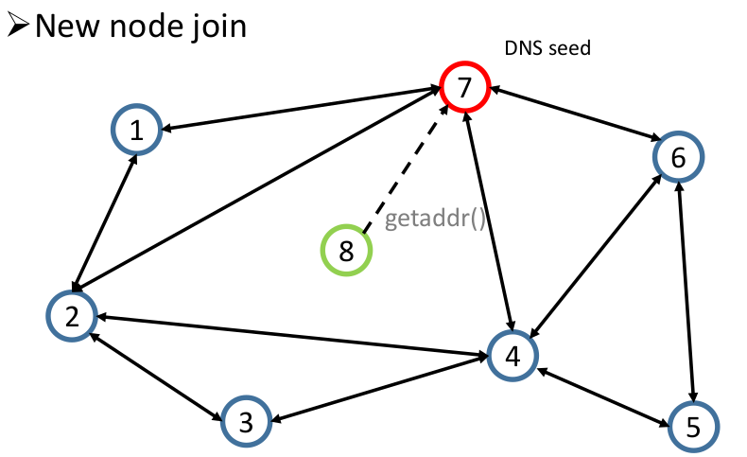

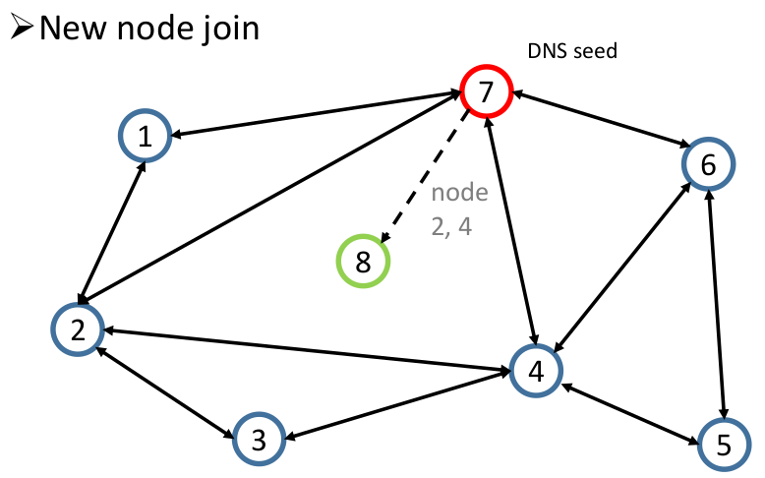

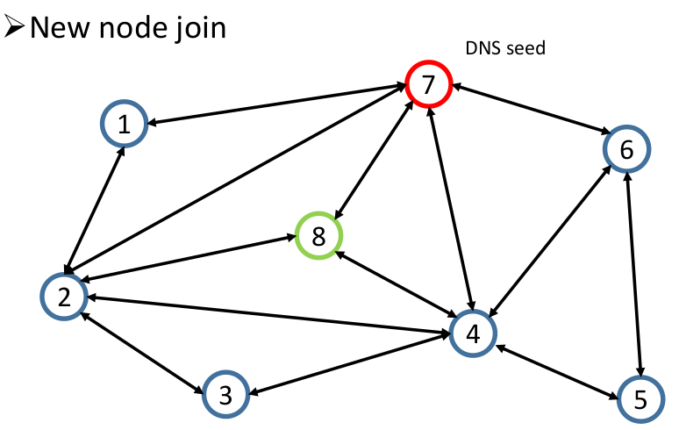

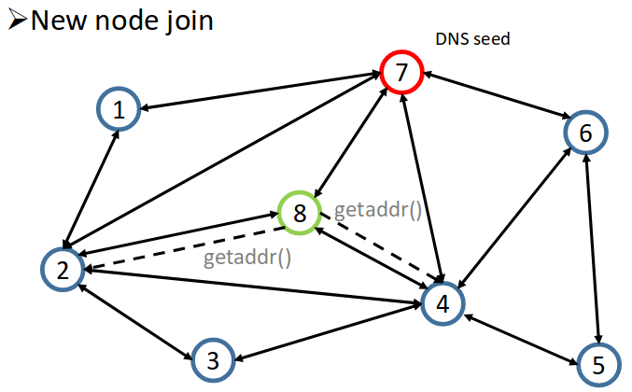

- DNS Seeds
- Servers returning know nodes
- Hard-coded in the Bitcoin client
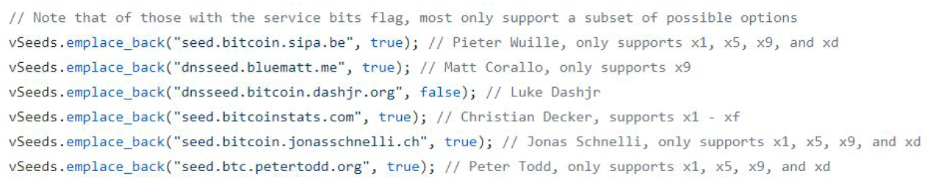
- Specify IP Of known node
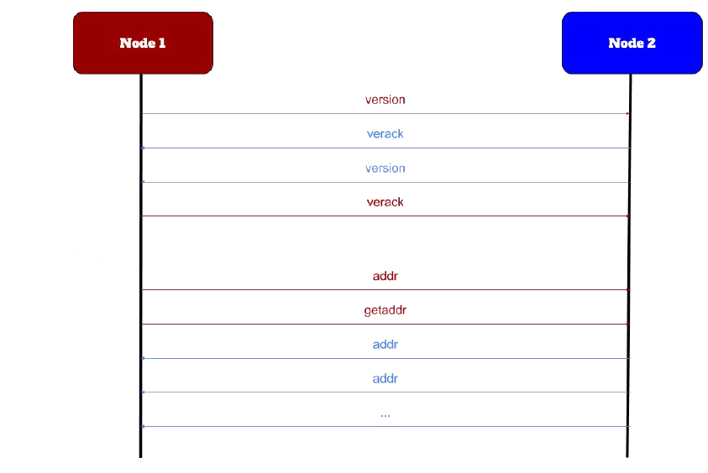
Les différents messages échangées et leur signification :
version- Information about version and block count. Exchanged when first connection.
verack- Sent in response to a version message to acknowledge that we are willing to connect.
addr- List of one or more IP addresses and ports
inv- “I have these blocks/transactions:…” Normally sent only when a new block or transaction is being relayed. This is only a list not the actual data.
Getdata- Request a single block or transaction by hash.
Getblocks- Request an inv of all bloks in a range.
Getheaders- Request a headers message containing all block headers in a.
Tx- Send a transaction. This is sent only in response to a getdata request.
block- Send a block. This is sent only in response to a getdata request.
Headers send up to 2000 block headers. Non-generators can download the headers of blocks instead of entire blocks.
Getaddr- Request an addr message containing a bunch of known-active peers (fo bootstrapping)
Submitorder, checkorder, and reply- Used when performing an IP transaction.
Alert- Send a network alert.
Ping- Does nothing. Used to check that the connection is still online. A TCP error will occur if the connection has died.

In order to maintain a connection with a peer, nodes by default will send a message to peers before 30 minutes of inactivity. If 90 minutes pass without a message being received by a peer, the client will assume that connection has closed.

