Correction#1: USER INTERFACE
We need to have a catchy User Interface of our website when the user first opens our website. You need to replace the above interface with something like reference interface shown in the picture below
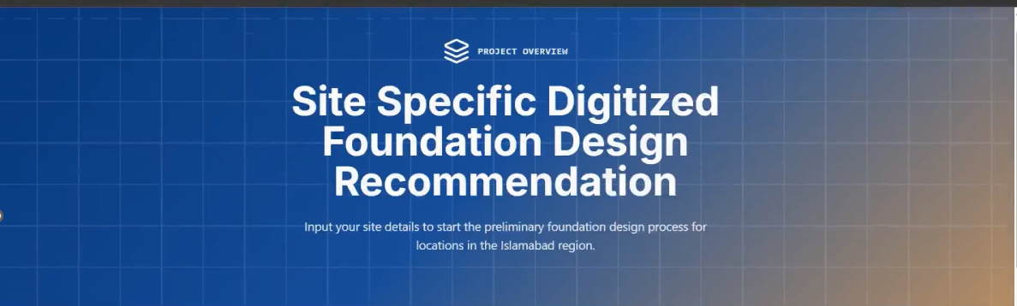
We need the logo of GeoFound (attached below) alongwith the tagline (Precision benath the surface), as well as the enlarged topic which is “ Site Specific Foundation Design Recommendations and Prefeasibility Assessment”.

Correction#2: When the user chose Foundation Design tab on the website, this Terzaghi Bearing capacity Theory and it’s points should not be shown to the user. So hide this thing from the interface dashboard.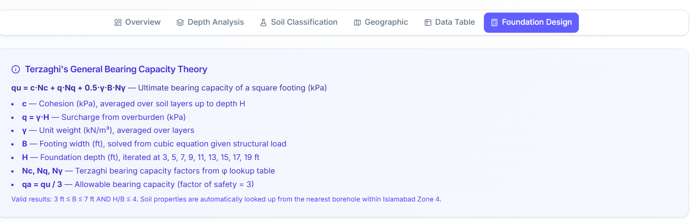
Correction#3: When the user selects the foundation design tab, then our system should ask the user to select the location on map as below by giving a pop up to user.
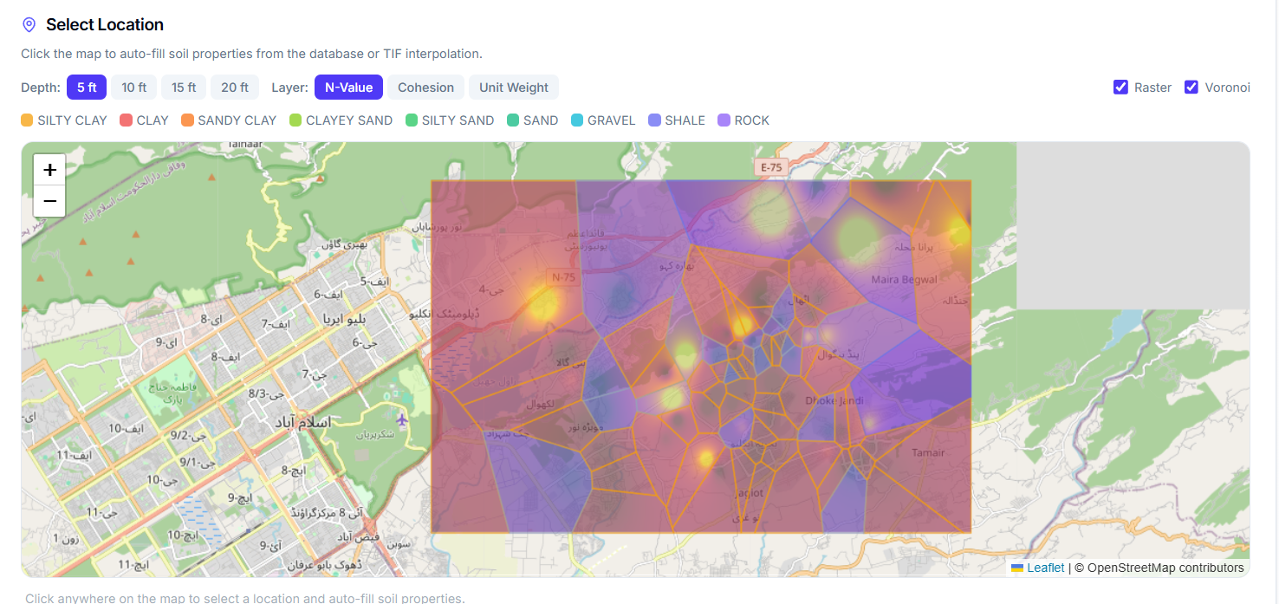

Correction#4: When user selects the location, our system should identify whether the input by the user falls within our database/ interpolated region. If Yes, then ask the user to input structural load only and then the Foundation Inputs table would appear as it is as already being done.
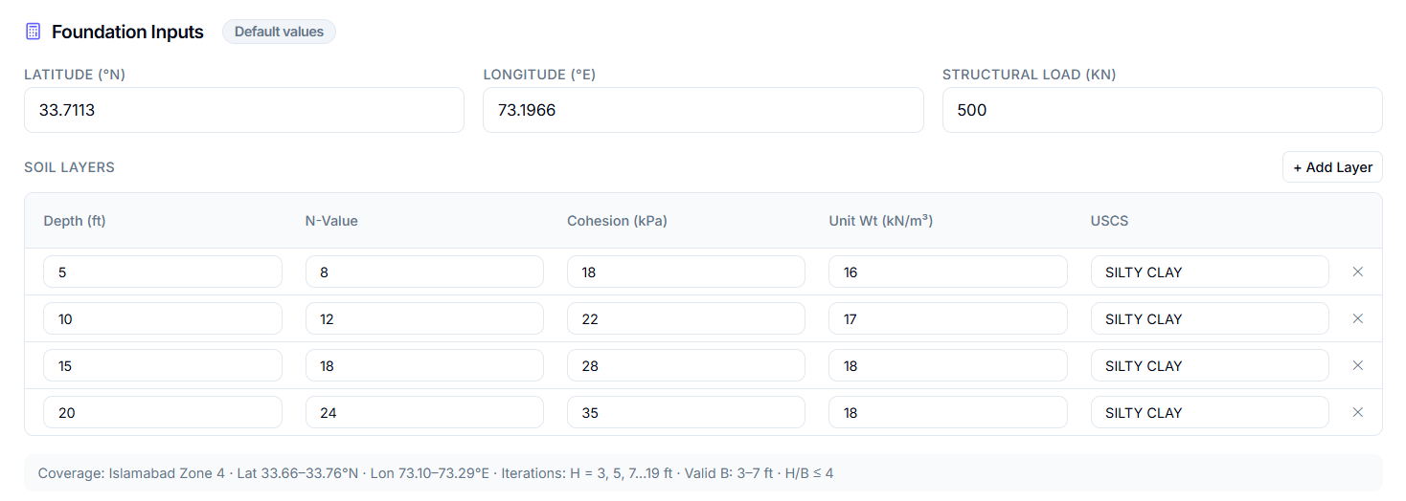
If the input location doesn’t fall within our interpolated region, then the foundation input table should not have any values because we don’t have values in our system. It should be empty. Then it should ask the user in a form of pop up to direct the user to input all the values manually.
While directing the user to input all the details manually in the foundation inputs table we want our system to give a note to user that the all the values of unit weight beneath the water table should be submerged unit weight while the values of unit weight above the water table would-be dry unit weight. Note that the the heading remains as it is which is “Unit Weight (kN/m3) in foundation inputs table. As it is just to guide the user to input the values correctly.
Once user inputs all the values of the foundation inputs table, then our system should demand the structural load as well as the groundwater table depth in ft from the top from the user. This ground water table would have no influence on any calculations. This is just for the output purposes.
In our database, there was no ground water table encountered. So when displaying the foundation inputs table , show that no water table was encountered. For location outside our database, obviously user would enter the water table , so display that water table in foundation inputs table.
Correction#5: In foundation inputs table, you are not displaying the the column of friction angle, Display that column as well. In our interpolated region, as you know that the frction angle is zero, so include that column showing friction angle to be zero However if user inputs the details manually then it may have the value of friction angle as well. So take the input of friction angle from the user in that table as well.
Addition of Weighted Friction Angle Concept:
When the user inputs the details manually (User#2) , then the friction angle to be used for bearing capacity factors from the tables would be the weighted average value of friction angle (avg) which would be calculated exactly with the same logic as c_{avg} & _{avg}.

Addition of General Bearing Capacity Equation for Foundation Design Calculation:
After performing Terzaghi Bearing capacity calculations and providing the iteration results of Terzaghi bearing capacity equations,
Display the same output using General Bearing capacity Equation just like Terzaghi Bearing Capacity calculations. Only the formula for the ultimate bearing capacity is changed.
The formula for General Bearing capacity Equation is as follows
Where
, and are bearing factors which will be taken from table against friction angle value . Note that these tables are different from Terzaghi tables.
where
are inclination factors
are depth factors
are shape factors
And is ultimate bearing capacity.
Everything is same as we have done for Terzaghi earlier just the formula of qu (ultimate bearing capacity is different) is different else every thing is same.
To calculate B that is width of foundation we wil do same as we did for Terzaghi just this time equation is changed plus do use the same factor of safety 3 as used earlier
Shape factors
- = 1+ ($\frac{B}{L})$ ($\frac{}{})$
- = 1+ ($\frac{B}{L})$tan
- = 1 – 0.4 ($\frac{B}{L})$
Depth factors
For $\frac{H}{B}$1 and for = 0
- = 1 + 0.4 $\frac{H}{B}$
- = 1
- =1
For $\frac{H}{B}$1 and for > 0
- = 1+ 2tan${(1-sin)}^{2}\frac{H}{B}$
- = - $\frac{1-}{tan}$
- =1
For $\frac{H}{B}$>1 and for any value of
- = 1 + 0.4 ( $\frac{H}{B})$
- = 1+ 2tan${(1-sin)}^{2}( \frac{H}{B})$
- =1
Note that ( $\frac{H}{B})$ is in radians.

Inclination factors
In our case will be zero because it is angle of inclination of load but we are not dealing with inclined loads

1 Last Addition:
Now the last addition is that after all these calculations of Terzaghi & General Bearing Capacity Equations,
Give a prompt to the user to Generate Geotechnical Report. We need a separate heading/option of that after the iteration results table.
Once the user clicks that BUTTON, a PDF report should be shown to the user.

