Lab number: 1
Lab Title : Introduction

Abstract:
This lab was the introduction to the practical activities, that concern the previous lectures, about the network topologies, protocols and data transmition. This lab is also the first experience working with the Network simulator, NAM and the TCL scripting language.

Aim objectives and goal:
The goal of this lab is to create a simple wired network between 4 nodes, with a specific topology. It is required to set up a connnection oriented and a connectionless type of protocols. The protocols chosen were TCP and CBR connections that will send data from node 3 to node 4.

Observation/ Results and Discussion:
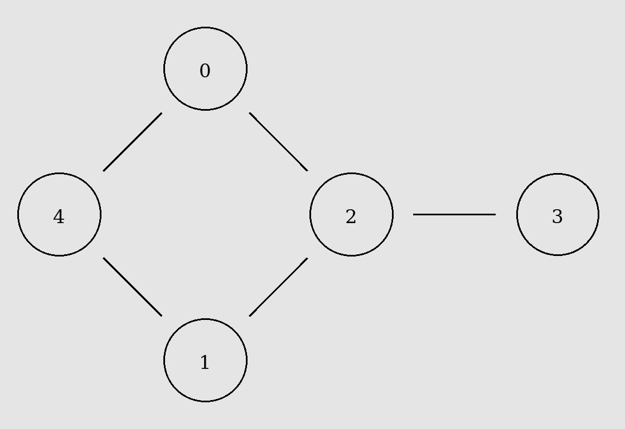
This exercise was very important to visualise how conection-oriented and connectionless protocols differ from each other.
The TCP protocol show to have high overhead due to starting and ending handshaking but mostly due to lost packets that need to be retransmitted. The data was sent less regularly as well since the packet need to be sent in order.
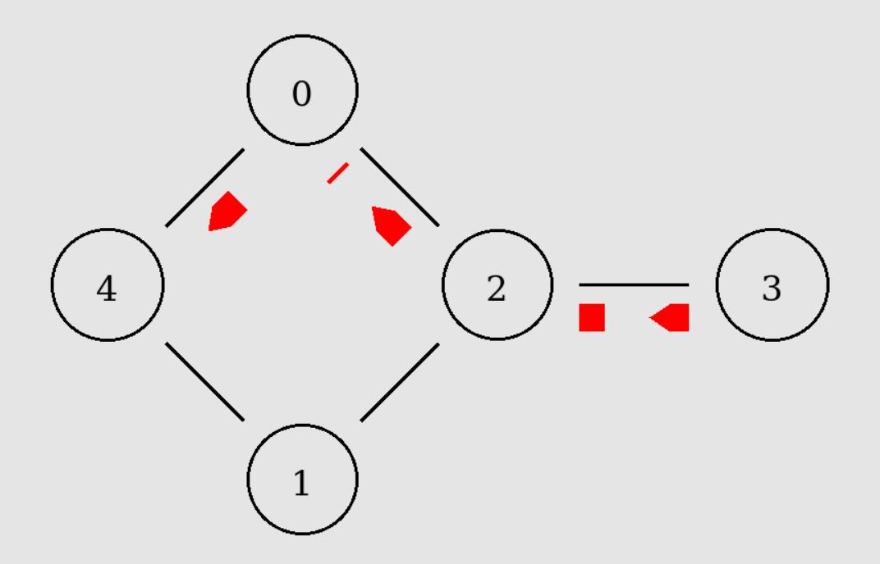
The CBR type of connection had no overhead as packets were sent regularly without any handshaking or re-transmission requests even when packets were dropped. The data was sent disregarding its order. For these reasons it was clear that CBR transferred more data even compared with a reliable protocol such as TCP.
The Link between node 3 and node 2 was always congested especially when both TCP and BCR packets were being transferred. This caused a considerable loss of packets when node 2 was transmitting the packets. This could be prevented if the length of the trasnmission queue was increased.
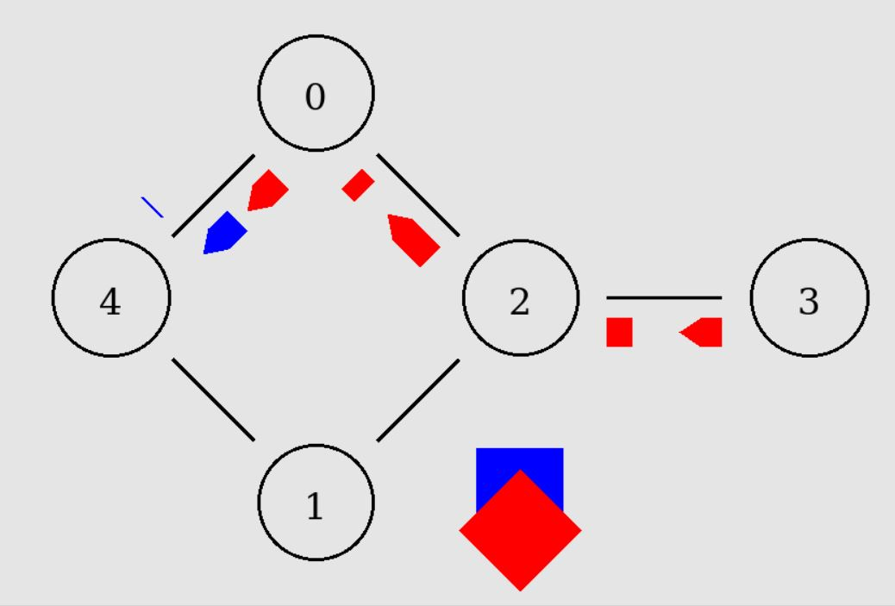
I have used the droptail type of queue which simply drops the lastest packets but I found that to be bad because it can block data from more recent connections, for example. After trying it out I found the

