Lab number: 5
Lab Title : Dynamic Networks and Creating Output Files for XGraph

Abstract:
This lab has a more emphasis on the networking layer and how the routing works under specific circumstances. It presents the Xgraph tool which is very important to analyse and measure the performance of networks.

Aim objectives and goal:
The main goal of this lab is to fundamentally understand how dynamic routing happens in the networking layer. This is important because almost all networks that we use daily are always adding and removing nodes. This lab does that by comparing the Distance Vector (DV) and the Link State (LS) protocols.
Additionally the lab also covers the XGraph tool that is important to output visual graphics to better interpret the data stored in the trace file.

Observation/ Results and Discussion:
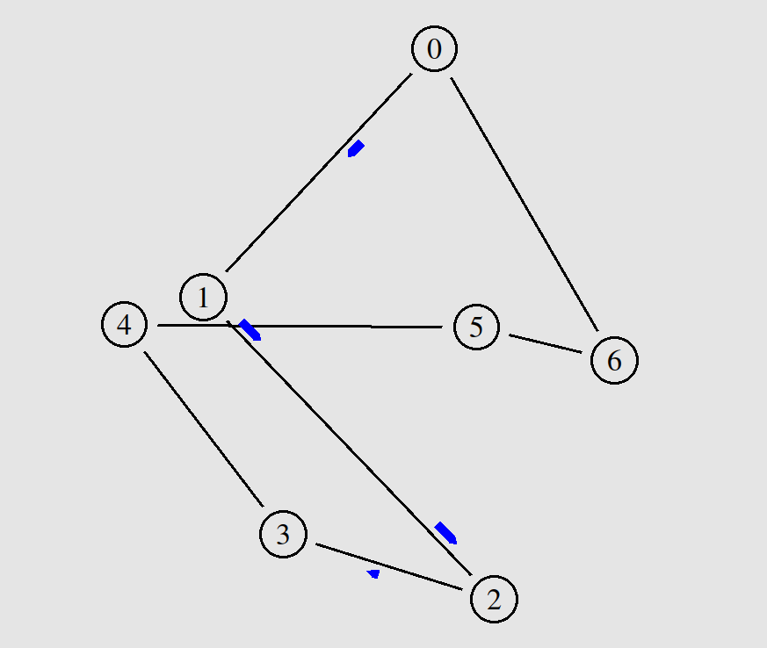
This lab was compelling because I was possible to explicitly view how dynamic routing really works, in the case of a link failure.
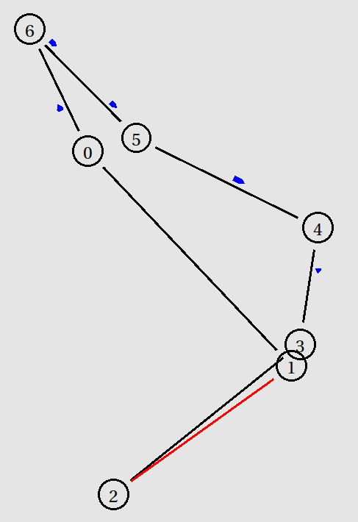
It was visible the differences between the distance vector (DV) and link state (LS) Protocols. In the distance vector protocol the routing packets were much smaller but the network took slightly longer to recover from the link failure since the each routing packet data refers to a single node, so the adjacent nodes need to advertise the lost link. On the contrary the link state traffic is significantly heavier because packets have a global map to all other network nodes and it reduced the data packet’s traffic bandwidth. The advantage of having global information in the packets is that it the network is faster reacting to changes on the network, as it does not need to advertise the links individually.

Another event that was clear is how the network can immediately change when a link is down. In this case the network follows the ring topology so when a link goes down, the traffic flow takes the opposite direction to reliably deliver the data using another route.

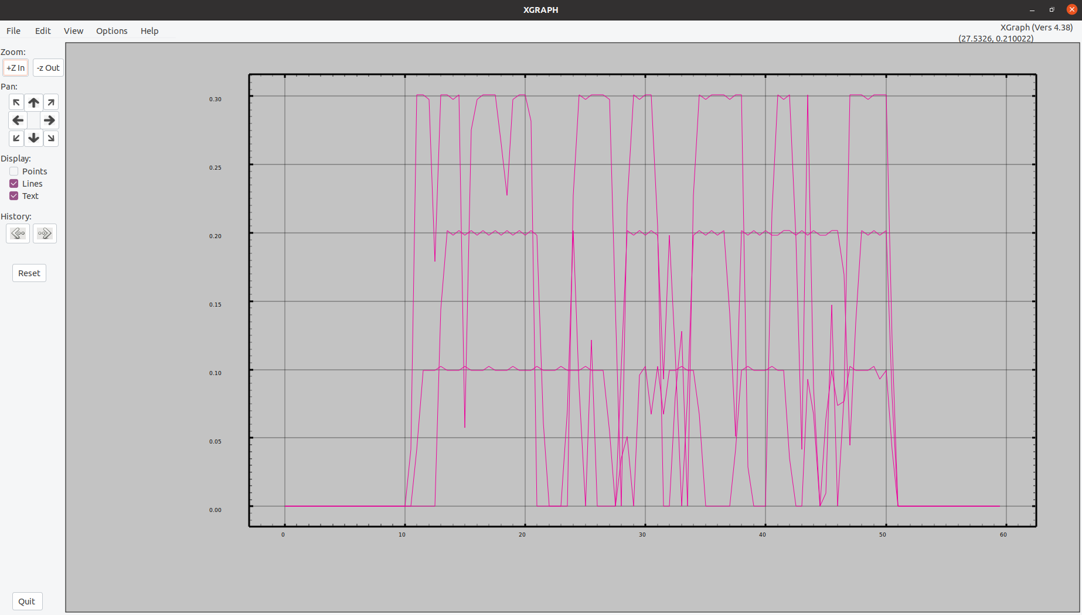
Additionally, the XGraph visualising tool was also executed to process the trace file created by the tcl file. This outputted a graph, specifying the performance of each node during the period of this scenario.

