Lab number: 4
Lab Title : Run, Trace ...

Abstract:
This lab covers two main topics one technical and other theoretical. The technical is the tracing functionality and the theoretical is how two different data link protocols behave in a practical scenario.

Aim objectives and goal:
The main goal for this lab is to observe the differences between the “stop-n-wait” and the “sliding window” protocols. These protocols are essential for connection-oriented communication. The secondary goal is to familiarise with the tracing capabilities of network simulator.

Observation/ Results and Discussion:

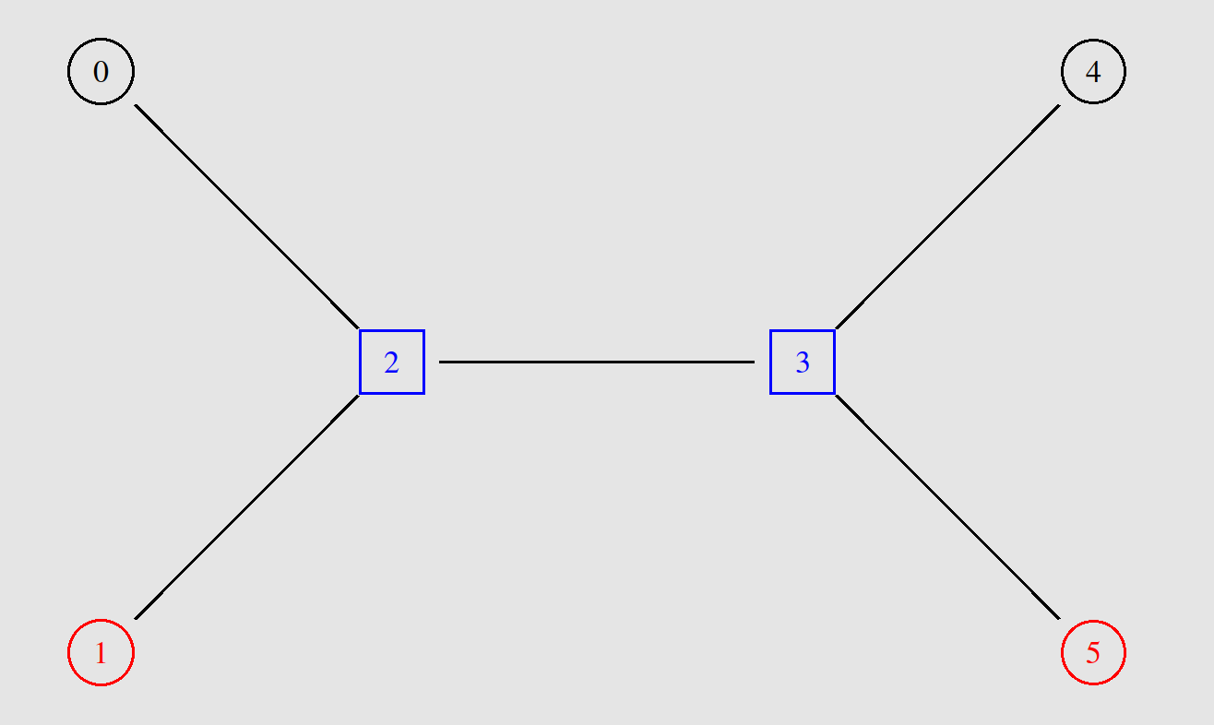
In this experiment, the scenarios differ only on the data link connection-oriented protocols, everything else stays the same.
There are 4 clients and two routers connected in a specific way. The 0 and 4 will communicate in a connection oriented way, node 1 and 5 will exchange a parallel connectionless communication. Both communications will share the link between the routers.

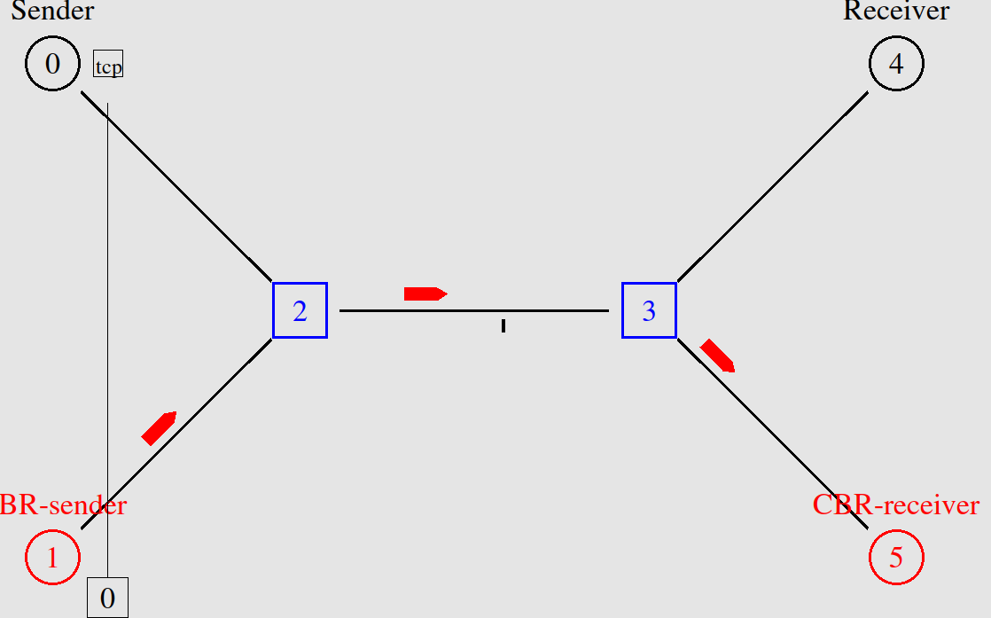
The two connection-oriented protocols behave exactly the same in the first phase of communication. Node 0 and 4 exchange the 3-way handshake that establishes an reliable “channel”, ensuring that data is sent in a sequence, without any losses or duplications.

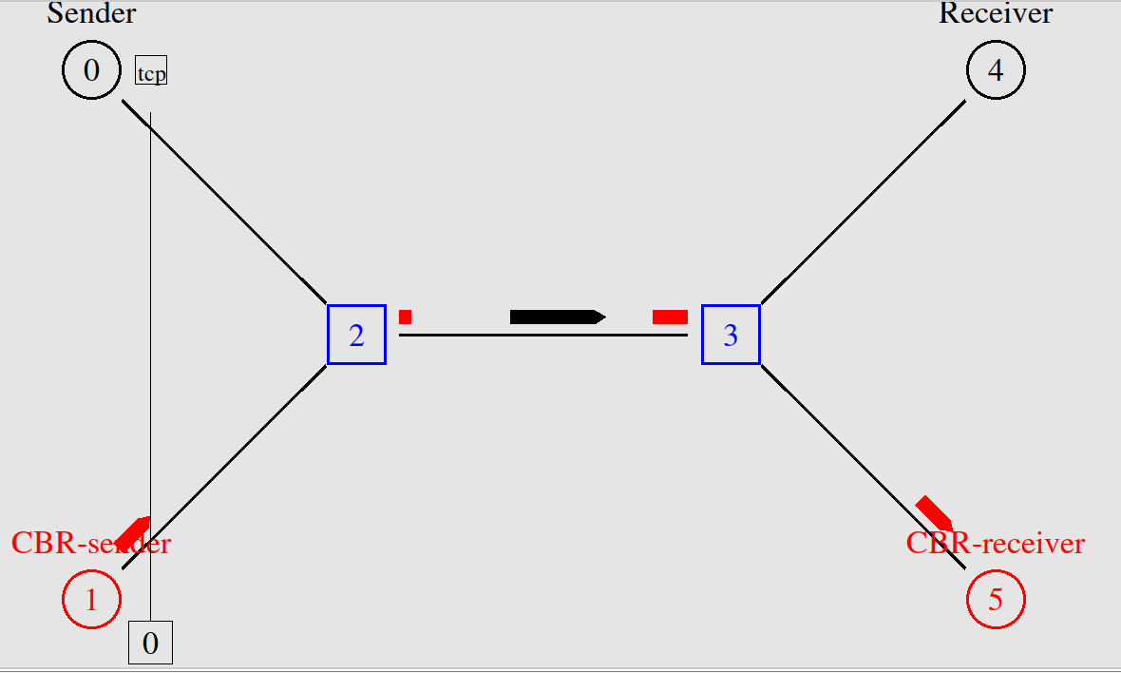
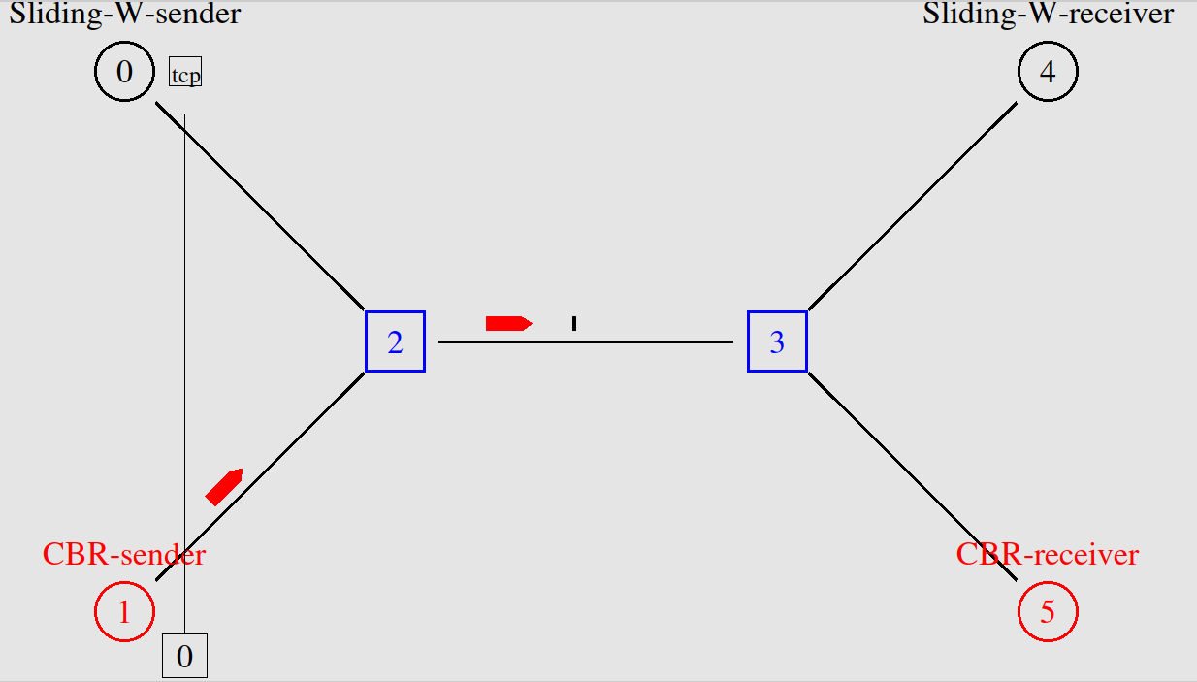
The first scenario runs a connection-oriented protocol called “stop-n-wait” which is very simple but not very efficient as it can be seen in theses images. The sender only sends 1 packet and then it waits for the receiver to send the acknowledgement packet back. In the worst case it can wait up to the timeout which starts counting after the data packet is sent. The efficiency can be observed both in terms of time per packet but through this image, that shows that almost the full bandwith is being wasted, apart from this single packet.

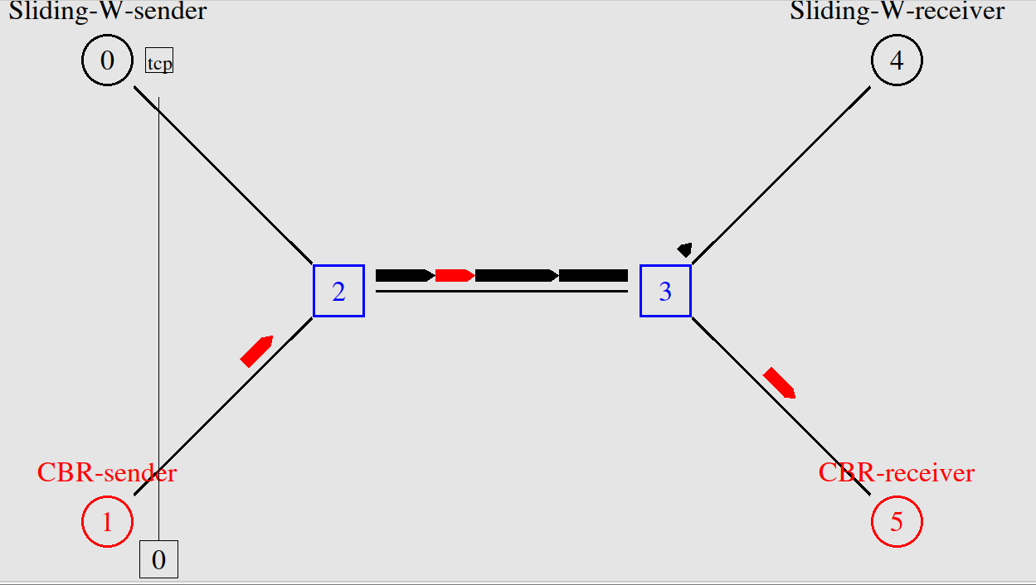
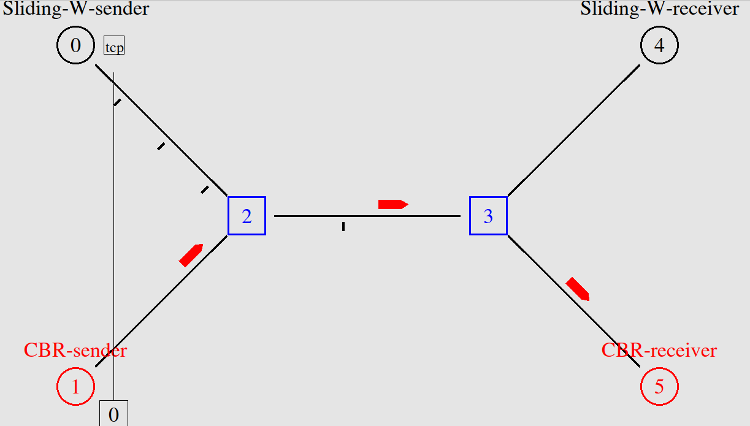
The second protocol is a better solution because when the 3-way handshake is exchange, the sender and receiver agree on a size of the window, which means that agree on the amount of packets being sent at each time. This is more efficient because it sends more packets at a time, using more of the bandwidth and not waiting a full cycle per each packet.
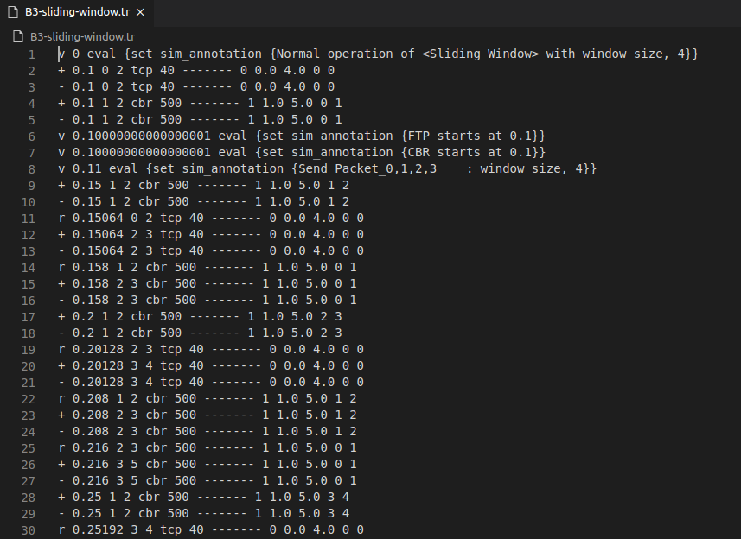
In the first image the link between the routers is being fully used, mostly to carry the data connection-oriented packets to the destination. Then it is also visible that the acknowledgement packets are all sent in the same sequence.

In terms of tracing files, the labs 1, 2 and 3 do not differ much from each other but the tracing of the sliding window contains extra information about the acknowledgement signals that set the window size.
