Lab number: 2
Lab Title : Congestion

Abstract:
This lab will cover the congestion on networks, and how the data behaves when transmitted over a busy environment. It will not require much advanced configuration as it only requires to do a basic configuration over the data link layer and the transport layer.

Aim objectives and goal:
The primary focus of your lab is usually expressed in terms of aims and objectives.
The goal is to extend the previous network in order to stress some of the media edges. It is required to create 2 connectionless protocols, between node 3 to 4 and 1 to 3, and 2 connection oriented, between node 4 to 0 and 0 to 3. The communication will endure by 10 seconds and it needs to follow a especific sequence of data transmission.

Observation/ Results and Discussion:

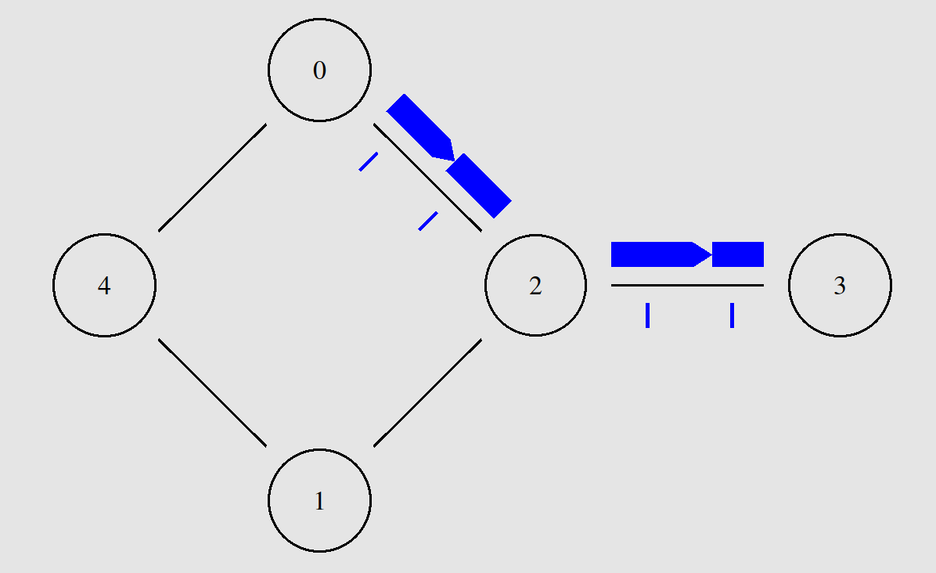
This lab was very interesting because it completes what is currently being covered on the class. Especially that poorly configured networks will not provide reliable data transmission to all nodes.

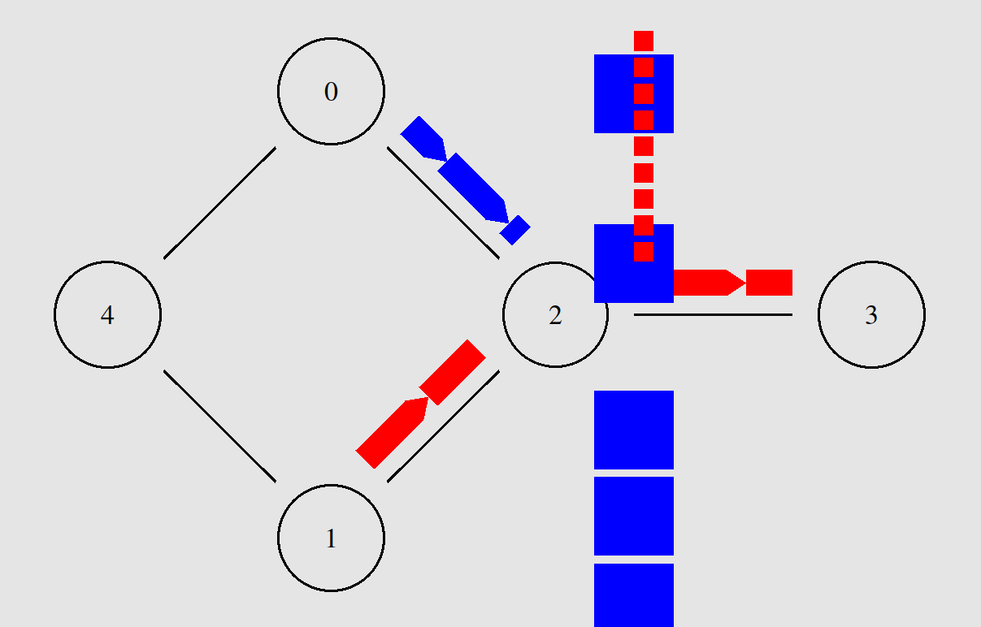
During the first data transmission occurs without any unexpected behaviour and the TCP data transmission occurs normally and it even speeds up to a constant rate of trasnmission. The behaviour changes completely as the UDP connection is established the TCP’s rate drops dramatically. The TCP data transmission relies on data ordering and the received signal from the destination for the next ordered packet to be sent.
To worsen the situation, the node 2 queue is set to be droptail type which it “punishes” reliable transmission and it ends up blocking it from being transferred.

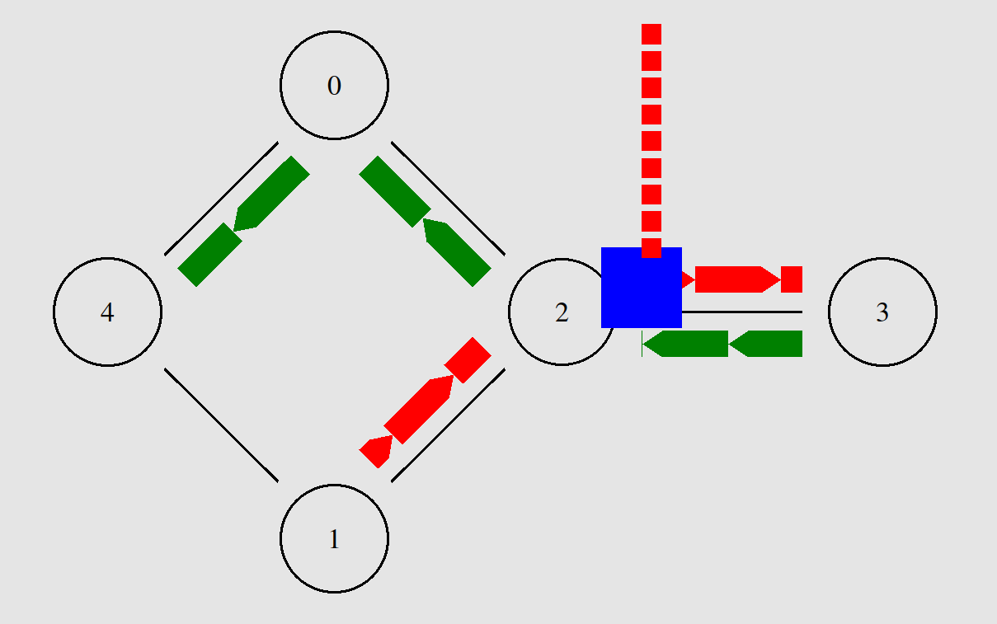

The first stage consists on setting up 3 data tranmissions. Two connectionless and one connection oriented. It is also possible to perceived that the problem described above persists even as time goes forward and the 3 connections are running.

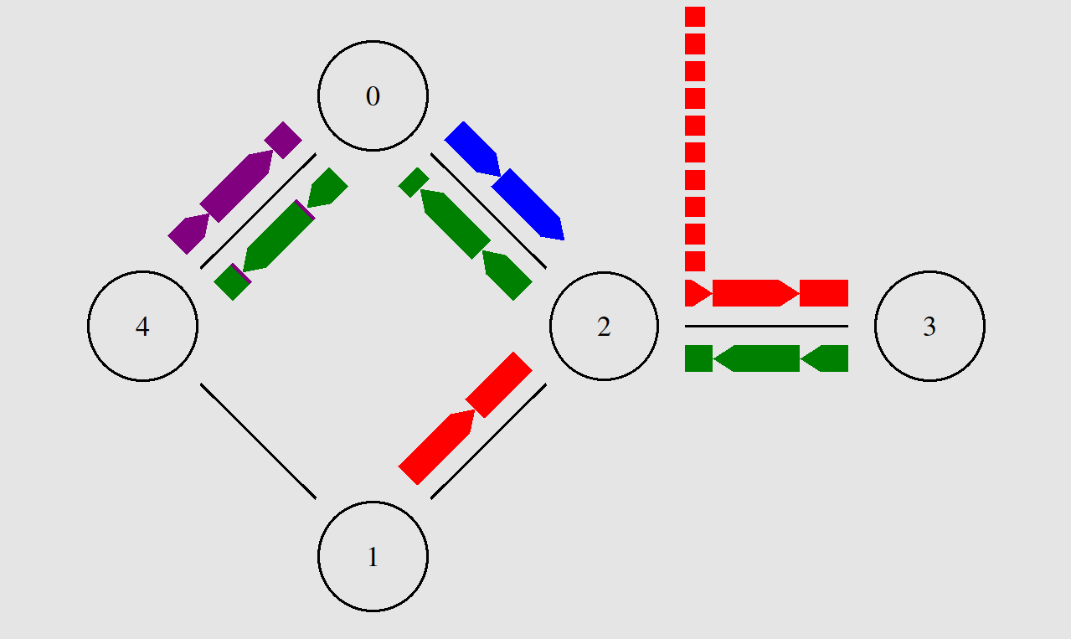

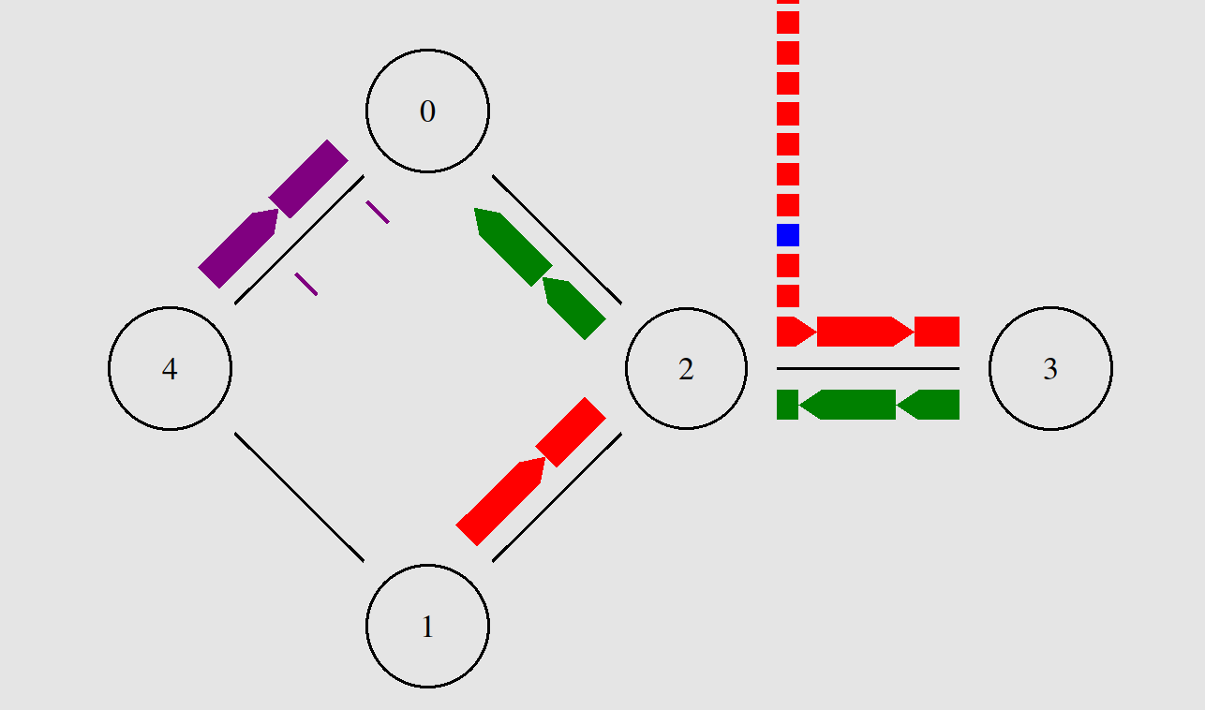
The second stage consist on adding a ftp connection from 4 to 0, to the existing network. The same problem with the blue connection persists, as the packets continue to be dropped constantly.

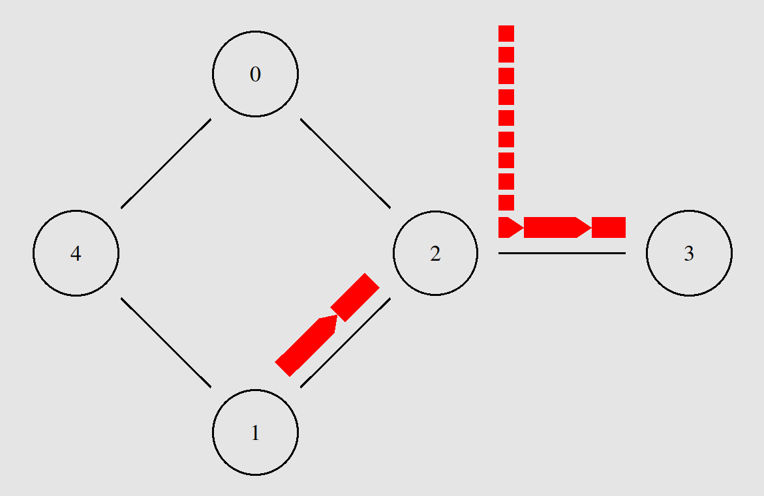

Furthermore, it is clear that the transmission delay on node 2 is as fast interval of packet arrival because its queue stays constant when no other data transmission is being undertaken.

