Lab number: 3
Lab Title : Creating a larger wired topology

Abstract:
This lab was important because it allows for experimenting with many different network. It was possible to run many different scenarios that represent real-world situations.

Aim objectives and goal:
This lab sheet has the goal of exposing many different types of wired topologies and network protocols by running many different files. The overall aim is to prepare for any scenario that may be presented for coursework.

Observation/ Results and Discussion:

Thanks to the large set of tcl files contained in the ns2 wired examples it was possible to explore many different types of wired topologies, network protocols and how to set them up.

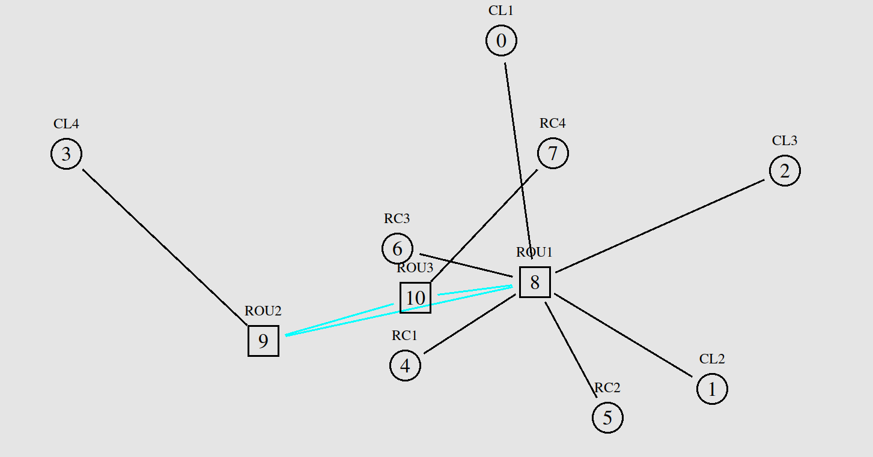
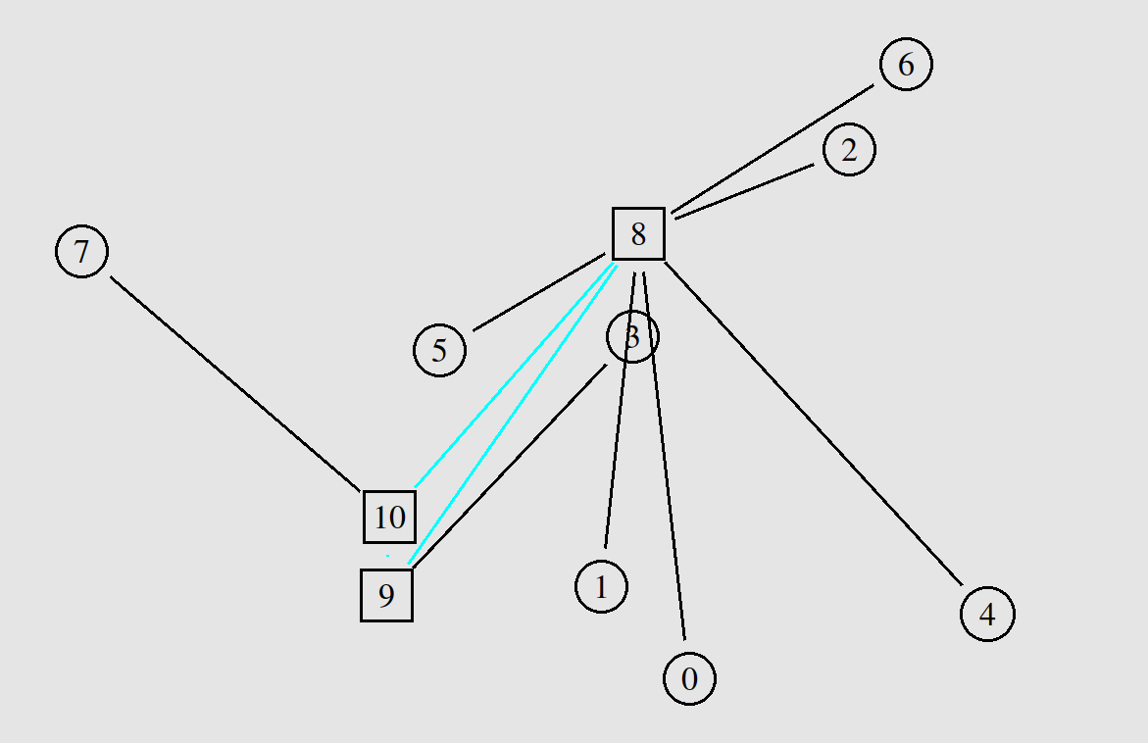
The first exercise consists on running the “tcp4.tcl” file that runs a network composed of 3 subnetworks connected using 3 routers. The subnetwork connected to router 8 have a start topology what can suggest that the network may serve, for example a room with 5 clients. The other subnetwork are just a simple connection directly with the its router.
The connections between the routers have a different colour, maybe signalling that they operate on the link and networking layers.
Overall this might represent a scenario of a building network where each router is on a different floor and clients 7 and 3 have their own network maybe adding a extra layer of security (an access list, for example) on more sensitive resources held in the network.
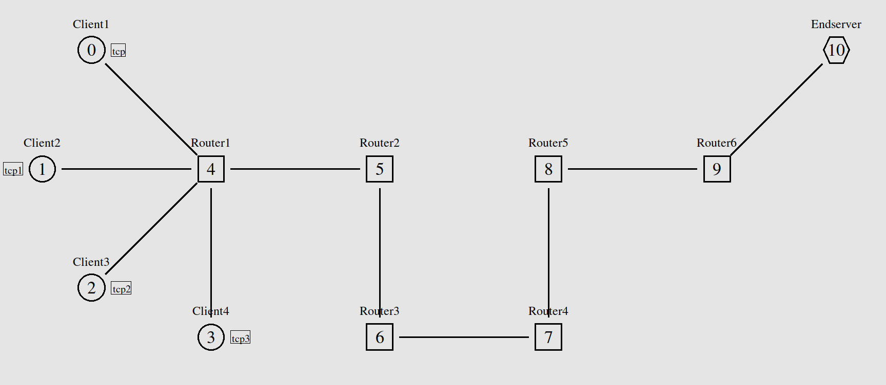
This network has similarities with the tcp4 one but is way less efficient. It has many redundant routers which is good to route high traffic and to extend the network but it only has one path between the routers. To improve this network, it is necessary create more redundant links between the routers to create a mesh and balance the load of the traffic. Currently any traffic between the end-server and the clients will create a cluttered transmission where many packets will be dropped since the router queues will overflow.

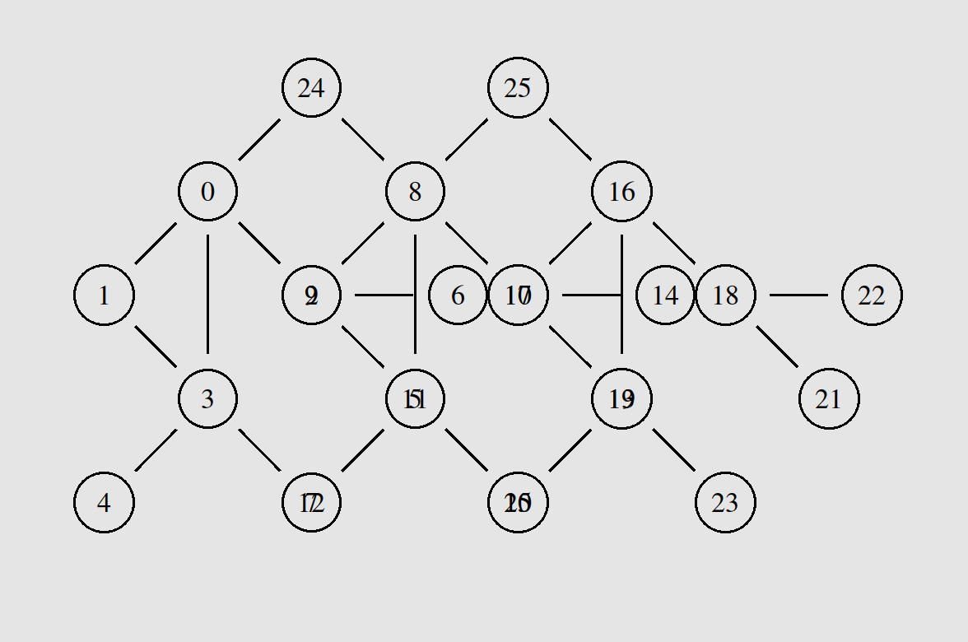
This network was one of the best in terms of topologies. In this representation nodes are an abstractions for clients or routers. It is highly distributed and it might represent a peer-to-peer service where all the nodes have the same privileges. Although this network is “meshy”, it is not the optimal mesh network since it does not have links connecting each pair of nodes in the network.

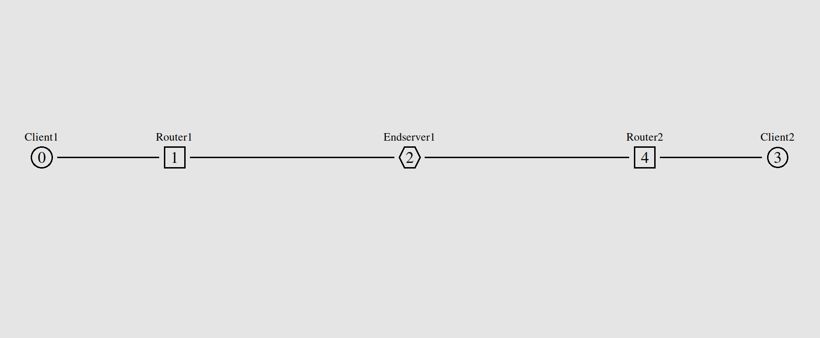
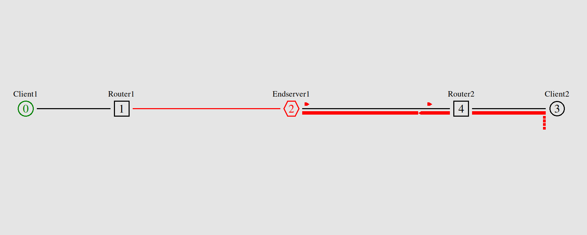
This last network is a interesting example because it looks like a non-efficient rudimentary centralised topology but it might a intentional decision. If the network was poorly designed, the solution is to have the routers connected to each other, the end server and the two clients, to avoid the scenario where one link completely fail like the very last image. If this network has an intentional design, it might mean that the clients connected to one router have different access to the end server.

