Table of Contents
Question 1: Lab Reports 3
Question 2: Topologies Report 4
Start Topologies 4
Advantages 4
Disadvantages 4
Mesh Topologies 4
Advantages 4
Disadvantages 4
Question 3 and 4: Routing Protocols Report 5
Distance Vector Protocol 5
Link State Protocol 5
Comparison 5

Question 1: Lab Reports

Lab 1: Introduction

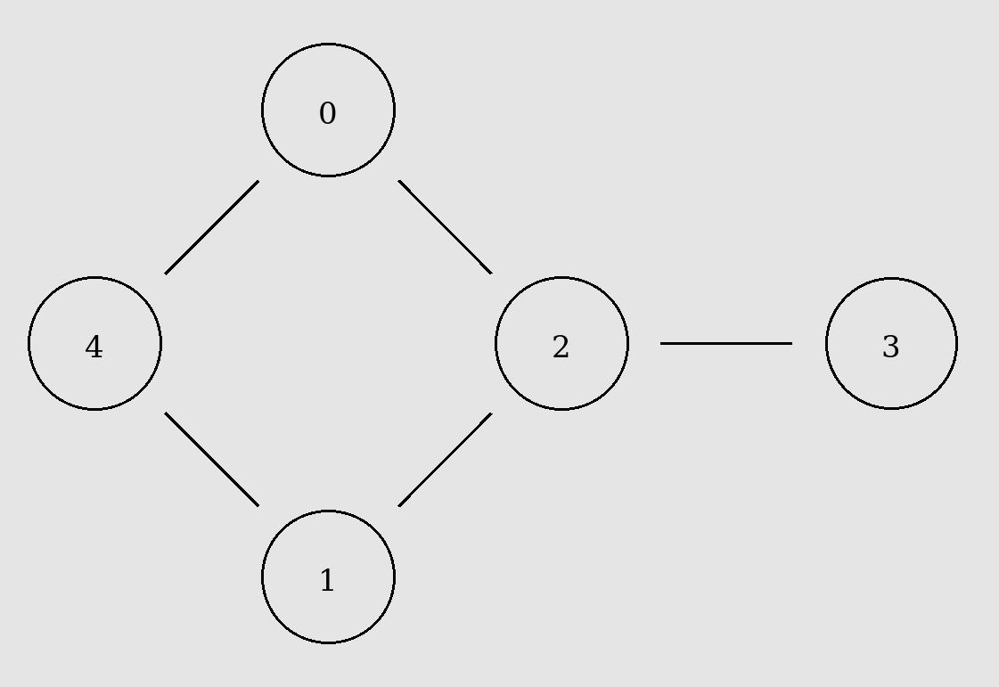
This exercise was very important to visualise how conection-oriented and connectionless protocols differ from each other.

The TCP protocol show to have high overhead due to starting and ending handshaking but mostly due to lost packets that need to be retransmitted. The data was sent less regularly as well since the packet need to be sent in order.

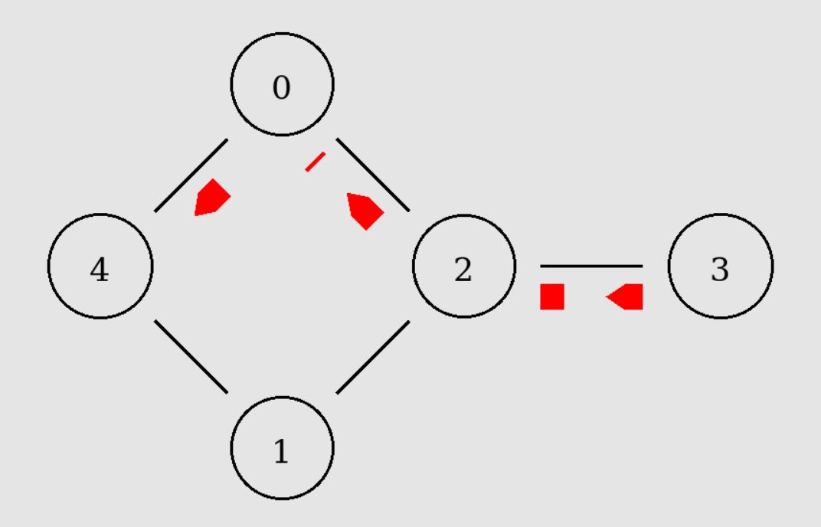
The CBR type of connection had no overhead as packets were sent regularly without any handshaking or re-transmission
requests even when packets were dropped. The data was sent disregarding its order. For these reasons it was clear that CBR transferred more data even compared with a reliable protocol such as TCP.

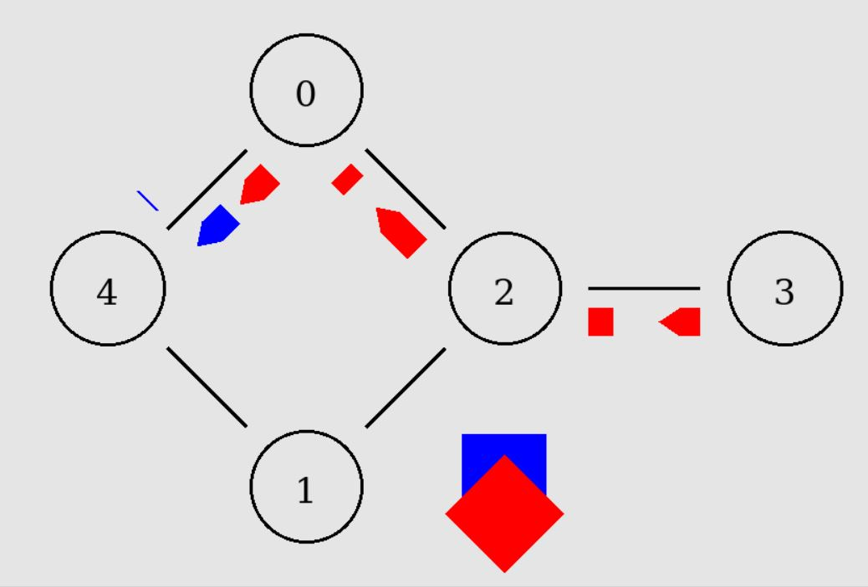
The Link between node 3 and node 2 was always congested especially when both TCP and BCR packets were being transferred. This caused a considerable loss of packets when node 2 was transmitting the packets. This could be prevented if the length of the trasnmission queue was increased.
I have used the droptail type of queue which simply drops the latest packets but I found

Lab 2: Congestion

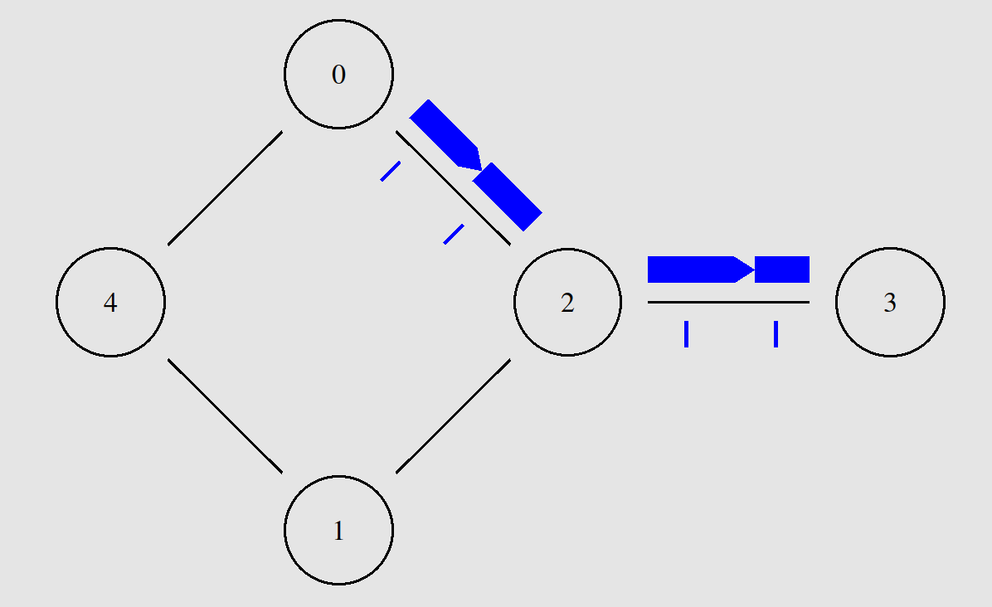
This lab was very interesting because it completes what is currently being covered on the class. Especially that poorly configured networks will not provide reliable data transmission to all nodes.

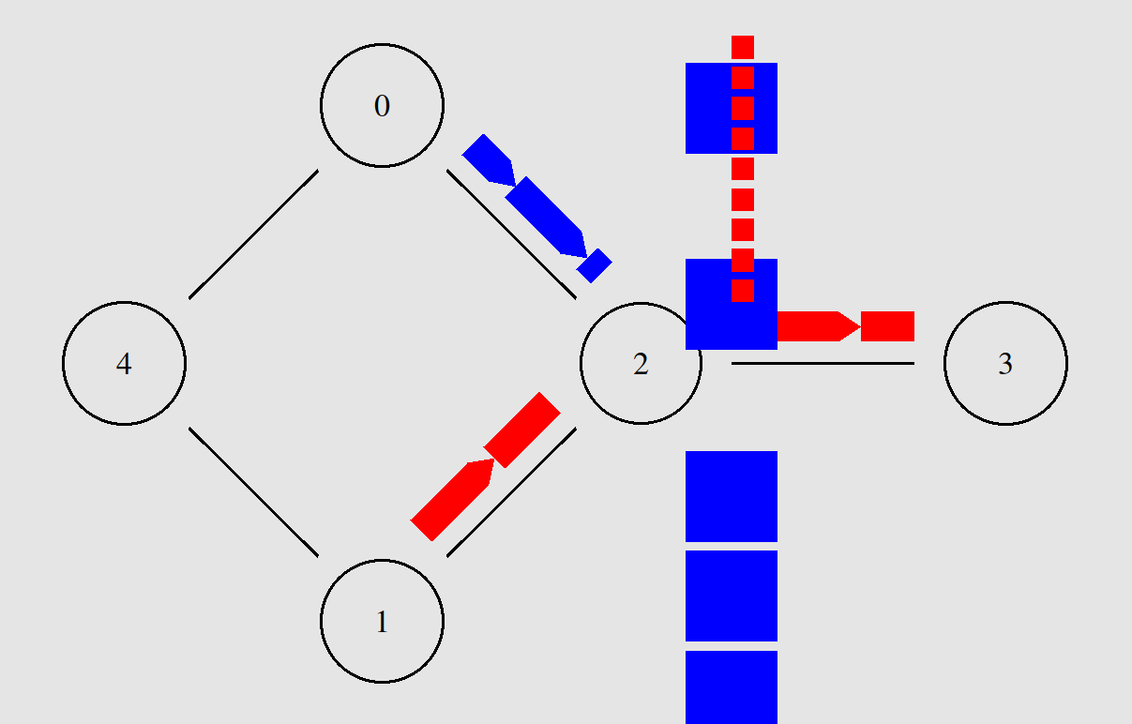
During the first data transmission occurs without any unexpected behaviour and the TCP data transmission occurs normally and it even speeds up to a constant rate of trasnmission. The behaviour changes completely as the UDP connection is established the TCP’s rate drops dramatically. The TCP data transmission relies on data ordering and the received signal from the destination for the next ordered packet to be sent.
To worsen the situation, the node 2 queue is set to be droptail type which it “punishes” reliable transmission and it ends up blocking it from being transferred.

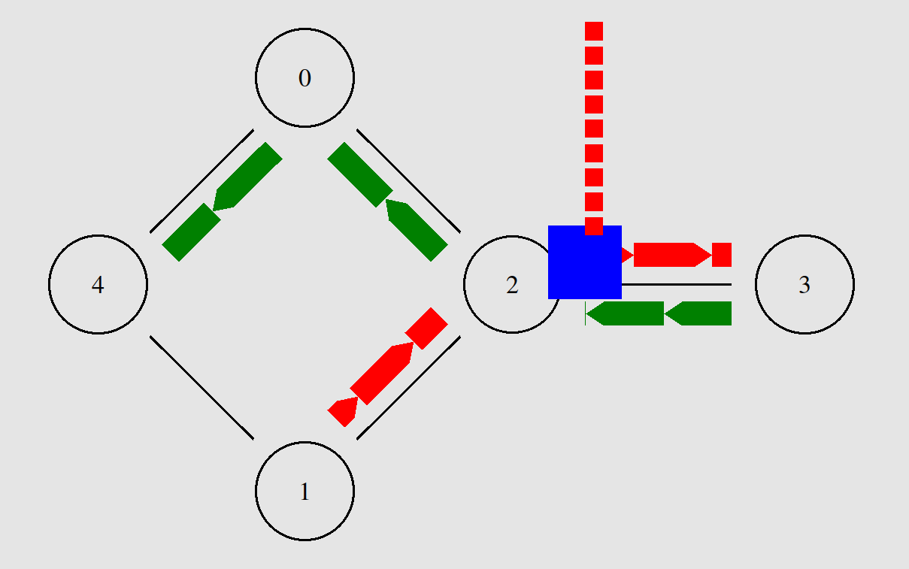

The first stage consists on setting up 3 data tranmissions. Two connectionless and one connection oriented. It is also possible to perceived that the problem described above persists even as time goes forward and the 3 connections are running.

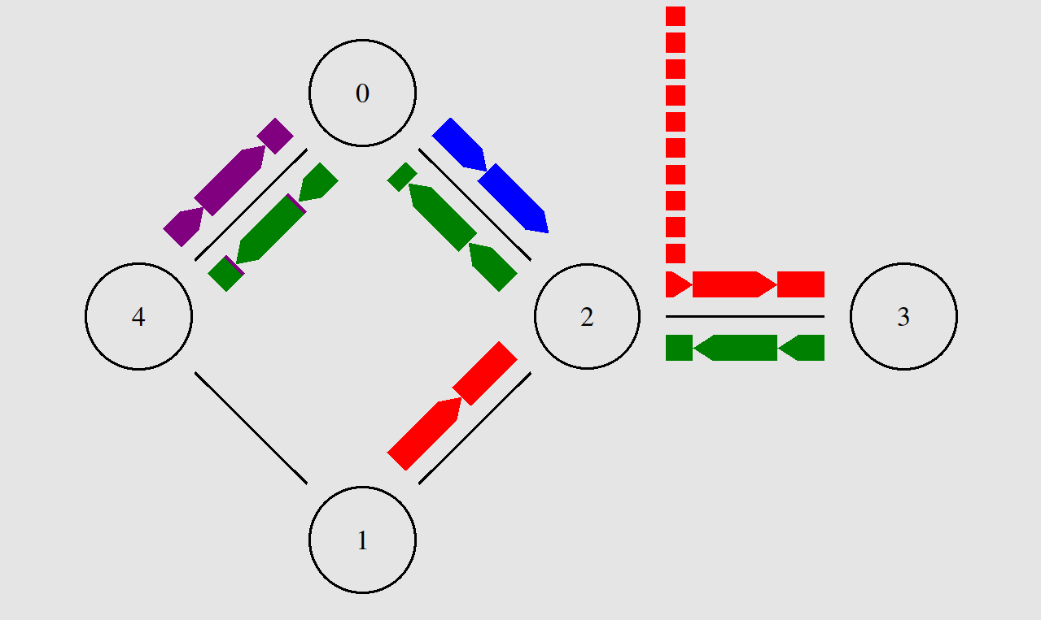

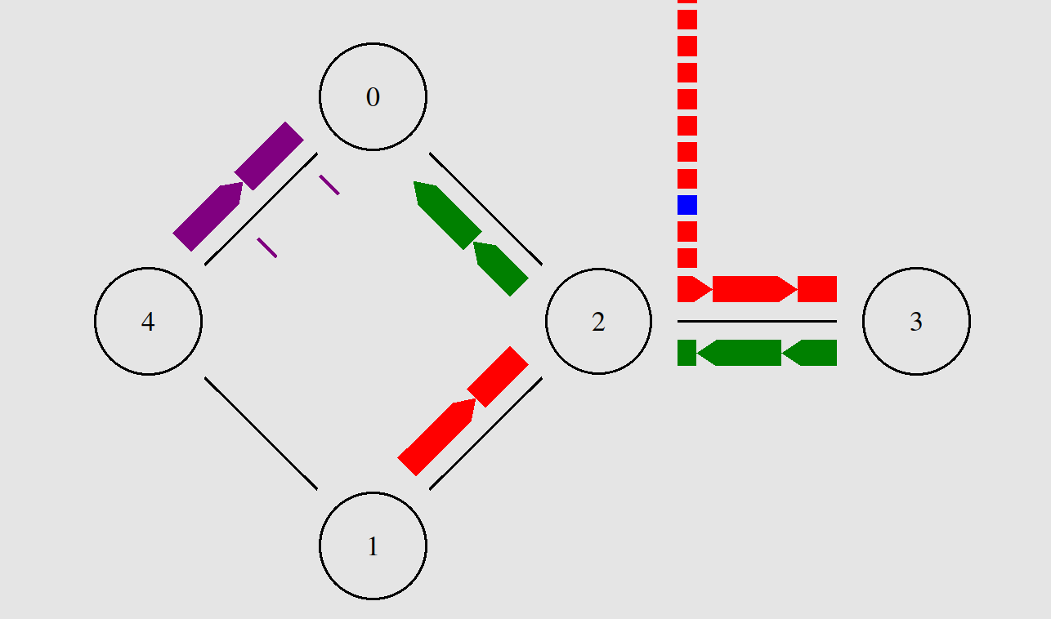
The second stage consist on adding a ftp connection from 4 to 0, to the existing network. The same problem with the blue connection persists, as the packets continue to be dropped constantly.

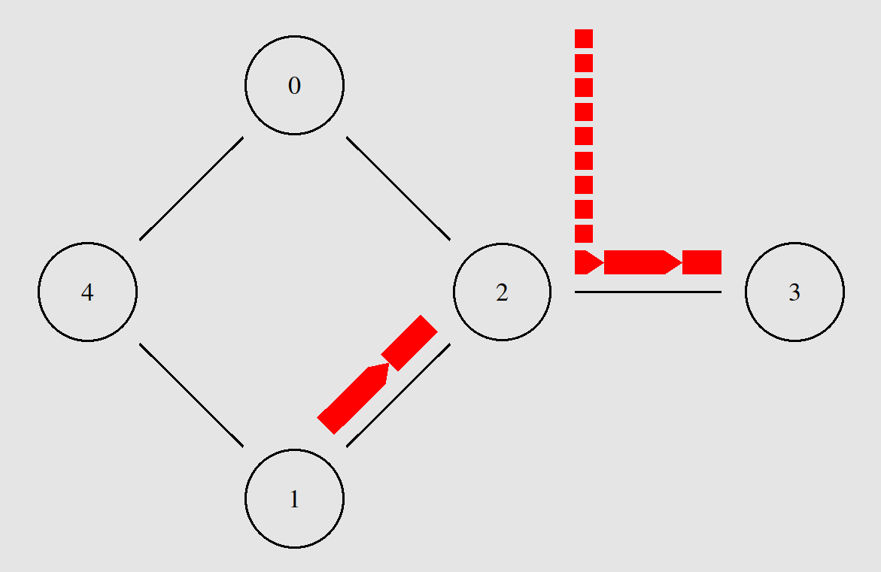

Furthermore, it is clear that the transmission delay on node 2 is as fast interval of packet arrival because its queue stays constant when no other data transmission is being undertaken.

Lab 3: Creating a larger wired topology

Thanks to the large set of tcl files contained in the ns2 wired examples it was possible to explore many different types of wired topologies, network protocols and how to set them up.

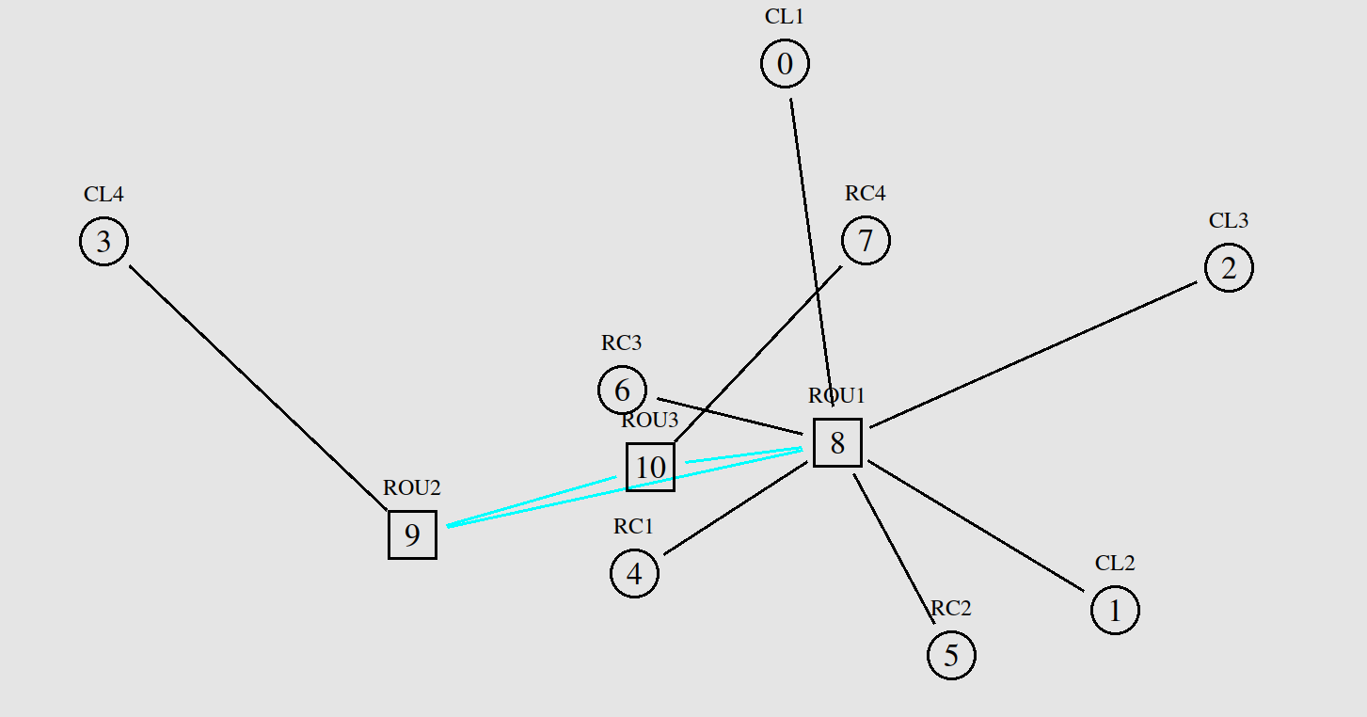
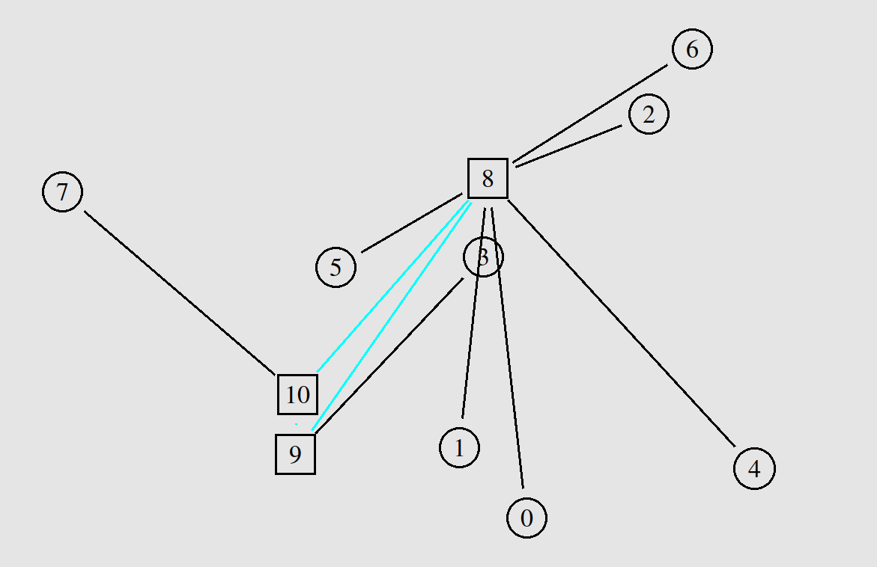
The first exercise consists on running the “tcp4.tcl” file that runs a network composed of 3 subnetworks connected using 3 routers. The subnetwork connected to router 8 have a start topology what can suggest that the network may serve, for example a room with 5 clients. The other subnetwork are just a simple connection directly with the its router.
The connections between the routers have a different colour, maybe signalling that they operate on the link and networking layers.
Overall this might represent a scenario of a building network where each router is on a different floor and clients 7 and 3 have their own network maybe adding a extra layer of security (an access list, for example) on more sensitive resources held in the network.
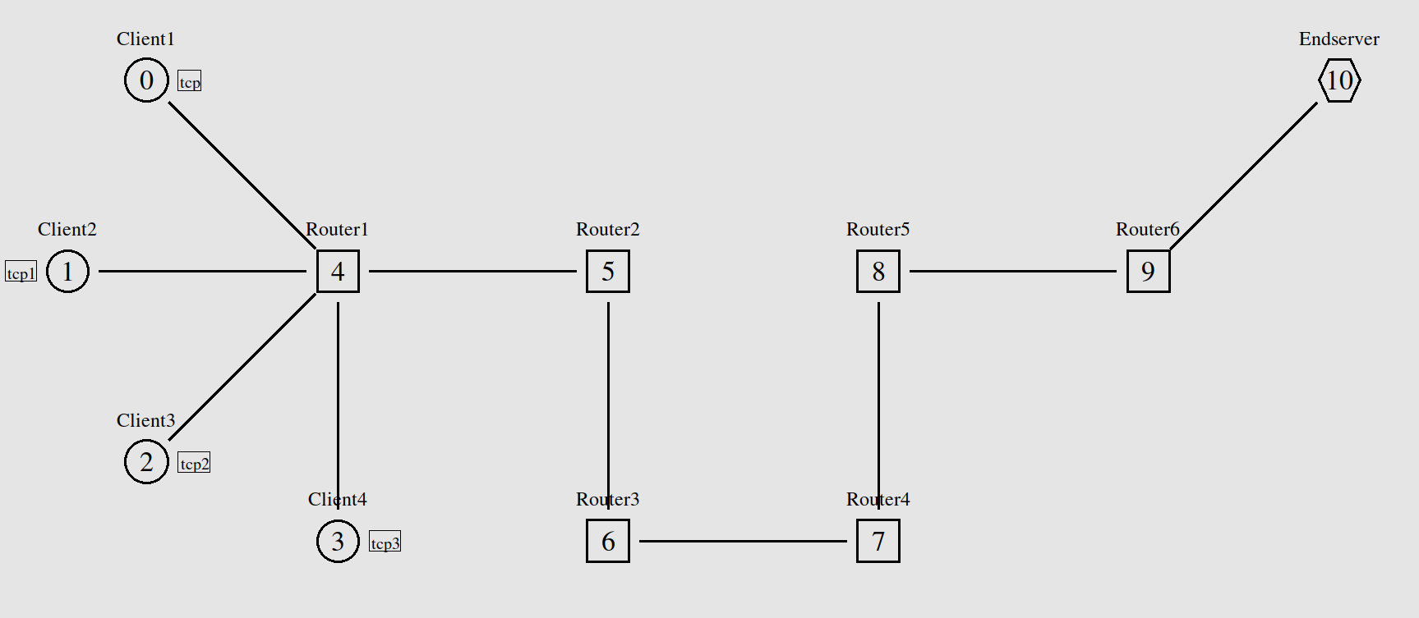
This network has similarities with the tcp4 one but is way less efficient. It has many redundant routers which is good to route high traffic and to extend the network but it only has one path between the routers. To improve this network, it is necessary create more redundant links between the routers to create a mesh and balance the load of the traffic. Currently any traffic between the end-server and the clients will create a cluttered transmission where many packets will be dropped since the router queues will overflow.

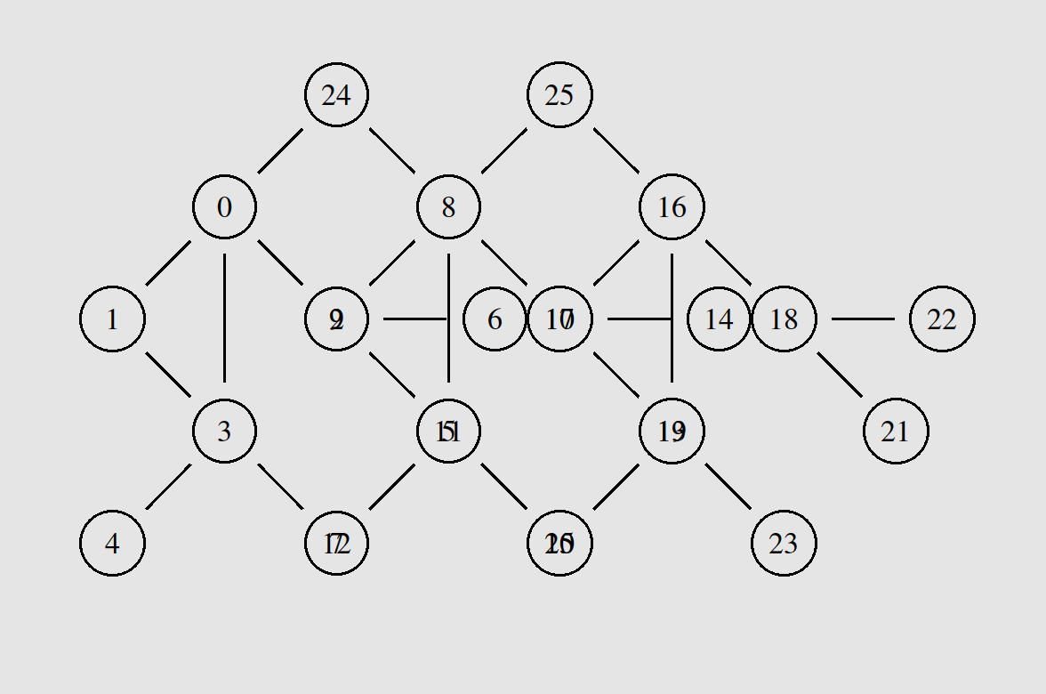
This network was one of the best in terms of topologies. In this representation nodes are an abstractions for clients or routers. It is highly distributed and it might represent a peer-to-peer service where all the nodes have the same privileges. Although this network is “meshy”, it is not the optimal mesh network since it does not have links connecting each pair of nodes in the network.

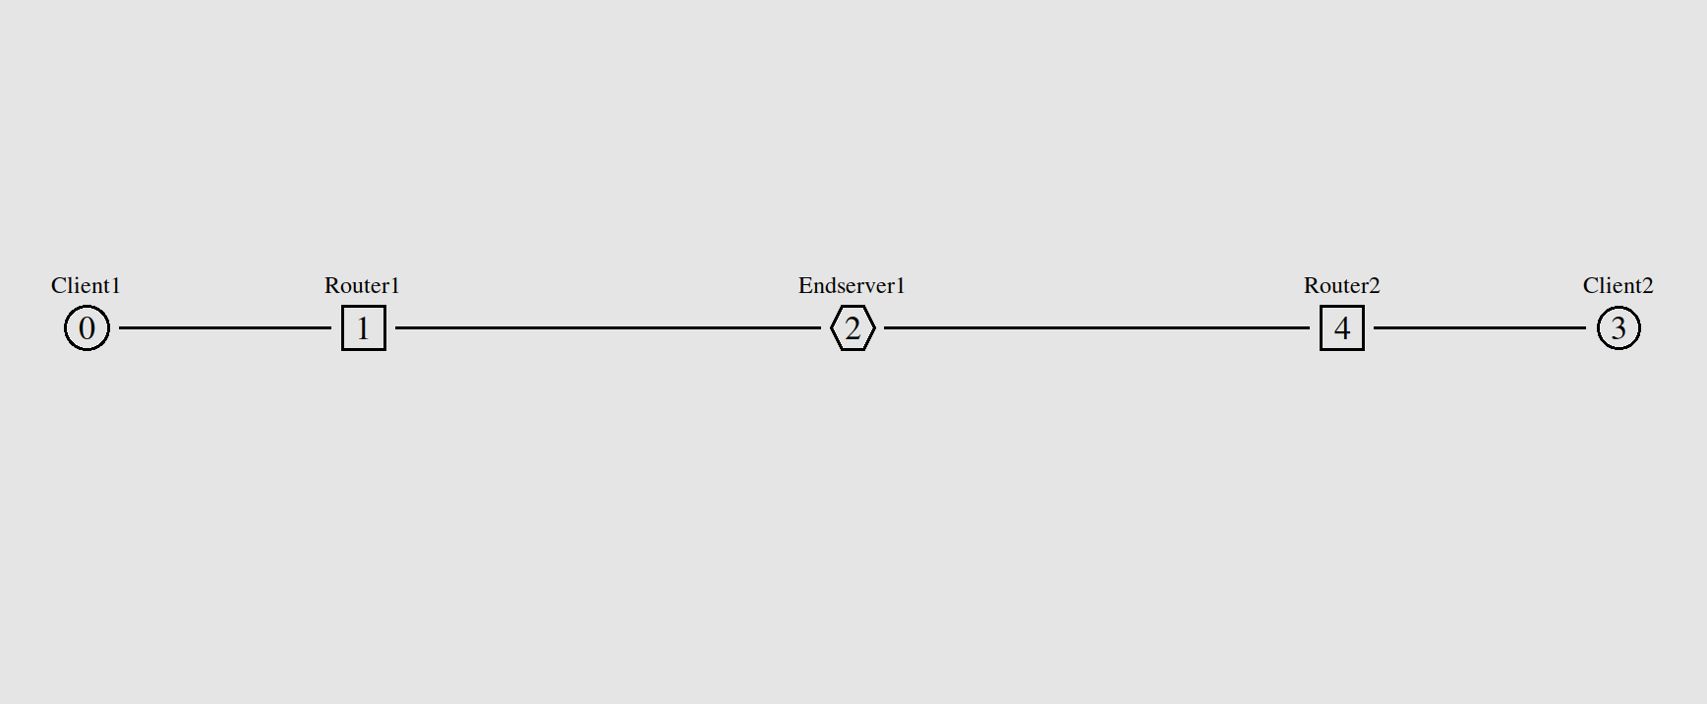
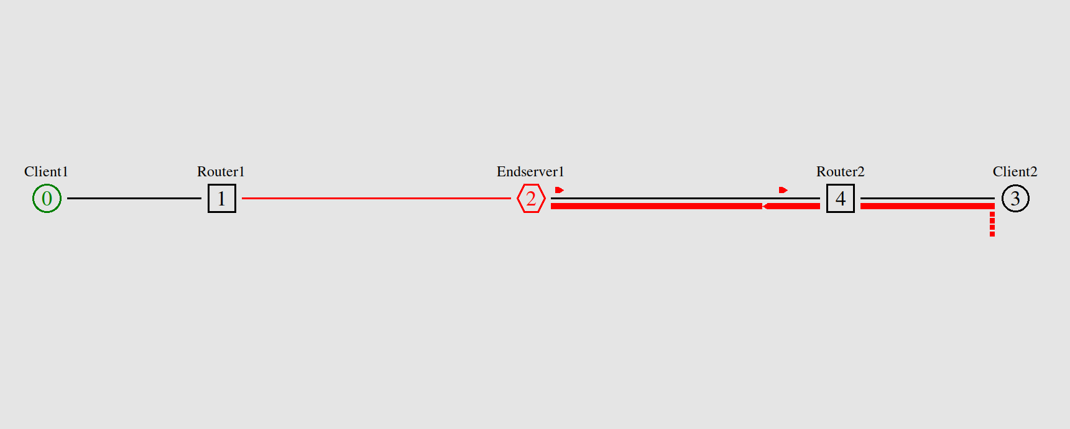
This last network is a interesting example because it looks like a non-efficient rudimentary centralised topology but it might a intentional decision. If the network was poorly designed, the solution is to have the routers connected to each other, the end server and the two clients, to avoid the scenario where one link completely fail like the very last image. If this network has an intentional design, it might mean that the clients connected to one router have different access to the end server.

Lab 4: Run, Trace ….

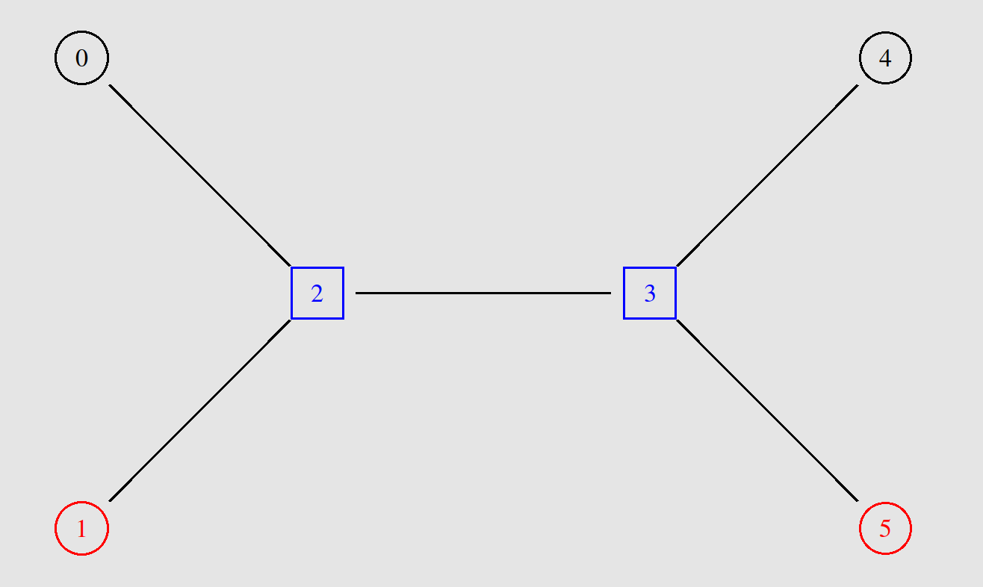
In this experiment, the scenarios differ only on the data link connection-oriented protocols, everything else stays the same.
There are 4 clients and two routers connected in a specific way. The 0 and 4 will communicate in a connection oriented way, node 1 and 5 will exchange a parallel connectionless communication. Both communications will share the link between the routers.

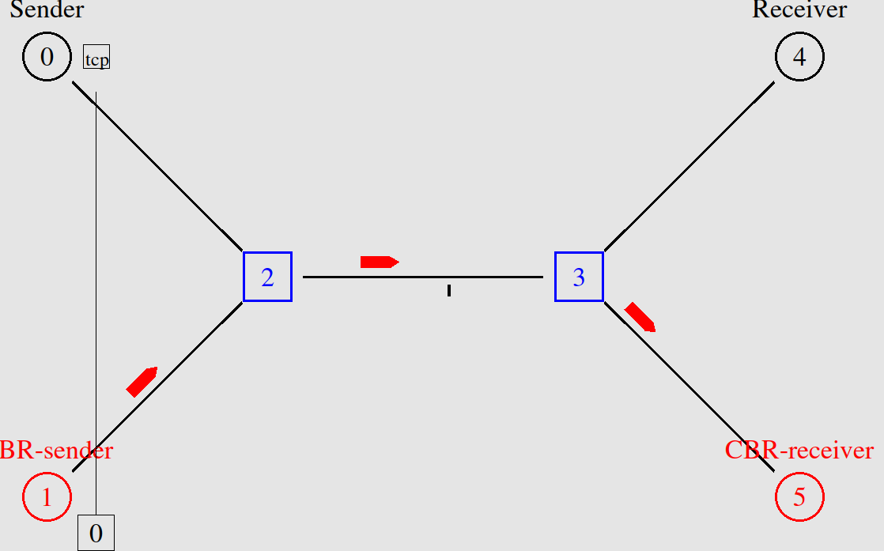
The two connection-oriented protocols behave exactly the same in the first phase of communication. Node 0 and 4 exchange the 3-way handshake that establishes an reliable “channel”, ensuring that data is sent in a sequence, without any losses or duplications.

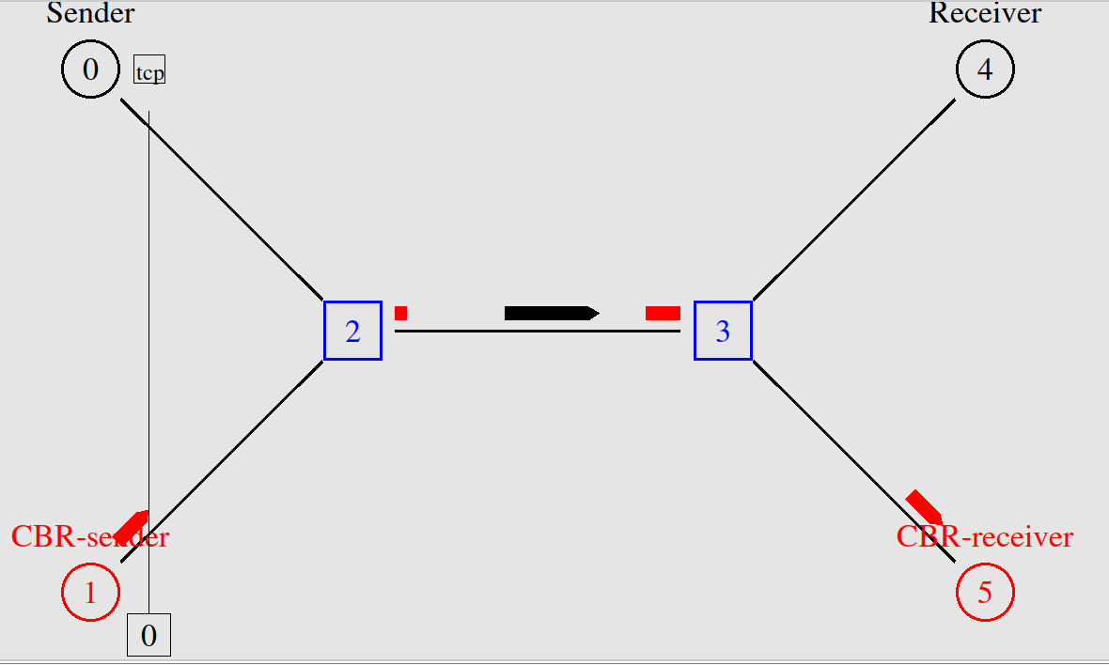
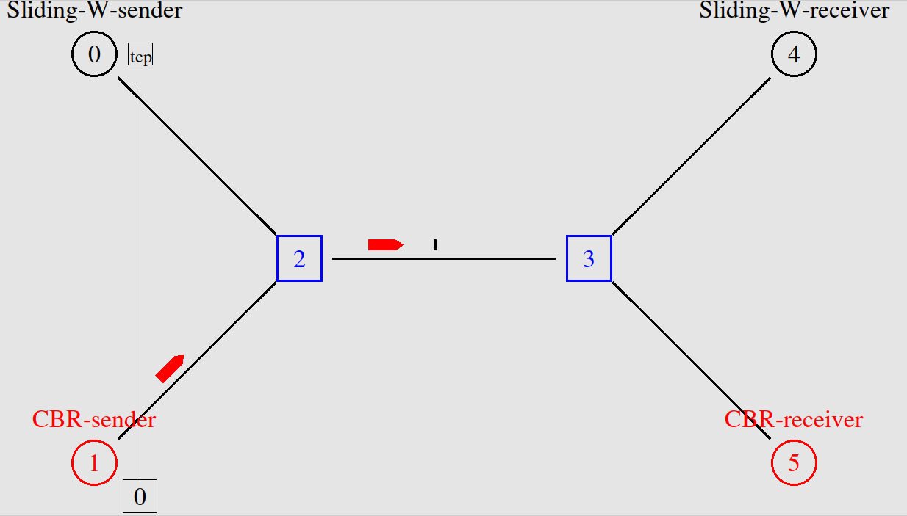
The first scenario runs a connection-oriented protocol called “stop-n-wait” which is very simple but not very efficient as it can be seen in theses images. The sender only sends 1 packet and then it waits for the receiver to send the acknowledgement packet back. In the worst case it can wait up to the timeout which starts counting after the data packet is sent. The efficiency can be observed both in terms of time per packet but through this image, that shows that almost the full bandwith is being wasted, apart from this single packet.

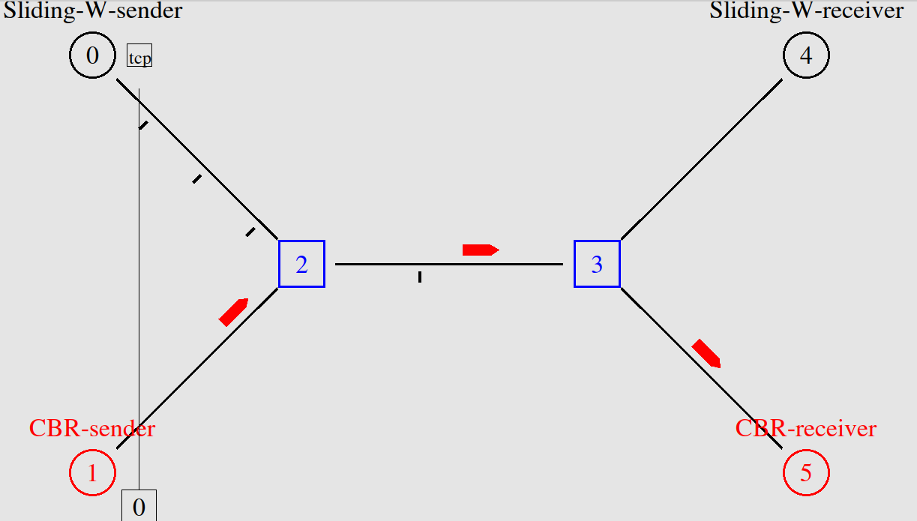
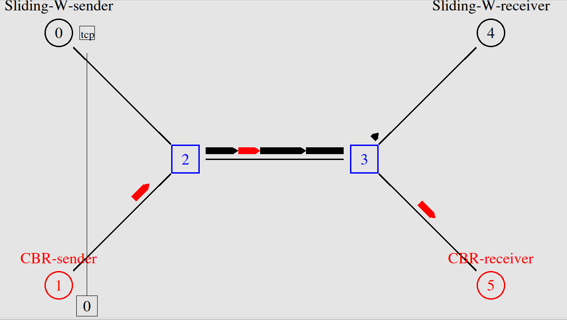
The second protocol is a better solution because when the 3-way handshake is exchange, the sender and receiver agree on a size of the window, which means that agree on the amount of packets being sent at each time. This is more efficient because it sends more packets at a time, using more of the bandwidth and not waiting a full cycle per each packet.
In the first image the link between the routers is being fully used, mostly to carry the data connection-oriented packets to the destination. Then it is also visible that the acknowledgement packets are all sent in the same sequence.
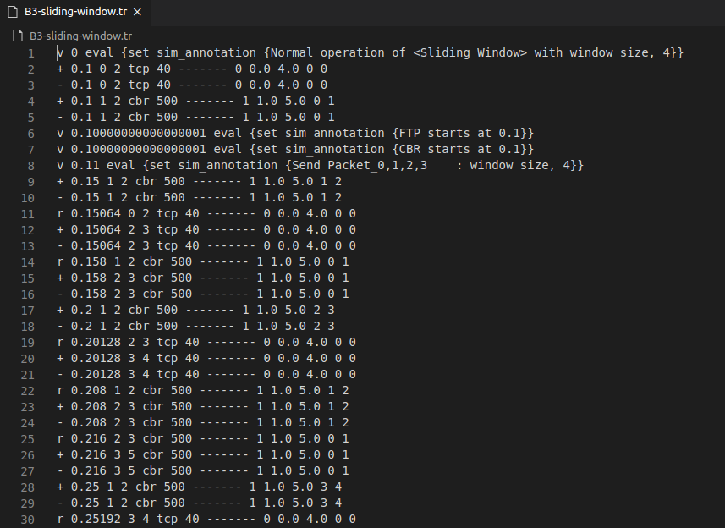
In terms of tracing files, the labs 1, 2 and 3 do not differ much from each other but the tracing of the sliding window contains extra information about the acknowledgement signals that set the window size.

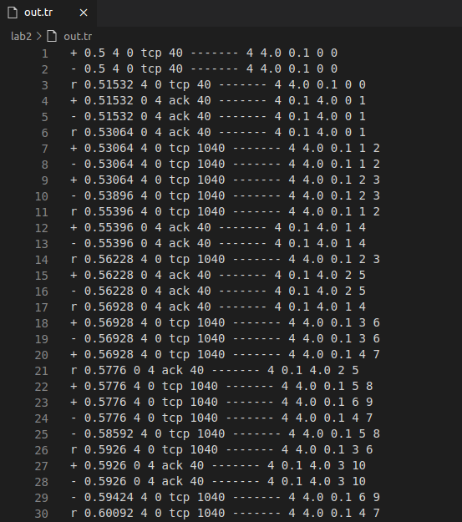
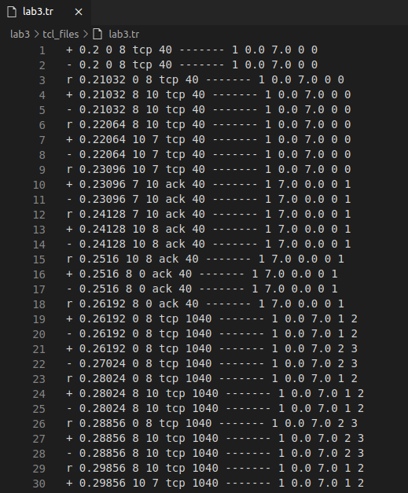

Question 2: Topologies Report

Start Topologies

Advantages

Disadvantages

Mesh Topologies

Advantages

Disadvantages

Question 3 and 4: Routing Protocols Report

Distance Vector Protocol

Link State Protocol

Comparison
Throughput
Packets Dropped

