**Android Source Code**

ButtonCode Click Work On Android Monitor

**package** com.thekarachimensaloon.androidapplication;  
  
**import** android.app.Activity;  
**import** android.os.Bundle;  
**import** android.util.Log;  
**import** android.view.View;  
**import** android.widget.Button;  
  
**public class** MainActivity **extends** Activity **implements** View.OnClickListener {  
 **private** Button **NFirstBtn**;  
 **private static final** String ***Tag*** =MainActivity.**class**.getSimpleName();  
 @Override  
 **protected void** onCreate(Bundle savedInstanceState) {  
 **super**.onCreate(savedInstanceState);  
 setContentView(R.layout.***activity_main***);  
*// Log.v(Tag,"This is my Error: "+Name);* **NFirstBtn**=(Button) findViewById(R.id.***mFirstButton***);  
 **NFirstBtn**.setOnClickListener(MainActivity.**this**);  
 Log.*i*(***Tag***,**"Inside the Msg"**);  
 Log.*e*(***Tag***,**"Inside the Msg"**);  
 }  
  
 @Override  
 **public void** onClick(View view)  
 {  
 Log.*d*(***Tag***,**"Button CLick By Me"**);  
  
 }  
}

**2ButtonCode Click Work On Android Monitor**

**__________________________________________________  
package** com.thekarachimensaloon.androidapplication;  
  
**import** android.app.Activity;  
**import** android.media.tv.TvContract;  
**import** android.os.Bundle;  
**import** android.util.Log;  
**import** android.view.View;  
**import** android.widget.Button;  
  
**import static** com.thekarachimensaloon.androidapplication.R.id.***mSecondButton***;  
  
**public class** MainActivity **extends** Activity **implements** View.OnClickListener {  
 **private** Button **NFirstBtn**;  
 **private** Button **NSecondBtn**;  
 **private static final** String ***Tag*** =MainActivity.**class**.getSimpleName();  
 @Override  
 **protected void** onCreate(Bundle savedInstanceState) {  
 **super**.onCreate(savedInstanceState);  
 setContentView(R.layout.***activity_main***);  
*// Log.v(Tag,"This is my Error: "+Name);* **NFirstBtn**=(Button) findViewById(R.id.***mFirstButton***);  
 **NSecondBtn**=(Button) findViewById(***mSecondButton***);  
 **NFirstBtn**.setOnClickListener(MainActivity.**this**);  
 **NSecondBtn**.setOnClickListener(MainActivity.**this**);  
 Log.*i*(***Tag***,**"Inside the Msg"**);  
 Log.*e*(***Tag***,**"Inside the Msg"**);  
 }  
  
 @Override  
 **public void** onClick(View view)  
  
  
 {  
 **switch**(view.getId()){  
 **case** R.id.***mFirstButton***:Log.*d*(***Tag***,**"1Button CLick By Me"**);**break**;  
 **case** R.id.***mSecondButton***:Log.*d*(***Tag***,**"2Button CLick By Me"**);**break**;  
 }  
  
  
 }  
}

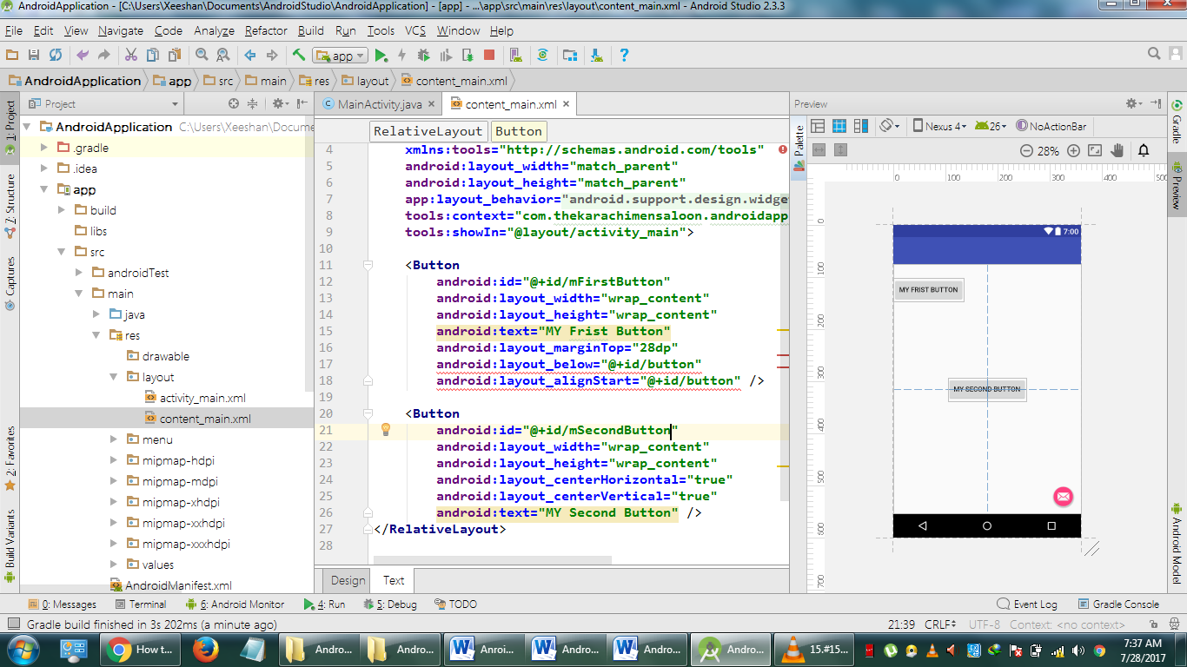 **Intent-manifest.xml   
onePage(ActivityA to🡪 ActivityB) to Another Page***<?***xml version="1.0" encoding="utf-8"***?>*<**manifest xmlns:android="http://schemas.android.com/apk/res/android"  
 package="xeeshan.xami"**>  
  
 <**application  
 android:allowBackup="true"  
 android:icon="@mipmap/ic_launcher"  
 android:label="@string/app_name"  
 android:roundIcon="@mipmap/ic_launcher_round"  
 android:supportsRtl="true"  
 android:theme="@style/AppTheme"**>  
 <**activity  
 android:name=".ActivityA"  
 android:label="@string/app_name"  
 android:theme="@style/AppTheme.NoActionBar"**>  
 <**intent-filter**>  
<**action android:name="android.intent.action.MAIN"** /> <**category android:name="android.intent.category.LAUNCHER"** />  
 </**intent-filter**>  
 </**activity**>  
 <**activity  
 android:name=".ActivityB"  
 android:label="@string/app_name"  
 android:theme="@style/AppTheme.NoActionBar"**>  
 <**intent-filter**>  
 <**action android:name="xeeshan."** />  
  
 <**category android:name="android.intent.category.LAUNCHER"** />  
 </**intent-filter**>  
 </**activity**>  
 </**application**>  
  
</**manifest**>

**Circle Arround Your Location Code:**

Cicle =drawCircle(new LatLng(lat,lng));  
private Circle drawCircle(LatLng latlng)

{

CircleOptiobns option=new CircleOption()  
.center(latlng).radius(1000).fillColor(0x33FF000).strokeColor(Color.Blue).strokeWidth(3);

Return mGoogleMap.addCircle(options);

}  
**LANSCAPE & PORTRAIT CODE  
public void** onConfigurationChanged(Configuration newConfig) {  
 **super**.onConfigurationChanged(newConfig);  
  
 **if**(newConfig.**orientation**== Configuration.***ORIENTATION_PORTRAIT***)  
 {  
 Toast.*makeText*(getApplicationContext(),**"Portrait"**,Toast.***LENGTH_LONG***).show();  
 }  
 **else if**(newConfig.**orientation**== Configuration.***ORIENTATION_LANDSCAPE***)  
 {  
 Toast.*makeText*(getApplicationContext(),**"Lanscape"**,Toast.***LENGTH_LONG***).show();  
 }

**MENIFEST FILE:**<**activity  
 android:configChanges="orientation|screenSize|keyboardHidden"**

</**activity>**

**SaveInstanceState Values**

**Protecte void onSaveInstanceState(Bundle outstate)**

**{**

**Super.onSaveInstanceState(outstate);**

**Et.String-et.gettext().toString();  
 outState.putString(“ettext”,etString);  
 outstate.putInt(“score”,score);**

**}**

**Protecte void onRestoreInstanceState(Bundle saveInstanceState)**

**{**

**Super.onRestoreInstanceState(saveInstanceState);  
 et.setText(onSaveInstanceState.getString(“editText”));  
 score=onSaveInstanceState.getInt(“score”);**

**}**

**FRAGMENTS:**

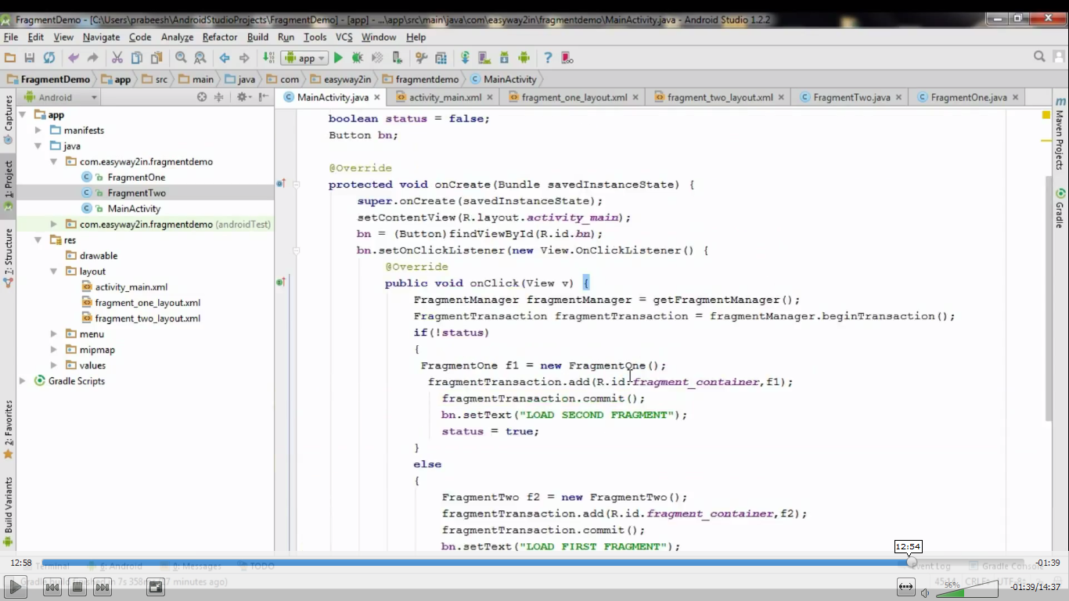

**FRAGMENT CLASS**