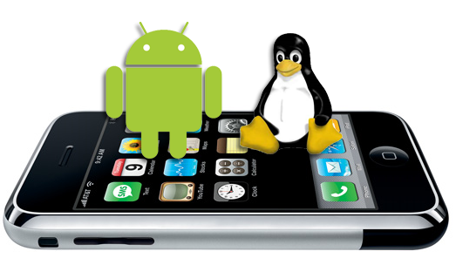

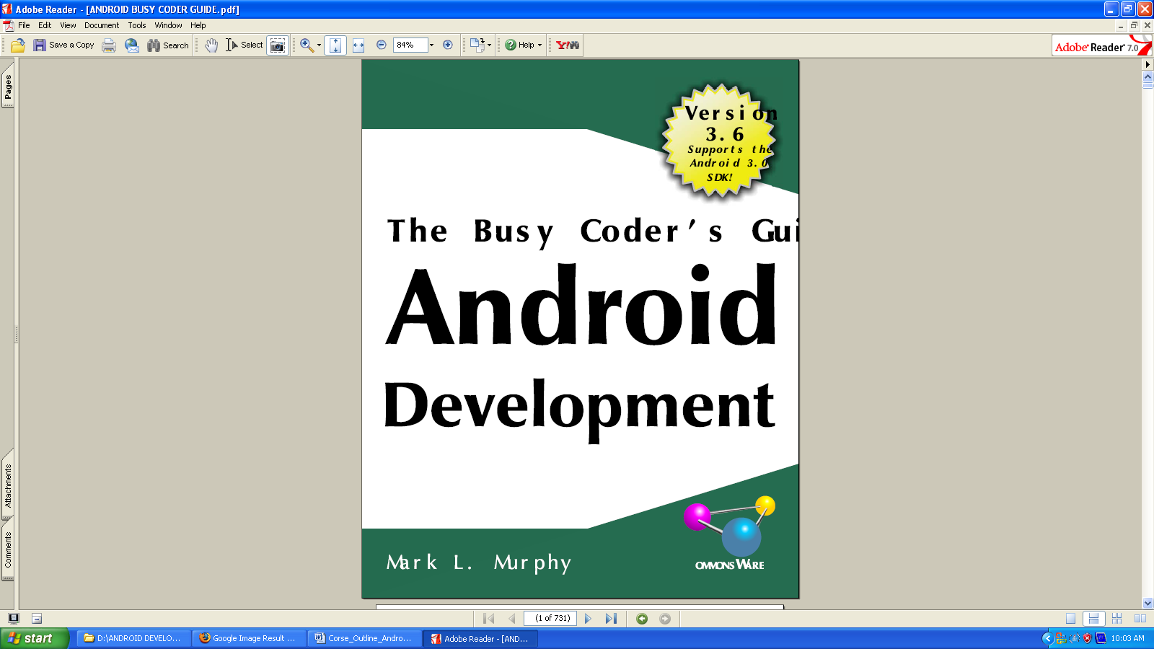

How To Get Started. .
Install the JDK. .
Learn Java.
Install the Android SDK. .
Install the Base Tools.
Install the SDKs and Add-Ons
Install the ADT for Eclipse.
Set Up the Emulator.
Set Up the Device.

Your First Android Project.
Create the New Project.
Eclipse.
Command Line
Build, Install, and Run the Application in Your Emulator or
Device.

About Eclipse.
What the ADT Gives You.
Coping with Eclipse.
How to Create an Emulator.
How to Run a Project.

Enhancing Your First Project.
Supporting Multiple Screens.
Specifying Versions.

Rewriting Your First Project. .
The Activity.
Dissecting the Activity.
Building and Running the Activity.

Using XML-Based Layouts. .
What Is an XML-Based Layout?.
Why Use XML-Based Layouts?

Employing Basic Widgets.
Assigning Labels.
Button, Button, Who's Got the Button?.
Fleeting Images.
Padding.
Useful Properties. .
Useful Methods.
Colors.

Working with Containers.
Thinking Linearly.
Concepts and Properties.
The Box Model. .
The Input Method Framework.
Keyboards, Hard and Soft.

Using Selection Widgets
Adapting to the Circumstances. .
Using ArrayAdapter. .
Lists of Naughty and Nice.
Selection Modes. .
Spin Control.

Getting Fancy With Lists.
A Dynamic Presentation.
Inflating Rows Ourselves
A Sidebar About Inflation. .
Using convertView
Using the Holder Pattern
Interactive Rows

Still More Widgets and Containers.
Pick and Choose.
Time Keeps Flowing Like a River.
Seeking Resolution
Putting It On My Tab
The Pieces
Wiring It Together. .
Adding Them Up. .
Flipping Them Off. .
Getting In Somebody's Drawer. .
Other Good Stuff.

Embedding the WebKit Browser
A Browser, Writ Small. .
Loading It Up. .
Navigating the Waters.
Entertaining the Client. .
Settings, Preferences, and Options.

Applying Menus.
Flavors of Menu
Menus of Options
Menus in Context. .
Taking a Peek.
Yet More Inflation.
Menu XML Structure
Menu Options and XML. .
Inflating the Menu. .
In the Land of Menus and Honey

Showing Pop-Up Messages.
Raising Toasts.
Alert! Alert!.
Checking Them Out.

Handling Activity Lifecycle Events.
Schroedinger's Activity.
Life, Death, and Your Activity.
onCreate() and onDestroy(). .
onStart(), onRestart(), and onStop(). .
onPause() and onResume().
The Grace of State. .

Handling Rotation. .
A Philosophy of Destruction
It's All The Same, Just Different. .
Picking and Viewing a Contact.
Saving Your State.
Now With More Savings!.
DIY Rotation.

Dealing with Threads
The Main Application Thread.
Making Progress with ProgressBars. .
Getting Through the Handlers. .
Messages.
Runnables.
AsyncTask, Generics, and Varargs
Threads and Rotation.
Manual Activity Association. .
Flow of Events. .

Creating Intent Filters. .
What's Your Intent?.
Pieces of Intents.
Intent Routing. .
Stating Your Intent(ions).
Narrow Receivers
The Pause Caveat

Launching Activities and Sub-Activities. .
Peers and Subs
Make an Intent.
Make the Call
Tabbed Browsing, Sort Of. .

Working with Resources. .
String Formats
Styled Text. .
Styled Text and Formats
Miscellaneous Values.
Dimensions.
Colors.
Arrays

Defining and Using Styles.
Elements of Style.
Inheriting a Style. .
The Possible Values

Handling Multiple Screen Sizes.
Consider Physical Dimensions.
Avoid "Real" Pixels. .
Choose Scalable Drawables.
Resources and Resource Sets.
Finding Your Size.
Replace Menus with Buttons.
Replace Tabs with a Simple Activity.
Consolidate Multiple Activities. .

Managing and Accessing Local Databases.
A Quick SQLite Primer. .
Start at the Beginning. .
Setting the Table.
Makin' Data.
Raw Queries.
Regular Queries.
Using Cursors.
Custom CursorAdapters

Alerting Users Via Notifications.
Notification Configuration.
Hardware Notifications.
Icons. .
Notifications in Action.
Staying in the Foreground.
FakePlayer, Redux
Notifications and Honeycomb. .

Accessing Location-Based Services. .
Location Providers: They Know Where You're Hiding.
Finding Yourself.

Mapping with MapView and MapActivity. .
The Key To It All.
The Bare Bones.
Optional Maps
Exercising Your Control.
Zoom
Center. .
Layers Upon Layers. .
Overlay Classes.
Drawing the ItemizedOverlay.
Handling Screen Taps
Maps and Fragments
Use onCreateView() and onActivityCreated().
Host the Fragment in a MapActivity

Handling Telephone Calls.
Report To The Manager.
You Make the Call!.
No, Really, You Make the Call!. .

PROJECTS

CREATING LOCATION-BASED SERVICES APPLICATIONS

Displaying Maps
Obtaining the Maps API Key
Displaying the Map
Displaying the Zoom Control
Changing Views
Navigating to a Specifi c Location
Adding Markers
Getting the Location That Was Touched
Geocoding and Reverse Geocoding
Getting Location Data

SMS MESSAGING AND NETWORKING

SMS Messaging
Sending SMS Messages Programmatically
Getting Feedback after Sending the Message
Sending SMS Messages Using Intent
Receiving SMS Messages
Caveats and Warnings
Sending E-Mail
Networking
Downloading Binary Data
Downloading Text Files
Accessing Web Services Using the GET Method
Performing Asynchronous Calls

Class Schedule

Basic
1-Hellow
2-CheckBox2
3-RadioButton2

Containers
4-TableLayout2
5-ScrollView2
6-LinerLayout2

Input Method
6-Input2

Selection
7-ComboBoxControl2
8-GridViewControlActivity2
9-AutoCompleteDemo
10-Message
11-Calculator

Fancy List
12-Static
13-Dynamic
14-RateList

Other
15-Clock
16-Drawer
17-Chorono
18-Flipper-1
19-Flipper-2
20-Tab

Browser
21-browser-2
22-browser-3

Rotaion
24-RotaionOne
27-RotationFive

Thread
29-Asyncer
30-Handler
31-ReadWriteStrict

Resources
32- ImagesDemo
33- StringsDemo
34- XMLDemo

Styles
35- Style2

Screen Sizes
36- EU4You_1
37- EU4You_2
38- EU4You_3
39- EU4You_4
40- EU4You_5

Activities
36-IntentTab
37-Launch

